COVID – 19 REPORT
STUDENT NAME: LILIANA TURBATU
STUDENT ID: 1919066
LECTURERS NAME: DR. EDWARD GOKA
COURSE NAME: PUBLIC HEALTH POLICY
COURSE CODE: BMHP5013

Table of Contents
Introduction / Background Contextual information 4
Overview of study 4
Background of Covid-19 4
Rationale of choosing UK and Italy 6
Main Body 7
1. Strategies 7
2. Public health policy: 8
3. Theories: 9
4. Impact of legislation and policies on the health and wellbeing of individuals in the health care settings 11
5. Ethical considerations: 13
Summary and recommendations 14
Reference List 15

Introduction / Background Contextual information

Overview of study
The particular study is based on the implications of comparing different aspects through which UK and Italy had faced health related circumstances during the outbreak of covid-19 within respective nations. The study further enumerates the adoption of different health-related strategies that were used within chosen counties in order to measure, monitor, and control incidence of covid-19. The assessment of current public health policies is also identified and evaluated within the study that are been adopted by different health-related organisations in respective nations along with the applications of different theories and models associated with health behavioural change. Legislations and ethical considerations are also incorporated in order to identify how effectively and ethically wellbeing of individuals was achieved, which is further supported with recommended strategies for improvements in the future.

Background of Covid-19
The Covid-19 disease is caused by coronavirus that causes severe acute respiratory syndrome within human when projected to SARS-COV-2 virus. In the words of Corriere della Sera (2021), the virus was noted to be spread within Italy on 31st January 2020, when two Chinese tourists in Rome were tested positive from the virus followed by repatriation of an Italian man back from Wuhan, China after one week. After the case as stated above, cluster of cases were detected in Lombardy and Veneto on 21st February 2020, leading to first detected death from the virus on 22nd February (Anzolin and Amante, 2020). Detection of the virus started within Italy on 3rd February 2020 with the help of enhanced thermal cameras and recruiting medical staffs at airports.
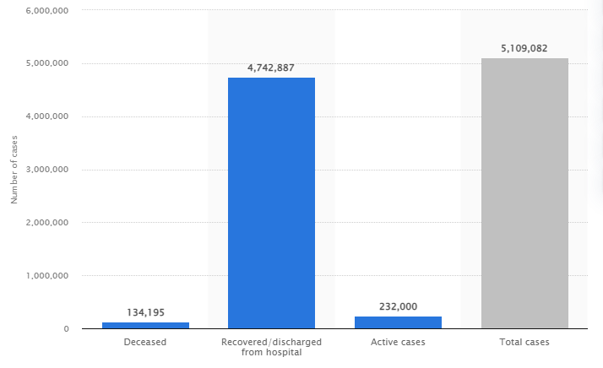
Figure 1: Number of Covid-19 cases, recoveries, and deaths in Italy as of December 5th, 2021
(Source: Stewart, 2021)
The statistics presented above depicts the current scenario of Italy projected to active, recovered, and death cases from covid-19. It can be seen that people within the nation is recovering at faster rate from the disease compared to the state of recovery and increased state of death when it was recorded to be 40,000 deaths by spring 2021 (Nair, 2020). On the other hand, the covid-19 cases within UK were traced to be imported cases from Italy, France, and Spain rather than original cases from China (Devlin, 2020). People subjected to the virus can be stated to be having origin dating from late 2019 and started to spread since late January 2020 (Coleman, 2020).
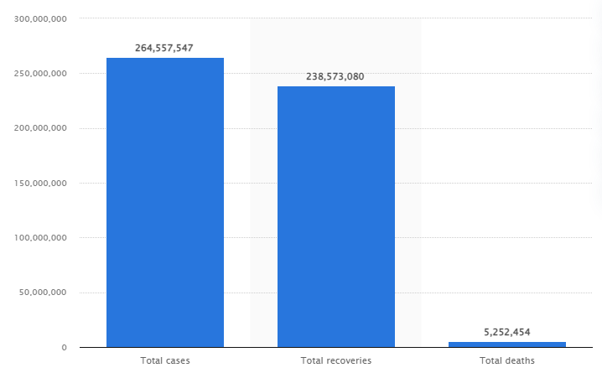
Figure 2: Number of Covid-19 cases, recoveries, and deaths in UK as of December 3rd, 2021
(Source: Stewart, 2021)
From the above statistics, it can be seen that number of deaths and recovery rates within UK is more compared to that of Italy from covid-19. It can be assumed that the differences within the higher rates of deaths and recoveries within UK compared to that of Italy is majorly due to fact that the current population of UK is 66 million whereas that of Italy is 60 million (Morris et al., 2020).

Rationale of choosing UK and Italy
The choice of comparing the different health-related aspects of covid-19 between UK and Italy within the study is that both nations were subjected to the outbreak of the virus very sooner to any other nations across the globe. In the words of Worldometers.info (2021), UK and Italy are among the top 15 nations compared to other nations that were severely affected from Covid-19, both standing at 145,646 and 134,287 deaths respectively. Thus, assessing the aspects associated with acute monitoring, measurement, and control of covid-19 within both the nation will be appropriate to consider within the study.

Main Body

1. Strategies
Bases of comparison | UK | Italy
Measure | The detection and measurement of people affected from the virus were undertaken by several companies and laboratories through developed serological tests that detect antibodies produced by the body in response to infection. The choice of measurement technique was approved by Public Health England and had been effectively used within UK (Dalton, 2020). | However, as mentioned above, the recent measures with which people affected from the virus in Italy was undertaken through the enhanced thermal cameras medical staffs, which were installed at national airports of the nation (Corriere della Sera, 2020)
Monitor | Within UK, the monitoring process of the virus was undertaken through the covid-19 symptom tracker app that had been witnessed with 3.9 million downloads (Budd et al., 2020). It allowed national-level surveillance with the help of time-series charts and geographic maps due to which it was possible to monitor the cases ranging from region-level statistics to individual-level coordinate data. | In the words of Mavragani (2020), regional analysis was performed in the nation by the ministry of health along with identified times-series from Google trends. With time, different policy measures were undertaken in order to support people within Italy with continuous yet effective monitoring of results.
Control | Within the national premieres, new reforms for controlling the spread of the virus and its corresponding new variants are undertaken. The control reforms include compulsory face coverings at shops using masks, mandatory PCR test to be taken by people entering UK, self-isolation for 10 days if found to be a suspect from the disease, and so on (BBC News, 2021). National-level lockdowns were issued so that the increased death rates from the virus could have been controlled. | National-level lockdown were also issued within Italy however, the monitoring of the regulation being followed was different. Mobile phone tracking movement were recorded at individual basis since it was one of the best methods to track whether people are following lockdown protocols or not, as people carry their phones while leaving their homes for any purpose (Vinceti et al., 2020). Strict lockdown was issued during Easter in the nation as well so that the higher incidence rate of covid-19 could be reduced within the nation.
Table 1: Difference between measurement, monitoring, and control of coronavirus incidence in UK and Italy
Similarities
From the aspects identified above, both the nations had equally considered issuing lockdown protocols within respective national premises, although having different ways to carry out those regulations. National government of UK and Italy had viewed severe negative influences of the virus due to which they had been undertaking acute measurements, monitoring, and deployed control strategies. Thus, in the future, the approach of both the nations towards newer variants of the virus will be planned more strictly so that there are least aspects of pandemic development.

2. Public health policy:
In terms of current public health policies within UK, COVID-19 policy tracker 2020 had been designed. The particular policy tracker focuses on national government as well as health and social care projected to respond towards Covid-19 in England. The tracker provides five different areas that have data associated with policy interventions, which includes answers to some of the basic aspects such as where available, what it is, and so on along with detailed overview regarding the emergence of new variants and corresponding fatality from the same (The Health Foundation, 2021).
The “Overall policy narrative health policy” focuses to explain overall governmental response towards covid-19, depicting trends in development of governmental strategies, pursue of key policies, ways in which policies were and will be presented by governmental officials at present as well as in the future. The “Measures to limit spread” policy had enumerated different aspects to national population regarding social distancing, transport restrictions, testing and contact tracing throughout the pandemic, which can be imposed at times associated mass transmission from the virus (The Health Foundation, 2021). Other current policies stated within the UK’s governmental supervision are health and social care system response, interventions to support research and development, and broader social, economic, and other policy intervention.
Whilst the current health polices associated with the control of incidence from the virus is different in Italy compared to the aspects identified above in the case of UK. The Italy’s health care system known as INHS includes principles such as universal coverage, non-discriminatory access to healthcare services, and social financing from general tax revenues. With the help of principles mentioned above, INHS response to covid-19 pandemic locally and future crisis had included 160 decrees, circular letters, orders, notices and advice associated with covid-19 emergencies across the nation. The INHS had stated that until the arrival of valid vaccines to fight against the virus, the public health standards must manage the risks of increased transmission so that overall population is supported with better health and wellbeing aspects within the national premises.
For people coming to Italy for with the perspective of hospitalisation within the nation, the Italian government had launched EU covid-19 passport in order to attain insights and valid proofs from travellers of being vaccinated, recovered, or negative test reports. Moreover, policy associated with restricting the entry of people from Southern African nations had been issued as soon as new variant of coronavirus had been detected globally. From the current health policies enacted within both the nations, it can be seen that national government in association with public and private business entities are taking measures to avoid any chances of widespread destruction of people’s health and wellbeing considerations in the future.

3. Theories:
Health belief model (HBM)
With the help of the theory, it becomes easier to predict human behaviours based upon the implications of how far an individual has the willingness to change their health behaviours due to respective health perceptions. The dimensions that are stated within the model are perceived susceptibility, severity, benefits, and barriers. According to the theory, individual’s demographic aspects such as age, gender, ethnicity, and others can be related to four dimensions that individually have role in development of actions and corresponding cues to those developed actions.
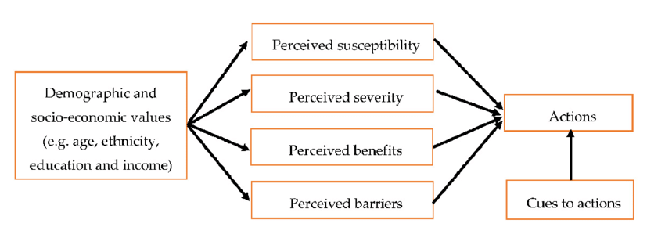
Figure 3: Dimensions of Health Belief Model
(Source: Alhamad and Donyai, 2021)
Perceived susceptibility refers to that stage of human behaviour change where an individual is expected not to change their respective behaviours until they believe they are at any risk. For example, an individual thinking that they would not be subjected to any kind of illness will not undertake any vaccines. Individuals that are found to perceive a behavioural change in order to avoid any consequence depending upon its seriousness are said to be positioned under perceived severity. It is also seen that it become difficult in convincing people to change until the desired change has any benefits associated with the same thus, the aspect of perceived benefit is another dimension of the model. Finally, perceived barriers reflect that an individual is not found to change its behaviour, when it perceives the change is going to be hard. All the dimensions lead to development of actions and prompts for those corresponding actions at individual base.
Social cognitive theory (SCT)
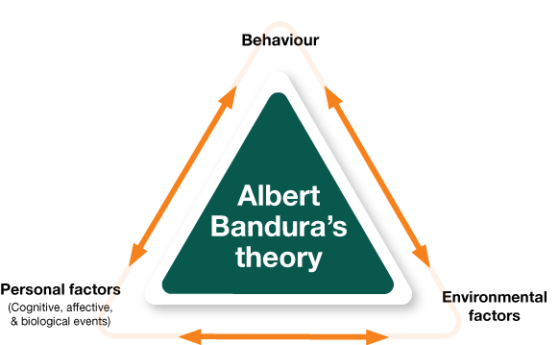
Figure 4: Bandura’s social cognitive theory
(Source: Nabavi, 2012)
The aspects of changes in human behavior are subjected to different personal and environmental factors to which individuals are surrounded or rather associated. The social cognitive theory is based on the implication mentioned above, which was developed by Albert Bandura in 1977 through his article. Within bandura’s research, it has been stated that the aspect of social learning is based on a person’s perceived self-efficacy and behavioral change. Self-efficacy within individuals are developed due to any accomplishment in terms of performance, vicarious experience, different physiological states and verbal persuasion. Thus, the aspects stated above allows whether an individual to seeking to bring any change in accordance with its personal aspects and changes in external environments.

4. Impact of legislation and policies on the health and wellbeing of individuals in the health care settings
Italy
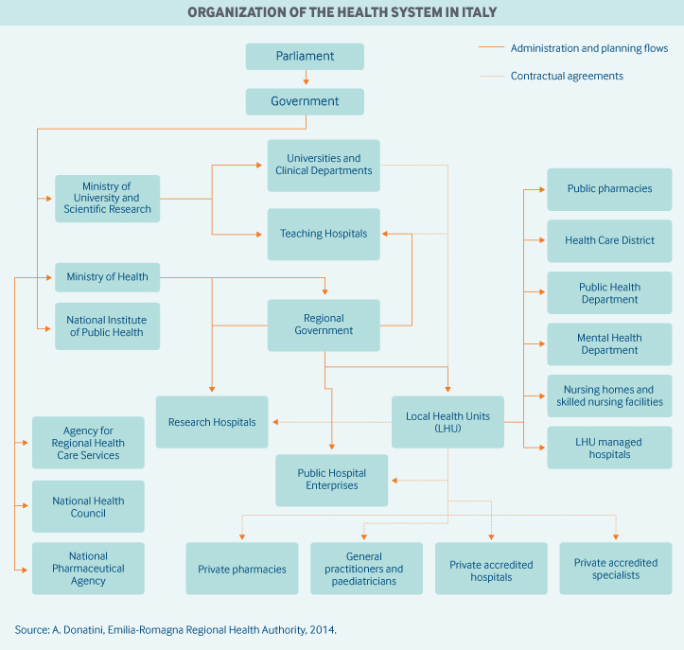
Figure 5: Organisation chart of Health system in Italy
(Source: Donatini and Romagna, 2020)
It is said that Italy has no overreaching Public Health Act or any other legislation to centralise public health laws within the nation however, Italy’s National Health Service (INHS) plays a vital role to cover health related aspects of citizens and foreign residents. The INHS is said to have eight different sections that oversees different health related aspects such as universal health coverage, care delivery and payments, ensured quality of care, disparities reduction, maintenance of electronic health records, cost containment, and innovation within the field of health and social care (Donatini and Romagna, 2020). The impact of INHS over health and wellbeing of people residing within Italy is based on how the governing body operates. From the sections mentioned above, it is seen that ethics and validity of health care services provided to people in the nation are mostly free primary care, and health screenings. Thus, it can be said that there are least aspect of biasness towards residents of Italy as well as foreign people in terms of projecting effective health services.
UK
The Health and Social Care 2012 is the major law that provides its legal duties for the elimination of health inequalities to people residing within the UK. Under the particular law, the operations of Department of Health, Public Health England, Clinical Commissioning Groups, and NHS England are governed so that acute level of health and social care services are provided to every citizen of UK (England.nhs.uk, 2021). Some of the other supporting legal acts are Equality Act 2010 and Social Value Act 2012 that focuses oversee whether people within UK receives better quality health services from local authorities and other heath sector bodies operating within the nation. Based upon the laws stated above, health and social care organisation provides clinical services and fulfills its duty to contribute to accordance with development of positive social value.

5. Ethical considerations:
In the words of Who.int (2021), WHO had established certain implications that are associated with integration of ethics for working groups that operates to measure, monitor, and control implications of Covid-19. The expert group formed in February 2020 had been engaged in ethical activates such as providing advice to researchers regarding ethical considerations of covid-19, providing practical guidance on the application of ethical values, policy briefing on resource allocation, and so on. The prime focus of the group is to ensure that the patients that had been victimised from the virus are not kept away from ethical rights regarding medical treatments (Rcpsych.ac.uk, 2021). The ethical rights to patients include availability of proper inpatient beds, better clinical offers, reduced blanket restrictions, communication with families and friends to a certain level, and so on.

Summary and recommendations
From the aspects mentioned above, it can be summarised that the extent of care that had been provided to people across Italy and UK during the covid-19 pandemic was based on the state of urgency within respective nations. In the future, the governmental as well as private organisations within both the nations are coming up with innovative medical equipment, medicines, and technologies with which people can stay away from newer variants of the virus. Thus, it will lead in achieving better health and wellness aspects within UK and Italy. The aspects of self-isolation, social distancing and other similar approaches must be considered by residents of the nation since this way they shall be able to contribute towards supporting the productivity of health and social care organisations that is working to bring more advancement in improved ways to measure, monitor, and control the virus from spreading.

Reference List
Alhamad, H. and Donyai, P., 2021. The Validity of the Theory of Planned Behaviour for Understanding People’s Beliefs and Intentions toward Reusing Medicines. Pharmacy, 9(1), p.58.

Anzolin, E. and Amante, A., 2020. First Italian dies of coronavirus as outbreak flares in north. [online] Reuters.com. Available at: <https://www.reuters.com/article/us-china-health-italy/coronavirus-outbreak-grows-in-northern-italy-16-cases-reported-in-one-day-idUSKBN20F0UI> [Accessed 7 December 2021].

BBC News. 2021. Omicron: How are Covid rules changing in the UK?. [online] Available at: <https://www.bbc.com/news/explainers-52530518> [Accessed 7 December 2021].

Budd, J., Miller, B.S., Manning, E.M., Lampos, V., Zhuang, M., Edelstein, M., Rees, G., Emery, V.C., Stevens, M.M., Keegan, N. and Short, M.J., 2020. Digital technologies in the public-health response to COVID-19. Nature medicine, 26(8), pp.1183-1192.

Coleman, L., 2020. Covid started a year ago - but did this bricklayer bring it to UK sooner?. [online] Metro. Available at: <https://metro.co.uk/2020/11/17/bricklayer-66-claims-to-be-britains-covid-patient-zero-13609231/> [Accessed 7 December 2021].

Corriere della Sera. 2021. Coronavirus, primi due casi in Italia: sono due turisti cinesi. [online] Available at: <https://www.corriere.it/cronache/20_gennaio_30/coronavirus-italia-corona-9d6dc436-4343-11ea-bdc8-faf1f56f19b7.shtml> [Accessed 7 December 2021].

Dalton, J., 2020. NHS staff will be first to get new coronavirus antibody test, medical chief promises. [online] The Independent. Available at: <https://www.independent.co.uk/news/uk/home-news/coronavirus-test-antibody-covid-roche-immune-nhs-staff-a9515466.html> [Accessed 7 December 2021].

Devlin, H., 2020. No 'patient zero' as Covid-19 came into UK at least 1,300 times. [online] the Guardian. Available at: <https://www.theguardian.com/world/2020/jun/11/british-clampdown-on-non-essential-travel-came-a-week-too-late> [Accessed 7 December 2021].

Donatini, A. and Romagna, E., 2020. Italy | Commonwealth Fund. [online] Commonwealthfund.org. Available at: <https://www.commonwealthfund.org/international-health-policy-center/countries/italy> [Accessed 7 December 2021].

England.nhs.uk., 2021. NHS England » Key legislation. [online] Available at: <https://www.england.nhs.uk/about/equality/equality-hub/resources/legislation/> [Accessed 7 December 2021].

Mavragani, A., 2020. Tracking COVID-19 in Europe: infodemiology approach. JMIR public health and surveillance, 6(2), p.e18941.

Morris, C., Reuben, A. and Kovacevic, T., 2021. Coronavirus: Can you compare the UK with Italy?. [online] BBC News. Available at: <https://www.bbc.com/news/52530918> [Accessed 7 December 2021].

Nabavi, R.T., 2012. Bandura’s social learning theory & social cognitive learning theory. Theory of Developmental Psychology, pp.1-24.

Nair, A., 2020. Coronavirus: Italy deaths jump to 463, with 300 in just one region. [online] Sky News. Available at: <https://news.sky.com/story/coronavirus-italy-sees-largest-daily-rise-in-deaths-and-confirmed-cases-11953192> [Accessed 7 December 2021].

Rcpsych.ac.uk. 2021. COVID-19 - Ethical considerations | Royal College of Psychiatrists. [online] Available at: <https://www.rcpsych.ac.uk/about-us/responding-to-covid-19/responding-to-covid-19-guidance-for-clinicians/covid-19-ethical-considerations> [Accessed 7 December 2021].

Stewart, C., 2021. Italy: COVID-19 status | Statista. [online] Statista. Available at: <https://www.statista.com/statistics/1102808/coronavirus-cases-by-status-italy/> [Accessed 7 December 2021].

The Health Foundation. 2021. COVID-19 policy tracker 2020 | The Health Foundation. [online] Available at: <https://www.health.org.uk/news-and-comment/charts-and-infographics/covid-19-policy-tracker> [Accessed 7 December 2021].

Vinceti, M., Filippini, T., Rothman, K.J., Ferrari, F., Goffi, A., Maffeis, G. and Orsini, N., 2020. Lockdown timing and efficacy in controlling COVID-19 using mobile phone tracking. EClinicalMedicine, 25, p.100457.

Who.int. 2021. Ethics and COVID-19. [online] Available at: <https://www.who.int/teams/health-ethics-governance/diseases/covid-19> [Accessed 7 December 2021].

Worldometers.info. 2021. Countries where Coronavirus has spread - Worldometer. [online] Available at: <https://www.worldometers.info/coronavirus/countries-where-coronavirus-has-spread/> [Accessed 7 December 2021].

