Module Name: Computer Architecture and Operating Systems
Assignment Title: Operating Systems Assignment

Module Code: ACCA4022
Student Name: Archana Gurudas Salgaocar
Student ID: 2514522
Group: 3

University of Wales Trinity Saint David
LONDON CAMPUS

Table of Contents
Introduction 4
Key Functions of Operating Systems 4
Process Management 4
Memory Management 5
File System Management 7
Device Management 8
Network Management 9
Windows CLI Commands 10
Process Management 10
File and Directory Management 11
Network Management 13
User Management 14
Task Scheduling 15
Linux CLI Commands 16
Process Management 16
File Management 17
Network Management 18
User Management 19
Task Scheduling 20
Windows Batch Scripts 21
Script 1: Addition Script 21
Script 2: File Checker 22
Linux Batch Scripts 23
Script 1: Multiplication Script 23
Script 2: Directory Checker 24
Conclusion 25
References 25

Introduction
An operating system (OS) is the necessary software for the effective functioning of the hardware and provides services to the applications installed on a computer system. An OS acts as a bridge between the hardware and users in a computer system, enabling processes to run effectively and making the best possible use of the resources in the system. Modern operating systems provide graphical user interfaces as well as command line interfaces (CLI), thus providing users with options to control the system. This project aims at understanding the basic role of operating systems and implementing them using Windows and Linux CLI, among others [1].

Key Functions of Operating Systems

Process Management
Process management is one of the essential functions of the operating system in managing various applications by executing them concurrently. A process can be described as a running program in which the operating system creates, schedules, and terminates it during its lifetime. Each process goes through certain states like new, ready, running, waiting, and terminated, and their management allows the orderly execution of processes [1].
In order to effectively manage processes, several scheduling algorithms such as First-Cit-First-Served, Shortest Job First, and Round Robin are implemented to allocate CPU time among several programs. For example, in Round Robin, processes receive a fixed amount of time quantum to use the CPU before giving way to another process, so that no program consumes the whole amount of the available CPU.
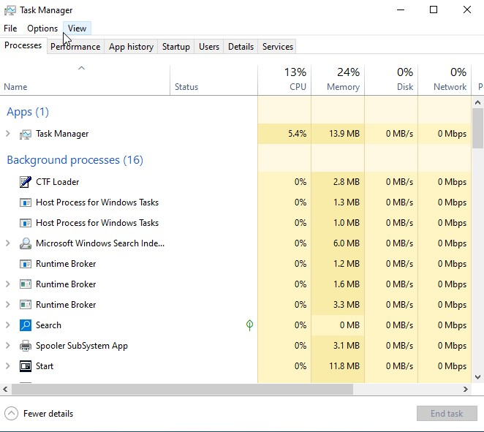
Figure 1: Windows Task Manager displaying active processes and CPU usage.

Memory Management
The purpose of memory management is to manage and control the memory (RAM) of the computer for the proper running of applications. Memory management takes care of allocating and reclaiming memory for processes. This helps in optimising the use of memory and reduces wastage [2]. Preventing any kind of interference of processes with each other while using memory is the main objective of memory management. The memory of the process can only be accessed by that process itself and cannot be used by anyone else. Therefore, it increases security and reduces system crashes because of memory interference.
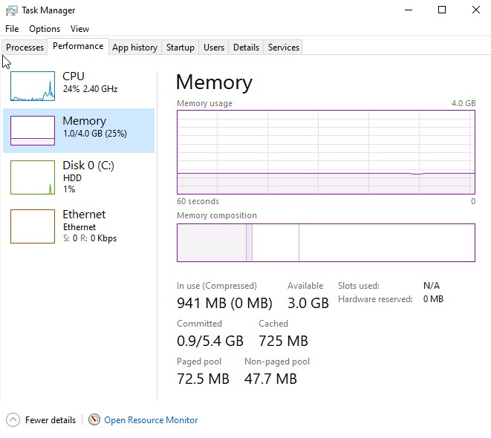
Figure 2: Memory usage monitoring in Windows Task Manager

File System Management
File system management is the process of organizing and managing the data stored on the storage device. Operating systems organize the information into files and directories that help users manage their data efficiently. Organized data improves the ease of data handling. Different file systems are employed by different operating systems for instance NTFS file system used in windows and ext4 used in Linux. File systems determine how information is stored and retrieved in addition to the rules that define how access to the file can be made and controlled. This function helps to protect the privacy and data security. Many tasks related to files can be performed by an operating system ranging from creation of new files, deletion of old files, moving, copying, renaming and deleting the files. The operating system also maintains metadata for each file like size, location, access dates, and permissions among other things. File metadata help in organizing the information in an effective manner.
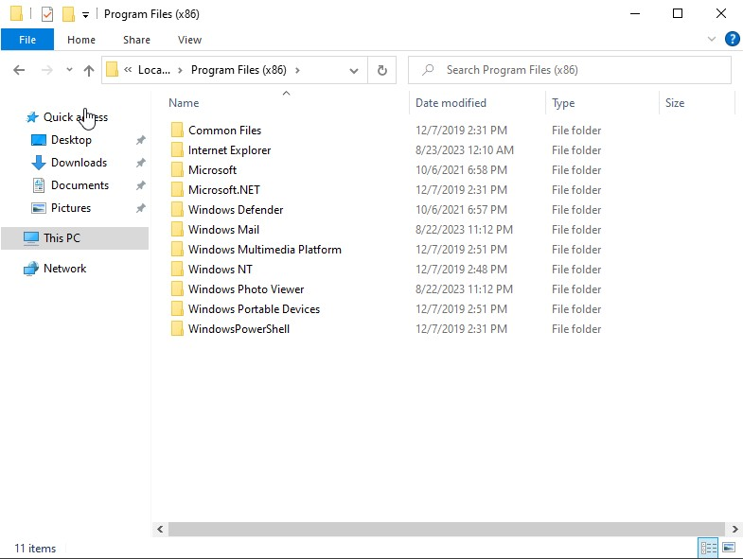
Figure 3: File system management using Windows File Explorer

Device Management
The process of device management enables the communication between the operating system and hardware devices such as printers, keyboards, storages, and adapters. Device drivers are the interfaces between hardware and software which make such communication possible. Every hardware requires its own driver to facilitate interaction with the operating system [3]. The task of the operating system here is to manage multiple devices simultaneously in a way that prevents conflicts. The operating system allocates system resources necessary for the devices' functioning. It also manages input/output buffers and caches to improve the performance of input/output operations.
One more important responsibility of the operating system in relation to devices is their error handling. The operating system constantly monitors the state of hardware devices in order to notice any problems with them. When problems occur, the operating system allows using diagnostic tools for solving them. Windows has a graphic tool called Device Manager which can be used for managing hardware devices. Linux uses such commands as lsusb and lspci for getting more information about hardware devices. As a conclusion, it should be stated that device management enables the interaction between hardware and software which results in improved efficiency.
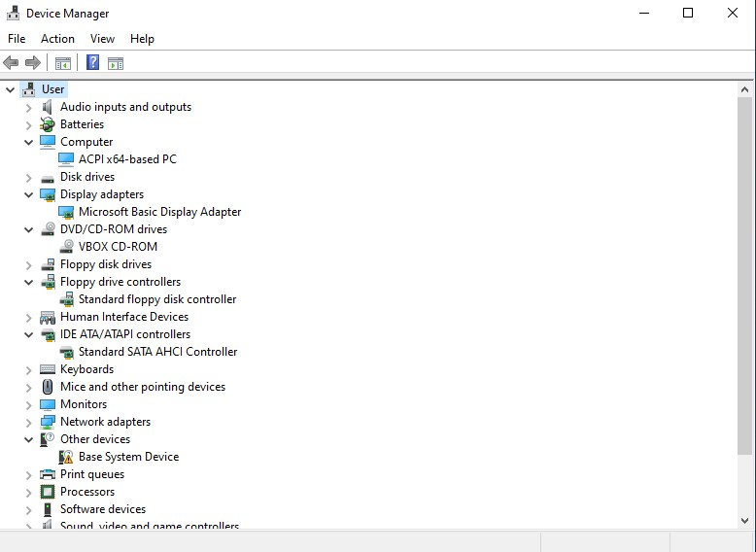
Figure 4: Hardware management through Windows Device Manager

Network Management
One of the functions performed by an operating system is the management of a network. Network management refers to the process of creating connections and communicating on a network of connected computers and devices [4]. The operating system can configure automatic or manual settings, including IP addresses, subnet masks, gateways, and DNS servers. Such parameters play a key role in effective local and Internet communication. An operating system should monitor and troubleshoot connectivity. It offers such options as the use of ipconfig in Windows and Ip –or ping in Linux for diagnostic purposes. By providing such possibilities, the OS allows users to view their current network setting and check communications with other computers.
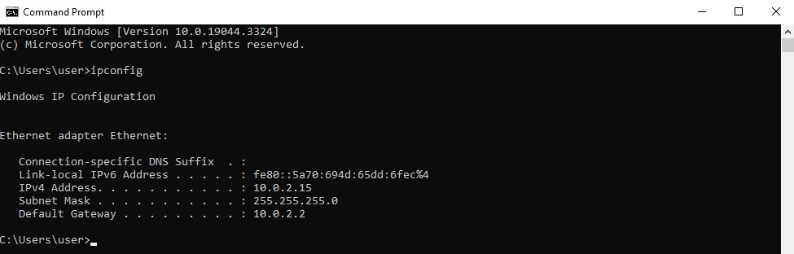
Figure 5: Network configuration details using ipconfig command.

Windows CLI Commands
The Windows Command Line Interface allows users to perform administrative tasks efficiently using commands [3].

Process Management

Command: tasklist
The tasklist command displays all running processes along with their memory usage, helping monitor system performance.
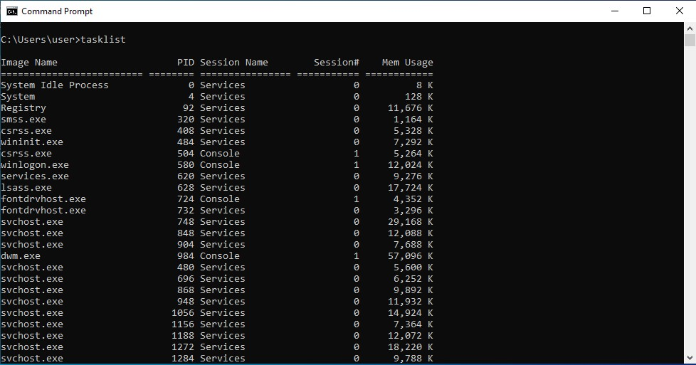
Figure 6: Output of tasklist command

Command: taskkill
The taskkill command is used to kill/terminate processes using their names or pid. /F flag ensrues unresponsive process can be closed effectively by forcefully terminate the process.
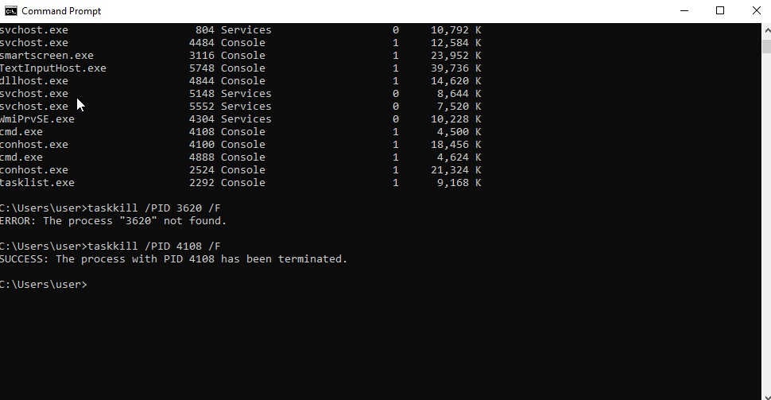
Figure 7: taskkill command execution

File and Directory Management

Command: dir
dir command is used to list the content of the directory. It helps the user to navigate through the filesystem in Windows Operating System.
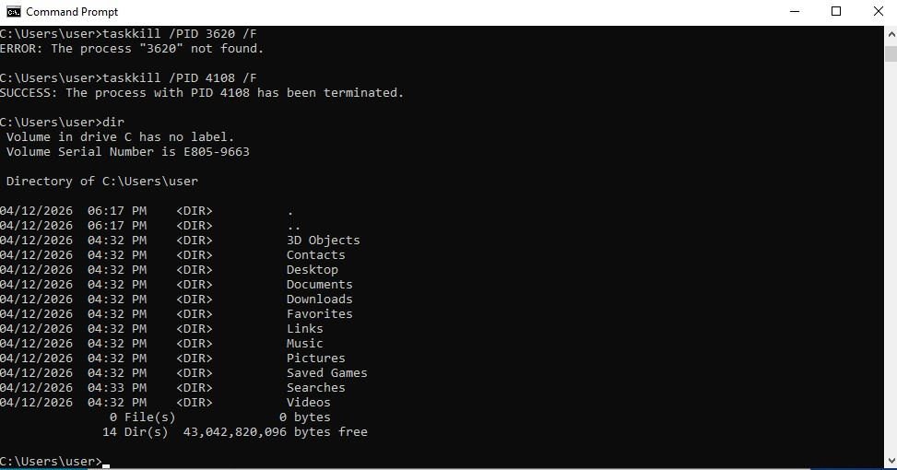
Figure 8: dir command output

Command: mkdir
Creates a new folder/directory. mkdir a\b creates a folder b inside folder a, if folder a doesn’t exist, it will first create folder and then create another folder b inside folder a.
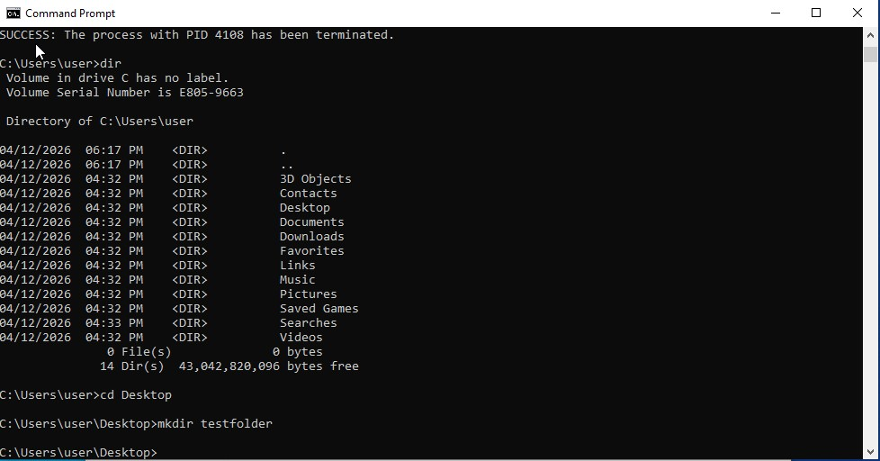
Figure 9: mkdir command output

Command: copy
The copy command allows duplication of files from one location to another.
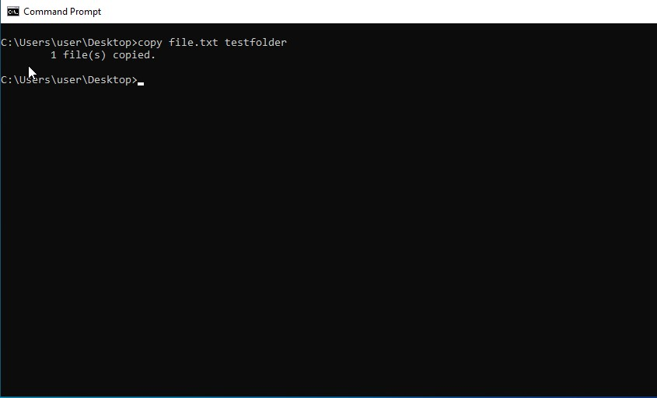
Figure 10: copy command output

Command: del
delete command is used to delete a file.
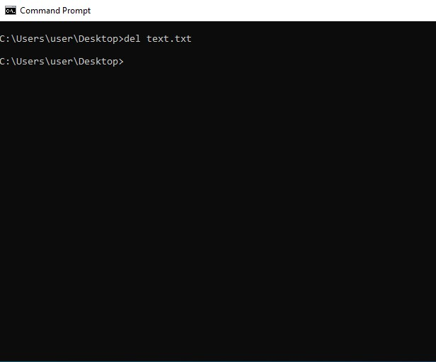
Figure 11: del command output

Network Management

Command: ipconfig
Ipconfig command is used to display network configuration details including ip address, associated subnet and gateway path information.
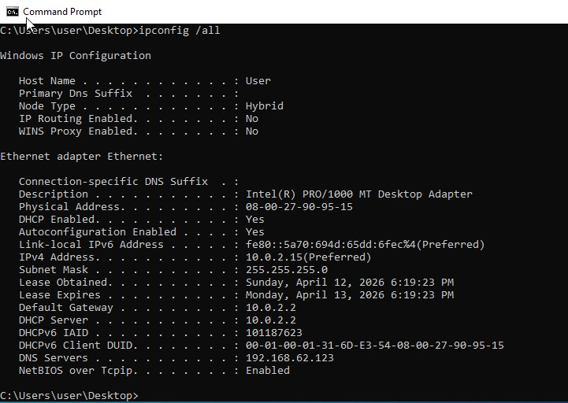
Figure 12: ipconfig output

Command: ping
ping command is used to check the connectivity between two devices over the internet. It sends packet to target device and check for its response time.
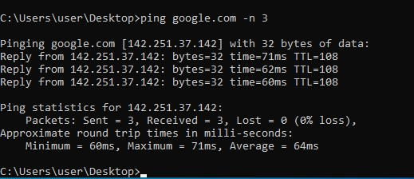
Figure 13: ping output

Command: netstat
netstat command is used to verify network configuration and troubleshoot connection issues. It shows active connections and listening ports which helps diagnosing network problems.
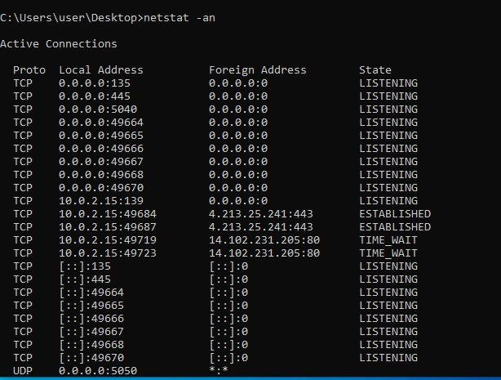
Figure 14: netstat output

User Management

Command: whoami
whoami command shows which user you are currently logged in. It is very useful command when you are working with multiple users.
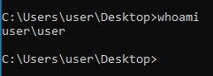
Figure 15: whoami output

Command: net user
The net user command provides a list of user accounts and can also be used to create, modify, or delete users.
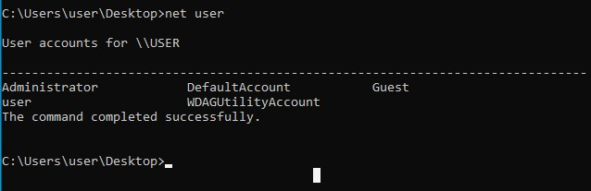
Figure 16: net user output

Task Scheduling

Command: schtasks
The schtasks command is used to view and manage scheduled tasks. It enables automation of repetitive processes, improving system efficiency and reducing manual workload.
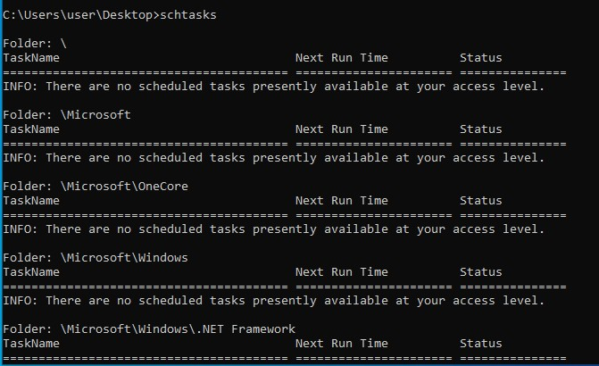
Figure 17: schtasks output

Linux CLI Commands
Linux CLI provides powerful tools for system administration [5]. Following are some of the most common linux commands used:

Process Management

Command: ps aux
The ps aux command lists the detailed information about all running processes including CPU and memory usage.
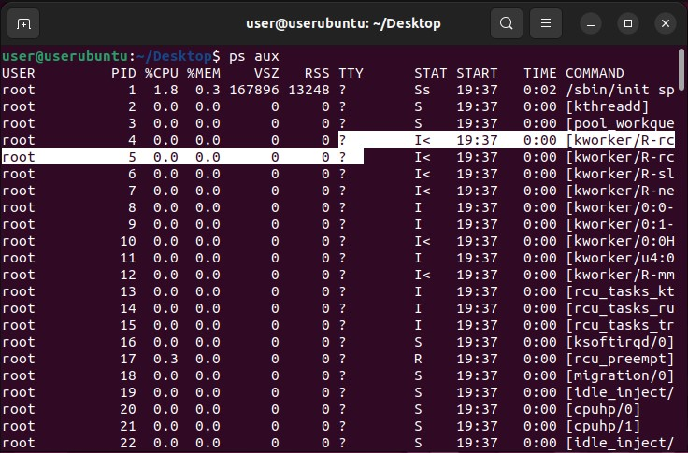
Figure 18: ps command output

Command: top
Top command is used to view and manage real-time system resources. It provides you real-time information about how much CPU or memory each running process is consuming.

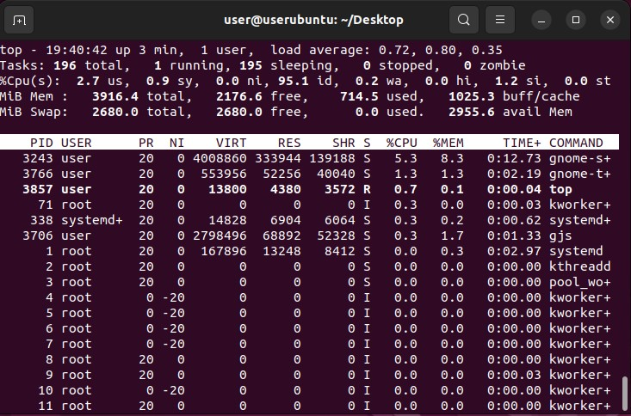
Figure 19: top command output

File Management

Command: ls
ls command is used to display files and directories in your present working directory. If you use –l flag after ls command, it gives you the detailed information associated with each file or directory.
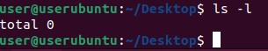
Figure 20: ls command output

Command: mkdir
mkdir creates a new folder/directory. –p flag is used to create empty directory in mentioned path if it already doesn’t exist.
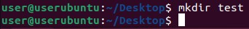
Figure 21: mkdir command output

Command: rm
Delete files or directories inside current directory. –r flag is used to recursively delete the content inside that directory.
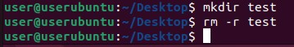
Figure 22: rm command output

Command: cp
Copy files and directories from one place to another.
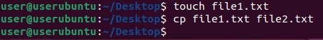

Network Management

Command: ip a
The ip a command displays network interfaces and IP configurations.
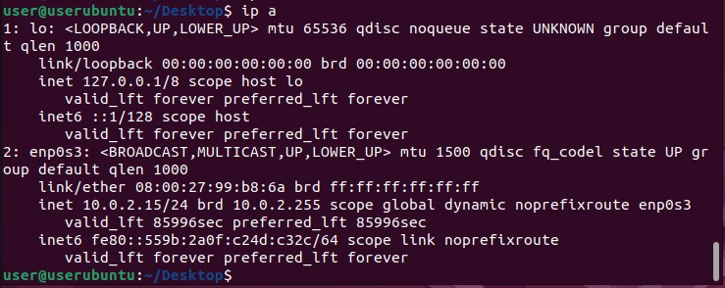
Figure 24: ip command output

Command: ping
ping command is used to check the connectivity between two devices over the internet. It sends packet to target device and check for its response time.
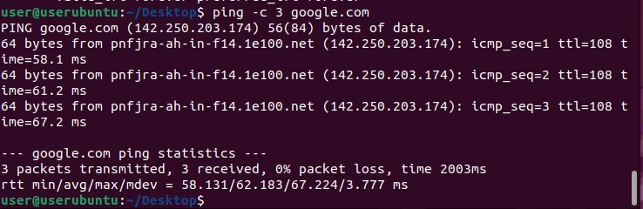
Figure 25: ping command output

Command: ss –tuln
ss –tuln command display active network sockets and listening ports.
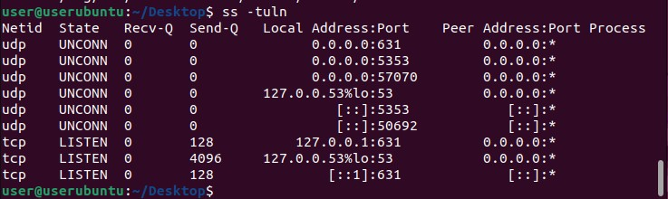
Figure 26: ss command output

User Management

Command: id
id command displays current users detailed information including its UID, GID and groups.
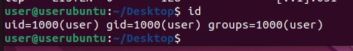
Figure 27: id command output

Command: whoami
Display which user you are currently logged in.
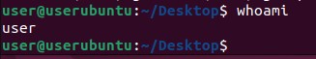
Figure 28: whoami output

Task Scheduling

Command: crontab
crontab command create and manages scheduled tasks.
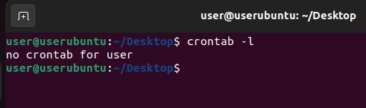
Figure 29: crontab output

Windows Batch Scripts
Batch scripting is widely used in windows system administration for tasks such as file handling and monitoring. It helps improves system efficiency by automating routine system operations.

Script 1: Addition Script
This is an addition script that takes user input and performs a mathematical calculation. It uses variables to store values and performs arithmetic operations to generate the result. This demonstrates how scripts can interact with users and process data.

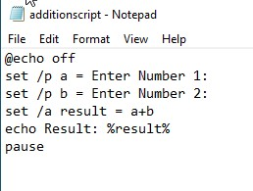
Figure 30: Batch script code
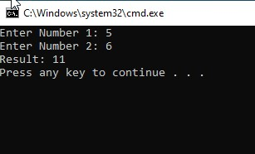
Figure 31: Script execution output

Script 2: File Checker
The script is a file checker that verifies whether a file exists. It uses conditional statements (IF conditions) to check for file presence. If the file exists, a success message is displayed; otherwise, an error message is shown.
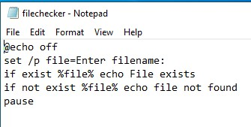
Figure 32: Script code

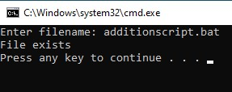
Figure 33: Script Output

Linux Bash Scripts
Bash scripting is widely used in Linux operating system. It is widely used for tasks such as file handling and monitoring. It helps improves system efficiency by automating routine system operations.

Script 1: Multiplication Script
This is a multiplication script that takes user input and performs arithmetic operations. It uses variables and performs arithmetic operations to calculate results, demonstrating user interaction in scripts.
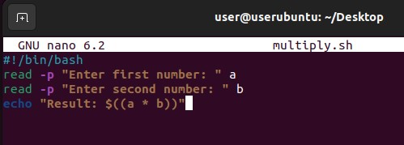
Figure 34: Script code
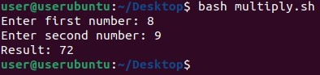
Figure 35: Script output

Script 2: Directory Checker
The second script is a directory checker that verifies whether a directory exists. It uses conditional statements (if-else) to display appropriate messages based on the result.
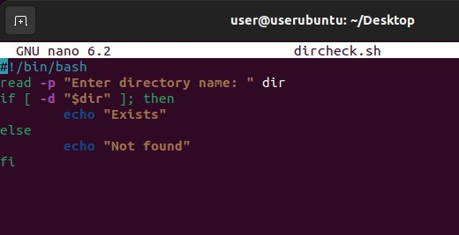
Figure 36: Script code
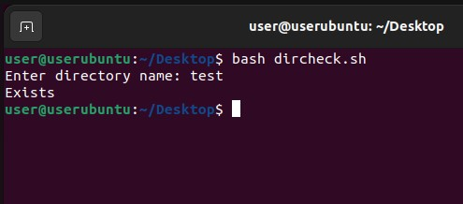Figure 37: Script output

Conclusion
The paper highlights the main purposes of an operating system and discusses their realization in practical computing environments. The students will get a comprehensive idea of what the main functions of the OS include: process control and scheduling, memory management, file system maintenance, device management, and communication. Not just the theory but the practical implementation of the concepts discussed in class will be considered in the form of command-line interfaces in Windows and Linux OSes. This will demonstrate how efficient operation can be done through the command line.
The use of scripts in this regard is one more step towards automation that plays an important role in modern-day computing. With the help of scripts, namely Batch and Bash scripts, any repeated tasks can be completed efficiently and accurately, which will save time and effort while eliminating the chances of making a mistake. Thus, it can be concluded that the combination of theoretical knowledge and practical skills gained during studying command lines and scripts creates a basis for successful system administration.

References
- W. Stallings, Operating Systems: Internals and Design Principles, 9th ed. Pearson, 2018.
- D. A. Patterson and J. L. Hennessy, “Computer Organization and Design: The Hardware Software Interface - RISC-V Edition,” Elsevier, vol. 01, 2019.
- M. Russinovich, D. A. Solomon, and A. Ionescu, Windows Internals, 7th ed. Microsoft Press, 2017.
- J. Kurose and K. Ross, Computer Networking: A Top-Down Approach, 7th ed. Pearson, 2017.

