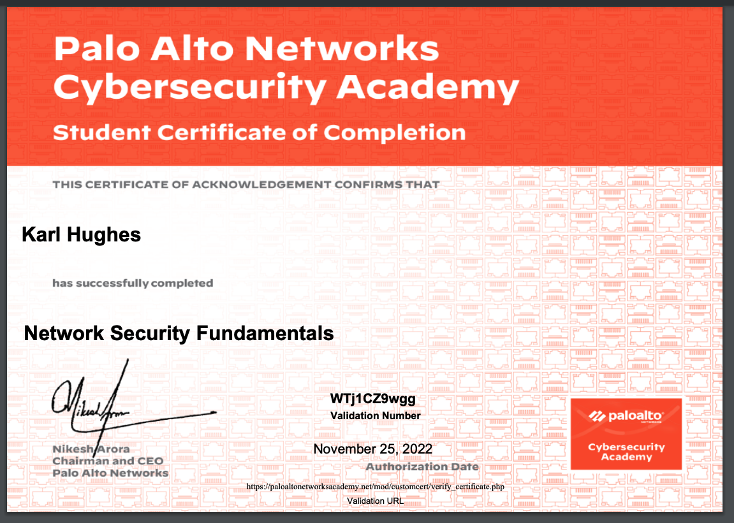

Link

https://paloaltonetworksacademy.net/mod/customcert/view.php?id=287206&downloadown=1

