4/27/2026
Assessment
Portfolio Report on Contemporary Software Applications for Business


Student Name: Biniam Aregawi Abraha
Student ID:2532266

Module NaMe: Software solutions for business
Module Code: ACCA 4026
Lecturer: amitave banik
Trinity saint david University of Wales (London Campus)

Table of Contents
Introduction 2
Main Body 2
Task 1 3
e-Commerce Website builders/software solutions 3
Task 2 4
Mind-map of Contemporary Software Applications 4
Task 3 6
Office Applications for Creating, Storing, Presenting, and Analysing Data 6
a. 6
b. 11
Task 4 18
Communication and Collaboration applications 18
a. 18
b………………………………………………………………………………………………………………… 23 Conclusion 26
References 27

Introduction
Businesses of all sizes are running more applications than ever before. Many of today’s enterprise software environments consist of tens, hundreds, or even thousands of applications—each one supporting key business operations and contributing to overall success. As software has become so integral to business value and efficiency, it naturally has become the backbone of most organizations. Whether selling online, collaborating with customers and colleagues, or running Microsoft Office to manage email, Word documents, or spreadsheets, modern business depends on technology. Organizations are using software to become more efficient, more competitive, and to deliver better customer experiences. As software is so critical to these objectives, managing it is a top priority.

Software programs are used in every sector of business. This report focuses on three categories of software: (1) e-commerce website builders which can help develop an online retail store; (2) mind mapping programs designed to create, organize and navigate ideas and maps to assist in business decision making; and (3) office suites such as Microsoft Office which contain word processing, data analysis, presentation software and relational database software.

The report also shows examples of how the tools and functions can be put into practice in the daily work. The report also looks into the possibilities for data analysis and automated document generation. The report also briefly presents communication and collaboration tools such as Microsoft Teams and Miro and how they can be used in team work in remote and hybrid work environments.

This report explains how modern software is enabling efficient business operations and informed decision making in the technology age.

Main Body
This report aims to detail the main characteristics of common software packages currently used by organisations.
There is a vast array of software packages currently available to businesses ranging from web design packages to large enterprise resource planning systems. The purpose of most software is to allow organisations to be as efficient as possible, to meet the needs of customers and to manage data and communication.
The following four tasks outline the different types of software, their roles and purposes and how they can be used to support a business.
This report compares a number of tools that allow organisations to create an e-commerce website. The report focuses on two market leading providers, Wix and Shopify, and compares their features and usability. We also assess how easy each tool is to use, and evaluate their suitability for use by different organisations.
The report goes on to examine the topic of mind mapping, a relatively modern method of organisation and decision making, and then considers the use of more visual approaches to creativity, problem solving and planning.
This section looks at the software office packages that allow users to create, store, display and analyse data and applications such as Microsoft Word, Microsoft Excel, Microsoft PowerPoint and Microsoft Access. The packages are covered in depth with live demonstrations of their features, including data analysis and automation of documents.
The report also delves into the communication and collaboration applications that are driving teamwork in remote and hybrid work environments, including Microsoft Teams, Miro and more.
This section examines the contribution made by different types of software applications to business efficiency, productivity and decision-making.

Task 1
(10 marks)

e-Commerce Website builders/software solutions
(Approx. 500 words)
Several widely used e-commerce website builders include Shopify, Wix, WooCommerce, BigCommerce, and Squarespace. These platforms help businesses create and manage online stores without advanced technical skills.
Shopify – Overview
Shopify is a top e-commerce platform that takes care of hosting, security, and maintenance, so you don't have to. It's really easy to use, even if you're not tech-savvy, and it lets you manage your products, track orders, and get insights into your customers' behaviour. One of the best things about Shopify is its templates - they're professional, customizable, and make your store look great[1] . Plus, there are tons of apps you can add to get more features, like SEO tools and marketing integrations, which helps your business grow. And when it comes to payments, Shopify's got you covered - it supports lots of different options, including its own payment system, so your customers can check out quickly and easily.
But there's a catch - costs can add up quickly with monthly fees and paid apps. If you want to customize your site to the max, you might need to know how to code or hire a developer to do it for you, according to Webiprog and WebsiteBuilderExpert, who both weighed in on this issue in 2024.
Wix eCommerce – Overview
Wix makes it easy to sell things online with Wix Stores. It's also really good at helping people design websites without needing to know a lot of technical stuff. They have a drag-and-drop editor that lets you move things around and make your site look nice. Wix has lots of modern templates to choose from and important features like lists of products, discounts, and ways to get people to come back and finish buying things they left in their carts. You can also connect your site to social media, which is really helpful. Wix is a good choice for small businesses or ones that really care about how their site looks because it's not too expensive. Some other sites, like SimiCart and Futuremerce, have said good things about Wix too [2].
But it's not the best choice for big stores, because it doesn't have all the advanced tools you might need, and it can be slow when you have a lot of things going on. Also, if you want to change the way your site looks after it's already up and running, you'll have to rebuild the whole thing, which can be a hassle, as Maktagg pointed out in 2024.

Task 2
(15 marks)

Mind-map of Contemporary Software Applications
(Approx. 500 words)

Overall, mind maps are a great tool to have in your toolbox, and they can really help you get your thoughts together and make sense of a. Describe mind mapping and explain the benefits of using mind mapping in business operations (approx. 2/3 sources). 5 marks
Mind maps are a great way to get your thoughts in order. They're like a big picture that shows how everything connects. You start with a main idea in the middle, and then you add branches that spread out from there. These branches can have smaller ones coming off them, kind of like a tree. This way of organizing things is really similar to how our brains work, so it makes sense that it helps us understand and remember things better. Plus, it's a great way to come up with new ideas. Tony Buzan, who's an expert on this stuff, says that mind maps can really help boost your creativity, get your thoughts organized, and make complicated things seem simpler. By using mind maps, you can see everything laid out in front of you, and that can be really powerful. It's a pretty flexible way of working, too, so you can use it for all sorts of things, from planning a project to just brainstorming ideas[3].
Mind maps are a great way to show ideas in a simple and visual way, using keywords, colors, symbols, and images. This makes it easy to see how different ideas are connected, without having to read through a lot of text. According to some research from MindTools in 2024, using pictures to learn can really help us understand and remember things better. This is especially useful when we're trying to come up with new ideas, make plans, or solve problems. By using mind maps, we can quickly get a sense of how different ideas fit together, and make connections that might not be obvious at first. It's a really powerful tool for helping us think and learn in a more visual way.
Mind maps are really useful in professional settings because they help teams be creative and come up with new ideas. When people are brainstorming, mind maps let them write down and connect all their ideas in one place, which encourages people to think outside the box. They're also great for planning and making decisions, because they show everything you need to consider - like what you want to achieve, what might go wrong, and what you have to work with - in a way that's easy to see and understand. This makes it easier for managers to weigh their options and make good choices. Actually, some research in the International Journal of Management Studies from 2022 found that using visual tools like mind maps can really help reduce mental fatigue and speed up the decision-making process. By using mind maps, teams can work more efficiently and come up with better solutions[4].
Mind maps also improve communication and collaboration, especially when using digital tools like MindMeister, Miro, and XMind. Overall, they enhance productivity by breaking complex projects into manageable tasks, making them a powerful tool for modern businesses.

b. Create a mind map of contemporary software applications that are used to support day-today business/Organisation operations. 10 marks
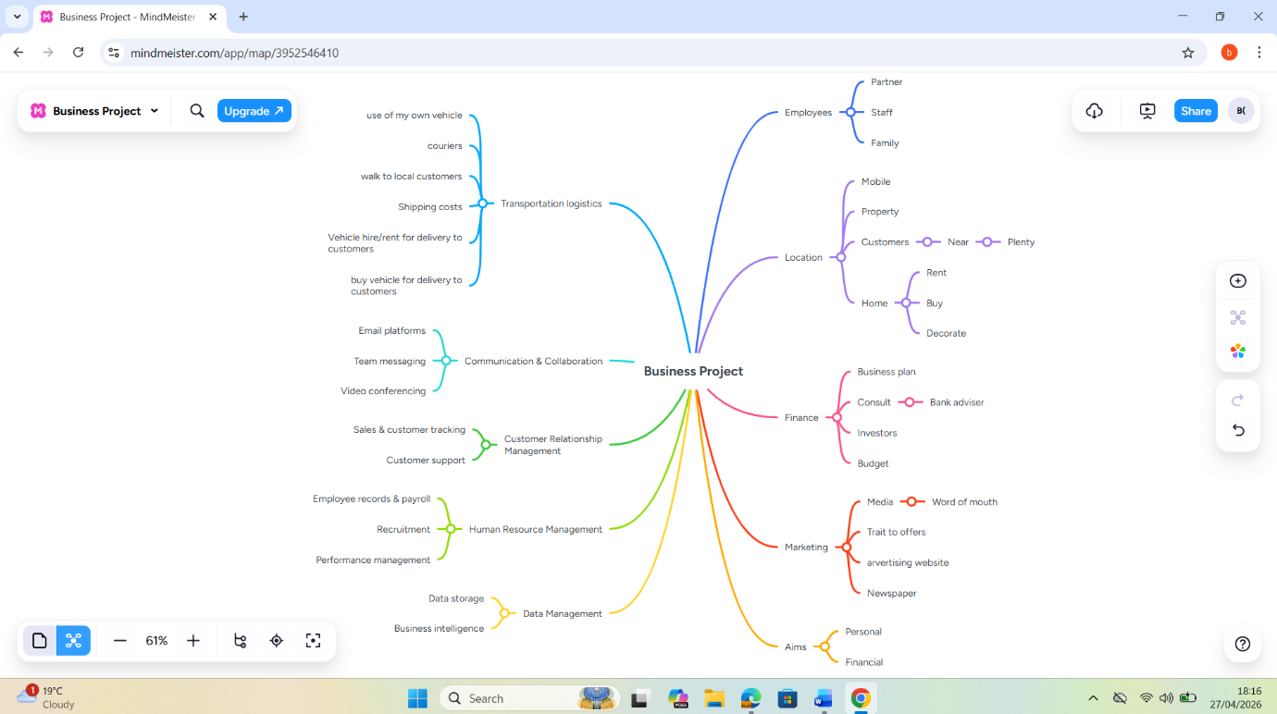
Shopping and services software is really useful for businesses to manage their daily work. It has lots of tools that help with selling things, keeping track of stock, handling payments, and storing customer information. It also helps with online shopping, booking appointments, running marketing campaigns, and getting things delivered. By using this software, businesses can work faster, make fewer mistakes, and make their customers happier. This means they can focus on more important things and give their customers better experience overall.

Task 3
(50 marks)

Office Applications for Creating, Storing, Presenting, and Analysing Data
(Approx. 2000 words)

a.
30 marks
Today companies use digital tools a lot to run their daily operations, make things more efficient, and help with decision-making. Some of the most popular office software tools are Microsoft Word, Microsoft PowerPoint, Microsoft Excel, and Microsoft Access. These tools are all part of the Microsoft Office package and are really important for handling documents, communicating, analysing data, and managing information in businesses of all sizes [5]. Each tool has its own unique features, benefits, and limitations, which makes them better suited for different needs. For example, Microsoft Word is great for creating documents, while Microsoft Excel is better for analysing data. Microsoft PowerPoint is perfect for making presentations, and Microsoft Access is useful for managing databases. By using these tools, businesses can streamline their operations, improve productivity, and make better decisions. Overall, the Microsoft Office ecosystem is a powerful tool that can help businesses of all sizes achieve their goals.
Microsoft Word is a really popular tool for making and editing documents in the workplace. It's great for creating things like reports, letters, and contracts. Word has a lot of features that help you make your documents look professional, like templates, styles, and tools for formatting text and pictures. You can even work with other people on a document at the same time, thanks to features like Track Changes and comments. And with OneDrive, you can access your documents from any device, which is really convenient. The best things about Word are how easy it is to use, how versatile it is, and how it can work with lots of different file types. But, like any tool, it's not perfect. For example, it's not the best choice if you need to make complicated graphics or layouts - there are other programs that are better for that. Also, sometimes documents can look a little different when you open them on a different computer or with a different version of Word. And some of the more advanced features can be a bit tricky to use, so you might need some training to get the most out of them. Overall, though, Word is a really powerful and useful tool for anyone who needs to work with documents.
When it comes to creating presentations, Microsoft PowerPoint is a popular choice for businesses, schools, and professionals. It's a great tool for making slides that include text, pictures, charts, and even videos. This makes it perfect for getting your point across in meetings, training sessions, and sales pitches. One of the best things about PowerPoint is that it has lots of templates and design tools that make it easy to create good-looking presentations, even if you're not a great designer. You can also work with your team on presentations and share them with others. The good things about PowerPoint are that it helps you communicate better, makes complicated ideas easier to understand with pictures, and keeps your audience interested. But, there are some downsides. If your slides are messy or you use too many fancy effects, it can be distracting and hard to follow. To make a really good presentation, you need to have a good sense of style, and sometimes it can make complex information seem too simple. Overall, PowerPoint is a powerful tool that can help you make great presentations, as long as you use it wisely [6].
Microsoft Excel is a really powerful tool for organizing and analyzing data. It's great for storing lots of information in a way that makes sense, and you can use formulas and functions to do calculations. Excel also has some advanced features like pivot tables, charts, and data visualization tools that help you understand your data better. And with macros, you can automate tasks to make your work easier. All these features make Excel super useful for businesses, especially when it comes to looking at finances, making budgets, and predicting what might happen in the future. One of the best things about Excel is how flexible it is - you can use it for all sorts of tasks in different industries. It's also great at turning raw data into something that actually means something, using visual representations like charts and graphs. But it can be a bit tough to learn if you're new to it, and if you're not careful, mistakes in your formulas can give you wrong answers. And while it's good for handling moderate amounts of data, it's not the best tool for really huge databases or complex systems that have lots of related data.
Microsoft Access serves as a database management system that allows businesses to store, organize, and retrieve structured data efficiently. It uses a combination of tables, queries, forms, and reports to manage information in a relational format. Access is particularly useful for small to medium-sized businesses that need a cost-effective solution for handling customer data, inventory records, or internal operations. One of its key advantages is its integration with other Microsoft Office applications, enabling seamless data exchange and reporting. It also provides a user-friendly interface for building databases without requiring extensive programming knowledge. However, Access has some limitations. It is not as scalable as enterprise-level database systems such as SQL Server or Oracle, making it less suitable for large organizations with high data demands. It may also require technical expertise for advanced customization, and performance can be limited in multi-user environments with heavy data usage.
Mind maps are really useful for businesses because they help people organize and understand information better. It's a way of showing ideas and concepts in a visual format that isn't linear, but still makes sense. This method was made popular by Tony Buzan, who said it's great for boosting creativity, organizing your thoughts, and making complex information simpler. When you make a mind map, you start with a main idea in the middle of the page, and then you add branches that come out from it to show related ideas or categories. These branches can then be divided into smaller ones that include more details, examples, or supporting information. By using mind maps, businesses can improve the way they work and make decisions, which can lead to better results. Mind maps are also a great tool for individuals to use in their own work, as they can help with planning, problem-solving, and communication. Overall, mind maps are a powerful tool that can help businesses and individuals achieve their goals more effectively.

Our brains work better with pictures, so mind maps are a great way to learn[7]. They use short words, colors, and images to show ideas, instead of long paragraphs or lists. This helps us see how things are connected and remember them better. Some research from MindTools in 2024 found that using pictures to learn, like with mind maps, can really improve how well we understand things, solve problems, and make decisions. It's a pretty simple idea, but it can make a big difference in how we learn and think. By using mind maps, we can see the big picture and all the little details, and that can help us make better choices and learn more easily.
In a business setting, mind maps are really useful for coming up with new ideas and brainstorming. When teams are brainstorming, they can write down their ideas on a shared map and connect them to the main idea or to other ideas. This helps people think outside the box and come up with more creative solutions. Because all the ideas are in one place, nothing gets lost. This makes mind maps a great tool for planning marketing campaigns, developing new products, and thinking about the big picture. They help teams be more innovative and come up with better solutions. By using mind maps, teams can make sure everyone's ideas are heard and seen, which can lead to some really great ideas.
maps are really useful when it comes to planning and making decisions. Companies have to think about lots of things like what they want to achieve, what might go wrong, what they have to work with, and how long things will take. A mind map helps by showing all these things in a way that's easy to understand, so you can see how they're all connected and what's most important. For instance, if a company wants to start selling its products in a new market, it can use a mind map to get all the information it needs in one place - things like what customers are like, who the competition is, what the rules are, and how it will get everything from one place to another. By seeing everything together like this, the people making the decisions can come up with plans that are more informed and more likely to work. Some studies, like ones published in the International Journal of Management Studies in 2022, have found that using visual tools like mind maps can help people think more clearly and make better decisions faster. This is because mind maps can help reduce the amount of thinking you have to do, and make it easier to understand complex information.
Mind maps are really useful for teams because they help everyone communicate and work together better. They're like a shared picture that everyone can look at and add to, so everyone's on the same page. This means there's less chance of people getting confused or mixed up, and everyone knows what they're supposed to be doing. There are some great digital tools out there, like Mind Meister, Miro, XMind, and Coggle, that make it easy for teams to work together in real time, even if they're not in the same place. These tools also let you add things like videos, links, and to-do lists to your mind maps, which makes them really interactive and helpful for planning. For example, when you're working on a project, you can use a mind map to brainstorm ideas and assign tasks to team members. You can also use it to track progress and make sure everyone's on track to meet their deadlines. And because it's all digital, you can access it from anywhere and make changes in real time. This makes it really easy to collaborate and get things done quickly. Overall, mind maps are a great way to improve communication and collaboration within teams, and digital tools have made it easier than ever to use them. By using mind maps, teams can work more efficiently, effectively, and creatively, which can lead to better results and a more successful project.

Mind maps are really helpful when it comes to getting things done and staying organized. They let you take big projects and break them down into smaller tasks that are easier to handle. Each part of the map shows a specific thing that needs to be done, or who is responsible for what. This makes it easier for teams to figure out what to do first, use their resources wisely, and keep track of how things are going. Mind maps are also great for teaching new people and passing on knowledge. They show how things work and how different parts of the company fit together in a way that's easy to understand. New employees can quickly get a handle on complicated information and see how everything is connected.
Mind maps are really useful, but they also have some downsides. When you have a lot of ideas and they all branch out in different directions, it can get pretty messy and hard to follow. Some people who are used to taking notes in a straight line might find it tough to switch to the more free-form way that mind maps work. And even though mind maps are great for getting a visual sense of your ideas, they might not be the best way to keep track of lots of numbers or details - you might need to make some extra notes to go along with them[8].
In the end, it's clear that office software like Microsoft Word, PowerPoint, Excel, and Access are really important for businesses to run smoothly. They help with things like making documents, communicating, analyzing data, and managing information. But mind maps are also super helpful because they give us a visual way to organize our ideas, think outside the box, and make better decisions. When we use these tools together, businesses can work more efficiently, communicate better, and handle challenges in a world that's always changing and full of information. This means businesses can stay on top of things and make smart moves to succeed.

b.
20 marks
Test some (Two different functions/tools from two different software applications. Show the process step by step through screenshots) business-related features of Office Applications (e.g., Mail merge, IF Function, VLOOKUP, Pivot Table, Goal Seek, Database concept using MS Access) and document several screenshots with accompanying description to provide evidence of practical use.
Purpose Mail Merge is used to generate a series of letters / emails etc. using data from an Excel file[9].
Steps 1. Create an Excel sheet:
Name Email
John john@email.com
Sarah sarah@email.com
2. Open up the Word document and go to Mailings then click on Start Mail Merge.
3. Select Recipients → Use Existing List (choose Excel file)
4. Insert fields like «Name»
5. Finish & Merge
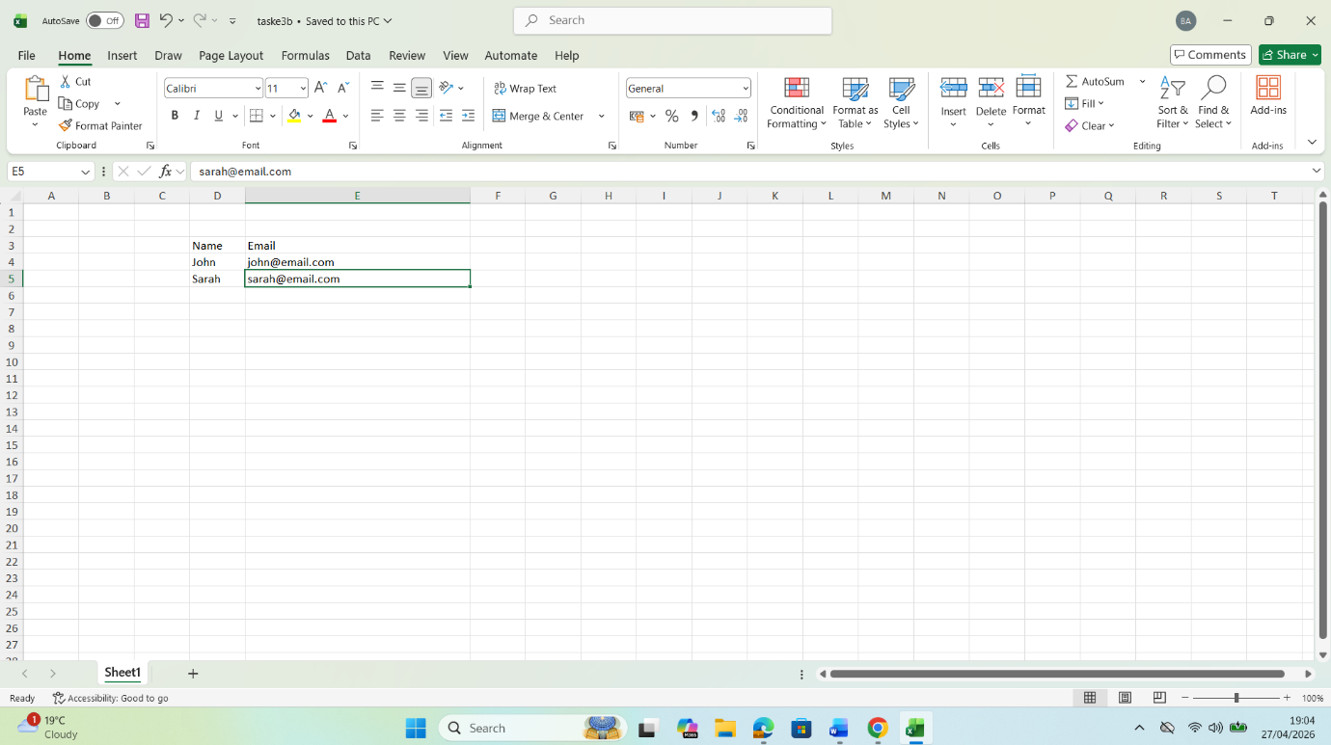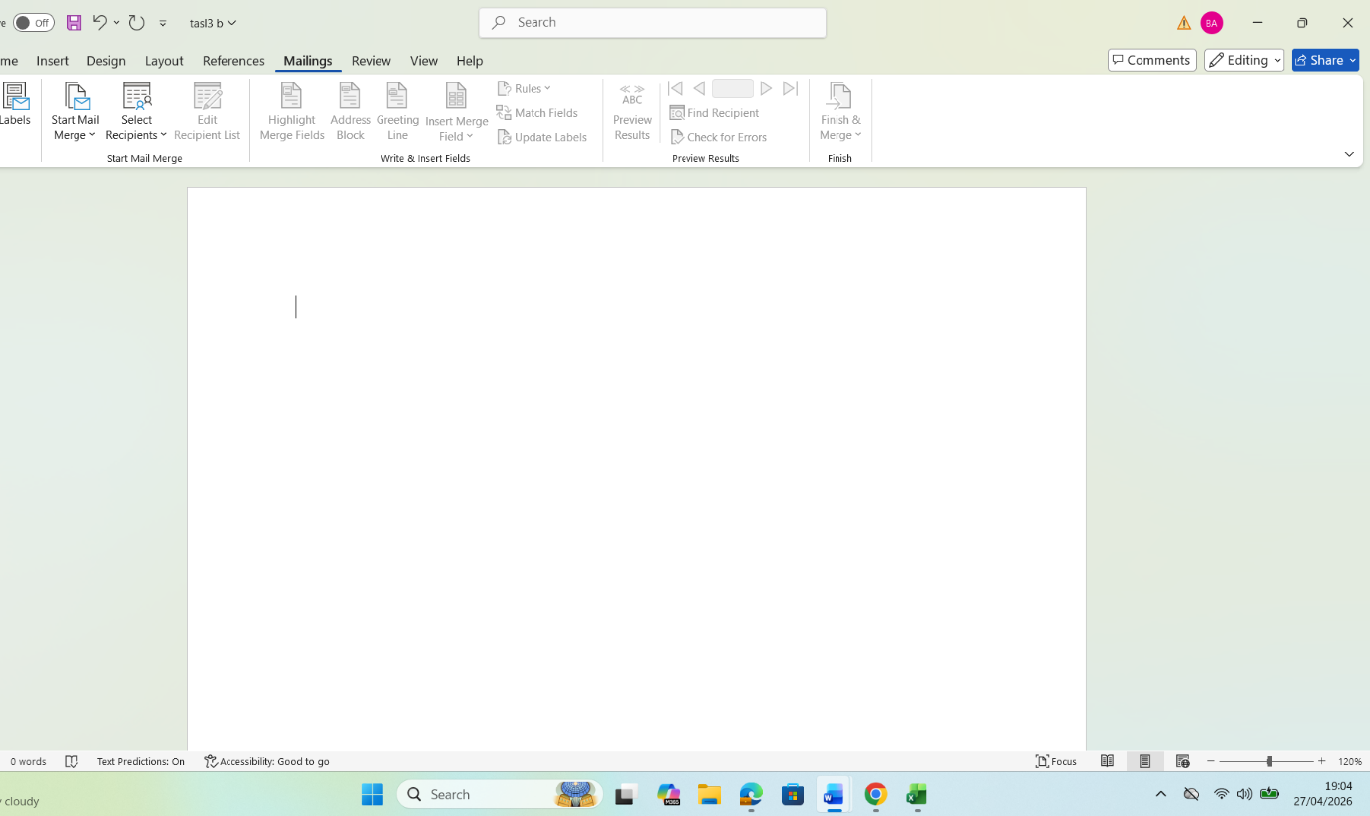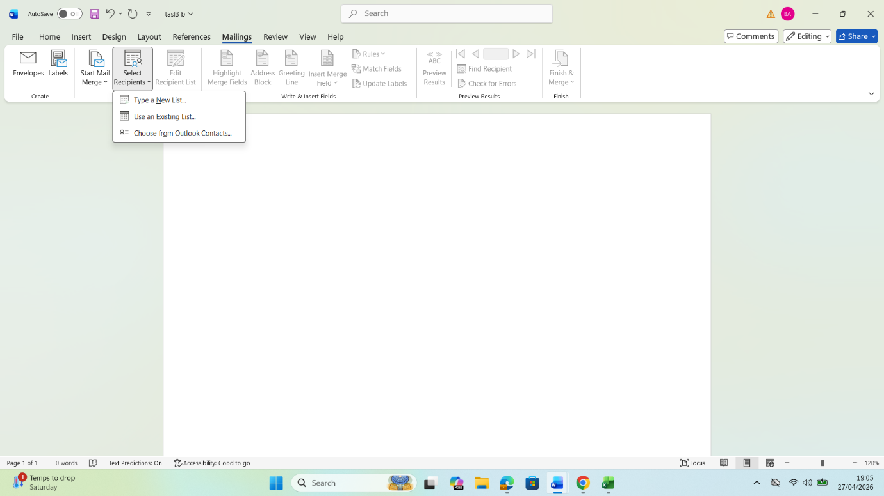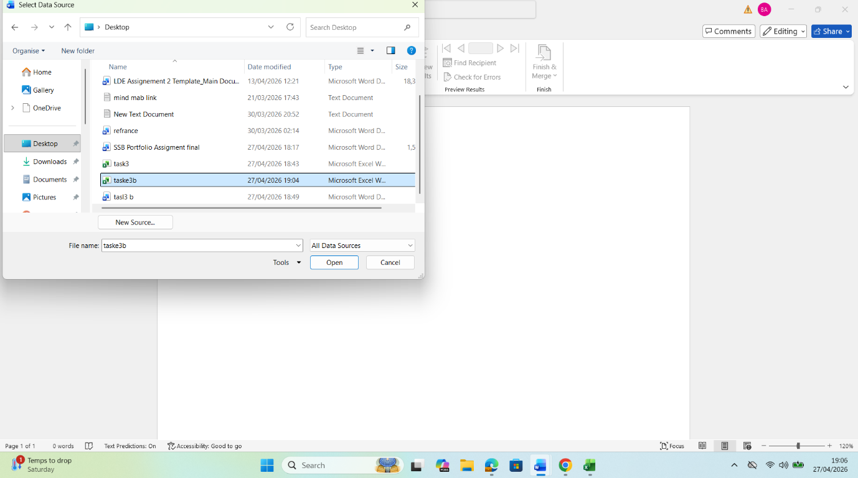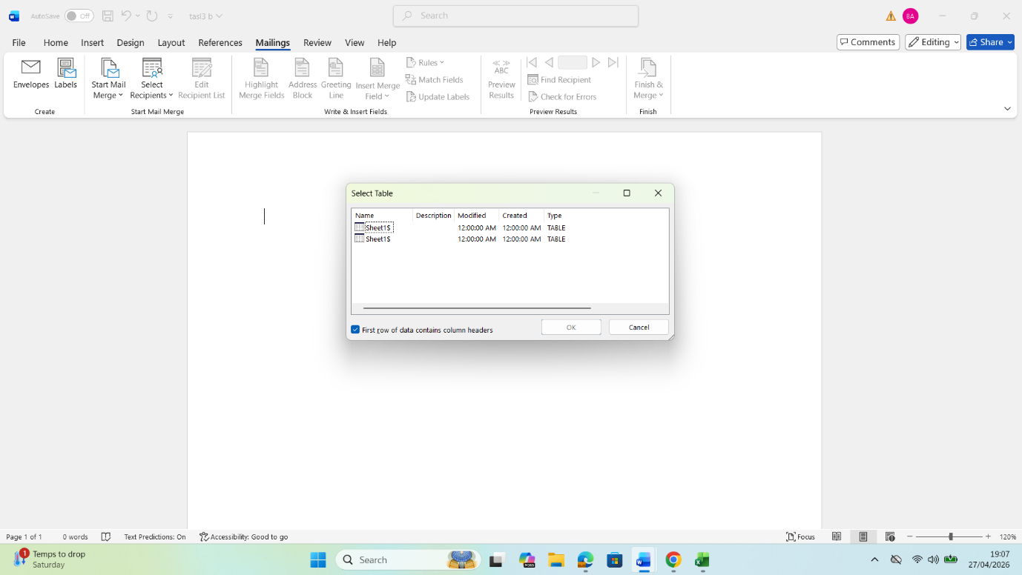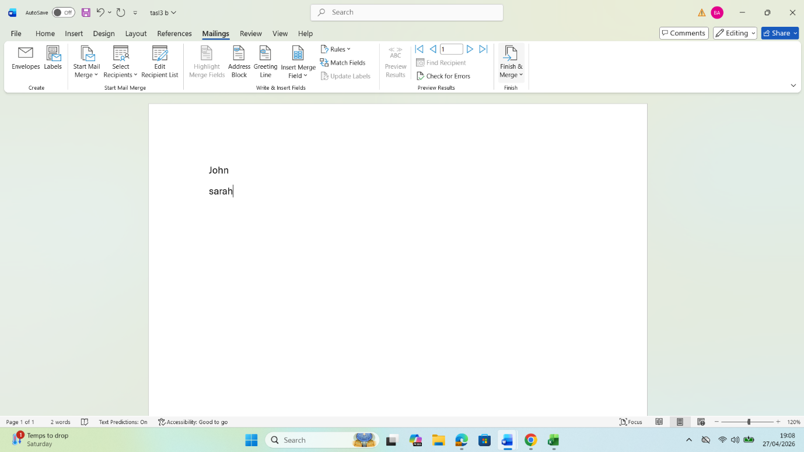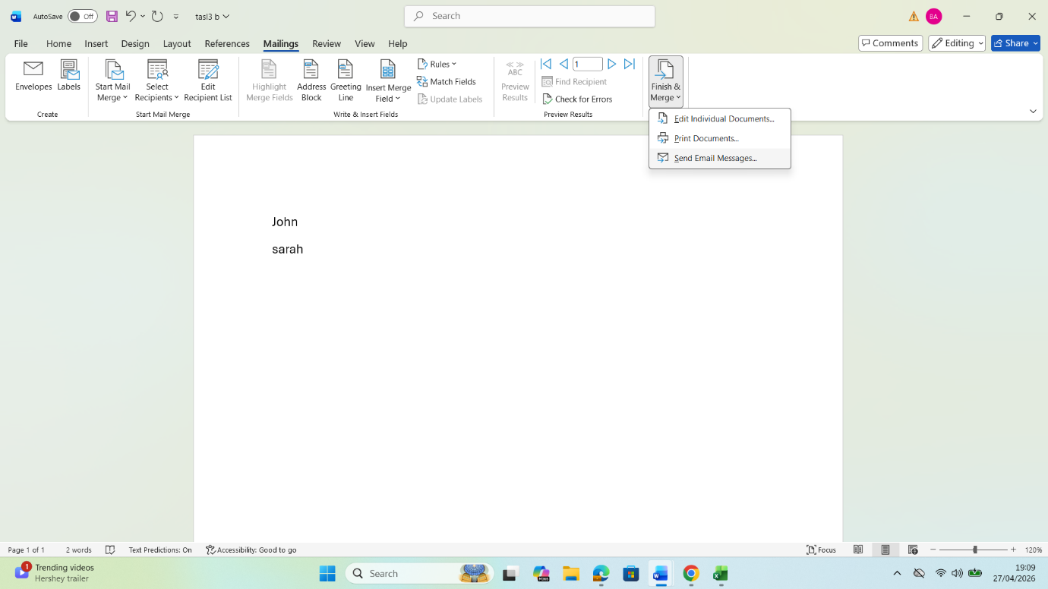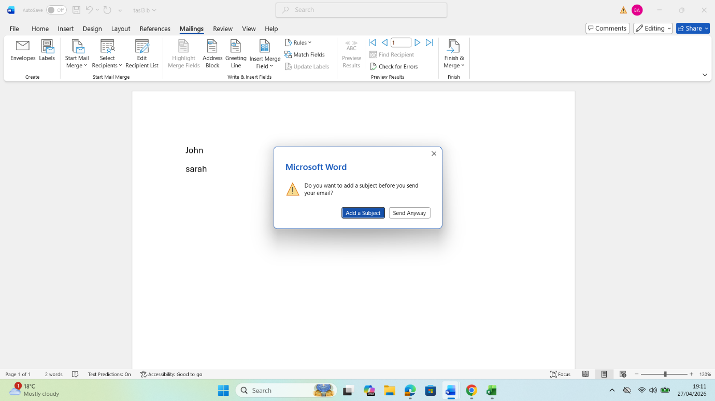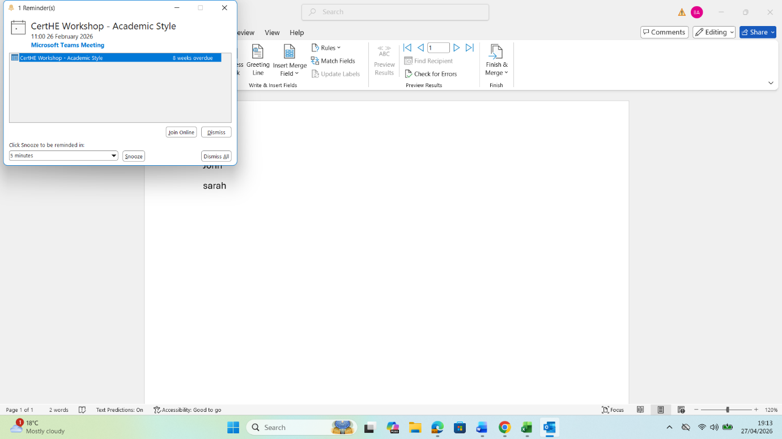
1. IF Function
Objective:
Using the IF function, data can be classified. This example classifies scores as either "Pass" or "Fail"[10].
Procedure:
1. Create a table with the following elements: Student Name, Score, Result.
2. Type the following formula in the topmost cell of the Result column:
=IF(C4>=60,"Pass","Fail")
Enter the formula and then copy down to fill all the rows.
As you change the condition, the Result will update based on the new rule.
The IF function can be used to automatically classify the students’ scores as “Pass” or “Fail”. For instance, scores 60 and above can be classified as “Pass” and those that score below 60 can be classified as “Fail”. The IF function processes information on an “if this then that” basis.
2. VLOOKUP Function
Objective:
Use VLOOKUP function to lookup and return data from another table / list. In this example we will use VLOOKUP to lookup Employee ID and return Department Name for each employee.
Procedure:
1. Create Table 1 (Employee Data) - populate Employee ID, Name and Department.
2. Set up Table 2 - Department Lookup with Employee ID and Department Name.
3. In the Department column of Table 1, enter the name of the department receiving federal funds.
VLOOKUP (B4, $G$4:$h$7, 2, FALSE)
• B4= The Employee ID you are looking up.
• $G$7 : to use for the lookup function (VLOOKUP in this example) • $H$7 : the value to look up • $A$8 : the range of values to search within
• 2 = the column number in the lookup range that contains the actual data you are looking up (Department).
• FALSE = ensures an exact match.
4. Press Enter, and then drag down to fill in the rest of the rows. The Department column will now automatically fill in with the correct department name for each employee.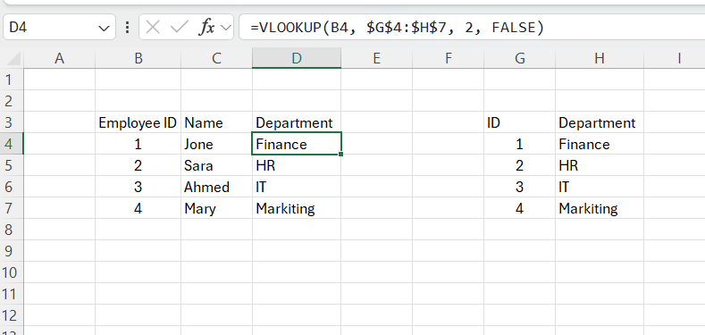

VLOOKUP is used to look up an Employee ID in a table and then extract the Department from the next column. By automating this manual process and removing the potential for human error, the formula makes it possible to quickly retrieve information from large datasets to ensure accurate data[11].

Task 4
(25 marks)

Communication and Collaboration applications
(Approx. 1000 words)

a. 13 marks
In today's fast-paced business world, communication and teamwork are crucial for success, especially when people work from home or in a mix of office and remote settings. Technology has changed the way coworkers talk to each other, share information, and work on projects together [12]. One popular tool for communication is Microsoft Teams, which combines messaging, video meetings, and file sharing into one platform within the Microsoft 365 system. It helps users keep conversations organized, supports real-time chatting, allows meeting scheduling, and enables simultaneous collaboration on documents using tools like Word, Excel, and PowerPoint. By putting all communication in one place and reducing the need for emails, this integration boosts productivity and makes it easy to work together across different devices. However, with so many messages coming in, Teams can feel overwhelming, and users might need some guidance to get the most out of its advanced features. As Microsoft noted in 2024, the goal of Teams is to make communication and teamwork smoother through a single workspace that supports both real-time and delayed interactions.
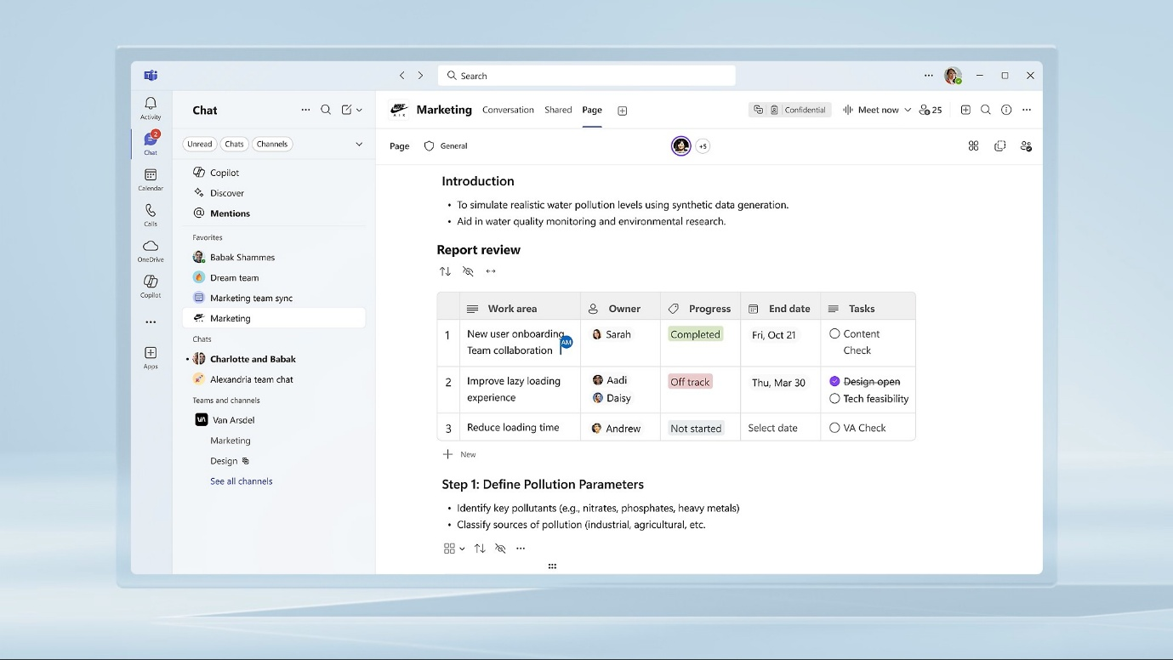
Mero is a great tool for teams to work together online. It's like a big digital whiteboard where everyone can share ideas, plan projects, and create content at the same time. When someone makes a change or adds a comment, everyone can see it right away, which helps people work together and be more creative. Mero has lots of templates to help teams get started, like mind maps, Kanban boards, and flowcharts. These templates make it easier to plan and come up with new ideas. Teams can also use sticky notes, comments, and polls to give feedback and make decisions in a way that's easy to understand. Mero works with other tools like Microsoft Teams and Slack, so teams can use all their favorite apps together seamlessly. One of the best things about Mero is that team members can work together even if they're in different parts of the world, because it allows for asynchronous collaboration. This means people can contribute to a project at their own pace, no matter where they are. The visual and interactive way that Mero works makes it easier for teams to understand complex projects and work together more effectively. However, it might take some time for new users to get used to how Mero works, especially if they're working with really big projects that have a lot of different elements. can sometimes impact performance.
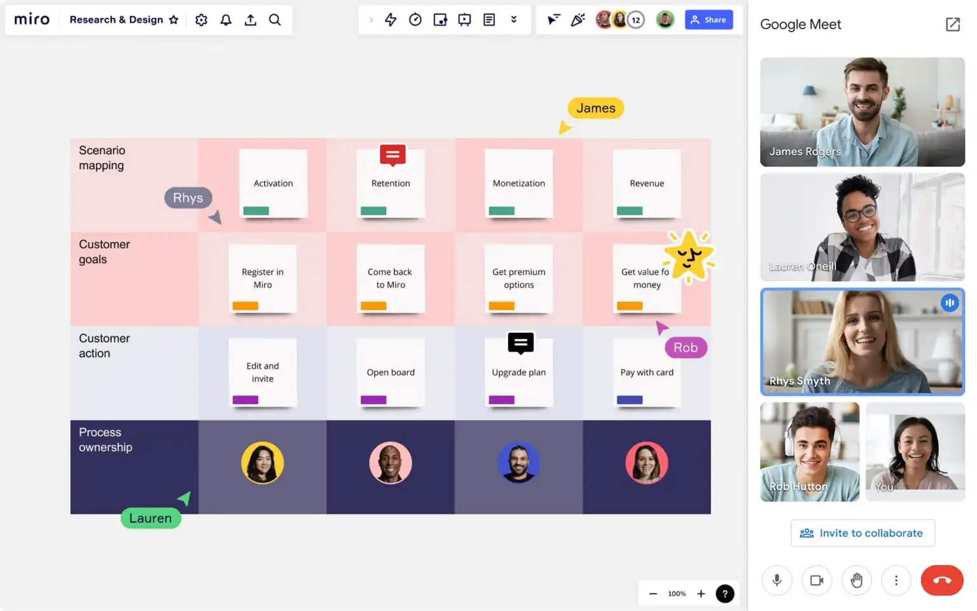
In today's workplace, Microsoft Teams and Miro work really well together. Teams helps people communicate more clearly and quickly, by giving them a structured way to send messages, have meetings, and work on documents together. Miro, on the other hand, helps teams collaborate and be creative, by making it easy to visualize ideas and workflows. When you use these two tools together, it can really help organizations communicate better, manage projects more effectively, and create a work culture that's all about collaboration - whether people are working together in real-time or on their own schedules. By using Teams and Miro, companies can get rid of obstacles, be more transparent, and stay productive, even when people are working remotely or in different locations. This is especially important in today's digital age, where people are often working from different places and need to be able to work together seamlessly [13].
Test some features of a freely available Communication (1) and Collaboration (1) application and document several screenshots with brief accompanying description to provide evidence of practical use.
With digital technologies underpinning all sectors, increasingly modern applications of technology require teams to communicate and collaborate remotely or in hybrid ways. In this report we are going to look at two free tools that Microsoft has developed for communication and collaborative working, Microsoft Teams and Miro. We will walk through each step of how to use the two tools, with explanatory illustrations to aid understanding.
This use case outlines the use of Microsoft Teams in a commercial setting for holding virtual team meetings and carrying out general communication between employees. It will guide you through each step to set up and use Microsoft Teams, explaining all the features and accompanying screenshots.
Step 1: Creating or Joining a Team
Employees are added to a team or channel created for a specific department or project.

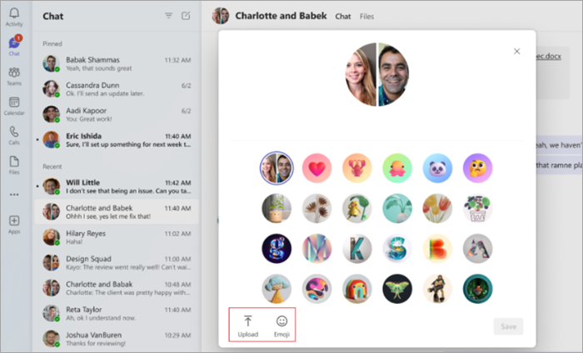
Step 2: Chat and Messaging
Team members communicate by sending instant messages, announcements, and updates within the channel chat. This enables quick, clear, and organized communication among members, reducing the need for email and ensuring that important information is shared efficiently in real time.

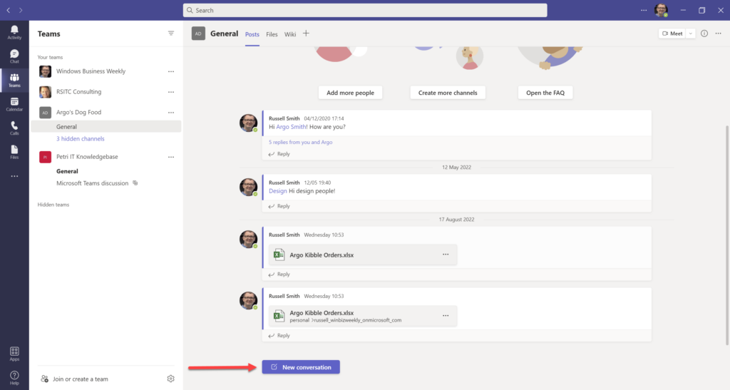Step 3: Video Meeting
A meeting can be scheduled in advance or started immediately to enable discussions and presentations among team members. This functionality allows participants to connect in real time regardless of location. From a business perspective, it supports remote collaboration, improves accessibility, and reduces the need for physical meetings, thereby lowering travel-related costs and saving time.

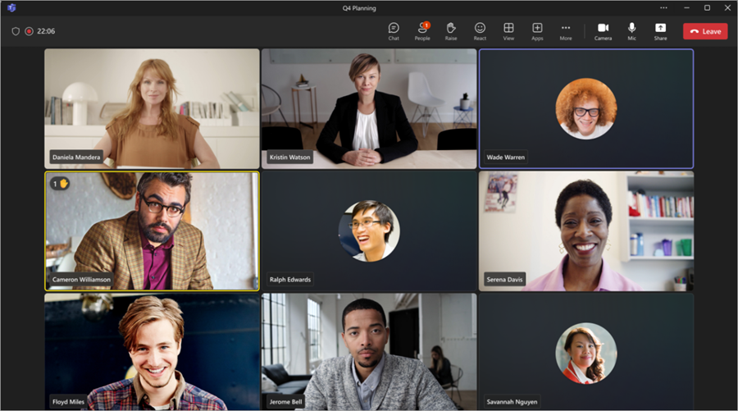
Microsoft Teams offers several advantages in a business environment. It enables instant and efficient communication between employees through chat, calls, and channels, helping teams stay connected in real time. It also supports remote and hybrid work models by allowing users to collaborate from different locations using desktop, web, or mobile devices. In addition, it integrates seamlessly with Microsoft applications such as Word, Excel, and PowerPoint, enabling users to co-author documents, share files, and work collaboratively within a single platform, which improves productivity and workflow efficiency.
2. Collaboration App
App Name: Miro
Reasons for Choice:
Miro is a free online platform & software designed to help teams & workgroups make planning more concrete. Tasks and topics can be organized in a structured manner and discussions turned into interactive real-time conversations. Ideas can be jointly explored and new concepts developed through collaborative brainstorming. Miro is being used by businesses for collaboration, brainstorming, and conversation.
Using Miro in Business. This use case demonstrates how to use Miro for brainstorming and project planning in business settings during team workshops. Participants can jot down their ideas, create diagrams and structure the workflow[14].
Step 1: Create a New Board
First, make a board on the Miro platform to brainstorm ideas or to make a to-do list.
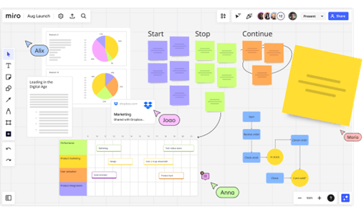
Added Value:
Provides a shared visual work environment for all team members.
Step 2: Add Content Team members add sticky notes, charts, and various shapes to present and share their ideas.

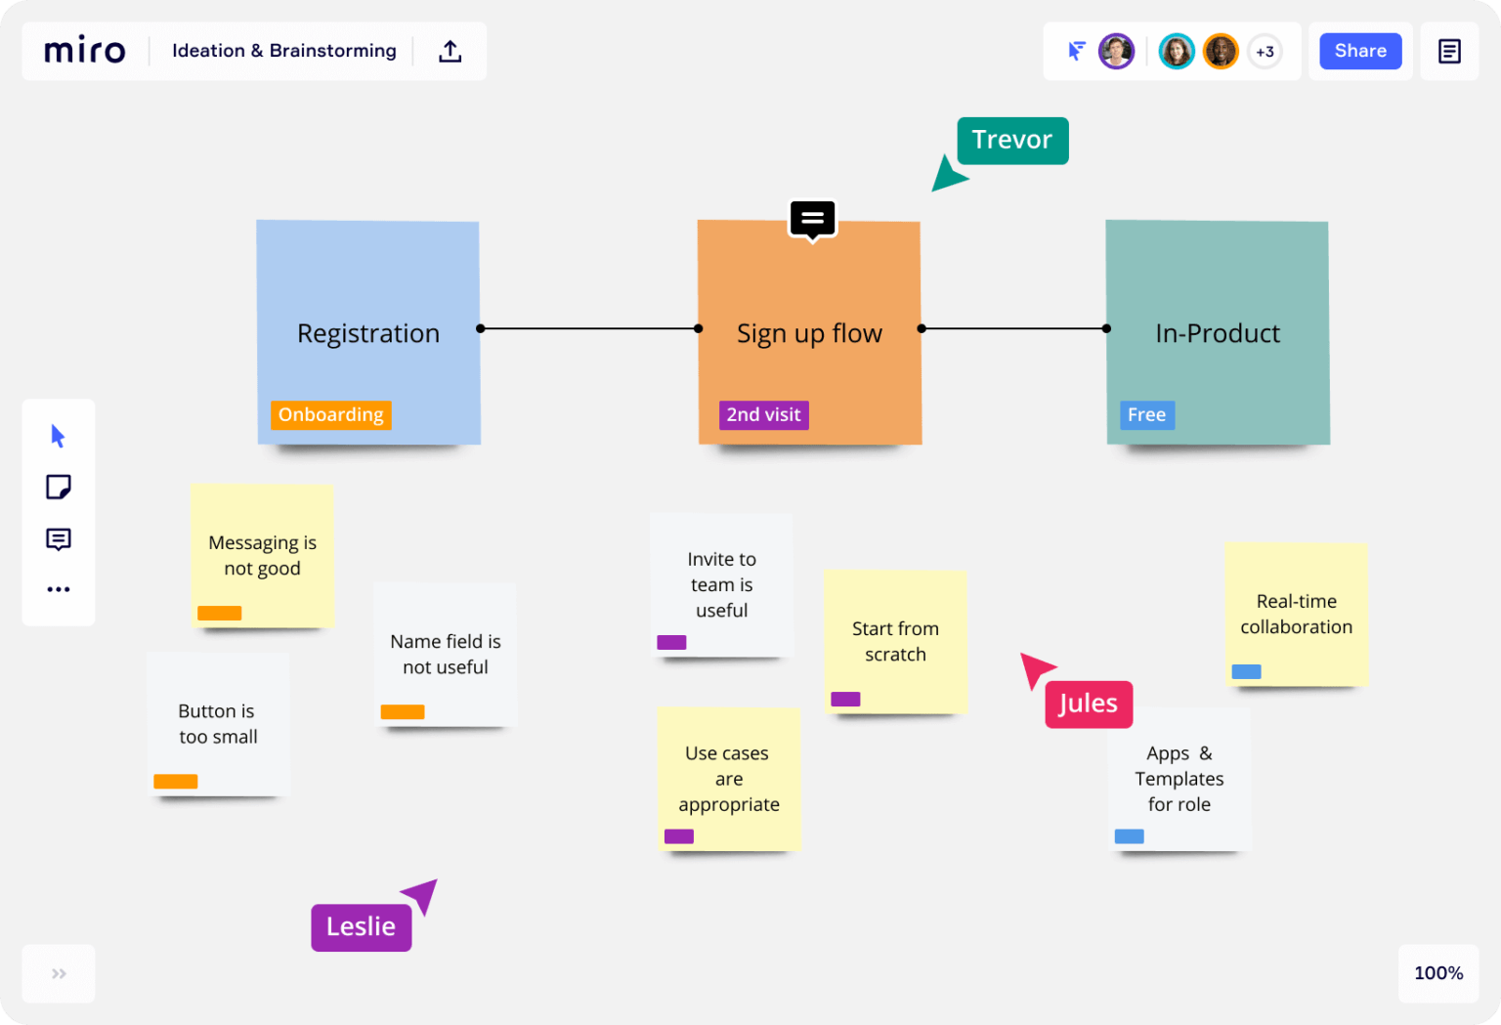

Added Value:
Helps stimulate creative thinking and generate new ideas.

Step 3: Collaborate in Real Time
Multiple users can work on the same board simultaneously and see changes as they happen.
Added Value:
Enhances teamwork and increases interaction among team members.

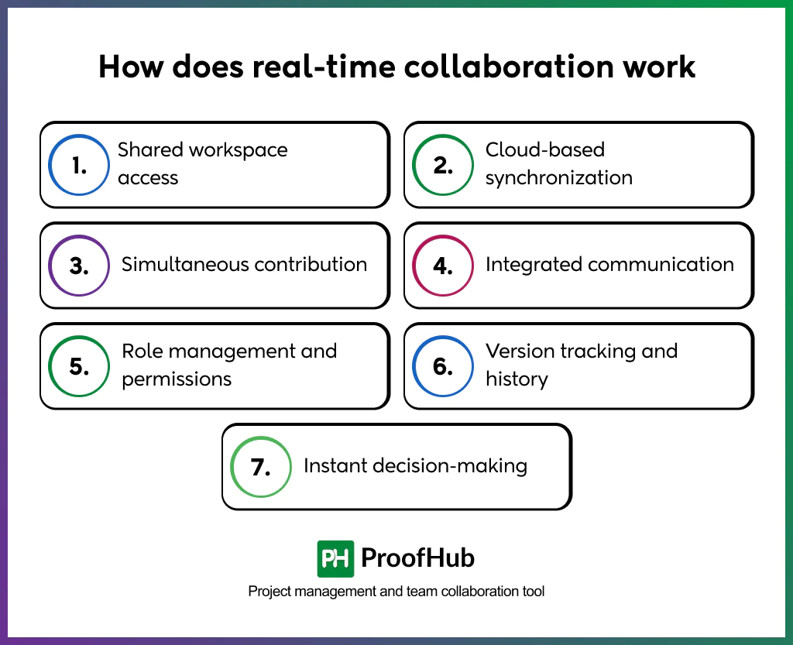

Step 4: Share the Board
A link to the Miro board is shared with team members, allowing them to access and actively participate in the session from any location. This approach enables real-time collaboration without the need for physical presence, making it easier for distributed teams to contribute ideas, interact with shared content, and work together efficiently regardless of their geographic location.

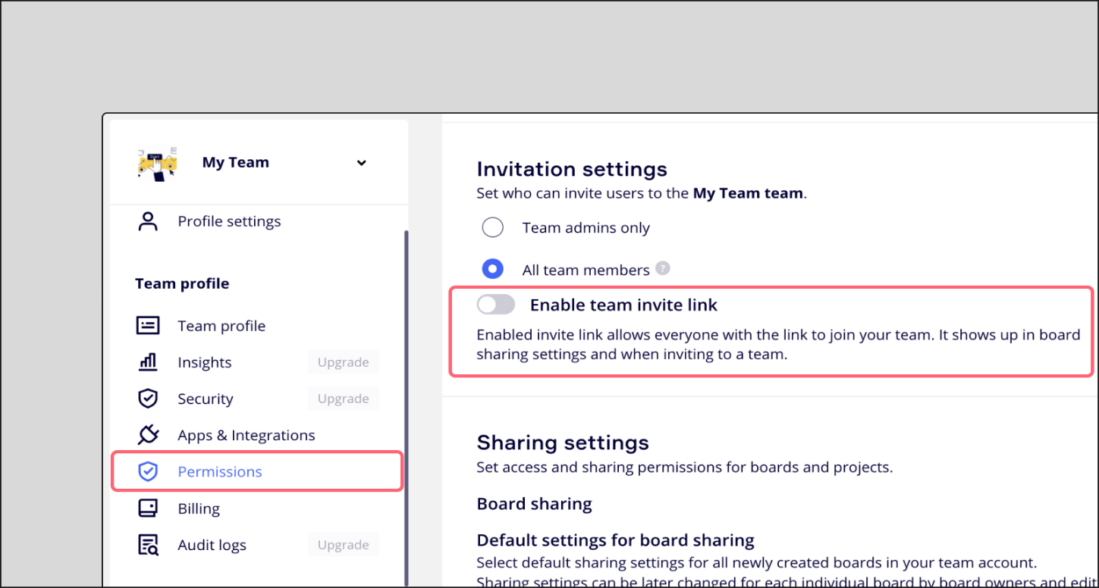
Miro offers several benefits in a business environment by enabling effective visual collaboration among team members. It supports interactive methods such as diagrams, mind maps, and whiteboards, which help teams organize and present ideas clearly. It is particularly useful for brainstorming sessions and project planning, where participants can contribute ideas in real time and structure workflows visually. Additionally, Miro promotes creativity and encourages active participation from all team members, making collaboration more engaging and productive, especially in remote and hybrid work environments.

Conclusion
Ideas can be generated and brainstormed using collaborative digital tools to help stimulate creative thinking. Collaborating digitally enables groups and teams to work in real time and simultaneously on a project, allowing for better communication and increased productivity. Instant feedback and decision making enables participation from everyone involved in the project. Collaborative digital tools also aid in keeping teams on track and help complete tasks and projects both in an academic setting and real-world environment.

References

References
[1] K. Lin, "A comparative analysis for emerging e-commerce business owners: Shopify & Amazon", SHS Web of Conferences, pp. 01033.
[2] G. V. Sreenivasamurthy, "A STUDY ON E-COMMERCE MARKETING," vol. 7, no. 12, pp.256, 2018,
[3] S. Edwards and N. Cooper, "Mind mapping as a teaching resource," vol. 7, no. 4, pp.236–239, 2010,
[4] T. Buzan and B. Buzan,The mind map book, Pearson Education, 2006.
[5] V. Prakash, Office Tools for Efficient Documentation, Analysis, and Presentation, Addition Publishing House, 2025.
[6] E. Hild and C. Wach, "Office Business Applications," in Pro SharePoint 2010 Solution Development: Combining. NET, SharePoint, and Office 2010, Springer, 2010, pp. 1–8.
[7] L. Aho, "Mobile data collection and storing solution for Microsoft environments," 2018,
[8] C. K. Hess, M. Román and R. H. Campbell, "Building applications for ubiquitous computing environments", International Conference on Pervasive Computing, pp. 16–29.
[9] J. L. Popyack and N. Herrmann, "Mail merge as a first programming language," vol. 25, no. 1, pp.136–140, 1993,
[10] S. P. Gordon, "Functioning in Excel," vol. 50, no. 2, pp.86, 2016,
[11] B. Held, Microsoft Excel functions & formulas, Jones & Bartlett Publishers, 2006.
[12] A. Lyndon, "Communication and teamwork in patient care: how much can we learn from aviation?" vol. 35, no. 4, pp.538–546, 2006,
[13] B. N. Ilag and A. M. Sabale, "Microsoft teams overview," in Troubleshooting Microsoft Teams: Enlisting the Right Approach and Tools in Teams for Mapping and Troubleshooting Issues, Springer, 2022, pp. 17–74.
[14] R. K. Allah, "The use of Miro in teaching practice," vol. 10, no. 3, pp.77–91, 2023,

