UNIVERSITY OF WALES
TRINITY SAINT DAVID

Topic: Personal Development Portfolio

Student: Salma Jabeen:
Student number: 2212335

Programme: CertHE Skills for the Workplace Health and Social Care

Module: Personal Development within Health and Social Care LCHS4008

Lecture: Dr Olubukola Adeghite

21/11/25

Contents
Task 1. A Strategy for My Future in Health and Social Care 3
1.1. Key Skills and Strengths 3
1.2. Skill Gaps and Personal Development Plan 3
1.3. Interview Preparation 4
Task 2. Academic Report on One Key Skill: Digital Competence 5
Task 3 – Reflective ERA Model 6
3.1. Experience 6
3.2. Reflection 7
3.3. Action 7
4. Conclusion 8
References: 9

Task 1. A Strategy for My Future in Health and Social Care
Staying reflective, always learning, and adapting to the changing needs of the system are essential for a fulfilling career in health and social care. Helping people with mental health issues take charge of their own emotional and psychological health and working towards more autonomy would be my main responsibilities in the mental health support worker position I want to one day fill.

1.1. Key Skills and Strengths
Effective care delivery is built on two of my fundamental strengths: flexibility and empathy. Since no two days are ever the same in mental health settings, the capacity to adapt quickly and quietly is a must-have quality for me. Adaptability, according to Greenwood (2023), allows practitioners to be professional even when faced with uncertainty, which in turn makes service consumers feel safe and supported. Working as a volunteer in a community support capacity taught me to remain calm and collected under pressure and with a wide variety of clients.
Concurrently, empathy bridges the gap between human comprehension and therapeutic purpose. As a result, the doctor is better able to identify the patient's lived experience and go beyond their symptoms. The ideals of person-centred care outlined in the Care Act of 2014 are consistent with this method. The importance of empathy in fostering cooperation and making service users feel valued and included in decision-making was highlighted to me during reflection activities (Greenwood, 2023).
It is increasingly important to have strong digital literacy abilities with interpersonal skills. Digital technologies are the backbone of secure information exchange, according to Health Education England (2023), but many employees aren't sure how to utilise them. The NHS Digital Learn programs are helping me become more proficient in areas such as data protection compliance and record-keeping. Having these generalisable abilities will make it easier for me to adjust to new health technology when they emerge.

1.2. Skill Gaps and Personal Development Plan
My strengths lie in empathy and communication, but I know I can improve in two areas: my comfort with technology and my ability to manage my time effectively. Though taking CPD courses would help me feel more competent, the prospect of integrating technology into healthcare settings is intimidating (Topol, 2022). Also, I have a propensity to overcommit myself, which may lead to burnout and stress. Both productivity and health may be safeguarded by mastering the art of delegation and prioritisation (see table 1).

Table 1. Personal Development Plan PDP (Topol, 2022)
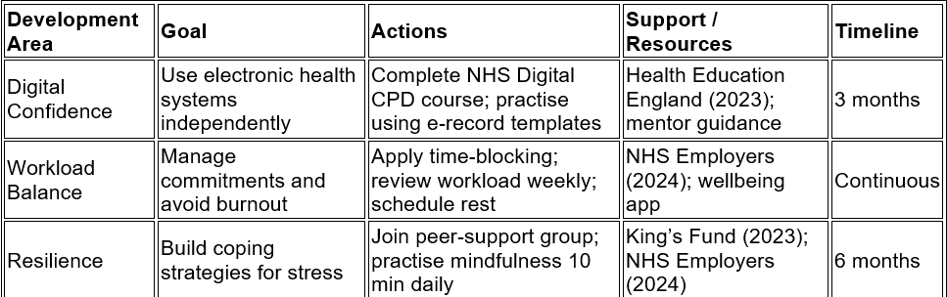

1.3. Interview Preparation
To show that I am prepared, I have thought of some questions that represent the expectations of the sector:
1. "How do you deal with situations that are emotionally stressful?"
For self-care, I would say calling on empathy, professional boundaries, mindfulness, and reflective supervision to remain calm.
2. "What is one way that you have dealt with workplace change?"
In a prior position, I demonstrated adaptability, preparation, and collaboration while handling fluctuating caseloads.
3. What are your strategies for using technology into patient care?
My talk would concentrate on the National Health Service's digital records, encrypted communication systems, and the significance of precise keeping of records.
A dedication to career advancement is shown by this individual strategy. The challenges of mental health support job will be manageable for me since I am resilient, adaptable, empathetic, and tech savvy. I will keep striking a balance between my aspirations and my self-care in accordance with the NHS Employers (2024) recommendations for workforce well-being. I want to become a practitioner who exemplifies compassion, responsibility, and lifelong learning via reflective practise, constructive criticism, and continuing professional development.
The methodology is progressing, but it needs ongoing assessment and change to succeed. Policy and technology changes affect health and social care environments and professional expectations. Reflective practice, as underlined by the Health Foundation (2024), must be ongoing to maintain competence and ethics. This implies I must be open to criticism, seek advice constantly, and be willing to adjust my goals when impediments arise. Genuine professional growth involves quantitative change and knowledge application. This strategy will help me provide long-term, evidence-based therapy that is adaptable to diverse organisations and individuals.

Task 2. Academic Report on One Key Skill: Digital Competence
Digital competence is becoming an essential job skill due to the prevalence of technology in contemporary social and health care. Professionals are able to work together more effectively, safely, and efficiently. Topol (2022) asserts that trust in digital platforms is crucial for bolstering worker resilience and bettering patient outcomes.
The ability to accurately input data, manage information, communicate online, and use assistive devices are all examples of digital skills. Competence in digital health allows for safe data transmission between practitioners, virtual consultations, and quick modifications to treatment plans in mental health settings. In accordance with the "What Good Looks Like" framework outlined in the NHS Digital Strategy, Health Education England (2023) stresses that all healthcare professionals must use digital technologies responsibly.
The advantages aren't enough to overcome the obstacles of lack of confidence and training. Many medical professionals are wary about adopting electronic records due to security concerns. I can relate to this "digital hesitancy" as I, too, have been driven to utilise technologies but have often struggled with doubts about how to do things properly. According to research conducted by Greenwood in 2023, training programs that include both practical technical skills and reflective learning are far more effective in increasing adoption rates.
In addition, being digitally competent is strongly related to being healthy. According to research by the King's Fund (2023), stress levels drop as a result of better training and seamless integration of technology, which makes mundane but necessary jobs easier to do. On the other hand, when there is inadequate assistance or bad design, it only adds more aggravation and labour. Therefore, according to NHS Employers (2024), health strategies should include digital inclusion.
Compliance with GDPR and confidentiality standards is assured by digital literacy, which brings us to our ethical considerations. The importance of safe data procedures on public trust is emphasised by the Care Quality Commission (2024). Maintaining continuity of care while protecting the rights of service users requires professionals to strike a balance between accessibility and privacy.
From the standpoint of career advancement, being digitally competent helps one be more adaptable and employable. People who can think outside the box when it comes to technology and provides individualised treatments are in high demand in today's healthcare system. I will be able to meet national workforce objectives and increase my efficiency by gaining digital confidence via mentorship and organised continuing professional development.
By connecting innovation, ethics, and safety in the digital realm, digital competency is the bedrock of contemporary healthcare practice. It ensures privacy and respect while maximising productivity. Acquiring this competency will put me in a better position to make strides in a dynamic field being more impacted by digital transformation, provide person-centred assistance, and connect with technology with assurance.

Task 3 – Reflective ERA Model
The systematic Experience–Reflection–Action (ERA) approach turns introspection into observable professional improvement (figure 1). It links experience, evaluation, and action to go beyond passive self-observation. The University of Portsmouth (2025) states that the ERA approach deepens learning by requiring practitioners to critically assess performance rather than explain occurrences. ERA helps learners apply understanding to conduct, unlike simpler reflective cycles. Because it promotes evidence-based improvement and lifelong learning, this method is useful in health and social care. Reflective competence improves professional safety and responsibility, according to the Health Foundation (2024). Thus, ERA helps practitioners identify strengths and shortcomings and employ systematic tactics to promote growth, confidence, and service quality.

Figure 1. Experience–Reflection–Action (ERA Health Foundation, 2024)
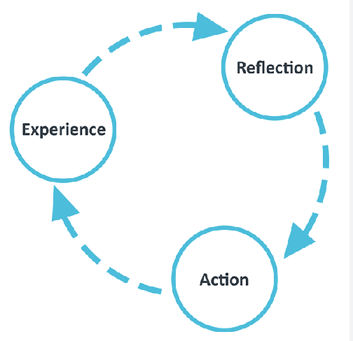

3.1. Experience
I gained a better understanding of the practical application of theory in communication while giving my presentation on self-awareness. When asked questions, particularly those pertaining to technology usage, I remained calm and empathic, but I could also feel my anxiety rising. While my empathy and flexibility were noted by both my classmates and my professor, I was told that I needed to exude greater self-assurance while discussing technological subjects.

3.2. Reflection
Using the ERA model to reflect on the event allowed me to make sense of my feelings and how well I did. I was reminded to simplify explanations and utilise positive body language after using the notion that successful communication influences comprehension, as pointed out by Sharkiya (2023). The fact that I was anxious mirrored what Topol (2022) found: that even the most driven professionals might suffer from digital anxiety. But if I can see this obstacle before it becomes a problem, I can transform my fear into knowledge.
I was already a firm believer in the value of teamwork before our pre-presentation contact. Consistent with the results of the Care Quality Commission (2024) that shared learning improves professional standards, joint rehearsals demonstrated how group feedback improved clarity. The NHS Leadership Academy (2024) believes that genuine leadership develops from acknowledging and accepting one's own shortcomings; my lecturer's comments further supported this idea.
The impact of time constraints on presentation and organisation was also apparent to me. The Health Foundation (2024) states that reflective learning enhances attention under pressure; I want to refine this skill further by practicing controlled rehearsals and mastering time management strategies. Skills for Care (2024) emphasises the significance of combining ambition with relaxation, and my stress reaction confirmed this. Resilience training is correlated with retention and well-being.

3.3. Action
These lessons will guide my actions going forward. An NHS-approved continuing professional development course in digital skills will be my first step in building my self-assurance in the face of technology challenges. Second, in order to improve my delivery fluency and overcome my fear, I want to rehearse brief presentations once a week and ask for comments from my peers. Third, after finishing each big project, I will follow the ERA cycle, which entails taking notes, reflecting, and making specific changes. This practice turns introspection into quantifiable career advancement, as the University of Portsmouth (2025) elucidates. It will need resilience and time management to regularly implement these steps. Professional growth is most successful when reflection is integrated into everyday activities, according to the Health Foundation (2024). I will examine my progress monthly with a mentor and take brief contemplation times after each shift to maintain this practice. This systematic, continual method will turn learning into quantifiable behavioural progress and boost confidence and competence.

4. Conclusion
Reflection has shown that, rather than striving for perfection, self-awareness, constructive criticism, and organised learning are the key ingredients for professional confidence. Both my emotional intelligence and my room for practical growth were highlighted by my encounter. Improving my digital competency, honing my communication skills, and continuously using the ERA model will enable me to grow into a Mental Health Support Worker who is more adaptive and resilient. Improving service user outcomes and fostering a supportive, competent staff in accordance with national goals may be achieved via my combination of empathy and evidence-based learning, which will allow me to provide care that is both up-to-date technologically and deeply human. Growth requires responsibility via systematic reflection and expert supervision. Reflective practise works best when consistent and integrated into daily work, according to the Health Foundation (2024). Without this, understanding risks becoming theoretical rather than transformational. I may guarantee learning lasts by intentionally tying reflection to quantifiable changes like communication outcomes, service-user happiness, and digital fluency. This critical awareness will keep my growth aligned with organisational objectives and my clients' changing demands.

References:

Care Quality Commission (2024) The state of health care and adult social care in England 2023–24. London: CQC. Available at: https://assets.publishing.service.gov.uk/media/671b5ce3044f28e776c609dc/care-quality-commission-the-state-of-health-care-and-adult-social-care-in-england-2023-to-2024.pdf (Accessed: 26/10/2025).
Commons Library (2024) Adult social care workforce in England. Research Briefing CBP-9615. Available at: https://researchbriefings.files.parliament.uk/documents/CBP-9615/CBP-9615.pdf (Accessed: 25/10/2025).
Greenwood, J. (2023) Developing resilience and adaptability in health and social care. ProQuest Ebook Central. Available at: https://ebookcentral.proquest.com/lib/uwtsd/detail.action?docID=7326525 (Accessed: 26/10/2025).
Health Education England (2023) NHS apprenticeship and training opportunities. Available at: https://www.hee.nhs.uk/apprenticeships (Accessed: 29/10/2025).
Health Foundation (2024) Building capability in health and social care teams. Available at: https://www.health.org.uk/publications/building-capability-in-health-and-social-care-teams (Accessed: 28/10/2025).
King’s Fund (2023) The state of the social care workforce in England 2023. Available at: https://www.kingsfund.org.uk/publications/social-care-workforce-england-2023 (Accessed: 28/10/2025).
NHS Employers (2024) Supporting workforce wellbeing in health and social care. Available at: https://www.nhsemployers.org/articles/supporting-workforce-wellbeing (Accessed: 24/10/2025).
NHS Leadership Academy (2024) Healthcare leadership model: supporting leadership development. Available at: https://www.leadershipacademy.nhs.uk/resources/healthcare-leadership-model (Accessed: 24/10/2025).

Topol, E. (2022) ‘Digital health education: preparing the workforce,’ BMJ Leader, 6(3), pp. 230–234. Available at: https://bmjleader.bmj.com/content/6/3/230 (Accessed: 25/09/2025).
University of Portsmouth (2025) Using Gibbs and ERA reflective models. Available at: https://www.port.ac.uk/student-life/help-and-advice/study-skills/reflective-practice/using-gibbs-reflective-cycle (Accessed: 26/10/2025).

