

Can Data Driven Digital Medications Dashboards Reduce the Number of Missed Medication Administrations in Haemodialysis Patients?

by
Mike Wakelyn
Supervisor: Gaynor Thomas

Project submitted as part of the requirements for the award of
BSc (Hons) Computing (Data & Information Systems)

April 2022

DECLARATION
I, Mike Wakelyn declare that I am the sole author of this Project; that all references cited have been consulted; that I have conducted all work of which this is a record, and that the finished work lies within the prescribed word limits.

This work has not previously been accepted as part of any other degree submission.



Date : 29/04/2022

FORM OF CONSENT
I Mike Wakelyn hereby consent that my Project, submitted in candidature for the B.Sc.(Hons) Computing (Data & Information systems) degree, if successful, may be made available for inter-library loan or photocopying (subject to the law of copyright), and that the title and abstract may be made available to outside organisations.

Date : 29/04/2022

Abstract
Delivering healthcare to those who need it is a virtuous path. On top of having to consider the best course of action for those in dire need, it is necessary to review the data captured and improve clinical practice for the future. But what if it was possible to capture data, and use it at the same time?
The paper details the design and development digital dashboard that displays live data of medication doses due for patients sitting in a chair, receiving Haemodialysis. It discusses the idea of digital technology in a clinical environment, including how it can help, how it can hinder and how it has developed over the years to be engrained in clinical practice.
Considered within are the concepts of data driven tools, developed by those close to the clinical setting with intimate knowledge of the requirements of clinical data outputs. It discusses the benefits and drawbacks of retrospective medication surveillance and tackles the idea of prospective medication surveillance using a myriad of digital technologies.
When there is so much data being captured, it is prudent to find a way to utilise it at the point of capture, as opposed to retrospectively. The benefits are far reaching and go beyond simply viewing the most recent information. The paper explores how real-time data can affect the level of care offered to patients, the cognitive loads on those who rely upon it and the far-reaching implications beyond the workplace.

Acknowledgements
It is important to recognise those who supported me through not only the development work detailed below, but through the entirety of my studies.
I would like to pay special thanks to my project supervisor, Gaynor Thomas. Thank you for all your support, advice, and optimism throughout my project. Your motivation and encouragement have been invaluable to its progress and essential to its completion.
I would also like to thank the many lectures at UWTSD that guided me through my degree and taught me the skills required to achieve the desired outcome.
Lastly, to my family. Thanks to my wife for being there to talk me down when I was on the edge of giving up, and to my son and daughter, whose entire lives have consisted of “daddy going to school”. I cannot recover the time missed but promise to make the most of the time to come.

Contents
Table of Figures 7
Table of Acronyms 8
1. Introduction 9
2. Literature Review 10
2.1. Clinical Data Capture 10
2.2. Computers and Data Analysis 11
2.3. Dashboards – What is Needed? 13
2.3.1. Accurate 13
2.3.2. Clear 17
2.3.3. Empowering 19
2.3.4. Succinct 20
2.4. User Experience (UX) Design, Usability and Affordance 22
2.4.1. UX Design 22
2.4.2. Usability and Affordance 23
2.5. Clinical Dashboards – Are They Effective? 26
3. Requirements 27
3.1. Introduction 27
3.2. Electronic Prescribing and Medicines Administration (EPMA) 28
3.3. Retrospective to Prospective 29
3.4. MoSCoW – Must Have, Should Have, Could Have, Will Not Have 30
3.4.1. Must Have Initiatives 30
3.4.2. Should Have Initiatives 30
3.4.3. Could Have Initiatives 31
3.4.5. Will Not Have Initiatives 31
4. Methodology 32
4.1. Research Method 32
4.2. Development Methods 33
4.2.1. Becoming Agile 33
4.2.2. Feature Driven Development (FDD) 34
4.2.3. The Waterfall Process 35
4.2.4. Other Development Methodologies Considered 35
4.3. The Study Population 36
4.4. Identifying Risks, Limitations, Ethical and Legal Issues 36
5. Design and Implementation 37
5.1. Crystal Reports Dashboard 37
5.2. Crystal Server and Microsoft PowerBI Dashboard 37
5.2.1. Crystal Reports PowerBI Process 38
5.2.2. Implementing for Testing 42
5.2.3. Working Dashboard 48
5.3. Web Based Dashboard Development 48
6. Evaluation 49
7. Conclusion 51
7.1 Future Developments and Recommendations 51
8. Reflection 52
9. References 53
Appendices 55
Appendix 1 – Meeting notes to discuss initial development of dialysis dashboard 55
Appendix 2 – Wireframe diagram for first dashboard iteration 56

Table of Figures
Figure 1 - Percentage of adult patients prevalent to CKD stage G5 on 31/12/2019 with adjusted serum calcium (Ca) [6] 11
Figure 2 - Dialysis Centre Status provides an aggregated overview of the haemodialysis related key performance indicators (KPIs) 12
Figure 3 - Patient List area of specific KPI. Presented in a specific context, to the list of patients who are respectively out of the target range 12
Figure 4 - Patient Status area shows the data for the average value for a specific KPI across all selected patients and the minimum respectively the maximum measured value 13
Figure 5 - Example of information to tell users how old the data is that they are viewing 14
Figure 6 - Notice to viewers that the dashboard they are using is not working 14
Figure 7 - Dashboard metric for assessing employee reasons for leaving their job. The key at the bottom helps with metric comprehension (http://www.hrmssolutions.com) 15
Figure 8a - Good Y-axis Range - Can clearly see the variability [11] 16
Figure 9 - Examples of colour palettes: How to Design a Dashboard, M David 18
Figure 10 - Example Dashboard: How to Design a Dashboard, M David 19
Figure 11 - Poor Dashboard Design: Tableau.com 20
Figure 12 - Bank of America: Banking Web-app 22
Figure 13 - Monzo: Banking Web-app 23
Figure 14 - Example Student Dashboard, S.R.Haley 24
Figure 15 - Example Student Dashboard, S.R.Haley 25
Figure 16 - Example electronic drug chart 29
Figure 17 – The Research Wall 32
Figure 18 - Granular look at positivistic and phenomenological epistemologies 32
Figure 19 - The Waterfall process 35
Figure 20 - Phases of USD Process 36
Figure 21 - MySQL query to extract due medication data 39
Figure 22 - Example .XLSX output of due medications 40
Figure 23 - Dashboard with due medications for West Renal Unit 40
Figure 24 - Medications moving through the layers of the dashboard 41
Figure 25 - Adjusted WHERE clause for due medications not administered during dialysis 42
Figure 26 - Fully functioning clinical dashboard 42
Figure 27 - Dialysis prescription in EHR 43
Figure 28 - Typical dashboard reflecting patient on treatment due medications 43
Figure 29 - Dashboard as it appears when patient is dialysing on a non-prescribed day 44
Figure 30 - EHR showing that a nurse has registered a patient as being on dialysis 45
Figure 31 - PowerBI refresh button 45
Figure 32 - Dashboard before Crystal Server refresh 45
Figure 33 - Dashboard after Crystal Server refresh 46
Figure 34 - 1000mL dose of Sodium Chloride administered and awaiting witness 46
Figure 35 - Medication marked as witnessed and removed from the outstanding witness section 47
Figure 36 - EHR showing that a nurse has registered a patient as finishing dialysis 47
Figure 37 - Remaining outstanding medications move to "Outstanding Medications" section 47
Figure 38 - Completed dashboard with remaining outstanding medication 48

Table of Acronyms
Acronym | Meaning
WCP | Welsh Clinical Portal
EHR | Electronic Health Record
MBD | Mineral Bone Disease
CKD | Chronis Kidney Disease
CDSS | Clinical Decision Support Systems
FMC | Fresenius Medical Care
KPI | Key Performance Indicators
UX | User Experience
EPMA | Electronic Prescribing and Medicines Administration
USD | Unified Software Development
PID | Personal Identifiable Data

Introduction
In a clinical environment, the pressure is often high and people who are often very unwell rely on clinical staff to provide treatment and nurse them back to health. This is particularly the case for patients suffering from chronic kidney disease, where their kidneys have a degraded ability to clean the toxins from their blood and so they need dialysis treatment to do it for them. Haemodialysis is the process of running a patient’s blood through a machine where it is cleaned and then delivered back to the patient. This usually takes place in a designated unit within a hospital and the patient is required to sit or lay in one place for around four hours, three times per week.
As well as getting their blood cleaned, Renal patients as they are known require complex medication regimes. Chronic kidney disease often brings other illnesses such as diabetes and the mix of medication to supplement their food, iron intake and control the level of toxin build up in their blood streams often requires careful balance with medications issued by other medical disciplines for other ailments, particularly those who have received a kidney transplant and are immunosuppressed.
Historically, recording these medications regimes was done on paper, as was the recording of the dates, times, and doses of medication administered to the patients. Over time, clinical organisations have adopted technology to help store this data. It was captured on paper and then transcribed to a digital system of some variety. Like most places now, this system of data recording and management has been further developed within Swansea Bay University Health board. Data is now often captured directly on the electronic system, negating the need for transcription from paper records and reducing the room for transcription errors. However, capturing data is one thing. But using it to improve clinical practice is another. Many organisations, both clinical and non-clinical, capture masses of data without the tools or the knowhow to extract it, display it meaningfully and use it to their advantage.
With such large volumes of medication being prescribed, administered, changed, and then administered every day, Swansea Bay University Renal Unit is data rich and has invested time and resources in developing tools that give a retrospective view of a patient’s condition with considerable detail. However, identifying issues after the event, whilst useful for longer term understanding, does not do enough to improve clinical practice in real-time.
This project aims to explore the use of digital technology to provide tools that facilitate data driven clinical practice. To understand, using the data captured during dialysis treatment, what is happening and how can the level of service be improved.
It focuses specifically on the use of a data driven digital medications dashboard that displays a live view of medications due for patients that are receiving treatment at that moment. It puts the current situation in front of those providing treatment and at-a-glance, rather than relying on retrospective analysis that, in the case of medication administration, only shows what has already happened, rather than what is currently happening. By its nature, seeing data in real-time provides opportunities to act appropriately before the risk of patient harm increases from events such as a missed medication dose.
Through a review of the wider literature and development of a data driven digital dashboard, in conjunction with a clinical team, this project aims to answer the question:
“Can a data driven digital medications dashboard reduce the number of missed medication administrations (known as “never-events”)”?

Literature Review

Clinical Data Capture
Clinical dashboards are digital tools that complement the efficient delivery of medical care.
Historically, information has been captured, recorded on paper, and analysed by humans. This produced large quantities of paper based medical charts where any attempt at overview analysis or pattern identification was laborious. Countless hours could be spent reading through patient charts, extracting, and collating relevant data and presenting concisely.
Additionally, history shows that data captured by physicians was generally inaccurate and incomplete, lessening its clinical value and sometimes obstructing clinical decision making [1]. Further research also shows that many healthcare professionals already perceive an increased responsibility for collecting, analysing, and reporting data to community partners and, in turn, growing surveillance capacity [2].
Over time, medical services employed the use of computers to store clinical data with increasing detail. Communication between healthcare professionals is paramount to patient safety. Database and spreadsheet systems such as Microsoft Access and Microsoft Excel meant that data could be stored on mass in a single location that provided access to a single source of truth to multiple users at the same time. This reduced the need for paper-based medical records to be lifted from one service and delivered to another and resulted in significant reductions in missing data [3]. The widespread availability of computer networks meant that not only was it easier to provide access to other clinicians outside of the service in which they were stored, data captured in one digital system could be linked to that stored in another and soon came a rapid expansion in the use of bespoke computer systems. Cancer services had a cancer computer system, nephrology services had a nephrology computer system, pathology systems had a pathology computer system and the data captured in each could be linked back to the patient using a unique patient identifier. For the first time, services treating the same patients for separate but linked ailments had a means to access their patients wider clinical record quickly and easily.
The progression of this was the amalgamation of computer systems across health providers. For example, the NHS service in Wales, UK has a Welsh Clinical Portal (WCP). WCP is a complex system that gives clinicians a place to store much of the clinical data they wish to capture in a standardised format, agreed by the wider healthcare community [4]. Additionally, interfaces with the above-mentioned bespoke systems can be developed, facilitating the flow of data from one system to another which ultimately means a single source of truth. For example, nephrology physicians no longer need to access the cancer services systems to track their patient cancer treatment and medication regimes. They simply need access to the Welsh Clinical Portal to see their patients consolidated Electronic Health Record (EHR).

Computers and Data Analysis
The speed at which access can be granted as well as the relative reliability of the data means that research and analysis can be carried out much faster and in much more detail, utilising computer-generated graphics to identify trends and support positive change.
For example, the Renal Association guideline on mineral bone disease (MBD) in patients with Chronic Kidney Disease (CKD) contains only one audit measure, which is the percentage of patients with adjusted calcium levels above a target range [5].
Figure 1, from the 23rd Annual UK Renal Registry Report shows the percentage of adult patients prevalent to CKD stage G5 on 31/12/2019 with adjusted serum calcium across renal centres throughout the UK that submitted data. It describes the overall mean, upper and lower levels, and the percentage of patients with adjusted calcium levels of >2.5 mmol/L. Outliers are identified, and centres can see their performance in relation to the overall national mean. This, along with other data analyses can be used to better understand inefficiencies and improve patient care for CKD5 patients with MBD.
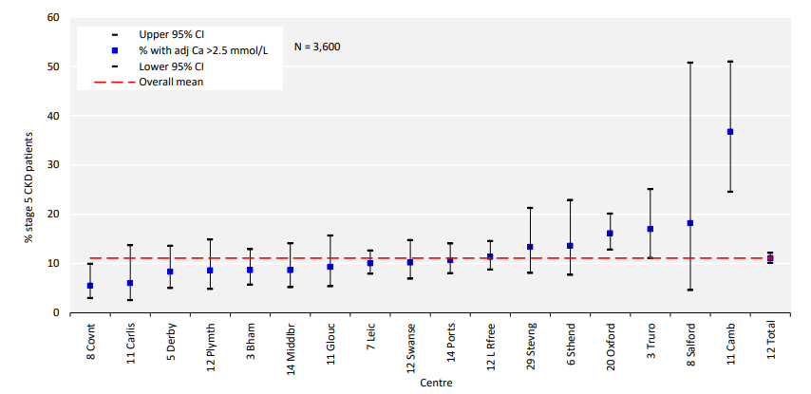
Figure 1 - Percentage of adult patients prevalent to CKD stage G5 on 31/12/2019 with adjusted serum calcium (Ca) [6]

A single source of truth for all patient data brings many other benefits. It improves data quality and data availability, giving healthcare providers the tools needed for faster and more efficient clinical decision making and emphasises the need for Clinical Decision Support Systems (CDSS).
A CDSS enhances medical decision making with targeted clinical knowledge and health information. Computer based CDSSs can be traced to the 1970s where ethical and legal issues around the use of computers in medicine were big concerns. Today, CDSSs make use of web-applications (such as WCP) or rely on integrations with other EHRs [7].
Clinical dashboards are one variety of computer-generated graphic and are an important component of much wider CDSSs. They offer dynamic visualisations that make understanding large datasets less arduous. In healthcare, clinical dashboards can inform both clinical and business decision, having a direct impact on improving patient care and organisational management.
Healthcare organisations have introduced dashboards for a number of other purposes, such as monitoring health system performance, optimising treatment regimes, reducing clinical errors, reducing the incidence of infections and general improvement in the quality of care [8].
Fresenius Medical Care (FMC), a private renal treatment provider based in Germany use clinical dashboards to show aggregated views of Key Performance Indicators (KPI) related to haemodialysis (figure 2) and provides interaction with the end users. Users can click on individual KPIs to drill into the data and view it in a specific context for groups of patients (figure 3) and furthermore, drill down to individual patient levels (figure 4) [9]
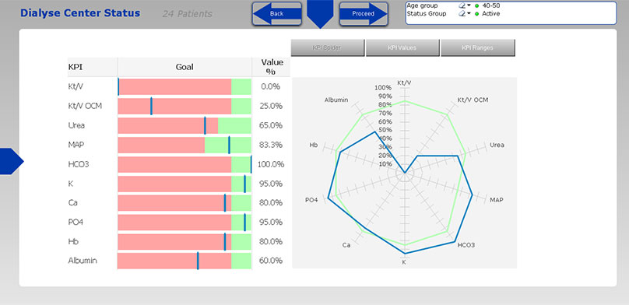
Figure 2 - Dialysis Centre Status provides an aggregated overview of the haemodialysis related key performance indicators (KPIs)
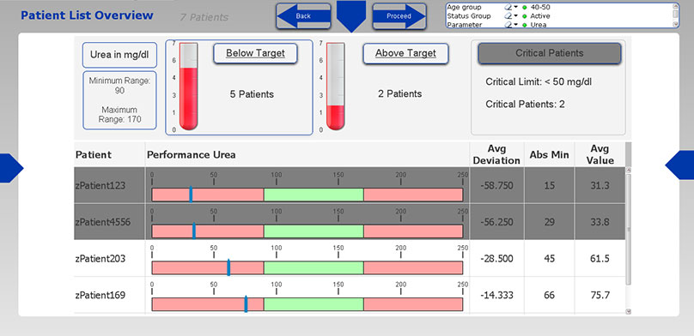
Figure 3 - Patient List area of specific KPI. Presented in a specific context, to the list of patients who are respectively out of the target range
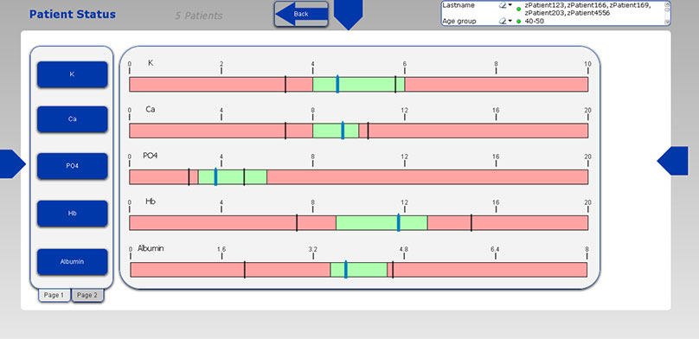
Figure 4 - Patient Status area shows the data for the average value for a specific KPI across all selected patients and the minimum respectively the maximum measured value

Similarly, an article published in the Journal of Medical Internet Research, a leading peer-reviewed journal for health and healthcare described developing an ‘Intranet-Based Lymphedema Dashboard for Breast Cancer Multidisciplinary Teams’. They concluded that health professionals are interested in using data visualisation tools that make routinely collected clinical data more accessible, however, to be effective, dashboards need to be reliable and driven by comprehensive and accurate data sets [10].

Dashboards – What is Needed?
Of course, digital dashboards are only useful if they display relevant and accurate data for the audience at which they are aimed. In his book, How to Design a Dashboard, M David uses the acronym ACES to describe four key tenets to creating powerful dashboards that can be applied regardless of subject area [11].

Accurate
In data analysis, accuracy is essential. A dashboard can only survive if the viewers have trust in the information they are seeing. Inaccurate dashboard data cannot and will not be used to make decision and in fact, has the opposite effect of that intended. Rather than rely on digital systems for decision support, users can lose trust in digital completely and instead turn to hard copies and faithful paper-based records. Inaccuracy in one dashboard can nurture a lack of faith in the underlaying data itself.
Dashboard accuracy can be affected by data quality, metric comprehension, and visual design. When it comes to data quality the data being displayed needs to be correct, always. In clinical environments, important decisions in patient treatment are made based on digital visualisations and inaccurate data could result in incorrect clinical decisions being made, which could then result in harm to the patient. Similarly, dashboard users need to know if they are seeing all the data available. In most cases, limitations in data loading mean that data is refreshed periodically and so it is important to let users know the refresh period (e.g., “Page refreshed every 10 minutes).
Figure 5 - Example of information to tell users how old the data is that they are viewing

If a dashboard is querying data from a Data Warehouse (DW), it is unlikely to be displaying all the available data, which is down to how DWs are manufactured and maintained.
Most of the time, data engineers use batch processing to load the data from their production (or current live database) to the data warehouse at scheduled intervals. It is then this data warehouse that provides the data to drive the dashboard. Without a notice such as that in figure 5, users dealing in real-time scenarios can get confused when they do not see all the data. For example, a dashboard updated 10 hours ago only displays data that was loaded in to the DW up to that point in time. Any data captured in the production database would not be available to the dashboard until the next update. In figure 5, this would not be for another 2 hours.
As well as information on how old the data is, it is useful for user to know when a dashboard is not working. This can be achieved simply by adding a notification to state that it is so. Figure 6 is an example warning to dashboard viewers to inform them that the dashboard they are accessing is not working.
Figure 6 - Notice to viewers that the dashboard they are using is not working

Other than visualisation, metrics are what make successful dashboards. Dictionary.com defines “metrics” as a standard for measuring or evaluating something [12]. Metric comprehension relates to the viewers ability to understand what a dashboard graphic is trying to say and so it is best to include formulas and definitions for metrics directly on the dashboard, particularly those considered non-traditional
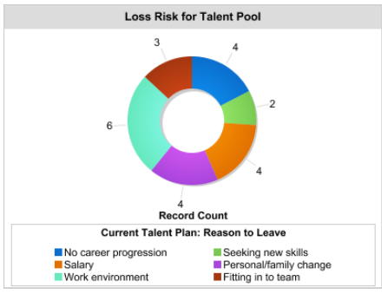
Figure 7 - Dashboard metric for assessing employee reasons for leaving their job. The key at the bottom helps with metric comprehension (http://www.hrmssolutions.com)

Lastly, visualisation is the key aspect of digital dashboards and data visualisation is their primary application.
Tableau, a leading player in the world of dashboarding define data visualisation as the graphical representation of information and data, using visual elements to represent and understand trends, outliers, and patterns in data. Data visualisation tools and technologies are essential to analyse massive amounts of information and make data-driven decisions [13].
“Data viz” can come in many forms, such as tables, pie charts, line graphs, tree maps and so on. However, simply creating visual elements out of data is not enough, the graphics need to be easily understood and related to the information of which they are attempting to convey. For example, figure 8a shows a simple line graph representing marketing spend per month. The Y axis range is small enough that the variation in the monthly figures can be seen clearly (0k – 32K). Figure 8b on the other hand shows the same data, represented on a graph with a much high range on the Y axis (0K – 1,000,000K). Given the small variation in monthly figures compared to the size of the range, it difficult to identify any variation and impossible to make accurate statements about it.
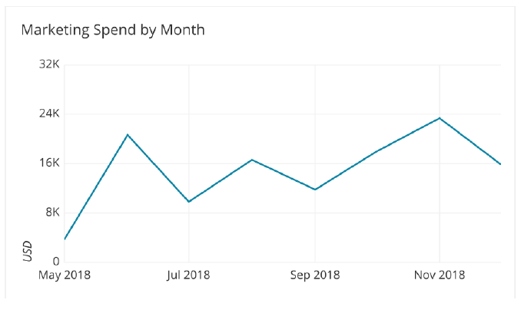
Figure 8a - Good Y-axis Range - Can clearly see the variability [11]

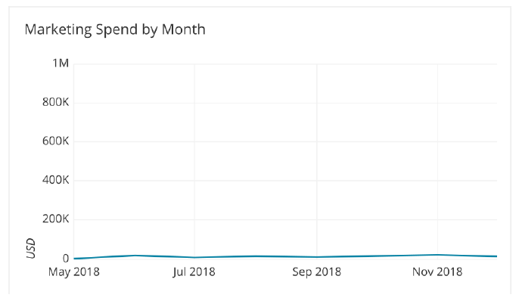
Figure 8b - Bad Y-axis Range - Cannot see the variability [11]

Clear
Having accurate data is essential, but it is also important for this accurate data to be displayed clearly. M David suggests several factors the contribute to a clear data:
- Font
- Colour
- Context
- Layout
The objective is to design a legible output. Fonts for titles, labels and details should not be decorative and a sans serif font is recommended such as Verdana or Arial. The below example demonstrates the importance of clear and legible use of fonts.

This is a Dashboard Title
Font: Vivaldi
This is a Dashboard Title
Font: Verdana

As well as legible font, colour is an important aspect of visual experience. Colours give data context, connect information together and, draw attention.
A study into the ecological valence of human colour preference by the Department of Psychology, University of California theorises that colour preference is related to objects that people like. For example, blue is often associated with clear skies and clean water, whereas browns and darker colours are associated with object such as rotten food and faeces [14].
In his publication entitled The Colour Currency of Nature, N Humphrey proposes that colour preferences originate from signals conveyed to organisms in nature. A good example flowers and fruit that appear inviting to pollinating and seed dispersing animals. Conversely, the colours of a poisonous toad suggests it is dangerous if eaten, and so protects it from predators [15].
Whatever the deep rooted, evolutionary reasons for colour preference, dashboard designers can take advantage with well-considered use of colour palettes, which should be easy on the eyes and not overweight one colour compared to another and serve to better illustrate the point made by the display.
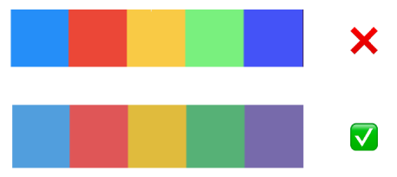
Figure 9 - Examples of colour palettes: How to Design a Dashboard, M David
Data visualisation is one thing, but without context, dashboards are simply graphical representations of irrelevant data.
When considering the point that the dashboard is wishing to convey, information such as descriptive titles, categorical labels and value labels should be included. The addition of this information makes it easier for viewers to understand what is going on much more quickly [11].
In their Tableau Blueprint article, dashboard designers at Tableau note that “good stories involve more than just data”. They suggest that dashboard designers need to be mindful of aesthetics and know that what is effective can often be affective and evoke an emotional response. They also note that views must be consistent, pleasing to the eye and flow in a natural way that leads the viewer on a journey through the story being told [16].
Layout is also important to producing a successful dashboard. In most countries, people read from left to right and top to bottom. If left to right readers make up most of the target audience, then it is sensible to place the most important information in the top left corner, working left to right and top to bottom.
Selecting the best layout is in a large part down to the nature of the data that the dashboard is trying to convey and the interests of the users it is aimed at. Qlik, another market leader in data management, analysis and dashboard design suggest four categories of top-performing dashboards [17].
- Executive – This is a reporting tool to monitor long-term business strategy, it’s aims are to give users a way to examine critical success factors and KPIs at a senior management level.
- Operational – One of the most common types, operational dashboards present current information to demonstrate progress towards a goal. They are generally not designed to be interactive.
- Tactical – Designed to track progress towards a goal, tactical dashboards are interactive and help users/teams determine if what they are doing is working.
- Analytical – Used to drive business decision making, these dashboards contain vast amounts of data that is used by analysts, particularly those in business data and middle management, to support executives.

The below image, taken from M Davids How to Design a Dashboard is a good example containing the above-mentioned points. The colour palette is aesthetically pleasing and does well to differentiate the data while still showing that it is connected. The fonts are legible, and the titles and other descriptors give context to the visual. The red arrows, whilst not part of the actual design show the direction of travel on the journey through the data, which as discussed flows left to right, top to bottom.
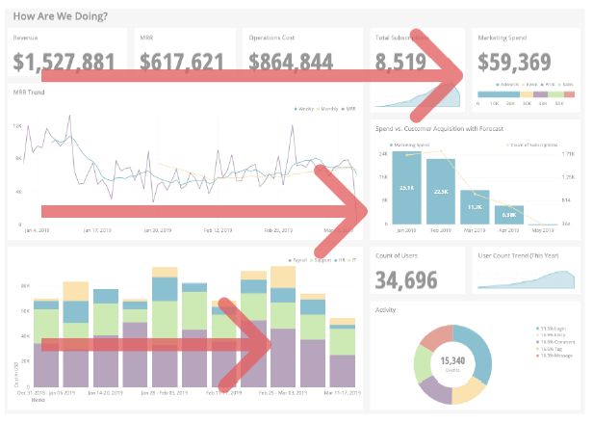
Figure 10 - Example Dashboard: How to Design a Dashboard, M David

Empowering
The aim for any dashboard developer is to create tools that will help others achieve a goal. Having access to the right data, at the right time, in an easy to access and easy to understand manner empowers users to act, thus helping them achieve that goal.
Dashboard design is an iterative process, and it is necessary to assess the number of views and even who is viewing as time goes on. This can be achieved using access logs, such as the ones built into most BI tools, or simply by discussing with users the good and bad points, provided the audience is relatively small.
By iterating and asking questions like “is the dashboard useful?!, “is it missing some crucial information?” and “how can the dashboard be modified to better serve its purpose?”, viewers will feel engaged by the process and that they have a level of control over what they see. This promotes quality in design and empowers the viewer.

Succinct
Data dashboards exist to make understanding and visualising large volumes of data easier. However, it is essential that the information displayed is brief and related, making it easier to evaluate all the data elements simultaneously.
Scrolling through a dashboard is inefficient. Particularly having to scroll to see graphics that are related. Scrolling prevents viewers from being able to compare visualisations side-by-side and makes it more difficult to draw conclusions. This also relates to the points around layout, and how graphics should be in the appropriate locations based on priority and direction of travel through the data journey.
The below image shows a large dashboard with scrolling bars. By forcing users to scroll, important graphics are hidden from view. They are now required to remember information they can no longer easily see and figure out how it relates to the other graphics that have become visible.
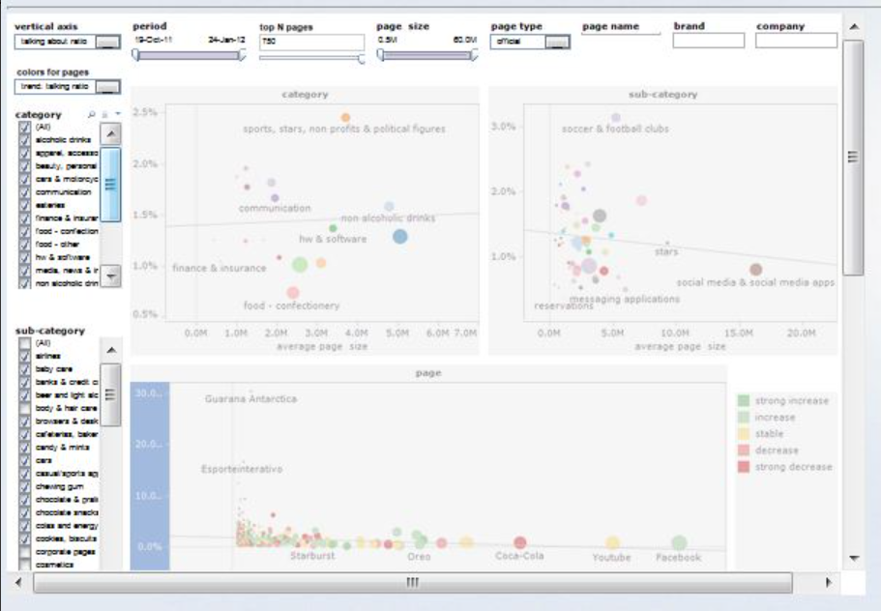
Figure 11 - Poor Dashboard Design: Tableau.com
Dashboards like the one above usually hold too much information. They are not succinct, and they lose their at-a-glance appeal. This can cause viewers to disengage quickly and jeopardise the success of the dashboard.

Daniel Kahneman, in his book Thinking, Fast and Slow, suggests that humans have two ways of thinking labelled System 1 and System 2, when presented with information, be it a dashboard, newspaper, or image. System 1 requires little to no effort. There is no voluntary control, and the brain operates quickly and automatically. System 2 thinking allocates attention to the mental activities that demand it, such as analysing and absorbing information. System 2 thinking is associated with the subjective experience of the user, such as when making a choice or concentrating [18].
An effective dashboard engages users in a way that encourages System 2 thinking. It provides a balance between easy-to-understand data interactions and the cognitive load in understanding what the data is saying.

User Experience (UX) Design, Usability and Affordance
Don Norman and Jakob Nielsen, widely accepted as an authority on usability and affordance, summarise User Experience below:
‘ ”User Experience” encompasses all aspects of the end-user’s interaction with the company, it’s services, and it’s products’ [19]
They go on to suggest that ‘the first requirement for an exemplary user experience is to meet the exact needs of the customer without bother or fuss.’ Furthermore, they suggest that products that are simple and elegant are a joy to use and that true user experience is more than giving customers or users what they say they want.

UX Design
User Experience (UX) Design involves following a human-centred approach to system development and designing the experience around the requirements of the intended audience [20]. But what does it mean to take a human-centred approach?
Humans are complicated beings, with feelings and moods that can change. Christopher Murphy is a writer, designer, educator, and organiser of the design conference Break. In his article for Adobe, Universal Principles of User Experience Design – An Introduction, to take a human-centred approach is to try to understand and factor those feelings in to the design process, whilst maintaining functionality [21].
Consider the following example. Traditional banks are built on traditional principles where the history of their customer base has relied on in-person interactions. In today’s digital age, many customers prefer digital platform for online banking, such as a web-app and traditional banking apps, in general, look more like screen versions of paper-based bank statements. They are considered additions and not fundamental to way that people prefer to control their finances. This shows in the poor design of the Bank of America web-app, below.
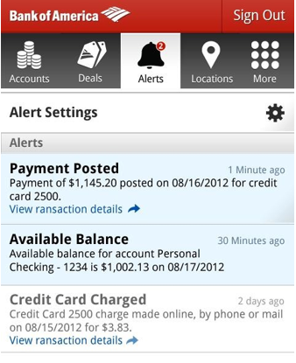
Figure 12 - Bank of America: Banking Web-app
Conversely, modern “challenger banks” such as Monzo design their web-apps with digital accessibility in mind. They include features such as graphing and spending analysis tools in the hands of their customers and at the click of a button. It is this consideration towards usability and human interaction that UX Design processes try to capture.
The below image shows a typical Monzo banking web-app graphing feature.
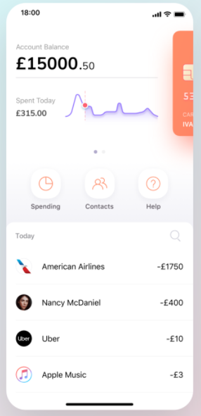
Figure 13 - Monzo: Banking Web-app

Usability and Affordance
Good usability is an integral aspect of superior design. Usability is a quality attribute to assess how easy a user interface is to use and refers to the methods for improving ease-of-use during the UX design process. Jakob Nielsen describes usability with five key components [22]:
Learnability: How easy it is for users to accomplish basic tasks the first time they encounter the design?
Efficiency: How quickly can users perform tasks once they have learned the design?
Memorability: How easily can users re-establish proficiency when returning to the design after a period of not using it?
Errors: How many errors do users make, how severe are they and can they recover from the errors?
Satisfaction: How pleasant is the design to use?

Affordance, a term first coined in 1977 by psychologist J. J. Gibson refers to actionable properties between the world and an actor, the actor in this case being the user of the clinical dashboard [23].
The Merriam-Webster dictionary further defines affordance as “the quality or property of an object that defines its possible uses or makes clear how it can or should be used” [24]. When we apply that to the digital dashboard development, affordance is the term for the design and intuitiveness of the dashboard interfaces that enables its use. More clearly, a dashboard should be designed to complement its purpose, with a layout that fits the common flow of use and be intuitive enough that users are able to discover how to do what they need, without significant increase to cognitive workload: systems need good affordance.
In the context of interface design context, Don Norman elaborates on the concept of affordance and expands to term to “perceived affordance.” Perceived affordance relates more to what the user perceives than to what is true, and designers are more concerned with ensuring that the user perceives an action as possible [25].
An example of perceived affordance would be graphical objects on a dashboard. The graphical object “affords clicking,” but the questions is whether the user perceives that clicking on the graphic is a meaningful action. In terms of dashboard development and user engagement, it is this perceived performance that can be brought out during the UX design process and used to make a useful, interactive, and engaging dashboard.
Figures 14 and 15 show examples of a dashboard developed both before and after the outcomes of usability assessments and using UX design [26].
Figure 14 has several features that seem intuitive. The “upcoming Class Activity” section shows what is next in the student’s calendar and the “My Progress” section presents their progress to date. To the right, the “My Assignments Status” is separated into assignments due and assignments already submitted.
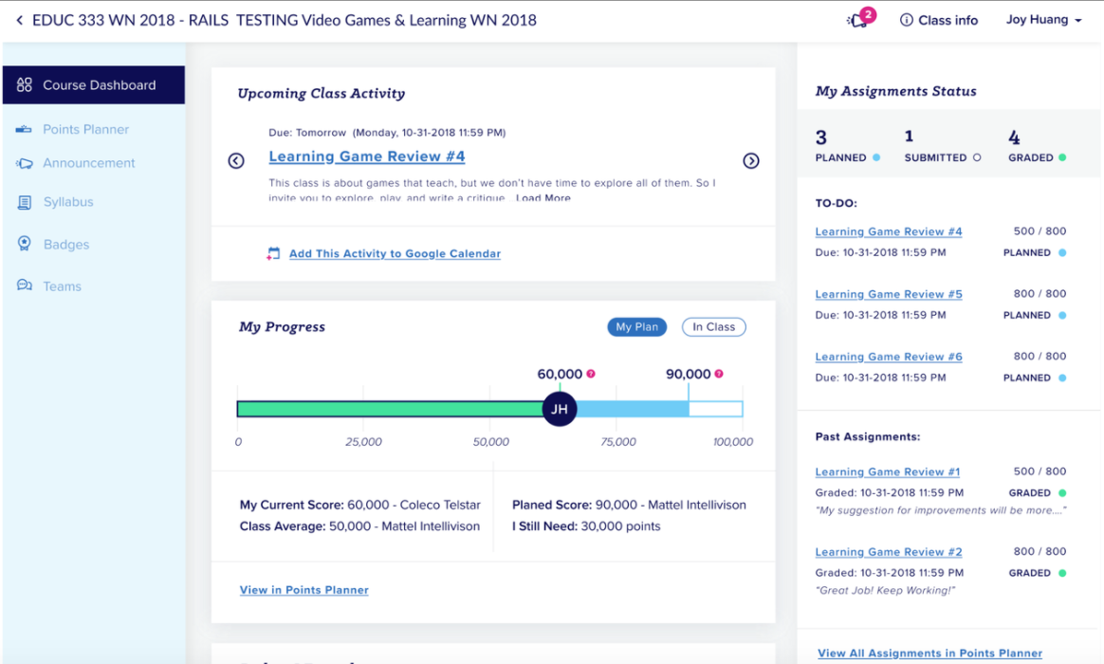
Figure 14 - Example Student Dashboard, S.R.Haley
Figure 15 shows an updated version of the dashboard post usability assessment and feedback. Both the “My Progress” and assignment sections have been updated. “My Progress” more clearly status what the “Class Comparison” does, simply by changing the button title, while the “My Assignments” section has been redeveloped to better show the status of all assignments.
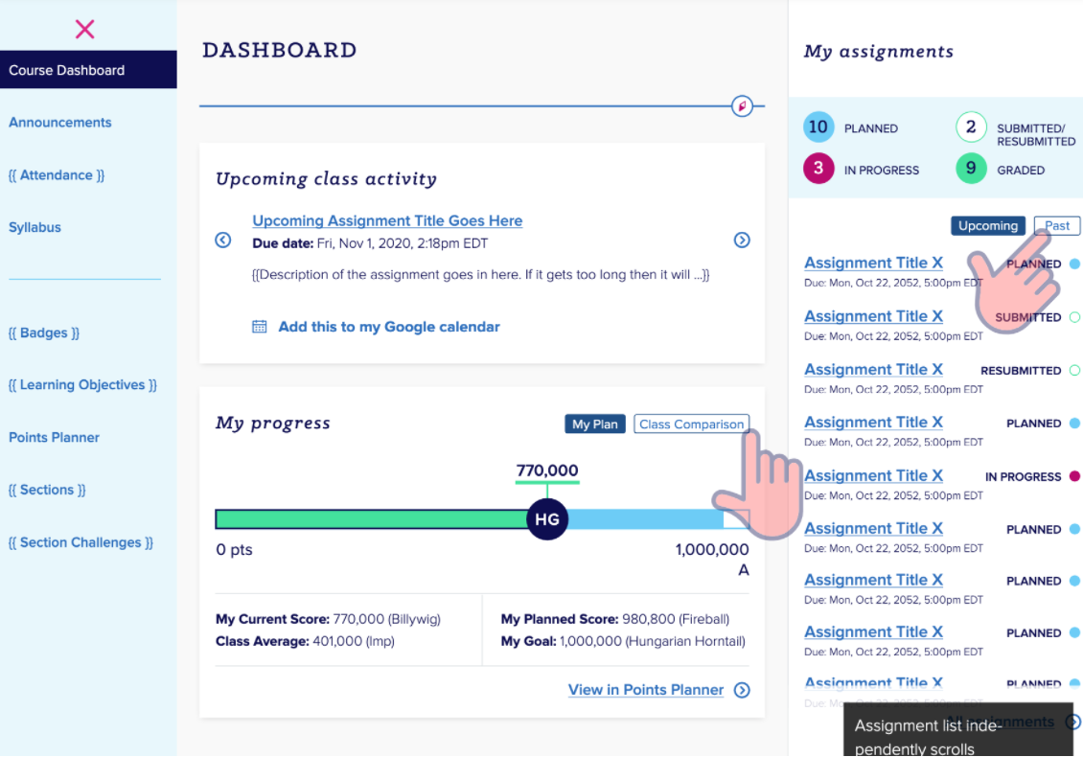
Figure 15 - Example Student Dashboard, S.R.Haley
In both versions, affordability of clickable object is good. Users can instinctually tell which objects are clickable, and what action they are likely to perform.

Clinical Dashboards – Are They Effective?

Designing and implementing dashboards, particularly in a clinical environment, instinctively feels like a good idea. Clinicians are responsible for caring for people, often in high pressure, life-threatening situations and rely heavily on large volumes of data collected by many different clinical disciplines. As mentioned previously, this was historically analysed using software packages such as MS Excel and MS Access. But flat spreadsheets and complicated databases are not conducive to being able to act quickly based on the information available. Dashboards, where the relevant information is collated and displayed in an easy-to-understand graphical representation seems far more likely to compliment clinical practice as opposed to hinder it.
In 2013, Singh, Spitzmueller, Petersen, Sawhney, and Sittig performed a cross-sectional study of nearly 2,600 primary care providers to evaluate predictors of missed test results in the setting of EHR alerts. The results showed that 87% felt the quantity of alerts received to be excessive whilst 70% described receiving more alerts than they could be managed effectively. Furthermore, 56% reported that the current notification system made it possible for practitioners to miss test results, and 30% reported having personally missed test results that led to delays in treatment [27].
In 2009, Victor Zaydfudim et al. at the Vanderbilt University, US conducted a study on the “Implementation of a Real-time Compliance Dashboard to Help Reduce SICU Ventilator-Associated Pneumonia (VAP) with the Ventilator Bundle”.
The study found the introduction of a dashboard resulted in a decrease in the mean VAP infection rates from 15.2 (7.0) to 9.3 (4.9) incidents per 1000 ventilator days. Similarly, Quarterly VAP rates were reduced significantly for the November 2007 to January 2008 and February 2008 to April 32008 quarters and compliance with ventilators grew from 39% in August 2007 to 89% in July 2008 [28].

Requirements

3.1. Introduction
Medication administration compliance is of utmost important when caring for those who are sick, especially those who rely on clinical practitioners to provide and administer those medicines. This is particularly the case at the many Renal units treating those with chronic kidney disease around the world.
At each of the three Swansea Bay University Health Board (SBU) units, based at Morriston Hospital in Swansea, there are three dialysis sessions per day that cover the hours of 7am to 11pm. These are broken down to AM, PM and Twilight sessions with patients usually assigned to three sessions per week. For example, a CKD patient reliant on haemodialysis may attend a unit every Monday, Wednesday, and Friday morning for four hours of dialysis from 7am to 11am. At the time of writing, there are 270 dialysis patients under Morriston Hospitals’ care and when divided across the number of session averages 15 patient per session. In reality, some sessions are busier than others as every effort is made to accommodate peoples’ preferences and lifestyles. Most often, morning sessions are busier on Mondays, Wednesday, and Fridays as people are keen to complete their four hours of treatment early in the day, and on weekdays, freeing up their weekends. Additionally, Morriston is the main dialysis centre for South West Wales and provides significant numbers of treatments for those on holiday in the area, and is the first port of call for all patients in Mid to South West Wales patients when they present with acute kidney injury. It is not unusual to find over 40 patients dialysing in one unit in one session, so pressure on clinical personnel is considerable.
Each patient is prescribed anywhere from 10 to 50 medications per session. If we take the median number of medications as 30 per patient and multiply this by the number of patients in a single session (40), the total number of potential medication administrations per dialysis session is 1200. When considered across a whole day and furthermore the whole week, we see roughly 3600 and 21,600 medications respectively in a single unit. With three units in Swansea alone, the numbers of medications prescribed and administered to dialysis patients is vast.
Not all the above medications are administered by nurses and only those given whilst on dialysis are recorded as such. However, with even a fraction of a patient medication being administered by clinical personnel, over a day, a week and an organisation, the numbers can grow rapidly the risk of human error becomes a significant factor in medication compliance.
Medication compliance has several contributing factors. For example, patients may not take medication because they chose not to, like when the side effects outweigh the benefits. Similarly, depending on health at the time or other illnesses that accompany failing kidneys, a mix of certain medications can be detrimental to the patient. An example of this is with immunosuppressants supplied to patients having had a kidney transplant. Interactions between some antimicrobial drugs and these immunosuppressants can reduce the affect the antimicrobials have on an infection and even become toxic.
Or course, the most unacceptable of factors that contribute to poor medication compliance is human error. Patient and their families entrust themselves to the care of specialist clinicians and should expect the highest level of care in return. Given the large volumes of drug administrations, together with a combination of digital and paper-based systems with which to monitor and record the data, resulted in an unacceptable level of missed medication doses due to human error and in 2014, the Andrews Report (Trusted to Care) was released detailing several concerns and failings at SBU (known as Abertawe Bro Morgannwg at the time).
In SBU Renal, it was identified that an average of 50 doses of essential, “given-on-dialysis” medication doses where being missed as a result of human error, known as “never-events”, highlighting a significant failure in medication compliance. Based on the outcome of this report, SBU Renal were instructed to achieve a target of zero never-events, which meant a culture shift in how medication administrations are recorded and monitored.
Medication regimes are tailored specifically to each patient and whilst some medications are common across the whole cohort, dosage and delivery method vary significantly and change regularly based on many contributing factors, making them complex and difficult to track. Historically, dialysis nurses would check the clinical record for each patients’ medication and treatment regime using a digital system called VitalData. They would then administer the medications and record their activity on paper-based medication charts. Whilst VitalData had excellent mechanisms for storing prescription information, it had no way to record administrations of medications whilst on dialysis and so the loop between prescribing and administering needed to be closed.

3.2. Electronic Prescribing and Medicines Administration (EPMA)
Electronic Prescribing and Medicines Administration (EPMA) is the term given to a system that can record both prescription and medication administration data. Essentially, it closes the loop between the two and provides a far more accurate and comprehensive medical record. It also provides the opportunity to become paper-light, even paper-less in some cases.
In 2017, an EPMA module was introduced to SBU VitalData based on the paper-based medication chart that replicated paper-based medicine administration methods digitally, using touch screen technology. Additionally, signing to say that the medication was given and similarly that the administration of that medication was witnessed by an appropriate level clinician could be done using digital authentication. Nurses could then sign in to VitalData with a username and password and record the administration directly in the system, eliminating the problem of illegible wet signatures and damaged medication charts.
The introduction of EPMA drastically reduced the number of never-events but did not eliminate them completely. However, as the data captured was now stored digitally, it was possible to develop medication surveillance.
Using MySQL, it was possible to investigate where, when, and why the remaining never-events occurred, providing a clear and easily accessible (albeit retrospective) view of medication administration compliance. This generated the opportunity to approach those responsible for never-events, highlight their mistakes and educate them as to the importance of accurate medication dosing.
Figure 16 below shows an example electronic drug chart.

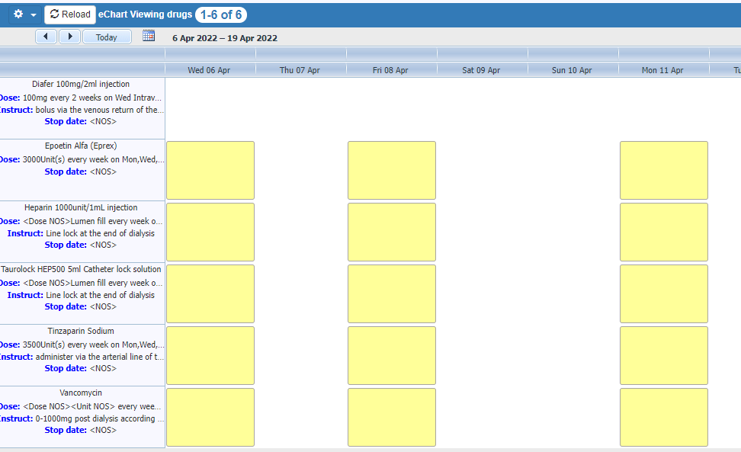
Figure 16 - Example electronic drug chart

3.3. Retrospective to Prospective

The ability to quickly, albeit retrospectively identify poor med admin compliance had some positive impact. It made those administering medication more conscious of their actions, which resulted in greater care being taken when reading and interpreting the digital charts and administering medications. Coupled with a digital system that put all the information at their fingertips, benefits of the system were quickly realised. However, a reduction in never-events was not the mandate of the Andrew Report. SBU Renal was instructed to reduce poor medication compliance to zero and be able to account for only the genuine cases of deviation from prescription. A prospective view of the data was required for further improvements.
The scope of this development project is to investigate mechanisms by which live medication data could be provided to assist dialysis nurses in eliminating never-events.
When analysing data using the retrospective medication surveillance tools, it was clear that regular and “standard” medications, like anticoagulants, rarely formed part of the collections of never-events. Similarly, instances of never-events including rigidly prescribed treatments that were less common or more specialised, such as treatments for iron deficiency, were very infrequent. This was attributed to either the standard procedure of adding anticoagulant to dialysis treatments being ingrained in nursing practice, or the strict nature of treating iron deficiencies forcing clinicians to focus more fully on delivering care.
From the analysis of 2140 medication administrations given over 18 dialysis sessions, non-standard medications made up 80% of deviations from prescription (17 out of 21 total deviations). Of those 21 deviations, 50% were classed as never-events, resulting in 9 cases of poor medication administration compliance. The 9 cases were then reported to the appropriate body.
From the days of 50 missed doses per week, retrospective medication surveillance and targeted education resulted in a significant drop in never-events. However as stated, SBU Renal was mandated to be fully compliant, with zero accidental missed doses. It was evident that retrospective monitoring and education alone would not achieve that which was mandated and a prospective, or live system was required.
Engaging with the dialysis nurses was the first step in understanding what was required. During a meeting with senior clinical colleagues (appendix 1), a list of requirements was drawn and prioritised using the MoSCoW prioritisation methodology.

3.4. MoSCoW – Must Have, Should Have, Could Have, Will Not Have

The MoSCoW method for prioritisation groups development initiatives by those that the final product must have, should have, could have, and will not have. As their names suggest, the “Must Have“ category consists of initiatives that are “musts” for the development. The “Should Have” category details initiatives that are important, but not vital to its’ release.
“Could Have” initiatives are things that would be nice to include but are not necessary to the core function whilst “Will Not Have” initiatives consist of those that are not being considered, at least for this iteration of the development.

3.4.1. Must Have Initiatives
The finished product must have:
- Clear display of relevant medication data
  - Should not display patient identifiable data
  - Should only display those medications due, but not yet given
    - Name of drug
    - Dose
    - Units
    - Frequency
  - Should only display the above for the patients currently on dialysis
- Pull data from a replicated database that is no more than 1 minute behind the live data store
- Display of date and time the data was last refreshed

3.4.2. Should Have Initiatives
The finished product should have:
- Minimal development costs
- Minimal revenue tail – very low/no on-going cost
- Name of dialysis nurse responsible for the patient
- Dynamic link to patient medication chart
  - Ability to click on a link and load the patient of interest without the need to search manually.
- Medications should not appear on the dashboard where patients are being treated on days other than those explicitly prescribed

3.4.3. Could Have Initiatives
The finished product could have:
- Auto-refresh functionality
- Function to move administered but non-witnessed medications to new section
- Function to display medications given within the last 24 hours that have not been witnessed by a senior member of staff.
- Links to other departmental facilities and useful resources

3.4.5. Will Not Have Initiatives
The finished product will not have at this time:
- Direct interaction with the patient medication records
- Ability to scale-up beyond SBU Renal treatment centres

Consideration of the above indicated that a medication dashboard was required. This could present an at-a-glance view of only the important and relevant information for the nurses. It would achieve most of the must, could and should have initiatives from the MoSCoW analysis. Further research was carried out into the development tools available, and these included a Crystal Server and Business Objects environment already implemented by the department, a free version of Microsoft PowerBI and a HTML and PHP based web dashboard.

Methodology

Research Method
With the requirements agreed upon, the following section will consider a suitable research and development methodology and study population, as well as data collection mechanisms used throughout the project evaluation.
Figure 17 shows The Research Wall. It divides research philosophy in to two distinct categories, Positivistic and Phenomenological.
Positivistic research methods centre around a deductive approach. They largely relate to research carried out using experiments, where facts and figures are collected and analysed. Given that software is usually developed to achieve specific tasks such as, but not limited to improving community engagement, providing access to vital resources, or improving patient care, it aligns with a positivistic philosophy. Software development should be AGILE, targeted towards requirements and iterative, with hard facts collected during evaluation that show whether it is fit for purpose.

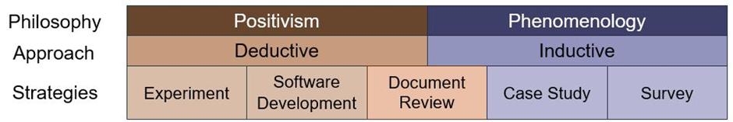
Figure 17 – The Research Wall

Figure 18 illustrates the granularity in the positivistic and phenomenological epistemologies.
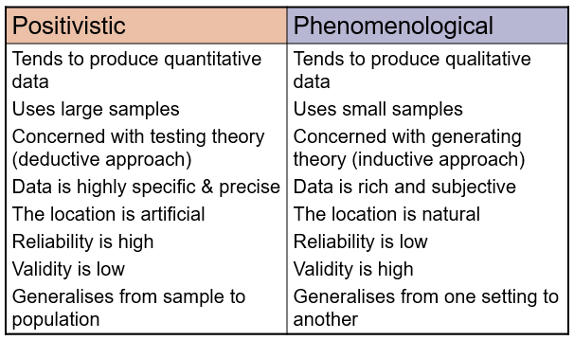
Figure 18 - Granular look at positivistic and phenomenological epistemologies
In research and development of the medication dashboard, a positivistic approach was taken. The samples used concerned entire local populations of hospital haemodialysis patients. The medication data generated is extremely precise and tailored specifically to each patient but the count and analysis of the number of missed doses generalises from individual sample to population. The questions being asked can be addressed with “true or false” answers.
- Did the patient receive the medication that they were due to receive?
- If no:
  - Was there an approved deviation from medication regime?
  - Was the missed administration recorded as a never-event?
This leaves little room for error, provided that the administered doses and the approved deviations were recorded correctly.
With the dosing practices recorded in a MySQL database, analysis of data is highly quantitative. Using a MySQL querying system and Crystal Reports, outcomes are generated that clearly show never-events and calculations can be made providing both exact counts and aggregate figures.
N.B. Correct recording of the above is reliant on the clinician administering the medication.

Development Methods

Becoming Agile

With a development of this nature, it is important to keep processes lean and this can be done by following the Agile development methodology.
Agile software development has four key values. They ensure interactions with individuals are considered more important than processes and tools. With medication dashboards, the clinical users should drive the development process, and the development process should evolve as those individuals respond to business needs. Discussions with pharmacists, consultants and nurses were key to understanding the requirements and iterating through multiple designs allowed the system to be tailored as requirements changed.
After the initial requirements were agreed, focus shifted to developing a working model. In keeping with the Agile principles, it was important to concentrate on developing a working system, rather than convolute the process with thorough documentation. The dashboard was designed to provide only the relevant data with minimal interaction required from users. If it was preferred, users could launch the dashboard and do nothing else, but still see up-to-date and relevant information. This was taken a step further by scheduling the dashboard to launch when a user logged in an approved device, such as a laptop allocated to a nurse for dialysis treatment.
With major steps forward in developing key features, nurses were kept informed via demonstrations. This collaboration allowed for early identification of features that may be included and not be necessary or highlight additional features that are necessary but were not part of the initial requirements analysis. However, to ensure additional requests did not hinder development or change the original scope, it was agreed that minor requests were to be added to the Should Have initiatives of the requirements analysis. Any major changes that deviated from the original scope where to be discussed at length and included in the next iteration if deemed essential.
Continuing with this approach the final Agile value suggests development teams focus on responding to change, as opposed to avoiding it as an undesired expense. The short development iterations afforded by the Agile cycle allow changes to be made easily and the process to be modified to best fit the needs. A combination of these four values ensured all parties were aware of the key stages, felt involved in the development and that they could positively contribute, and approach changes comfortably with colleagues, and had an equal voice in the discussion.

Feature Driven Development (FDD)
Feature Driven Design is a framework from the Agile manifesto that organises developments around making progress on features. Features in this case being the tasks that the users are trying to achieve. In our clinical dashboard, the main features are:
- See when a medication is due for the patients currently receiving treatment
- See when a medication has been administered but not signed as witnessed by a senior colleague for the patient currently receiving treatment
- See a list of medications administered but not signed as witnessed by a senior colleague for all patients having receive treatment within the last 24 hours.
Following the five-step development process of FDD, the project lifecycle is:

- Develop an overall model
- Build a features list
- Plan by feature
- Design by feature
- Build a feature

During the design process, each of the features listed above where addresses as individual developments, until they were all ready to be put into a single display.
For example, a wireframe diagram (appendix 2) was first created to serve as the overall model. It enabled the users to visualise what they were going to be using. Next, a features list was developed, and a plan formulated around what features would be the most useful and easiest to develop. The first feature decided on was being able to see when a medication is due for the patients currently receiving treatment. This was followed by a design session for the feature, where it was then added to the wireframe. Lastly, the feature was developed.
This process worked well because it allowed the wider team to positively contribute to design, however it was highly dependent on the developers to make progress with the design.

The Waterfall Process
The waterfall process is another methodology that can be used in system development; however, its scope is far wider than FDD. Indeed, the below illustration shows the steps of the Waterfall Process and for the purposes of designing SBU’s medication dashboard, FDD fits under the “Design” section of the Waterfall Process.

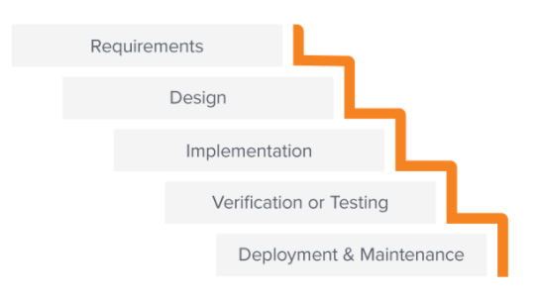
Figure 19 - The Waterfall process
The waterfall process was employed to ensure the project and system development was controlled. Firstly, the requirements were discussed with all relevant parties. This included technical staff, pharmacists, consultant physicians and dialysis nurses. Secondly, the design process, using the FDD methodology was addressed. When a working model had been created, the system was implemented in a single dialysis unit for nurses to test and to provide feedback. Lastly, the system was approved, deployed, and maintained.

Other Development Methodologies Considered
There are several frameworks within the Agile manifesto that can be adapted depending on the desired development process and outcomes.
The LSD framework is based on optimising development time and resources. Often referred to as the Minimum Viable Product (MVP) strategy, it relies on releasing a version of the system with minimal functionality and iterating based on user feedback.
The LSD framework uses a streamlined approach to allow more functionality to be delivered in a shorter time and empowers those developing the system to make development decisions. However, it does make development heavily reliant on the wider team and with busy dialysis nurses and pharmacists included, this approach would be difficult to coordinate.
As well as those contained within the Agile manifesto, there are several other development methodologies available for developing software. One such is the Unified Software Development (USD) Process, and much like the Agile methodology, consists of a few phases, as shown in figure 20.
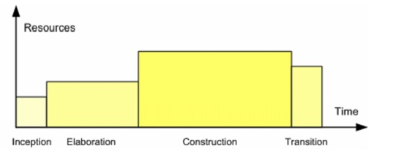
Figure 20 - Phases of USD Process
The Unified approach would have worked for development of a clinical dashboard, but the Agile methodology includes the Lean Software Development (LSD) process within its manifesto, and this was most appropriate when considering the urgency of the task, the team involved and the ability to produce the system at minimum cost.

The Study Population

The existing electronic patient record is well established with millions of rows of prescription data. At the three sites in Morriston hospital there are 18 dialysis shifts delivering an average of 733 dialysis sessions per week. A dialysis shift is a four-hour treatment period where multiple patients will be treated at the same time (e.g., 7am – 11am (morning), 12pm – 4pm (afternoon), 5pm – 9pm (Twilight).
To generate data for testing, there exists a test database environment that replicates the live environment exactly, including all treatment and prescription data with all personal identifiable data (PID) redacted. It is this test database that was used during the system development and testing.

Identifying Risks, Limitations, Ethical and Legal Issues
It was important to consider possible risks, limitations, ethical and legal issues with any new development that relies on displaying and using data.
It was agreed that given all identifiable data is redacted and the system would be used by a limited number of approved nurses, there was limited to no risk of accidental exposure. However, ethically, approval was sought from the University of Wales Trinity Saint David ethics committee regarding the use of hospital data. Similarly, and again as all PID was redacted, SBU governance agreed the use of the system for testing and were happy that it complied with GDPR regulations.
Some limitations were identified that had to be considered throughout the development process. Dashboard design was something in which the development team were relatively inexperienced. It was important to account for this when allocating development time. Similarly, testing of the system relied on clinical colleagues who themselves have essential and busy jobs. Creating a testing schedule that fit around their clinical commitments was imperative.
Lastly, agreement from the SBU IT managers was sought to allow the installation of systems and software to aid in development. This was approved early on, and developers given appropriate privileges to install whatever software was required.

Design and Implementation
With Crystal Reports, Crystal Server and Microsoft PowerBI, and HTML and PHP based websites being available as development tools for building data driven dashboards, it was natural to take an iterative approach to development.

Crystal Reports Dashboard
At first, starting with Crystal Reports seemed the simplest option and discussions were had with the clinical team about what they required with a view to build a simple Crystal Report. However, it quickly became apparent that, whilst the data could be displayed graphically via a Crystal Report and many of the features could be implemented, refresh functionality was limited. A Crystal Report built to look like a dashboard required considerable user interaction to request the data and no automatic scheduling function to query the database, run the report and display the output existed. For this reason, it was decided that Crystal Reports was not fit for this purpose.

Crystal Server and Microsoft PowerBI Dashboard
Although Crystal Reports on its own was deemed unfit for purpose, the availability of a Crystal Server instance meant that it was possible to configure a schedule that would execute the MySQL queries and extract the data. Nevertheless, it was still not possible to use the Crystal tools to automatically refresh the data, once the generated report was open. Once the newly delivered file was available, nurses could open it and see the most recent dialysis information extracted during execution. But having the file open for reading resulted in it becoming locked, and subsequent deliveries of the file failed, as the process could not overwrite the previous file.
To remedy this, investigations in to whether a combination of Crystal Reports, Crystal Server 2016 and Microsoft PowerBI could achieve what was required.

Crystal Reports PowerBI Process
Step 1:
A MySQL process was built to query the database and extract the minimum dataset required. An example of the MySQL query can be seen in figure 21.

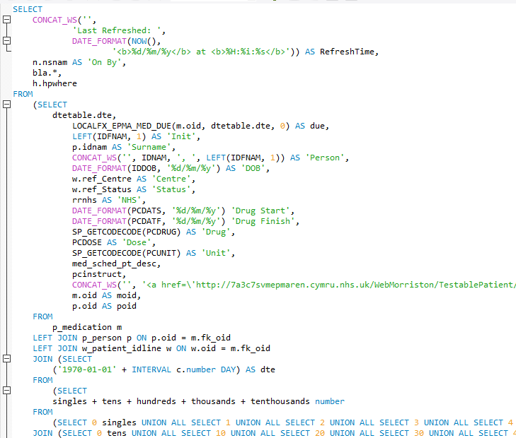
Figure 21 - MySQL query to extract due medication data

Step 2:
After confirming that the query extracted the appropriate data, the query was added to a blank Crystal Report.
The report was intentionally designed to look somewhat like a Microsoft Excel spreadsheet. This was to allow the Crystal Server process to output the file in .XLSX format and present the data in a way that MS PowerBI would be able to read. Figure 22 shows the .XLSX output.

Figure 22 - Example .XLSX output of due medications

Once the data had been generated as above, the file was automatically saved to a shared folder every 5 minutes using a Crystal Server schedule. This meant that the data the nurses were seeing was never older than 5 minutes and this was acceptable providing the last refresh time was also displayed.

Step 3:
Once saved to a shared folder, the file was available to PowerBI, and the first iteration of the clinical dashboard was created. This first version displayed only the medications due for administration to the test patients in one unit and worked well to prove the concept.

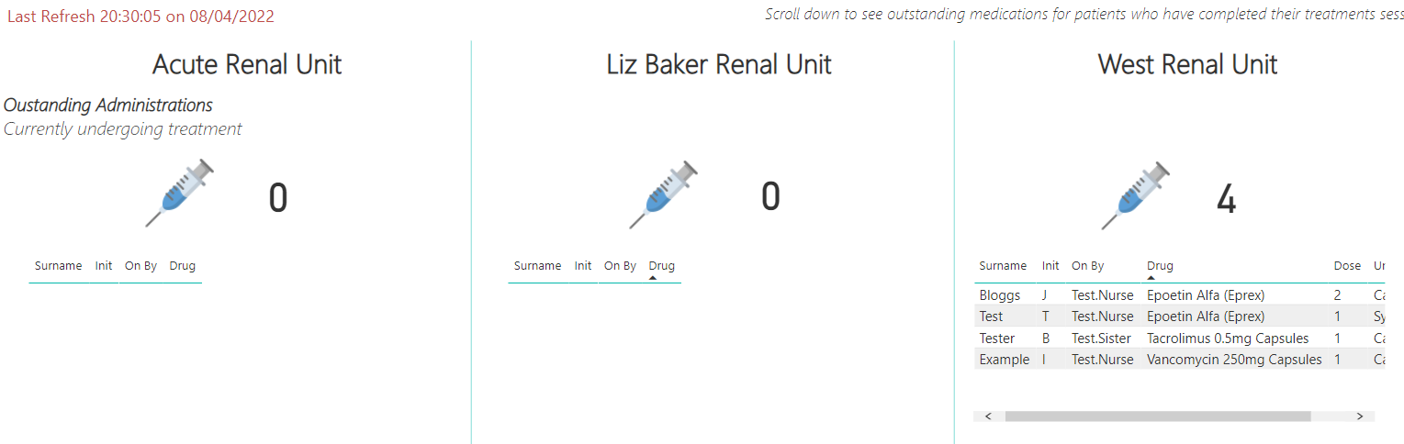
Figure 23 - Dashboard with due medications for West Renal Unit
Given the length of the data, a scroll bar appeared at the bottom of the table. This was discussed and accepted, as the information visible was enough to be useful, and users could scroll to see more information if necessary. Additionally, this dashboard would not be considered the single source of truth, and careful checks would be carried out using the digital medication chart during drug administration.

Step 4:
After the initial proof of concept, the MySQL query was modified to target medications that had been given, but not been witnessed. This was done by copying the original query and changing the WHERE clause appropriately.
- From this. Where the filter searches for medications due but not given.
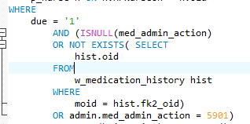

- To this. Where the filter searches for medications due, given, but not witnessed.
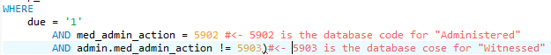

This query was then place in to a second Crystal Report that also outputted to .XLSX using a Crystal Server schedule. PowerBI was then configured to look at both .XLSX files upon refresh.
As can be seen in figure 24 below, the medication for patient I Example has been removed from the dashboard as it has been marked as administered and witnessed by a senior colleague. Whereas the medication for patient T Test, has moved to the “Unchecked Administration” section ready for witnessing. The outstanding medication counts have also changed.
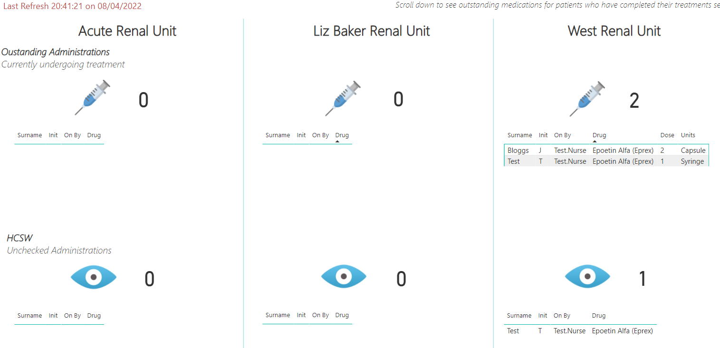
Figure 24 - Medications moving through the layers of the dashboard
Step 5:
Lastly, the above steps were repeated for those medications that were due, but not administered during the dialysis session. This section displays any medication not marked as administered within 24 hours of the patient receiving treatment and it here that genuine missed medication doses, such as when chemical conflicts prevent the patient from receiving the prescribed medication, or never-events appear.
Figure 25 shows the WHERE clause filter for displaying those medications not administered within 24 hours of treatment. “AND h.HPNurseOff IS NOT NULL” is the part of the filter that differentiates this query from that in the first section. All other parameters are the same (i.e., look for due medications not yet given), but it also looks for patients where the “Nurse Taking Off” field is NOT NULL. Put more plainly, a nurse has registered this patient as having finished their dialysis session.
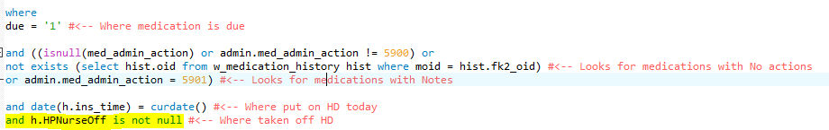
Figure 25 - Adjusted WHERE clause for due medications not administered during dialysis

The below image shows a fully functioning dashboard. Section one has medications that are due for patients currently receiving haemodialysis, section two shows those medications administered, but that still need to be marked as witnessed by a senior clinical colleague and section three shows those medications not administered to the patient at all during the dialysis session.
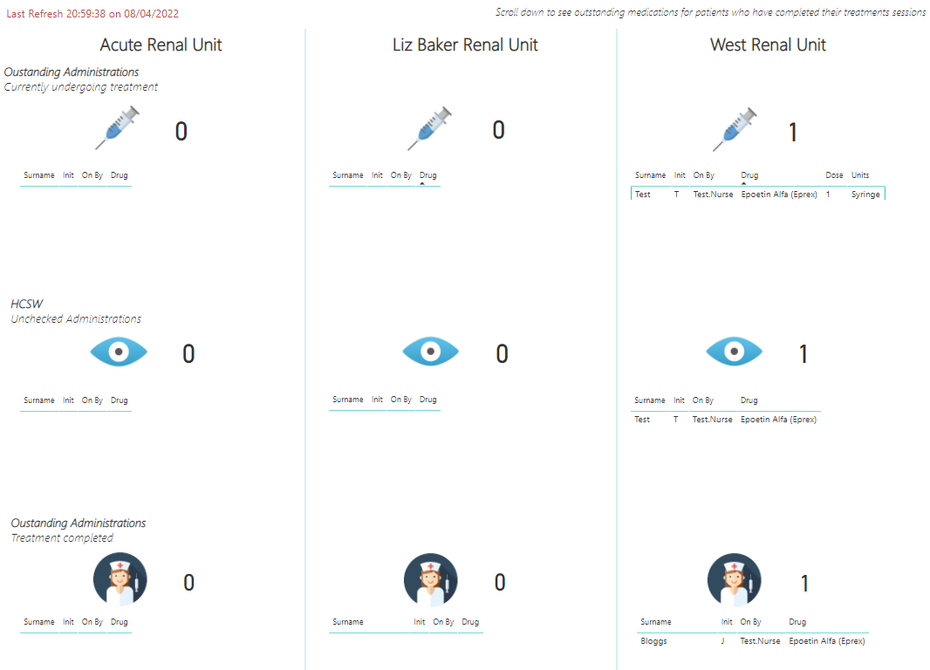
Figure 26 - Fully functioning clinical dashboard

Implementing for Testing
To test the fully developed dashboard, several clinical individuals where employed. Firstly, a pharmacist was asked to add multiple prescriptions of varying complexity to a test patient withing a single unit. This was to ensure that the correct information was displayed when the dashboard was refreshed, and the patient marked as starting treatment in the clinical EPR.
Figure 27 below shows part of a typical dialysis prescription. The medications highlighted in yellow are those prescribed to be given whilst the patient is on dialysis. This can be seen from the schedule information stating, “every week on” and the dialysis days.
The two other medications are those not given by the dialysis nurses during treatment and so should not show on the dashboard. Figure 28 shows the dashboard for the West Unit on a Monday morning where the two due medications can be seen under the first section, denoting that they patient has started treatment and still requires the drug doses.
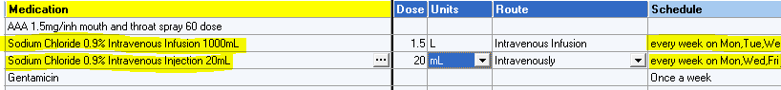
Figure 27 - Dialysis prescription in EHR

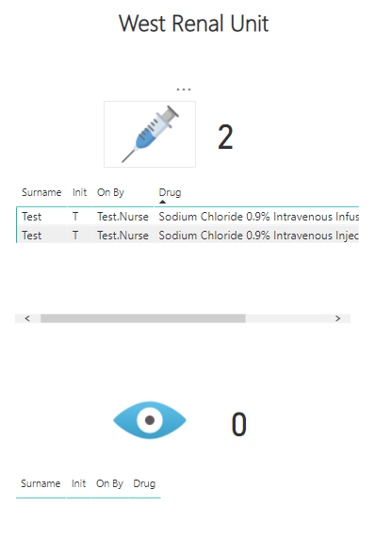
Figure 28 - Typical dashboard reflecting patient on treatment due medications

Of course, there are occasions when patients attend hospital for dialysis treatment on days other than those prescribed. This is marked as a deviation from treatment regime and treated differently to those who attend on prescribed dialysis days. In this case, the prescribed medications should not appear on the dashboard, as the prescription schedule states explicitly that they should be given on dialysis days (e.g., Monday, Wednesday, Friday).
Figure 29 below shows the dashboard how it appears on days when the patient is receiving treatment, but not on a prescribed dialysis day. As can be seen, any prescribed dialysis medications do not appear. This is expected behaviour and would be dealt with differently by the clinicians.
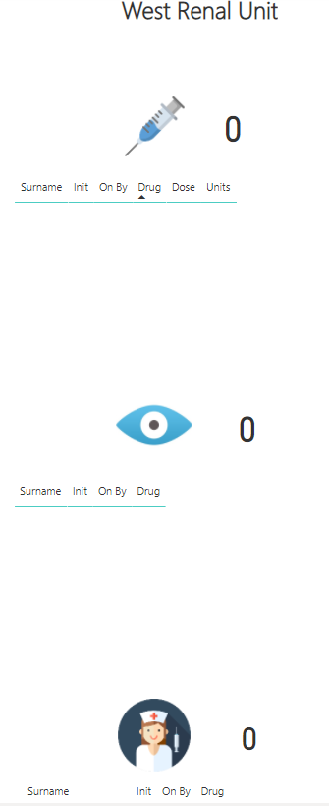
Figure 29 - Dashboard as it appears when patient is dialysing on a non-prescribed day

Secondly, a team of three senior nurses where tasked with using the dashboard without any instruction at first. This was to gauge its affordance and to assess how easy it was to understand for someone who had not been involved in development.
The nurses where happy that they could launch the system and view everything required easily. They did however require assistance on finding the refresh button, as well as have explained to them the need to refresh, as it was neither obvious (until pointed out) nor automatic. Furthermore, explanation was required as the update time of the data, even after it was refreshed, owing to the delay in file delivery by the Crystal Server.
Thirdly, all clinical colleagues above were asked to execute the entire process of marking a patient as starting treatment, refreshing the dashboard, checking the medication data, administering the medication, marking as witnessed and removing the patient from treatment. This is shows in the steps below.

Step 1: Marking a patient as starting treatment.
The MySQL query that executes to extract the data filters on patients that are within the unit of interest and that have a value in the “Nurse on” field, but no value in the nurse off field in the dialysis section of the EHR.
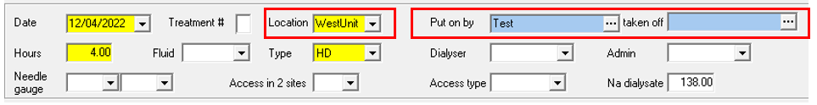
Figure 30 - EHR showing that a nurse has registered a patient as being on dialysis

Step 2: Refreshing the dashboard
Refreshing the dashboard simply requires clicking the “Refresh” button in PowerBI
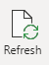
Figure 31 - PowerBI refresh button

Step 3: Check for patient due medication data
Due to the delay in file delivery, because of the Crystal Server schedule, the dashboard did not update immediately.

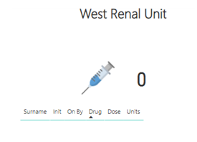
Figure 32 - Dashboard before Crystal Server refresh
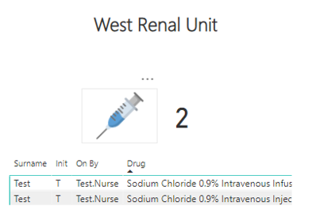
Figure 33 - Dashboard after Crystal Server refresh

Step 4a: Marking medication as administered
Marking a medication as administered requires it to be witnessed by a senior member of the clinical team. For the purposes of testing, the nurses witnessed their own administrations, but as can be seen below, once marked as administered, the medication successfully moves to the witnessing section.
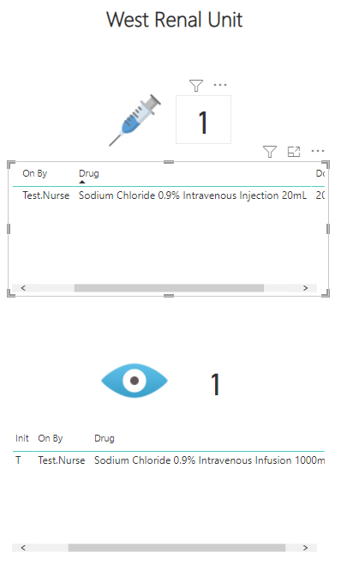
Figure 34 - 1000mL dose of Sodium Chloride administered and awaiting witness

Step 4b: Marking medications as witnessed
Once marked as witnessed, the medication should be removed from the dashboard with the next data refresh. The below image shows that the medication no longer exists under the “witnessed” section.
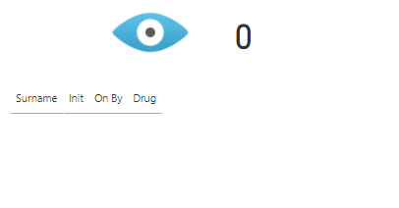
Figure 35 - Medication marked as witnessed and removed from the outstanding witness section

Step 5: Removing the patient from treatment
With Step 5, one of the due medications was intentionally left recorded as not administered, that is, it remained in the top section of the dashboard until the treatment had ended. This was to test that those medications, possibly classed as never-events, were highlighted in the bottom section of the dashboard labelled “Outstanding Administrations: Treatment Completed”. As described earlier, this was important to show where patients missed medication doses completely, and where other medical intervention may be required.
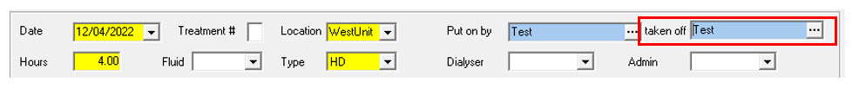
Figure 36 - EHR showing that a nurse has registered a patient as finishing dialysis
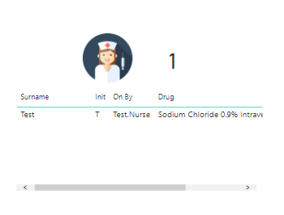
Figure 37 - Remaining outstanding medications move to "Outstanding Medications" section

Finally, figure 38 below shows the dashboard in full after the patient has completed treatment. Note that the medications due whilst on treatment (top section) have been removed, all medications given that required witnessing (middle section) have been addressed, and there was a single medication due that was not administered before the treatment ended, which appears in the bottom section.
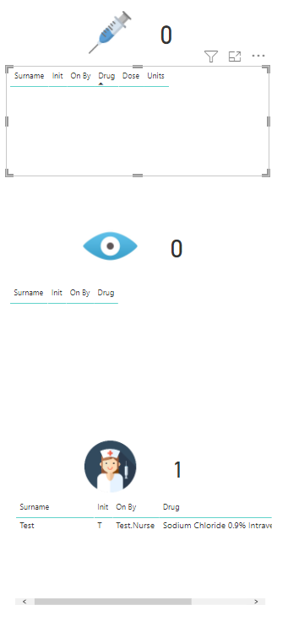
Figure 38 - Completed dashboard with remaining outstanding medication

Working Dashboard
The PowerBI development was well received. It was aesthetically pleasing and displayed all the required data in an easy-to-read manner. The nurses were happy with this model and stated they would be happy to use it in a real clinical treatment area when available, however improvements could be made to the functionality that would improve the user experience.
By using the free desktop version of PowerBI there were some limitations. Dashboards designed in this manner cannot be published without a PowerBI Workspace. This proved too costly to fall within the scope of this project
Additionally, without a PowerBI Workspace, it is not possible to configure refresh schedules for the dashboard itself. So, whilst Crystal Server allowed for automatic refresh of the data in the .XLSX files, nurses found they had to manually click a refresh button for those changes to be reflected in the PowerBI dashboard. Whilst not too taxing, automatic refresh would improve user experience and the reliability of the dashboard, as it would not rely on human intervention to remain up to date.
It was for this reason that the decision was made to develop a HTML, CSS, JavaScript, and PHP based web dashboard.

Web Based Dashboard Development
With the development of the PowerBI Dashboard, most of the hard work was complete. There was a means to target the medication and patient data for each section and the graphical layout had been well received. It was prudent to replicate this as best as possible in the web-based dashboard and so speed up development of the next iteration.
As stated above, a combination of Crystal Server automatic delivery and PowerBI dashboard development worked somewhat, but it lacked the finesse of automatically refreshing display that required little to no interaction. Additionally, with the number of components involved in getting the data out of the database and into the dashboard, there were too many points of failure. For example, the whole process could be interrupted but a failed schedule within Crystal Server itself. The connection to the database may be functioning, and the dashboard itself working well, but if the Crystal Server schedule fails to deliver the new files, then the dashboard data quickly becomes out of date. This misrepresentation of the current situation could be dangerous and result in the patient coming to harm.
I language-based dashboard using HTML and PHP can connect directly to a MySQL database when querying for data. This reduces the number of dependencies as well as improves security. The drawback is that developers need HTML design skills to build a customised dashboard from scratch.
Another advantage was scalability. With the MySQL queries designed to filter based on dialysis location, and the web dashboard based on .php files, it was simple to replicate across all Renal units.

Evaluation
Medication drug charts have been around in paper format for many years. Similarly, paper records of medications being given during dialysis treatment have also existed for a considerable time, but these mechanisms did not afford the opportunity to use the data easily, certainly not in real-time.
The introduction of an electronic method for prescribing medications and recording administrations opened meant data was useful within seconds of it being captured. As a result, SBU Renal took a step towards becoming data driven and not simply data rich.
Developing a digital dashboard on which to display that data offered great functionality and put the data at the fingertips of those who need it. Nurses could see accurate drug records of the patients at the time of treatment without walking to a filing cabinet to search for paper notes. Additionally, paper notes that would usually be collected and stored at the patient bedside while treatment was ongoing were no longer required. With this no longer necessary, the risk of damage to paper records was lower and space would be released on the patient table. Another vast improvement in nurse time management was the fact that less time would be spent locating doctors to rewrite damaged drug charts or correct illegible handwriting.
Spending more time with the patient bedside would allow nurses to deliver a higher quality of care, be that clinically or in the time spent comforting and conversing with those receiving treatment. All of which would improve the patient experience and reduce the cognitive load on the dialysis nurses. This cognitive release would provide senior sisters the time required to address the managerial tasks required of them under less pressure, contributing towards a more positive working environment and allowing them time to be more clinically active. It was suggested that, on average, a staff nurse spent around 1.5 hours per day looking for, reading through and arranging amendments to paper-based treatment and medication records. When considered against 6 nurses and then again across the 2 nursing shifts that tale place throughout the day, a time saving of around 18 man-hours per day is anticipated.
Most importantly of all, nurses had sufficient oversight of their patients’ requirements by simply glancing at the screen, with the ability to see that their patient was receiving treatment and what medications they were due to have administered. Additional functionality, where the medications marked as administered were removed made it simple for clinicians to know what to do next. Knowing that if a medication existed in the top section of the screen, it was outstanding and needed to be addressed. The result of this ability to see live medication regimes was that less administrations would be missed and the organisations commitments, mandated by the Andrews Report of 2014 were more likely to be met. In a test carried out over 4 hours, with 4 test patients, it was predicted that a digital medication dashboard would yield a 95% decrease in accidental missed medications in the West Renal Unit, with the remaining 5% allowing for system downtime and temporary reversion to paper-based records.
As well as the positive outcomes above, there are some negative effects of moving towards a digital system. Extra training time was required to show nurses how to access the medication dashboard. Peoples’ natural aversion to technology could become a significant boundary to success. This could be addressed with initial training during induction and become part of the employment process, but there is a substantial training effort needed during initial roll out. If not for the technical aspects, certainly to ensure nurses are interpreting the data correctly and acting appropriately based on what they are seeing. This can be addressed I real-time, with “dashboard champions”, those who are more comfortable being identified as super users, but this would need to be monitored closely.
It would also be prudent to create a monitoring system that checks how recent the data being displayed is. For example, the dashboard may be refreshed at regular intervals, but a technical error or bug in the database may mean the data being displayed is out of date. To this end, nurses should be advised that what they see on the dashboard should be considered a guide and is not a replacement for good nursing practice such as checking the patients live electronic record before administrating, or indeed not administering a medication.
Also considered where the pressures of technical support. The technical development team have limited resources and personnel, with other professional commitments. Any technical support arrangements would need to be discussed and agreed before the system is deployed into a live environment.
With such high pressures on the clinical teams, it seems sensible to utilise technology as much as possible to streamline clinical service delivery. The introduction of a digital dashboard would have several effects, both positive and negative on those reliant upon it.
Having live data at their fingertips, nurses could provide better care as well as feel less pressure themselves. Doctors time could also be released as less effort was needed to maintain paper-based patient records. Similarly, prescribing, and particularly ad-hoc prescription changes to dialysis medication regimes during treatment could be addressed by clinicians from anywhere. Nurses would no longer need to leave the unit to locate an appropriate doctor, for them to then make the changes or re-write an illegible drug chart.
The ability to see in real-time what their patients require could act as a trigger to administer medications that, when still using the paper-based equivalent system, could have been missed. This helps SBU fulfil its commitments borne out of the Andrews investigation and may prevent any legal fallout in future. Equally, it affords the nurses a better chance of fulfilling their commitments to their patients. They need to think less about what the paper record says, or where the record is and can focus more providing better quality treatment. Senior colleagues would have more time for non-clinical duties and so the quality of managerial work would be likely to increase.
Less pressure on the workforce and a more positive working environment may positively impact other elements too. A less stressful working day results in a less stressful home life and so it is entirely possible that a relatively simple dashboard that puts information at their fingertips, nurtures positive changes outside of “the office”.

Technical development of a clinical system is not without its challenges. The necessary design and technical development skills need to be learned and a robust testing schedule should be agreed. Furthermore, seldom does a digital or technical system work without flaw or failure and it is imperative to have appropriate technical support arrangements in place as well as a receptive team of clinical support staff to manage reversion to paper-based records should the need arise. Service level agreements and standard operating procedures should be drawn up that detail how the system works, what to do in a “break glass” situation and who to contact in the event of a system error or failure.

Conclusion
In conclusion, the positives of developing a digital medication dashboard far outweigh the negatives. With suitable resource allocation (time, funding etc.) and a stable clinical/technical personnel relationship, the introduction of digital clinical tools can positively influence clinical practice and help to drive clinical decision making.
The feedback received was constructive and mostly positive. With the major negatives being around learning a new technical system and understanding the particulars around ensure that when the patient starts treatment, they are marked as having done so correctly so that they appear on the dashboard. It was also noted that having the information so readily available to so many people, encouraged better data quality when prescribing drugs. During testing, prescribers were careful about how the notes they were making would be interpreted by those reading them later. This was counterintuitive in that one would expect greater care to be taken when recording on paper, given the likely hood that the record could become damaged or be illegible. In fact, it appeared that users where more careful about what was recorded when they knew it was easily accessible be all.
In terms of the technical aspects, the dashboard is heavily reliant on other systems that would not be readily available to an average Renal department. The use of Crystal Server was made possible because an established Crystal Server environment was already available within the SBU Renal service. Similarly, SBU Renal is unusual in that it has in-house technical development personnel, something that most clinical departments do not have. Given MySQL is unable to link directly with PowerBI, without the ability to develop the data outputs and schedule them using the Crystal suite, development of a PowerBI based medication dashboard would not be possible. Moreover, the development personnel had agreement to install software on SBU owned devices, providing opportunity to try multiple methods of delivering the data. Had this not been the case, extra dependencies on the SBU IT department would have existed and may have negatively impacted the ability to develop the system.
Both the positive and negative points detailed above should be considered as they would have a significant impact on requirements, development time, capabilities and of course, the success of a digital medication dashboard.

7.1 Future Developments and Recommendations
When contemplating the future of a the PowerBI digital medication dashboard, a number of recommendations can be drawn.
Firstly, the ability to develop a PowerBI based dashboard, particularly using Crystal Server, is heavily reliant on expensive systems already being established. Crystal Server has an annual revenue tail and serves other purposes than to deliver data for the dashboard. These include delivering files for the EPMA business continuity solution and a reporting suite for clinical data extraction. It was necessary to consider the burden that regular medication data extractions would put on this existing system and ensure that it was not adversely affected.
To combat this, a web-based version using HTML, PHP and MySQL could be developed. This would provide several other benefits such as automatic page refresh using JavaScript and Active Directory authentication. This would also be beneficial when upscaling to other renal units across Wales. Once the initial HTML file had been designed, simply copying it, and modifying the WHERE clause of the MySQL statement to filter for a different unit is all that is required to create a new dashboard, for a new unit.
However, before these recommendations could be considered, a longer and more rigorous testing schedule should be designed that considers the impact of multiple inbound connections and MySQL statements on the integrity of the electronic patient record. As well as this, time and resources taken to design, develop and test this new system need to be measured. A web hosting server would be required, and this would involve agreements with the organisational IT department, as well as incur a financial cost.

Reflection
My time spent developing a clinical dashboard for my university project has been challenging. In the many years taken to plan and develop both the project itself and the digital dashboard, I have had to overcome a number of personal difficulties.
The work was undertaken entirely during my own time. Although the degree was arranged as part of a professional/academic agreement between Swansea Bay University Health Board and University of Wales Trinity Saint David, managerial commitment was not forthcoming, and I was not released from my day job to attend lectures. With a young family to care for and professional commitments that took me away from home for extended periods of time, this has been by far the biggest threat to my seeing the project through to completion.
Additionally, mid-way through degree studies and project planning, the world experienced a global pandemic that change the way we live our lives. As a healthcare employee this put immense professional pressure on me as well as my family and home life. I often spent long days supporting clinicians on the front line with technical support, data extractions and other system developments to aid in the pandemic response, which had a negative impact degree study, dashboard development and personal relationships.
More positively, the degree, and particularly this project has provided me an opportunity to develop skills I would otherwise not have considered. This has broadened my employability and more importantly, given the chance to engage deeper with clinical colleagues, putting me often at the patient’s bedside when treatment is being delivered and highlighting the importance my role in maintaining the National Health Service, as well as the significant impact that digital systems can have and how reliant the world has become on digital technology.
On reflection, it has been a challenging but rewarding experience and I look forward to applying the skills I have learned to my daily life. It is very clear that there is significant need for a medication dashboard within the Renal unit at SBU and beyond, and I am keen to further develop it and deploy it into the live clinical environment, with support from my clinical colleagues.

References
[1] D. Zakim et al., “Computerized history-taking improves data quality for clinical decision-making—Comparison of EHR and computer-acquired history data in patients with chest pain,” PLoS ONE, vol. 16, no. 9 September. 2021, doi: 10.1371/journal.pone.0257677.
[2] P. Alberti, “Community Health Needs Assessments: Filling Data Gaps for Population Health Research and Management,” eGEMs (Generating Evidence & Methods to improve patient outcomes), vol. 2, no. 4. p. 5, 2014, doi: 10.13063/2327-9214.1174.
[3] N. I. Bakti, M. Williamson, R. Sehjal, and M. Thilagarajah, “The use of microsoft excel as an electronic database for handover and coordination of patients with trauma in a district general hospital,” BMJ Innov., vol. 3, no. 3, pp. 130–136, 2017, doi: 10.1136/bmjinnov-2016-000182.
[4] “GP Access to WCP - Digital Health and Care Wales.” https://dhcw.nhs.wales/coronavirus/digital-support-updates-for-healthcare-professionals/primary-care/gp-access-to-wcp/ (accessed Nov. 04, 2021).
[5] M. W. James Burton, David Goldsmith, Nicki Ruddock, Rukshana Shroff, “Commentary on the KDIGO Guideline on the Diagnosis, Evaluation, Prevention and Treatment of CKD-MBD,” p. 8, 2018.
[6] UK Renal Registry, “UK Renal Registry 23rd Annual Report,” p. 7, Accessed: Nov. 25, 2021. [Online]. Available: www.renalreg.org.
[7] R. T. Sutton, D. Pincock, D. C. Baumgart, D. C. Sadowski, R. N. Fedorak, and K. I. Kroeker, “An overview of clinical decision support systems: benefits, risks, and strategies for success,” npj Digit. Med. 2020 31, vol. 3, no. 1, pp. 1–10, Feb. 2020, doi: 10.1038/s41746-020-0221-y.
[8] G. Laurent, M. D. Moussa, C. Cirenei, B. Tavernier, R. Marcilly, and A. Lamer, “Development, implementation and preliminary evaluation of clinical dashboards in a department of anesthesia,” J. Clin. Monit. Comput., vol. 35, no. 3, pp. 617–626, 2021, doi: 10.1007/s10877-020-00522-x.
[9] Fresenius Medical Care, “Nephrological Cockpit — Dialysis Continuous Quality Improvement - Fresenius Medical Care.” https://www.freseniusmedicalcare.com/en/healthcare-professionals/renal-it/nephrologic-cockpit/ (accessed Nov. 25, 2021).
[10] A. Janssen et al., “Developing an Intranet-Based Lymphedema Dashboard for Breast Cancer Multidisciplinary Teams: Design Research Study,” J. Med. Internet Res., vol. 22, no. 4, Apr. 2020, doi: 10.2196/13188.
[11] M. David, “How to Design a Dashboard,” 2019.
[12] “Metric Definition & Meaning | Dictionary.com.” https://www.dictionary.com/browse/metric (accessed Jan. 27, 2022).
[13] “What Is Data Visualization? Definition & Examples | Tableau.” https://www.tableau.com/learn/articles/data-visualization (accessed Jan. 27, 2022).
[14] S. E. Palmer and K. B. Schloss, “An ecological valence theory of human color preference,” Proc. Natl. Acad. Sci. U. S. A., vol. 107, no. 19, pp. 8877–8882, 2010, doi: 10.1073/pnas.0906172107.
[15] N. Humphrey, “The Colour Currency of Nature,” Colour Archit. Today, no. April, pp. 9–12, 2019, doi: 10.4324/9781315881379-3.
[16] “Visual Best Practices - Tableau.” https://help.tableau.com/current/blueprint/en-us/bp_visual_best_practices.htm (accessed Jan. 29, 2022).
[17] F. M. Examples, “How to Design Best-in-Class Dashboards :” pp. 5–17, [Online]. Available: https://www.qlik.com/us/-/media/files/resource-library/global-us/register/ebooks/eb-how-to-design-best-in-class-dashboards-en.pdf.
[18] Daniel Kahneman, Thinking, Fast and Slow, 1st ed. Penguin, 2012.
[19] D. N. and J. Nielsen, “The Definition of User Experience (UX).” https://www.nngroup.com/articles/definition-user-experience/ (accessed Feb. 15, 2022).
[20] M. Rae, “What Makes a Good User Experience? | Adobe XD Ideas,” 2020. https://xd.adobe.com/ideas/principles/web-design/what-makes-good-ux/ (accessed Feb. 15, 2022).
[21] Christopher Murphy, “The Evolution Of User Experience Design | Adobe XD Ideas,” 2019. https://xd.adobe.com/ideas/guides/evolution-user-experience-design-intro/ (accessed Feb. 15, 2022).
[22] “Usability 101: Introduction to Usability.” https://www.nngroup.com/articles/usability-101-introduction-to-usability/ (accessed Apr. 01, 2021).
[23] J. J. Gibson, The Senses Considered as Perceptual Systems·. GEORGE ALLEN & UNWIN LTD.
[24] “Affordance | Definition of Affordance by Merriam-Webster.” https://www.merriam-webster.com/dictionary/affordance (accessed Mar. 29, 2021).
[25] D. A. Norman, “Affordances and Design View project.” Accessed: Apr. 01, 2021. [Online]. Available: https://www.researchgate.net/publication/265618710.
[26] S. R. Haley, “GradeCraft Student Dashboard Usability Test.” https://www.stephanierhaley.com/gradecraft-student-dashboard-usability-test (accessed Feb. 15, 2022).
[27] A. Manuscript, “Information overload and missed test results in EHR-based settings,” Changes, vol. 29, no. 8, pp. 997–1003, 2012, doi: 10.1001/2013.jamainternmed.61.Information.
[28] V. Zaydfudim et al., “Implementation of a real-time compliance dashboard to help reduce SICU ventilator-associated pneumonia with the ventilator bundle,” Arch. Surg., vol. 144, no. 7, pp. 656–661, 2009, doi: 10.1001/archsurg.2009.117.

Appendices

Appendix 1 – Meeting notes to discuss initial development of dialysis dashboard

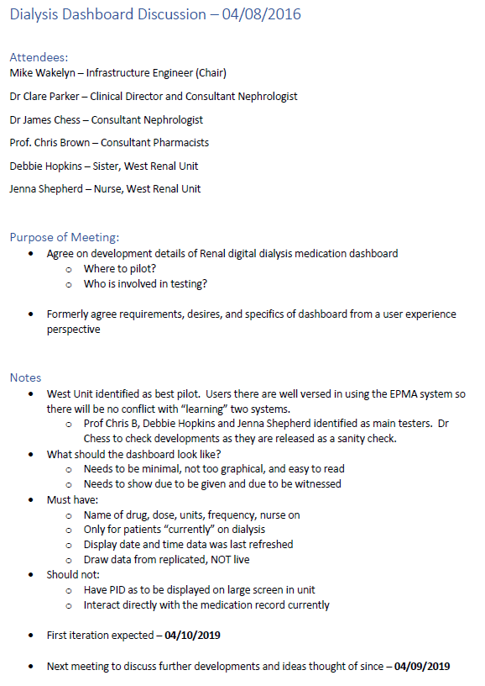

Appendix 2 – Wireframe diagram for first dashboard iteration



