
LCBB 6000 – Dissertation Thesis

Strategies for the Marketing of Personal Care Products in Romania
Views, outlooks, and actions of Romanians about the quality of personal care items available in Romania

Student name: Vali-Daniela Pantazi
Student number: 2212835

Project Supervisor: Alastair Moyes

Acknowledgements

I want to extend my gratitude to the Module Leader Liyanage Rodrigo and Supervisor Alastair Moyes for their dedicated support and guidance throughout my studies.

I also want to thank the University of Wales Trinity Saint David for providing me with the opportunity to pursue the degree I have always wanted and to complete this research.

Finally, I want to thank my family for their unwavering support throughout my academic journey.

Table of Contents

Introduction 5
Chapter 1 - Research Problem 6
1.1. Theoretical Aspects Regarding Marketing Strategies in Trade 6
1.2. Trade marketing strategies 7
1.3. 4P’s Analysis of the Romanian cosmetic market (Based on Kotler’s marketing principles) 9
1.4. Strategic Marketing Behaviour - The Influence and Content of Fashion and Beauty Blogs on Product Sales 9
1.5 The Romanian Cosmetic Market Through the PESO Model 11
Chapter 2 – Literature Review 12
2.1. Examination of Romania's Personal Care Products Market 12
2.2. Presentation of studies conducted on the national market. 13
Chapter 3 - Research Methodology 14
3.1. The objectives of the research 14
3.2. Research methodology. 14
3.2.1 Research approach applied in this study. 14
3.2.2 The studied population 14
1. Sample 15
2. Sampling method 15
3. Data Collection Instruments 15
4. Data collection method 15
5. The constraints of the research 15
Chapter 4- Data analysis and interpretation 16
4.1. Objective I 16
4.2. Objective II - Determine respondents' preferences for BIO versus non-BIO personal care products based on gender. 16
4.3. Objective III - Identifying consumer preferences for various brands of personal care products. 17
4.4. Objective IV - Assessing respondents' satisfaction with personal care products. 18
4.5. Objective V - Determining respondents' attitudes regarding the price of personal care products. 19
4.6. Conclusions 20
Chapter 5 - Conclusions and recommendations 21
5.1. Conclusions 21
5.2 Recommendations 22
References 23
Appendices 26
Appendix 1- PESTLE Analysis 26
Appendix 2 – SWOT Analysis 28

Introduction

This research aims to analyse the marketing strategies for personal care products in Romania and assess consumer perceptions of product quality. The goal is to create effective marketing strategies that meet consumer expectations and preferences.
In the contemporary business landscape, it is imperative for firms aspiring to achieve operational success and capitalize on the advantages of effectively executed marketing strategies to prioritize the quality and relevance of their products. This necessity is exacerbated by the prevailing conditions of heightened competition across various sectors. Companies that fail to deliver high-quality goods will inevitably face decline. However, it is crucial to recognize that firms must also address additional challenges beyond merely providing timely, high-quality products (Catana, 2021).
The methodologies employed for product promotion and their effective execution play a vital role in today’s market dynamics. Marketing encompasses a range of strategies designed to foster more productive communication among all stakeholders in the sales process, spanning from producers of goods or services to consumers. It facilitates the optimal utilization of existing products while offering firms the opportunity to present their offerings in a manner that resonates with customers. Additionally, marketing strategies contribute to enhanced sales performance by optimizing and maximizing the efficiency of the supply chain (Trivedi, 2018).
From a marketing perspective, specialized strategies are delineated for suppliers alongside specific consumer-oriented approaches, reflecting the unique consumption patterns and behaviours of suppliers concerning procurement and usage.
The work is organized into five major chapters, progressing from a general overview to more specific details pertinent to the study.
Chapter 1 introduces the main research problem and lays the theoretical groundwork for the study. It starts with an overview of trade marketing strategies, then provides a detailed discussion on trade marketing approaches. The chapter also includes a 4P’s analysis (product, price, place, promotion) of the Romanian cosmetic market, following Kotler’s principles. Furthermore, it explores the strategic significance of marketing behaviour and how beauty and fashion blogs influence product sales.
Chapter 2 examines existing studies and academic views concerning Romania's personal care products market. It assesses prior research on the national market, highlighting key findings, emerging trends, and gaps that this study aims to fill.
Chapter 3 outlines the goals, approach, and methodology of the research. It specifies the target population, details the sampling methods, and describes the data collection tools and procedures. Additionally, it addresses the constraints and limitations encountered during the study.
Chapter 4 examines the collected data to meet the research goals. It investigates respondents’ preferences for BIO versus non-BIO products, brand loyalty, satisfaction levels, and perceptions of pricing. The results are analysed to offer valuable insights into consumer behaviour and market trends.
The final chapter, although more succinct, presents the conclusions and recommendations drawn from the preceding analyses. This section aims to provide a foundational basis for future research endeavours that will investigate consumer attitudes, reactions, and emotional responses regarding the beauty industry.

Chapter 1 - Research Problem

1.1. Theoretical Aspects Regarding Marketing Strategies in Trade
For a firm to thrive and benefit from effective marketing, it must prioritize the quality and relevance of its products in today's highly competitive landscape. Companies that fail to deliver high-quality goods are likely to fail; however, a business must address other issues in addition to timely delivery of quality products (Catana, 2021).
Due to a growing public awareness of the importance of the strategies and tools utilized by companies, e-commerce marketing has become increasingly significant for businesses of all sizes (Cronin-Gilmore, 2021). Effective product promotion methods and their implementation are also crucial in today's market, making it essential for marketing to oversee this aspect of the business. Modern marketing comprises strategies designed to enhance communication among all parties in the sales process, from product producers to consumers. Marketing leverages current products and provides an opportunity to present the company's offerings in a manner that resonates with customers. Additionally, strategic marketing can drive sales growth by optimizing and enhancing the supply chain (Trivedi, 2018).
From a marketing perspective, there are tailored strategies for suppliers and specific consumer-oriented strategies that reflect the unique market behaviours regarding purchasing and consumption. The functions of commerce, which further elucidate its purpose, are:
- To prepare products for sale to end users, the purchasing and transfer function is tasked with procuring products from suppliers and subsequently transferring them to designated warehouses.
- The necessity of storing goods arises from the continuous demand to fulfil consumer consumption needs.
- Preparing goods for sale is accomplished by segmenting the vast array of products from manufacturers, categorizing them into lots, and creating a commercial assortment.
- The product transfer function encompasses the sales process, essential for effectively transferring ownership of goods from the producer to the consumer. This occurs through a series of activities conducted in the intermediary space between production and consumption locales.
- The establishment of an optimal environment for the execution of sale-purchase transactions necessitates a robust technical-material foundation and appropriately trained personnel, thereby allowing consumers to select and acquire items that fulfil their specific requirements (Al-Surmi et al., 2020).
In strategic planning, there appears to be a reversal in the conventional cycle of processes. Initially, enterprises develop the strategic components of marketing—namely segmentation, targeting, positioning, and the marketing mix. Subsequently, they address aspects related to storage and acquisition, which seem to be contingent upon the marketing strategies designed earlier. Consequently, marketing strategies assume a critical role in the strategic planning process, thereby elevating them to the status of general (higher order) strategies. In contrast, strategies focused on storage and supply are perceived as derivative (lower order) strategies (Ashok et al., 2004).

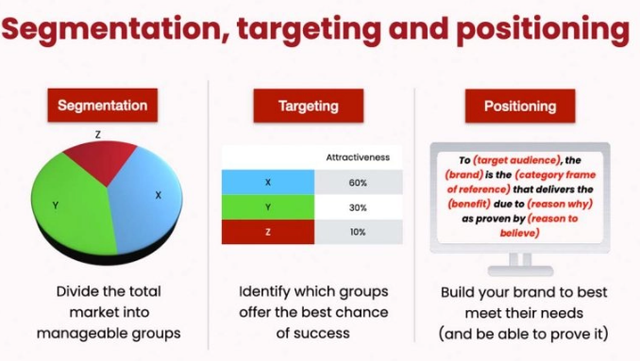
Fig 1. Marketing strategies. Source: self-mode
From a marketing perspective, the interconnections among the components of the business cycle—namely supply, storage, and sales—underscore the necessity of implementing an effective strategy. This emphasizes the importance of the supply-distribution chain as a critical concept. The precise relations between sourcing, warehousing, and sales have significant implications for the strategic elements of these operations, particularly regarding marketing strategies aligned with sourcing and sales (Doyle, 2009).

1.2. Trade marketing strategies
The aim of a company’s marketing strategies is to effectively enhance the organization’s overarching marketing approach. Primarily, these strategies drive the achievement of optimal economic outcomes, such as boosting sales and increasing profitability. The strategies should focus on the judicious use of the domestic budget, maximizing the effective use of available resources to meet set objectives (Diyamova et al., 2019).
Companies' marketing strategies can focus on several different functional areas:
- Interaction strategies engage all representatives of the commodity chain, primarily aimed at establishing and ensuring the smooth functioning of every link in the distribution chain, from producer to final consumer.
- In developing various promotional initiatives such as lotteries, auctions, and discount systems, establishing cooperative strategies between customers and target audiences is imperative within the marketing domain.
- Marketing strategies fundamentally rely on formulating recommendations for the effective presentation of products throughout each stage of their implementation. The importance of these strategies lies in their capacity to articulate the distinct advantages of utilizing specific products or services while also considering their unique characteristics (Mohr et al., 2018).
These strategies help select the right product location at sale points and set minimum inventory levels. Marketing strategies are effective only when all components increase sales and profits (Kumar et al.,2025). They can address various issues through implementation.
- Establishing the main, primary, and supporting elements of goods and services.
- Arranging and determining the assortment of products that need to be available at each sales location, identifying the specific position of each product within the distribution channel (product category, placement area, additional sales venues).
- Setting the minimum stock level needed for each item (Morgan et al., 2019).
Creating a marketing strategy involves the following steps:
- Market research and analysis of its current state.
- Competitor analysis and self-evaluation of the company.
- Setting objectives for the marketing strategy.
- Investigating consumer interests.
- Market positioning and growth.
- Economic analysis strategy (Diyanova, 2019).
Marketing strategies encompass a wide range of approaches, with new tools continuously emerging. This is largely driven by the ever-evolving demands of customers within the market.
The most common marketing strategies include:
- Motivating sales representatives is essential because manufacturers usually lack direct contact with customers, relying on intermediaries. Incentives like bonuses, gifts, and rewards motivate salespeople to meet sales goals, increase sales, and launch new products. This includes organizing exhibitions and presentations (Loring, 2021)..
- Organizing training for employees is essential. Training employees, sellers, and participants in marketing boosts sales and brand loyalty (Dabholkar et al., 2008)..
- Understanding the motivations of end customers is essential. A diverse range of tools and strategies can be employed to foster this motivational approach, including rewards, gifts with purchase, prize draws, additional coupons, and more (Zichermann et al., 2010).
- An effective advertising campaign uses all available methods—print, radio, billboards, internet—in high-traffic areas like malls, entertainment centres, supermarkets, and airports to maximize reach at minimal cost, growing the customer base (Mukonza et al., 2020).
- Innovative approaches to trade development.
Current economic processes heighten competition, turning it into a fight for market share. To stay competitive, companies must optimize tech processes. Tax data helps marketers personalize messages, analyse, and develop products based on aggregated insights. A key trend in marketing is automating customer communication, like email marketing (Ferrell et al., 2021).
Each company independently chooses marketing tools based on its unique traits, informed by micro and macro analysis. The decision depends on circumstances and opportunities, focusing on strategies and tools that achieve desired results cost-effectively (Baker, 2017).

1.3. 4P’s Analysis of the Romanian cosmetic market (Based on Kotler’s marketing principles)

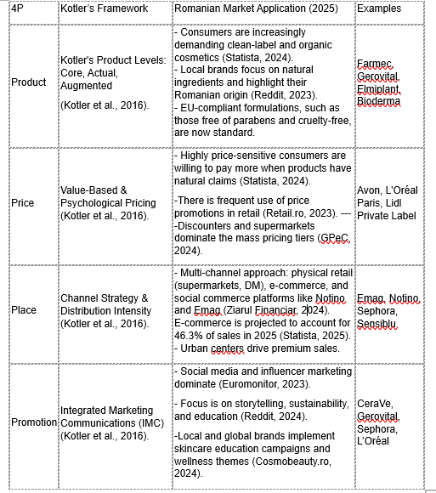
Source: Self-mode

1.4. Strategic Marketing Behaviour - The Influence and Content of Fashion and Beauty Blogs on Product Sales
Authors utilize blogs to share their writings or topics that interest them, hoping to attract readers. Additionally, blogs serve as a social mirror reflecting phenomena in fashion and beauty, as anyone can share their opinions on beauty product reviews (Arminda et al, 2017).
The fashion and beauty industries benefit from blogging, which offers diverse topics and engages audiences with innovative content. Bloggers provide an alternative to traditional media by sharing styles, products, insights, and brand stories through their platforms. These blogs, seen as "street fashion," influence public opinion through engagement, idea exchange, and consumer inquiries (Marwick, 2016).
A significant proportion of bloggers actively participate in the consumption of cosmetic products while diligently tracking market trends. By engaging in the “global flow of consumption"—a phenomenon characterized by the purchase of cosmetics, the composition of blogs, and the dissemination of images that promote fashion as a conceptual framework—it can be posited that bloggers occupy dual roles as both content consumers and content creators (Sedeke, 2012).
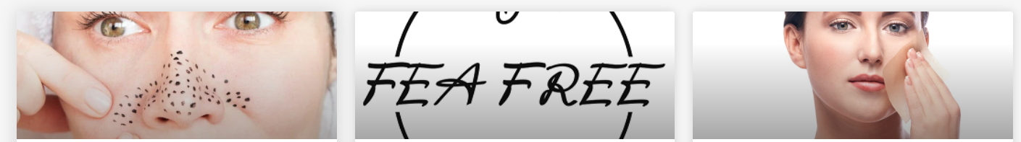
Fig. 2 Example of Romanian skin care blog (Source: Damas.ro).
The website is a credible source on fashion and beauty trends, showing women's growing reliance on blogs for inspiration. The next marketing step is selecting an appropriate influencer after defining a target demographic for a campaign. This choice is crucial for campaign success, as neglecting it can lead to poor financial returns from online campaigns (Ge, 2024).
The process of selecting an influencer can be informed by overarching themes that encourage individuals to partake in discourse that may not hold personal relevance. Additionally, it is essential for the organization to designate an individual who has a substantive affinity for the subject matter, demonstrates a comprehensive understanding of the topic, and functions within a framework that aligns with their platform (Hudson et al., 2015).
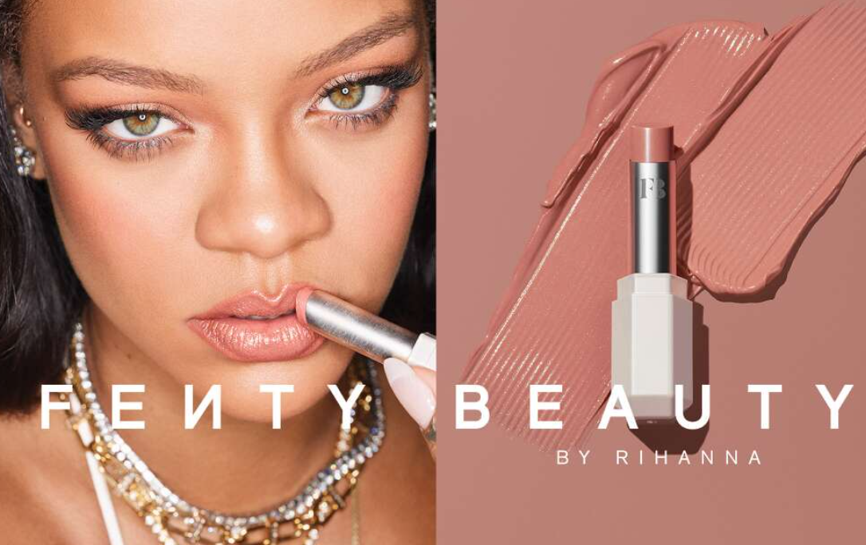
Fig. 3 Rihanna promotes her makeup brand. (Source: Fenty Beauty)

This marketing approach emphasizes influencing consumers and understanding the factors that shape their decision-making, rather than prioritizing a large online following. Consequently, factors such as customer testimonials and the perceived value and benefits of a product play a vital role in shaping purchase intentions (Abubakar et al., 2016).
Businesses and bloggers increasingly collaborate, as companies see this as an effective and lucrative advertising method benefiting both. Beauty industry firms use strategies like paid posts, affiliate programs with influencers, branded ads, product gifting, and event invitations (Halvorsen, 2013).

Fig. 4 Street advertising for the MAC brand, made with the help of influencers.
(Source: Icondvertising.ro)

Consumers frequently engage with peer reviews to acquire comprehensive insights regarding products of interest. Such reviews are generally rich in content and consist of two interrelated types of information: brand-provided product details and consumer-generated evaluations. Ultimately, these reviews furnish valuable guidance for potential purchasers, often motivating them to emulate the aesthetic choices presented by influencers (Hudson, 2015).

1.5 The Romanian Cosmetic Market Through the PESO Model
The Romanian cosmetic market has experienced significant growth recently, driven by increasing consumer interest in premium, biodegradable, and organic products, as well as the expanding influence of digital marketing and social media. The PESO model, which combines Paid, Earned, Shared, and Owned media, offers a helpful framework for understanding how cosmetic brands in Romania design their marketing strategies to enhance visibility, trust, and customer engagement (Verhoef et al, 2015).
Paid media is central to the campaigns of both international and local brands in Romania. Companies like L’Oréal, Farmec, and Yves Rocher invest heavily in digital advertising through channels such as Facebook Ads, Google Display Networks, and influencer partnerships. For instance, Farmec’s 2023 campaign incorporated Romanian beauty influencers on Instagram, using sponsored tutorials and targeted ads to reach young, tech-savvy audiences (Popa et al., 2022). These activities boost brand awareness and support the broader omnichannel strategies that aim to integrate online and offline touchpoints smoothly.
Earned media enhances brand credibility through organic exposure sourced from online reviews, user testimonials, and mentions in lifestyle magazines and blogs. Gerovital, for instance, benefits from positive coverage in Elle Romania and beauty-focused YouTube reviews, which enhance the brand’s reputation for quality and reliability (Dumitrescu et al., 2020). Such authentic endorsements are increasingly valued as consumers rely more on peer opinions and trusted content creators when making purchasing decisions.
Shared media is also vital, as social platforms encourage user participation and content sharing. Brands like Avon Romania leverage TikTok and Instagram challenges to generate user-created content, turning consumers into active storytellers. Hashtag campaigns, giveaways, and interactive content enhance engagement and foster a sense of community around the brand (Nistorescu et al., 2019). This strategy aligns with the omnichannel marketing principles described by Verhoef et al. (2015), emphasizing the importance of integrating social and digital channels to create cohesive consumer experiences.
Owned media rounds out the PESO model, providing platforms like websites, online stores, blogs, and newsletters that brands control. Romanian brands such as Farmec and Gerovital keep active online blogs with skincare advice, while their official websites offer exclusive deals and loyalty programs. Combining these owned platforms with social and paid efforts allows brands to create a comprehensive marketing ecosystem that strengthens their value propositions and nurtures customer loyalty (Dumitrescu et al., 2020).
Overall, the Romanian cosmetic market effectively uses the PESO model to compete successfully. Paid advertising boosts visibility, earned media builds trust, shared content increases engagement, and owned platforms promote customer retention. These strategies exemplify the shift from traditional multichannel retail to omnichannel marketing, where the seamless integration of digital and physical channels is key to delivering tailored and smooth consumer experiences (Verhoef et al., 2015).

Chapter 2 – Literature Review

2.1. Examination of Romania's Personal Care Products Market
The cosmetics and personal care industry exerts a substantial influence on both national and regional economies within the European Union, yielding significant economic and social benefits. This sector generates considerable economic activity through the procurement of products and services, thereby supporting ancillary sectors within Romania. Beyond the economic implications, cosmetics have profoundly enhanced the quality of life for individuals in various respects. The financial contribution of the cosmetics sector in Romania can be categorized into three primary dimensions based on the sector's economic impact (Turcu et al., 2023).
- Direct impact refers to the economic value generated by the manufacturing of cosmetic products.
- Indirect impact arises from the purchases of services and goods by various companies directly involved in cosmetic production. This impact accumulates both within and beyond the supply chain.
- Induced impact is the extra economic contribution resulting from increased spending by the workforce employed, both directly and indirectly, by the cosmetics industry. Known for its dynamic and expanding nature, the cosmetics sector is propelled by science, innovation, and creativity, making substantial investments in research and development at both global and national levels (Chen et al., 2020).

In Romania, most cosmetics companies are owned by the 10 largest cosmetics firms in the world, which are:
- Maybelline, Garnier, and Giorgio Armani, owned by L'Oréal.
- Dove and Vaseline, owned by Unilever.
- Gillette and Head & Shoulders, owned by Procter and Gamble (Roşca, 2024).
In theory, the 19.29 million Romanian consumers who utilize cosmetics or personal care products contribute to a lifestyle that is healthy, well-groomed, and positive, which in turn boosts their self-esteem in daily life. On average, these consumers spend approximately 400 lei each year on care items. However, spending declines with age; women aged 40-60 and over 60 invest nearly three times less in facial care products compared to those aged 19-24 (Profit.ro, 2019).
A study indicated that 75% of urban Romanians consider the application of sunscreen to be an essential practice for skin protection, in contrast to only 32% of Romanians residing in rural areas who share this belief. Additionally, research conducted in 2018, which examined the relationship between self-confidence and its progression, revealed that individuals aged 14 to 21 allocate significantly greater resources towards their personal appearance. Notably, 85% of the youth demographic reported feeling "safer" after utilizing grooming products (Messner, 2004).
Over the past two decades, the beauty market has exhibited a compound annual growth rate of approximately 4.5%, with annual growth rates fluctuating between 3% and 5.5%. This cosmetics sector has demonstrated a significant capacity for stable and continuous growth, coupled with resilience against difficult economic conditions (Abrudan et al., 2019). Beauty products can be categorized into two primary segments: premium and mass products, which are differentiated by their pricing strategies and distribution channels. An analysis of the Romanian market shows that the mass segment made up 72% of total sales in 2010, with the premium segment comprising the other 28%. Throughout the first decade of the 21st century, sales of cosmetic products grew consistently, achieving 4.5% in the first half and 4.4% in the second half (Turcu et al., 2023).
The makeup and cosmetics industry experienced significant impacts due to the 2009 recession; however, a recovery was noted in 2010 as the national economy began to improve. This economic downturn catalysed a transformation in consumer behaviour, leading to an increased awareness of premium products. Consequently, many luxury brands reported substantial profits, particularly within the domestic beauty market. The cosmetics industry is characterized by its continuous evolution in response to shifting consumer demands. Recent trends emphasize efficiency and the utilization of long-lasting makeup products (Abrudan et al., 2019).

2.2. Presentation of studies conducted on the national market.
A study conducted by StartUp Cafe in collaboration with Transilvania Bank and the online news platform HotNews.ro has provided insights into the current status of the beauty and cosmetics product market at the national level, as well as consumer interaction with these products. According to a survey administered among salon proprietors via a Romanian online booking platform for beauty salons, it was identified that over 80% of beauty salons and certified stylists anticipate an increase in revenues during the first quarter of 2022, despite the ongoing COVID-19 pandemic, as per the data relevant to the year 2022 (Hotnews, 2022).
Thus, over 40% of beauty entrepreneurs anticipate a revenue increase of 10-20% in the first quarter of 2022 compared to the same period in 2021. Furthermore, 23.3% of salon owners foresee growth between 20-50%, while 16.3% are even more optimistic, expecting at least a 50% rise. Only 14% predict no change in revenue for 2022, and 3.5% expect a decline. More than half of beauty services and hair salons (61.6%) reported a revenue boost in 2021 compared to 2020, whereas 12.8% experienced stable business, and 26.6% reported revenue drops (Moneybuzz.ro, 2022).
In 2020, during the pandemic's onset, the local beauty industry faced imminent collapse, with black labour competition reaching a critical level. A recovery for this sector, employing over 37,000 specialists (PFAs and SRLs), began in 2021 when private events like weddings, baptisms, and other celebrations were permitted. The shift toward digitization helped mitigate the pandemic's adverse impacts on the beauty industry, while consolidating salons into a dedicated platform enhanced service quality (Paduraru et al., 2021). This platform also allowed users to explore a diverse array of services, compare qualifications, and select the best options available,” stated Andrei Ursachi, CEO and co-founder of Stailer.
Nearly 47.7% of salons and stylists report that beauty service prices rose by 10 to 20% during the pandemic. In contrast, only 5.8% raised prices by 20 to 50%, while a mere 3.5% lowered their rates, and 41.9% maintained their original prices (Startupcafe.ro, 2022).
The primary concern for beauty salons is the instability caused by the Omicron variant of Covid-19, affecting 37.2% of respondents. This is followed by worries about rising operational costs, which challenge 26.7%, and a decline in customer disposable income, impacting 24.4%. Additionally, 11.6% of respondents are concerned about labour shortages and the lack of specialists (Năstase, 2022).
The research involved a representative group of 86 participants from medium and large beauty salons across Romania. Stailer, an online booking platform for beauty salons, is currently amid the digital transformation of the beauty industry. Launched a year ago, the platform now features 1,040 salons spread over 40 cities (Businessmagazin.ro).

Chapter 3 - Research Methodology

3.1. The objectives of the research
The principal objectives of this research are to:
⮚ Investigate the demographics of individuals who regularly utilize personal care products.
⮚ Analyse the preferences of respondents concerning BIO versus non-BIO personal care products, with a distinction made by gender. Additionally, evaluate consumer brand preferences within the realm of personal care products.
⮚ Assess the level of satisfaction reported by respondents in relation to the effectiveness of personal care products. Further, examine respondents’ attitudes toward the pricing of these products. Lastly, gauge the interest demonstrated by respondents regarding their frequency of engagement with the labelling of personal care products.

3.2. Research methodology.
The subsequent sections will delineate the research methodology, the population under study, the selected sample, the sampling technique employed, data collection instruments utilized, the data collection procedures, and the constraints of the research.

3.2.1 Research approach applied in this study.
The selected research methodology is a survey-based inquiry explicitly designed to elucidate the opinions, attitudes, and behaviours of the Romanian population concerning the quality of personal care products available in the Romanian market. This research incorporates a questionnaire comprising of 11 questions, which include both closed-ended and open-ended items, aimed at delineating essential characteristics of the subjects necessary for the accurate interpretation of statistical data. The question scales employed in this study consist of nominal scales, numerical scales, and interval scales, facilitating a comprehensive analysis of the data collected.

3.2.2 The studied population
The studied population encompasses all individuals in Romania who utilize personal care products, including a variety of categories such as skincare products. Additionally, the research aims to include individuals who do not currently engage with any personal care products, with the objective of determining which quality alterations in these products may incentivize their potential purchase. Notably, the demographic factors of age, gender, education, occupation, background, or income will not be taken into account in this investigation.

Sample

Gendre | Female |  |  | Male |  | Rather not say
Gendre | 40 |  |  | 26 |  | 5
Educational  level | Middle school |  | High school | College | Under-graduate | Post-graduate
Educational  level | 22 |  | 18 | 12 | 10 | 4
Occupation | Student | Employed |  | Unemployed | Looking for job | Retired | Self employed | Other
Occupation | 7 | 33 |  | 15 | 11 | 2 | 0 | 3
Source: Self-mode

Sampling method
The sampling method employed in this study is non-random, also referred to as reasoning-based sampling. This selection process exhibits an arbitrary and subjective character, predominantly relying on the personal judgment of the researcher. Non-random sampling encompasses various methodologies; among these, conventional (random) sampling techniques were utilized.

Data Collection Instruments

The primary instrument for data collection is a structured questionnaire, comprising of 11 questions categorized into two sections. The initial questions are designed to be straightforward to engage respondents effectively. As the questionnaire progresses towards its midpoint, more complex questions and the conclusion of the questionnaire are included, along with demographic questions. These questions maintain a confidential nature and are intended solely for statistical analysis of the data.
Questionnaire link: https://www.survio.com/survey/d/L8M3J7G2H9I2J6C0X and QR code:

Data collection method
Data collection was conducted online by sharing a link to the questionnaire with friends, colleagues, and acquaintances. They were asked to further distribute it through their social networks or contacts.

5. The constraints of the research
A total of 71 respondents participated in this questionnaire. It is recommended to have a larger sample size, ideally exceeding 100 respondents, to capture a broader range of opinions, thereby enhancing the clarity of the data. Consequently, future efforts will focus on collecting additional responses through the distribution of this questionnaire across various social media platforms and to groups specializing in the personal care products market. The sampling method employed in this research is non-random, which limits the ability to generalize the findings to the wider population being studied (Shamsudin et al., 2024). The results obtained from this research apply solely to the individuals within the sample. Moreover, a noted limitation of the research is attributed to the sample size itself. Nonetheless, the sample used in this marketing research is deemed valid, as all 71 respondents are categorized within the age ranges specified in the questionnaire.

Chapter 4- Data analysis and interpretation

  - Objective I - Identify individuals who often use personal care products.
This initial objective was addressed with question 2: "Do you often use personal care products?" This preliminary question was placed at the beginning of the survey to identify how many people regularly use personal care products, regardless of the particular type. Of the 71 respondents, 85.8% said they frequently use personal care products, amounting to 53 individuals. In contrast, 18 respondents reported that they do not often use personal care products.
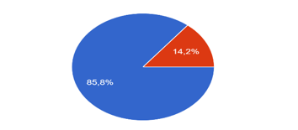
Fig 4.1 Frequency of use of personal care products. Source: Self-mode

Objective II - Determine respondents' preferences for BIO versus non-BIO personal care products based on gender.
Two questions were used to test this objective: question 8, "If you have a choice between BIO-labelled and non-BIO personal care products featuring this element, what is your choice?” and question 9, "What is your gender?" A total of 71 participants took part, including 51 females, 18 males, and 1 respondent who preferred not to disclose their gender. The combined responses indicate that female respondents mostly prefer BIO personal care products, with 45 females choosing this option. Conversely, 10 men preferred BIO products, and one person who declined to specify their gender also selected this option. Non-BIO products were the least favoured, receiving 15 votes, accounting for 10.6% of the total. Of these, 11 women preferred non-BIO products over BIO. Interestingly, most men, four respondents, chose non-BIO products.
Question 3. "What type of personal care products do you use?"
This objective aims to fulfil part of the research goal by identifying two respondent categories: those who use basic products such as soap, shower gel, toothpaste, or deodorant, and those who use skincare items like face masks, creams, moisturizers, or cleansing foams. Respondents could select both categories since using skincare products does not exclude using basic personal care items. Additionally, 25 respondents believed no products from either category suited them. Consequently, 30 of the 71 respondents prefer using products from the first category, while 29 prefer skincare products from the second category.
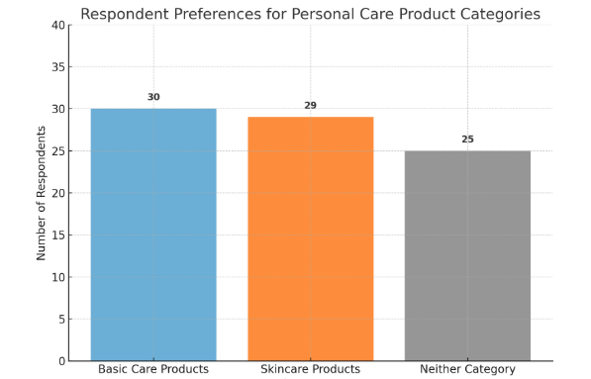

Fig 4.2 Type of personal care products used by respondents. Source: Self-mode

Objective III - Identifying consumer preferences for various brands of personal care products.
To test the objective "Identifying consumer preferences regarding different brands of personal care products," question 4, "Which do you consider to be the best brands of personal care products?" was used. All 71 respondents who completed the questionnaire answered this question.
These responses also allowed me to test hypothesis no. 2: that the monopoly is held by Dove with a 42.2% market share, followed by NIVEA with 38.7%, and CeraVe, the newer brand on the Romanian market, which holds a 31% share. Conversely, brands categorized as 'Other' by respondents- such as Rilastil, Avene, RNW, Clinique, and Sensodyne- each claim only 0.5%. From this, we can conclude that the favourite personal care brands among Romanians, are the classic L’Oreal and Nivea.
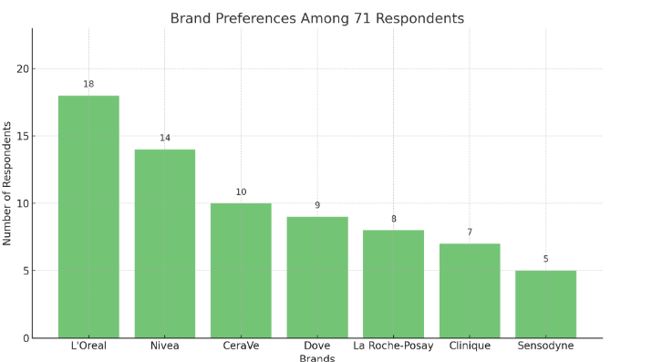
Fig. 4.3. Consumer preferences for different brands of personal care products-Source: self-mode

Objective IV - Assessing respondents' satisfaction with personal care products.
To evaluate this, we will use question 5: "How satisfied are you with the action of the personal care products you use?".
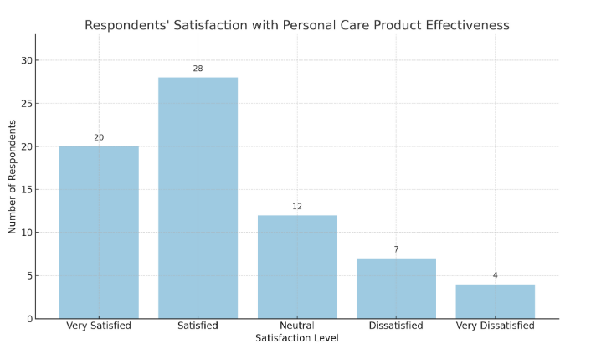
Fig. 4.4.- Respondents' satisfaction when it comes to the action of personal care products. Source: Self-mode

Majority Satisfaction (67.6%) reflects strong brand credibility, as over two-thirds of respondents are either “Very Satisfied” (28.2%) or “Satisfied” (39.4%). This indicates that most consumers are pleased with their personal care products. Brands available in Romania—such as L’Oréal, Nivea, CeraVe, and Dove—are trusted and effectively fulfill essential functions like cleansing, moisturizing, or protecting the skin. Consumers tend to select products that match their needs and skin types. Marketing claims such as "hydrating" and “dermatologically tested" are generally accurate, which enhances brand value and fosters customer loyalty through consistent product performance.
According to question 6, "How often do you purchase personal care products regardless of their nature?" this question had a single answer with 6 options, aimed at determining the frequency of personal care product purchases. The results showed that most respondents, 50 out of 71, buy these products once a month. The second most common response was "A few months, no more than three," with 10 respondents selecting this option. Close behind were those who reported purchasing personal care products very frequently, specifically "Once a week," with 11 respondents. The lowest response percentages were recorded for the last three options, in the same order as presented: for "After more than three months," 0 respondents answered affirmatively; for "Very rarely" and "Not at all," also, 0 respondents out of 71 responded affirmatively.

4.5. Objective V - Determining respondents' attitudes regarding the price of personal care products.
Question 7 "Do you think that the price of personal care products reflects their quality?" helps to test objective V.
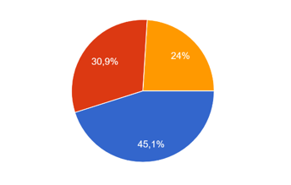
Fig. 4.5. - Respondents' attitudes towards the pricing of personal care products.Source: Self-mode
According to the adjacent graph presented above, 45.1% of the 71 respondents, i.e. 42 of them believed that yes, the price of personal care products reflects their quality, followed by those who consider the opposite, in the number of 15 respondents and states that price does not influence the quality of personal care products. In the last place, 13 respondents are those who do not have a formed opinion on this subject and thus cannot declare whether, in their opinion, the price influences the quality of the products or not. This question was constructed to understand the kind of stereotypes the researched population holds regarding the connection between product prices and their quality.
Customer satisfaction is crucial for the success of companies in the personal care sector, particularly in competitive markets like Romania. Philip Kotler (2003) describes five levels of customer satisfaction: basic, expected, desired, unanticipated, and delighted. Each level offers insights into consumers' perceptions of product and service quality and value.
Based on the analysis of the respondents, the five levels of product are synthesized in the table below:
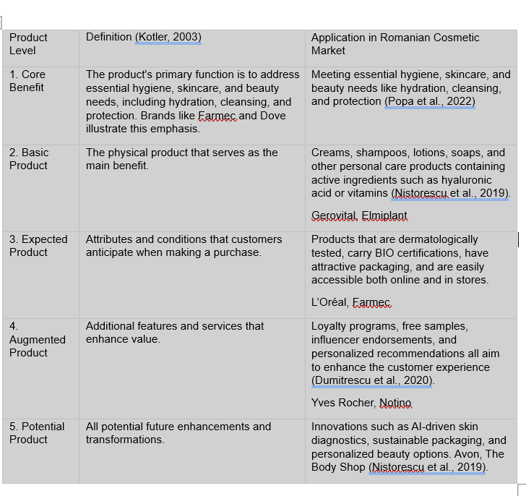

4.6. Conclusions
This research aimed to explore the opinions, attitudes, and behaviours of Romanians regarding the quality of personal care products available in the Romanian market. The findings show that 85.8% of respondents regularly use personal care items, while 14.2% do not use these products often. Most respondents reported purchasing items such as soap, shower gel, toothpaste, and deodorant. Since multiple responses were allowed, many also indicated they bought products like face masks, creams, moisturizers, and cleansing foams.
The study shows that most respondents only rate their satisfaction as 4 out of 5 after using personal care products. Out of 71 respondents, only 1 is very dissatisfied with using these products.
Although personal hygiene is crucial, few individuals report purchasing personal care products very rarely. Price remains a key factor in these purchases, with 45.1% of respondents indicating it influences their perception of quality. When choosing between bio and non-bio products, a clear majority of 65.7% prefer bio personal care items, finding them more attractive.
It is essential for companies producing personal care products to choose the best options for their customers, with a focus on quality. In today’s health-conscious and environmentally aware market, quality goes beyond effectiveness; it includes ingredients, safety, sustainability, dermatological testing, and ethical sourcing (Kotler et al., 2017). Consumers now expect transparency through clear labels, cruelty-free certifications, and products free from harmful chemicals like parabens, sulphates, or synthetic fragrances (Euromonitor International, 2023).

Chapter 5 - Conclusions and recommendations

5.1. Conclusions
The cosmetics and personal care industry is experiencing a change in consumer preferences, moving from just buying products to seeking holistic experiences (Pine et al., 1998). This trend, fuelled by increased convenience, technological progress, and wider global access, is making it essential for beauty companies to adopt more personalized marketing strategies to keep consumers engaged (Armstrong et al., 2021).
With these advancements, experiential marketing has become more prominent in the beauty sector, providing companies with ways to enhance brand differentiation and build emotional connections with consumers (Schmitt, 1999). This work suggests several experimental marketing approaches aimed at shaping positive consumer perceptions. In Chapter Two, we examined how traditional marketing strategies influence consumer reactions and promote co-creation activities, which help develop deeper emotional bonds and increase brand loyalty (Prahalad et al., 2004).
Furthermore, as consumer demand and perceptions rapidly change, adopting consumer-focused strategies is crucial. These approaches not only inspire consumers but also foster long-lasting relationships (Solomon, 2018). Recent studies indicate that marketing methods like emotion-based e-commerce, information-dense platforms, and tailored personalization are becoming more effective in keeping existing customers and drawing in new ones within the digital shopping space (Kapferer, 2012).
The demand for cosmetic products in Romania is expected to grow steadily, mirroring global trends, with emerging markets in Asia and Latin America playing a supporting role (Statista, 2024). As a result, global cosmetics producers will need to innovate and tailor their products to meet the specific expectations of new consumer demographics (Euromonitor International, 2023). The skincare segment continues to demonstrate the highest growth potential and is likely to remain the leading sector within the cosmetics industry (Grand View Research, 2023).
International brands also need to adjust to shifting consumer preferences. As living standards improve and job opportunities expand in Romania, shopping habits have evolved. While practicality stays important culturally, rising incomes have fuelled more aspirational purchases and a focus on personal identity and lifestyle choices (GfK Romania, 2022). This shift has fostered higher brand loyalty and increased awareness of product health and ethical standards.
Moreover, the move to digital shopping channels is transforming Romania's retail environment. Classic stores are declining in popularity, while online platforms like Sephora are prospering thanks to strong infrastructure, user-friendly shopping apps, and secure payment methods (Deloitte, 2023). To stay competitive in this changing landscape, companies need to adopt flexible, data-driven strategies.
Effective communication depends on a nuanced understanding of social media platforms. Romanian consumers mainly rely on social media, peer recommendations, and online reviews for beauty-related decisions (PwC, 2022). Therefore, companies should customize their messages for each platform, incorporating contests, short videos, and interactive content to boost engagement. Social media has evolved from being merely a marketing tool to become the main point of contact for brand and consumer interactions (Keller, 2020).
The growth of influencer marketing keeps reshaping the industry. Partnering with online celebrities and local micro-influencers is now crucial for product launches and boosting brand awareness in Romania’s competitive beauty sector (Forbes, 2023). Ultimately, the shift of e-commerce surpassing traditional retail emphasizes the importance for companies to focus on creating a smooth digital experience—balancing practical features with emotional connection—to stay competitive.

5.2 Recommendations

As lifestyle and fashion trends become more influential, the need for cosmetics and personal care items keeps rising (Statista, 2024). Yet, income inequality acts as a barrier to broader product adoption since lower-income populations often lack the means to purchase premium beauty products, restricting market reach (Euromonitor International, 2023).
To close this gap, implementing more advanced marketing strategies is crucial. As wealthier consumers become more aware and socially responsible, companies must prioritize delivering high-calibre, emotionally engaging brand experiences to keep their interest (Solomon, 2018). Consumer-focused marketing has been recognized as a vital approach that centres on the needs, values, and experiences of the customer, thereby boosting their motivation to buy (Armstrong, 2021).
Beauty companies constantly seek new consumer segments to keep up with changing market dynamics. Experiential marketing plays a key role in building long-term customer relationships by generating desire, altering negative perceptions, and encouraging positive emotional connections (Schmitt, 1999). For instance, consumers often view in-store experiences with luxury cosmetic brands not just as shopping but as personal rewards (Deloitte, 2023).
As the demand for personalization grows, experiential marketing has expanded into digital platforms, emphasizing consumer data privacy and personalized interactions. Unlike traditional push tactics, interactive online luxury stores minimize sensory overload and promote informed, deliberate purchasing choices (Kapferer, 2012). Companies that implement digital experiential marketing with detailed product info and engaging interfaces tend to foster more positive consumer behaviours (McKinsey, 2022).
Research further confirms that product sampling boosts customer engagement and purchase intent by engaging multiple senses (Keller, 2020). This method is especially impactful in cosmetics, where touch and smell are vital. Additionally, to attract Generation Z and Millennials, beauty brands need to harness social media platforms like Instagram, TikTok, and YouTube, which are crucial for building brand interaction and equity (Forbes, 2023).
The rising internet access in Romania has expanded consumer exposure to global beauty trends and brands, boosting consumerism and elevating expectations for product transparency and ethics (Deloitte, 2023). Consequently, Romanian consumers are more often making value-based choices, aligning their purchasing habits with personal ethics and environmental considerations.
To capitalize on this trend, beauty brands should strengthen their digital presence and invest in experiential digital marketing, which has been demonstrated to increase consumer interest and foster personalized engagement (Armstrong et al., 2021). However, the main challenge is developing strategies that resonate strongly with consumers’ psychological and emotional needs (Schmitt, 1999).
The above strategies are crucial for entering Romania's digital beauty market, where competition is intensifying and consumer preferences are shifting. In this context, innovative marketing methods—like gamification, virtual try-ons, and AI-powered suggestions—can successfully attract attention and foster positive consumer perceptions (McKinsey, 2022).
Ultimately, experiential marketing fosters immediate engagement, enhancing customers' perceptions of the brand and promoting loyalty. By combining sensory, emotional, and cognitive aspects, these approaches strengthen consumer-brand connections and help secure a lasting competitive edge (Solomon, 2018).

References

Andreea Năstase (2022). Studiu: Peste 80% dintre saloanele de înfrumuseţare mizează pe o creştere a veniturilor în 2022. [online] Stiri pe surse. Available at: https://www.stiripesurse.ro/studiu-peste-80prc-dintre-saloanele-de-infrumusetare-mizeaza-pe-o-crestere-a-veniturilor-in-2022_2209870.html?utm_source=chatgpt.com [Accessed 26 May 2025].
Armstrong, G., Kotler, P. (2021). Marketing: An Introduction (14th ed.). Pearson.
Cosmobeauty Romania (2024). Beauty trade events and brand activities. https://www.cosmobeauty.ro
Dabholkar, P.A. and Abston, K.A., (2008). The role of customer contact employees as external customers: A conceptual framework for marketing strategy and future research. Journal of Business Research, 61(9), pp.959-967.
DAMAS Cosmetics Romania. (2021). Ce este sau ce inseamna #FEAFree? - DAMAS Cosmetics Romania. [online] Available at: https://damas.ro/ce-este-sau-ce-inseamna-feafree/ [Accessed 26 May 2025].
Deloitte. (2023). E-commerce in Central and Eastern Europe: Growth and Digital Trends. https://www2.deloitte.com
Dumitrescu, L., & Vinerean, S. (2020). Consumer behavior and digital marketing trends in the beauty and personal care industry. Journal of Marketing Research and Case Studies, 12(1), 23–34.
Euromonitor International. (2023). Beauty and Personal Care in Romania. [Market Research Report].
Forbes (2023). Beauty Influencer Marketing: Changing How Consumers Buy. https://www.forbes.com
Ge, J. (2024). Influencers Marketing and Its Impacts on Sustainable Fashion Consumption among Generation Z. Journal of Soft Computing and Decision Analytics, [online] 2(1), pp.118–143. doi: https://doi.org/10.31181/jscda21202438.
GfK Romania. (2022). Beauty and Lifestyle Trends in Romania. GfK Market Insights.
GfK Romania. (2022). Consumer Trends in Romania: Aspirational Spending and Brand Loyalty. GfK Market Insights.
GPeC (2024). E-commerce market reports. https://www.gpec.ro
Grand View Research. (2023). Cosmetics Market Size, Share & Growth Analysis. https://www.grandviewresearch.com
Grand View Research. (2023). Cosmetics Market Size, Share & Trends Analysis Report. https://www.grandviewresearch.com/
ICON Advertising. (2020). MAC Cosmetics, launch in Romania — ICON Advertising. [online] Available at: https://iconadv.ro/en/portfolio/mac-cosmetics-launch-in-romania/ [Accessed 26 May 2025].
Kapferer, J. N. (2012). The Luxury Strategy: Break the Rules of Marketing to Build Luxury Brands. Kogan Page.
Kapferer, J. N. (2012). The New Strategic Brand Management: Advanced Insights and Strategic Thinking. Kogan Page.
Keller, K. L. (2020). Strategic Brand Management (5th ed.). Pearson.
Kotler, P., Keller, K. L. (2016). Marketing Management (15th ed.). Pearson.
Kumar, V. and Petersen, J.A., (2005). Using a customer-level marketing strategy to enhance firm performance: a review of theoretical and empirical evidence. Journal of the Academy of Marketing Science, 33(4), pp.504-519.
Latana (2020). How Fenty Beauty Has Built Brand Awareness — and Won. [online] Medium. Available at: https://latanabrandtracking.medium.com/how-fenty-beauty-has-built-brand-awareness-and-won-913157f0ec53 [Accessed 26 May 2025].
Loring, A.J., (2021). Employee Engagement: A Qualitative Study of Inside Sales Representatives (Doctoral dissertation).
McKinsey & Company. (2022). The Future of Beauty: The Age of the Conscious Consumer. https://www.mckinsey.com
McKinsey & Company. (2022). The State of Fashion and Beauty 2022: Inside Consumer Behaviour. https://www.mckinsey.com
Mintel, (2022). Consumer Attitudes Towards Personal Care Products – Europe. [Industry Report].
Nistorescu, T., & Puiu, S. (2019). Marketing strategies of Romanian cosmetic brands: A case study. Management & Marketing Journal, 14(2), 158–171.
PADURARU, M.C., OPRISAN, F.R., Managerială, I. and Romano-Americana, U., (2021), Impactul industriei cosmetice asupra economiei. Studii și Cercetări Academice, p.113.
Pine, B. J., Gilmore, J. H. (1998). The Experience Economy. Harvard Business Review.
Popa, A., & Ionescu, C. (2022). Customer satisfaction in Romania’s cosmetics market: BIO vs. non-BIO products. Romanian Journal of Business and Economics, 17(1), 45–57.
Prahalad, C. K., & Ramaswamy, V. (2004). Co-creation experiences: The next practice in value creation. Journal of Interactive Marketing, 18(3), 5-14.
PwC. (2022). Global Consumer Insights Pulse Survey: Online and Social Commerce. https://www.pwc.com
PwC. (2022). Global Consumer Insights Pulse Survey: Online Buying Behaviour and Preferences. https://www.pwc.com
Reddit (2023–2024). Threads on local cosmetic brands – r/Romania.
Retail.ro (2023). Discounts and Retail Channel Analysis.
Roşca, C. (2024). L’Oreal, liderul pieţei de cosmetice din România, face afaceri de aproape 1 mld. lei bazându-se doar pe. [online] ZF.ro. Available at: https://www.zf.ro/companii/retail-agrobusiness/l-oreal-liderul-pietei-de-cosmetice-din-romania-face-afaceri-de-22621034 [Accessed 26 May 2025].
Schmitt, B. (1999). Experiential Marketing: How to Get Customers to Sense, Feel, Think, Act, Relate. Free Press.
Shamsudin, M.F., Hassim, A.A. and Abd Manaf, S., (2024). Mastering Probability and Non-Probability Methods for Accurate Research Insights. Journal of Postgraduate Current Business Research, 9(1), pp.38-53.
Solomon, M. R. (2018). Consumer Behavior: Buying, Having, and Being (12th ed.). Pearson.
Statista (2023). Leading personal care brands in Romania by market share. Retrieved from www.statista.com
Statista (2024). Beauty & Personal Care – Romania Market Outlook.
Statista (2025). E-commerce Revenue – Beauty & Personal Care, Romania.
Statista. (2024). Cosmetics and Personal Care Industry Outlook. https://www.statista.com
Statista. (2024). Cosmetics Industry Outlook: Global and Romanian Trends. https://www.statista.com
Turcu, O. and Brancu, C. (2023). The Impact of the Beauty Industry on the Economic Growth at the European Union Level. [online] Available at: https://sciendo.com [Accessed 26 May 2025].
Verhoef, P. C., Kannan, P. K., & Inman, J. J. (2015). From multichannel retailing to omnichannel retailing: Introduction to the special issue on multichannel retailing. Journal of Retailing, 91(2), 174–181.
Ziarul Financiar (2024). Urban sales insights. https://www.zf.ro
Zichermann, G. and Linder, J., (2010). Game-based marketing: inspire customer loyalty through rewards, challenges, and contests. John Wiley & Sons.

Appendices

Appendix 1- PESTLE Analysis

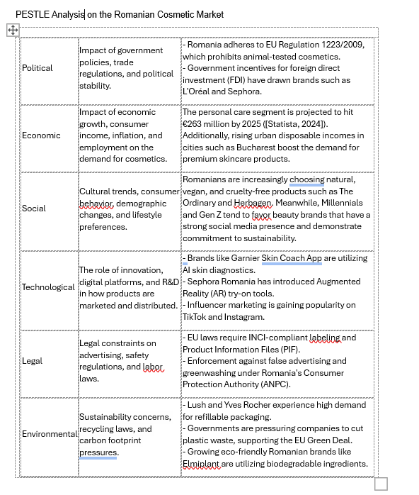
Source: Self-mode

Appendix 2 – SWOT Analysis
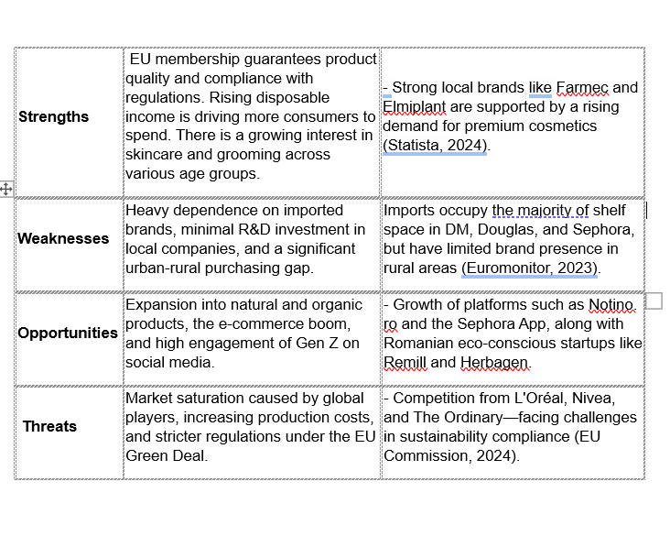
Source: Self-mode

