Marriott International – Marriott’s Response to the COVID Crisis

Course name: MBA in General Management
Student name: Rashmibahen Thakor
Student I’d: 2211283
Module title: Marketing Management
Module code: LCMB_7001
Prof Name: Efua Adams

Executive summary
The study has highlighted the marketing strategies of Marriott in the international business market in terms of business expansion. It has shown the values of strategies of business that have mainly impacted the pandemic period of COVID-19. It can be determined that the value of technological advancements has been analysed through SWOT, Porter's five, and metrics methods to grow the global business market. During the pandemic period, the organisation has traded to focus on a new application of business to make continuous development in the global place. The managerial implication of the marketing strategies, especially for Marriott International, have been thoroughly demonstrated in the premise of covid issue. The operational feasibility of the business have been critically recognised in the recommendation portion, suggesting the future actions of the company in terms of the post-pandemic era.

Table of Contents
Introduction 3
Task 1: 3
Concept and Importance of Marketing during the Covid Crisis 3
Critical evaluation of the SWOT analysis of Marriott International 4
Marketing strategies deployed by Marriott International during the Covid Crisis and the effect on its stakeholders 5
Competitive analysis of the strategies used by Marriott International during the Covid Crisis 7
Impact of technology on the strategies implemented during the crisis 8
Strategies implemented by Marriott International during the Covid Crisis 8
Task 2: 10
Managerial implication on the marketing strategies 10
Task 3: 13
Recommendation to enhance operational feasibility 13
Conclusion 15
Reference list 16

Introduction
An appropriate marketing method in business is the most valuable factor that mainly helps in business expansion in the marketplace. Marketing strategies can be analysed through swot analyse, marketing mix strategies, their importance, and their effects on the working values. Marriott International is one of the largest travel and tourism industries in the American states (Marriott, 2023). The major aim of the study is to focus on the values of the marketing method of Marriott international organisation especially in the pandemic period of COVID-19 and its impacts on the business. During the pandemic time, the international organisation has developed through the values of the marketing mix and other strategies. Managerial implications also have been well improved in the workplace in terms of increasing the bhs8ens callus in the international business market. It is most important to apply the recommended ways in aspects of developing the managerial function within the workplace to grow the business.

Task 1:

Concept and Importance of Marketing during the Covid Crisis
During the pandemic period, the marketing method of the organisation has focused on the consumer's sentiment in terms of providing them a priority. Marketing values have included the values of proper business strategy such as monitoring the consumer's long-term business orientation and its positive effects on the business market (Kang et al. 2021). Marketing is most important to increase the business rates in the international business market. In the post-pandemic period, the values of consumer priority have helped the organisation to expand its business.
Marriott International organisation has followed the marketing strategies such as developing digital business values in the international business market. Recovery in the business method through digitalisation in the business method in terms of tracking the consumer’s effectiveness and purchase methods in the organisation. It can be determined by the values of marketing through digital recovery in the business method (thinkwithgoogle.com, 2022). The values of well-structured methods such as understanding hyper local strategies in the business market can be the most effective way in the business market to grow digitalisation among the consumer’s needs in the internal business place. Marriott International has applied the factors such as deep collaboration among the business collaborators and other business consumers.
It is one of the most effective factors for the organisation in terms of developing the business more in the international business market. Hence, the organisational methods such as technological aspects and digital methods in the international business market can be enhanced through the values of the maximum number of technological aspects in the business market. Marriott International has mainly taken the strategies such as monitoring the consumer's expectations towards the organisation. The business owners have engaged in the strategies of development of luxury and relaxation in the business market through their services and business values.
Marriott internal has increased the consumer's number through marketing policies during the pandemic time, they reached around 177 million in the business market (Annual report, 2022). Hence it is most important to utilise the marketing factors in terms of increasing the consumer's elements. It can be most effective in the future to enhance the consumer's engagement by accomplishing their needs and basic requirements through developing marketing strategies.

Critical evaluation of the SWOT analysis of Marriott International
SWOT analysis
Strengths  - Values of consumer loyalty in the international business market in 130 countries (Marriott.com, 2022)  - Expansion of the global trends  - Huge partnership in the global market (Marriott.com, 2022) | Weakness  - Depending on the franchise model  - Economic downtown during the pandemic time (marriott.gcs-web.com, 2022)  - Lack of data security in the business market
Opportunities  - Expansion on the emerging markets  - Technological advancements and their innovation process in the organization  - Partnerships and loyalty programs in the marketplace | Threats  - Huge loss in the economy downtown  - Huge competition in the market  - Huge compliances and changes in the organisational business through climate changes
Table 1: SWOT Analysis
Based on the SWOT analysis of Marriott International, it can be determined that the values of consumer loyalty towards the organisation in the pandemic period in the international business market (Marriott.com, 2022). The company has expanded the global trends such as technological advancements and partnerships among international stakeholders or collaborators. The main weakness of the company has shown the economic fall down in the international business market through a lack of purchases from consumers. Economic fall down has created a major risk in the business in terms of expanding the business by developing or mitigating the lacks.
Major opportunities of the company such as technological innovation of online ticket booking is the most appropriate factor in the international business market. Technological advancements in the global market can be very effective for business expansion through making digital connections with consumers (marriott.gcs-web.com, 2022). Huge competition in the business marts and economic fall down are the main threats to the company. The organisation needs to mitigate the threats to expand business by increasing digitalisation.

Marketing strategies deployed by Marriott International during the Covid Crisis and the effect on its stakeholders
7P marketing analysis
JW Marriott International has affected both the internal and external stakeholders by developing a marketing mix analysis in order to improve the organisational services and market plans.
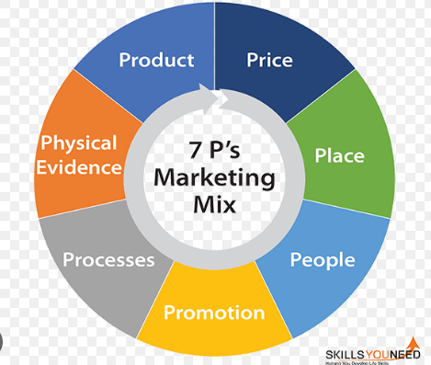
Figure 1: 7P marketing mix
(Source: skillsyouneed.com, 2022)
Product
During the pandemic period of COVID-19, the organisation has well improved its organisational services such as hotel reservations, rental packages, and attractive hotel and flight packages in the international business market. It has affected the internal and external stakeholders such as consumers and employees in terms of increasing their engagement after the pandemic.
Price
During the pandemic period of COVID-19, the organisation had to face a huge loss through an economic downfall in the business market. The organisation has developed the most attractive and affordable pricing rates on their services such as 30 premium brands in the business place (Annual report, 2022). It has affected the consumers positively to get effective services with effective ranges. Internal stakeholders such as collaborations have also increased their profits by providing gift vouchers on the hotel booking of consumers.
Place
Marriott International has engaged around 8550 hotels in international countries, in the pandemic period, the organisation has operated 20 hotel reservation centres by managing the business (marriot.com, 2023). It has impacted the consumers negatively, as the company did not provide an effective range of services during the pandemic. Internal stakeholders and the partners also had to face the loss in the economic values of the country.
Promotion
The company has promoted its services and business values through online marketing and digital advertisements to make consumers aware of the services (Damore-mckim.northeastern.edu, 2022). External stakeholders such as the consumers have been impacted positively through the promotional values. Internal stakeholders have impacted a little bit positively through promotions, as it helps to engage a little number of consumers in the market.
Process
Technological aspects in the international business market of Marriott International have engaged the consumers positively, as the company has created loyalty towards every employee and their work. Employees have managed the working strategy also in the endemic period, the consumers also get the values of proper process in the organisation.
People
During the pandemic period of COVID-19, around 53% of employees have been moved out of the organisation (Marriott.com, 2022). It has impacted the internal stakeholders negatively lot in the international business market in terms of business expansion.
Physical evidence
Annual revenue of the organisation, Marriott Internal has been reduced by around 49% to the poor purchase rate of the consumers (lagrange.edu, 2022). It has impacted both the internal and external stakeholders in the international business market. The consumers had to face major issues in purchasing through a huge lack of proper services. Hence, the employees and the business managers had to face negative outcomes throughout the business.

Competitive analysis of the strategies used by Marriott International during the Covid Crisis
Porter’s five forces

The threat of new entrants | New entries in the post-pandemic period in the global business market | Moderate force
Competitive rivalry | Huge competition in the global market, in the post-pandemic period | Moderate-weak force
Bargaining power of the suppliers | The bargaining power of the suppliers is low through the loyalty program and effective relations | Strong force
Bargaining power of the consumers | Consumers have trusted the services of the organisation and the organisation has made loyal relationships with the customers | Strong force
Threats of substitutes | Substitute products or services in the tourism industry did not match the organisational services | Strong force
Table 2: Porter’s five forces
The organisation developed a strong force in the substitute service from other travel and tourism industries in the global market during COVID-19. During the pandemic period, most of the suppliers have engaged a strong force towards the organisation, as the company has helped all the suppliers to construct an effective relationship. Most of the suppliers have tried to provide accurate products and services to the business organisation in terms of developing the business values during the pandemic time. It has helped the organisation to well maintain its business in the crisis (marriot.com, 2022). Consumers also have developed a good relationship with the business owners in terms of getting proper services from them. It has helped the company to create a strong force in the global business market.
In the competitive market, the organisation had to face huge difficulties, as the maximum number of travel and tourism industries has exceeded their business after the pandemic. The organisation had to face around 49% fall in the financial state through the competitive difficulties in the global business market (news.marriott.com, 2022). In the global business market, the organisation had to face the issues of new entrants. As a huge number of travel and tourism industries expanded their business in the market, hence, the organisation had to overcome the economic fall down in the market. Marriott International can develop a future business plan by expanding the business by taking economic advantages through improving the employee’s working values.

Impact of technology on the strategies implemented during the crisis
Marriott International has focused on technological advancements, especially during the pandemic period of COVID-19. It has affected the communication process of the organisation with any stakeholders positively. Digital guest services have helped the company to increase its business values during the crisis of COVID-19 through providing accurate rental services to consumers (globaldata.com, 2022). During the pandemic time, most of the audiences have cancelled their stripes, though the organisation has communicated with them through their official mobile app. It has helped them to cancel the tickets and make effective relations with the customers.
In digital marketing, the company has utilised the values of the check-out chat process to develop promotional ways by making interaction among the business managers and stakeholders (globaldata.com, 2022). The organisation has also utilised the strategy of internationalism by expanding its business in various countries. Smart robotics has been utilised in the pandemic, by the organisation in terms of extending the global business, it has helped the company to increase sales in the global market through maxi, the number of consumer engagements. Hence, it can be determined that the value of technological advancements has helped the organisation a lot in terms of improving communication and internationalism in the global business place through the proper values of the business.

Strategies implemented by Marriott International during the Covid Crisis
The metrics of sales revenue, gross margin, and net profit margin can be utilised in the success strategies of the business organisation, JW Marriott.
Sales revenue
Marriott has engaged in online promotional policies during the pandemic period. The organisation has collected around 22.189 billion from total sales in the pandemic, it has reduced around 40.97% rather than normal business time (Annual report, 2022).
Net profit margin
Over a year the organisation has reduced around 50% net profit margin in the global business market (Satista, 2023). The organisation needs to focus on successful strategies to grow its margins. The organisation has applied online pricing and promotional strategies in the business place.
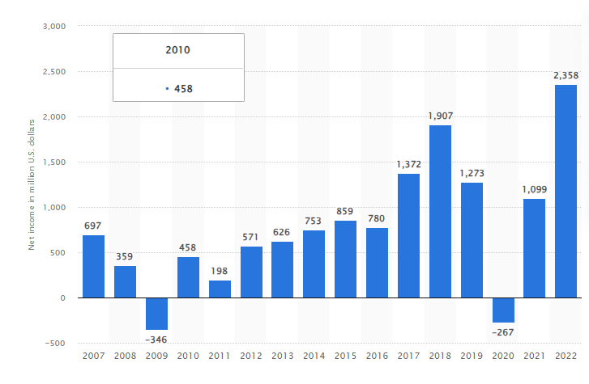
Figure 2: Net income of Marriott in 2022
(Source: Statista, 2023)
Gross margin
Marriott has collected around 2.80 billion in gross margins; it has reduced approx 90% gross margins rather to the previous year of COVID-19 (Macrotrends.net, 2022).
The organisation can utilise successful strategies such as technological innovation in terms of developing their communication with the consumers to know their needs properly. It can be very helpful for the organisation to control the marketing functions in the aspects of developing the business values. Sales revenue and margin can be increased through the strategies such as the digital communication process. A maximum number of consumers can be engaged in the business through the strategies utilised by the organisation.

Task 2:

Managerial implication on the marketing strategies
The pandemic has become a major aspect for Marriott International to stay relevant in the market, followed by suggesting the growth of business in order to manage customer satisfaction and growth in worker enthusiasm. It is not surprising that as the travelling of people suggested a major hit due to the pandemic situation, the hotel industry has shut down including Marriott. During the pandemic, the overall profit of Marriott International fell to 100 million USD, a massive shrinkage in their share value by 31 cents (Reuters, 2020). However, the managerial implications can be an ideal measure for increasing the occupancy rate, which is preferably the major issue encountered by travel business. An inclusion of different marketing theories will be helpful for the business as well to concretise the implications around managerial level.
The pandemic issue has been suggested as a critical prospect for the business, which pushed them to take ideal measures. The company has suggested the inclusion of keyless room entry, followed by accessible room service by text message and other related measures (THE WALL STREET JOURNAL, 2021). These aspects are thoroughly interrelated with the digital transformation and progress demonstrated by Marriott, suggesting the growth of hospitality minimising contacts. The increase of disinfection process by using 70% alcohol, followed by thermal scanners and hand sanitising stations is included in the premise of Marriott International (Kim and Han, 2022). In this required measure, Kotler's theory of marketing can be suggested in terms of creating a strong customer value, followed by targeting and segmentation. All these aspects are responsible for suggesting their precautionary measures against the rapid spread of coronavirus.
The meet-up of human and social needs has been thoroughly measured by suggesting the amplification of the marketing theory of Kotler. The theory is helpful to provide a positive relation to business service management and consumer decision-making (Praesri et al. 2022). The understanding of this theoretical management is helpful around the individualistic synergy with the institution. The diminishing layoffs amidst the tough COVID-19 pandemic situation are suggested around the forgoing of salary by the president and CEO of the company, followed by the executive team taking a 50% cut in their pay (Medium, 2020). The company has also taken the step of a 24-hour cancellation policy, including prepaid or non-refundable reservations. The commitment to providing 10 million USD worth of stay for the responders has also been suggested by the business, suggesting the company's willingness for helping people in need and charitable measures for frontline workers including healthcare professionals during the pandemic (Medium, 2020). 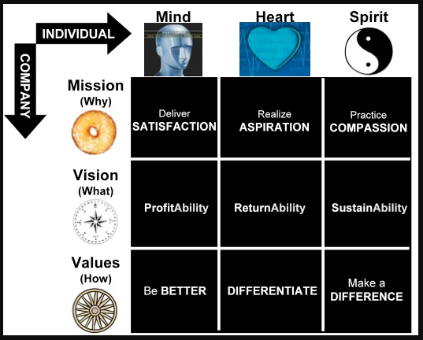
Figure 3: Kotler’s theory of marketing management
(Source: Influenced by Praesri et al. 2022)
It is ideal to suggest that there are four aspects ideally in the way of targeting audience and social apprehension, appreciating managerial implications for marketing. Effective communication among stakeholders, followed by creating value for the business and customer knowledge development is necessary for the managerial implications. Online marketing for hotel businesses, including social media promotion for Marriott International is ideal to suggest profit growth and expansion, especially for brand value management. The solution for advertisers in today's terms is mostly in social media preference, followed by strategies for sophisticated product and service management (Bloomberg, 2021). The 7P marketing mix, especially based on other related aspects can also be a major aspect in the premise of managerial implications.
Based on these theories and frameworks, the conceptual understanding of the situation can be determined. As the pandemic continues, there is a lingering chance of spreading the pandemic, which follows the premise of regular sanitation. One of the critical focuses upon which the long-term sustainability of Marriott International can be suggested is environmental and social issues. Sustainable practices are needed to be developed around the environment and their required help, followed by community work (Marriott International, 2021). During the pandemic situation, customer and audience attraction have been derived towards Marriott International due to their donations, followed by food, shelter, PPE, and hospital supply contribution. The priority towards diversity and inclusion, followed by mitigating the social evils with regards to managerial implications have been helpful measures for the business to their progress for marketing in the post-pandemic era.

Task 3:

Recommendation to enhance operational feasibility
The operational feasibility of this business can be recommended on the basis of managerial implications during the pandemic. Therefore, the recommendations are appropriately considered by the points related to the realistic measures of resources present in Marriott International. All these aspects are thoroughly suggested in the following ways-
- As customer demand is growing in terms of the travel and hospitality market, the apprehension of operational management and feasibility have taken a prominent place for businesses including Marriott International. Product management and customer demand understanding can be identified as the operational efficiency of the company based on digital transformation (Fabeil et al. 2020). Managing customer value and business development is suggested in certain changes in business models. The inclusion of digital transformation, followed by technological apprehension of existing workers can be suggested as a great choice in order to deliver the company's growth.
- The pandemic has really pushed businesses in terms of developing organisational strategies and operational efficiencies (McKinsey & Company, 2022). Staff management, followed by community help can suggest the social responsibility of the company. This is followed by organisational strategic management in order to increase the number of people visiting. In these ways, the outcomes of the business are potentially managed in these kinds of feasibility with relative measures.
As the pandemic has happened, the importance of online tools and techniques for the travel and tourism industry has also surfaced. Digital marketing is an effective tool for approaching customer relationships and management. This has been provided with fast response to customer questions and response management, accessing information in a swift manner (Haudi et al. 2022). Therefore, the online and digital marketing growth, followed by managing the social media is effective in terms of market sustainability for Marriott International.
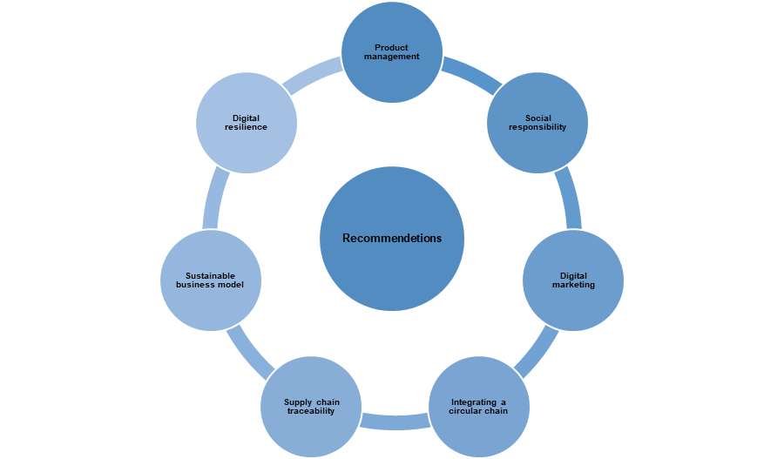
Figure 4: Recommendations
(Source: Self-created)

- Improvements in direct organisational operation can be most effective in terms of increasing the operational feasibility of the business. Integrating a circular chain model can be most helpful for the organisation to enhance the operational feasibility in the global market by making and developing the value chain cycle among all the services and goods (Chen et al. 2020). It can help the organisation to develop marketing strategies by emerging continuous flow in the services values chain in the post-pandemic period. Hence, the organisation needs to utilise the integrating value chain model to increase sales and expand the business in the global market.
- Supply chain traceability needs to be enhanced in the organisation in terms of developing the operational feasibility of the business. It has helped in tracking any services or goods' entire life cycle. Hence, in order to develop the managerial implications, the organisation can utilise the supply chain traceability to track its effects and values among the consumers (Hastig and Sodhi, 2020). It can be one of the effective choices to deliver the best quality services among the consumers to develop the business and its operational feasibility. The consumers can get prior services through this managerial implication in the organisation.
- The organisation can utilise a sustainable business model to increase the positive values of operational feasibility in the workplace. The tool mainly helps in supporting the organisational prototypes applications in terms of developing the business operation (Baldassarreet al. 2020). In the improvement of the organisational operational feasibility, the tool can support the development of financial viability through business expansion in the national and international markets. It can play a key role in operational management within the organisation through increasing financial stability and applying them in the operational feasibility through business expansion in the global business market.
- Marriott International needs to follow the strategy of digital resilience in terms of developing the operational feasibility by the managerial implications. It mainly focused on the values of online approaches to mitigate any challenges of business by monitoring them and the main sources (Dragoneet al. 2020). It is one of the most accurate factors to improve the operational feasibility of business by avoiding challenges and increasing safety behaviours among the organizational staff. Hence, the strategy can be most crucial for the company in terms of developing operational feasibility through the managerial strategy implications in the global business market.

Conclusion
The marketing management process is most helpful in terms of expanding the business in the global business market. The study has determined the values of marketing strategies of Marriott International in the global market. It has helped to evaluate the main outcomes of the business in the international market through marketing strategies and their effects on the business. The study has focused on the strategies such as marketing mix, SWOT analysis, and valuable impacts in the business expansion during COVID-19, in the global business place. It can be concluded that the values of managerial implications can be developed in terms of improving the operational feasibility in the global market. Technological advances and innovation strategies have helped the organisation to overcome the issues of economic fall down in the monetary state in the global market. It can be very helpful for the organisation to extend the business in the international or global business market.

Reference list
Annual report, (2022). Annual report. Available at: https://marriott.gcs-web.com/static-files/b82978a6-9d28fzippia-4e38-9855-fc4ae2cebe11 [Accessed on 25 July 2023]
Baldassarre, B., Konietzko, J., Brown, P., Calabretta, G., Bocken, N., Karpen, I.O. and Hultink, E.J., (2020). Addressing the design-implementation gap of sustainable business models by prototyping: A tool for planning and executing small-scale pilots. Journal of Cleaner Production, 255, p.120295.
Bloomberg, (2021). What a Post-Pandemic Advertising Market Looks Like. Available at: https://www.bloomberg.com/press-releases/2021-07-29/what-a-post-pandemic-advertising-market-looks-like [Accessed on 13th July 2023]
Chen, L.H., Hung, P. and Ma, H.W., (2020). Integrating circular business models and development tools in the circular economy transition process: A firm‐level framework. Business Strategy and the Environment, 29(5), pp.1887-1898.
Damore-mckim.northeastern.edu, (2022). Marriott case. Available at: https://damore-mckim.northeastern.edu/wp-content/uploads/2022/04/Marriott-Case-CEM-2021.pdf [Accessed on 25 July 2023]
Dragone, G., Kerssemakers, A.A., Driessen, J.L., Yamakawa, C.K., Brumano, L.P. and Mussatto, S.I., (2020). Innovation and strategic orientations for the development of advanced biorefineries. Bioresource Technology, 302, p.122847.
Fabeil, N.F., Pazim, K.H. and Langgat, J., (2020). The impact of Covid-19 pandemic crisis on micro-enterprises: Entrepreneurs’ perspective on business continuity and recovery strategy. Journal of Economics and Business, 3(2).
Globaldata.com, (2022). International Marriott. Available at: https://www.globaldata.com/store/report/marriott-international-enterprise-tech-analysis/#:~:text=Marriott%20International%20is%20focused%20on,%2C%20mobile%20key%2C%20and%20more. [Accessed on 25 July 2023]
Hastig, G.M. and Sodhi, M.S., (2020). Blockchain for supply chain traceability: Business requirements and critical success factors. Production and Operations Management, 29(4), pp.935-954.
Haudi, H., Rahadjeng, E., Santamoko, R., Putra, R., Purwoko, D., Nurjannah, D., Koho, I., Wijoyo, H., Siagian, A., Cahyono, Y. and Purwanto, A., (2022). The role of e-marketing and e-CRM on e-loyalty of Indonesian companies during Covid pandemic and digital era. Uncertain Supply Chain Management, 10(1), pp.217-224.
Kang, J., Diao, Z. and Zanini, M.T., (2021). Business-to-business marketing responses to COVID-19 crisis: a business process perspective. Marketing Intelligence & Planning,39(3), pp.454-468.
Kim, J. J., and Han, H. (2022). Saving the hotel industry: Strategic response to the COVID-19 pandemic, hotel selection analysis, and customer retention. International Journal of Hospitality Management, 102, 103163.
Lagrange.edu, (2022). Academics. Available at: https://www.lagrange.edu/academics/undergraduate/undergraduate-research/citations/2-Citations2021.MWhite---ACCT.pdf [Accessed on 25 July 2023]
Macrotrends.net, (2022). operating income. Available at: https://www.macrotrends.net/stocks/charts/MAR/marriott/operating-income [Accessed on 25 July 2023]
marriot.com, (2022). Consumers of Marriott. Available at:https://www.marriott.com/default.mi?scid=07fc8d0c-c7ef-428a-bc3b-79c551352255&gclid=Cj0KCQjw5f2lBhCkARIsAHeTvlhUryxeNaS3pOpCpPKX6jOzSTdHSQYD8iQQxly-qNiTjfPYV056NDsaAk9ZEALw_wcB&gclsrc=aw.ds [Accessed on 25 July 2023]
marriot.com, (2023). experience. Available at:https://www.marriott.com/marriott/aboutmarriott.mi#:~:text=A%20Brand%20Leader,experience%20and%20expand%20their%20world. [Accessed on 25 July 2023]
Marriott International, (2021). Marriott International Reports on Environmental, Social, and Governance Progress. Available at: https://news.marriott.com/news/2021/09/14/marriott-international-reports-on-environmental-social-and-governance-progress [Accessed on 17th July 2023]
Marriott, (2023). About us. Available at: https://www.google.com/aclk?sa=l&ai=DChcSEwj5wrrFqamAAxXdmWYCHc0YA3YYABAAGgJzbQ&sig=AOD64_0o5B1If4Xhq-Kna95aCXm9mMxohQ&q&adurl&ved=2ahUKEwjj17LFqamAAxWMTWwGHbzGCJcQ0Qx6BAgOEAE [Accessed on 25 July 2023]
Marriott. gcs-web, (2022). Static file. Available at: https://marriott.gcs-web.com/static-files/b82978a6-9d28-4e38-9855-fc4ae2cebe11 [Accessed on 25 July 2023]
Marriott.com, (2022). Life at Marriott. Available at:https://careers.marriott.com/life-at-marriott/ [Accessed on 25 July 2023]
Marriott.com, (2022). Loyalty earnings. Available at: https://www.marriott.com/loyalty/earn/reward-partners.mi [Accessed on 25 July 2023]
Marriott.com, (2022). Loyalty. https://www.marriott.com/loyalty.mi [Accessed on 25 July 2023]
McKinsey & Company, (2022). COVID-19: Implications for business. Available at: https://www.mckinsey.com/capabilities/risk-and-resilience/our-insights/covid-19-implications-for-business [Accessed on 14th July 2023]
Medium, (2020). How Marriott International’s Response to COVID-19 Set An Example For The Travel Industry. Available at: https://medium.com/marketing-in-the-age-of-digital/how-marriott-internationals-response-to-covid-19-set-an-example-for-the-travel-industry-2c2a70aba228 [Accessed on 14th July 2023]
News.marriott.com, (2022). business update. Available at: https://news.marriott.com/news/2020/03/18/marriott-international-provides-business-update-amidst-the-rapidly-evolving-coronavirus-situation [Accessed on 25 July 2023]
Praesri, S., Meekun, K., Lee, T.J. and Hyun, S.S., (2022). Marketing mix factors and a business development model for street food tourism. Journal of Hospitality and Tourism Management, 52, pp.123-127.
Reuters, (2020). Marriott posts 74% fall in quarterly profit as virus hits bookings. Available at: https://www.reuters.com/article/marriott-intnl-results-idUSL4N2HS36U [Accessed on 14th July 2023]
skillsyouneed.com, (2022). 7p marketing strategy. Available at: https://www.skillsyouneed.com/lead/7-marketing-ps.html [Accessed on 25 July 2023]
Statista, (2023). statistics. Available at: https://www.statista.com/statistics/256252/net-income-of-marriott-international/ [Accessed on 25 July 2023]
THE WALL STREET JOURNAL, (2021). In the Face of a Pandemic, Marriott Leans on Its Values. Available at: https://deloitte.wsj.com/articles/in-the-face-of-a-pandemic-marriott-leans-on-its-values-01610568129?tesla=y&tesla=y [Accessed on 14th July 2023]

