Task 1 – Written summary
Essential Academic and Employment Skills for a Career in Data Analysis
The profession of data analysis involves effective professional, technical and analytical skills which would be achieved through training in the academy. Data analysts deal with massive data sets to find trends, comprehend information and aid decision-making within organisations. Hence building academic and employability skills at the university level is a key to career success.
Analytical thinking and problem-solving is one of the most crucial skills of a data analyst. The data analysts should be capable of interpreting sophisticated data, making trends and drawing significant conclusion that justify organisational plans [1]. These skills are developed in academic study in research activities, coursework projects and statistical analysis. The other important skill is technical competence in different data analysis tools such as spreadsheets, databases, programming languages, and data visualisation softwares. The technical skills will help analysts in cleaning, processing and visualising data [2].
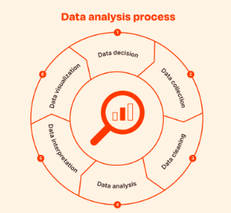
Figure 1: The data analysis process used by data analysts
Besides technical knowledge, psychological knowledge is also required. Data analysts have to transform the complicated results into simple explanations that can be comprehended by the managers and other stakeholders [3]. Written and spoken communication through academic assignments, presentation and group projects also aid students in enhancing written and oral communication skills, which are essential in the workplace.
In addition, technology knowledge and lifelong learning are crucial in the sphere of data analytics since technologies and analytical procedures keep changing. Graduates with good research and learning capabilities will be in a position to embrace new tools and techniques in their workplaces [4].
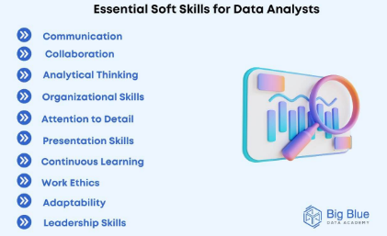
Figure 2: Important technical and analytical skills necessary for a data analyst.
Thus, the acquisition of critical thinking, technical skills, communication skills and digital literacy in the course of the academic study gives an excellent background to my successful data analysis career. Such skills can help graduates to be able to interpret and present insights and make informed decisions in organisations.

