Workplace Culture and its impact on Organisational Efficiency
Module Number: BMSW5105_LON
Company Name: Google Inc.

Student Name: Linda-Ruth Makoutou-Ngondet
Student Number: 1807164

Lecturer Name: Dr. Hossein Shokri

Table of Contents
Introduction 2
Google Background 2
Organizational Structure 2
Google Organisational Structure 3
Culture and Subculture 4
Workplace Culture 5
Organisational Culture and Its Importance 5
Google's Organisational Culture 7
PESTEL and SWOT Analysis 8
The PESTLE analysis of GOOLE 2019 10
The impact of environmental factors on Google’s culture and performance 14
Google Ethical Behavior 15
Google social responsibility 16
Conclusion 16
Bibliography 17

Introduction
In today’s fast changing business environment there are different factors contribute to the success of the organizations. Organizational structure and cultures have key role in the success of many organizations because of this.
This report critically assesses the organisational structure, culture, and management theories in the Google organization. It will also use an environmental scanning tool to provide a critical evaluation of the broader environment in which Google operates and its impact on the organizations culture and performance.

Google Background
Google Inc. was founded by Sergey Brin and Larry Page when they were students at Stanford University. They officially launched the company in September 1998 in a friend’s garage. In August 2004, in one of the biggest anticipated Initial Public Offerings (IPO) the company raised $1.67 billion. Today, Google has more than 12,000 employees in offices all over the world. The official mission statement of Google is to “organise the world’s information and make it universally accessible and useful” (Battelle, 2005).
Google has 90.46% of the search engine market share worldwide, where 15% of all searches have never been searched before on Google. The company gets more than 63,000 searches per second every day. In 2019 the company has 88,110 full-time employees; this number is up from its 57,100 full-time employees in 2015. Google’s market value is $739 billion (J. Clement, 2019).

Organizational Structure
Organisational structure is utilized by different companies as a control system to influence worker work results, to guarantee that the demanded tasks are carry out efficiently and effectively, and to help the achievement of objectives and goals. Organisational structure define the inside components of a business. These internal components gain consideration since they are critical to organisational collapse and achievement, and one of these is organisational responsibility. Organisational responsibility will increase the accomplishment of a business by making workers devoted to the accomplishment of its objectives. The accomplishment of any business can be anticipated by its achievement in raising and looking after employee’s dedication. There are significant levels of dedication that brings about positive beliefs and behaviors in businesses (Al-Qatawneh, 2014).
Organisational structure can be characterized in different ways yet its fundamental goal is to shape connections between various leveled elements of an organisation. These elements decide the amount of directors' authority over subordinates while gathering teams or groups at different levels who are allocated jobs to be accomplished through a successful and well-organized collaboration and communication. The significant columns on which a hierarchical structure is shaped and incorporate, describing relationships, plan of units or offices and successful communication channels. These parts or columns are arranged under two significant hierarchical structures: the vertical and flat. The vertical structure sets the managers' level of power over different functions of their subordinates. It sets limits, level of power and builds up awareness where upper levels of vertical structure take control over the tasks for further decision making. This structure sets obstacles between various hierarchical levels through rules and regulations or laws that whenever broken call upon legal procedures (Ali, 2018).
All the companies are using organizational structures intensely. They establish a chain of command inside a company. A fruitful organisatiolnal structure fix each employee's task and how it fits inside the general system. Briefly, the organisational structure spreads out who does what so the organization can meet its targets. Not having a conventional structure set up may indicate hard demanding for some companies. For example, workers may experience issues not knowing to whom they should report. That can conduct to doubt to who is liable for what in the company (Kenton, 2019).

Google Organisational Structure
Google has a cross-functional organisational structure. The traditional corporate structure is to have workers at the bottom, supervisors above them, middle managers above supervisor and top directors above all of them. This is the vertical way to deal with the board. Choices are made at the top and requests are sent down to the workers at the bottom. The cross-functional organisational structure utilized by Google is of a team way to deal with the executives. By enabling all workers to be a piece of basic leadership, and by doing this Google keeps a small company feel and encourages the concept that all workers have a similarly significant and influence in Google's prosperity. This sort of structure puts more significance on knowledge and thoughts than on titles (Skyler, 2018).

Culture and Subculture
While controlling this business world, scientists and specialists have discovered that some of the most basic things to research and handle cannot be directly controlled. They discovered that a company needs social energy, named culture, to be able to make people to act. In general, as an individual has personality, an organisation also has a culture that is unseen but has a consistent theme that gives sense, guidance, and mobilization. It is convenient to say that organisational charts and staff handbooks are simply not enough to get employees to work next to each other.
According to Marie-Joëlle Browaeys and Roger Price, culture is a set of attitudes, values and beliefs, a way of thinking ... Culture defines the way we see ourselves and the world. Culture is not correct or incorrect, culture is about human behavior (Marie-Joelle Browaeys, 2011).
Culture is the result of society's expression, mostly through material items and principles. Definitions of culture itself must be common to an individual. Society means people who socialise and share a culture in a defined territory. There may be many different cultures in every country, and many different subcultures.
Although small communities tend to be culturally standardised, large industrial societies are culturally diverse and include many subcultures. Subcultures are distinct concepts and values from those of the community and are maintained by a collective in a larger society. In the Middle east, subcultures may include hipsters, punks, rap or hard rock followers, and even bikers, there are endless examples. Another subject of importance relates to deviant subcultures. Richard Cloward and Lloyd Ohlin mentioned in their book “Delinquency and opportunity: a theory of delinquent gangs”, that deviance outcomes from a variety of opportunity frameworks that shape a human life. A deviant subculture is a subculture that has norms and values that are significantly different from the rest of individuals in society.

Workplace Culture
A company is created to accomplish its goals and objectives by putting people together on a unified platform and inspiring them to do their best. It is important for workers to feel a sense of loyalty to them at the workplace. Work culture plays a vital role in getting the best out of workers and helping them commit to the company for a longer period. The company must give to their workers a positive atmosphere so that they can focus on their jobs rather than compete with each other's work (Juneja, 2015). Work culture is a term that involves the study of:
- Workplace behaviors
- Beliefs
- Thought processes
- Concepts and values of the company
It is the workplace culture that determines how workers communicate with others and how a company operates. A company has a solid working culture if workers are following the rules and regulations of the company and comply with the current regulations. Though, there are several companies where workers are unwilling to follow the guidelines and can work only through strict methods. Such companies have a poor culture (Juneja, 2015).

Organisational Culture and Its Importance
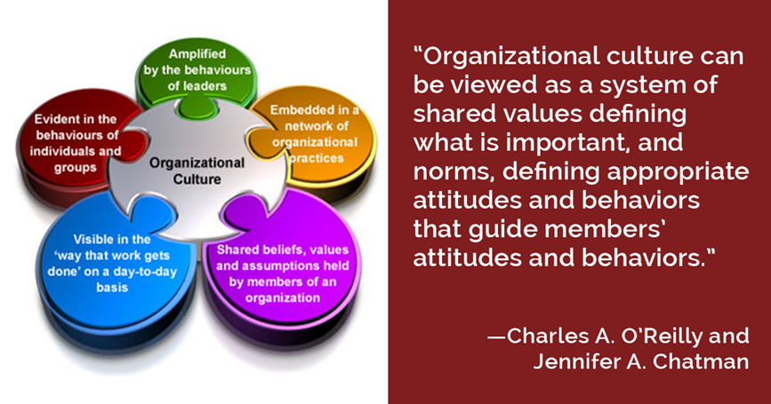

Fig. 1 Organisational Culture Definition
Source: https://gelinasjames.com/why-your-organizations-culture-matters/
The organizational culture it is extremely important for the prosperity and health of a company, for the employees, and company’s customers. It is therefore useful to spend quality time contemplating why the company's culture is the way it is, and why it is important that it stays that way (or improve it). It is the quality that ties the company together and protects it from drifting apart, the quality gives to the company power to deal with tough challenges, the quality that makes it stand out from the rest. Like people, companies have a distinct personality that they describe to as ' culture. ' It's an unseen but strong force that keeps the thoughts and beliefs of any of its employees. It is a structure of common values, beliefs, and objectives. Organizational culture has a massive impact on the business's ability to compete and make it big throughout the competitive society we live in today (Sun, 2008).
There are some valuable reasons why organisational culture has an essential role in the effectiveness of any enterprise:
- Stability
Absence of interest and motivation has been one of the main reasons why some people are sometimes unhappy at work and why they leave their jobs to search for better opportunities. Organizational culture, by its existence, guarantees that the aim of its individuals is consistent with the aim of the organisation. And, this consistency of objectives and mindset helps the individuals to work effectively, to be auto directed, and also to be committed to the company to which they belong (Moseley, 2019).
- Identity
' Identity ' and ' branding ' emerge from the culture of an organization and its employees. It's the people who make up the company, and it's the company that produces the ' brand value. ' And, we know how much the identity of the brand contributes in how well the market accepts it and how far it goes (Moseley, 2019)
- Sense of Direction
When a company has defined out its values goals and priorities, its employees have a clear plan in which to operate. They can differentiate right from wrong, relevant and irrelevant, and this consistency guarantees a centered way of working and a good use of the company's resources and time (Moseley, 2019)
- Business Success
Google Inc. is a company with a tangible organisational culture. One look at Google goods and workplaces around the world, few encounters with its staff, and we would realize what the company stands for, innovation and creativity. Building and operating Google's culture takes unwavering commitment, as Google's Developer Advocate Don Dodge describes in this blog post. However, the company knows by now that the key to its growth is its employees and the culture that they build and maintain (Beattie, 2018).

Google has a creative organisational culture. The organisation also highlights the importance of open-mindedness among workers as a means of promoting innovative thinking. The resulting innovation refers to Google's competing approaches in different industries. For example, the business is innovating on its technological funds and services to people in the internet advertising sector. The following factors describe the workplace culture of Google:
- Transparency
- Innovation
- Quality which comes with competence
- Hands-on strategy
- Small business-family relationship

Google's Organisational Culture
The company culture is the leading force behind the company's continued success in the information technology and internet advertising fields. The company’s organizational culture allows staff to share the information in support of innovation. Innovation has become a factor that allows the organisation to remain competitive with several other technology companies, such as Apple, Linkedin, IBM, Amazon.com, Microsoft, Intel, Twitter, and Snap Inc. (Snapchat). Google's organisational culture is unique to meeting the needs of the IT and online services sector. For instance, by means of the cultural trait of creativity, the organisation guarantees that its goods follow regulatory standards and are at the forefront of technological advancement. These factors lead to the strong points set out in the SWOT analysis of Google LLC. As one of the largest technology companies on the world market, the business is an example of successful managerial structure and human resource advancement in the culture of the company. The further intensification of information sharing is a possible improvement in Google's organisational culture. At present, even if the business's cultural aspects endorse contact and information sharing, such sharing takes place in a controlled way (Smithson, 2018).

PESTEL and SWOT Analysis
A PESTEL analysis is a method or technique used by companies to evaluate and track macro-environmental (external marketing) factors that has an influence on the company. While conducting such an evaluation, it is vital that the factors affecting the organisation are not only established but also evaluated. For example, what effect could they have on the organisation? PESTLE analysis is the foundation for the evaluation and study of the external environment for a company. The structure describes six important areas that need to be addressed when trying to identify the causes of change (James et. al, 2010).
These six dimensions are:
- Political
Types of political factors could include a possible new election, subsequent changes to policies and strategies, or the creation of a new government scheme. These can be restricted to the native country where the company works, but this appears to be hard to find these days as a lot of changes have an impact in various countries. The growth of entities such as the European Union and the rise of global commerce and international corporations has altered the scope of political activity. These have doubled the potential for political matters that could have an impact on the company and how it functions (Tanya Sammut-Bonnici, 2015).
- Economical
Economic factors are indicating how successful is the economy of a certain country. Factors involve growth in the economy, interest rates, inflation, household disposable income and rates of unemployment. Such factors could have a negative or positive long-term effect on a business because they influence customer buying power and might potentially change demand-supply processes in the economy. Therefore, this also influences the way businesses value their services and goods (Tanya Sammut-Bonnici, 2015).
- Social
This aspect of the environment in general reflects the social background, standards, traditions, and principles of the community in which the company performs. It involves demographic trends like rate of population growth, age spread, distribution of income, job habits, protection emphasis, health awareness, lifestyle behaviors and cultural differences. Such considerations are particularly important for advertisers when approaching those consumers. In fact, there is something regarding the local workforce and their desire to work in certain circumstances (Tanya Sammut-Bonnici, 2015).
- Technological
Such considerations apply to technological innovations that can have a positive or negative impact on the operations of the industry and the market. It applies to technological opportunities, the scale of innovation, robotics, research and technology programmers, changes in technology and the level of technical knowledge that the consumer enjoys. Such variables drive change on whether to join some markets, to release or not to release certain goods or to outsource manufacturing operations internationally. Through understanding what is going on in terms of technology, a company might be able to avoid the business from spending a fortune on creating a product that would quickly become outdated due to rapid changes in technology abroad (Tanya Sammut-Bonnici, 2015).
- Environmental
Environmental factors have only recently come to the surface. These are now essential given the increasing lack of raw resources, the limits for emissions and the targets set by governments for carbon footprint. Such aspects involve ecological and environmental characteristics such as climate, global warming, environmental compensation, and climate change, that may have an impact on businesses such as hospitality, agriculture, forestry, and healthcare. In addition, raising awareness of the possible effects of climate change is going to change the way businesses operate and the goods they sell (Tanya Sammut-Bonnici, 2015).

- Legal
Even if some of these aspects coincide with political factors, they provide more specific legislation like the law on racism, corruption, labor law, consumer safety, patent and copyright law, and the law on health and safety. It is obvious that businesses must understand about what is or is not legal to compete efficiently and ethically. If a company sells worldwide, this is particularly difficult because each state has its own set of regulations and rules. In general, a company would like to be informed of any forthcoming legislative changes and the effects that could have on the business in the future. It is important that company have a legal adviser or a lawyer to assist the organisation with this kind of stuff.

The PESTLE analysis of GOOLE 2019
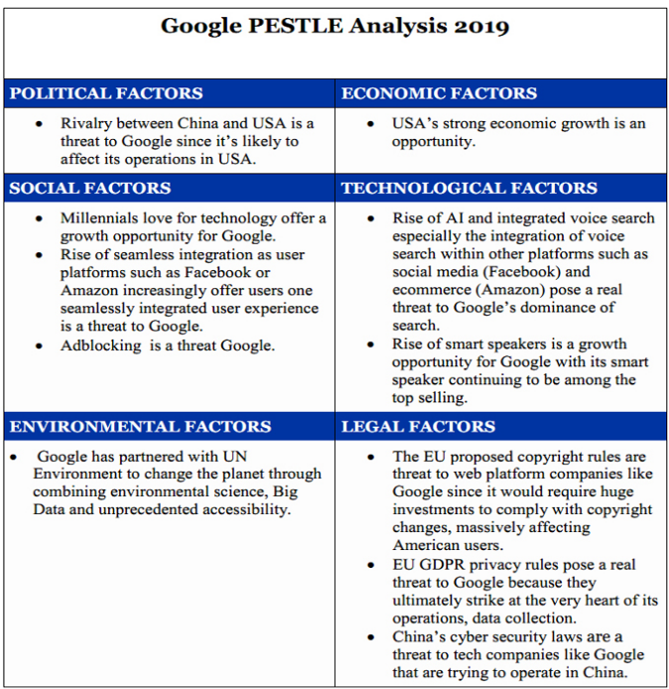

Fig.2 Google PESTLE Analysis 2019
Source: https://www.123writing.com/sample/pestle-and-swot-analysis-of-google-2019
Political environment
The rivalry between China and the USA
The friction between China and the US has escalated over 2017 due to increased trade tensions, intellectual property theft charges, military showdowns and diplomatic ill-will. Chinese businesses are important to the open technology platform where companies like Facebook, Google and Microsoft are using to make servers and other data center tools a major threat. As shown in a study by Wojazer, Google's new partnership with Huawei was challenged by US senators, alleging that it poses a significant threat to US national safety. This big competition is a challenge to U.S. multinational technology companies that have built alliances with companies in China because it will influence their U.S. activities. Trump has inflicted $60 billion tariffs on goods made in China every year, a challenge to technology companies such as Google (Kush, 2019).
Economic environment
US strong economic growth
Strong economic growth in the US tends to provide growth prospects for companies such as Google. The U.S is the world's top GDP economy, with GDP growth of 4.1 per cent year-on-year by 1 per cent in the second period of 2018 at 5 per cent, up from 0.5 per cent in the first quarter of 2018. Employment growth, real wage growth and tax reductions offer customers the freedom to buy and trust. Changes in consumer trust are associated with changes in consumer spending, where buyers are optimistic regarding the current economic situation and their personal situation, they consume more. This is therefore a chance for Google to expand, as more clients should be able to purchase its services (Kush, 2019).
Social environment
Ad-blocking
One of the most common challenges faced by Google is the rise of user blockades. Although Google has introduced adblocking in Chrome, customers irritated by displaying ads from online marketers are gradually turning to adblocking apps and plugin add-ons as they try ad-free viewing experience.
The threat of seamless integration
The larger challenge Google sees seems to be the increase of tight integration as user sites like Amazon or Facebook continually give customers a fully integrated customer experience. For example, Facebook already provides its customers social media feeds, retail feedback, searches, and a platform from which they can purchase without leaving the site. Also, Amazon customers can navigate the store via Alexa voice control and had any product purchased and shipped on a single platform. It's this smooth unification that compresses multiple procedures into a several phases that constitute a risk to Google, as consumers are starting to look for browsing experiences powered by the convergence of search, voice control, social networks, and e-commerce everything under a single platform (Kush, 2019).
Technological environment
The rise of AI and integrated voice search
Machine intelligence is a phenomenon which is affecting our daily lives in a range of ways, from buying, scheduling taxis, and engaging with clients care services among many others. ding to certain studies, the AI market is expected to grow between $50 billion and $100 billion within the next 3 years. Through AI, apps and services are rapidly combined with voice command features in a way that clearly bypasses Google search, a move driven by Amazon, that is guiding the way for the future with Amazon Echo voice control tech combined with Alexa's help. Although voice control alone cannot lead to the destruction of Google, it is the connectivity of voice search across other sites such as social media (Facebook) and e-commerce (Amazon) which represents a real menace to Google's supremacy. New devices, particularly smartphones, laptops, and smart speakers, may now conduct voice searches. This may clarify why Google had to launch Google Home in 2017 to achieve a position in a movement that saw big technology companies enter the hunt, like Apple with Siri, Microsoft with Cortana, and Facebook with Portal (Kush, 2019).

Legal environment
China’s cybersecurity laws
The legislation always requires internet providers to collaborate with China’s crime and security law enforcement officials and to offer full access to information. To be able to obey the law, foreign investors will be investing in new data servers in China or face additional fees by recruiting new service providers, that will, in any case, subject them to government inspections. This is indeed a challenge to technology companies like Google who are struggling to succeed in China (Kush, 2019).
SWOT Analysis
The SWOT analysis assesses organisational strengths and weaknesses and potential opportunities and threats in the company's climate. This analysis was by Albert Humphrey during a research project at Stanford University between 1960s and 1970s. Internal analysis recognises assets, abilities, competencies, and competitive advantages through a functional strategy to finance, leadership, services, distribution, production, marketing, reputation, and innovation review. Internal analysis is crucial in determining the root of the competitive advantage. This defines the assets which need to be improved in order to stay competitive. The external analysis recognizes market opportunities and threats when looking at the competitive environment, the business climate, and the general environment. The purpose of the SWOT analysis is using the information that the company has about the climate and to develop the plans accordingly (Fine, 2009).

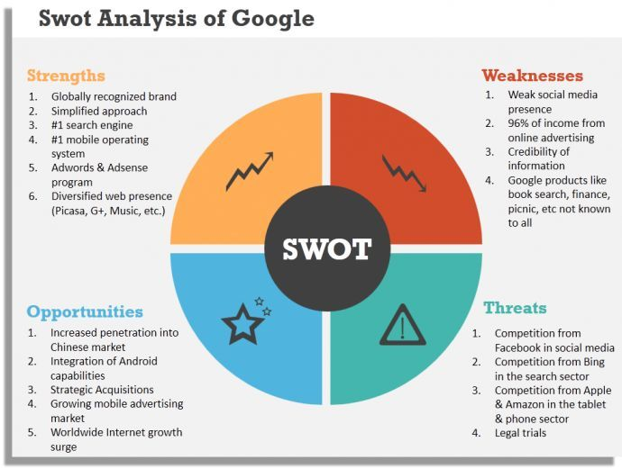
Fig. 3 Google Swot Analysis
Source: Google

The impact of environmental factors on Google’s culture and performance
Information and education are crucial element in human growth. Google is a representative of culture that is increasingly global because its objective is to arrange information around the world by making widely accessible and helpful to everyone. Even if Google achieves almost all its income online, the organisation is subject to external environmental or ecological factors (Dudovskiy, 2017). Ecological / environmental conditions affects company’s operational strategy in the PESTEL / PESTLE research model. These are the environmental external factors that are meaningful in the remote / macro climate of Google
- International propagation of environmentalism (possibility)
- Increasing awareness in successful business (opportunity)
Google is the one who has opportunity to highlight such specific ecological and environmental factors. The core idea is to enhance the effect on the environment. By doing this , Google may predict strengthened client reactions based on good perceptions of the company's ecological and environmental efforts.
Legal Factors
Google must work under legal boundaries. In the PESTEL / PESTLE research process, legal obligations have an effect on what companies may do. Below are the key legal external influences within Google's remote and macro environment:
- Much more rules on data privacy (possibility)
- Additional restrictions on intellectual property rights (opportunity)
Google must take advantage of every opportunity on the basis of these specific legal requirements. For instance, the business should enhance its confidentiality measures in order to protect individual customers. Google could also create groundbreaking strategies to stop people from infringing copyrights.
Google's PESTEL / PESTLE analysis suggests that almost all external influences in the remote and macro-environment of the business are incentives. In order to keep the strategic advantage of the business, the organisation should concentrate on utilising these incentives. For instance, Google could use its culture of creativity to build skills like increased functionality of Google apps and services to smartphones. Google may anticipate tougher competition and impact in the sector to properly address the opportunities recognised throughout this PESTEL / PESTLE analysis (Dudovskiy, 2017).

Google Ethical Behavior
Google has always been successful in promoting healthy ethical behavior inside the industry. Google is no better than many other companies today who are trying to strike a balance among company management and social responsibility while promoting a climate that recruits and preserves ethical management across the company. The broader their global influence, the more difficult it will be for Google to comply ethically (Brooks, 2018).

Google social responsibility
Google's stakeholders are varied due to the current business's variety of goods. The business's diversity involves the initial goods, like Google Search, but also latest goods like Google Fiber and Google Glass Web and broadcast television services. Stakeholders of the company belong to different communities that have had an influence on these complex companies. To continue to keep its strong leadership as a revolutionary tech company, Google should highlight the desires of its stakeholders via appropriate corporate social responsibility (CSR) regulations. The current CSR actions of the business are rigorous and acceptable, based on global expectations and standards. There is still work to be done in all of these CSR measures to make Google a heavier competitor in the world stage (Google , 2018).

Conclusion
This report shows that the organizational culture does have a profound effect on the diverse process of organisations, staff and their efficiency. It also explains the multiple dimensions of culture. This also shows that if workers are dedicated, have the same standards and value with each organisation, they could improve their efficiency towards accomplishing the overall organisational objectives. Further work could be conducted in this field to understand the complexity and capacity of culture to influence the organization's results. Executives and representatives are suggested to build a solid organisational culture in order to greatly improve efficiency of workers and the organisation.

Bibliography
Ali, S. A., 2018. The Fundamentals of Organisational Structure. [Online]
Available at: https://www.researchgate.net/publication/322854742_The_Fundamentals_of_Organisational_Structure
[Accessed 10 December 2019].
Al-Qatawneh, M. I., 2014. The Impact of Organizational Structure on Organizational Commitment: A Comparison between Public and Private Sector Firms in Jordan. European Journal of Business and Management , 6(12).
Battelle, J., 2005. The Birth of Google. [Online]
Available at: https://www.wired.com/2005/08/battelle/
[Accessed 10 December 2019].
Beattie, A., 2018. The Story Behind Google's Success. [Online]
Available at: https://www.investopedia.com/articles/personal-finance/042415/story-behind-googles-success.asp
[Accessed 18 December 2019].
Brooks, R., 2018. Workplace Spotlight: What Google Gets Right about Company Culture. [Online]
Available at: https://peakon.com/blog/workplace-culture/google-company-culture/
[Accessed 7 January 2020].
Dudovskiy, J., 2017. Alphabet (Google) PESTEL Analysis: Company’s Growing Ability to Impact External Factors. [Online]
Available at: https://research-methodology.net/google-pestel-analysis-2/
[Accessed 8 January 2020].
Fine, L. G., 2009. The SWOT Analysis Using your Strength to overcome Weaknesses, Using Opportunities to overcome Threats. [Online]
Available at: http://lawrencefine.com/downloads/SWOT%20-%20PDF.pdf
[Accessed 7 January 2020].
Google , 2018. Google Environmental Report. [Online]
Available at: https://sustainability.google/reports/environmental-report-2018/
[Accessed 8 January 2020].
J. Clement, 2019. Market capitalization of the biggest internet companies worldwide as of June 2019 (in billion U.S. dollars). [Online]
Available at: https://www.statista.com/statistics/277483/market-value-of-the-largest-internet-companies-worldwide/
[Accessed 10 December 2019].
James Cadle, D. P. a. P. T., 2010. BUSINESS ANALYSIS TECHNIQUES 72 Essential Tools for Success. s.l.: British Informatics Society Limited (BISL).
Juneja, P., 2015. Work Culture - Meaning, Importance & Characterics of a Healthy Culture. [Online]
Available at: https://www.managementstudyguide.com/work-culture.htm
[Accessed 1 January 2020].
Kenton, W., 2019. Organizational Structure. [Online]
Available at: https://www.investopedia.com/terms/o/organizational-structure.asp
[Accessed 11 December 2019].
Kush, P. K. M. &. J., 2019. Pestle and Swot Analysis of Google 2019. [Online]
Available at: https://www.123writing.com/sample/pestle-and-swot-analysis-of-google-2019
[Accessed 2 January 2020].
Marie-Joelle Browaeys, R. P., 2011. Understanding Cross-Cultural Management. 2nd ed. s.l.:Financial Times/ Prentice Hall.
Moseley, C., 2019. 7 reasons why organizational culture is important. [Online]
Available at: https://blog.jostle.me/blog/why-is-organizational-culture-important
[Accessed 17 December 2019].
Schein, E. H., 2010. Organizational Culture and Leadership. 4th ed. s.l.:John Wiley & Sons.
Skyler, H., 2018. Google's Organizational Structure. [Online]
Available at: https://bizfluent.com/about-6692920-google-s-organizational-structure.html
[Accessed 11 December 2019].
Smithson, N., 2018. Google’s Organizational Culture & Its Characteristics (An Analysis). [Online]
Available at: panmore.com/google-organizational-culture-characteristics-analysis
[Accessed 18 December 2019].
Sun, S., 2008. Organizational Culture and Its Themes. International Journal of Business and Management, 3(12).
Tanya Sammut-Bonnici, D. G., 2015. PEST analysis. [Online]
Available at: https://www.researchgate.net/publication/257303449_PEST_analysis
[Accessed 2 January 2020].
Tran, S. K., 2017. GOOGLE: a reflection of culture, leader, and management. International Journal of Corporate Social Responsibility.

