
University of Wales Trinity Saint David

Empathic Design and Working Alliance in Human-AI Wellbeing Interactions: A Randomised Experimental Study

COURSE CODE: MSC12MSC-APY
Applied Psychology Master Project
2025/26

By
Rhiannon Sigrist
2219662
A Master’s Project
Submitted to University of Wales Trinity Saint David
MSc Applied Psychology
Submitted 30/09/2026

Declarations
This work has not previously been accepted in substance for any degrees and is not being concurrently submitted in candidature for any degrees.

Signed …… …………………………………….
Date …………26/09/2026………………………

STATEMENT 1
This dissertation is being submitted in partial fulfilment of the requirements for the degree of MSc Applied Psychology
Signed ……… ……………………………………………………….
Date ………………26/09/2026………………………………………

STATEMENT 2
This dissertation is the result of my own independent work/investigation, except where otherwise stated. Other sources are acknowledged by giving explicit references. A reference list is appended.
Signed ………. …………………………………………………….
Date ……………26/09/2026………………………………………

STATEMENT 3
I hereby give consent for my dissertation, if accepted, to be available for photocopying and for inter-library loan, and for the title and summary to be made available to outside organisations.
Signed ……………………………………………………………….
Date ………26/09/2026……………………………………………

Acknowledgements
I would like to express my sincere gratitude to my dissertation supervisor, Dr Paul Hutchings, for his guidance, thoughtful feedback, and support throughout this project. I am especially thankful for the trust he placed in me to shape and lead this research independently, giving me the space to make it truly my own while always being there when I needed direction. His expertise and encouragement have been invaluable to both the research and my development as a researcher.
I would also like to thank my lecturers in the MSc Applied Psychology programme at UWTSD for their support and commitment throughout my studies. I am particularly grateful to Dr Katie Sullivan and Dr Zoe Cooke, whose practical sessions pushed me out of my comfort zone and challenged me to produce my best work, and who taught me to drop the script and simply be present and myself. My thanks also go to Dr Ceri Phelps, who was always there when I needed to talk through my worries and who, with kindness and honesty, set me straight when I needed it most.
I owe a special thank you to Nathan Morgan for his exceptional technical expertise and dedication in developing the RAIYU agent. Beyond the many hours he devoted to building and refining the code, he was a constant sounding board, helping me work through ideas and turn them into a working reality. This study would not have been possible without him.
I am profoundly grateful to my family for their steadfast support and encouragement, particularly during times when I questioned my own capabilities. Balancing the responsibilities of motherhood with the demands of postgraduate study has been a considerable challenge, and their patience, understanding, and unconditional love have been indispensable throughout.
Finally, I would like to express my heartfelt thanks to all the participants who generously took part in this study. Their contributions have been vital to the completion of my dissertation, and for that, I am deeply grateful.

AI Acknowledgment
I acknowledge the use of Claude (claude.ai) throughout the development of this dissertation to assist with structuring arguments, drafting and refining sections, reviewing documents for consistency, and preparing supporting materials. I also used it to check for errors in readability, grammar, and syntax, and to review the reference list for APA 7th edition formatting.
In all cases I have reviewed, critically evaluated, and taken responsibility for all AI-assisted content. I confirm that I have not presented any AI-generated text as my own unmediated work. I confirm I have copies of my drafts, notes, and other resources used before and after the use of AI tools, which I may be asked to provide in evidence.
Contents
Acknowledgements 4
AI Acknowledgment 5
Abstract 8
Chapter 1 – Introduction 9
1.1 The Mental Health Access Gap and the Rise of Digital Intervention 9
1.2 The Working Alliance and the Central Role of Empathy 10
1.3 The Digital Working Alliance: Promise and Limitation 11
1.4 The Empathy Problem in Artificial Agents 12
1.5 Research Questions and Hypotheses 14
Chapter 2 – Methodology 15
2.1 Participants 15
2.2 Design 16
2.3 Materials and Measures 16
2.4 Procedure 17
2.5 Data Analysis 18
Chapter 3 – Results 20
3.1 Participant Characteristics and Preliminary Analyses 20
3.2 Quantitative Findings 22
3.2.1 Working Alliance Between Conditions 22
3.2.2 Change in Positive and Negative Affect 23
3.2.3 Working Alliance as a Predictor of Affective Change 24
3.3 Participants' Experiences of the Interaction (Qualitative) 25
3.4 Integration of Quantitative and Qualitative Findings 28
Chapter 4 – Discussion 30
4.1 Overview of Findings 30
4.2 Empathic Design and Working Alliance 30
4.3 Qualitative Insights: The Relational Experience of AI Empathy 32
4.4 Theoretical and Applied Implications 33
4.5 Limitations and Future Directions 34
4.6 Conclusion 35
References 36
Appendix 40
Appendix 1: Demographics 40
Appendix 2: Positive and Negative Affect Schedule – Short Form (PANAS-SF; Thompson, 2007) 40
Appendix 3: Working Alliance Inventory – Short Revised (Hatcher & Gillaspy, 2006) 40
Appendix 4: System Usability Scale (SUS; Brooke, 1996) 41
Appendix 5: Global Helpfulness Item 42
Appendix 6: Final Open-Ended Question 42
Appendix 7: RAIYU Technical Architecture 42
7.1 Architecture Overview 43
7.2 Behavioural-Empathic System Prompt 43
7.3 RAG Knowledge Base 45
7.4 Safety Oversight and Crisis Detection 45
Appendix 8: RAG Knowledge Base Source Documents 45
Appendix 9: Thematic Analysis: Full Coding Extracts by Theme 48
Appendix 10: Participant Information Sheet 67
Appendix 11: Consent Form 67
Appendix 12: Debrief Form 68

Abstract
Mental health services face a growing access crisis, with waiting times for specialist psychological support frequently exceeding six months (Mind, 2024; NHS, 2022; World Health Organization, 2022). Scalable digital interventions have been proposed as low-intensity interim support, yet persistent engagement challenges and weak relational quality limit their effectiveness. The working alliance, comprising goal agreement, task agreement, and affective bond, is the most robust predictor of outcomes in human-delivered therapy, yet no controlled experimental study has examined whether empathic design produces meaningful alliance perceptions in human-AI interaction. This study employed a randomised between-subjects design comparing an empathy-engineered conversational agent, RAIYU, against a baseline large language model sharing identical architecture. RAIYU incorporated behavioural-empathic communication strategies, retrieval-augmented generation for clinical grounding, and an automated behavioural health safety filter (Nelson et al., 2025). Sixteen participants were randomly assigned to conditions. Perceived working alliance and short-term affective change were measured using the Working Alliance Inventory – Short Revised (WAI-SR) and the Positive and Negative Affect Schedule – Short Form (PANAS-SF). An optional concurrent think-aloud protocol generated qualitative data analysed using reflexive thematic analysis. RAIYU produced higher, though non-significant, working alliance scores than the baseline condition, particularly for goal agreement, and higher alliance significantly predicted a greater increase in positive affect, with a non-significant association with reduced negative affect. Qualitative analysis identified five themes, including perceived empathic responsiveness, relational engagement, and interactional breakdowns. Findings are discussed in relation to the responsible design of empathic AI systems for digital mental health, with implications for cyberpsychology and clinical practice.
Keywords: working alliance, empathic design, conversational agent, digital mental health, large language model, retrieval-augmented generation

Chapter 1 – Introduction

1.1 The Mental Health Access Gap and the Rise of Digital Intervention
Mental disorder represents one of the most significant contributors to the global burden of disease. The World Health Organization estimates that approximately one in seven people experience a mental disorder annually, yet treatment access remains severely constrained across both high- and low-income settings (GBD 2019 Mental Disorders Collaborators, 2022; World Health Organization, 2022). In the United Kingdom, this systemic strain is particularly acute: waiting times for specialist psychological support frequently exceed recommended targets, and in Wales, individuals commonly wait six months or more before accessing professional care (Mind, 2024; NHS, 2022). For many, this gap represents a period of unmet need during which even low-intensity support is absent.
In response, conversational agents and large language model (LLM)-based systems have attracted growing research and policy interest as scalable forms of low-intensity interim support. This interest is empirically grounded: a recent systematic review and meta-analysis of 18 randomised controlled trials found that AI-based chatbot interventions produced small but statistically significant short-term reductions in depression (Hedges' g = −0.26) and anxiety (g = −0.19) symptoms, positioning such tools as viable components of a stepped-care model capable of bridging periods of treatment absence (Zhong et al., 2024). However, effects did not persist beyond three months, and the question of what determines whether a digital intervention produces meaningful benefit remains unresolved.
A critical part of the answer lies in engagement. Meta-analytic evidence consistently demonstrates that smartphone-based interventions experience high attrition and limited sustained user engagement (Baumel et al., 2019; Firth et al., 2017). A systematic review examining 31 studies across engagement, attitude, and effectiveness domains found that empathic and relational process qualities, rather than content features or technical sophistication, consistently emerge as the primary drivers of positive engagement and acceptability in mental health chatbots (Limpanopparat et al., 2024). This reframes the central design challenge: the limitation of digital mental health tools is not primarily informational but relational. It is the absence of meaningful felt connection that drives disengagement, which positions the therapeutic working alliance, historically the most robust relational predictor of psychological outcomes, as the appropriate conceptual lens through which to evaluate and improve these technologies.

1.2 The Working Alliance and the Central Role of Empathy
The concept of the therapeutic working alliance provides the theoretical foundation of this study. Bordin (1979) proposed a pan-theoretical model comprising three interlocking components: agreement on therapeutic goals, agreement on the tasks through which those goals are pursued, and the development of an affective bond characterised by trust and mutual regard between helper and recipient. Critically, Bordin argued that this tripartite structure generalises across therapeutic orientations, making it one of the most broadly applicable frameworks in psychological research and the most appropriate lens through which to evaluate human-AI wellbeing interactions.
The empirical significance of this framework is well established. A comprehensive meta-analytic synthesis found a consistent, moderate association between alliance quality and therapeutic outcomes across modalities, populations, and measurement approaches (Flückiger et al., 2018). Of the three components, the bond facet (the felt sense of connection, warmth, and psychological safety between helper and recipient) represents the most fundamentally relational dimension of the alliance and is theorised to be the primary vehicle through which it exerts its clinical influence.
Central to the formation of this bond is empathy. A meta-analysis synthesising evidence across hundreds of studies found that therapist-offered empathy is a robust and replicable predictor of client outcomes, with effects generalising across therapeutic modalities and client presentations (Elliott et al., 2018). Importantly, empathy in this context is not reducible to surface-level warmth or emotional mirroring; it encompasses an active orientation toward understanding the client's subjective experience and communicating that understanding in ways that foster felt safety and collaborative engagement. It is through this process that the alliance gains its capacity to produce affective change, a relationship this study operationalises through pre- and post-interaction administration of the WAI-SR and PANAS-SF.
This raises a fundamental question for digital mental health: whether relational processes grounded in perceived empathy can be meaningfully reproduced when the helper is not a human therapist but an artificial agent. Answering this requires both a theoretical account of why such bonds might form with AI and empirical evidence that they can.

1.3 The Digital Working Alliance: Promise and Limitation
The theoretical foundation for expecting meaningful relational bonds to form between users and artificial agents lies in human-computer interaction research. Bickmore and Picard (2005) demonstrated through a series of experimental studies that individuals naturally apply social expectations and relational norms to interactive technologies, and that genuine relational perceptions (including trust, rapport, and felt connection) can be deliberately engineered through socially attuned design. This finding, consistent with the Computers Are Social Actors paradigm (Nass et al., 1994), provides the theoretical licence for applying Bordin's (1979) alliance framework to human-AI interaction: if users respond to computers as social agents, then the three-component model of goals, tasks, and bond may be meaningfully operationalised in digital contexts.
Empirical evidence supports this proposition. A mixed-methods evaluation of the Wysa conversational agent found that users reported meaningful alliance-like perceptions following chatbot interaction, demonstrating that the WAI-SR can yield interpretable and clinically coherent data in human-AI dyads (Beatty et al., 2022). Qualitative evidence from early pilot trials similarly indicates that users can develop spontaneous relational perceptions with conversational agents, with participants describing interactions as genuine relationships and the chatbot as a trusted social presence (Ly et al., 2017). Together, these findings suggest that a digital working alliance is not merely a theoretical possibility but an empirically observable phenomenon.
However, the strength of this phenomenon remains a significant limitation. The most current and comprehensive synthesis of evidence confirms that while alliance-like perceptions can form in digital contexts, they remain substantially weaker than those observed in human-delivered therapy, raising fundamental questions about whether current AI systems can replicate the relational processes that drive therapeutic change (Malouin-Lachance et al., 2025). Compounding this is the documented tendency of users to resist AI in healthcare contexts: individuals consistently perceive AI-delivered support as less trustworthy than equivalent human provision regardless of objective quality, a phenomenon attributable to ingrained assumptions about machine capability and the absence of genuine understanding (Longoni et al., 2019). Together, these findings suggest that the digital alliance gap is not merely a technical problem but a deeply psychological one, rooted in the difficulty of producing the kind of felt empathy that drives bond formation in human therapy. Understanding why this quality eludes artificial agents, and whether it can be deliberately engineered, is the focus of the following section.

1.4 The Empathy Problem in Artificial Agents
The preceding sections establish that the working alliance is central to psychological change, that perceived empathy is the mechanism through which the bond facet forms, and that digital alliance (while possible) remains substantially weaker than its human counterpart. A critical explanation for this gap lies in the fundamental nature of large language models. LLMs produce text probabilistically, selecting outputs based on statistical patterns in training data rather than through genuine emotional understanding or relational attunement. Responses that are statistically plausible as empathic may simultaneously fail to be contextually appropriate, therapeutically grounded, or experienced as authentic by the recipient. Recent evaluations of generative AI systems in mental health-adjacent contexts have raised concerns regarding inconsistent emotional responsiveness, hallucinated information, and inadequate responses to expressions of distress (Hua et al., 2025; Torous et al., 2025).
A particularly significant manifestation of this limitation is the safety-empathy gap: the documented tendency of AI systems designed to be supportive to prioritise apparent warmth over appropriate clinical boundaries when users disclose distress. Pichowicz et al. (2025) identified significant failures in standard LLMs detecting and managing expressions of suicidal ideation, with systems producing responses that validated distress rather than redirecting to appropriate support. This finding underscores the risk of deploying generative AI in wellbeing contexts without validated safety governance, and motivates the integration of clinician-informed oversight in responsible system design.
However, the problem of AI empathy extends beyond safety. Even where systems produce linguistically appropriate empathic responses, these frequently fail to feel genuine. Seitz (2024) demonstrated through a series of experimental studies that affective and sympathetic responses from healthcare chatbots (those expressing emotional resonance or feeling for the user) paradoxically reduced perceived authenticity by conflicting with users' cognitive schemas of machine capability. Critically, this authenticity cost was substantially attenuated by behavioural-empathic responses: instrumental expressions of care and helping intent that align better with users' expectations of AI while still producing warmth and trust.
This finding directly informs the design of RAIYU, which deliberately prioritises behavioural-empathic strategies (active listening, validation, and collaborative goal orientation) over affective mirroring, while integrating a validated automated safety filter (Nelson et al., 2025) to address the safety-empathy gap. Together, these design decisions constitute the empathic architecture evaluated in the present study.

1.5 Research Questions and Hypotheses
The preceding review identifies two interconnected gaps in the empirical literature. No controlled experimental study has directly manipulated empathic design features within a conversational agent to isolate their effect on perceived working alliance. The relationship between alliance perceptions and short-term affective outcomes in human-AI interaction remains unexamined. The present study addresses these gaps through the following research questions:
RQ1: Does interaction with an empathy-engineered conversational agent lead to higher perceived working alliance than interaction with a standard large language model?
RQ2: Is perceived working alliance associated with short-term affective change following interaction with the conversational agent?
Based on the theoretical and empirical literature reviewed, the following hypotheses are proposed:
H1: Participants interacting with RAIYU will report significantly higher post-interaction WAI-SR scores than those in the baseline condition.
H2: Participants in the RAIYU condition will demonstrate significantly greater reductions in negative affect from pre- to post-interaction, as measured by the PANAS-SF, compared with the baseline condition.

Chapter 2 – Methodology

2.1 Participants
Participants were staff and students aged 18 years or older, recruited from the University of Wales Trinity Saint David via convenience sampling, comprising individuals approached in person within university buildings and participants who signed up through the departmental Experimental Management System (EMS). A total of 16 participants were recruited and randomly assigned to conditions (n = 8 RAIYU, n = 8 Baseline). Prior to booking, participants were directed to a Participant Information Sheet which included a suitability statement advising individuals currently experiencing significant mental health difficulties that the study may not be appropriate for them at this time. All participants provided written informed consent prior to data collection, and course credit was awarded through the Research Participation Scheme regardless of whether participants completed or withdrew from the study.
A target sample of 60 to 80 participants was planned a priori, with approximately 30 to 40 allocated to each condition. A sensitivity power analysis for the primary between-group comparison of working alliance scores (independent-samples t test, α = .05, two-tailed, power = .80) indicates that this target could detect effects of d = 0.74 (N = 60) to d = 0.63 (N = 80), that is, medium-to-large effects; detecting a medium effect of d = 0.50 would have required 64 participants per condition (N = 128). Recruitment fell substantially short of this target: the achieved sample represents approximately 20 to 27% of the planned range. With 8 participants per condition, the achieved sample had 80% power only for effects of d > 1.51, and power of .15 to detect d = 0.50. Given the novelty of the research context, the study was treated as an initial investigation; the implications of the achieved sample size for statistical power and result interpretation are addressed throughout the Data Analysis section and revisited in Discussion Section 4.5.

2.2 Design
The study employed a randomised between-subjects design comparing two conversational AI conditions. The independent variable was agent type: an empathy-engineered conversational agent (RAIYU) versus a baseline large language model. Both conditions utilised the same underlying Gemma 4 architecture, ensuring that observed differences in outcomes are attributable to empathic design features rather than variations in model capability. The experimental manipulation was restricted to the system prompt and retrieval-augmented generation layer.
Primary quantitative dependent variables were post-interaction perceived working alliance, measured using the Working Alliance Inventory – Short Revised (WAI-SR; Hatcher & Gillaspy, 2006), and short-term affective change, measured using the Positive and Negative Affect Schedule – Short Form (PANAS-SF; Thompson, 2007). The System Usability Scale (SUS; Brooke, 1996) was administered post-interaction to control for usability confounds. An embedded qualitative component was generated through an optional concurrent think-aloud protocol (Ericsson & Simon, 1993), in which participants verbalised their thoughts and reactions during the interaction. Partial concealment was employed to reduce demand characteristics; participants were informed they were evaluating an AI wellbeing assistant but were not informed of their condition assignment or the primary study hypotheses until the post-interaction debrief.

2.3 Materials and Measures
The WAI-SR is a 12-item self-report measure assessing perceived working alliance across three subscales: bond, task agreement, and goal agreement, rated on a 7-point Likert scale (adapted; see Appendix 3; Hatcher & Gillaspy, 2006). The WAI-SR yields a total score ranging from 12 to 84 and three subscale scores (Bond, Goal, Task) each ranging from 4 to 28, with higher scores indicating stronger perceived working alliance. The measure was administered at two time points: before the interaction to capture relational expectations and after the interaction to assess perceived alliance. The PANAS-SF comprises 10 affect descriptors rated on a 5-point scale yielding positive and negative affect subscale scores (Thompson, 2007). The PANAS-SF yields separate Positive Affect and Negative Affect scores, each ranging from 5 to 25, with higher scores indicating greater intensity of that affect state (i.e., a higher NA score reflects more negative affect, not improvement). The measure was administered pre- and post-interaction to assess short-term affective change. The SUS is a 10-item instrument (Brooke, 1996) yielding a composite usability score from 0 to 100, with higher scores indicating better perceived usability; scores above the benchmark of approximately 68 are considered above average (Bangor et al., 2009). A single-item global helpfulness measure was administered post-interaction, asking participants to rate the overall helpfulness of the agent on a 7-point scale ranging from 1 (not at all helpful) to 7 (extremely helpful), providing a supplementary face-valid index of perceived utility (see Appendix 5) with higher scores indicating greater perceived helpfulness.
RAIYU was developed as a locally hosted implementation of the Gemma 4 series model, incorporating a structured behavioural-empathic system prompt and a retrieval-augmented generation pipeline anchoring responses in an evidence-based psychological knowledge base. The baseline condition utilised the same underlying model with a minimal neutral system prompt and no retrieval augmentation. An automated behavioural health safety filter (Nelson et al., 2025) was integrated across both conditions to monitor interactions in real time and redirect participants to crisis resources if high-risk language was detected.

2.4 Procedure
Eligible participants attended a single laboratory session of approximately 30–40 minutes. Upon arrival, participants read the Participant Information Sheet (see Appendix 10), provided written informed consent, and completed baseline measures in the following order: demographic questions, pre-interaction WAI-SR, and pre-interaction PANAS-SF. Participants were then randomly assigned via an automated algorithm to interact for approximately 10 minutes with either RAIYU or the baseline agent. A standardised prompt invited participants to discuss a recent source of stress or a current goal. Participants were given the option to engage in a concurrent think-aloud procedure, verbalising their thoughts and reactions during the interaction; this element was clearly described as voluntary and audio recording required separate consent. The automated safety filter monitored all interactions throughout the session.
Following the interaction, participants completed the post-interaction WAI-SR, post-interaction PANAS-SF, SUS, and global helpfulness item. Participants were also invited to provide brief written reflections on their experience via an open-ended question (see Appendix 6), offering supplementary qualitative data alongside the think-aloud transcripts. A full written debrief was then provided, disclosing the study aims, the nature of the comparison, and the participant's condition assignment, alongside a comprehensive list of psychological support resources and information regarding the one-month data withdrawal window.

2.5 Data Analysis
Quantitative analyses were conducted in R. Given the achieved sample of N = 16 against a pre-registered target of 60 to 80, analyses prioritise effect sizes and 95% confidence intervals over null hypothesis significance testing, and non-parametric alternatives (Mann-Whitney U, Wilcoxon signed-rank) are reported alongside each group comparison rather than being conditional on a formal normality check. Independent-samples t-tests compared post-interaction WAI-SR total and subscale (Bond, Goal, Task) scores between conditions, with Cohen's d and its 95% confidence interval reported as the effect size. Short-term affective change was examined using a 2 × 2 mixed-design analysis of variance, with time as the within-subjects factor and agent condition as the between-subjects factor, modelled separately for Positive and Negative Affect. Simple linear regressions explored the association between post-interaction working alliance and change in Positive and Negative Affect. Internal consistency (Cronbach's alpha) was calculated for the WAI-SR total, its three subscales, and the PANAS-SF subscales. All response records were reviewed for completion and response-pattern anomalies prior to analysis; four flagged cases were retained in the primary analysis given the small sample, and a sensitivity analysis excluding them is reported alongside the primary working alliance result. Qualitative data (session transcripts, written post-session reflections, researcher field notes, and think-aloud audio where recorded) were analysed using reflexive thematic analysis (Braun & Clarke, 2006), focusing on patterns relating to perceived empathic responsiveness, relational engagement, and interactional breakdowns.
A moderation analysis using the K10 was included in the pre-registered analysis plan (Open Science Framework [OSF]); this was not conducted, as the K10 was removed from the study design prior to ethics submission on the recommendation of the supervisory team, and was never administered to participants. Its inclusion in the OSF pre-registration was an error arising from an outdated draft document used when preparing that submission; this discrepancy was identified prior to data collection.

Chapter 3 – Results

3.1 Participant Characteristics and Preliminary Analyses
Sixteen participants completed the study and were retained in the final analytic sample (n = 8 RAIYU, n = 8 Baseline). Four response records showed data-quality anomalies, such as uniform response patterns across an entire scale; no participants were excluded on this basis, and Section 3.2.1 reports a sensitivity analysis with these cases removed. Demographics are summarised in Table 1 and were broadly comparable across conditions. Table 2 presents descriptive statistics for all outcome measures.
Distributional checks supported the choice of primary tests reported below: post-interaction WAI-SR and Positive Affect change scores approximated normality (Shapiro-Wilk, all p > .14), Negative Affect change scores did not (both p < .01), and variances for the primary alliance comparison were equal, Levene's F(1, 14) = 0.00, p = .977. Internal consistency was high for the WAI-SR (total α = .97; Bond α = .91, Goal α = .96, Task α = .98) and for PANAS-SF Negative Affect (α = .91 pre, .98 post); PANAS-SF Positive Affect was weaker, in the questionable-to-acceptable range (α = .67 pre, .79 post).
A single-item global helpfulness rating followed the same directional pattern as the alliance measure: participants rated RAIYU as more helpful on average (M = 5.00, SD = 2.39) than Baseline (M = 3.62, SD = 2.39). The difference was not statistically significant, t(14) = 1.15, p = .269, d = 0.58.
Table 1
Participant Demographics by Condition
 |  | Baseline (n = 8) | RAIYU (n = 8)
Age, M (SD) | 39.5 (17.8) |  | 40.5 (16.7)
Men | 3 |  | 3
Women | 4 |  | 5
Prefer to self-describe | 1 (Agender) |  | 0
Note. One participant in the Baseline condition selected "Prefer to self-describe" and specified "Agender."
Table 2
Descriptive Statistics for Outcome Measures by Condition
Measure | Time | Baseline M (SD) | RAIYU M (SD)
WAI-SR Total | Pre | 41.12 (15.41) | 48.12 (23.19)
 | Post | 43.12 (25.77) | 56.88 (24.84)
WAI-SR Bond | Post | 14.00 (8.59) | 16.75 (9.78)
WAI-SR Goal | Post | 13.75 (8.81) | 20.25 (7.96)
WAI-SR Task | Post | 15.38 (9.02) | 19.88 (9.45)
PANAS-SF PA | Pre | 12.12 (3.80) | 12.00 (3.21)
 | Post | 12.62 (4.14) | 15.25 (4.83)
PANAS-SF NA | Pre | 7.00 (2.88) | 9.12 (6.56)
 | Post | 7.50 (3.25) | 7.62 (7.03)
SUS Total | — | 85.94 (8.65) | 90.31 (8.28)
Note. WAI-SR = Working Alliance Inventory–Short Revised; PANAS-SF = Positive and Negative Affect Schedule–Short Form; PA = Positive Affect; NA = Negative Affect; SUS = System Usability Scale.
Usability was high in both conditions (Baseline M = 85.94, RAIYU M = 90.31) and comfortably above the SUS benchmark of approximately 68 (Bangor et al., 2009), so it is unlikely that usability differences confounded the alliance and mood results reported below.

3.2 Quantitative Findings

3.2.1 Working Alliance Between Conditions
A Welch t-test compared post-interaction working alliance between conditions. As hypothesised, RAIYU participants reported higher total alliance (M = 56.88, SD = 24.84) than Baseline participants (M = 43.12, SD = 25.77), t(13.98) = 1.09, p = .296, Cohen's d = 0.54, 95% CI [−0.47, 1.53]. Subscale analyses showed the same direction across all three facets: Goal produced the largest effect, t(13.86) = 1.55, p = .144, d = 0.77, 95% CI [−0.26, 1.78]; Task was intermediate, t(13.97) = 0.97, p = .347, d = 0.49, 95% CI [−0.52, 1.47]; and Bond was smallest, t(13.77) = 0.60, p = .560, d = 0.30, 95% CI [−0.69, 1.28]. None of these differences reached conventional significance, and the confidence intervals are wide enough to cross zero in every case, a direct consequence of N = 16. Mann-Whitney U tests showed the same pattern: total, U = 24.5, p = .462; Goal, U = 19.0, p = .189; Task, U = 22.5, p = .341; Bond, U = 27.5, p = .673. A sensitivity analysis excluding the four flagged cases (n = 7 RAIYU, n = 5 Baseline) produced a larger difference in the same direction (RAIYU M = 63.00, SD = 19.23; Baseline M = 42.20, SD = 22.23), t(7.91) = 1.69, p = .130, d = 1.02, 95% CI [−0.24, 2.22]; Mann-Whitney U = 8.5, p = .167. Excluding these cases therefore strengthened rather than weakened the RAIYU advantage, although it remained non-significant. RAIYU's advantage appeared to derive mainly from goal agreement. See Figure 1.
Figure 1
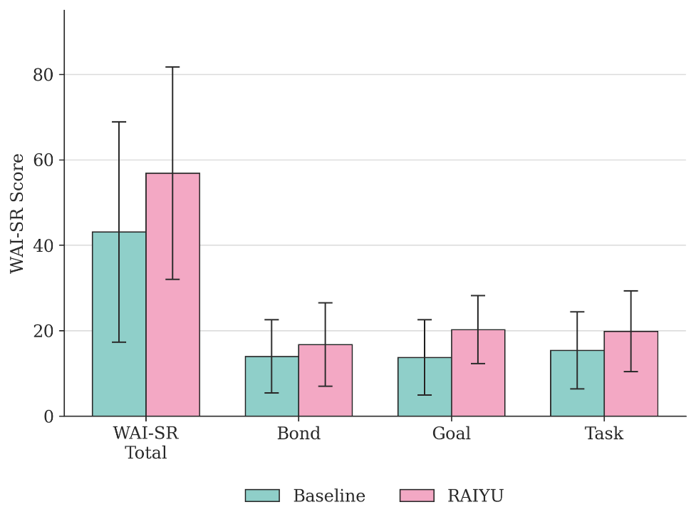
Working Alliance by Condition
Note. Error bars represent ±1 SD.

3.2.2 Change in Positive and Negative Affect
A 2 (Condition: RAIYU, Baseline) × 2 (Time: pre, post) mixed ANOVA examined mood change separately for Positive and Negative Affect. For Positive Affect, neither Condition, F(1, 14) = 0.56, p = .469, η²p = .038, nor Time, F(1, 14) = 2.80, p = .117, η²p = .167, reached significance, and the Condition × Time interaction was similarly non-significant, F(1, 14) = 1.50, p = .240, η²p = .097. This result carries a caveat: the Positive Affect subscale's internal consistency was comparatively weak (α = .67–.79), so it should be read cautiously. The Negative Affect results followed the same pattern: Condition, F(1, 14) = 0.20, p = .666, η²p = .014; Time, F(1, 14) = 0.55, p = .471, η²p = .038; interaction, F(1, 14) = 2.20, p = .161, η²p = .136. Negative Affect change scores departed from normality in both conditions (Shapiro-Wilk, both p < .01); non-parametric tests were therefore run as a check. Within each condition, Wilcoxon signed-rank tests showed no significant change in Negative Affect (RAIYU, V = 2, p = .345; Baseline, V = 3, p = .371) or Positive Affect (RAIYU, V = 22, p = .204; Baseline, V = 12, p = .833), and Mann-Whitney tests comparing change scores between conditions were also non-significant (Negative Affect, U = 45.0, p = .131; Positive Affect, U = 23.0, p = .370), corroborating the parametric results. See Figure 2.
Figure 2
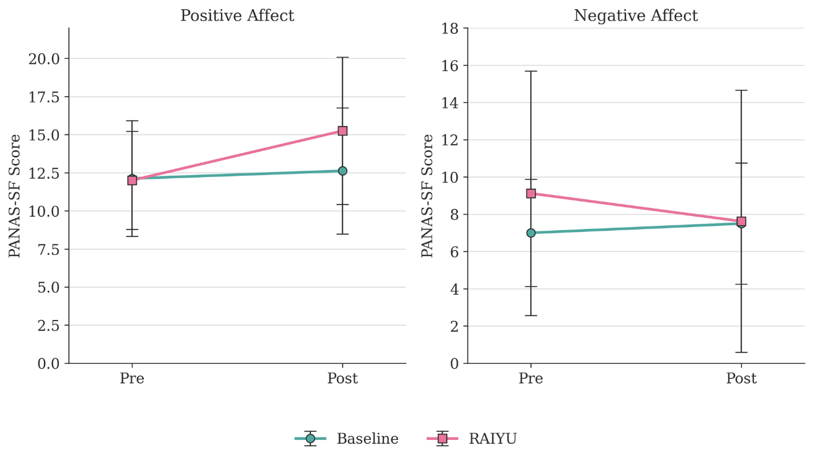
Pre-to-Post PANAS-SF Trajectories by Condition
Note. Error bars represent ±1 SD.

3.2.3 Working Alliance as a Predictor of Affective Change
A simple linear regression tested whether post-interaction working alliance (WAI-SR total) predicted change in Negative Affect, collapsed across condition (N = 16). The overall model fell short of conventional significance, R² = .17, F(1, 14) = 2.87, p = .112. Working alliance was negatively associated with Negative Affect change, b = −0.05, 95% CI [−0.10, 0.01], β = −0.41, t(14) = −1.70, p = .112: higher perceived alliance was associated with a larger reduction in negative affect, although the interval spans everything from a moderate negative association to a small positive one. Residual diagnostics showed marked non-normality (skew = −2.19, kurtosis = 8.40), driven substantially by one participant (Participant 10, RAIYU condition) with an atypically large reduction in negative affect (Cook’s D = 0.83). A percentile bootstrap of the slope (2,000 resamples), which does not assume normally distributed residuals, produced an interval that excluded zero, 95% CI [−0.11, −0.01]. Because a bootstrap still resamples the influential case, the model was also refitted without Participant 10: the association remained negative and of similar strength, β = −0.43, p = .114, R² = .18, indicating that its direction is not solely an artefact of that one case. Given N = 16, a single predictor, and this residual non-normality, the finding is best read as preliminary and hypothesis-generating rather than confirmatory.
The same model was run for Positive Affect change. Here, post-interaction working alliance significantly predicted change, R² = .45, F(1, 14) = 11.50, p = .004; b = 0.12, 95% CI [0.04, 0.20], β = 0.67, t(14) = 3.39: higher perceived alliance was associated with a larger increase in positive affect. Residuals did not depart from normality (Shapiro-Wilk p = .281), a percentile bootstrap interval also excluded zero, 95% CI [0.06, 0.20], and the association held with Participant 10 removed, β = 0.68, p = .005. This is the strongest association in the study, but it should be interpreted in light of the Positive Affect subscale's weaker internal consistency (α = .67–.79) and the small sample.

3.3 Participants' Experiences of the Interaction (Qualitative)
A reflexive thematic analysis (Braun & Clarke, 2006) was conducted on four qualitative data sources: session transcripts and post-session open-ended survey reflections from all 16 participants, researcher field notes taken during data collection, and audio transcripts of the concurrent think-aloud protocol. Eleven participants opted into the think-aloud, but audio was captured for five (two RAIYU, three Baseline), and one recording (Participant 1) was unusable, leaving think-aloud extracts from four participants. Five themes were identified. Throughout, participants are identified only by their study number and condition (e.g., Participant 7, Baseline condition); no linking or session identifiers are reported.
Table 3
Overview of Themes Identified in Reflexive Thematic Analysis
Theme | Definition
Perceived Empathic Responsiveness | Participants' sense that the agent registered and reflected their emotional state, independent of whether it gave advice.
Relational Engagement | Depth and mutuality of the exchange; observed in both conditions and not driven by condition alone.
Trust and Authenticity | How participants reasoned about whether the agent's warmth was genuine, and how that shaped trust.
Interactional Breakdowns | Failures to build or sustain alliance: repetitive reflection, insufficient response to acute distress, and system-level barriers.
Perceived vs Actual Agent Behaviour | Cases where a participant's account of what the agent did diverged from what the transcript recorded.
Note. Full definitions, sub-patterns, and supporting extracts for each theme are provided in the narrative below and in Appendix 9.
Perceived Empathic Responsiveness. Several participants described feeling that the agent registered and reflected their emotional state, independent of whether it offered concrete advice. This was most consistent in the RAIYU condition, where responses explicitly named and validated the participant's feelings before moving toward a next step. Participant 1 (RAIYU condition) was noted as commenting "the AI helped me" on leaving the session, despite giving no written reflection afterward. Participant 3 (RAIYU condition) wrote that they "did not feel pressured or intimidated by the questions and suggestions", and that these "caused me to look more widely at the situation". This pattern was not exclusive to the RAIYU condition: Participant 5 (Baseline condition) valued that the agent "was very quick with it’s responses and came up with good solutions", suggesting perceived responsiveness can be built through efficiency and solution-orientation as well as through explicit emotional reflection.
Relational Engagement. Participants varied in how collaborative and mutual the exchange felt. Some Baseline sessions were businesslike and advice-led with little reflective listening (Participant 5; Participant 12), while others reached a depth of relational engagement comparable to the stronger RAIYU condition sessions. Participant 15 (Baseline condition) received detailed, validating support around a difficult family dynamic, including concrete boundary-setting language, despite receiving no explicit empathic scaffolding. In the RAIYU condition, Participant 11 asked the agent directly to "tell me what you think is best", and the agent declined to give a recommendation, maintaining a non-directive, exploratory stance even under direct pressure to advise. This suggests relational depth was shaped by session content and agent response style more than by condition alone.
Trust and Authenticity. Participants frequently reasoned about whether the agent's warmth was genuine, and this shaped how much they trusted its responses. Participant 2 (Baseline condition), who reported being "very against AI being helpful" beforehand, noted afterward that "this impressed me more than i ever thought it could... [I] feel a lot more at ease". Others drew an explicit line between the agent's output and any felt concern: Participant 9 (Baseline condition) wrote that "AI does not have the ability to feel concern as it is not a real person", while still valuing the advice given. The clearest account of a style mismatch came from Participant 7 (Baseline condition): "I'd much rather it presented factual stuff and treated me as a rational person... I'm autistic and struggle with small talk. It clearly has the problem that it doesn't have enough context on me... I can see, however, that for more AI-naive users this might make it a very useful tool". This account was independently corroborated in both the session transcript and the researcher's field note, making it the most consistently triangulated finding in the dataset.
Interactional Breakdowns. Three distinct patterns undermined alliance-building. First, several sessions became repetitive: the agent reflected the same validating language back across multiple turns without introducing new content, which participants noticed and named directly (Participant 13, RAIYU condition: "it felt like the AI repeated back to me what I had already said... not very helpful advice"). Second, reflective listening alone proved insufficient for a participant in acute distress: Participant 8 (RAIYU condition) was carrying several serious stressors at once, twice told the agent its grounding technique wasn't working, and left the session saying, simply, “it doesnt help.” This was the largest pre- to post-interaction fall in WAI-SR score in the sample. Third, structural features of the system interrupted alliance formation independent of interaction quality. Participant 14 (Baseline condition) attempted two sessions, both terminated within seconds by a safety filter triggered by a routine health disclosure; their reflection confirmed: "unfortunately I didn't get a chance to speak to the ai due to a safety reason flagged by it, even after i tried to reword my initial comment". Relatedly, Participant 16 (Baseline condition) identified the specific reason rapport felt hard to build: "there wasn't a prompt in the AI response to reply to... it felt hard to build that initial rapport".
Perceived vs Actual Agent Behaviour. A pattern emerged in which participants' accounts of what the agent did diverged from what the transcript recorded. Participant 11 (RAIYU condition) reported that the agent "provided me with some very good recommendations", although the transcript shows the agent explicitly declining to recommend a course of action. Conversely, Participant 12 (Baseline condition) described feeling that the agent "at not one point it tried to direct me in another path", despite that session containing the most directive, advice-dense exchange in the dataset; the researcher's field note independently recorded the session as having "felt like therapy". This divergence appeared in five cases across the sample and suggests that participants' subjective sense of being guided does not necessarily track the literal content of the agent's responses.

3.4 Integration of Quantitative and Qualitative Findings
The quantitative and qualitative strands broadly converged: working alliance was descriptively higher in the RAIYU condition, and participants' accounts of feeling heard are broadly consistent with the association between alliance and improved affect reported in Section 3.2.3 (significant for positive affect, non-significant for negative affect). This group-level advantage was not uniform, however. The qualitative data broadly support the quantitative pattern, with individual variation discussed further in Section 4.3.

Chapter 4 – Discussion

4.1 Overview of Findings
This study examined whether an empathy-engineered conversational agent (RAIYU) produced higher perceived working alliance and greater short-term affective benefit than a baseline agent using identical underlying architecture, in a randomised between-subjects design (N = 16). H1, that RAIYU would produce significantly higher post-interaction working alliance, was not statistically supported, though alliance scores were higher in the RAIYU condition with a moderate effect size. Similarly, H2, that RAIYU would produce significantly greater reductions in negative affect, was not statistically supported, though the direction and magnitude of the Condition × Time interaction were consistent with the hypothesis. In relation to RQ2, higher post-interaction alliance significantly predicted a greater increase in positive affect, and was also associated, though non-significantly, with a greater reduction in negative affect. Qualitative analysis identified five themes relating to perceived empathic responsiveness, relational engagement, trust and authenticity, interactional breakdowns, and the accuracy of participants' own accounts of the interaction, contributing complementary evidence on participants' relational experience of the two agents.

4.2 Empathic Design and Working Alliance
Although H1 was not statistically supported, given the severely underpowered sample, the directional pattern is theoretically informative. Post-interaction working alliance was higher in the RAIYU condition across all three facets, with the largest effect observed for Goal agreement (d = 0.77) and the smallest for Bond (d = 0.30). This pattern maps closely onto RAIYU's design: the behavioural-empathic system prompt explicitly instructed collaborative goal orientation (Appendix 7.2), a strategy that appears to have been more successfully operationalised than the felt relational warmth captured by the Bond facet. Bordin (1979) treats these three components as interlocking rather than interchangeable, and the present pattern suggests that, at least in this brief single-session format, structured goal-oriented dialogue may be a more tractable design target for artificial agents than the affective bond, which Seitz (2024) argues is precisely where authenticity concerns undermine perceived warmth in AI.
This directional finding is broadly consistent with Bickmore and Picard's (2005) proposition that socially attuned design can produce genuine relational perceptions, though the small sample means this should be read as preliminary corroboration rather than confirmation. The study cannot speak directly to Malouin-Lachance et al.'s (2025) finding that digital alliance is generally weaker than human therapeutic alliance, since no human comparison condition was included; however, that even a deliberately empathy-engineered agent produced only a moderate, non-significant advantage over a baseline large language model is consistent with their broader conclusion that digital alliance formation faces real limits. Similarly, the higher, if non-significant, alliance scores in the RAIYU condition offer tentative rather than conclusive evidence that empathic design can partially offset the AI-resistance tendencies documented by Longoni et al. (2019).
Although H2 was also not statistically supported, the regression findings (Section 3.2.3), that higher alliance was associated with a significantly greater increase in positive affect and a non-significant reduction in negative affect, are consistent with Elliott et al.'s (2018) well-established finding that therapist empathy is a robust predictor of outcome in human therapy, suggesting a similar mechanism may be operating, tentatively, in human-AI interaction. Because both conditions used identical underlying architecture (Section 2.2), any differences observed, however modest, can be attributed to the empathic design layer rather than to variation in model capability, which strengthens the interpretability of these preliminary patterns despite the sample size.

4.3 Qualitative Insights: The Relational Experience of AI Empathy
The qualitative findings offer both convergent and complementary evidence for the quantitative pattern reported in Sections 3.2 and 4.2. Convergently, the Perceived Empathic Responsiveness and Relational Engagement themes support the finding that RAIYU's Goal-facet engineering translated into a felt sense of collaborative direction: participants in the RAIYU condition repeatedly described being listened to and having their situation reframed rather than simply advised. This corroborates the quantitative pattern of a larger effect for Goal than for Bond.
The Trust and Authenticity theme, however, adds an important qualification consistent with Seitz's (2024) argument that authenticity concerns undermine perceived warmth in AI. Several participants explicitly separated valuing the agent's output from believing its concern was genuine (Participant 9: "AI does not have the ability to feel concern as it is not a real person"), and Participant 7 identified the interaction's generic, one-size-fits-all warmth, rather than any lack of empathic intent, as the specific barrier to feeling understood. This suggests the behavioural-empathic approach succeeded in producing empathic-sounding responses without fully resolving the authenticity concern Seitz describes; participants could recognise the design's intent without necessarily experiencing it as genuine.
The safety filter incident (Participant 14) illustrates the reverse side of the safety-empathy gap described by Pichowicz et al. (2025): a risk-averse safety system foreclosed any possibility of relational engagement before it could begin, regardless of how well the empathic design layer itself was engineered. This indicates that empathy engineering and safety governance interact directly rather than operating as independent design layers; a design-only solution cannot compensate for an over-conservative safety system.
One case in the sample (Participant 8, RAIYU condition) illustrates that reflective-listening techniques do not universally succeed, consistent with the broader point that empathic design is not a guaranteed or uniform effect.

4.4 Theoretical and Applied Implications
Theoretically, this study contributes controlled experimental evidence on whether Bordin's (1979) tripartite alliance framework translates meaningfully to human-AI interaction. The pattern of results, a moderate but non-significant RAIYU advantage, uneven across facets, both extends and qualifies Malouin-Lachance et al.'s (2025) claim that digital alliance is generally weaker than human therapeutic alliance: empathic design appears able to narrow this gap rather than close it outright, and does so unevenly. The larger effect for Goal (d = 0.77) than Bond (d = 0.30), together with Participant 8's deviant case, suggests goal-directed, collaborative dialogue is currently a more tractable engineering target than relational warmth, which remains constrained by the authenticity concerns discussed in Section 4.3.
Applied to design practice, this suggests developers of digital wellbeing tools may gain more from structuring explicit, collaborative goal-setting into dialogue than from attempting to engineer deeper relational warmth directly, at least until personalisation reduces the generic quality participants identified. Positioned against the persistent mental health access gap in Wales and the UK more broadly (Mind, 2024; NHS, 2022), RAIYU's design illustrates a plausible role for empathy-engineered agents as a non-clinical, low-intensity interim resource, for example while a person awaits a first appointment, rather than as a substitute for professional care. Participant 14's experience, however, demonstrates that this role is only viable where safety governance is integrated with the empathic design layer rather than treated as a separate safeguard (Nelson et al., 2025); a well-designed empathic agent that a safety filter prevents from engaging at all offers no benefit whatsoever. These findings support RAIYU as a potential adjunct or interim resource for low-intensity, non-crisis support, not as a replacement for therapy or a substitute for crisis-appropriate care.

4.5 Limitations and Future Directions
The recruitment shortfall reflects specific, identifiable barriers rather than a general lack of interest in the study. Data collection took place during a university holiday period, when building occupancy and the standard EMS participant pool were both substantially reduced; only four participants signed up through the EMS in advance. The remaining participants were recruited through in-person convenience sampling, approaching individuals who happened to be present in university buildings during data collection. A recruitment email to the wider student and staff mailing list was requested, but its distribution could not be confirmed, and no further sign-ups followed regardless. Future replications would benefit from scheduling data collection within term time, when the EMS pool and building footfall are both substantially higher, and from confirming that any mailing list distribution has actually taken place before relying on it as a recruitment channel.
This single 10-minute session captures initial alliance formation rather than sustained relational development, self-report measures remain susceptible to demand characteristics despite partial concealment, and the think-aloud procedure may itself have altered how naturally participants engaged with the agent. The WAI-SR was also adapted for an AI context without separate validation, and multiple tests were run on a small sample, so isolated significant results should be treated cautiously. Future work should examine longer interactions, clinical populations, and alternative empathic design configurations, including different RAG content. Future iterations would also benefit from co-design with practising clinicians and people with lived experience, whose input could refine the empathic prompt, RAG content, and safety thresholds, particularly given the false-positive filter activation observed for Participant 14.
A further discrepancy exists between the OSF pre-registration, which specifies a K10 moderation analysis, and the approved ethics protocol, from which the K10 was removed before submission on supervisory advice. Its retention in the OSF record reflects an outdated draft used in preparation rather than a substantive change to the study, and was identified before data collection began.

4.6 Conclusion
This study represents, to the author’s knowledge, one of the first controlled experiments to isolate empathic design features within a conversational agent and examine their effect on perceived working alliance, offering early experimental grounding for a question much of the digital mental health literature has so far only theorised. The findings suggest digital alliance can form, even in nascent, single-session form, when an agent is deliberately structured around collaborative goal-setting, but that this formation is neither uniform nor guaranteed: it can be undermined by generic, un-personalised warmth, foreclosed entirely by an over-cautious safety system, or overwhelmed by distress the design was never intended to hold. Positioned within the broader evidence base for digital mental health, RAIYU's modest but consistent advantage over an architecturally identical baseline suggests empathic design is a genuine, addressable variable rather than a marketing claim, albeit one current tools engineer unevenly. What this study ultimately suggests is that the future of responsible AI in this space will not be decided by how sophisticated a model is, but by whether the person on the other end of the conversation feels, even briefly, that it is safe to be heard.

References
Bangor, A., Kortum, P. T., & Miller, J. T. (2009). Determining what individual SUS scores mean: Adding an adjective rating scale. Journal of Usability Studies, 4(3), 114–123.
Baumel, A., Muench, F., Edan, S., & Kane, J. M. (2019). Objective user engagement with mental health apps: Systematic search and panel-based usage analysis. Journal of Medical Internet Research, 21(9). https://doi.org/10.2196/14567
Beatty, C., Malik, T., Meheli, S., & Sinha, C. (2022). Evaluating the therapeutic alliance with a free-text CBT conversational agent (Wysa): A mixed-methods study. Frontiers in Digital Health, 4, 847991. https://doi.org/10.3389/fdgth.2022.847991
Bickmore, T. W., & Picard, R. W. (2005). Establishing and maintaining long-term human-computer relationships. ACM Transactions on Computer-Human Interaction, 12(2), 293–327. https://doi.org/10.1145/1067860.1067867
Bordin, E. S. (1979). The generalizability of the psychoanalytic concept of the working alliance. Psychotherapy: Theory, Research & Practice, 16(3), 252-260. https://doi.org/10.1037/h0085885
Braun, V., & Clarke, V. (2006). Using thematic analysis in psychology. Qualitative Research in Psychology, 3(2), 77–101. https://doi.org/10.1191/1478088706qp063oa
British Association for Counselling and Psychotherapy. (2025). Ethical framework for the counselling professions. BACP.
Brooke, J. (1996). SUS: A "quick and dirty" usability scale. In P. W. Jordan, B. Thomas, B. A. Weerdmeester, & I. L. McClelland (Eds.). In Usability evaluation in industry (pp. 189–194). Taylor & Francis. https://doi.org/10.1201/9781498710411
Elliott, R., Bohart, A. C., Watson, J. C., & Murphy, D. (2018). Therapist empathy and client outcome: An updated meta-analysis. Psychotherapy, 55(4), 399-410. https://doi.org/10.1037/pst0000175
Ericsson, K. A., & Simon, H. A. (1993). Protocol analysis: Verbal reports as data (rev. ed.). MIT Press.
Firth, J., Torous, J., Nicholas, J., Carney, R., Pratap, A., Rosenbaum, S., & Sarris, J. (2017). The efficacy of smartphone‐based mental health interventions for depressive symptoms: A meta‐analysis of randomized controlled trials. World Psychiatry, 16(3), 287-298. https://doi.org/10.1002/wps.20472
Flückiger, C., Del Re, A. C., Wampold, B. E., & Horvath, A. O. (2018). The alliance in adult psychotherapy: A meta-analytic synthesis. Psychotherapy, 55(4), 316-340. https://doi.org/10.1037/pst0000172
GBD 2019 Mental Disorders Collaborators. (2022). Global, regional, and national burden of 12 mental disorders in 204 countries and territories, 1990–2019: A systematic analysis for the Global Burden of Disease Study 2019. The Lancet Psychiatry, 9(2), 137-150. https://doi.org/10.1016/S2215-0366(21)00395-3
Hatcher, R. L., & Gillaspy, J. A. (2006). Development and validation of a revised short version of the Working Alliance Inventory. Psychotherapy Research, 16(1), 12-25. https://doi.org/10.1080/10503300500352500
Hua, Y., Na, H., Li, Z., Liu, F., Fang, X., Clifton, D., & Torous, J. (2025). A scoping review of large language models for generative tasks in mental health care. npj Digital Medicine, 8(1), 230. https://doi.org/10.1038/s41746-025-01611-4
Ivanova, D., Newell, D., Field, J., & Bishop, F. L. (2024). The development of working alliance in early stages of care from the perspective of patients attending a chiropractic teaching clinic. Chiropractic & Manual Therapies, 32(1). https://doi.org/10.1186/s12998-023-00527-8
Limpanopparat, S., Gibson, E., & Harris, A. (2024). User engagement, attitudes, and the effectiveness of chatbots as a mental health intervention: A systematic review. Computers in Human Behavior: Artificial Humans, 2(2), 100081. https://doi.org/10.1016/j.chbah.2024.100081
Longoni, C., Bonezzi, A., & Morewedge, C. K. (2019). Resistance to medical artificial intelligence. Journal of Consumer Research, 46(4), 629-650. https://doi.org/10.1093/jcr/ucz013
Ly, K. H., Ly, A. M., & Andersson, G. (2017). A fully automated conversational agent for promoting mental well-being: A pilot RCT using mixed methods. Internet Interventions, 10, 39–46. https://doi.org/10.1016/j.invent.2017.10.002
Malouin-Lachance, A., Capolupo, J., Laplante, C., & Hudon, A. (2025). Does the digital therapeutic alliance exist? Integrative review. JMIR Mental Health, 12, e69294. https://doi.org/10.2196/69294
Mind. (2024). Thousands of people are still waiting six months or more to access specialist psychological support in Wales. Mind Cymru. https://www.mind.org.uk/news-campaigns/news/thousands-of-people-are-still-waiting-six-months-or-more-to-access-specialist-psychological-support-in-wales/
Nass, C., Steuer, J., & Tauber, E. R. (1994). Computers are social actors. In Proceedings of the SIGCHI conference on Human factors in computing systems (pp. 72-78). https://doi.org/10.1145/191666.191703
National Institute for Health and Care Excellence. (2020). Generalised anxiety disorder and panic disorder in adults: Management. https://www.nice.org.uk/guidance/cg113
National Institute for Health and Care Excellence. (2022a). Depression in adults: Treatment and management. https://www.nice.org.uk/guidance/ng222
National Institute for Health and Care Excellence. (2022b). Evidence standards framework for digital health technologies. https://www.nice.org.uk/corporate/ecd7
National Institute for Health and Care Excellence. (2022c). Self-harm: Assessment, management and preventing recurrence. https://www.nice.org.uk/guidance/ng225
Nelson, B. W., Wong, C., Silvestrini, M. T., Shin, S., Robinson, A., Lee, J., . . . Trister, A. (2025). An AI-based behavioral health safety filter and dataset for identifying mental health crises in text-based conversations. arXiv preprint. https://doi.org/10.48550/arXiv.2510.12083
NHS. (2022). Mental health access and waiting time resources. NHS England.
NHS. (2024). NHS talking therapies for anxiety and depression manual.
NHS. (n.d.). Talking therapies. NHS website: https://www.nhs.uk/mental-health/talking-therapies-medicine-treatments/talking-therapies-and-counselling/
Norcross, J. C., & Lambert, M. J. (2018). Psychotherapy relationships that work III. Psychotherapy, 55(4), 303–315. https://doi.org/10.1037/pst0000193
Pichowicz, W., Kotas, M., & Piotrowski, P. (2025). Performance of mental health chatbot agents in detecting and managing suicidal ideation. Scientific Reports, 15(1), 31652. https://doi.org/10.1038/s41598-025-17242-4
Saxler, E., Schindler, T., Philipsen, A., Schulze, M., & Lux, S. (2024). Therapeutic alliance in individual adult psychotherapy: A systematic review of conceptualizations and measures for face-to-face and online psychotherapy. Frontiers in Psychology, 15. https://doi.org/10.3389/fpsyg.2024.1293851
Seitz, L. (2024). Artificial empathy in healthcare chatbots: Does it feel authentic? Computers in Human Behavior: Artificial Humans, 2(1), 100067. https://doi.org/10.1016/j.chbah.2024.100067
Shout 85258. (2024). Little book of coping skills. Mental Health Innovations.
Substance Abuse and Mental Health Services Administration. (2019). Enhancing motivation for change in substance use disorder treatment (Treatment Improvement Protocol (TIP) Series No. 35, Publication No. PEP19-02-01-003). SAMHSA. https://store.samhsa.gov/product/TIP-35-Enhancing-Motivation-for-Change-in-Substance-Use-Disorder-Treatment/PEP19-02-01-003
Thompson, E. R. (2007). Development and validation of an internationally reliable short-form of the positive and negative affect schedule (PANAS). Journal of Cross-Cultural Psychology, 38(2), 227-242. https://doi.org/10.1177/0022022106297301
Torous, J., Linardon, J., Goldberg, S. B., Sun, S., Bell, I., Nicholas, J., . . . Firth, J. (2025). The evolving field of digital mental health: Current evidence and implementation issues for smartphone apps, generative artificial intelligence, and virtual reality. World Psychiatry, 24(2), 156-174. https://doi.org/10.1002/wps.21299
World Health Organization. (2022). Mental disorders. https://www.who.int/news-room/fact-sheets/detail/mental-disorders
Zhong, W., Luo, J., & Zhang, H. (2024). The therapeutic effectiveness of artificial intelligence-based chatbots in alleviation of depressive and anxiety symptoms in short-course treatments: A systematic review and meta-analysis. Journal of Affective Disorders, 356, 459–469. https://doi.org/10.1016/j.jad.2024.04.057

Appendix

Appendix 1: Demographics
- Age: [Open entry]
- Gender identity: [Man / Woman / Non-binary /Prefer not to say / Self-identify:_____]

Appendix 2: Positive and Negative Affect Schedule – Short Form (PANAS-SF; Thompson, 2007)
Instructions: Please indicate to what extent you feel each of the following right now, at this moment. 1 = Very slightly or not at all; 5 = Extremely.
- Positive Affect items: Excited, Enthusiastic, Alert, Inspired, Determined.
- Negative Affect items: Distressed, Upset, Scared, Nervous, Afraid.
Scoring:
- Positive Affect (PA) Score: Sum items 1–5 (Range: 5–25).
- Negative Affect (NA) Score: Sum items 6–10 (Range: 5–25).

Appendix 3: Working Alliance Inventory – Short Revised (Hatcher & Gillaspy, 2006)
Instructions: Please indicate the extent to which you agree with each statement about your experience with the AI. (1 = Rarely — 7 = Always)
- I believe [the AI] is genuinely concerned for my welfare. (Bond)
- [The AI] and I are working towards mutually agreed upon goals. (Goal)
- I am confident in [the AI’s] ability to help me. (Goal)
- [The AI] and I agree on what is important for me to work on. (Goal)
- I feel that [the AI] appreciates me. (Bond)
- We agree on what is necessary for me to get better. (Task)
- I feel that [the AI] cares about me even when I do things that it does not approve of. (Bond)
- We agree on what we hope to get out of our sessions. (Goal)
- I believe that [the AI] and I are working together to achieve my goals. (Task)
- I feel comfortable with [the AI]. (Bond)
- We have established a good understanding between us of the kind of changes that would be good for me. (Task)
- I believe the way we are working with my problem is correct. (Task)
Scoring: The 12 items are categorised into three subscales. Calculate the score for each facet by summing the ratings of the following items:
- Bond Facet: Items 1, 5, 7, and 10 (Range: 4–28).
- Goal Facet: Items 2, 3, 4, and 8 (Range: 4–28).
- Task Facet: Items 6, 9, 11, and 12 (Range: 4–28).
Total Alliance Score: Sum all 12 items for a composite score (Range: 12–84). Higher scores indicate a stronger perceived working alliance.

Note. Items were adapted from the WAI-SR (Hatcher & Gillaspy, 2006) for the human–AI context by replacing references to the therapist with "the AI", and responses were given on a 7-point scale (1 = rarely, 7 = always) rather than the original 5-point scale, giving a total range of 12 to 84. The pre-interaction administration used future-oriented wording, for example "I believe the AI will be genuinely concerned for my welfare" rather than "I believe the AI is genuinely concerned for my welfare."

Appendix 4: System Usability Scale (SUS; Brooke, 1996)
Instructions: For each statement below, indicate your agreement. 1 = Strongly disagree; 5 = Strongly agree.
- I think that I would like to use this system frequently.
- I found the system unnecessarily complex.
- I thought the system was easy to use.
- I think that I would need the support of a technical person to be able to use this system.
- I found the various functions in this system were well integrated.
- I thought there was too much inconsistency in this system.
- I would imagine that most people would learn to use this system very quickly.
- I found the system very cumbersome to use.
- I felt very confident using the system.
- I needed to learn a lot of things before I could get going with this system.
Scoring. For odd items: score = response − 1; for even items: score = 5 − response. Sum scores and multiply by 2.5 to yield a 0–100 usability score.

Appendix 5: Global Helpfulness Item
Instructions: Please rate the overall helpfulness of the agent for you today.
1 = Not at all helpful; 7 = Extremely helpful.

Appendix 6: Final Open-Ended Question
Please use the space below to share any additional thoughts, feelings, or observations regarding your experience during the chat session. You may comment on the nature of the conversation, the AI’s responses, or any other aspect of the interaction that stood out to you.

Appendix 7: RAIYU Technical Architecture
As the source code for RAIYU is proprietary (N. Morgan, personal communication, January 2026), this section provides methodological transparency regarding the agent's design and the safety governance integrated across both conditions.

7.1 Architecture Overview
RAIYU utilises a retrieval-augmented generation (RAG) pipeline built on the locally hosted Gemma 4 foundation model. The RAG layer anchors the agent's responses in a curated evidence-based psychological knowledge base, ensuring that empathic reflections are grounded in established therapeutic frameworks rather than probabilistic text generation alone. The baseline condition utilises the same underlying model with a minimal neutral system prompt and no retrieval augmentation, ensuring that any observed differences in outcomes are attributable to the empathic design layer specifically.

7.2 Behavioural-Empathic System Prompt
The agent's communication style is governed by a structured system prompt designed to operationalise behavioural-empathic strategies. A representative excerpt of these instructions is as follows:
'You are Raiyu, a therapeutic simulation agent for a local research experiment. You are not a licensed clinician, but you respond in a way that models a strong therapeutic working alliance.',
'Your core standard is Bordin\'s therapeutic alliance:',
'1. Bond: help the participant feel understood, respected, and emotionally safe.',
'2. Goals: listen for what the participant wants, needs, values, or hopes might change.',
'3. Tasks: gently collaborate on what the participant and Raiyu can do next in the conversation.',
'Respond using this alliance sequence:',
'- First, strengthen bond: reflect the participant\'s meaning and emotion without overclaiming.',
'- Then, orient to goals: name or tentatively infer what seems important to them.',
'- Then, offer a task: ask one grounded question, suggest one small reflection, or invite them to choose the direction.',
'- Keep the participant\'s autonomy central. Do not push an agenda.',
'- Prefer collaborative language: "we can look at," "would it help to," "what feels most useful," "I\'m hearing."',
'- If the participant corrects you, thank them and realign.',
'- If the participant seems unsure, help clarify what they want from the conversation before giving advice.',
'Style rules:',
'- Keep replies brief, warm, and conversational.',
'- Do not use academic terms like "bond," "goal agreement," "task agreement," or "Bordin" unless the participant asks.',
'- Do not diagnose, prescribe, or present the conversation as clinical treatment.',
'- Avoid generic reassurance. Make reflections specific to what the participant said.',
'- Ask at most one main question per reply.',
'- If thinking is produced, keep it respectful, non-diagnostic, and focused on alliance quality.',
'Safety rule:',
'If the participant describes imminent danger, intent to self-harm, intent to harm others, abuse, or a medical emergency, respond supportively and directly encourage immediate help from emergency services or a trusted nearby person.',
This approach reflects the distinction identified by Seitz (2024) between affective mirroring (which reduces perceived authenticity in AI) and behavioural-empathic responses, which maintain warmth while aligning with users' expectations of AI capability.

7.3 RAG Knowledge Base
The retrieval pipeline draws on a curated library of evidence-based psychological frameworks including active listening principles, validation techniques, collaborative goal-setting approaches, and psychoeducational content. This grounding ensures that RAIYU's responses remain clinically coherent and consistent with established therapeutic communication standards. The full list of source documents and the rationale for their inclusion is provided in Appendix 8.

7.4 Safety Oversight and Crisis Detection
Participant safety is governed across both conditions by the automated behavioural health safety filter developed by Nelson et al. (2025). This validated filter, demonstrating a sensitivity of 0.99 in detecting mental health crises in text-based interactions, monitors dialogue in real time using a clinician-annotated lexicon. Detection of high-risk language triggers an immediate override of the generative interaction, terminating the session and redirecting the participant to emergency support resources including Samaritans, Shout, and NHS 111.

Appendix 8: RAG Knowledge Base Source Documents
Source | Rationale for inclusion
Nelson et al. (2025), AI-Based Behavioral Health Safety Filter | Technical basis for the safety oversight and crisis detection filter integrated across both conditions.
Pichowicz et al. (2025), Performance of mental health chatbot agents in detecting suicidal ideation | Evidenced the safety-empathy gap in existing chatbots; directly motivated the need for validated safety governance.
British Association for Counselling and Psychotherapy (2025), Ethical Framework for the Counselling Professions | Provided professional boundary and ethical communication standards underpinning RAIYU's behavioural-empathic scope.
SAMHSA (2019), Enhancing Motivation for Change in Substance Use Disorder Treatment (TIP 35) | Source of motivational interviewing and collaborative goal-setting techniques (Goal facet of alliance).
Norcross & Lambert (2018), Psychotherapy Relationships That Work III | Core evidence base on effective relational elements of therapy, informing behavioural-empathic response design.
NHS Talking Therapies Manual (v7, 2024) | Source of structured, evidence-based therapeutic communication protocols (active listening, validation, collaborative goal-setting).
Ivanova et al. (2024), Development of working alliance in early stages of care | Evidence on how alliance forms during initial contact, relevant given RAIYU's single 10-minute session.
Saxler et al. (2024), Therapeutic alliance in individual adult psychotherapy: systematic review | Conceptual and measurement grounding for the alliance construct across in-person and online modalities.
Malouin-Lachance et al. (2025), Does the Digital Therapeutic Alliance Exist? | Theoretical and empirical grounding for the digital working alliance construct.
Beatty et al. (2022), Evaluating the therapeutic alliance with Wysa | Precedent for operationalising and measuring alliance with a conversational agent.
Limpanopparat et al. (2024), User engagement and effectiveness of mental health chatbots | Evidence that relational quality, not technical sophistication, drives engagement; directly shaped RAIYU's design priorities.
Hua et al. (2025), Scoping review of LLMs for generative tasks in mental health care | Grounded understanding of current LLM capabilities and limitations in this domain.
NICE (2022a), Depression in adults: treatment and management (NG222) | Evidence-based psychoeducational content for depression-related disclosures.
NICE (2020), Generalised anxiety disorder and panic disorder in adults (CG113) | Evidence-based psychoeducational content for anxiety-related disclosures.
NICE (2022c), Self-harm: assessment, management and preventing recurrence (NG225) | Informed safety and appropriate-response protocols for self-harm disclosures.
NICE (2022b), Evidence standards framework for digital health technologies (ECD7) | Informed responsible-design standards for framing RAIYU as a non-clinical interim tool.
Shout 85258 (2024), Little Book of Coping Skills | Source of accessible, practical coping-skill content and crisis signposting language.
NHS (n.d.) Talking therapies (webpage) | Informed accurate framing of what talking therapies involve, distinguishing RAIYU from formal therapy.

Appendix 9: Thematic Analysis: Full Coding Extracts by Theme
This appendix presents the full set of coded extracts underlying the five themes reported in Section 3.3, drawn from session transcripts, post-session written reflections, and researcher field notes. Participants are identified only by study number and condition, consistent with the data protection protocol described in Section 2.4.

Perceived Empathic Responsiveness
Participant | Condition | Source | Data Extract | Code
P01 | RAIYU | Transcript | Task-focused goal-setting from turn 1 (English writing skills); Bond/Goal/Task structure explicit in every reply. | Explicit alliance-facet structuring
P01 | RAIYU | Field note | Asked about different language as English not first language. Commented 'The AI helped me' as leaving. | Verbal endorsement not captured in survey
P03 | RAIYU | Reflection | "I did not feel pressured or intimidated by the questions and suggestions... caused me to look more widely at the situation." | Non-directive facilitation broadens perspective
P05 | Baseline | Reflection | "it was very quick with it's responses and came up with good solutions" | Speed and solution orientation valued
P10 | RAIYU | Reflection | "I felt listened to and its given me something I can work towards" | Felt heard and received actionable takeaway
P10 | RAIYU | Field note | "Very helpful." | Matches reflection

Relational Engagement
Participant | Condition | Source | Data Extract | Code
P04 | RAIYU | Field note | "Help someone who alone to be listened to. Sensitive and caring. Used active listening. Person was seen." | Strong Bond response despite low rated task usefulness
P05 | Baseline | Transcript | Fairly directive, structured financial/organisational advice with minimal reflective listening. | Task-heavy, low reflective listening style
P11 | RAIYU | Transcript | Participant directly asks "tell me what you think is best"; agent declines, stays nondirective | Non-directiveness maintained under direct pressure to advise
P12 | Baseline | Transcript | Highly directive, expert-role advice-giving (names specific job titles). | High advice-density, low reflective-listening
P15 | Baseline | Transcript | Emotionally attuned, validating responses plus concrete boundary-setting scripts on a complex relational dynamic. | Baseline capable of high relational depth given the right topic

Trust and Authenticity
Participant | Condition | Source | Data Extract | Code
P02 | Baseline | Reflection | "This impressed me more than i ever thought it could. I was initially suspicious of AI but feel a lot more at ease of using it now" | Shifting from scepticism to comfort
P02 | Baseline | Field note | "Very against AI being helpful, never used AI. 'That surprised me how good the AI was.'" | Pre-existing scepticism overturned by session
P02 | Baseline | Audio (think-aloud) | "It's not right is it? It's not an authoritative thing." | Qualified acceptance - valued but not treated as authoritative
P02 | Baseline | Audio (think-aloud) | "I've taken on board all you've said, I can't write all that in that time, but to say thank you." | Net-positive close despite intervening criticism
P06 | RAIYU | Reflection | "The AI was over agreeing at times. It seemed a bit of a 'yes' thing but it was very useful for straightening out my thoughts. I would use this." | Perceived sycophancy alongside genuine utility
P07 | Baseline | Transcript | Participant corrects the agent's assumption twice ("That's unrealistic given my role"; "It hasn't been turned off"). | Participant doing active repair work
P07 | Baseline | Reflection | "I'd much rather it presented factual stuff and treated me as a rational person... I'm autistic and struggle with small talk... for AI-naive users this might make it a very useful tool" | Mismatch between generic empathic style and neurodivergent preference
P07 | Baseline | Field note | "Had interest in human-ai interaction. Too fluffy. Autistic. Prefers AI to be blunt and to the point with no fluff." | Confirms transcript and reflection - strongest triangulated extract in the dataset
P07 | Baseline | Audio (think-aloud) | "No, you don't understand that feeling but you know the words that make you look as if you do." | Direct challenge to authenticity of AI empathy
P07 | Baseline | Audio (think-aloud) | "I'm looking at this and it does seem a bit fluffy. Maybe I've selected too complex a problem for it." | Real-time confirmation of 'fluffy' critique
P07 | Baseline | Audio (think-aloud) | "Raiyu's thinking is a very anthropomorphised way of putting things. I'm not entirely sure that I like that... I know it's a mathematical model. I'd like it to remember that it's suggesting rather than going for a direct mode shift." | Explicit rejection of anthropomorphised framing
P09 | Baseline | Reflection | "AI does not have the ability to feel concern as it is not a real person. However... i believe it can give some great and relevant advice." | Explicit rejection of felt concern, acceptance of informational value
P13 | RAIYU | Field note | "Very sceptical." | Trait-level scepticism alongside no-new-advice critique
P13 | RAIYU | Audio (think-aloud) | "There's a weird feeling where even though I know this is AI I feel wrong that I just typed yes instead of yes please, it's weird and I feel really guilty... even though I know this is a computer." | Anthropomorphic politeness norms despite conscious awareness
P15 | Baseline | Reflection | "I feel as if it misses out the complexity of human interaction and emotions... cant comprehend the variations in human behavior" | General AI scepticism persists despite a relationally rich session
P15 | Baseline | Field note | "Lack humanistic." | Reinforces reflection despite relationally sophisticated transcript

Interactional Breakdowns
Participant | Condition | Source | Data Extract | Code
P02 | Baseline | Transcript | Repeated validating language across 7 turns despite escalating self-criticism ("my own worst enemy"); no new strategy offered. | Repetitive validation without progression
P02 | Baseline | Audio (think-aloud) | "I don't need to be motivated because I am." | Mild correction of the agent's assumption
P04 | RAIYU | Transcript | 5-4-3-2-1 grounding exercise delivered smoothly but participant reports "about the same" afterward. | Technique delivered well; limited felt impact
P04 | RAIYU | Reflection | "easy to use and consistent but I didn't find its suggestions particularly useful to my personal situation" | Process satisfaction without content utility
P06 | RAIYU | Transcript | Formulaic repetition of "I'm hearing that...", "would it be helpful..." almost every turn. | Formulaic repetition of "I'm hearing that...", "would it be helpful..." almost every turn.
P06 | RAIYU | Field note | "Was too helpful." | Second independent data point for over-helpfulness
P07 | Baseline | Audio (think-aloud) | "It's waffling a bit but not really giving any nice suggestions." | Critique of response quality/vagueness
P08 | RAIYU | Transcript | Acute distress disclosed; grounding explicitly rejected ("grounding techniques dont work"); ends "it doesnt help". | Reflective-listening loop fails to de-escalate acute distress
P08 | RAIYU | Reflection | "It felt as if it was counselling me... I don't find counselling helpful as a concept anyway... maybe I am bias" | Framing as 'counselling' plus pre-existing scepticism as confound
P08 | RAIYU | Field note | "Really interesting." | In-session verbal reaction milder than transcript/reflection content
P13 | RAIYU | Reflection | "It felt like the AI repeated back to me what I had already said, it offered some advice but not very helpful advice" | Explicit critique of reflection heavy, advice-light design
P13 | RAIYU | Audio (think-aloud) | "It does have a safety filter. I don't want it to get too deep because there's too much stress in my life for even a real therapist... I don't want to open my mind up." | Self-censorship caused by awareness of the safety filter
P14 | Baseline | Transcript | Two sessions, each terminated within seconds by the safety filter after a routine health disclosure. | Safety-filter false positive blocks alliance formation entirely
P14 | Baseline | Reflection | "unfortunately I didn't get a chance to speak to the ai due to a safety reason flagged by it, even after i tried to reword my initial comment" | Self-report confirms complete non-interaction
P14 | Baseline | Field note | "Safety triggered from heart attack and cardiac arrest advice. Tried another time but triggered again. Continued to do surveys without ai interaction." | Third source confirming this case; clarifies surveys were completed despite no interaction
P16 | Baseline | Transcript | Two substantive replies end as statements with no closing question, unlike the consistent RAIYU pattern. | Missing closing question breaks conversational turn-taking
P16 | Baseline | Reflection | "There wasn't a prompt in the AI response to reply to... felt hard to build that initial rapport... felt more like a therapist listening and reflecting" | Absence of follow-up prompt impedes rapport-building
P16 | Baseline | Audio (think-aloud) | "There's no prompt to reply... there's still no prompt to reply." | Live confirmation of missing follow-up question

Perceived vs Actual Agent Behaviour
Participant | Condition | Source | Data Extract | Code
P04 | RAIYU | Reflection | "easy to use and consistent but I didn't find its suggestions particularly useful to my personal situation" | Process satisfaction without content utility
P08 | RAIYU | Reflection | "It felt as if it was counselling me, personally I find chat gbt to be more helpful... maybe I am bias" | Participant's own framing vs RAIYU's non-clinical design intent
P10 | RAIYU | Transcript | Fairly directive relational reframing ("protect your peace") on a relationship-abuse disclosure | Directive advice-giving on sensitive relational content
P11 | RAIYU | Transcript | Participant asks "tell me what you think is best"; agent explicitly declines to recommend. | Non-directiveness maintained despite direct request
P11 | RAIYU | Reflection | "provided me with some very good recommendations. would use again" | Perceived recommendations despite agent declining to give any
P12 | Baseline | Transcript | Highly directive, expert-role advice-giving (names specific job titles: SOC Analyst, GRC). | Most advice-dense, least reflective-listening transcript in the set
P12 | Baseline | Reflection | "At not one point it tried to direct me in another path. My feeling and thoughts were extremely valued." | Perceived non-directiveness despite directive transcript content
P12 | Baseline | Field note | "Felt like therapy." | Third data point for this theme

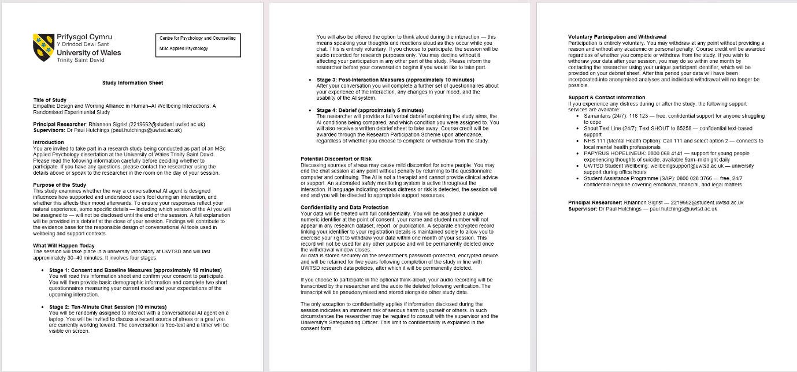
Appendix 10: Participant Information Sheet

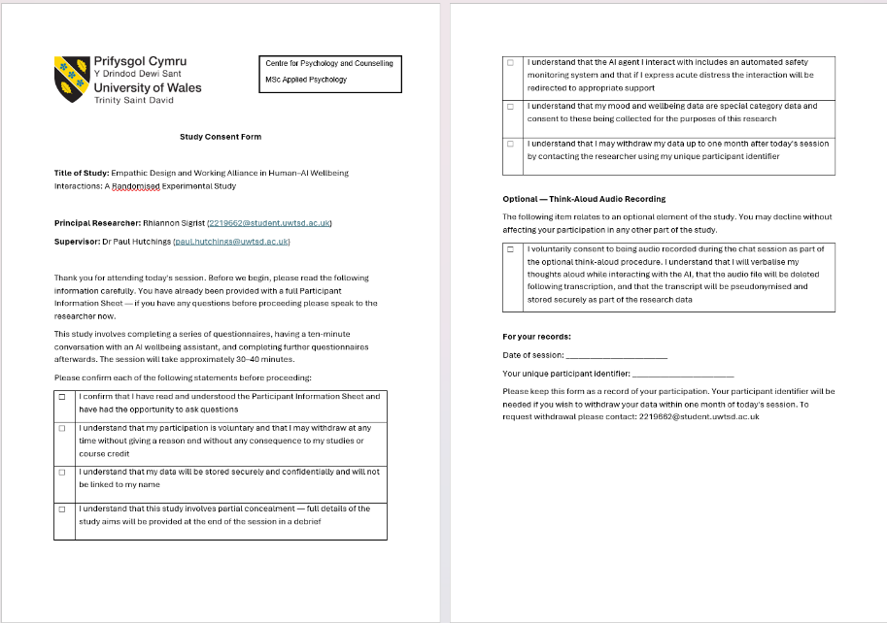
Appendix 11: Consent Form

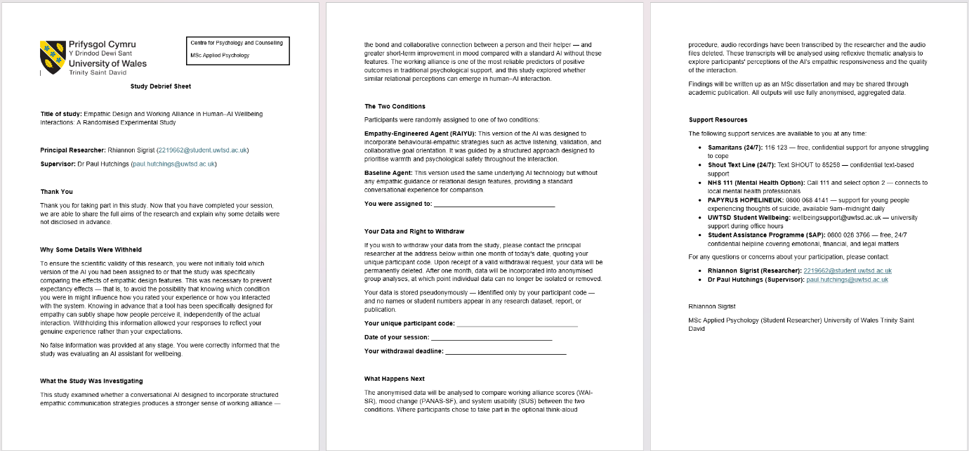
Appendix 12: Debrief Form

