

Holding the UK Government to account

BMLW4006, BMPL4011-CARD

Student name: Elena Cristina Martinica

LEGAL PROCESS
Table of Contents
Introduction 3
Main Body 3
Conclusion 7
References 8

Introduction
Parliamentary scrutiny is referred to as one of the most effective methods in the context of reinforcing the condition of the legislative measures that are being adopted in a country (Albanesi, 2021). As a nation's federal government is drafting legislation, it can be said that “good scrutiny makes good government.” In the context of the UK government, the executives hold the power to regulate legislation in the Parliament. Executives are the ministers and cabinets who form the government in the “House of Commons.” Besides, parliamentary scrutiny is also impacted by the “Separation of Powers Theory,” which states that “the executive” and “legislature” should work independently to avoid tyranny (Benwell and Gay, 2011). However, the executive system of the UK Parliament does not abide by the “Separation of Powers Theory” to address efficiency. Therefore, to embrace these contradictions, the extent and impact of parliamentary scrutiny of the UK government will be discussed below.
Main Body
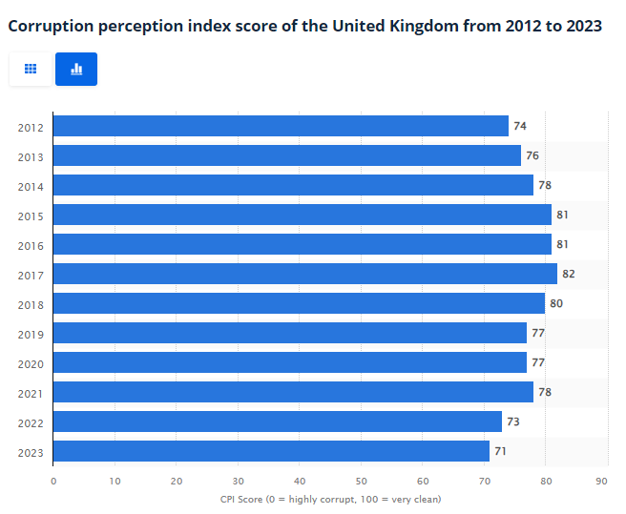
Figure 1: Corruption Perception Index (CPI) of the UK
Source: (Clark, 2023)
Argument 1:
Point: Over the last few years, corruption has been increasing in the UK context. This indicates that there is a lack of transparency in the country's parliamentary system in terms of legislation that is being drafted. From the above statistical data, it is evident that the "corruption perception index (CPI)" has decreased over the timeframe of 2021 to 2023, which is indicative of the fact that the rate of corruption has increased in the UK (Clark, 2023).
Evidence: Thus, the executive system of the nation lacks transparency, supporting the above-mentioned fact, executives were observed to spend 20% less time than their predecessors in the UK Parliament debating on legislative matters of concern (Leam, 2022).
Explain: Debates are considered effective ways of putting a real-time check on parliamentary proceedings of legislation drafting as they help the members of the opposition party minutely scrutinise legislative decisions that the parliament's executives are framing. The fact mentioned above reveals that lesser legislation concerning debates, which is a form of scrutiny, has decreased the extent of transparency in the legislative aspects of the UK government.
Link: This argument supports the idea that parliamentary scrutiny is essential to creating a sound governance system.
Argument 2:
Point: "Adaptive governance" is a crucial characteristic of a good government and requires efficient flexibility (Craig et al., 2017). Thus, a flexibility requirement can be identified in drafting legislative bills in a country's parliament, and flexibility can be incorporated using "pre-legislative scrutiny."
Evidence: Considering the governance system's context, it has been seen that it lacks flexibility in terms of legislation. The data shows that, at most, about 11% of the bills being passed in the UK Parliament go through the procedure of "pre-legislative scrutiny" (Leam, 2022).
Explain: This statistical data shows that the opinions of opposition party members have not been considered while drafting or passing most of the legislation in the UK parliament. This fact, in turn, indicates that the UK government executives are losing democracy in the legislation drafting procedure.
Link: Loss of democracy highlights a lack of flexibility in the legislative governance of the UK government, which stipulates a chance of misuse of power by the government (UK Parliament, 2024). Thus, this fact reinforces the statement that to create a good government, the government of the UK must adopt good scrutiny.
Argument 3:
Point: One crucial way to carry out effective scrutiny in the Parliament is to include "oral evidence" during debates regarding the framing of legislation in the Parliament of the UK (House of Commons Select Committee, 2016). This helps control transparency in the legislation context and form a good government.
Evidence:
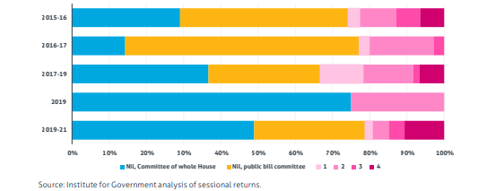
Figure 2: Number of Oral evidence sessions in the UK Parliament from 2015 to 2021
Source: (Sargeant and Pannell, 2022)
From the above-mentioned statistical data, it can be observed that the UK government executives have considered including "oral evidence" in only 27% of the total number of parliamentary legislative bills that have been framed and passed in the UK parliament over the last five years (Sargeant and Pannell, 2022).
Explain: The statistics shown above demonstrate that the legislation has been drafted as well as passed by the executive members of the parliament without any proper supporting reason to frame the draft or to support the points that have been incorporated in the legislation that will, later on, be implemented as the law (Sargeant and Pannell, 2022). On the other hand, it is known that a government passes legislation intending to solve the problem of the concerned nation. Thus, from the analysis of the above data, it can be understood that the government of the UK has lacked transparency in providing any evidence regarding the legislation formation.
Link: Transparency is a crucial aspect of forming a good government from the perspective of democracy (Alessandro et al., 2020). Therefore, it can be concluded that scrutiny of the government is important in forming a good government by implementing parliamentary actions such as "oral evidence," and the lack of "oral evidence" indicates a not-so-good government.
Argument 4:
Point: Parliamentary scrutiny is an essential component to maximise the potential of the productivity of the government as it consistently checks the quality of the work being carried out by the government, and committees are an essential part of parliamentary scrutiny. Thereby, the executive committees are identified as crucial to forming a good government (White, 2015).
Evidence: In 1979, a "systematic committee" was established in the UK Parliament to scrutinise the "expenditure, administration, and policy" of every department of the UK government (White, 2015). With the incorporation of the "systematic committee" and its scrutiny activities, an improvement was observed in the government's performance ability, which was not possible previously with the help of conventional scrutiny methods such as "debates" or parliamentary questioning.
Explain: The above-mentioned enhancement in the performance of the UK government can be explained by the fact that with the formation of the committee, a consistent and continuous method was incorporated into the parliament sessions of the UK to evaluate its performance. This created pressure on the government to perform its roles and responsibilities better.
Link: The improvement in the government's performance after including the "systematic committee" is evidence that committees are an essential form of parliamentary scrutiny. In turn, parliamentary scrutiny has been noted to increase the quality of government performance, reinforcing the concept that to form a "good government," it is important to have a tool of "good scrutiny."

Conclusion
By viewing four pieces of evidence mentioned earlier, which include three statistical data points and one case from the UK Parliament, it has been observed that improved scrutiny has motivated the formation of a good government. Besides, it has also been noted that the executives are responsible for regulating parliamentary scrutiny and forming a better government as they hold the authority to create legislation. Also, it has been observed that with the implementation of the scrutiny tools, the legislation of the UK Parliament can be framed better and, thus, an improved form of the government. However, it has also been noted that a significant amount of time is consumed in the scrutiny process, which may be a disadvantage. Therefore, as a remedial measure, the number of questions being asked in the parliament as a part of the scrutiny process can be reduced. In addition, the debate sessions can be shorter, so the time required for scrutiny is shorter, but ignoring the scrutiny in the parliamentary processes should never be a choice.

References
Albanesi, E. (2020). Parliamentary Scrutiny of the Quality of Legislation within Europe. Statute Law Review. doi:https://doi.org/10.1093/slr/hmaa001.
Albanesi, E. (2021). Models of parliamentary scrutiny of the quality of legislation. How different drafting models and forms of government shape them. The Theory and Practice of Legislation, 9(2), pp.141–158. doi:https://doi.org/10.1080/20508840.2021.1904553.
Alessandro, M., Cardinale Lagomarsino, B., Scartascini, C., Streb, J. and Torrealday, J. (2021). Transparency and Trust in Government. Evidence from a Survey Experiment. World Development, [online] 138, p.105223. doi https://doi.org/10.1016/j.worlddev.2020.105223.
Benwell, R. and Gay, O. (2011). The Separation of Powers. [online] Parliament. Uk. Available at: https://researchbriefings.files.parliament.uk/documents/SN06053/SN06053.pdf.
Clark, D. (2023). Corruption in the UK 2019. [online] Statista. Available at: https://www.statista.com/statistics/868971/corruption-perception-index-in-the-uk/.
Craig, R.K., Garmestani, A.S., Allen, C.R., Arnold, C.A. (Tony), Birgé, H., DeCaro, D.A., Fremier, A.K., Gosnell, H. and Schlager, E. (2017). Balancing stability and flexibility in adaptive governance: an analysis of tools available in U.S. environmental law. Ecology and Society, 22(2). doi:https://doi.org/10.5751/es-08983-220203.
House of Commons select committee (2016). Guide for witnesses giving written or oral evidence to a House of Commons select committee. [online] Available at: https://www.parliament.uk/globalassets/documents/commons-committees/witnessguide.pdf [Accessed 15 Mar. 2024].
Leam, R. (2022). Government should give parliament proper power to scrutinize legislation. [online] Bennett Institute for Public Policy. Available at: https://www.bennettinstitute.cam.ac.uk/blog/legislation/.
Sargeant, J. and Pannell, J. (2022). The legislative process. [online] Benett Institute for Public Policy, pp.1–58. Available at: https://www.instituteforgovernment.org.uk/sites/default/files/2022-12/the-legislative-process.pdf [Accessed 15 Mar. 2024].
UK Parliament (2024). Parliamentary Scrutiny of International Agreements in the 21st Century. [online] Available at: https://publications.parliament.uk/pa/cm5804/cmselect/cmpubadm/204/report.html#heading-6 [Accessed 15 Mar. 2024].
White, H. (2015). Parliamentary Scrutiny of Government. [online] Institute for Government. Available at: https://www.instituteforgovernment.org.uk/sites/default/files/publications/Parliamentary%20scrutiny%20briefing%20note%20final.pdf.

