
2019
Matthew Howells
University of Wales Trinity Saint David
11/30/2019

Matthew Howells (1702520)
Project Management and Research Methods (ACCA5004)
Individual Project Report
(FACE)
Sue Maw

Tuesday 14th January 2019 3pm

Managing a Hardware/Software Project
  - Table of Contents:

0.2. Table of Figures 1
1. Introduction: 2
2. Risk Management 3
2.1. Risk Evaluation Matrix: 3
2.1.1. What Is A Risk Evaluation Matrix? 3
2.1.2. Why Use A Risk Evaluation Matrix? 3
3. Identifying and Analysing Risks for project: 4
4. Codes of Practice: 6
4.1. Sustainability Issues 6
4.1.2. Sustainability Issues of The Smart Brain Project: 7
7.2.2. British Computer Society and IET Codes of Conduct: 10
7.2.3. General Data Protection Regulations: 11
9. References: 12

Table of Figures

Figure 1 Project Impact Matrix 3
Figure 2 Demo Feedback 14

Introduction:

This document is a report built on a Group Project known as “Smart Brain”. The objective of the project is to plan and implement a software application, which can be used as a way of assisting elderly individuals and dementia sufferers, 24 hours a day. It seems that as lifestyles move on, some individuals begin to develop certain amounts of difficulties throughout their daily lifestyle [1]. This means more support should be made available. The planned application shall have the ability of providing essential everyday services, which can be controlled by family or carers, as well as, streaming information through an earphone device.

This earphone shall be controlled using the implemented app, which can be accessed through a selection of technology devices. This would be suitable for the 21st Century as there are a lot of elderly that are technophobes. This is the most ideal way to communicate information using applications. Some examples of the embedded services include carers information, family contacts and photographs, medical information plus other important materials. Unfortunately, the need for support is increasing as illnesses continues to escalate in families. We believe Smart Brains services may help make those lives easier.

Risk Management

2.1. Risk Evaluation Matrix:

2.1.1. What Is A Risk Evaluation Matrix?

A Risk Evaluation Matrix is a common style of grid used during a risk assessment stage [2]. This breakdown can be extremely useful, especially, while planning to analyse hazards. The grid can be created by using a 4x4 dimension. This can be used to break down, analyse and assess different levels of risks. This matrix aims to split each risk into suitable sections while predicting possible impacts that could apply while working on different projects.

2.1.2. Why Use A Risk Evaluation Matrix?

People may choose to use this method due to the fact it is useful while trying to categorise different risks. This method reflects different ways of categorising because the methods are based on the probability of the risk occurring. By identifying potential risks project leaders can prioritise and improve team actions in order to prevent further problems along the way; It is always ideal to control risks beforehand.
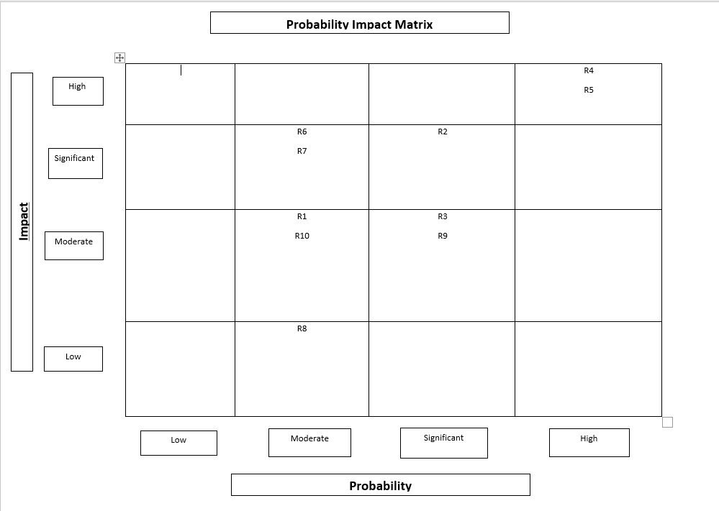

Figure 1 Project Impact Matrix

Identifying and Analysing Risks for project:

As expected, every project has a selection of risks [3]. This project report identifies and reviews how risks has an overall effect on projects. The objective is to recognise exactly how risks can be analysed by using a selection of different methods. This can successfully lead to expanding certain skills within a team. In order to succeed we must explore how embracing identified risks can lead to becoming successful.

  - Change of team Management – R1:

As time develops every company requires certain amounts of transformations in order to survive. All company transformations and progression should be annually reviewed in order to maintain a strong relevant structure for the business. Businesses must plan beforehand by using a coordinated business plan before executing any team changes [4].

  - Stakeholders – R2:

Stakeholders express an interest in the involvement of any project. The most important part of any project is the role and management of stakeholders, and just how the use of communication is enforced during the process. While conducting risk management, it is always perfect to have a selection of stakeholders, who intend to fully approve and support the project. In order to support stake holders, it seems ideal to address the use of Stake holder Management techniques [5]. This technique splits the positive impacts and minimises the effect of the negative effects on an overall project. The management techniques can be identified as: -
- Identifying potential stakeholders;
- Assess stakeholders’ interest and influence within a project;
- Develop communication strategies within the team;
- Involvement and influence of stakeholders within future proposals.

  - Financial Costs – R3:

While implementing a project the amount of financial facts can always cause a disruption on how a development intends to go forward. The risk of financial, costs, such as, cost estimations can easily become underestimated unfortunately leading to overspends. This can be prevented by producing and maintaining a finance Document containing expected expenses in a spreadsheet based on the entire project. This remains crucial as this is where the actual project costs are maintained considering a set budget allowance linked to project. Ideally, a dedicated team member could hold full responsibility controlling any flow of financial costs. Any crucial financial matters must be professionally investigated, discussed and fixed with the full team [6].

  - Health and Safety – R4

Health and safety is a critical category that requires fully accurate and professional arrangements within any organisation or business industry [7]. As the senior represented the teams dedicated project manager remains the most responsible for addressing this point ensuring everything is fully considered. As expected, this happens to be critical in any industry, especially while conducting any team experiments. For all team members to work safely within a healthy and suitable environment a formal risk assessment addressing any external hazards must always be produced and followed. This can include first aid as a precaution to treat any injuries’ during the process.

  - Timescales – R5

In order to carry out a successful group project, as expected, group members must identify any timescales for performing each task professionally; as well as, the amount of time required [8]. A timescale can be a planning schedule breaking down the amount of time each member must spend implementing each task. Timescales are flexible due to the fact Individuals could easily underestimate the amount of time required for a task. Schedules can usually be adjusted by possibly granting additional time which can be sensibly used in order to allow members to get back on track.

  - Feasibility – R6

Feasibility can help determine whether a project has the possibility of having a space within the industry and how the business idea has the possibility of performing, based on a certain financial budget. Potentially, some business ideas may not be suitable for purpose or possibly may have already been developed. In order to avoid these circumstances, it is always ideal to conduct further marketing research on any business ideas before commencing to write any planning documents. This is known as a Feasibility Study in market management [9].

  - Quality – R7

The quality of an implemented project can always be challenging due to the fact a planned prototype may not completely match an original or expected idea. This can lead to potential losses within projects as nobody may wish to purchase the product if an improved version is available. Potentially, customers expect high quality products to suit their sufficiency [10].

  - Suppliers – R8

Businesses may rely on certain suppliers to deliver technical equipment in order to implement a product idea. Unfortunately, products could arrive late leading to disruptions to schedules. While purchasing technology it is always wise to use reliable suppliers in order to avoid delays in services [11].

  - Skills – R9

In order to carry out a successful development within the business industry each associate within, a team must hold a high quantity of skills. These skills and capacities could be useful and developed further. As technology develops further resources are produced opening new opportunities for enterprise environments [12]. For businesses to understand further developments certain skills must be redeveloped further. It is always ideal to research further skills in order to continue learning while aiming to develop a successful organisation.

  - User Acceptance – R10

While carrying out any type of project; user acceptance members shall, ideally, make use of member acceptance training [13]. This strategy can helps settle any problems along the line while seeing how certain individuals interact overall.

Codes of Practice:

Sustainability Issues

Project managers seek to establish a relationship by combination between project management and sustainability methods [14]. As expected within project organisation Sustainability is one of the most important points within project management. It is a fact that sustainability needs to be assessed and considered on a few occasions. This can be identified as the environment, local economy, and society in general. Based on national changes, there has been an immense increase in sustainability policies for selected reasons. For this reason, there is a huge importance to understand the topic of sustainability and how small changes can make a difference.

Sustainability Issues of The Smart Brain Project:

      - Community:

A successful project manager should always pursue to engage with members of the team. In order to have a positive and helpful influence on team members it is always ideal to consider the amount of sustainable methods throughout the community during the construction of any prototypes. This can encourage students to work towards cutting down on pollution rather working together [14]. As a team everybody must work together in order to establish and complete any assigned tasks correctly.

      - Sustainability Policies:

As time moves on companies are establishing a selection of policies. Policies define the context for management on individual levels. Sustainability Policies can help companies brand their products much more environmental [15]. These policies can have a positive influence on companies encouraging them to change how they run businesses. This can help cut down on energy in order to save money and balance additional funding. This point addresses that companies can be much more sustainable if they address a sustainable policy within their final product.

      - Product lifecycle:

The Product lifecycle is a significant method taken while dealing and maintaining the existence of a product while taking sustainability into account [16]. This is to guarantee that any damaging impacts on the environment is minimized as much as possible. This can help to evaluate the environmental impacts of a product or a service throughout its full life cycle.

      - Business continuity:

Business continuity is approximately known as having a backup strategy to deal with tough circumstances [17]. This ensures that organizations can continue to function with as little disruption. An example could a power cut where certain information could unfortunately get lost or corrupted. By having a backup in place administrators can still offer their data in order to resume. This is completed using online mirroring [18].

      - Pollution:

Pollution could be common problem within this project due to a certain quantity and factors. As this project requires a high amounts of electrical features certain alterations would be essential in order to help cut down on pollution. This can be completed by asking What exactly is the Power usage of this project and how can power be cut down in order to save energy.

- Possible Requirements affecting sustainability:

Database Designer | Software Developer | Electronic Engineer
Data centres can request the use of cooling features while generating their data. This still uses power which can have an impact by giving off air pollution. | Software Developers rely on working hardware to produce the correct software for companies | Electronic engineers require plenty of power resources
Data analysers use Cloud storage in order to store data which is not green. | Developers can establish connectivity to a database provided by Data Analysers | Electronic Engineers Occasionally require the Use of Batteries
A High amount of Power Availability is required in order to generate and store people’s data. | Developers rely on Top quality software in order to program pieces of software | High quality Electronics could Possibly lead to the Overload of any computer systems
A large amount of data required for applications to communicate |  | Requires a High amount of availability of power resources. This can include energy efficient lights, motors, appliances, and heating and cooling systems.
Continuous involvement within people’s daily lives |  | Use of Planning documents which unfortunately are usually printed on paper.

- First, second and third order sustainability issues for the project.

  - First order sustainability issues:

First order sustainability issues focus on individuals that benefit from the existence of the Smart Brain Project and the process of making the application available to assist vulnerable individuals at sensible rates. For example, various people must be trained using different pieces of hardware in order to implement the outcome. This can include involved manufactures and developers who may focus on the production of the implementation.

  - Second order sustainability issues:

As a team Smart brain wishes to cut down on pollution as much as possible while implementing our services conducting any important meetings online instead of travelling to any chosen meeting points. Our product wishes to create a sustainable communication method for elderly people. This shall allow full communication with others in the outside world while offering 24-hour support services. For further developments to go ahead new dedicated roles must be created. This aims towards creating possible new jobs later within the future. Creating new jobs for people shall allow new sustainable services to be implemented for our customers to enjoy.

  - Third order sustainability issues:

The long-term changes of society highly focus on the way Smart Brain plans to implement changes later within the future. This can include cutting down on the amount of carbon emission involved within products and services. This can have an impact on company costs due to the fact companies can unfortunately get taxed by governments for high emission levels. This situation could lead to smart brain losing money which could be used for later developments. If corporations modify the way they function green criteria could be adapted leading to much more sustainable working environments.

- Ethical and Legal issues for the project:

There are many ethical lines that can be crossed in project management. Most project managers may find themselves faced with tough ethical decisions that require immediate action. In order to assess certain situations full communication methods must be enforced across the company addressing information to dedicated team members.

  - Health and Safety:

In order to abide with society’s regulations there are specific guidelines that must be enforced following health and safety regulations. As expected, team members work under immense amounts of pressure in order to meet set deadlines. Unfortunately, this can easily affect certain state holders putting team members at risk. All project manages must should asses working conditions and be ready to discourse any potentially harmful hazards.

  - Loss of Data:

Within todays society everything resolves around technology running through networks and servers. Regrettably the expectancy of potential data getting lost is increasing which can lead to potential consequences for the business. Altogether employees must understand the importance and Reconisation of looking after stored data and recognise solutions to solving potential issues. In order to avoid potential data loss businesses could consider implementing data backup solutions onto cloud base storage and introducing communication platforms for all members of the industry [19].

British Computer Society and IET Codes of Conduct:

The British computing society defines the characteristics about building a responsible computing profession responsibly [20].While working within a technology institution in today’s environments it is important to work with ICT in a suitable manor . This ensures everybody remains safe making ICT great for everyone.

As part of daily life managers expect everybody to develop themselves while working. This allows opportunities to improve a selection of skills to complete competitive tasks. As part of security everybody must abide with any set codes of conducts in a correct manor. These codes of conducts are designed to keep everybody safe and positive. Anybody who indicates any sort of breach to these rules prepares to suffer simple consequences inside the organisation.

Both Code of Conducts discuss the importance of how Employees must always remain fully alert while acting professional within their chosen establishment. This includes remaining respectful with all professions within any organisation whatever background or situation is witnessed. Members must ensure to report any dangers or wrongdoing to dedicated managers and ensure personal data remains private following any dedicated laws. [21]. Each identified legal eminent has been demonstrated abiding with full GDPR.

General Data Protection Regulations:

General Data Protection was established and recognised on 25 May 2018 [22]. GDPR has been introduced by the government intending to modernise established laws that help shield any individual’s personal information. It is important to abide with set regulations in order to prevent personal data getting into the wrong hands. If GDPR are breeched companies can suffer consequences possibly impacting the reputation of any company or organisation. It is possible for individuals to approach directors of any establishments in order to request the removal of any stored personal information on a database. This is addressed as the right to be forgotten.

- Quality Assurance Issues:

Quality assurance is a way of preventing mistakes and problems within any company establishment. This method helps companies determine whether provided services are fit for purpose and how future changes can be adapted.

  - Appropriate quality metrics.

As anticipated, each company must demonstrate fully appropriate points based on quality metrics [23].Metrics should always be made clear by reporting each point using a suitable method. Metrics can be broken down using smart. It is important to identify and define all quality metrics before beginning any projects. This can be conducted as part of planning preparation. This can be a way of addressing and measuring exactly how much time must be spent completing a project. Some examples of planning could include a Gannt chart. Gannt charts offer the opportunity to break down exactly how much time each task requires.

References:

[1] | J. S. McPhee, “Physical activity in older age: perspectives for healthy ageing and frailty,” Manchester, Manchester Metropolitan University, 2016.
[2] | safeopedia, “Risk Assessment Matrix,” safeopedia.com, [Online]. Available: https://www.safeopedia.com/definition/730/risk-assessment-matrix. [Accessed 01 Jan 2020].
[3] | D. Hillson, “RISK MANAGEMENT,” Project Management for Instructional Designers, 2003. [Online]. Available: https://pm4id.org/chapter/11-2-risk-management-process/. [Accessed 01 Jan 2020].
[4] | A. Phillips, “How to Lead Your Team Through Change,” Entrepreneur Europe, 1st August 2014. [Online]. Available: https://www.entrepreneur.com/article/235832. [Accessed 30th Janurary 2020].
[5] | E. Verzuh, “Stakeholder management strategies,” Project Management Institute, 13 September 2005. [Online]. Available: https://www.pmi.org/learning/library/stakeholder-management-strategies-applying-risk-management-7479. [Accessed 31 Janurary 2020].
[6] | e. a. Wiley, “Budget Planning,” Project Management, 2019.
[7] | D. S. O’Neill, “Measuring and reporting health and safety,” Safe Work Australia, Australia, 2007.
[8] | “Considering Timescales,” The Scottish Qualifications Authority, 19 October 2011. [Online]. Available: https://www.sqaacademy.org.uk/pluginfile.php/25893/mod_resource/content/2/F37X11_materials/Final%20Self%20and%20Work%20F37X%2011%20191011%20complete/_13.htm. [Accessed 01 Jan 2020].
[9] | “What Is a Feasibility Study in Project Management?,” wrike.com, 19 Jan 2006. [Online]. Available: https://www.wrike.com/project-management-guide/faq/what-is-a-feasibility-study-in-project-management/. [Accessed 20 Jan 2020].
[10] | D. Greenblatt, “5 Steps to Improve Quality,” www.inc.com, 22nd Jan 2014. [Online]. Available: https://www.inc.com/drew-greenblatt/5-steps-to-improve-quality.html. [Accessed 30th 01 2020].
[11] | K. Corrigan, “Supplier,” Oberlo, 18 Oct 2018. [Online]. Available: https://www.oberlo.co.uk/ecommerce-wiki/supplier. [Accessed 20 Jan 2020].
[12] | E. Klein, “Technology is changing how we live, but it needs to change how we work,” vox, [Online]. Available: https://www.vox.com/a/new-economy-future/technology-productivity. [Accessed 31 jan 2020].
[13] | G. Contributor, “Understanding User Acceptance Testing in a Project,” Project Management Works, 8 May 2015. [Online]. Available: http://www.projectmanagementworks.co.uk/understanding-user-acceptance-testing-project/. [Accessed 30 Jan 2020].
[14] | A. Alonzi, “What is Project Sustainability?,” proposalsforngos.com/, [Online]. Available: https://proposalsforngos.com/what-is-project-sustainability/. [Accessed 10th December 2019].
[15] | T. C. Commission, “Environmental and sustainability policy,” gov.uk, 10 May 2013. [Online]. Available: https://www.gov.uk/government/publications/environmental-and-sustainability-policy. [Accessed 24 jan 2020].
[16] | M. Rouse, “product lifecycle sustainability,” techtarget.com, December 2013. [Online]. Available: https://whatis.techtarget.com/definition/product-lifecycle-sustainability. [Accessed 1 December 2020].
[17] | D. Slater, “Business continuity and disaster recovery planning: The basics,” CSO, 20 May 2015. [Online]. Available: https://www.csoonline.com/article/2118605/business-continuity-and-disaster-recovery-planning-the-basics.html. [Accessed 1 December 2020].
[18] | U. Nayak, “Data Backups and Cloud Computing,” in The InfoSec Handbook., Apress, Berkeley, CA, 2004.
[19] | “Team Collaboration Software,” Clarizen, [Online]. Available: https://www.clarizen.com/teams/. [Accessed 07 Feb 2020].
[20] | BCS, “BCS code of conduct,” British Computing Society, [Online]. Available: https://www.bcs.org/membership/become-a-member/bcs-code-of-conduct/. [Accessed 06 Feb 2020].
[21] | IET, “Rules of Conduct,” Institition of technology and engineering, 3 October 2019. [Online]. Available: https://www.theiet.org/about/governance/rules-of-conduct/. [Accessed 07 Feb 2020].
[22] | M. BURGESS, “What is GDPR?,” .gov, 25 May 2018. [Online]. Available: https://www.wired.co.uk/article/what-is-gdpr-uk-eu-legislation-compliance-summary-fines-2018. [Accessed 06 Feb 2020].
[23] | P. M. Documents, “QUALITY METRICS,” projectmanagementdocs.com/, [Online]. Available: https://www.projectmanagementdocs.com/template/project-documents/quality-metrics/#axzz6DJVyyoXi. [Accessed 06 Feb 2020].

- Appendix:

  - Project Demo

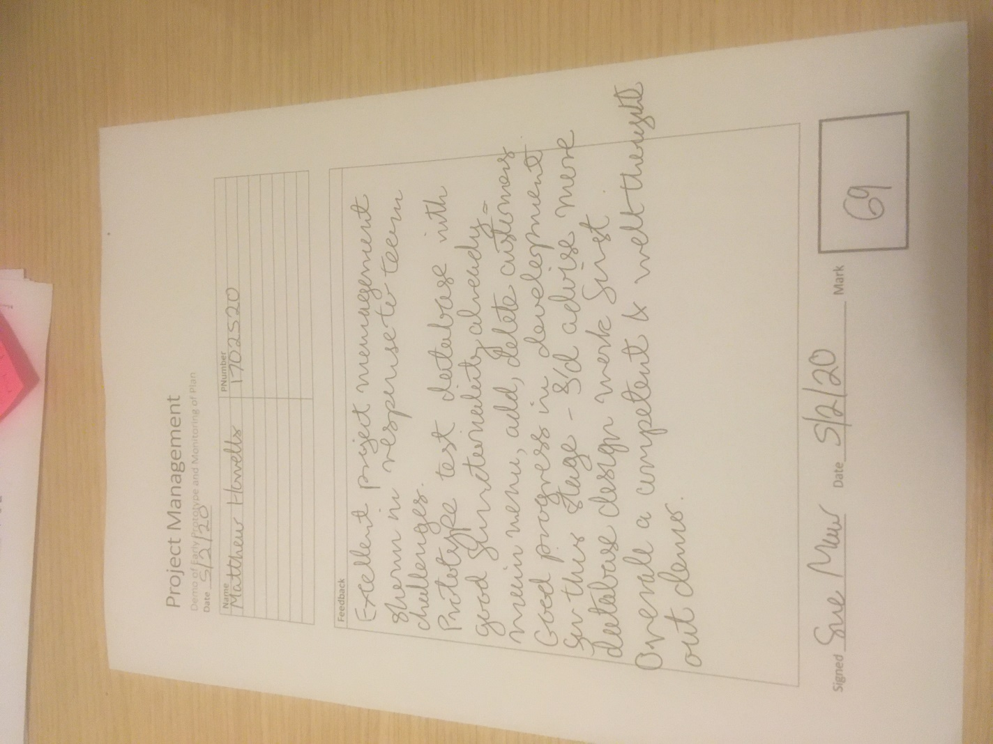
Figure 2 Demo Feedback

