University of Wales Trinity Saint David
Course: BA (Hons) Business Management Level 4 - Term 1
Name: Diana-Veronica Ciobanu
Student Id: 1913295
Module name: Introducing the Modern Workplace
Lecturer: Molly Jack
Date: 01/09/2020
Assignment Title: Assessment 1- Structure and culture of Unilever Plc

Structure and Culture

Of

Unilever Plc

Organisation structure refers to a systems that direct the organisational activities in a pre-planned shape in order to reach the companies’ goals and objectives. For instance, the organisation can define the rules and regulations, employees’ role as well as responsibilities to the organisation. It also dictates that in what way the information will flow to the CEO to the lower level employee. In this report, the selected organisation is Unilever Plc of which organisation structure as well as culture will be discussed though the report. Unilever plc is a well-known multinational organisation deals in consumer goods and operates its business over the world. Headquarter of the company lies in London, United Kingdom and Rotterdam. The organisation offers many types of products as well as services like food, energy drinks, soft drinks, tea, ice cream, pizza, frozen food, beauty products, medicine, and so on. It is one of the oldest as well as largest organisation the world which operates its business around 190 countries. It offers about 400 brands to the customers but it divided into 4 major divisions for instance, Food, Refreshment, Personal Care and Beauty Care. Unilever has likewise constructed solid connections with its auxiliary organisations around the globe for its teas and coffees, a significant part of the crude material required for food stuffs is sourced from African and Latin American nations, for example, cocoa, vanilla, palm oil and espresso beans (Unilever offers fragrance ingredients transparency for personal care products, 2019). To arrive at the size and level of assorted variety that they currently control, Unilever have looked to get a further brand or assembling enthusiasm at the pace of around one every year throughout the previous ten years. Such noteworthy action as far as corporate decent variety and solidification makes for an intriguing subject of study.
Organisation Structure; without a defined framework or an outline of an organisation, it cannot be operated well. Organisation prepare structure based on the company size, scope, risk, challenge etc. Unilever have expressly decided to make an administration structure, which is fit for settling on quicker choices and reacting all the more deftly to outer upgrade. In like manner Unilever has made a four-level progressive structure, which assists with piping data into the business, and permits the senior group to settle on suitable choices dependent on accessible information.

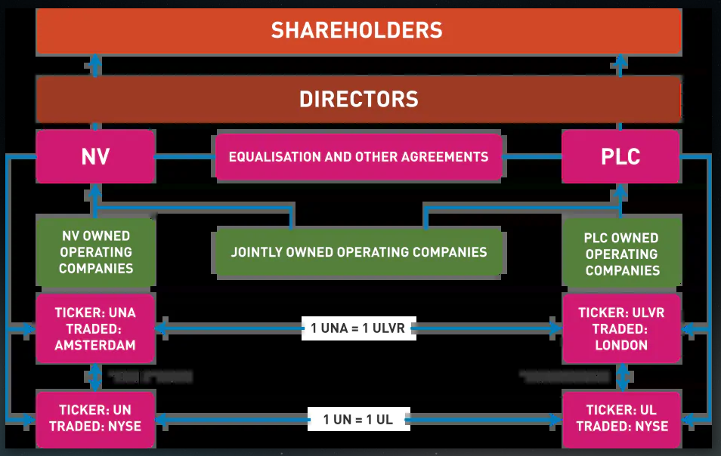
Figure: Corporate structure of Unilever
Source: Author
Unilever believes that the above structure is suitable to the organisation because it is prepared based on the organisation context. There are several levels in this hierarchical model which focused the core roles of each of the managers or others. According to the above structure, here two executive directors who are responsible to the organisation in their deed. One director, Paul Polman, as the position of Chief Executive Officer, another director, Jean-Marc Huet, Chief Financial Officer of the company (Update on the Executive Director/Chief Executive Officer Search, 2020). The Unilever Executives are liable for overseeing benefit and misfortune, gross, profit, classifications and capacities. It contains ten operational and chief chiefs every one of whom have extraordinary capabilities and involvement with the fields of science, innovation and business. Unilever has additionally taken consideration to guarantee that the full cross-segment of their multi-disciplinary capacities and worldwide expansiveness are spoken to on the board, with a few nationalities being spoken to. At last, the three senior corporate officials are answerable for guaranteeing that the leading group of Unilever have all the essential data to settle on judicious and convenient corporate choices on both operational and key premise. The senior corporate officials are entrusted with guaranteeing that the structure and system of Unilever is returning appropriate administration data on which to base basic choices.
Organisational Culture; It refers to a set of collection of values and norms that people share in the organisation. Organisation culture helps to understand the organisation values and overall organisational circumstances. Hofstede (1993) said about organisation culture that “Organisational culture is complex, and can be influenced by a huge variety of factors.” Hofstede identified and dictates clearly about organisation culture in the theory of cultural dimensions. In his cultural dimension theory he dictates that how the cultural factors influences on the organisation considering other strategies. This cultural dimension theory infers that in spite of the fact that not all the people inside a nation's populace will have the very same qualities, the social measurements will shading the institutional and managerial courses of action that are made inside the nation, and will set the standards for conduct (Parker, 2019). This is firmly confirm at Unilever where the way of life of the association is gotten from its own multinational. This has impacted the procedure of key dynamic at Unilever under the systemic approach. Analysing the Unilever executives, Paul Polman is the first external candidate whose background is Dutch and he is playing his role since 2008. His experience and involvement with the business product and manufacturing divisions make him a perfect contender for the job, as he is both monetarily insightful and economically mindful. In addition, from the investigation of the organisation and its working ethos and mission, it can likewise be suggested that his administration style is European-impacted and in this way prone to be intelligent of a comprehensive culture and style in that it is both vote based and free enterprise. On the contrary, according to the Tannenbaum and Schmidt continuum (1957) it may be that Paul Polman permits opportunity of his subordinates to seek after reasonable corporate systems based on their capacity and the use of law based dynamic (Conservationist Leadership Style and Corporate Culture in Indonesian Private Banks, 2020).
Organisational Performance; Cultural performance of Unilever is significantly emphasises on the employee output performances. Corporate culture is very much concern about organisational requirement to do the best for the organisation. First of all, corporate culture focus on individual as well as organisational performances, Then it is mostly focused on the quality work as well as efficiency of employees. Unilever's authoritative culture is centred on execution and quality. This corporate culture is discernible in the long history of the organisation. The business has developed from a little firm to a worldwide force to be reckoned with. Such achievement is fundamentally founded on the capacity of Unilever's hierarchical culture to impart superior and quality in representatives' hard working attitude to augment business yield (Ojo, 2017). For instance, Unilever’s product remain good and grab a strong position in the competitive market. Moreover, the organisation has high level efficiency in technology and it has a great control on human resource. Unilever is continuously working on innovation as well as HR development program.
Leadership role; Cultural performance relies on the supportive leader in the organisation. For instance, Unilever uses market-based as well as result-based approach to maintain the organisational activities and thus, enhanced the performance of the organisation. More clearly, Unilever uses market-based approach in order to change the organisational tactics whereas result-based approach used to increase the probability of achievement. These tactics are very effective approaches to enhance the productivity of human resources of the organisation. These activities dictates the leadership skills towards company’s goals and objectives (Performance Management System - A Noble Approach for Performance Enhancement of an Organisation, 2017). Leadership-based approaches is very much favourable to the integrity of corporate culture accomplishment. Employee integration as well as development is required for a successful business organisation. For instance, Unilever applies results-based administration to actualize its authoritative culture all through the recently consolidated association. Thus, the organisation's authority bolsters honesty for the coherence of the hierarchical culture of execution and quality considerably after mergers and acquisitions.
Though the effective leadership plays a significant role in the organisation, the leader must have to have organised leadership skills. Leadership skills not required same for all, it defers person to person according to their ranking in the organisation. A true leader always plays extraordinary role and take action to the right point. Some leadership that influence on the management and leadership for instance, initiation, speech and management. First of all, initiation refers to decision making policy or change of organisation structure. By this decision, management determine the organisational culture as well as mission. Strategic decisions intended for usage inside the foundation (Conservationist Leadership Style and Corporate Culture in Indonesian Private Banks, 2020). It incorporates altering or including to the current structure towards new approach requests. The executives is incorporating the strategies and measures that are accessible to keep up the activities of the company productively. These three sorts of Leadership are normally executed at assorted positions in the organisation with various capacities and aptitudes. The high level management would start new approaches that include an adjustment in the business' structure or understanding the whole organisation. A comprehension of the whole association, culture, strategic, and how it relates with the outside gatherings is compulsory for these high level people. Middle range manager are to understand the top level management’s policy as adapt them for the low level management or group. For instance, top level manage of Unilever make policy and mid-level convey it to the low level management to implement.
Unilever's way of life is a culture of execution. The various parts of the business are centred on improving budgetary execution and nature of items. Through community oriented endeavours of pioneers from various offices, the firm additionally guarantees a hierarchical culture of execution. As cultural diversification is crucial, it helps the cultural performance in the organisation and ensure the quality of consumer’s goods. If it is possible to maintain cultural balance in the organisation then it will help a lot to improve the policies that are really crucial to reach goals. For instance, Unilever already have taken action so that it can be ensured cultural balance. Moreover, technological advancement is a very basic need for any organisation (Mohd Din, Loo and Jauhar, 2017). It helps to do better market research, customer engagement, customer intention and relations and most importantly internal communication.
Behavioural approach to management refers to human relation as well as employee well-being. In this circumstance, management always try to satisfy the customers need as well as wants to fulfil the organisational goals and objectives. Several factors are related to this behavioural approach that is control by the management. For instance, Employee Suggestion Box that is use to get feedback from the employee regarding their demand or jobs. By this approach, employee can enjoy their job or respective responsibilities. Positive reinforcement is another aspects of behavioural approach that indicates the positive influence to increase the productivity as well as profitability (Guest, 2017). Day care is another aspect of behavioural approach which refers to day care for employee’s children in the workplace. It reflects positively on the organisation. It is seen that day care approach increase the employee performance, organisational performances and overall profit of the organisation as well. The importance of these behavioural approach is untold due to their impact on the organisation. Unilever should apply these approaches to increase the organisational productivity, profitability. These will help a lot to reach the desired goals and objectives. Most of cases it is found that good employee relation returns a positive feedback. Organisational structure as well as culture are crucial for maintaining the above approaches. Besides, good leader with extraordinary leadership skills are equally important for any types of positive changes in the organisation. Unilever have so many good leader in the organisation working with. Proper management will must return a charming outcome.

References
European Journal of Business and Management, 2020. Conservationist Leadership Style and Corporate Culture in Indonesian Private Banks.
Focus on Surfactants, 2019. Unilever offers fragrance ingredients transparency for personal care products. 2019(3), p.4.
Guest, D., 2017. Human resource management and employee well-being: towards a new analytic framework. Human Resource Management Journal, 27(1), pp.22-38.
International Journal of Science and Research (IJSR), 2017. Performance Management System - A Noble Approach for Performance Enhancement of an Organisation. 6(1), pp.357-361.
Microbe Magazine, 2020. Update on the Executive Director/Chief Executive Officer Search. 10(3), pp.120-121.
Mohd Din, A., Loo, W. and Jauhar, J., 2017. Implementation of Cultural Change towards an Organisation: Evidence from Malaysian Service Oriented Organisation. SSRN Electronic Journal,
Ojo, O., 2017. Organisational Culture and Corporate Performance: Empirical Evidence from Nigeria. Journal of Business Systems, Governance and Ethics, 5(2).
Parker, M., 2019. The Counter Culture of Organisation: Towards a Cultural Studies of Representations of Work. Consumption Markets & Culture, 9(1), pp.1-15.

