University of Wales Trinity St David
(UWTSD)
Institute of Science & Art



Energy in a Flywheel
Motor vehicle engineering science

Name: Ethan Thomas
Student Number: 2511104
Date of Report: 17/03/2026

Contents
1 Introduction 3
2 Experimental procedure 4
3 Results 6
4 Analysis 6
5 Conclusion 9
6 Evaluation 10
7 Further work 10
8 References 10

Introduction
The task, to conduct an experiment able to demonstrate and measure kinetic and potential energy. This is the experiment below:
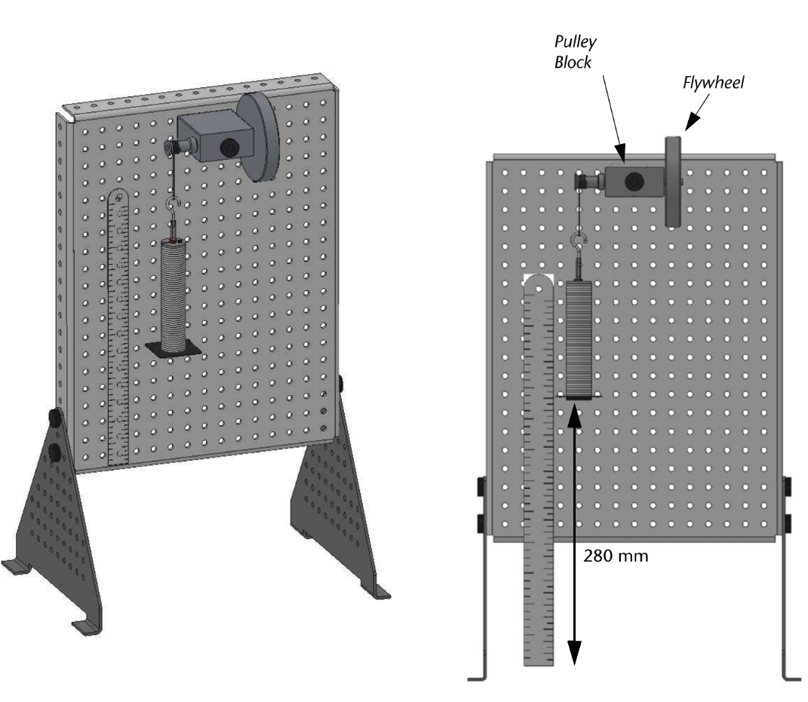
Figure 1 - (Tecquipment, 2012)
Letting the weight (multiple weights to get more data) drop from a fixed height (max potential energy) whilst timing how long it took for the weight to fall to its maximum distance and back up again (potential turned into kinetic energy) and measuring that distance (max potential energy to min potential energy).
Using these measurements we can calculate: Falling time, acceleration, velocity, PE, MG and Pe loss and with them the Inertia.
This experiment mimics a flywheel, “being among the oldest inventions of mankind, defined as a heavy wheel used to oppose and moderate any fluctuation of speed”. “Archaeologists claim they have found one in the middle east estimated to be 5500 years old, used as a potter’s wheel to keep it spinning between the occasional kicks of the potter’s foot” - (B.kaftanoglu, n.d.).
A flywheel mitigates the rough forces produces by the power pulses of the engine attached to it. We will not be getting into today.

Experimental procedure
This entire chapter will consist of the procedure list from (Tecquipment, 2012) which was the test book used.
Cut cord length so the Weight hangar to travel through a vertical drop of just under 290mm.
Allow the weight hangar to fall to the bottom of its travel. Move the magnetic rule behind weight hangar, so its 0mm edge aligns with the plastic guide.
Add 90g of masses (10g increments) to give a total of 100g on the weight hangar.
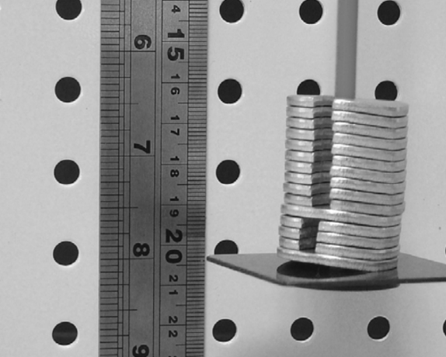
Figure 2 - (Tecquipment, 2012)
Slowly turn the flywheel to lift the weight hangar (which way doesn’t matter) until the bottom of the weight hangar reaches 280mm (h1) on the rule.
Use a stopwatch to measure how many seconds it takes for the weight hangar to fall from its 280mm position to the 0mm position and back up to its maximum height (h2). Do this several times to get a good average value for the time and the height (h2).
Repeat in 100g increments until 500g limit is reached.
Calculate PE (mass x gravity (9.81) x height 1), the mg (mass x gravity) and the PE loss.
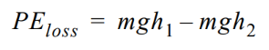
Figure 3 - Pe loss
Calculate the falling time, acceleration and velocity, torque (mass x gravity – mass x acceleration) and a/r (angular acceleration) values.
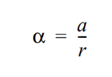
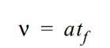
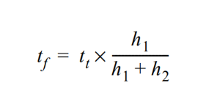
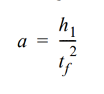
Figure 5 - Time falling (Tecquipment, 2012)
Figure 7- Angular acceleration
Figure 6 - Velocity
Figure 4 - Acceleration
Add the nominal I values for the flywheel and the pulley in the bearing block to find the total nominal I values for the flywheel. Use this to calculate the KE value for the Flywheel for each line of results.

Use the chart paper to create a chart of (mg-ma)r against a/r. Your results should give a reasonably straight line with little scatter. Use the chart to find an average value I for the flywheel.

Results
Mass | T1 | T2 | T3 | H1 | H2 | H3
100g | 3.93s | 4.00s | 4.00s | 25cm | 24.5cm | 25cm
200g | 3.3s | 3.4s | 3.4s | 25.5cm | 25.2cm | 25.5cm
300g | 2.84s | 3.27s | 2.55s | 25.5cm | 25.2cm | 25.5cm
400g | 2.13s | 2.2s | 2.08s | 24.5cm | 24.2cm | 24.5cmq
500g | 2.0s | 1.9s | 2.14s | 23cm | 23cm | 22.5cm
Table 1 - Raw results
This is the raw results we got from the experiment with mass down the first column, the times across the next three columns and the heights across the next three columns.

Analysis
Below is my table with all data calculated followed by the set values used for some of the calculations. (all numbers used were from personal results (thomas, 2026))
Mass | Initial PE | Time taken | Height | Mg | PE loss adjusted | Fall time | Acceleration | Velocity | Velocity | Torque (mg-ma)r | Angular acc | KE
kg | j | s | m | n | j | s | m/s2 | m/s | rad/s | nm | rad/s2 | j
0 | 0 | 0 | 0 | 0 | 0 | 0 | 0 | 0 | 0 | 0 | 0 | 0
0.1 | 0.27468 | 3.97 | 0.248 | 0.981 | 0.031392 | 2.10530303 | 0.126345214 | 0.265994962 | 40.96312839 | 0.980917876 | 19.43772525 | 66.19623
0.2 | 0.54936 | 3.36 | 0.254 | 1.962 | 0.051012 | 1.761797753 | 0.180416363 | 0.317857143 | 48.94988553 | 1.961765459 | 27.75636353 | 94.5258
0.3 | 0.82404 | 2.89 | 0.254 | 2.943 | 0.076518 | 1.515355805 | 0.243870233 | 0.369550173 | 56.91059356 | 2.942524453 | 37.51849735 | 127.7713
0.4 | 1.09872 | 2.14 | 0.244 | 3.924 | 0.141264 | 1.14351145 | 0.428259486 | 0.489719626 | 75.41664607 | 3.922886525 | 65.8860748 | 224.3786
0.5 | 1.3734 | 2.01 | 0.228 | 4.905 | 0.25506 | 1.107874016 | 0.456254619 | 0.505472637 | 77.84260404 | 4.903517172 | 70.19301829 | 239.0461
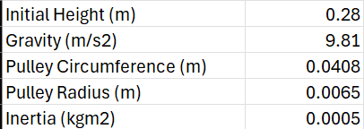
Figure 9 - Graph from excel sheet (thomas, 2026)
Figure 8 - Given values (Tecquipment, 2012)

  - Initial PE:
Energy based of position rather than motion
This is calculated by current mass x the given value of gravity (9.81) x the initial height
e.g 0.1kg x 9.81 x 0.28 = 0.275j
  - MG :
Commonly known as weight
Mass x gravity
e.g 0.1kg x 9.81 = 0.981n
  - PE loss adjusted:
Mgh1 – mgh2. This broken down means mass x gravity x initial height – mass x gravity x height 2 (an average of the three heights measured)
e.g 0.1 x 9.81 x 0.28 – 0.1 x 9.81 x 0.248 = 0.031j
  - Fall time:
Tt x (g/g + h2). Brakes down into time taken (average of the 3 times measured) x (gravity/ gravity + current height)
e.g 3.97 x 9.81/9.81+0.248 = 2.105s
  - Acceleration:
The rate of an objects velocity changes over time
2h1/tf^2. Initial height x 2 / fall time squared
e.g 2 x 0.248 / 2.105^2 = 0.126m/s^2
to convert to angular acceleration (rad/s^2). Acceleration x given value of the pulley radius
  - Velocity:
The speed of an object in a specific direction
Acc x tf. Acceleration x time falling
e.g 0.126 x 2.105 = 0.266m/s
to convert to radians per second (rad/s) used for angular velocity its velocity x 2PI (3.14) / the given value for the pulley circumference
  - Torque:
Turning forces causing an object to rotate around an axis
Mg-ma x r. mass x gravity – mass x acceleration x given value of pulley radius
e.g 0.1 x 9.81 – 0.1 x 0.126 x 0.0065 = 0.981
  - Kinetic energy:
The energy of a moving object
For kinetic energy there are 2 ways of calculating. Pe – Pe loss or 0.5 x Inertia values (given by figure 8) x angular velocity^2
e.g 0.275 – 0.032 = 0.243 or 0.5 x 0.0663 + 0.0126 x 40.963^2 = 66.196
  - Inertia:
The resistance to change in an object motion
0.5 x m r^2. 0.5 x mass x given value of pulley radius^2
e.g 0.5 x 0.1 x 0.0065^2

Conclusion
From all the data and calculations given we can conclude a few things
  - The heavier an object is the more PE it has:
According to our data we can see that a heavier object (an object with a higher mass) has more potential energy as shown in the table. This makes sense as one of the variables to calculate PE is weight (mass x Gravity). We could achieve the result by increasing the initial height.
  - A higher PE translates to a higher KE
This can be explained quite simply by using the definitions provided earlier having a higher energy stored when dropping the weight that increased PE is now being transferred into Kinetic energy (moving energy) and this is further proven all around as there is a direct correlation between PE and KE and as we know energy cannot be created or destroyed only transferred and we see this happening first hand here.
  - Heavier objects have a higher acceleration/angular acceleration, velocity/angular velocity and torque:
Although of our data shows that the more weight an object has the accelerations, velocity and torque, this isn’t technically accurate as we know lighter object accelerate quicker, this is because it requires less energy to move it, however in this case we see otherwise, lets find out why. The acceleration is higher upon increased mass due to the increased torque potential and because the torque isn’t a fixed value the acceleration is higher, this also explains the increase in torque. The velocity however is due to the higher potential energy which we know is caused by the increase in mass. All of this is due to the fact its energy driven not mass driven. Higher mass means increased Potential energy although this has diminishing returns, however in our case not so much.
  - Heavier objects take less time to fall:
This is because although gravity is a constant, how it acts upon an object will depend on its mass a higher mass means a higher weight being pulled by gravity. It’s the same as dropping a feather as opposed to an anvil the anvil weighs more and such falls quicker.

Evaluation
Accuracy could be improved by using automated sensors and a high-speed camera. Manual timing and ruler reading introduce human error.
String also stretches further adding to the reduced accuracy
Overall, we estimate an experimental error of around 3% which is allowable when the standard for school labs is 1%-5%

Further work
With unlimited resources, Automated timing with a high-speed camera would improve timing accuracy. For more precise distance measurement, a high-speed laser displacement sensor could be used. Placing a reflective marker beneath the weight the laser could measure said distance within a micrometre.

References
B.kaftanoglu, n.d. Flywheels and super-flywheel, s.l.: s.n.
Tecquipment, 2012. Engineering science worksheets - Energy in a flywheel, s.l.: tecquipment ltd.
thomas, E., 2026. excel sheet of compiled data. s.l.:s.n.

