Letter to client highlighting which BIM maturity level is required for their project and detailing how the information will be shared, managed and coordinated and managed through the appropriate international standards and the use of a BEP.

Cris Davies

Lifecycle Design LTD
ACBA 5010 – Gavin Traylor
Contents
Task 1 - Letter 2
BIM Maturity 3
Common Data Environment 4
BIM ISO STANDARDS 5
Task 2 - LOD & LOI throughout the RIBA stages 7
LOI: 7
LOD 9
Referencing 11

Task 1 - Letter

Lifecycle Design Ltd
Federated with Welsh government under the 21st Century School programme
Unit 1A, Pwllcwellyn Ind Estate, Cardigan. SA432AX
(t) 01239654061
Info@lifecycledesign.co.uk
www.Lifecycledesign.co.uk

Project Number: 5010
Project title: Ysgol yr Afon
Description: 1 form entry infant school for 90 pupils, with 48 PT Nursery provision.

Dear Sir/Madam,
I'm writing to you in response to our recent appointment to the position of lead consultant for the Ysgol yr Afan project, which is being carried out in collaboration with the Welsh government. We at Lifecycle Design LTD would like to give you an outline of the ways in which the BIM process will help your project from the beginning to the end, from construction to use in the future to decommissioning. This letter aims to give you an overview of the information sharing that will take place throughout the project. It will also clarify what is included in the BIM execution plan (BEP) and how information will be coordinated and managed using the relevant international standards and BIM maturity stages.
Additionally, as requested, we will analyze the researched examples of the LOI (Level of information) needed for your project throughout the RIBA stages and outline the steps taken to demonstrate the project teams' competencies and skills in meeting the BIM maturity requirements. This will allow you to evaluate and decide what to include in your EIR (Exchange information requirements).
Building information management, or BIM, is a method and a shared approach to working through the life cycle of a construction project. It is an information management technique that "uses a shared digital representation of an asset to facilitate design, construction, and operation processes to form a reliable basis for decisions" (bsigroup.com,2023). It is supported by collaborative working and digital technologies.
The primary goal of BIM is to increase project efficiency. In order to accomplish this, BIM records every stage of the project, including preplanning, design, construction, and client handover. All stakeholders have easy and efficient access to all project data and information.

BIM Maturity

During our initial conversation regarding the project, you specified that the project required whole life monitoring of the asset. For whole life monitoring, a BIM level 3 and the use of the CAFM system will be required. Below is a table demonstrating the various BIM maturity levels. BIM 0 would provide a minimal and outdated level of information while BIM level 3 would provide the client with the maximum level of information for the project.
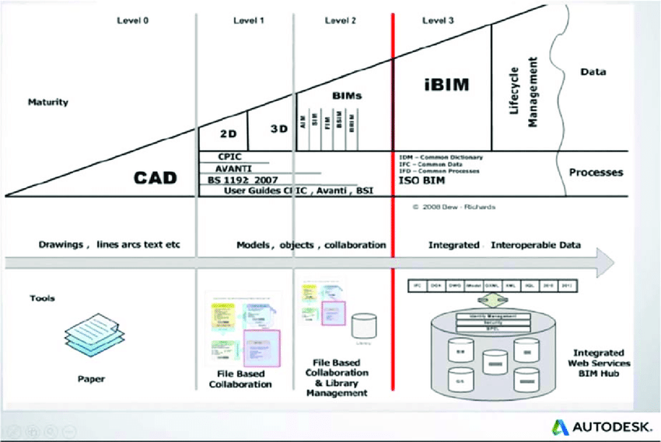
The advantage of BIM level 3, often known as "open BIM," over other BIM choices is the ability for all participants and stakeholders to work simultaneously on the same model, removing the possibility of contradicting information. (United-BIM.com 2023)
Figure 1 - BIM maturity levels explained (https://www.researchgate.net/figure/BIM-maturity-levels-4_fig1_321991917)
Building a fully cloud-based model is necessary for a BIM maturity level 3, allowing all project participants to collaborate on it through a "common data environment." ISO 19650-1:2018 is the worldwide standard that governs BIM maturity and must be adhered to. Following this guideline will guarantee that structured data, project data, sophisticated asset data, versioning, and increased information sharing, as well as asset and model project data, are satisfied. (Ukbimframework.org/standards 2023)

The delivery of your project will be outlined and agreed in the BIM execution plan which we will be submitting shortly. There are two stages to the BEP, a pre contract BEP and post contract BEP. In the pre contract BEP we will provide project details, EIR objectives along with the project programme, project goals and any agreed milestones or project targets. Once the contract is awarded the contractor (Life Cycle Design LTD) will be expected to provide you with a post contract BEP which is based on tender documentation, details of responsibilities of the delivery team, methodology of the delivery and further milestones and objectives (SIEBELINK, S et al 2021)
A BEP will contain information on the project's precise working methods, construction tolerances and parameters, file naming conventions, annotations and acronyms used during the project, data interchange management systems utilized, and database managers assigned. (McPartland and Hamil, NBS, 2021).

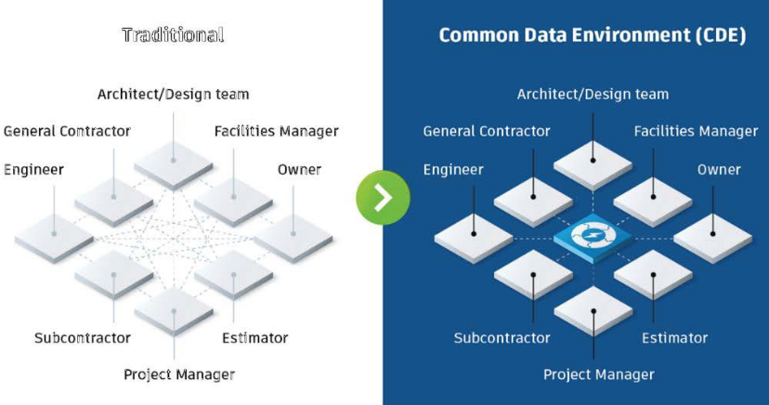
Common Data Environment
Table 1 - Traditional vs CDE data sharing methods -(www.autodesk.com 2022)

During the project The common data environment (CDE) will be used to collect, manage and circulate documentation, the graphical model and non-graphical information for the whole team. CDE is a digital hub where information is gathered as part of the BIM workflow. CDE has advanced over time and can now include the entire portfolio of project documentation such as project contracts, project schedules, charge orders and even Risk Assessment method statements for physical works.
The CDE is an important tool as the flow of information between project stakeholders is enhanced via the central repository where it is controlled and kept continually up to date when amendments are made. The benefits of the CDE is that it enhances collaboration between the project stakeholders by improving coordination and teamwork. The CDE provides a single source of information for all parties thus enhancing data reliability. Risk is reduced by improving data quality and ensuring that transparency is improved, all in a way that auditability is improved. Another key benefit of the CDE is that naming conventions are defined which reduces confusion. (www.autodesk.com 2022)

BIM ISO STANDARDS
There are many standards associated with BIM worldwide via the ISO platform. The relevant standards for us in the UK would be the BS EN ISO series which are detailed in the table below. It is important to note that there are many subcategories of standards within the larger framework standards that are associated with more detailed aspects of BIM.
Table 2 - Table 1 - ISO 19650 (bsigroup.com,2023).
ISO STANDARD | OBJECTIVE
BS EN ISO 19650-1:2018 | Organization and digitization of information about buildings and civil engineering works, including building information modelling (BIM).  Information management using building information modelling. Concepts and principles.
BS EN ISO 19650-2:2018 | Organization and digitization of information about buildings and civil engineering works, including building information modelling (BIM)  -Information management using building information modelling. Part 2: Delivery phase of the assets.
BS EN ISO 19650-3:2020 | Organization and digitization of information about buildings and civil engineering works, including building information modelling (BIM).  Information management using building information modelling. Operational phase of the assets.
BS EN ISO 19650-4:2022 | Organization and digitization of information about buildings and civil engineering works, including building information modelling (BIM).  Information management using building information modelling. Information exchange.
BS EN ISO 19650-5:2020 | Organization and digitization of information about buildings and civil engineering works, including building information modelling  (BIM). Information management using building information modelling. Security-minded approach to information management.
PD 19650-0:2019 | Transition guidance to BS EN ISO 19650 from the viewpoint of PAS 1192-2:2013.
PAS 1192-6:2018 | Specification for collaborative sharing and use of structured Health and Safety information using BIM.
BS 8536:2022 | Design, manufacture, and construction for operability. Code of practice
Table 1 - ISO 19650 (bsigroup.com,2023).

We hope to have clearly outlined how a BIM maturity of level 3 will be the best option for your project. BIM level 3 will assist with the whole life monitoring of the school and the data return from using the technology will exceed any other available options to you.
If you have any further queries then please don’t hesitate to get in touch and we’d be more than happy to assist.
We are very happy that you’ve chosen to work with us on this exciting project.
Thanks for choosing Lifecycle Design LTD.
Kind Regards,

Task 2 - LOD & LOI throughout the RIBA stages

LOI:
The Level of Information (LOI) is an essential part of Building Information Modelling (BIM) that completes the Level of Development (LOD) dealing with the quality and depth of non-graphical data in a 3D model. This concept is an integral part of the RIBA stages, ensuring that comprehensive information is incorporated into the developing design at each stage of the construction project. (https://www.thenbs.com/knowledge/riba-plan-of-work-2020)

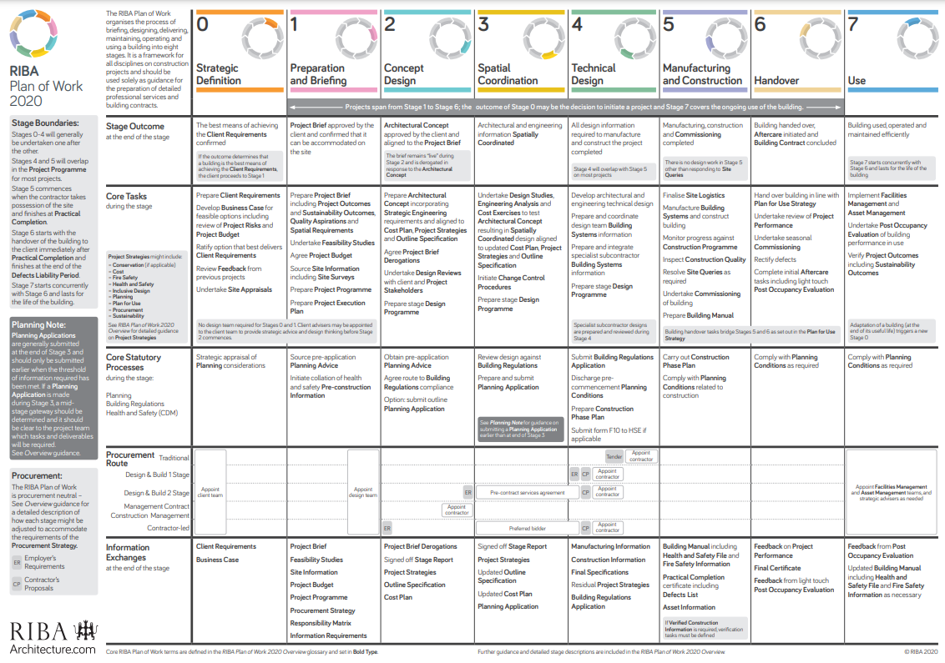
Figure 2 - RIBA stages (RIBAarchitecture.com 2023)
Early Stages:
In the initial stages of a project, falling within RIBA Stages 0 to 2, LOI is foundational for conveying conceptual information. Although the geometric representation might be at a lower LOD, the accompanying non-graphical data begins to take shape. This information includes high-level specifications, conceptual material choices, and initial performance requirements. LOI at this stage helps set the tone for the project, providing a basis for subsequent detailed development.

Developed Design:
As the project advances to RIBA Stage 3 - Developed Design, LOI gains prominence by expanding the depth of information. This stage sees architects and stakeholders collaborating to refine the design, and LOI becomes instrumental in incorporating detailed specifications for materials, systems, and components. This enriched information ensures that the model not only visually represents the design but also captures essential data for construction and subsequent stages.

Technical Design:
During RIBA Stages 4 and 5 - Technical Design, LOI reaches a point of precision. Detailed specifications, performance data, and other crucial information are embedded within the model. This depth of information supports the creation of construction documentation, aiding architects and engineers in ensuring that the design aligns with regulatory requirements and industry standards. LOI at this stage becomes indispensable for contractors as they rely on the model for construction planning and execution.

Construction Documentation:
In RIBA Stage 6 - Construction, LOI plays a pivotal role in supporting construction activities. The model, rich in information, becomes a valuable tool for contractors, providing detailed insights into materials, components, and systems. LOI aids in accurate sequencing, clash detection, and quantity takeoffs, contributing to a more streamlined construction process. The information contained in the model helps mitigate errors and enhances overall construction efficiency.

Handover and Closeout:
During the final stage, RIBA Stage 7 - Handover and Closeout, LOI extends its significance beyond construction. The model, enriched with detailed as-built information, serves as a comprehensive repository for facility managers and owners. Maintenance schedules, lifecycle costs, and other operational information are incorporated into the model, ensuring its usefulness beyond the construction phase. LOI at this stage contributes to efficient facility management, supporting ongoing operations and potential future renovations.

In conclusion, LOI is a dynamic and crucial component of the BIM process, providing depth and context to 3D models throughout the RIBA stages. From conceptual foundations to as-built conditions, LOI ensures that the information accompanying the design is comprehensive, accurate, and aligned with the evolving needs of various stakeholders. As the construction industry continues to embrace digitalization and BIM methodologies, the role of LOI is poised to evolve, contributing to more informed decision-making, enhanced collaboration, and improved project outcomes.

The integration of Level of Development (LOD) and Level of Information (LOI) within the Royal Institute of British Architects (RIBA) stages is pivotal for effective Building Information Modelling (BIM) processes in architectural projects. LOD and LOI, working in tandem, guide the evolution of 3D models from conceptualization to as-built conditions, ensuring a comprehensive and detailed representation throughout the project lifecycle.

LOD
Level of Development (LOD) is a critical aspect of the BIM process, providing a framework for describing the detail and accuracy in a 3D model at various stages of the project. Defined by different levels ranging from LOD 100 to LOD 500, it plays a significant role in ensuring consistent communication and expectations throughout the Royal Institute of British Architects (RIBA) stages. (Architecture.com 2023)

LOD 100 - Conceptual Design:
During the initial stages of a project (RIBA stages 0-2) LOD 100 is displayed as basic geometric information. Designers use simple shapes to convey design intent and overall spatial arrangements. While LOD 100 lacks intricate details, it forms the foundation for subsequent stages, setting the project’s initial parameters and guiding the design process.

LOD 200 - Developed Design:
As the project progresses, RIBA steps 3 and 4 are used in the advanced design stage at LOD 200. At this level, the model evolves to include finer details that provide a more detailed representation of the building. Designers present detailed elements such as specific products, materials, etc, which allows a more detailed visualisation of the proposed design. LOD 200 facilitates improved collaboration between project stakeholders as it moves beyond the concept stage to include specific design aspects.

LOD 300 - Technical Design:
LOD 300 becomes critical during the engineering design phase, which typically occurs at RIBA Stages 4 and 5. At this level, the model achieves greater detail and contains precise information about individual components. Detailed specifications, dimensions and relevant information are integrated into the model, providing essential information for construction documentation. Architects and engineers work closely together to ensure that the model accurately reflects the design and complies with regulations and building standards.

LOD 400 - Construction Documentation:
Moving to RIBA Stage 6, LOD 400 focuses on preparing the model for construction documentation. This level of development includes a comprehensive and detailed representation of all elements, including manufacturing and assembly information. LOD 400 models are valuable tools for contractors, enabling accurate construction sequencing, collision detection and accurate quantity lifting. The information contained in the model supports the preparation of construction documents and makes the construction process more efficient.

LOD 500 - As-Built Conditions:
The highest level of development, LOD 500, is achieved during RIBA Stage 7 - Handover and Closure. At this stage, the model is not only a construction tool, but also serves as a reliable source of information for properties and owners throughout the life cycle of the building. LOD 500 models accurately reflect construction conditions, including changes made during construction. These models become valuable assets through ongoing maintenance, property management and eventually decommissioning. (https://cms-group.co/the-8-riba-stages-explained 2022)

Significance of LOD in RIBA Stages:
The importance of LOD lies in its ability to adapt to the progressive nature of architectural projects across RIBA stages. It provides a structured approach that ensures that the details of the model evolve as the project evolves. The hierarchical nature of LOD enables effective communication between project stakeholders, from architects and designers to contractors and property managers. In earlier RIBA stages, the LOD helps to communicate design intent and spatial relationships, allowing stakeholders to understand the overall concept without getting bogged down in unnecessary details.

As the project progresses, LOD ensures that the model becomes a reliable and detailed representation that supports various aspects of the construction process and beyond. In conclusion, LOD is a key part of the BIM process, ensuring the proper development of 3D models during RIBA stages. LOD provides a structured framework for managing the details of architectural models from early conceptualization to final implementation conditions. As the industry continues to adopt BIM methods, the role of LOD will only increase in improving collaboration, reducing errors and improving project outcomes. (https://www.united-bim.com/bim-level-of-development-lod-100-200-300-350-400-500/ 2023)

Referencing

(No date) ISO 19650 - building information modelling (BIM) | BSI. Available at: https://www.bsigroup.com/en-GB/capabilities/buildings-and-construction/iso-19650-building-information-modelling-bim/ (Accessed: 10 January 2024).
BIM Level of Development (LOD) 100, 200, 300, 350, 400, 500. (2023, September 13). United-BIM | BIM Services - Architectural, Structural, MEP-FP & 3D Rendering. https://www.united-bim.com/bim-level-of-development-lod-100-200-300-350-400-500/
Standards UK BIM Framework. (n.d.). UK BIM Framework. https://www.ukbimframework.org/standards/
SIEBELINK, S., VOORDIJK, H., ENDEDIJK, M., & ADRIAANSE, A. (2021). Understanding barriers to BIM implementation: Their impact across organizational levels in relation to BIM maturity. Frontiers of Engineering Management, 8(2), 236–257. https://doi.org/10.1007/s42524-019-0088-2
BIM (Building Information Modelling). (2021, September 1). NBS. https://www.thenbs.com/knowledge/bim-building-information-modelling?p=2
Sinclair, D. (2020, June 17). RIBA Plan of Work 2020 and specification. NBS. https://www.thenbs.com/knowledge/riba-plan-of-work-2020-and-specification
LOD. (n.d.). Royal Institute of British Architects. https://www.architecture.com/search?Term=LOD&amp;page=2
ISO 19650, the Common Data Environment, and Autodesk Construction Cloud. (2022, August 17). www.autodesk.com. https://www.autodesk.com/autodesk-university/article/ISO-19650-Common-Data-Environment-and-Autodesk-Construction-Cloud

