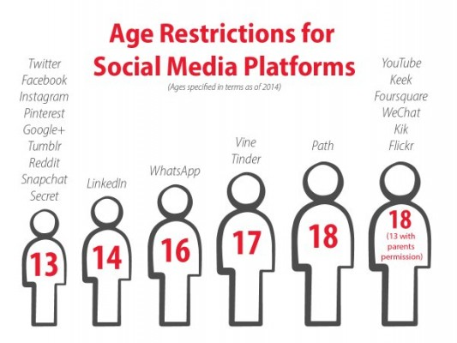  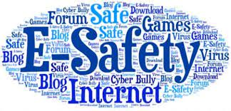  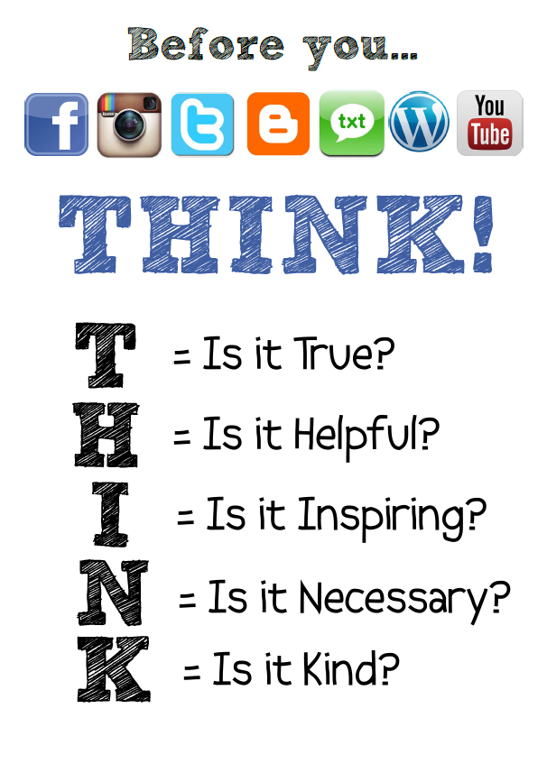 |  |   Digital footprint
 |  |  |  | E’Saftey

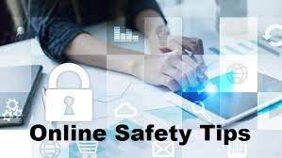 |  | 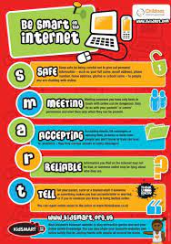  Be SMART online! |  | 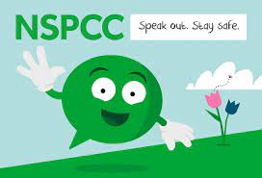  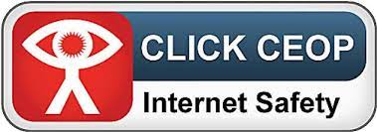
- Make sure they are the appropriate age to be using the social media apps for example your meant to be 13 to have a snapchat account.  - Make sure they speak to you or a trusted adult if they think something is wrong or someone is not nice to them.  - Make sure they have a safe and secure password that you are aware of.  - Make sure they are aware of how to use the internet safely before they use it. |  |  |  | Extra help and advice  - Visit child net online for more information https://www.childnet.com/  - Call bullying UK on 0808 800 2222  - Speak to your family support officer in your child’s school.  - Also, if your child has been a victim and needs support the following offers more information and advice on mental health in children https://youngminds.org.uk/find-help/your-guide-to-support/guide-to-camhs/
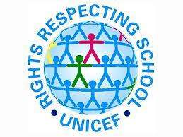
UNCRC Article 13
“I have the right to find out and share information”

Reference for leaflet
- Medium. 2021. My Digital Footprint from LLWW. [online] Available at: https://medium.com/@jack96p/my-digital-footprint-from-llww-d8698ac3af49 [Accessed 22 March 2021].
- The Children and Young People's Commissioner Scotland. 2021. UNCRC Article 13 - I have the right to find out and share information - The Children and Young People's Commissioner Scotland. [online] Available at: https://cypcs.org.uk/rights/uncrc/articles/article-13/#:~:text=Everyone%20has%20the%20human%20right,in%20the%20way%20you%20want. [Accessed 22 March 2021].
- Willow.lancs.sch.uk. 2021. think-social-media | Willow Lane Primary School. [online] Available at: https://www.willow.lancs.sch.uk/online-safety-tips/think-social-media/ [Accessed 22 March 2021].
- Safe4Me. 2021. NSPCC Stay Safe. Speak Out. Free School Visits. [online] Available at: https://www.safe4me.co.uk/2018/09/27/nspcc-stay-safe-speak-out-free-school-visits/ [Accessed 22 March 2021].
- Nghs.org.uk. 2021. Social Media Age Restrictions - Newport Girls' High School. [online] Available at: https://www.nghs.org.uk/c/social-media-age-restrictions/ [Accessed 22 March 2021].
- New Heights High School. 2021. E-Safety. [online] Available at: http://newheightsschool.co.uk/our-school/safeguarding/e-safety/ [Accessed 22 March 2021].
- Nationalonlinesafety.com. 2021. National Online Safety | Keeping Children Safe Online in Education. [online] Available at: https://nationalonlinesafety.com/ [Accessed 23 March 2021].
- Harper, P., 2021. Facebook, Instagram, Twitter, Snapchat, WhatsApp and YouTube age restrictions explained. [online] The Sun. Available at: https://www.thesun.co.uk/tech/4136922/age-restrictions-facebook-snapchat-twitter-instagram/#:~:text=Nearly%20all%20social%20networking%20sites,Privacy%20Protection%20Act%20(COPPA). [Accessed 22 March 2021].

Rationale
Throughout this rationale one will be discussing what safeguarding is and how it is implemented in schools. One will be explaining what child protection is and the policies that are in place to insure children are kept safe such as the children’s act 1989 but also the failures and procedures. E-safety will also be discussed in the rationale and what policies are currently in place within schools to make sure children stay safe online. The leaflet is for parents, careers and those working with children as it contains information that parents need to know in order to keep their children safe online such as age restrictions on certain apps but also what agencies they can contact if online abuse has occurred.
Safeguarding is an actin that is in place to promote and insure children are protected from harm, protected from abuse and maltreatment. It also protects children against health or development harm. Safeguarding is to insure children grow up living in a safe place with care and encouragement and support to be the best they can be. Following safeguarding measures and policies means children are safe from risk of harm weather that be from an adult or another child giving children equal opportunities in life. Child protection and safeguarding are used at the same time but they are different as safeguarding refers to all children were as child protection refers to children who are at risk of immediate direct harm, this could be from abuse and neglect. Types of abuse are physical, sexual, emotional and neglect, Exploitation and grooming are recognized types of abuse. “50,000 children in the UK are known to be at risk of abuse right now” (NSPCC-child abuse statistics) In the school setting everyone who works with children needs to have a CRB check (criminal records bruro) to check the employers have a clear background with no criminal offences. If the CRB check is not completed by the start of employment the adult can not work with children as they may be a risk to them. Two ten-year-old girls disappeared in 2002 in Soham they were Jessica Chapman and Holly wells. The senior caretaker at a local school where his girlfriend also worked was responsible, he was known as Ian Nixon. He had many offences against him including alleged sexual offences three of which involved underaged girls. He was regarded as a possible serial sex offender! When he did his CRB form for the caretaker’s job he used his new name of Nixon but did disclose his previous name! It was not checked if hutly was checked his burglary charge would have shown up and he wouldn’t have been employed at the school. The inquiry found that the police of Humberside where the offences happened destroyed information because it did not lead to a conviction this was contradicted by other police forces as Humberside police should have been contacted during the vetting process. Following the deaths of the two girls the Bichard inquiry report was written (2004) it included for information to be shared between police authorities more efficiently. CRB checks are now enhanced because of the Bichard report was written it is now known as the DBS check which is Disclosure Barring service which shows up all spent and unspent convictions, reprimands even final warning that are held on police file. In 2000 a eight year old girl Victoria Climbe died because of her auntie and partner she was living with and despite having two hospital visits and coming into contact with social services and the police her abuse was not discovered till her death! this led to lord lemmings report in 2003 which made changes to children’s services in England and Wales. He made 108 recommendations for government, health services and social services with these in place agencies can now work together and share relevant information. Following Victoria Climbe’s death Every Child Matters policy began. Due to the people who came in contact with her failed her. This caused a public outcry, which led to major changes to the child protection policies in the UK. ECM policy is for every child from birth to nineteen years of age with five key principles these are Be healthy, stay safe, Enjoy and achieve, make a positive contribution, Achieve economic wellbeing. Anyone working vulnerable adults and children must be aware of safeguarding and the policies and procedures there setting has in place to ensure that every child has the right to protection regardless of their religion, race, gender, disability, regardless of if the child/children are considered vulnerable. The primary school where I work in is based in a deprived area in South West Wales, it is a rights respecting school. The school uses the United Nations Convention on the Rights of the child (UNCRC) it is at the heart of everything the school does, this includes planning, ethos, practice, and policies. We as teaching staff not only teach the children all the articles but also model the rights between children and staff. Every member of staff has had training on the UNCRC rights and is familiar with Restorative Practice program. Our school has many policies which are all available to every parent via the school app, these are whistle blowing, safeguarding, data protection, anti-bullying, online safety and many more. Each staff member will be familiar with all of these policies and know the correct steps to follow if a disclosure is made. Everyone has a duty of responsibility to safeguard children having said that our school has designated safeguarding team that members of staff can report any disclosures/incodencces to, the safeguarding team and Head teacher then decide if a referral needs to be made to any out side agencies such as TAFF (team around the family) and CAMHS( child and adolescent mental health services).All the school policies and procedures are updated by the governors and board of directors to ensure the children’s needs are met.
The attached leaflet is to show parents the importance of children staying safe online. In today’s society the internet is being used more than ever! The UK safter internet center carried out research looking at the digital lives of young people it showed 1 in 6 young people shared a photo within the last hour. The research also showed that 70% of children had seen an image or a video that was not appropriate for them to see. Due to the recent pandemic of covid19 children are using technology and the internet from a younger age and for longer hours. This means children are more at risk of cyber bulling, dangerous situations, inappropriate images or videos and not age-appropriate gaming. The world has now become a very digital world. With that in mind it is important that children feel safe to be online and know the dangers that surround the internet, children can be easily enticed into inappropriate websites. These websites can often lure children in by advertising their favorite youtuber or show then when they click on it could be something different. The internet offers many ways of communication through various apps, this unfortunately is a window for cyber bullying to occur. Children need to know ho to be safe online, for example don’t share personal information I.E where you live, do not share passwords and make sure they are strong so no one can guess them. Never send indecent images, what goes online stays online forever! There are many types of cyber bullying the main ones are gossiping, harassment and trolling. Hate comments can be the most hurtful, the person writing the comments have no idea how hurtful it can be, just like the recent events that have happened to famous people like Jessy Nelson a singer from a popular band little mix who had sever mental health issues due to online trolling that caused her to leave the band, also Caroline Flack took her own life due to abuse on social media and press hate. The leaflet shows online safety tips such as the age restrictions on certain apps for example to have Facebook you need to be 13 years old, but the key information is to help children get support and advice if they are being cyber bullied or spoke to inappropriately or made to do things they don’t want to do, there are many agencies who can help such as NSPCC. We as teachers in school need to educate the children on being safe whilst keeping their rights in mind such as article 13 I have the right to find out and share information (UNCRC children’s rights) although bullying is not specific criminal offence in the Unite Kingdoms law, criminal and civil laws can be applied. The age of criminal responsibility in the UK starts at 10 years old. Schools also follow the online school policy which has been developed by the online safety group which consists of the pupils, parents and governors and staff and the online safety coordinator. The school monitors the impact of the policy by using logs of any incidents and logs of internet activity, the safeguarding team have a duty of online safety too, they are trained in online safety issues and be aware of the potential for services child protection that could arise from inappropriate materials, online contact with strangers could lead to potential grooming.
To conclude it is important that parents and schools work together to safeguard their child online in addiction with outside agencies if necessary. All procedures and policies are most effective when all information is shared between all parties involved. The children act 1989 began to ensure families and agencies state work together it was amended in 2004 largely in consequences of the Victoria Climbe inquiry. The welsh government 2015 advised “we all need to work together and make sure that children and young people are kept safe and have everything they need for a happy healthy life”. The welsh government also stated in 2016 “that information about online safety should be more widely available”. Schools do this by promoting online safety days, knowing the UNCRC rights, Planned online safety curriculum, we have digital leaders and also our children are asked to follow rules using the being internet awesome pledge. By teaching the children these strategies whilst using the internet they have an understanding and importance of reporting any misuse or abuse online. Despite all the schools and government polcies and procedures it is unfortunate that cyber bullying still occurs today, Companies of online gaming and social media apps need to take responsibility for this and there should be tighter restrictions when signing up to use these or if you are caught miss using the apps or games and they should be in close contact with other agencies and police to make sure people receive the relevant consequences for their actions.

Reference list
- NSPCC Learning. 2021. E-safety for schools | NSPCC Learning. [online] Available at: https://learning.nspcc.org.uk/research-resources/schools/e-safety-for-schools [Accessed 24 March 2021].
- Pembrokedockcommunityschool.co.uk. 2021. Home | Pembroke Dock Community School. [online] Available at: https://www.pembrokedockcommunityschool.co.uk/ [Accessed 23 March 2021].
- Gov.wales. 2021. [online] Available at: https://gov.wales/sites/default/files/publications/2018-07/online-safety-action-plan-for-children-and-young-people-in-wales.pdf [Accessed 23 March 2021].
- Bullying.co.uk. 2021. Bullying advice | Bullying UK. [online] Available at: https://www.bullying.co.uk/ [Accessed 24 March 2021].
- networking?, W., 2021. What age can my child start social networking? | Internet Matters. [online] Internet Matters. Available at: https://www.internetmatters.org/resources/what-age-can-my-child-start-social-networking/ [Accessed 24 March 2021].
- Verywell Family. 2021. Learn to Recognize the Real-Life Effects of Cyberbullying on Children. [online] Available at: https://www.verywellfamily.com/what-are-the-effects-of-cyberbullying-460558 [Accessed 24 March 2021].
- Unicef UK. 2021. UN Convention on the Rights of the Child (UNCRC) - UNICEF UK. [online] Available at: https://www.unicef.org.uk/what-we-do/un-convention-child-rights/ [Accessed 23 March 2021].
- Bbc.co.uk. 2021. BBC iPlayer - Jesy Nelson: Odd One Out. [online] Available at: https://www.bbc.co.uk/iplayer/episode/p07lsr4d/jesy-nelson-odd-one-out [Accessed 24 March 2021].
- Assets.publishing.service.gov.uk. 2021. [online] Available at: https://assets.publishing.service.gov.uk/government/uploads/system/uploads/attachment_data/file/273183/5730.pdf [Accessed 23 March 2021].
- 2021. [online] Available at: https://socialcare.wales/cms_assets/file-uploads/32-All-Wales-Basic-Safeguarding-Awareness-Training-Practice-case-review-3-%E2%80%93-Jessica-Chapman-and-Holly-Wells.pdf [Accessed 24 March 2021].

