Silvia Settle, 1708386

Beverly Holland Module ACCA5026

Databases and Application Development
The Smile Factory Case Study

Contents
Database Creation 1
Background 1
Project Aims 1
Context 1
Requirements for the system: 1
Design 2
Database ERD Diagram 2
Table Design with datatypes and constraints 2
Scope of the project and solution 8
Scope 8
Constraints and data integrity 9
Inserting data 10
Performance Tuning 11
Indexes 11
Triggers 11
Security Considerations 11
Backup and Restore 12
Distributed Database Solution 12
Suitable Fragmentation Schema 12
Sources: 14

Database Creation

Background

Project Aims
To create an application to allow the organisation and booking of dental services. Different type of dental treatments will require different appointment duration and depending on the status of the patient (NHS or private), different payment will be due. The system should allow for invoicing to be produced and revenue calculated. The system is to be used by the receptionist/admin staff. extension option could be the possibility of linking the database to a front-desk online service to allow the patient to book appointments online and dentists to receive communication by email.

Context
The Smile Factory has 4 dentists, 6 dental hygienists and 6 dental nurses. It offers 4 morning surgeries (rooms) and 2 afternoon surgeries. The surgery is open Monday to Friday. Morning surgeries are 8.30am till 11.30am and afternoon surgeries are 2pm till 5pm.
The patients make appointments for treatment. Dentists, hygienists and nurses must be scheduled into a surgery slot. Appointments are min of 15 mins long and are determined by the dental treatment. Patients are issued invoices for treatment and who pays for this treatment depends on the patient status: NHS or private. Private patients are charged.

Requirements for the system:
- It must record the invoices issued and payment made in order to keep track of the income generated from the appointments.
- It will automatically print out a schedule for each dentist
- Will print out invoices and keep record of the invoices.
- It should be able to keep a record of the income generated from patients’ appointments.
- It should be able to produce a query for patients seeking appointments (views, filtering through status)
- It will print out reports on time schedules.
- It will print out reports on current booking levels of rooms and dental surgery staff.

Design

Database ERD Diagram

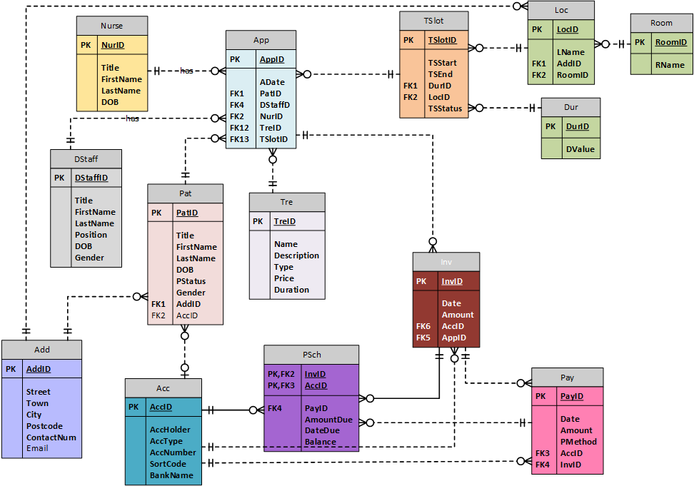

Table Design with datatypes and constraints

Acc=Accounts Receivable
Table Name | Acc
Fields | Data Type | Constraints | Sample Data
AccID | int IDENTITY(100000,1) NOT NULL | PK_AccID | 100001 100002
AccHolder | varchar(30) NOT NULL | UNIQUE | John Taylor, NHS
AccType | varchar(10) NOT NULL | CHK_Acc_AccType (NHS or PRP)  Default_Acc_AccType (PRP) | NHS or PRP
AccNumber | varchar(8) NOT NULL |  | 1002510 or 22245321
SortCode | varchar(8) NOT NULL |  | 55-25-25
BankName | varchar(30) NOT NULL |  | Natwest

Add=Address
Table Name | Add
Fields | Data Type | Constraints | Sample data
AddID | int IDENTITY(1,1) NOT NULL | PK_AddID | 1, 55, 14
Street | varchar(30) NOT NULL |  | 23 Meadow Lane
Town | varchar(30) NOT NULL |  | Clydach
City | varchar(20) NOT NULL |  | Swansea
Postcode | varchar(8) NOT NULL |  | SA88RR
ContactNum | varchar(12) NOT NULL |  | 01792544123
Email | varchar(40) NULL |  | silly_socks@gmail.com

App=Appointments
Table Name | App
Fields | Data Type | Constraints | Sample Data
AppID | int IDENTITY(1,1) NOT NULL | PK_AppID | 1005, 5488
ADate | datetime NOT NULL | CHK_App_ADate (cannot be in the past) | 12/05/2004
PatID | int NOT NULL | FK_App_Pat_PatID | 100001, 511115
DStaffID | varchar(4) NOT NULL | FK_App_DStaff_DStaffID | DS05, DS08
NurID | varchar(4) NOT NULL | FK_App_Nur_NurID | NU08, NU01
Tried | varchar(4) NOT NULL | FK_App_Tre_TreID | TR01, TR04
TSlotID | varchar(4) NOT NULL | FK_App_TSlot_TSlotID | TS01

TSlot = TimeSlot
Table Name | TSlot
Fields | Data Type | Constraints | Sample Data
TSlotID | varchar(4) NOT NULL | PK_TSlotID | TS01-TS24
TSStart | datetime NOT NULL |  | 2021-04-14 8:00
TSEnd | datetime NOT NULL |  | 2021-04-14 8:30
DurID | varchar(1) NOT NULL | FK_TSlot_Dur_DurID | A, B, or C
LocID | varchar(4) NOT NULL | FK_TSlot_Loc_LocID | SU01
TSStatus | varchar(1) NOT NULL | CHK_TSlot_TSStatus (A or B) | A, B

Dur - Duration
Table Name | Dur
Fields | Data Type | Constraints | Sample Data
DurID | varchar(1) NOT NULL | PK_DurID | A, B, C
DValue | int NOT NULL |  | 15, 30, 45

Room
Table Name | Room
Fields | Data Type | Constraints | Sample Data
RoomID | varchar(2) | PK_DurID | R1, R2
RName | varchar(10) |  | Room 1 – Room 3

Nurse
Table Name | Nurse
Fields | Data Type | Constraints | Sample Data
NurID | varchar(4) NOT NULL | PK_NurID | NU01 to NU06
Title | varchar(10) NOT NULL | CHK_Nur_Title (Mr or Mrs or Ms or Miss) | Mr, Ms
Firstname | varchar(30) NOT NULL |  | Helena
LastName | varchar(50) NOT NULL |  | Carter
DOB | date NOT NULL | CHK_Nur_Date (cannot be in the future) | 1954-05-14

Dstaff = Dental Staff (Dentists and Dental Hygienists)
Table Name | DStaff
Fields | Data Type | Constraints
DStaffID | varchar(4) NOT NULL | PK_DStaffID | DS01 – DS10
Title | varchar(10) NOT NULL | CHK_DStaff_Title (Mr or Mrs or Ms or Miss or Dr or Prof) | Dr, Prof
FirstName | varchar(30) NOT NULL |  | Julian
LastName | varchar(50) NOT NULL |  | Watson
Position | varchar(2) NOT NULL | CHK_DStaff_Position (DS or DH) | DS (dentist), DH (dental hygienist)
DOB | date NOT NULL | CHK_DStaff_DOB (cannot be in the future) | 1956-12-15
Gender | varchar(1) NOT NULL | CHK_DStaff_Gender (M or F) | M, F

Inv = Invoices
Table Name | Inv
Fields | Data Type | Constraints | Sample Data
InvID | int IDENTITY(1,1) NOT NULL | PK_InvID | 1, 56
Date | datetime NOT NULL | Default_Inv_Date (current date and time) | 2019-04-17
Amount | decimal(10,2) NOT NULL
AccID | int NOT NULL | FK_Inv_Acc_AccID | 100002, 854141
AppID | int NOT NULL | FK_Inv_App_AppID | 2, 59

Loc = Location/Surgeries
Table Name | Loc
Fields | Data Type | Constraints | Sample Data
LocID | varchar(4) NOT NULL | PK_LocID | SU01-SU05
LName | varchar(30) NOT NULL |  | Alexandra Road Surgery, Wern Surgery
AddID | int NOT NULL | FK_Loc_Add_AddID | 1, 2
RoomIS | varchar(2) | FK_Loc_Room_RoomID | R1, R2, R3

Pat = Patients
Table Name | Pat
Fields | Data Type | Constraints | Sample Data
PatID | int IDENTITY(100000,1) NOT NULL | PK_PatID | 100000-999999
Title | varchar(5) NOT NULL | CHK_Pat_Title (Mr or Mrs or Ms or Miss or Master or Dr or Prof) | Mr, Mrs
FirstName | varchar(30) NOT NULL |  | John
LastName | varchar(40) NOT NULL |  | Talyor
DOB | date NOT NULL | CHK_Pat_DOB (cannot be in the future) | 2000-05-12
PStatus | varchar(3) NOT NULL | CHK_Pat_PStatus (NHS or PRP) Default_Pat_PStatus (NHS) | NHS, PRP
Gender | varchar(1) NOT NULL | CHK_Pat_Gender (M or F) | F, M
AddID | int NOT NULL | FK_Pat_Add_AddID | 1,2
AccID | int NULL | FK_Pat_Acc_AccID | 100004

Pay = Payments
Table Name | Pay
Fields | Data Type | Constraints | Sample Data
PayID | int IDENTITY(1,1) NOT NULL | PK_PayID | 1, 58, 21
Date | date NOT NULL | Default _Pay_Date (today’s date) | 2020-01-01
Amount | decimal(10,2) NOT NULL |  | 45.00
PMethod | varchar(2) NOT NULL | CHK_Pay_PMethod (DD or CD) | CD, DD
InvID | int NOT NULL | FK_Pay_Inv_InvID | 14, 2
AccID | int NOT NULL | FK_Pay_Acc_AccID | 8,12,5

PaySch = Payments Schedule
Table Name | PSch
Fields | Data Type | Constraints | Sample Data
InvID | int NOT NULL | PK_PaySchID FK_PaySch_Inv_InvID | 4,89
AccID | int NOT NULL | PK_PaySchID FK_PaySch_Acc_AccID | 100001
PayID | int NOT NULL | FK_PaySch_Pay_PayID | 1
AmountDue | decimal(10,2) NOT NULL |  | £45
DateDue | date NOT NULL |  | 01/02/2012
Balance | decimal(10,2) NOT NULL |  | £45

Tre = Treatments/Dental Procedures
Table Name | Tre
Fields | Data Type | Constraints
TreID | varchar(4) NOT NULL | PK_TreID | TR01-TR04
Name | varchar(20) NOT NULL | CHK_Tre_Name (Band 1, Band 2, Band 3), preventative | Band 1, 2, 3 or preventative
Description | varchar(50) NOT NULL |  | Scale& Polish
Type | varchar(2) NOT NULL | CHK_Tre_Type (PC or HM) | PC (preventative care) or HM (health-management)
Price | decimal(10, 2) NOT NULL |  | Band A
Duration | int NOT NULL |  | 15

Scope of the project and solution

Scope

Staff Table
The database is only dealing with the type of staff involved in the treatment. Although we would expect that a surgery would have other members of staff such as administrators, managers, accountants, these are left out of the scope of this project. The project is also not dealing with the employment and financial side of staff management.

Treatment Table
The project is focusing only on the services ordinarily provided by the NHS-i.e. preventative and health-maintenance dentalcare (Health in Wales | Find an NHS Dentist). For convenience, the solution’s emphasis is on the revenue this treatment brings and therefore the detail of different types of treatment is left out. The project is not going to record detailed information on patients’ treatment and history, and as a result the treatment was grouped into bands (band1, 2 and 3 according to the fee they incur as well as the time required – 15, 30 and 45 min respectively). Another presumption is that the dental hygienists are qualified to complete dental procedures from Band 1. For convenience, the dental hygienist treatments (polish and scaling) were grouped within band 1 too, both from the point of view of time required for treatment and the fee.
Specialist dental treatments which is classed as cosmetic by the NHS (Health in Wales | Find an NHS Dentist) is left out of the scope of the project as it is not usually within the list of NHS treatments.

Surgery
This is interpreted as two sites with several rooms offering treatment in the morning and/or afternoon. One of the surgeries is open only in the morning.

Patients
For this solution the presumption was made that the Smile Factory staff will determine the type of patients when their information is entered into the database. Although in real life there is a list of criteria that trigger the exemption from treatment – such as age (under 18 and over….), means tested (low income and benefits), pregnant (during pregnancy and for a year after), the project will not investigate this area. If the patient does not meet the criteria for exemption and is classed as “private”, a payment account is created that will hold their DD details. The system of payment is focused on the private patients only, while the NHS ones are only tracked to the point of invoicing, where the presumption is that further processes are followed by the business to obtain the fees due for NHS treatment.

Constraints and data integrity
To ensure data integrity several measures were introduced into the database:

Tables and primary keys
The nurse, the dental staff, the treatment, and the location tables hold data that is relatively stable, and it is not very likely to change very often. For example, we expect the members of staff and the location to stay the same for a long time. This is the reason why the data type for the primary keys in those tables was chosen to be varchar and in a format that makes them look more like natural keys that will make sense to the humans looking at the data in the tables. For example, SU01 stands for Surgery 1 – the Alexandra Road Surgery, DS01 is the dentist Dr Joanne Jones, DH01 is the dental hygienist Dahlia Davadjikan and NU01 is the nurse Rosie Romford. The Dentists and the dental hygienists were grouped into a common table because of the presumption that they can both offer treatment from Band 1, and as such, their appointment allocation can follow the same process. The combination of different characters ‘DH’ for dental hygienist and ’DS’ for a dentist makes it easy to distinguish what type of surgery staff they are - a dentist or a dental hygienist. The decision which one will be assigned for an appointment will depend on the treatment type required and using the primary keys in this format allows to distinguish which is which. It is possible to split these two in separate tables, however the decision was made to keep the dental staff in one table for convenience. The dental staff has a gender column for situations where the patient may prefer to be treated by a specialist from a specific gender, however this was omitted from the nurses table as their numbers limit the options available.
The data in the patients table is more prone to change in terms of a patient can change status, address, name, title, or address. The number of records is also expected to increase over time, therefore the primary key was chosen to be ‘int IDENTITY’ to make the process of key allocation automatic. Similarly, the appointments, the appointments schedule, the invoices, the payments, and the private patients’ accounts tables hold more dynamic data so ‘int IDENTITY’ was chosen as the data type for their primary key too. For example, the combination of dates, timeslots and availability in the appointments schedule table varies throughout the lifespan of the system.
The accounts table contains a field for account name. It was decided that this is going to be a field to hold one account name that combines the first and last name of the account holder to ensure uniqueness. The UNIQUE constraint was added to the field to ensure this and to prevent situations where different patients with the same first and last name try to open an account and be considered by the system as already having one. The business can decide how they deal with situations like this, i.e. whether to introduce a middle initial or add an integer at the end of the account name to ensure uniqueness.
The Pay Schedule table has a composite/compound key having the foreign key columns from the invoices and the accounts tables. This decision was made to ensure that the combinations of invoices and payees accounts is unique. The design for the payments table used a surrogate key in contrast for ease of use at the stage of tracking payments and calculating income.
Any long-term considerations for the system operation were left out of the scope of the current design due to prioritising requirements and considering time and resources constraints. For example, scenarios where a patient dies or moves away and is not able to complete the direct debit (DD) payments for their treatment were not considered within the parameters of this solution. Similarly, another example of a rejected consideration was the use of a foreign key constraint ‘ON DELETE’ for the addresses table to allow for situations where if we delete a record from the patients, the dental staff, or the nurses table, we will want to delete the address associated with this table as well. This was not implemented due to not being considered critical to the current operational functionality of the system.

CHECK Constraints
Accounts table – account type has a default value of PHP. This was design with a view to be able to hold the details for NHS accounts that are used to pay for treatments for NHS patients. Later on, the design was changed, and the account was limited to hold private patients bank account details only. The feature was left in case of changes in the business requirements in the future.

Naming conventions
General naming conventions were used in the design and the implementation of the project. Hungarian notation as used for the naming of all constraints (primary keys, foreign keys, default values, check constraints), for example: FK for foreign key, CHK for check constraints. Table and column names used Camel Case, while any SQL key words were in capitals.

Inserting data
Stored Procedures were used to facilitate the process of database management, including DDL and DML commands. For example, the tables creation, insertion of foreign keys and check constraints.

Performance Tuning

Indexes
Indexes were considered for the tables that would be queried most often. Non-clustered Indexes were considered for the two main junction tables: appointments and payments. For example, an index on the date, invoiceNo and amount paid/payment method will allow for quicker retrieval and data aggregation. Indexed fields in the appointments table would allow for faster search on appointments by date, patient, dental staff/nurse, treatment type.
A clustered index was considered for the payment schedule table where larger volumes of data are expected to be stored and the composite key makes it a suitable candidate to organise the data by account number. Indexing was planned but not implemented in the database as it was deemed more appropriate to investigate this at the implementation stage, where the presence of data will make it easier to observe queries behaviour.

Triggers
SQL-triggers were considered for implementation to handle the complex queries at two points of the system – the booking of appointments and the payments. Their purpose is to automatically validate the data being processed in the tables handling the data manipulation, to ensure domain integrity of the business rules at these points and to handle post-processing procedures within the following tables: appointments, invoice, payments, and the payment-schedule tables. These were not implemented as the database was not developed at the advanced stages of operation. These are to be considered carefully and not overused as to not deter the performance of the database queries.

Security Considerations
Encrypting Stored Procedures
Stored procedures were used extensively in the design and implementation of the database in order to:
- Improve reusability and makes changes easy to implement and trace;
- Reduce network traffic once the database is operational;
- To allow for code reusability and better maintainability if changes are required during the lifespan of the application.

Backup and Restore
A regular back up on an external device was considered important to ensure the data security as part of the business planned and non-planned contingencies.
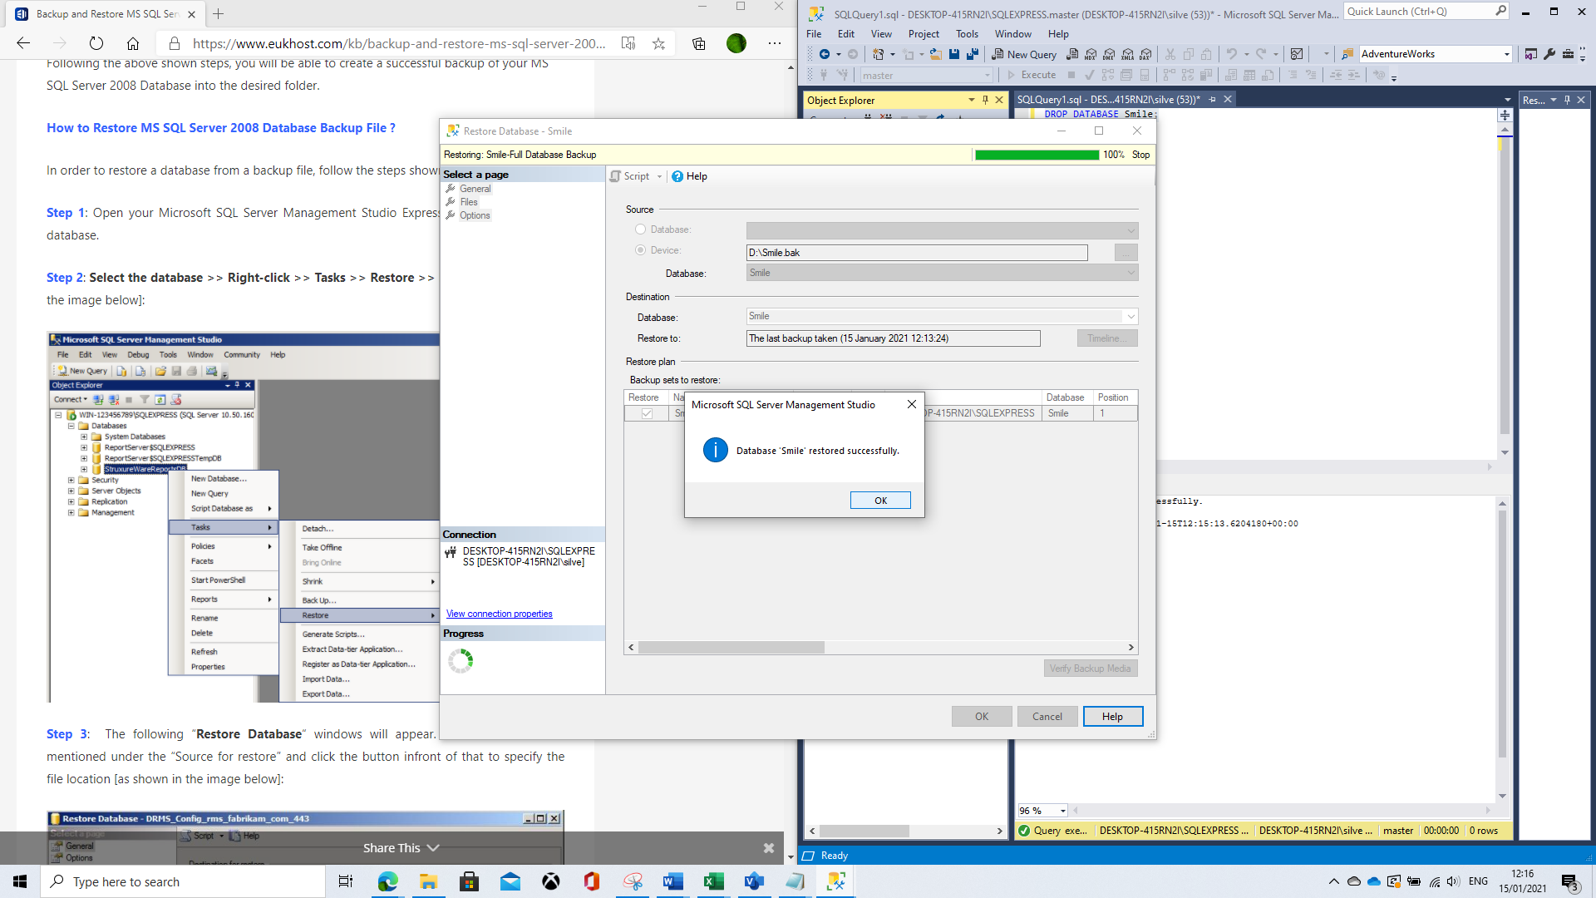

Distributed Database Solution

Suitable Fragmentation Schema
The Smile database is operational across two sites with the possibility of new surgeries being opened at other locations. The need for working across several sites in parallel and with the potential of increased volume of data entering the system, the consideration for a distributed database design seems appropriate. Distributed databases are understood as “the combination of autonomous processes that are linked over a computer network” (Tamer Ozsu et al).
At the same time, the context of the current system and the lower level of need for efficient management of the data does eliminate a solution on such magnitude as the Scalable Distributed Data Structures (SDDSs) in which the logical and physical segmentation is fluid and scalable (Litwin and co).
Traditionally, three general approaches to the practical implementation of a database distribution can be taken: horizonal, vertical and hybrid fragmentation, in all of which the tables are split into smaller segments called fragments (Saeed, et all). The choice will depend on the need of the business and the logical organisation of the data. With the vertical fragmentation the tables can be split into sub-sets by columns, while the horizontal fragmentation investigates sectioning the records within the tables by rows. The hybrid approach is a combination of the other two and seem to offer an opportunity the solution to be tailored to the needs of the client. The latter approach was considered for the Smile Factory. For example, the invoices and payments could be fragmented horizontally by dates or by financial year, while the physical need for the bookings and the payments to be made at different sites suggest that these parts of the database can be further segmented into bookings and payments systems by site. An integral part of the fragmentation process is the use of indexes, which were briefly discussed above, and which allow the practical implementation of database partitioning.
Among the benefits of distributed database systems are better overall database control (including authentication and access rights), semantic integrity control, query optimisation, controlling concurrency, deadlock handling, replication and transaction control, and security (Saeed, et al). All of these areas are crucial for the effective operation of any business, regardless of its type or size. And with view of more and more of the business operations being performed and stored online makes them even more dependent and in demand for distributed data solutions.
.

Sources:

Litwin, W., S. Sahri, T. Schwarz. Overview of Scalable Distributed Database System SD-SQL Server, Paris-Dauphine University 75016 Paris, France Scalable Distributed Databases Design (scu.edu)
NHS website, www.nhs.uk
Saeed K. Rahimi, Frank S. Haug Distributed Database Management Systems: A Practical Approach A John Wiley & Sons, Inc., Publication, 2010
SQL Shack website (How to identify and resolve SQL Server Index Fragmentation (sqlshack.com)
Tamer Ozsu, M., P. Vallduries, Principles of Distributed Database Systems, Springer New York Dordecht Heidelberg London
Tutorial Cup Data fragmentation in DBMS - Data fragmentation - SQL (tutorialcup.com)
Youtube videos by kudvenkat, Bhaskar Jogi, Caleb Curry and Lisa Ballbach

