

Module Name: Computer Architecture and Operating Systems.

Module Code: ACCA4022_BIRM

Student Name: Moses Pappoe

Student ID: 2507709

Lecturer Name: Shah Room

Submission date: 26/03/2026

Contents
Introduction 3
Key functions of general Operating Systems 3
Task Management: 4
Application/Program Management: 5
File/Directory Management: 5
Device Management: 6
Security Management: 7
Use of Windows OS CLI commands 8
Example 1: 8
Example 2: 9
Example 3: 10
Example 4: 10
Example 5: 11
Example 6: 11
Example 7: 12
Example 8: 13
Example 9: 14
Example 10: 14
Use of Linux OS CLI commands 15
Example 1: 16
Example 2: 16
Example 3: 17
Example 4: 17
Example 5: 18
Example 6: 18
19
Example 7: 19
Example 8: 20
Example 9: 21
Example 10: 21
Use of Windows OS scripts 22
Example 1: Variable and File Creation script. 22
Example 2: Process Monitoring script. 23
Use of Linux OS scripts 24
Example 1: 24
Example 2: 26
Conclusion 27
References 28
Appendices 29

Introduction
This coursework is a deep dive into Computer Operating Systems and Architecture. It’s all about how the hardware is built, the rules it follows, and how every part relies on the others to run. It explores how the gap is bridged between hardware and software, looking specifically at how the Instruction Set Architecture (ISA) connects to the physical components that make a computer work.
The main part of the report breaks down essential OS functions like process management, memory, and file systems. By looking at how the OS sits between the user and the hardware, it shows why a solid architecture is a vital key for a fast computer performance.

Key functions of general Operating Systems
Since its debut in 1985, Microsoft Windows has transformed from a simple graphical overlay for MS-DOS into the world’s most dominant desktop operating system. It was revolutionary because it moved computing away from cryptic text commands toward a visual interface of windows, icons, and menus, making technology accessible to the public.
It’s a universal standard for both personal and enterprise computing as it enables software and hardware can interact seamlessly.

Microsoft Windows was launched in 1985 and has since been the dominant OS for computers. It revolutionized computing by moving it away from text commands to a visual interface of icons and menus, making technology accessible to the public. Silberschatz et al note that Windows acts as a vital middleman in managing hardware resources to keep the computer easy and convenient for users [1].

Task Management:
The Task Management function in Windows acts as the brains or primary mechanism of the system as it handles responsibilities such as process scheduling and oversees all active processes [2]. This ensures that background services and user applications will equally and efficiently get a fair share of the CPU’s resources, thereby preventing a single program from monopolizing system resources. The tool for this is the Task Manager, which provides real-time visibility into CPU, memory, and disk usage. It enables users and the system to terminate any unresponsive tasks and re-organise process priorities. This coordination is what makes multitasking possible, without it the computer would lag or freeze up because processes will run at once, causing a deadlock.
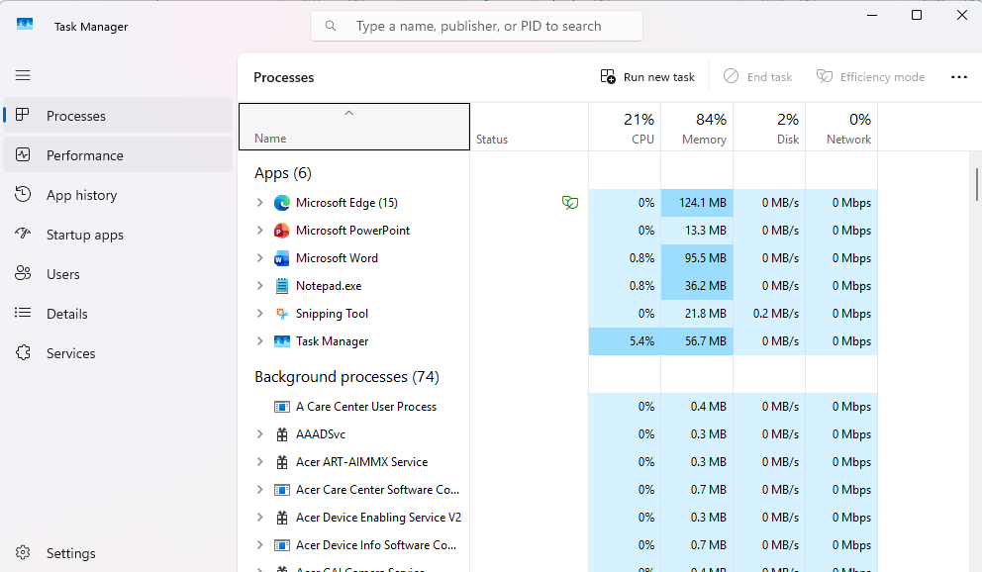

Figure 1: Task Manager in Windows.

Application/Program Management:
Windows manages the entire life of a program through its program management function. It tracks every app as it moves through the Ready, Running, and Waiting stages. Once a program reaches the Terminated stage, the OS finishes the task and removes it from the memory to free up space for other processes. As noted by Stallings (2018), the Windows OS uses Process Control Blocks (PCBs) and Thread Control Blocks (TCBs), as internal trackers to record and manage the real-time status of every active application and its associated threads [3].
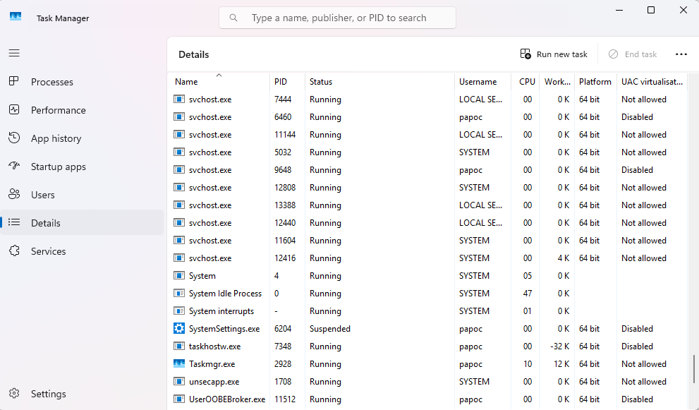
Figure 2: Processes running in the Task Manager.

File/Directory Management:

The Windows OS efficiently manages system storage by organizing data and optimizing disk space through its structured file system. It enforces data security using Access Control Lists (ACLs), ensuring that only authorized users can access specific files. This systematic architecture hides the complexity of physical storage; the user simply provides a file or directory name, and the OS instantly maps that request to the correct location within its vast database. According to Tanenbaum and Bos, this feature provides an abstract model of storage to the user because while we see a seamless hierarchy of folders and files, the OS performs the complex task behind the scenes, managing all that metadata to maintain the illusion [4].
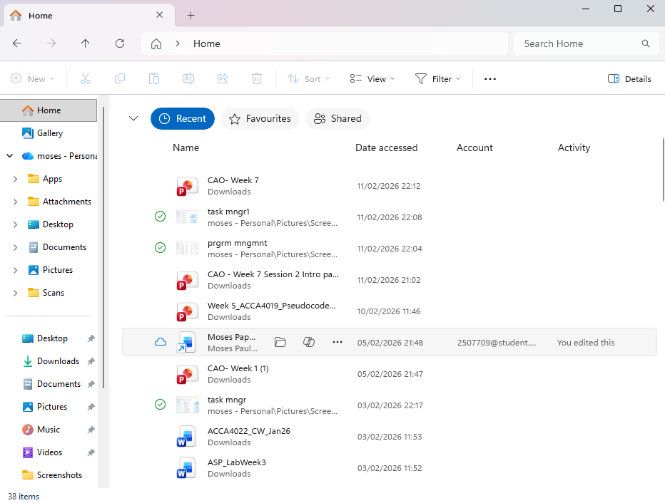
Figure 3: File Management in OS showing Directories and Files.

Device Management:

Device Management is how Windows controls the interaction between hardware and software. Due to the varying nature of gadgets/peripheral devices, the OS uses Device Drivers to act as 'translators' for the hardware. This allows Windows to remain simple and generic while still being able to use thousands of different devices. It has an I/O Manager, which ensures plug-in devices like a mouse, keyboard and a printer work seamlessly. The interrupt feature of the I/O Manager allows the processor to be engaged in other useful work and only prompted when a peripheral needs it, thus frees the processor and ensures efficiency [5].
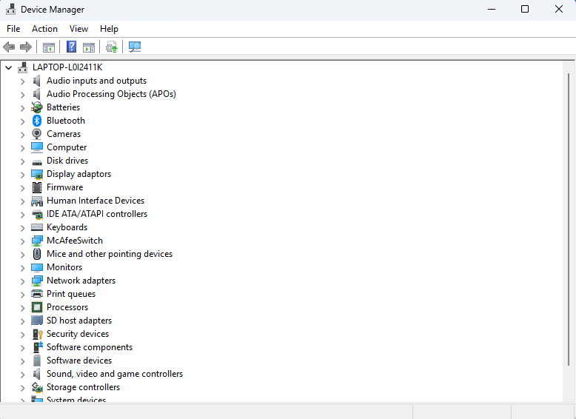
Figure 4: Device Manager of OS.

Security Management:

Security Management in Windows is the architecture built into the Operating system to provide protection from unauthorised access, thereby ensuring data integrity, system availability, and user privacy. It makes sure that users and processes only have the minimum level of access required to perform their tasks. Key components include the User Account Control (UAC), which prevents unauthorized administrative changes, and Windows Defender, which monitors for malicious activity such as viruses and malwares. The OS checks every access request against the Access Control List to authorize or deny actions based on predefined policies [6].

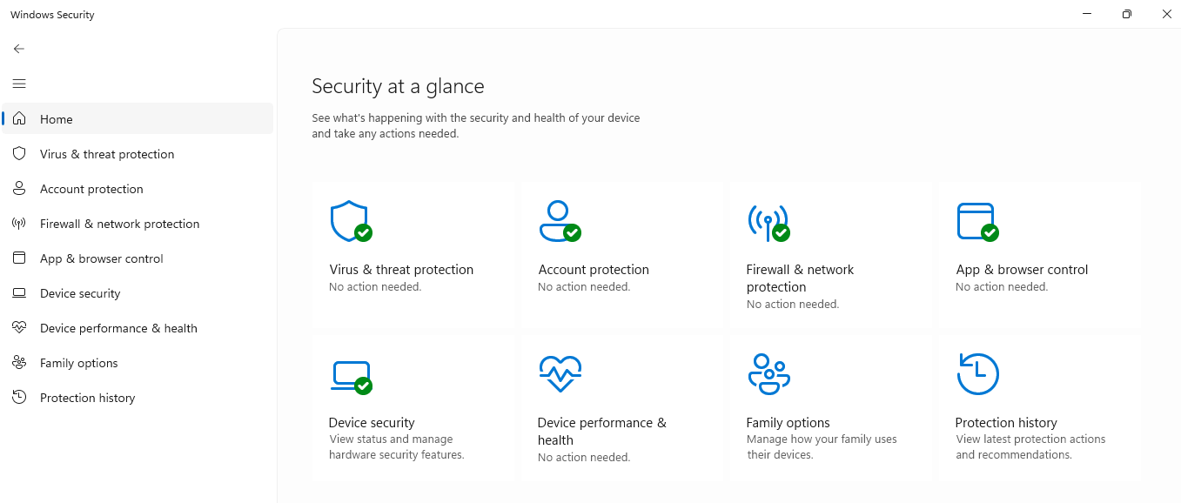
Figure 5: Windows Security

Use of Windows OS CLI commands
The CLI in windows is a text-based system whereby the user requests the performance of tasks by typing in specific instructions. Microsoft documentation explains that the CLI is composed of two distinct parts: the shell, which processes commands (Cmd) and the terminal, which acts as the host application providing the user interface [7].

Example 1:
dir (Directory):
This command lists all the files and folders in the user’s current location. This is the CLI version of opening a folder in File Explorer. It shows the user all "hidden" metadata like file size and last modified date.
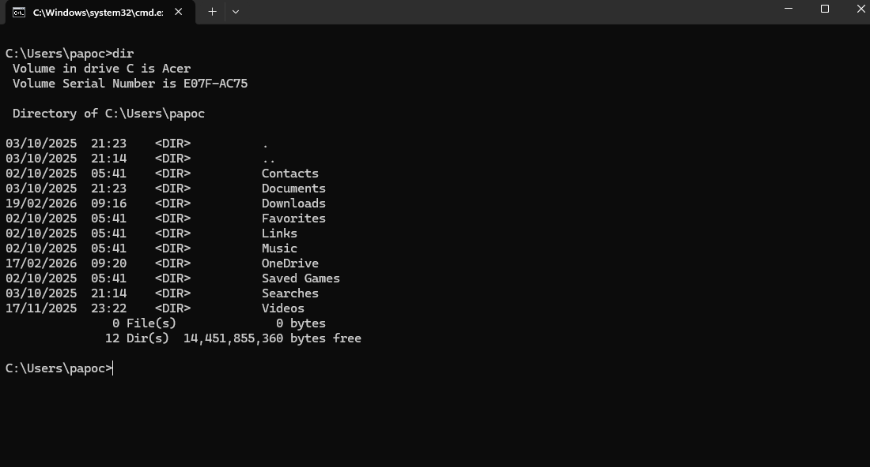
Figure 6: dir command prompt in OS CLI

Example 2:
cd (change directory):
This command moves the user into a different folder. It can be used to jump forward to a folder by including the folder name (e.g., cd Documents) or jump backwards (cd..) moves back one folder. It’s the CLI way to navigate without a mouse. 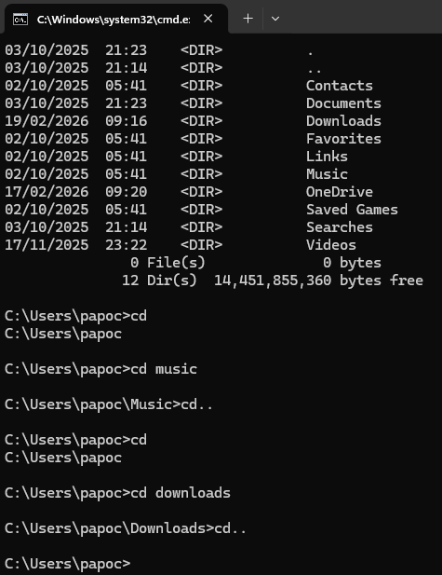

Figure 7: cd command in OS

Example 3:
mkdir [name} Make Directory:
A user can use this command to create a new folder, and the preferred name included in the command text will be applied as the folder name. It showcases the OS file management function.
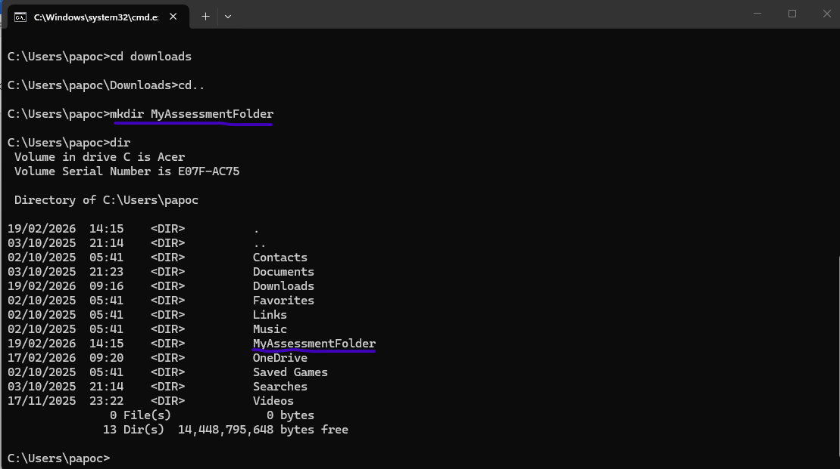
Figure 8: mkdir command on OS CLI

Example 4:
cls (Clear Screen):
A simple command that instructs OS to clear the screen of all typed text. An essential prompt to declutter the screen and keep things tidy.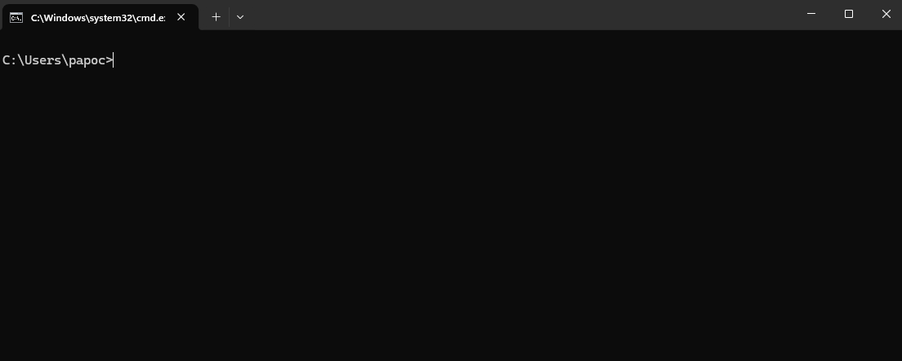
Figure 9: cls cmd has cleared the screen.

Example 5:
systeminfo (system information):
A user can request for a full report of the computer system using this command. The output will show the status of the computer’s hardware and OS including software version, date installed, RAM size, processor information amongst others.
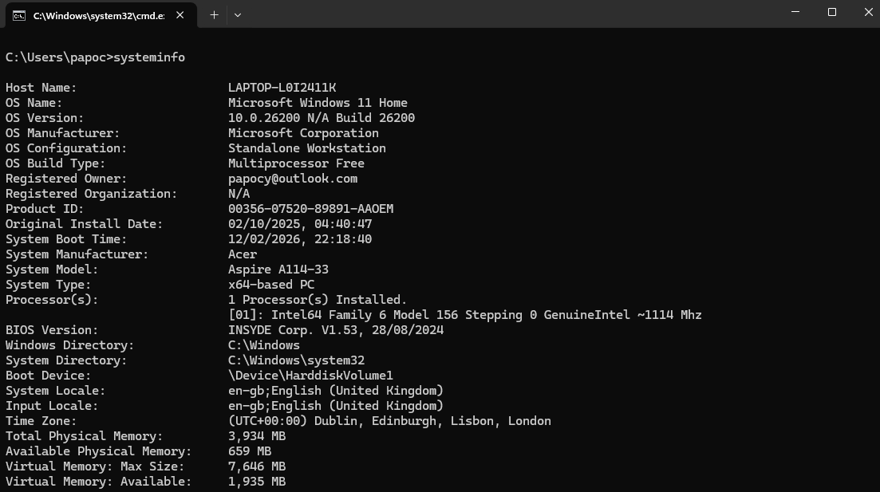
Figure 10: Systeminfo cmd showing a full report of a user’s computer.

Example 6:

Ipconfig (I.P configuration):
This CLI prompt is used to show the network settings and I.P address of the user’s computer. It also provides a holistic view of the computer’s connectivity/ networking performance, and it is the ideal troubleshooting starting point.
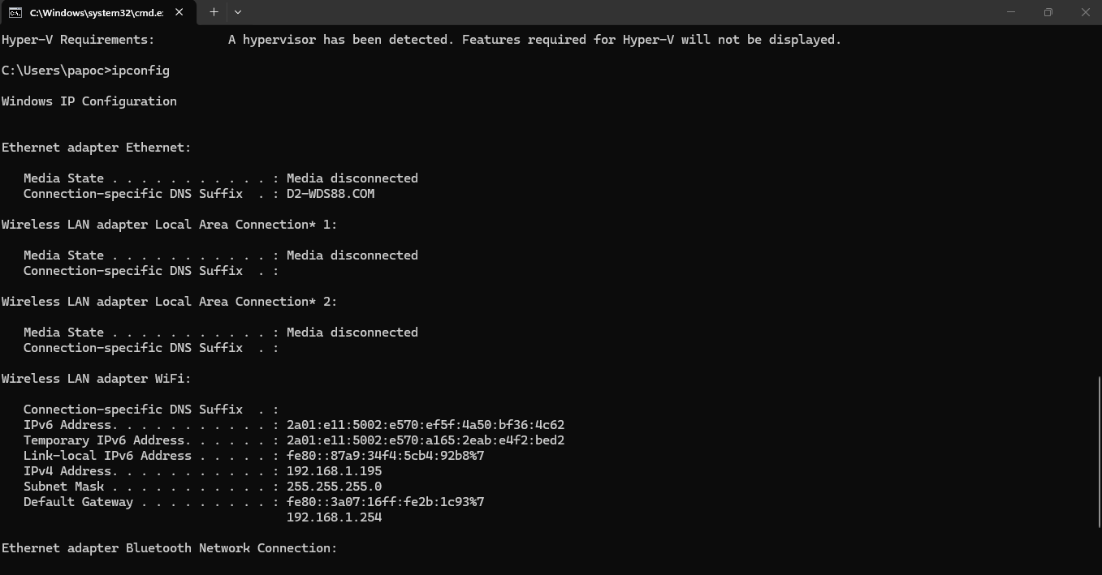
Figure 11: ipconfig cmd prompt in OS.

Example 7:
ping [website name]:
This command prompt is used to test the performance of the computer’s network cards and latency. It showcases the Device management function of the OS. A signal is sent to the named website, to gauge a response and time taken.
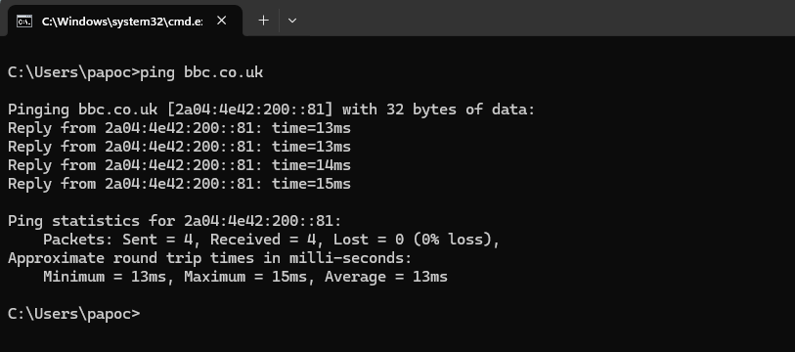
Figure 12: Ping cmd prompt in OS

Example 8:
tasklist:
A user can request for a list of all processes currently running in the computer’s memory by using this command. It gives a peak into the Task management function of the OS.
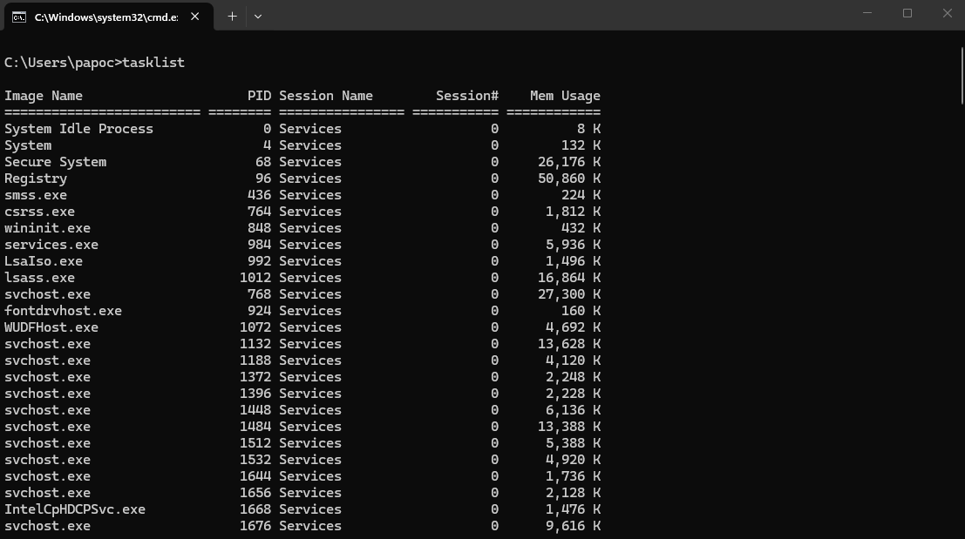
Figure 13: tasklist cmd showing output of processes running in the memory.

Example 9:
hostname:
A command used to request for the unique name of the user’s computer. This helps in the identification of the computer on a network.
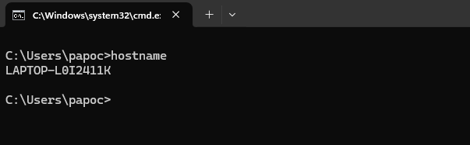
Figure 14: hostname command returns the unique name of the user’s computer.

Example 10:
help:
This command prompt returns a list of most available commands that can be used. It is much like a manual, which lists the prompts and explains what they are used for. It can be used to request help about a specific command as well by typing, ‘help [command name].
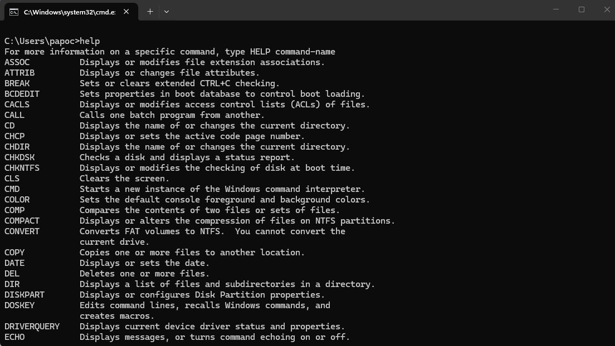
Figure 15: help cmd showing some prompts available.

Use of Linux OS CLI commands

The Linux Command Line Interface is Linux's way to make text-based requests to the computer system and the primary route for administrators and developers to interact with the Linux kernel. As opposed to Windows, nearly every system function can be managed through text. The Linux foundation states that the CLI is the direct, uninhibited link to the OS internal function [8].

Example 1:
Ls (list)
This Linux CLI command shows all files and folders in the user’s current directory. An extension of this command will be to add ‘-la’ to ‘ls’, (ls -la), which outputs "hidden" files (those starting with a dot) and detailed permissions.
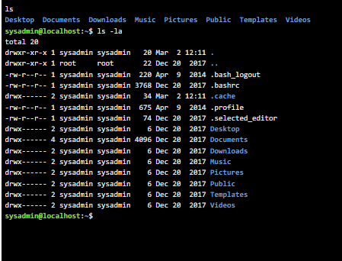
Figure 16: ls command script in Linux OS

Example 2:
pwd (Print Working Directory)
Used to show where precisely the user is currently working in the file system hierarchy. This command is necessary because there are no visual folders and there’s the possibility of user’s ‘losing’ their way sometimes.
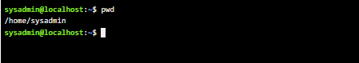
Figure 17: Output shows the pwd command showing current working directory.

Example 3:
Mkdir (Make Directory)
This command is used to create a new folder. In the image below, the CLI command was used to create the folder ‘LinuxAssessmnt’ and a directory search shows it in the list of folders.

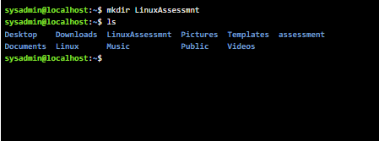
Figure 18: mkdir command In Linux

Example 4:
touch (Create a file)
This is the fastest way to create a file in Linux. The command starts by typing ‘touch’, followed by the name of the file and ‘.txt’. This new file is visible in the list of directories from the screenshot.

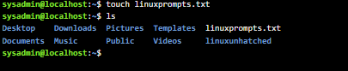
Figure 19: Touch command in Linux CLI.

Example 5:
cp (Copy)
This CLI is used to make copies of files or directories. In the image, a copy of the file, ‘linuxprompts.txt’ is copied into the folder, ‘linuxunhatched’.

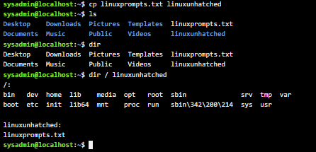
Figure 20: cp command in Linux CLI.

Example 6:
rm (Remove)
With this command, the user can permanently delete a file and unlike Windows, Linux doesn’t have a ‘recycle bin’ for the CLI. The file ‘linuxprompts.txt’ was deleted as seen in the image.

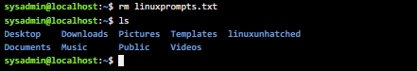

Figure 21: rm command in Linux CLI

Example 7:
man (Manual)
This command is very important for Linux users as it an offline documentation system for every command and configuration file on the system. It expatiates the command and any variations of its usage to the user. ‘man ls’, results shown in image below.

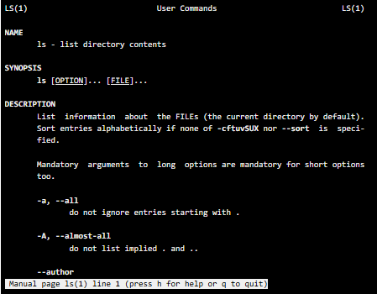
Figure 22: man command applied in Linux CLI.

Example 8:
cat (Concatenate)
This command displays the entire contents of a text file directly in the terminal and it’s the fastest way to read a configuration file without opening an editor.
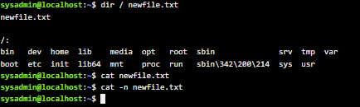
Figure 23: cat command

Example 9:
sudo (SuperUser Do)
This is a command that enables a regular user to execute a task with the security privileges of the root user, who is the "administrator" who has total control over the system. The user simply puts ‘sudo’ before any command that will require admin permission and the OS will ask for his password and not the main administrator, verify it and allow access.
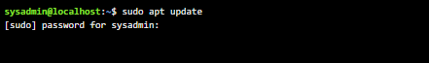
Figure 24: sudo command in LINUX CLI.

Example 10:
mv (Move / Rename)
This command, (short for move) has a dual-purpose in Linux. It allows the user to physically move files from one directory to another and is also the standard way to rename files. As seen below, the file ‘createfile.txt’ was renamed to ‘newcreatefile.txt’ using the ‘mv’ command.
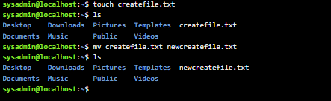
Figure 25: mv command in Linux CLI.

Use of Windows OS scripts

Batch scripting is the grouping of CLI instructions into a single executable file which automates the command for the user and negates the need for manual intervention especially for repetitive tasks such as file management. Microsoft highlights that Batch scripting is still popular today as it is reliable in legacy systems and can simplify basic administrative workflow [9].

Example 1: Variable and File Creation script.
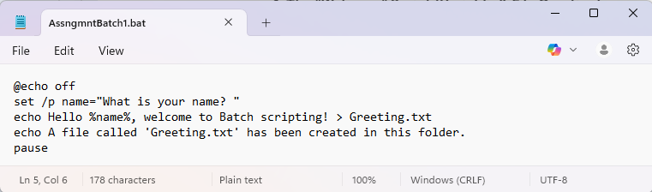
This batch script is designed to prompt and accept an input from the user, then proceed to create a file, ‘Greeting.txt’. This script shows the ability of Batch to handle user input, (creating a variable, ‘%name%’) and file management (creating a file inside a folder).
‘@echo’ is used to print a text display to the user. That is the developer’s way to prompt for input from the user. By adding ‘off’ to ‘@echo’, we prevent the line of script from being displayed. ‘Set /p’ is used to create a variable and ‘pause’ prevents the command prompt from closing, so the output remains on
Figure 26: Batch script written in notepad.
the screen. The script is saved with the extension ‘.bat’, which makes the script an executable batch file. The output of the shows the user’s input ‘Moses’ and the display message. The ‘>’, redirected the welcome message into the file ‘Greeting.txt’ instead of displaying to user.
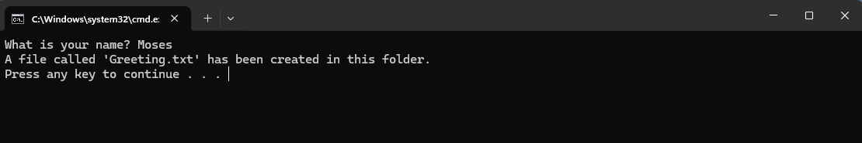
Figure 27: Batch script executed in cmd.

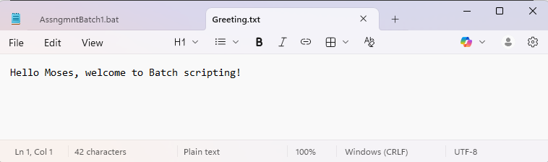
Figure 27b: The greeting message created and saved in file ‘Greeting.txt’

Example 2: Process Monitoring script.

This batch script is designed to automate and simplify the monitoring of a program; to check if it is running without opening the task manager. It begins by prompting the user with ‘set /p’ for the name of the application to check. It then follows with ‘app=Enter the name of the app…’, which creates a variable ‘%app%’. ‘tasklist | findstr /i "%app%" >nul’ pulls all processes running while ‘|’ called a pipe, moves the list straight to the next command without showing it. ‘findstr’ instructs to find the app typed, ‘/i’ makes the search case insensitive and ‘>nul’ restricts the result to only if the process is running. ‘%errorlevel%’ is the report of the search and if the value is ‘0’, the output ‘[FOUND]’ is printed else ‘[NOT FOUND]’. The search for ‘notepad’ in cmd returned a ‘FOUND’ output as the process was running.
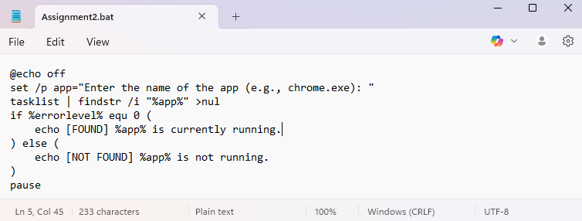
Figure 28: Script written in notepad.
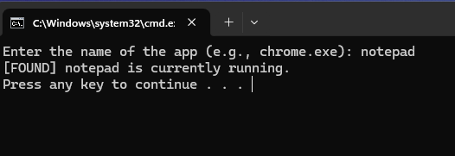
Figure 29: Script executed in cmd.

Use of Linux OS scripts

BASH (Bourne Again SHell) scripting enables the automation of command sequences into executable files, serving as the Linux equivalent to Windows Batch scripting. As established by the Linux Foundation, proficiency in Bash is a critical competency for system administrators; in addition to its convenience, automating repetitive tasks significantly reduce human error in high-stakes server environments [10]. Furthermore, Bash facilitates the efficient management of complex system configurations through single, reproducible scripts, ensuring consistent operational integrity.

Example 1:
The "Hello User" Script (Input & Variables)
This script demonstrates how the system interacts with the user to request for input data, store the data and retrieve it. The script is written in Linux’s text editor, nano, which is built into the CLI and is accessed with the command, ‘nano’ followed by the name the user wishes to assign to the script, then end with ‘.sh’ (bash extension). File ‘bashexample1.sh’ was created and made executable with the command, ‘chmod +x’. As seen in the image below, the file changes to a green colour to confirm its executable state. The command ‘. /’ is used to run the script. The output prints shows ‘echo’ used to prompt the user to input a name, for which a variable, ($Username) was created with the ‘read’ command to capture the input. The script displays the welcome message by inputting the variables ‘$username’ (provided by the user) and ‘$(date)’, which the OS gets from the system clock.
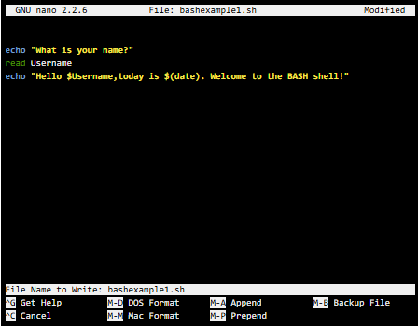
Figure 30: Written BASH script in Linux nano text editor.

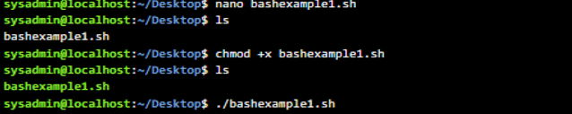
Figure 30a: commands to make the file executable and run.

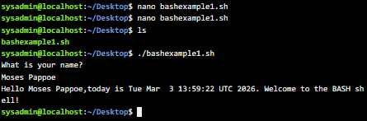
Figure 31: BASH script run in Linux CLI.

Example 2:
The File checker (conditional logic)
This script seeks to check if a specific file exists, and if so, to stream its contents onto the screen for the user. If it is not found, the user is informed with an error message, and OS will proceed to create it. ‘file=” config.txt” creates a container for the file being sought and the ‘-if’ code is there to flag for the specific name and ensure it is a regular file. ‘If’ starts the logic arm of the script, the quote marks of the variable “$file”, ensure that the search is space insensitive. ‘echo’ projects the message to the user that the file exists or otherwise and ‘cat’ streams the data of the file to the user’s screen. ‘else’ code moves the script to perform the alternative action (create the file), if it doesn’t exist and OS does this with the ‘touch’ code.

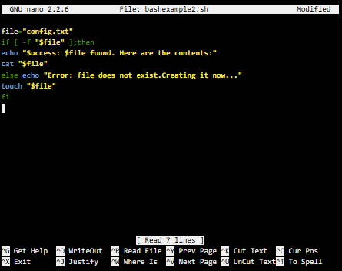
Figure 32: Bash script for file checker written in nano text editor.

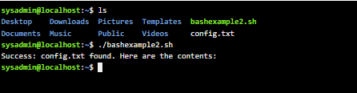
Figure 33: Output of the bash script run in CLI.

Conclusion
This report explores the core functions of Windows and Linux operating systems, which serve as a logical interface; whether through a GUI, which effectively shields the user from the complexity of the computer, allowing users to interact with physical components via simplified representations or the CLI, which is the entry path for Developers to delve deeper and interact directly with the computer’s architecture.

References

[1] | A. G. P. B. &. G. G. Silberschatz, Operating System Concepts, Wiley, 2018.
[2] | P. B. G. G. G. A. Silberschatz, Operating System Concepts, vol. 10, New Jersey: Wiley, 2018.
[3] | W. Stallings, Operating Systems: Internals and Design Principles, vol. 9th, New York: Pearson, 2018.
[4] | A. S. T. a. H. Bos, Modern Operating Systems, vol. 4th, Upper Saddle River, NJ, USA: Pearson, 2015.
[5] | W. Stallings, Operating Systems: Internals and Design Principles, New York, NY, USA: Pearson, 2018.
[6] | P. B. G. a. G. G. A. Silberschatz, Operating System Concepts, Hoboken, NJ, USA: Pearson, 2018.
[7] | Microsoft, “ "Command-line shells," Microsoft Learn,,” 24 Oct 2023. [Online]. Available: https://learn.microsoft.com/en-us/windows/terminal/get-started/shell-comparison. [Accessed 17 Feb 2026].
[8] | T. L. Foundation, “The Linux Command Line: A Guide for Beginners,” Linux.com, 2026. [Online]. Available: https://www.linux.com/training-tutorials/linux-command-line-interface-intro/. [Accessed 19 02 2026].
[9] | M. Learn, “Command-line shells,” Microsoft, 24 Oct 2023. [Online]. Available: https://learn.microsoft.com/en-us/. [Accessed 2023 02 21].
[10] | T. L. Foundation, “Introduction to Bash Scripting,” Linux.com, 2026. [Online]. Available: https://www.linux.com/training-tutorials/introduction-bash-scripting/. [Accessed 03 March 2026].

Appendices
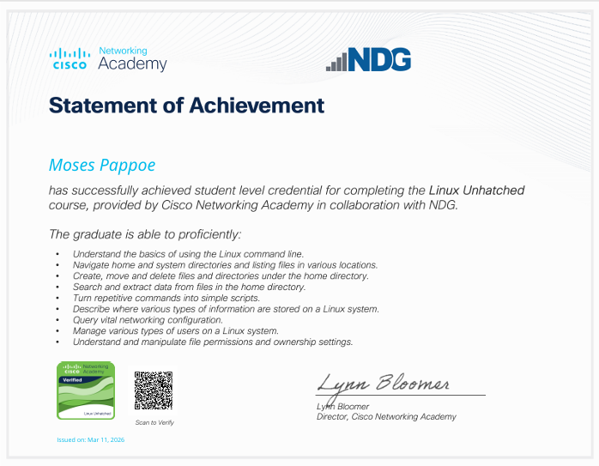
Online Course name: Cisco Linux Unhatched.
Figure 34: Certificate of completion

