

Module Cod: BMHP5014:
Module Name: Changemakers: Creativity and Value Creation
Student Name: Rosangela Maria de Sousa Rodrigues-Varkucs
Student ID: 2336619
Lecture Name: Dr Laila Surani

Date: 07/ 12/ 2025

Table of Contents
Section 1 – Poster 3
Section 2 – Written Pitch 4
Introduction 4
Rationale and Value Creation 4
Policy and Legislative Context 4
Evidence and Innovation 5
Implementation and Engagement Strategy 5
Technological Design and Accessibility 5
Social Impact and Sustainability 6
Creative and Ethical Considerations 6
Projected Outcomes 6
Conclusion 7
References 8

Section 1 – Poster
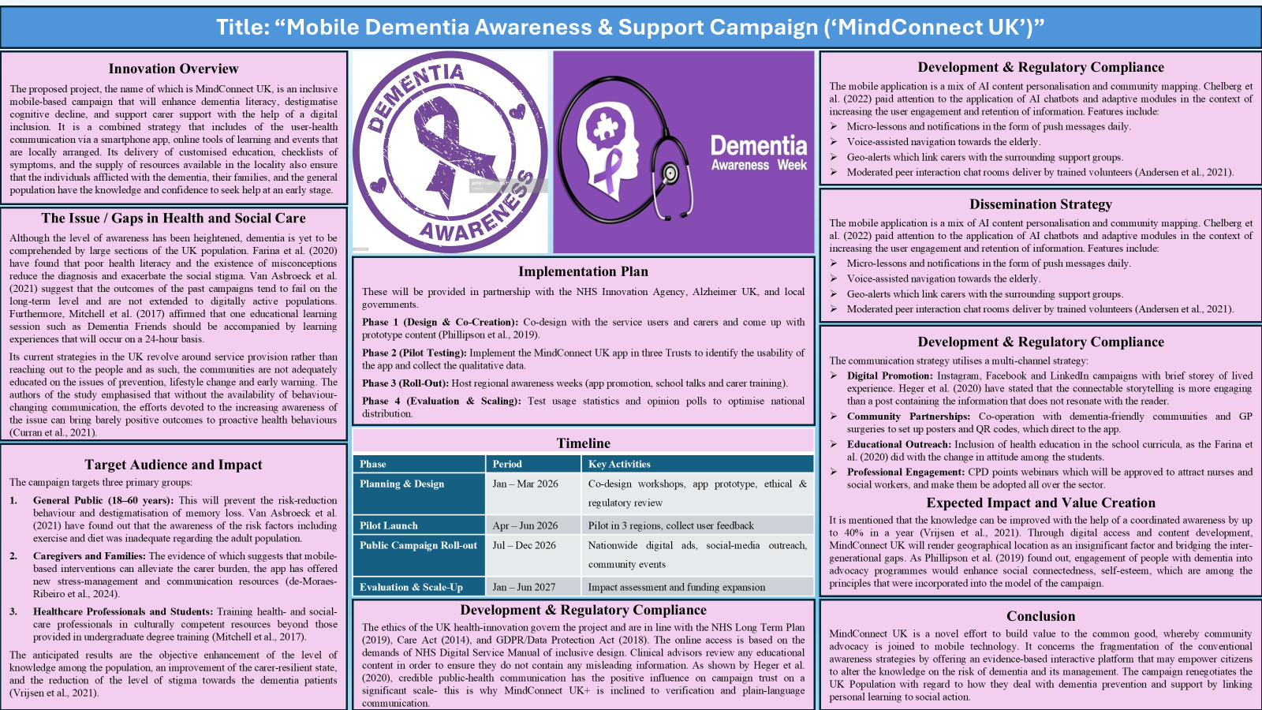

Section 2 – Written Pitch
Introduction
Dementia is one of the most pressing problems of the UK population and affects more than 900,000 people; it is also estimated to grow to the range of over 1.6 million by 2040 (Alzheimer’s Society, 2024 data). Despite the frameworks of clinical care, there is no standardization of risk and stigma reduction in society. Partly, it can be proven that educational campaigns based on the community may have significant effects on the degree of knowledge, empowerment of caregivers, and early detection (Farina et al., 2020). This makes a technology-enhanced campaign that is creative in converting fragmented awareness campaigns into sustainable, accessible and inclusive action.
Rationale and Value Creation
The traditional models of campaigns that cannot reach digitally interested groups are deemed to be face-to-face workshops or printed materials (Van Asbroeck et al., 2021). The use of smartphones at MindConnect UK has ensured that the generations are not left behind, since it will offer interactive learning and social support. The value creation in the common good is the campaign since it creates a sense of shared responsibility, which ensures the enhancement of empathy, involvement, and well-being. The principles of empowering citizens with technology, which are part of the Innovation Strategy (2021) by the UK Government and the principles of the Healthy Ageing Mission are also the focus of the project.
Policy and Legislative Context
The national policies that underpin the programme are the NHS Long Term Plan as well as the Prime Minister's Challenge on Dementia and Adult Social Care Reform White Paper. It falls under the Public Health England priority of creating dementia-friendly communities to aid the Dementia Friends and NICE QS1 in dementia care. The Equality Act 2010 assists in the equal access, and the data processing of the app does not breach the GDPR conditions. All these structures serve as ethical innovations and preserve the trust between the users and the professionals.

Evidence and Innovation
The concept of dementia awareness and caregiver support has already been demonstrated to be measurably helpful in the situation of using mobile technologies. The study by Chelberg et al. (2022) showed that mobile platforms are useful in enhancing the knowledge of risk reduction and care coordination. Similarly, the authors of de-Moraes-Ribeiro et al. (2024) also confirmed that Internet-based interventions are efficient in the reduction of the caregiver burden. With the addition of artificial intelligence, personalised messages can be provided, as well as personalised learning experiences, which is aligned with the present trends of digital-health (Mendez et al., 2023). In addition, the personalization and involvement can be improved using the co-creation processes by which one with dementia is involved in the design of the content (De-Rosende-Celeiro et al., 2024).
Implementation and Engagement Strategy
- Pilot Testing: NHS Digital Innovation Hubs. NHS Digital will have collaborated with NHS Digital to ensure accessibility and usability are tested.
- Community Involvement: In the footsteps of Dementia Friends, the local volunteers and carers will be trained as digital champions (Mitchell et al., 2017).
- Educational Integration: The success of the UK school-based programme shall be followed by the course of secondary school and inter-generational training (Farina et al., 2020).
- Ongoing Feedback: The surveys located in the app will assist customers in rating the content, which is an appropriate practice of participatory design (Phillipson et al., 2019).
This participatory involvement will render the campaign user-centred, ethical as well and adaptable to local circumstances.
Technological Design and Accessibility
The format applied by MindConnect UK is a symbiosis of the educational video, symptom checklists, and support maps with geolocation settings. Voice assistance, large font displays, and multilingual content are used to satisfy the accessibility needs of older users and carers with sensory impairments. Geo-alerts assist people in knowing an event or memory clinic open day in the community (Andersen et al., 2021). The system uses the anonymized analytics to evaluate the reach and patterns of interaction without the privacy being broken. The fact that it is interoperable with the NHS apps renders it credible and long-term sustainable.
Social Impact and Sustainability
There is also the social capital that is created by the campaign in the long term, since the campaign collaborates with councils and voluntary groups. The heightened understanding of the population will also imply an intervention in the disease earlier and reduced medical costs associated with late diagnosis (Heger et al., 2020). De-Moraes-Ribeiro et al. (2024) state that the programme also eradicates stress and improves mental-health outcomes through providing assistance to caregivers. Empathy, inclusion and shared responsibility are the pillars of social care transformation enhanced through constant communication with the community (Curran et al., 2021). Knowledge gains and behavioural change will be measured using the mixed-methods evaluation, e.g.,pre-/post-awareness surveys and post-awareness analytics of using the app, etc.
Creative and Ethical Considerations
The digital storytelling and experience are what make up the innovation. To humanize the campaign, dementia participants will be involved in video diaries co-production (Phillipson et al., 2019). Informed consent and protection of dignity will be done using ethical consideration. The design is also a cross-cultural and language-friendly design, which offers proportional representation of the marginalized groups (Vrijsen et al., 2021). It will also improve the levels of trust of the users regarding the data use and feedback mechanisms, which is also compliant with the NHS ethical principles of digital-health projects.
Projected Outcomes
It is assumed that the quantifiable outcomes will be:
- 30% average increase in overall awareness of dementia early warning signs in 12 months.
- 20% more on GP referral to early screening.
- 50% increase in the number of occasions on which the caregivers used the digital support tools.
- Improved working collaboration with the primary care and voluntary organizations.
Conclusion
Mobile Dementia Awareness and Support Campaign is one example of health and social care creativity and value-creation in the UK. It is founded on reasonable grounds and translates awareness into empowerment through digital engagement. By matching technology, community voices and entrenching compassion into routine relationships, MindConnect UK will be less stigmatizing, attend to better caregiver wellbeing, and embed compassion into routine relationships. Its creative, moral, and integrative approach to it renders it a long-term mode of the national dementia awareness and the promotion of the common good.
References
Andersen, N.S., Chiarandini, M. and Mauro, J. (2021). Wandering and getting lost: The architecture of an app activating local communities on dementia issues. In: IEEE/ACM 3rd International Workshop on Software Engineering for Healthcare (SEH), pp.36–43. IEEE.
Chelberg, G.R., Neuhaus, M., Mothershaw, A., Mahoney, R. and Caffery, L.J. (2022). Mobile apps for dementia awareness, support, and prevention – review and evaluation. Disability and Rehabilitation, 44(17), pp.4909–4920.
Curran, E., Chong, T.W., Godbee, K., Abraham, C., Lautenschlager, N.T. and Palmer, V.J. (2021). General population perspectives of dementia risk reduction and the implications for intervention: A systematic review and thematic synthesis of qualitative evidence. PLoS One, 16(9), p.e0257540.
de-Moraes-Ribeiro, F.E., Moreno-Cámara, S., da-Silva-Domingues, H., Palomino-Moral, P.Á. and del-Pino-Casado, R. (2024). Effectiveness of internet-based or mobile app interventions for family caregivers of older adults with dementia: A systematic review. Healthcare, 12(15), p.1494.
De-Rosende-Celeiro, I., Francisco-Gilmartín, V., Bautista-Blasco, S. and Ávila-Álvarez, A. (2024). Co-creation and evaluation of an app to support reminiscence therapy interventions for older people with dementia. Digital Health, 10, p.20552076241261849.
Farina, N., Hughes, L.J., Jones, E., Parveen, S., Griffiths, A.W., Galvin, K. and Banerjee, S. (2020). Evaluation of a dementia awareness programme in UK schools: A qualitative study. Public Health, 185, pp.348–355.
Heger, I., Köhler, S., van Boxtel, M., de Vugt, M., Hajema, K., Verhey, F. and Deckers, K. (2020). Raising awareness for dementia risk reduction through a public health campaign: A pre-post study. BMJ Open, 10(11), p.e041211.
Mendez, K.J.W., Labrique, A.B., Budhathoki, C., Sadak, T., Tanner, E.K., Cotter, V.T. and Han, H.R. (2023). Use of mobile applications and health technologies among dementia caregivers with chronic conditions: A cross-sectional study. Digital Health, 9, p.20552076231181213.
Mitchell, G., McGreevy, J., Carlisle, S., Frazer, P., Traynor, M., Lundy, H., Diamond, M. and Agnelli, J. (2017). Evaluation of ‘Dementia Friends’ programme for undergraduate nursing students: Innovative practice. Dementia, 16(8), pp.1075–1080.
Phillipson, L., Hall, D., Cridland, E., Fleming, R., Brennan-Horley, C., Guggisberg, N., Frost, D. and Hasan, H. (2019). Involvement of people with dementia in raising awareness and changing attitudes in a dementia friendly community pilot project. Dementia, 18(7–8), pp.2679–2694.
Van Asbroeck, S., van Boxtel, M.P., Steyaert, J., Köhler, S., Heger, I., de Vugt, M., Verhey, F. and Deckers, K. (2021). Increasing knowledge on dementia risk reduction in the general population: Results of a public awareness campaign. Preventive Medicine, 147, p.106522.
Vrijsen, J., Matulessij, T.F., Joxhorst, T., de Rooij, S.E. and Smidt, N. (2021). Knowledge, health beliefs and attitudes towards dementia and dementia risk reduction among the Dutch general population: A cross-sectional study. BMC Public Health, 21(1), p.857.

