Rebecca Dingwall
2217521
Computer Aided Engineering ACDB5007
Application of Computer Aided Engineering Processes
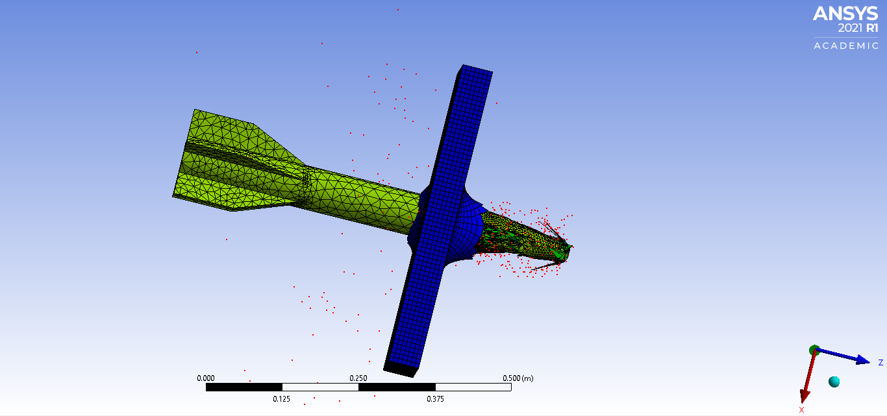

Table of Contents
1. Introduction to CAE 2
1.1 The CAE Process 2
1.2 Key CAE Techniques 2
1.2.1 Finite Element Analysis FEA 2
1.2.2 Computational Fluid Dynamics CFD: 2
1.2.3 Multibody Dynamics and Kinematic Analysis: 3
2. Practical Implementation Case Study 3
2.1 System Modelling 4
2.2 Kinematics Analysis 4
2.3 Static Structural Assessment 5
3. Validation 7
3.1 Comparison of Ansys results 7
4. Limitations and advantages of using CAE 7
5. Conclusion 8
Bibliography 9

Table of Figures
Figure 1. constraints confined on the model 5
Figure 2. demonstrating mesh sizing 6
Figure 3. animation of total deformation of brass plate 7
Figure 4. animation of total deformation of aluminium plate 7

1. Introduction to CAE
Computer Aided Engineering (CAE) plays a pivotal role in modern engineering by leveraging software and computational tools to enhance the design, analysis, and manufacturing of products across various industries. CAE encompasses a range of functionalities, including simulation, optimization, and validation. It guides engineers from initial design stages through testing and manufacturing planning. CAE has the ability to reduce the time needed to develop new products while increasing productivity. This is achieved through the optimization of production flow and scheduling combined with providing more flexibility in altering machine operations [1].

The CAE Process
The CAE process will typically involve 3 steps consisting of: pre-processing, solving and post-processing [2]. During pre-processing engineers model the system, its physical properties and this can sometimes include its operating environment. The constraints and applied loads are defined during this stage which significantly impacts all subsequent simulations. During the solving step, simulations are run to mimic real-world conditions and physics there are a variety of simulations that can be run on the model, some of the essential CAE techniques are: Finite Element Analysis FEA, Computational Fluid Dynamics CFD, Multibody Dynamics MBD and Kinematic analysis. During post-processing the results from the simulations are reviewed, aiding decision making and design refinements.

1.2 Key CAE Techniques
1.2.1 Finite Element Analysis FEA:
Can be used to predict how products respond to real-world forces, vibrations, fluid flow and other physical effects enabling the understanding of a particular products design and behaviour under various conditions. FEA is based on the Finite Element Method FEM, which breaks down intricate systems into smaller, simpler elements. These elements are then analysed individually using differential equations. The results obtained from FEM are interpreted through FEA, providing insights into how structures respond to various loads, temperatures, and other environmental conditions. Assessing stress distribution, deformation and other factors can optimize designs for safety, performance and efficiency due to the reduction of physical prototyping. FEA’s ability to approximate irregular dimensional complications means FEA is applicable to a diverse range of scenarios. [3] It aids in predicting maintenance needs, predicting long-term general wear as well as well as the prediction of what can be tolerated under extreme conditions [3]. Civil engineers use FEA in order to evaluate the integrity of structures such as bridges, buildings and dams. Within aerospace engineering, FEA can simulate the performance of aircraft components under various conditions and within automotive engineering FEA can evaluate structural crashworthiness among other systems within the vehicle [3]. This is done using a variety of mathematical equations some of the key equations used in FEA are as follows. Governing differential equations are the fundamental equations that describe the physical phenomena being modelled such as elasticity, heat transfer or fluid dynamics [4]. Weak form of governing equations is derived from the governing equations, the weak form is also sometimes referred to as the Galerkin form and is essential for dealing with problems where the original differential equation is too complex or impossible to solve analytically [5]. Discretization and element equations, where the domain is divided into finite elements, and then the weak form is then applied to each element, this then leads to a set of algebraic equations for each element that can be assembled into a global system of equations, this set with boundary conditions, both essential, being displacements and natural conditions being forces or transactions are then applied to the model to solve this system of equations [3].

1.2.2 Computational Fluid Dynamics CFD:
Is a powerful numerical technique used to simulate and analyze fluid flow behavior in various engineering and scientific applications. It analyses fluid flow, heat transfer and other related phenomena. CFD predicts air flow, fluid forces as well as heat transfer around products. CFD focuses on solving the governing equations that describe fluid motion, heat transfer and mass transport in more complex geometries. Some of the applications of CFD can be found in aerospace and automotive industries and energy and environmental engineering to optimize aircraft aerodynamics, engine combustion and vehicle performance, aiding in the design of efficient wings, reducing drag and improving fuel efficiency. CFD can model airflow in wind turbines, simulating pollen dispersion and the analysis of heat exchangers. Within Biomedical and pharmaceutical sciences, CFD can be used to study blood flow, drug delivery and respiratory air flow. It can also be found in civil engineering, process industries, turbomachinery, oceanography and more. Much like FEA, CFD reduces the need for physical trials by providing virtual insights, engineers can explore design alternatives and evaluate performance and refine geometries prior to production and so reducing cost. CFD also gives engineers the opportunity to subject the design to extreme conditions ensuring safety and reliability. This is done through various mathematical equations that the simulation is solving in order to produce a visual output. Some of the key equations producing this output are as follows. Navier-Stokes Equations are fundamental in CFD and describe the motion of fluid substances. Navier-stokes are a set of partial differential equations that express conservation of momentum and mass for incompressible flows [6]. The continuity equation, represents the conservation of mass in fluid dynamics and is used alongside Navier-Stokes equations [7]. Euler Equations are a simplified Navier-Stokes equations that can be used for inviscid flows where the viscous terms are negligible [8]. To calculate the temperature distribution within the fluid and for simulations involving heat transfer energy equation is used [9].

1.2.3 Multibody Dynamics and Kinematic Analysis:
Simulates motion and reaction forces within interconnected systems and provides an insight into motion behavior. Multibody Dynamics MBD deals with the motion and interaction of interconnected rigid or flexible bodies [10]. These bodies can be anything from mechanical systems to biological systems. MBD involves modelling the system as a collection of interconnected bodies, or particles and analyze their kinematics-motion, and dynamics- forces and torques. The interactions between the bodies are described using equations of motion. MBD is crucial for understanding how complex systems move, deform and respond to external forces [11]. Some of the types of equations MBD uses in order to calculate the output of the system are; Lagrange equations that are derived from D’Alembert’s principles and are used to describe the dynamics of motion for articulated systems. Lagrange equations are particularly useful for more complex systems where the direct application of Newtons second law of physics is difficult [12]. Newton-Euler Equations are essential for describing the motion of rigid bodies as they are defined in terms of velocities rather than position and orientation [12]. When modeling the behavior of a system over time and particularly for continuous dynamic systems, differential equations are used [13]. Recursive algorithms are an efficient method for solving equations of motion, particularly in systems with a large number of bodies [14].
Kinematic analysis focuses on the geometry of motion with none of the forces applied. The most common kinematic quantities include position, velocity, angular velocity and acceleration. Kinematics can investigate, for example, how the parts of a mechanism move relative to each other. And, what are the velocities and accelerations of different points in the system. Kinematic analysis helps us design linkages, understand joint constraints, and predict the behaviour of mechanisms. Much of the applications of MBD can be found in robotics for the design and controlling of robotic arms and other moving parts, kinematic analysis can optimize robot trajectories and workspace. Vehicle dynamics and mechanical systems use MBD to aid in the understanding and analysis of more complex moving parts on both vehicles, aircraft and complex machinery, such as engines, cranes and conveyor belts and kinematic analysis aids in the design of suspension systems, drive chains and steering mechanisms.

2. Practical Implementation Case Study
To accurately investigate the process, limitations and practical implementation of using CAE tools the following section of the report is to illustrate how this can be achieved. This case study examines the effects of long-rod penetrators or Kinetic Energy (KE) rounds on a metallic plate.

2.1 System Modelling
Firstly, to model a system in a computational environment this can be done using any Computer Aided Design CAD software. In this instance Solidworks was used to model both the long rod and the plate. The dimensions of the long rod were around ∅60mm and 750mm long. The dimensions of the plate were 500mm X 500mm and 50mm thick. After this has been completed an assembly of parts was put together in Solidworks. This can be defined as a group of components or parts brought together to accurately depict their original relationships and geometric alignment [15]. Solidworks is sometimes described as the more user-friendly option for CAD software [16] and it was shown to be the case whilst using Solidworks to create these simpler geometries. This CAD model can then be imported into another analysis software to conduct more complex simulations. Solidworks does have the ability to conduct more simple analyses like stress, strain and deformation however the types of analysis spoken about previously in this report another CAE software is required for more complex problems [17].

2.2 Kinematics Analysis
To analyze the system in motion under realistic operating conditions and to understand the motion behavior and reaction forces the CAE software used in this case was Ansys. In order to conduct this analysis representative of a real-world scenario constraints have to be placed on the model much as they would be fixed if conducting this experiment for real and not computationally. As denoted by the arrows in figure 1, the constrains confined in this case study were placed on the edges of the plate, as well as the other two opposite faces not shown. This is done to ‘fix’ the plate in place in order to prevent the long rod from just pushing the plate backwards in the simulation. Materials can also be applied during this stage. A key part of material application and how the software uses the material data will affect the output result. For example, using a basic material model will give you a basic result, whereas using a more comprehensive material data set, for example the Johnson cook model for a material will give a more accurate result. It could be argued that: for example, a simple tungsten carbide material data would give a broader result than that of a Jonson cook model for 1006 Steel. Realistically the tungsten would perform better, however, because the Johnson cook model for 1006 steel is more comprehensive and is a strong steel would give a more comparative results to a real-world example. If this study was focused on only the interaction between the rod and the plate it would be considered a kinematic study. However, a more comprehensive dynamic study is needed to be conducted as this encompasses both motion and forces.
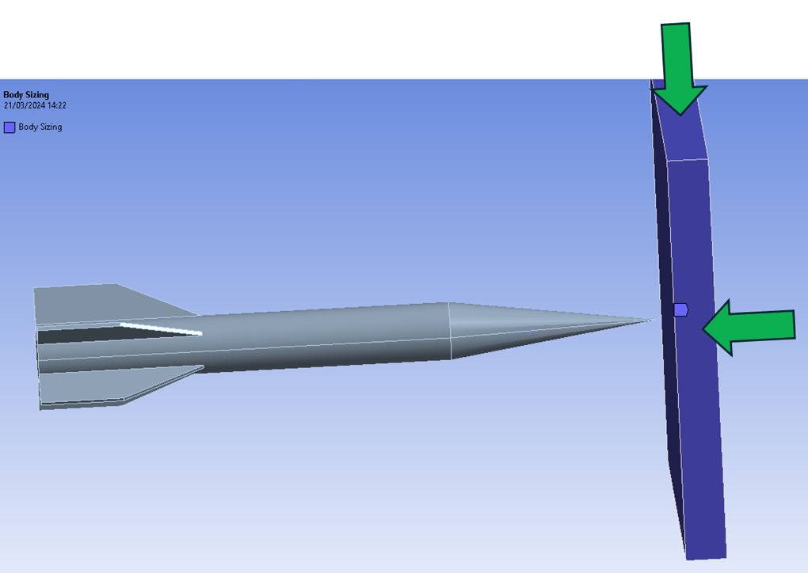

Figure 1. constraints confined on the model

2.3 Static Structural Assessment
As previously mentioned in section 2.2 the constraints have been applied to the model. In order to conduct the dynamic study, the static structural assessment must be completed. For this case study the impact of the plate is being studied rather than the long rod kinetic energy round. Before running this simulation, a mesh must be applied to the model.
In this case the mesh applied to the plate is a uniformed size and the mesh on the long rod has varying sizes. This was done to demonstrate the ease of being able to mesh sections of each part. for example, the front cone of the long rod has a finer mesh than that of the rest of the body and the fins. This was partly done to show the forces acting upon the plate from the long rod as seen in figure 2. This however should have been changed to the center of the plate and the impact zone having a finer mesh in order to more accurately predict the results.

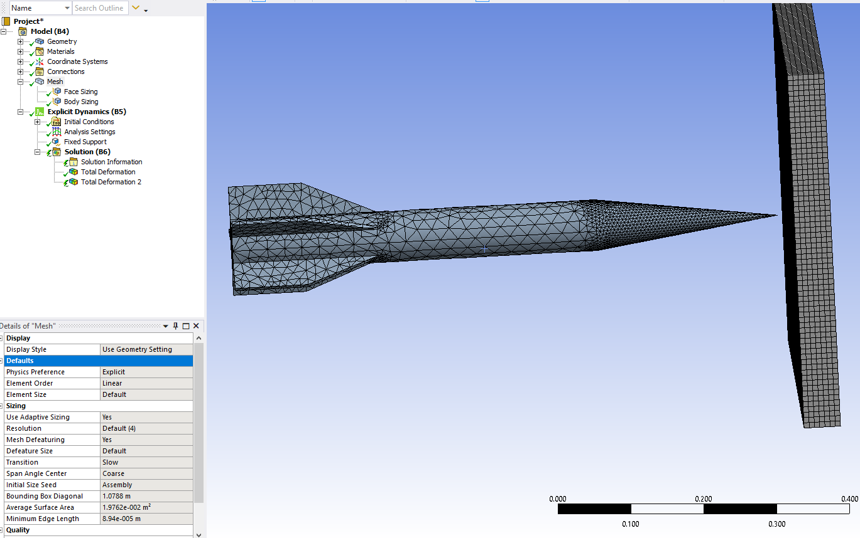

Figure 2. demonstrating mesh sizing

During this analysis the KE round was set to travel at 1700 M/s [18]. The Johnson cook material model of the KE round was set to 1006 steel and the plate set to Brass, all of the Johnson cook material models were in the material library of Ansys. As seen from figure 3 the total deformation of the plate was being investigated. To grasp a full understanding of the output from the software, double click the picture and the animation should play. While it is important to remember that the KE round was applied as a solid, so within the program essentially an unbreakable material so when the rod moves through the plate it gets stopped by the fins, this error gets repeated so can be discounted. The results from this show that the long rod does perforate the brass plate, but it can be surmised that if it wasn’t for the state of the rod being a ‘fixed solid’ there would be full penetration of the plate. It can be seen from figure 3 that some parts of the plate fully break away and this can be seen by the small red particles. This could be demonstrated better if the maximum stresses colors had been changed. The long rod was changed to be a solid part removing the FEA of the long rod from the simulation, this was done to reduce the amount of processing having to be done by the program and so reducing time. Another reason for this was; where each point of the mesh, called nodes were being impacted, rather than break off, they would overlap the mesh behind it causing the program to crash. This is due to the solver not being able to do the equations when that particular mode would be misused or in the wrong place essentially confusing the code. Much of the equations spoken about in section 1.2 rely on the meshing and the nodes. The nodes are where the mesh joins each other. If the node has not detached from the model and gets pushed back behind the nodes that it use to be in front of the solver cannot solve the equations, therefore causing the program to crash.
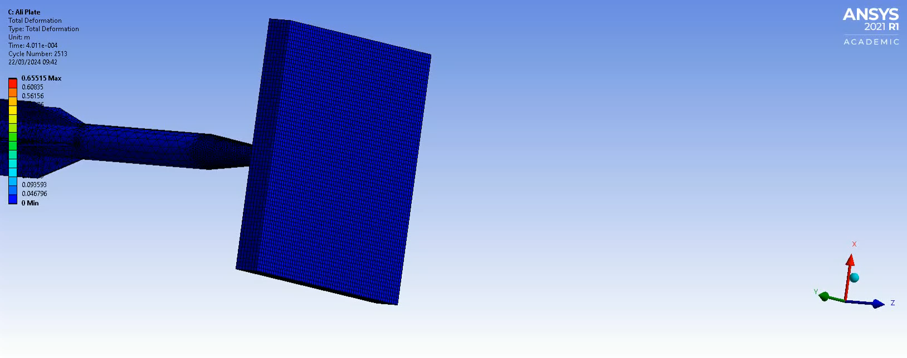
During the next result of the KE round against an aluminum plate as seen in figure 4, double click to play animation. There is minimal perforation from the rod into the plate and no penetration.
Figure 3. animation of total deformation of brass plate
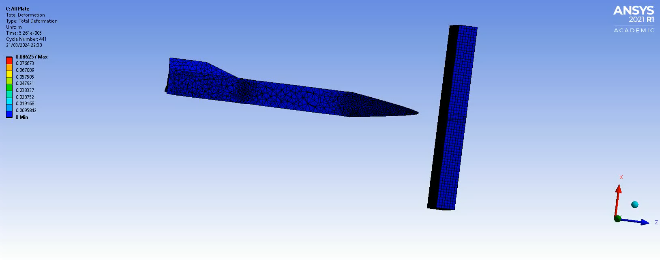
Now to take this at face value, it would seem that the aluminum has the ability to defeat the steel rod traveling at 1700 M/s. In a real-world scenario this is not the case. As shown in a similar study of small arms armor piercing rounds into aluminum plates by A. Manes et.al with velocities of up to 771 m/s into various thickness of aluminium plate it has shown there is a range of deep penetration to full perforation [19] demonstrating that this particular model is incorrect.
Figure 4. animation of total deformation of aluminium plate

3. Validation
Verification and validation of the model. Verification of the model or simulation is verifying that essentially the code is doing what you have set it to do, and that all materials and constraints are set correctly, there are no anomalies [20], or if for example there is a 5% anomaly can this be repeated for every simulation and can be replicated the same on each model meaning it can be accounted for and is consistent. Validation is done to ensure the model accuracy represents the real-world system that it is simulating, being able to compare the output result of the simulation model with the behavior of the real-world system it is intending to mimic. Without validation there is no way of knowing if the simulation is reliable or the results produced are meaningful [21]. To put it simply a models validity can be proven by comparing the output to experimental or independent field datasets that align with the simulated scenario [22].
Some other validation techniques can include: Event validity, Expert opinion of the output or a more extensive method of validation can be used. Naylor and finger proposed a combination of three methods of validation consisting of rationalism, empiricism and positive economics. Consisting of:
- Develop the models’ assumptions on theory, observations and general knowledge
- Validating the models’ assumptions by testing them
- Comparing the input/output relationships of the model to the real system [23]
Given that the some of the computational simulations that are being performed today this method as well as a numerical method of validation could be impossible as spoken about in 1.2.1 where the Galerkin form is used to calculate problems where the original differential equation is too complex or impossible to solve analytically [5].

3.1 Comparison of Ansys results
As previously mentioned in section 2.3 Manes et al conducted experimental simulations of small arms armor piercing rounds with velocities up to 771 m/s using both steel and tungsten projectiles, the study shows a range from full plate perforation at 25mm, deep penetration at 101.6mm. By using this data, it demonstrates that the validation of the aluminum plate cannot be achieved. Looking at the animation of figure 4, of a 50mm plate the long rod does not reach the halfway point.
Specific studies on brass plates appears to be less common, finding validation models has proven difficult, however if we look at the mechanical properties of brass, S237 Steel and S275 steel their mechanical properties are similar. See the table below.
Material | Tensile strength MPa | Yield strength MPa | Youngs Modulus GPa | Poisson's ratio
Brass | 338-469 | 124-310 | 97 | 0.31 [24]
Steel S235 | 360 | 215 | *210 | 0.30 [25]
Steel S275 | 410 | 255 | *210 | 0.30 [25]
As denoted by the star, the largest difference is that the youngs modulus of the steel is over double that of the brass, meaning it is more ductile. It is possible to partially validate the model using one of these steels to compare whilst in the knowledge that in the real-world scenario this wouldn’t act exactly as the model’s output. The most comparative result found was a study by M. Klosak et al. This unfortunately cannot be used to validate the model either due to the maximum velocity only reaching 120 m/s and the thickest plate being only 16mm [26] and not the 50mm thickness of the plate in this study.

4. Limitations and advantages of using CAE
There are many benefits to using CAE software these can include:
Giving predictions of how a design will perform under many conditions without having to physically build and test prototypes. This includes design iterations and exploration of different parameters and so in turn reducing the cost as the physical testing can be expensive. These designs can then be evaluated on performance, safety and efficiency. The process can also aid in the integration of various engineering disciplines into one single platform. For example, structural, thermal, and fluid dynamic [27]. Early detection of potential failure modes allowing for problem resolution and risk mitigation early on in the design phase. There are also some disadvantages to using CAE, even with the removal of the initial set up cost implication the human error and code error that has the potential to easily skew the results as spoken about in 2.2 about material models. The operator’s knowledge of the limitations of the software is integral in the accuracy of the output of the model, as spoken about in 3, verification and validation can reduce this error but it’s not infallible. In summary, CAE software enhances engineering productivity, accelerates innovation, and ensures robust designs when being operated by a proficient operator.

5. Conclusion
This report has explored the application of CAE processes, from what CAD and CAE is to the practical implementation of the types of analyses CAE is able to perform as well as the limitations and advantages of the software. In summary the knowledge of how CAE tools work compared to the application of the tools are vastly different. In order to be proficient in the use and practical application of CAE tools the operator must have vast knowledge of all aspects of the mechanical properties they are investigating as well as an understanding of the computational processing power and limitations. They must have a clear understanding of what is required for the validation, if a computational comparison isn’t available, is there the ability to carry out real-world validations of the model. In this instance there was not.

Bibliography

[1] | The Editors of Encyclopaedia Britannica Article History, “computer-aided engineering,” Britannica, 25 03 2023. [Online]. Available: https://www.britannica.com/topic/computer-assisted-instruction. [Accessed 22 04 2024].
[2] | S. Thorat, “What is CAE – Introduction To Computer Aided Engineering,” LearnMech.com, 12 02 2023. [Online]. Available: https://learnmech.com/cae-introduction-computer-aided-engineering/. [Accessed 22 04 2024].
[3] | Ansys, “What is Finite Element Analysis (FEA)?,” Ansys, [Online]. Available: https://www.ansys.com/en-in/simulation-topics/what-is-finite-element-analysis. [Accessed 22 04 2024].
[4] | University of Victoria, “Introduction to Finite Element Analysis (FEA) or Finite Element Method (FEM),” University of Victoria, [Online]. Available: https://www.engr.uvic.ca/~mech410/lectures/FEA_Theory.pdf. [Accessed 30 04 2024].
[5] | J. W. &. X. Ye, “A weak Galerkin finite element method for second-order elliptic problems,” Elsevier, 15 03 2013. [Online]. Available: https://www.sciencedirect.com/science/article/pii/S0377042712004220. [Accessed 01 05 2024].
[6] | W. L. Hosch, “Navier-Stokes equation,” Encyclopaedia Britannica, 12 04 2024. [Online]. Available: https://www.britannica.com/science/Navier-Stokes-equation. [Accessed 30 04 2024].
[7] | J. J.D. Anderson, “Governing Equations of Fluid Dynamics,” Springer-Verlag Berlin Heidelberg, 2009. [Online]. Available: https://eng.auburn.edu/~tplacek/courses/fluidsreview-1.pdf. [Accessed 30 04 2024].
[8] | NASA, “Euler Equations,” NASA, 13 05 2021. [Online]. Available: https://www.grc.nasa.gov/www/k-12/airplane/eulereqs.html. [Accessed 30 04 2024].
[9] | Simscale, “What is CFD | Computational Fluid Dynamics?,” Simscale, 07 12 2023. [Online]. Available: https://www.simscale.com/docs/simwiki/cfd-computational-fluid-dynamics/what-is-cfd-computational-fluid-dynamics/. [Accessed 30 04 2024].
[10] | F. V. e. al, “A peridynamics approach to flexible multibody dynamics for fracture analysis of mechanical systems,” Springer, 03 11 2023. [Online]. Available: https://link.springer.com/article/10.1007/s11044-023-09948-y. [Accessed 20 04 2024].
[11] | EnginSoft MULTIBODY DYNAMICS SOFTWARE, “What is Multibody Dynamics (MBD)?,” enginsoft, [Online]. Available: https://enginsoftusa.com/RecurDynMBD/What-is-Multibody-Dynamics.html. [Accessed 23 04 2024].
[12] | C. K. L. &. S. Jain, “A Quick Tutorial on Multibody Dynamics,” School of Interactive Computing Georgia Institute of Technology, [Online]. Available: https://fab.cba.mit.edu/classes/865.18/design/optimization/dynamics_1.pdf. [Accessed 30 04 2024].
[13] | University of Ottawa, “MATHEMATICAL MODELING OF DYNAMIC SYSTEMS,” University of Ottawa, [Online]. Available: http://by.genie.uottawa.ca/~necsules/MCG_3306/MCG%203306%20%20pdf/A3.pdf. [Accessed 30 04 2024].
[14] | A. M. ̈ller, “Screw and Lie Group Theory in Multibody Dynamics Recursive Algorithms and Equations of Motion of Tree-Topology Systems,” arXiv Cornell University, 30 07 2023. [Online]. Available: https://arxiv.org/pdf/2306.17793. [Accessed 30 04 2024].
[15] | Study Smarter, “What is Assembly Modeling?,” Study Smarter, [Online]. Available: https://www.studysmarter.co.uk/explanations/engineering/design-engineering/assembly-modeling/#:~:text=An%20assembly%20in%20CAD%20typically,within%20a%20system%20or%20product.. [Accessed 25 04 2024].
[16] | TECHNIA, “SOLIDWORKS or CATIA: Which is Best?,” TECHNIA, [Online]. Available: https://www.technia.co.uk/blog/solidworks-vs-catia-which-cad-software-is-right-for-you/#:~:text=When%20it%20comes%20to%20user,are%20new%20to%20CAD%20software.. [Accessed 26 04 2024].
[17] | I. A. M. a. Z. S. Sebaeva, “Comparative study of finite element analysis software packages,” IOP Publishing, 2020. [Online]. Available: https://iopscience.iop.org/article/10.1088/1742-6596/1515/3/032073/pdf. [Accessed 26 04 2024].
[18] | The Ontario Regiment RCAC Museum, “Modern Anti-Tank Ammunition,” Modern Anti-Tank Ammunition, [Online]. Available: https://www.ontrmuseum.ca/tankmuseum/blog-post/modern-anti-tank-ammunition/#:~:text=Modern%20APFSDS%20can%20reach%20muzzle,significant%20effect%20on%20their%20trajectory.. [Accessed 01 05 2024].
[19] | F. S. M. P. M. S. M. G. A. Manes, “Perforation and penetration of aluminium target plates by armour piercing bullets,” Elsevier, 22 02 2014. [Online]. Available: https://www.sciencedirect.com/science/article/abs/pii/S0734743X14000499. [Accessed 01 05 2024].
[20] | G. Heurtier, “Verification & Validation of a Simulation Model,” claytex, 22 06 2022. [Online]. Available: https://www.claytex.com/tech-blog/verification-validation-of-a-simulation-model/. [Accessed 01 05 2024].
[21] | Tutor Chase, “What is the importance of validation in simulations?,” Tutor chase, [Online]. Available: https://www.tutorchase.com/answers/ib/computer-science/what-is-the-importance-of-validation-in-simulations#. [Accessed 01 05 2024].
[22] | D. R. G. Lisa A. Kerr, “Simulation Modeling as a Tool for Synthesis of Stock Identification Information,” science direct, 2014. [Online]. Available: https://www.sciencedirect.com/topics/agricultural-and-biological-sciences/model-validation#:~:text=Models%20can%20be%20validated%20by,align%20with%20the%20simulated%20scenario.. [Accessed 01 05 2024].
[23] | J. M. F. J. L. M. W. E. S. a. C. C. H. Thomas H. Naylor, “Verification of Computer Simulation Models,” Managnent of science | Informs, 2 10 1967. [Online]. Available: https://www.jstor.org/stable/2628207. [Accessed 01 05 2024].
[24] | E-Z LOK, “Brass Material Properties,” E-Z LOK, [Online]. Available: https://www.ezlok.com/brass-properties. [Accessed 01 05 2024].
[25] | Euro Code Applied, “Table of design material properties for structural steel,” Euro Code Applied, [Online]. Available: https://eurocodeapplied.com/design/en1993/steel-design-properties. [Accessed 01 05 2024].
[26] | M. G. L. K. W. M. M. Klosak, “Perforation analysis of S235 steel sheets up to 573 K using experimental and numerical methods,” ARCHIVES OF CIVIL ENGINEERING, 2021. [Online]. Available: https://yadda.icm.edu.pl/baztech/element/bwmeta1.element.baztech-a875ca5f-b2c0-47e5-a6af-ee67ba0425a4/c/Klosak_M_Perforation_3_2021.pdf. [Accessed 01 05 2024].
[27] | K.-J. Bathe, “finite element procedures,” Prentice Hall, 1982. [Online]. Available: https://soaneemrana.org/onewebmedia/Finite%20Element%20Procedures%20in%20Engineering%20Analysis%20Bathe%20K.J.pdf. [Accessed 01 05 2024].

