management in practice
Alton Towers
Laweza Ali
P150429
Table of Contents
Executive Summary 2
Introduction 3
Environmental Analysis 4
Ratios 5
Analysis and Key Performance Indicators 5
SMART objectives 5
Performance Management Audit 6
Reference List 7
Appendix 8

Executive Summary
This report is an analysis of the factors affecting Alton Towers, throughout there is critical evaluation of the environmental factors which affect the businesses. This is further discussed via PESTEL and SWOT analysis. Touching up on the political factors which affect the organisation because of Brexit, also speaking on the economic effects the company are having to tackle such as minimum wage rising and touching on the subject of unemployment rates. Furthermore, looking at the Social culture and how the older generation want to remain fitter in order to spend time with family and also analysing how social media will and has affected the company. Technological factors that are impacting the industry such as the use of VR. Finally looking at the external threats which the company are facing by doing a financial analysis looking through KPI in ratios, probity liquidity and supporting the numbers with smart targets and recommendations. Lastly, the final part of the report analysis the performance management of Alton Towers and how good and bad their recruitment and selection process is compared to rival companies and how this could be improved.

Introduction
The purpose of this specific report is to analyse and critically evaluate Alton Towers, looking at SWOT and PESTEL, performance management, financial and HR and then providing recommendations for the next business year.

Environmental Analysis

Political Factors
Although within the UK there is uncertainty surrounding the topic of Brexit, society remains in a state of unawareness in terms of the tourism and hospitality industry “The nature of this uncertainty is different from that of a typical uncertainty shock because of its length, breadth and political complexity.” (BankOfEngland, 2019) However, Brexit is not something that will directly effect Alton Towers as a company since people from within the UK will still visit the tourist attractions. In a recent interview, according to Chief executive of Merlin Groups he states openly that Brexit will not effect them “In our case we don’t think it will make any difference as to whether we’re in or we’re out of the EU,” Varney told Reuters.
“I don’t believe that the German government is going to turn round and tell me that they don’t want me to employ the thousands of Germans that I employ.
“I don’t think local government and city mayors (in Europe) are going to say ‘please don’t bring your attractions to our cities and regions.’ And I don’t think tourists are going to stop wanting to come to UK.”
Although, Brexit does not effect the company financials, Alton Towers asked for a tax cut due to the profits dropping after the accident occurred with ‘The Smiler’. A tribunal in London revealed that the request was denied. “The attitude of members of the public to thrill rides in general, and to thrill rides at Alton Towers in particular”, had changed following the crash.
Merlin argued the switch in attitudes constituted a ‘material change’ for its business and one which had continued to impact on trade. (Davey, 2016)
Economic Factors
Since the repercussions of Brexit effecting Alton Towers is unclear, the economic state that will be caused or not caused by Brexit will not change the affairs or profits of the company. “If Brexit happened and the pound went down, I do not think that would be too much of a disaster, I think it could be quite good,” Varney Chief executive of Merlin Groups (Varney, 2019)
When looking at the minimum wage chart below it clearly shows the rise in the wages over the years with Alton Towers having 2000 employees, every year the budget for wages must also be increased, this effects how Alton Towers and Merlin Groups will manage their expenses and profits each year. Despite appearing as being beneficial by creating disposable income, it too has a substantial effect on Alton Towers budgeting.
Year | 25 and over | 21 to 24 | 18 to 20 | Under 18 | Apprentice
April 2018 to March 2019 | £7.83 | £7.38 | £5.90 | £4.20 | £3.70
April 2017 to March 2018 | £7.50 | £7.05 | £5.60 | £4.05 | £3.50
October 2016 to March 2017 | £7.20 | £6.95 | £5.55 | £4.00 | £3.40
April 2016 to September 2016 | £7.20 | £6.70 | £5.30 | £3.87 | £3.30
(GovUK, 2019)

Unemployment rates now are at the lowest they have ever been peaking at 3.9% (OFNS, 2019) Merlin Entertainment have a vast number of employees, ranging around 27,000 with Alton Towers boasting 2000 employees. Merlin contribute to the UK economy by providing jobs for the people that live within the UK, which in turn benefits the economy. Merlin have an obligation of care for their members of staff by providing employee transport for employees living in the surrounding towns and villages.
Social Factors
“Socio-cultural Factors are the larger scale forces within cultures and societies that affects thoughts, feelings, and behaviours.” (PshycologyWiki.com, 2018). In the 21st Century the use of social media platforms has grown significantly and the way it affects people has evolved. Many people showcase their lives through social media and the tactic that many businesses use is getting their customers to post a video or hashtag online for them to gain exposure. However, reverse psychology is used in this as when someone posts a video or hashtag which would be Alton Towers related, another person gets to view this they will then also want to visit the location to do the same thing.
With there being a demographic change people that are getting older are getting increasingly fitter as they grow older. This is down to a few factors “We are living longer than ever before and the age profile of our society is changing rapidly. The number of people aged 65 and over will increase by more than 40% within 20 years, and the number of household where the oldest person is 85 and over is increasing faster than any other age group” (OONS, 2017) The older generation want to continue living longer and grow to be fitter in order to spend more time with their grandchildren, this works well for Alton Towers in the respect that the older generation can bring their grandchildren to the theme parks and since the culture of showing your lifestyle of on social media is infectious, the grandchildren will give exposure by showing their followers the positive experience they have had at Alton Towers. An increasing amount of people see the importance in spending longer times with their families, therefore causing older generations to want to have fun with their grandchildren in a more socially acceptable way.
Technological
Young people are very affluent when it comes to technology, when looking back at the 19th or 18th century technology was not in existence people used less-advanced phones to make calls and the occasional text. Many were not allowed phones till the age of 16-18. However, in a generation where young children from the age of three are using phones better than the average adult the target audience alongside the marketing strategy changes.
Eco-Logical
Alton Towers have proven to be extremely eco friendly and sustainable, within the theme park and across all Merlin parks they use re-usable/re-fillable cups keeping plastic waste low, sustainable toilet censored taps and lights only being used when necessary, combined Heat power unit that reduces the amount of electric they use, waterless urinals and recycling for both staff and customers. “We know the impact the local environment in various ways – with noise, traffic and waste. To help minimize this we have a number of environmental teams who monitor our activities; a traffic management team to help improve congestion around the local villages at peak times and we are constantly expanding our recycling capabilities. We are custodians of the historical towers, grounds and gardens which belonged to the Earls of Shrewsbury. We are actively maintaining and preserving this heritage for future generations. We provide litter pickers to help (Towers, 2019) maintain the appearance of the local village and surrounding.” (Alton Towers, 2019)
This shows that Alton Towers go to many extreme lengths to ensure that sustainability is something at the forefront of the company.
Legal
Looking into the legal aspects of Alton Towers there are immediate breaches of the Health and Safety laws, these laws are important Alton Towers have had the experience of understanding what it is like to fail complying to the law. The company were handed a £7.5million fine after an incident on a ride in the theme park caused five people to be injured and two to be amputated. However, since the company pleaded guilty the fine was reduced to £5 million. "The company completed its own investigation and published the results in November, accepting responsibility for what happened. We have also kept the HSE fully informed of the subsequent actions that we have taken to ensure that something like this cannot happen again."
GDPR also known as General Data Protection Regulation, have overhauled how businesses process and handle data. Alton Towers have also been affected by this and comply to the new laws that came into place May 25th 2018. “Before GDPR started to be enforced, the previous data protection rules across Europe were first created during the 1990s and had struggled to keep pace with rapid technological changes. GDPR alters how businesses and public sector organizations can handle the information of their customers. It also boosts the rights of individuals and gives them more control over their information.” (Burgess, 2019)
SWOT
Strength
Alton Towers has always held the external strength in having a sponsored partnership with Kellogg’s, the offer is that with every cereal box purchase you get a buy one get one free ticket voucher. This is a smart marketing tactic by informing people they are saving money using the ticket but also boosting sales of their own and Kellogg’s. Although this is not only for Alton Towers but a smart business technique from Merlin Entertainment. (See appendix unknown)
Weakness
June 2nd 2015, Alton Towers had an incident on one of their rides ‘Smiler’
‘West Midlands Ambulance Service said two men, aged 18 and 27, and two women, aged 19 and 17, suffered "significant lower limb injuries". They were airlifted to trauma centers in Stoke and Coventry for treatment.’ (BBC, 2015) The tragedy left two friends amputated and since the incident a lot of people lost trust in Alton Towers especially since the failure was a preventable fault. Alton Towers held their hands up and took the blame for the incident that occurred “The company completed its own investigation and published the results in November, accepting responsibility for what happened. We have also kept the HSE fully informed of the subsequent actions that we have taken to ensure that something like this cannot happen again.” (Alton Towers statement, 2015)
Alton Towers also had bad reviews and got under the firing line once again when they refused entry to a female on one of the rides this is under the disability act "I have never been spoken to that way in my life. "They just said, 'you can't go on, you've only got one hand”. (Pond, 2016)
When the Smiler incident took place it later came on surface that Alton Towers had also breached Health a Safety Act. Complying with the health and safety laws is important as if not followed the company can get shut down or even fined as they have already done so and have received a 5 million fine for breaching section 33 health and safety act at work act 1974 the original sentence was reduced from 7.5million to 5million because of a guilty plea.
Opportunities
Alton Towers introducing new rides and exciting resort projects such as the gold course and two hotel resorts for customers to stay the night. Alton Towers also form strategic collaborations with other companies using Kellogg’s as an example to create exciting new opportunities.
Threats
Since technology is developing and the introduction of VR comes into play, people will naturally be more keen to go and visit a location close to the house, with the same realistic adventurous feeling for a cheaper price they are most likely to avoid going to a location like Alton Towers. Since the injuries occurred to those on the Smiler people will be more cautious to go to Alton Towers.

Ratios

Profitability
Gross Profit Margin
Gross Profit x 100 = x %
Sales
2015:
1,085,000,000x 100 = 84.9%
1,278,000,000
2016:
1,230,000,000 x 100= 89.7%
1,371,086,000
Net Profit Margin
Net Profit x 100 = %
Sales
2015:
170,000,000 x 100 = 13.3%
1,278,000,000
2016:
211,000,000x 100 = 19%
1,371,086,000
ROCE
Net Profit x 100 = %
Total Assets less current liabilities
2015:
170,000,000 x 100 = 6.86%
2,478,000,000
2016:
211,000,000 x 100 = 7.13%
2,959,000,000

Asset Turnover Ratios
Total asset turnover
Sales
Total assets less current liabilities = **
2015:
1,278,000,000= 0.52 times
2,478,000,000
2016:
1,371,086,000 = 0.46 times
2,959,000,000
Fixed Assets Turnover
Sales = times
Fixed assets
2015:
1,278,000,000= 0.52 times
2,475,000,000
2016:
1,371,086,000= 0.46 times
2,958,000,000
Working Capital Turnover
Sales Turnover = *** times
Net current assets
2015:
1,085,000,000= 361.61 times
3,000,000
2016:
1,230,000,000 = 1230 times
1,000,000
Liquidity
Current Ratio
Current Assets = **
Current Liabilities
2015:
260,000,000 = 1.01
257,000,000
2016:
340,000,000 = 1
339,000,000
Quick Ratio
Current Assets – Stock = **
Current Liabilities
2015:
260,000,000– 193,000,000= 0.26
257,000,000
2016:
340,000,000 – 227,000,000 = 0.33
339,000,000
Debtor days
Debtors x 365 = ** days
Sales
2015:
76,000,000x 365 = 21.7 days
1,278,000,000
2016:
86,000,000x 365 = 22.9 days
1,371,086,000
Creditor days
Creditors x 365 = ** days
Purchases
2015:
41,000,000 x 365 = 365 Days
41,000,000
2016:
63,000,000 x 365 = 98.7 Days
233,000,000
Gearing
Debt Ratio
Total debt/total assets =
No debt.

Analysis and Key Performance Indicators

‘Key Performance Indicators (KPIs) Financial and/or non-financial measures that reflect the critical success factors of a business.’ (Atrill and McLaney, pg486, 2012)
“The gross profit percentage’ or ‘Gross profit margin’ is the price of goods and services for sale many organisations will keep the breakdown of cost prices away from competitors and customers to have the competitive advantage and so customers do not complain at overpriced goods and extreme profit.” (Weetman, 2013) Calculations from 2015 Gross profit was 84.9% and then increased to 89.7% the acceptable gross profit benchmark is 40% this shows that Alton Towers are exceeding gross profit levels.
Alton Towers Net Profit margin calculations for 2015 was 13.3% and in 2016 they were 19% this shows that the company improved its profit margins and also shows that the business was run better in 2016.
“ROCE measures the performance of a company as a whole in using all sources of long-term finance.’ Otherwise known as ‘Earnings before interest and tax.” (Weetman, pg.349, 2013) The ratio is known as a measurement of management. Alton Towers ROCE calculations were below the 20% benchmark, scoring 6.86% in 2015 although improving in 2016 at 7.13% the low results are an indication that the company’s ratio of income to assets are low.
Total asset usage ‘indicates how well a company has used its fixed and current assets to generate sales’. (Weitzman, pg.350,2013). Alton Towers total asset turnover in 2015 was 0.52 and 2016 0.46 times.
Fixed assets turnover or fixed assets usage ‘indicates how successful the company is in generating sales from fixed assets.’ (Weetman, pg.350,2013) Alton Towers figure in 2015 was 0.52 and in 2016 this dropped to 0.46.
Alton Towers working capital turnover calculations for 2015 were 361.61 and then went up in 2016 to 1230 this means the assets are not being used as efficient as the previous year.
Liquidity is ‘the availability of cash in the near future after taking account of immediate financial commitments’ (Weetman, pg.351,2013)
‘Current Ratio indicates the extent to which short-term assets are available to meet short-term liabilities.’ (Weetman, pg.351,2013) Calculations in 2015 were 1.01 and in 2016 they were 1.0 this is lower than the benchmark of 1.5 this could be because Alton Towers has invested in more fixed assets.
Acid Ratio is a KPI which is used to determine if the organisation can pay off its liabilities with current assets which can be promptly turned into cash. A ratio of 1.1 is acceptable however, it is not unheard of for companies to have a lower ratio, not all creditors will seek out payment at the same time. (Weetman,2013) Alton Towers quick ratio calculations come up below the benchmark in 2015 0.26 and in 2016 0.33 this is similar to the current ratio, since they have less current assets to fixed in the shore term Alton Towers can not meet their financial liabilities.
Debtor days is the measurement of days it takes a debtor to pay. (Weetman, 2013) Alton Towers debtor in 2015 is 21.7 days and in 2016 22.9 days if they are able to pay with an average of 30 days this good as it’s below a month’s benchmark and allows them to quickly repay their debts.
Creditor days ‘measures the average period of credit taken from suppliers of goods and services.’ (Weetman, pg352, 2013) in 2015 Alton Towers took 365 Days days to pay its creditors and was much better in 2016 with 98.7 days.
‘Gearing is used to describe the mix of loan finance and equity finance in a company.’ (Weetman, pg.353, 2013)
Debt Ratios are a way of calculating how much of a company is financed by debt or equity. High gearing ratios indicate that the company has more debt than equity and borrowing money to finance a business can have good effects on the business as this can increase credit and business growth. (Hillier et al, 2010) Alton Towers are debt free.

SMART objectives/Recommendation’s
Realistic targets for the year ahead would be to work on reaching the benchmark of 1.5 on the current ratios since this has not been met on either of the years if not improved they will not be obtain cash quickly to settle debts or pay expenses. Alton Towers need to ensure that their creditor days do not exceed back to the high number in 2015 which was 365 days and then in 2016 98.7 days the acceptable benchmark is 30 days. A long-term goal would be to reach the benchmark of 30 days however; short term a more measurable figure would be to match 2015’s figure again. Finally, the short term goal should be that they maintain stability in the future.

Performance Management Audit
When performing a performance management audit, looking into the recruitment selection is one of the most vital processes of having a successful business. When looking at Alton Towers, the application progress for the company is very simple, once you have filled in the forms relating to appendix 2. Once the application is submitted and the application is accepted you will then be sent a list of questionnaire scenarios upon successfully filling in the questionnaire you will be called in for an interview. Roughly taking from 1-2 weeks. The interview is held in Alton Towers, Staffordshire. The interview process is split into two sections the first section being with a group of 16 applicants and doing a lot of team work e.g. design a new ride, restaurant. You start off with ice breaker challenges and get to know everyone who is also being interviewed. Finally, you will be told to wait in the waiting room, waiting for your turn to be interviewed by Human Resources (HR) there will be 1-1 personal interview lasting around 10-15 minutes and interview questions are asked including
- Why do you want to work here?
- What can you bring to this job?
- What relative previous experience?
Once the interview process was over, being shown around the park is a part of your interview and the opportunity to go on the rides. Once successful you will have a 3-day induction day which will include a food and health/hygiene test.
“Selection is the process of choosing which applicant should be appointed to a vacancy…. Effective selection is thus crucial to organisational effectiveness but is nevertheless recognised to be problematic.” (Torrington, pg133, 2014)
Royal Caribbean Cruise application progress is lengthy but rushed. In order to apply for a job working for The Royal Caribbean Cruise looking for a role that suits you best is vital when applying to work on the cruise. Once you have found your job role, you will be asked to fill in a form and create an account. Once the account is created you will fill in your personal details, education, experience, skills test. There is then a two step interview process one is from a member of HR and then the second interview is with the manager of department.
The time from your LOE (letter of acceptance) to boarding the ship is roughly 3-4 weeks. A member of staff from RCCL HR will contact you via email, informing you of the next steps which include:
- Medical (£400.00)
- Visa (£155.00)
- Police clearance Check (£90.00)
- SSA online test (£60.00)
- Background Check
The medical would take place in an RCCL approved doctor’s surgery and you pick from the list that they provide. Once this is completed booking yourself an appointment for your visa and ensuring that your police check is done before that, so you can take the certificate to your visa appointment as it is required as evidence.
You will then be sent a link to RCL APP and CTRAC this is where you will upload all of your documents going through a checklist Appendix 3. Upon completion of all requirements the date of your departure will be released and from your chosen airport, information about the cruise ship that you will be working on board, length of contract and what your salary is.
ILOVETOURS application progress to work acceptance is the easiest out of all three, ILOVETOURS application is very straight forward Appendix 4. Once the application is filled you are invited to an all day “training” and then a team party night out. Upon arrival of the training day you are emailed before hand being told where training will be held and what hotel/hostel you will be staying in. There is a £50.00 deposit for food and accommodation.
On the day of training there are many things that you are informed of all relating to the job selected. The training section is split into three sections first half being about the job role, what is expected, dates and any questions applicants may have. Lunch is provided on the day, the training continues into talking about lad culture and then ending with what the company is about.
You are required to stay in the location given and attend a staff party in the night, you are then required to attend at 8.00am to find out your hours, contract, pay and location.
Looking at the way the recruitment works for all 3, they all share some similarities in the application process. However, when it comes down to the interview process it all changes, where as ILOVETOURS has a very informal interviewing process, Royal Caribbean Cruise has a very professional take with there being expectations of smart wear. All three of the companies follow the Equal Employment act/ Equality act 2010 “The Equality Act has specified 9 areas that are termed in the legislation as protected characteristics. These include (in no particular order):
- Age
- Sex
- Race
- Disability
- Pregnancy
- Marital status
- Sexual orientation.
- Gender reassignment
- Religious background
Discriminating against workers because of any of the nine characteristics is against the law”
This goes to show that all three employers show a care factor for their employees. However, although this act is for employees it also is for the customers of the company in 2016 Alton Towers came under the heat for the fact that they did not allow a disabled woman to ride a ride Sarah Pond said a member of staff at the Staffordshire theme park said: "You need to get off, you have one hand. Never in my life have I been spoken to like this," said Miss Pond. "I was not offered a reason why when I explained I have been on this ride about 10 times." This shows that the company training is failing when it comes to disability awareness. Although when looking at the Royal Caribbean cruise they have won many awards one of them being “2017 Best Place to Work for LGBT Equality” by the Human Rights Campaign (HRC), one of the oldest gay and lesbian political action committees in the U.S., after scoring a perfect 100 on its Corporate Equality Index (CEI,2017).
“Performance management is the continuous process of improving performance by setting individual and team goals which are aligned to the strategic goals of the organization, planning performance to achieve the goals, reviewing and assessing progress, and developing the knowledge, skills and abilities of people.” (Armstrong, pg.9,2015)

Reference List

Bibliography
Davey, J., 2016. Merlin Entertainments says Brexit won't damage its business. [Online]
Available at: https://uk.reuters.com/article/uk-merlin-results/merlin-entertainments-says-brexit-wont-damage-its-business-idUKKCN0VY0QC
[Accessed 20 April 2019].
England, B. o., 2019. Bank Of England. [Online]
Available at: https://www.bankofengland.co.uk/working-paper/2019/brexit-and-uncertainty-insights-from-the-decision-maker-panel
[Accessed 20 April 2019].
GovUK, 2019. National Minimum Wage and National Living Wage rates. [Online]
Available at: https://www.gov.uk/national-minimum-wage-rates
[Accessed 20 APRIL 2019].
OFNS, 2019. Office for national statitics. [Online]
Available at: https://www.ons.gov.uk/employmentandlabourmarket/peoplenotinwork/unemployment/timeseries/mgsx/lms
[Accessed 19 April 2019].
Towers, A., 2019. Corprate social responsability. [Online]
Available at: https://altontowers.blob.core.windows.net/media/1055/csr.pdf
[Accessed 20 april 2019].
Atrill and McLaney (2012) Management accounting for decision makers 7th Edition, Harlow. Pearson
Pauline Weetman (2013) Financial and Management accounting fourth Edition, Harlow, Pearson {Accessed 23rd May}
Armstrong, M. (2015). Armstrong's handbook of management. 5th ed. London: Kogan Page.

Appendix
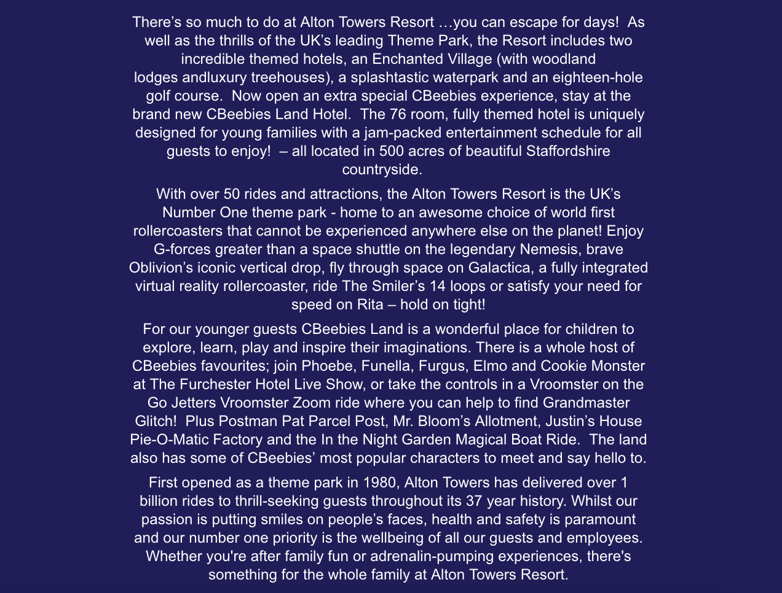
Appendix 1
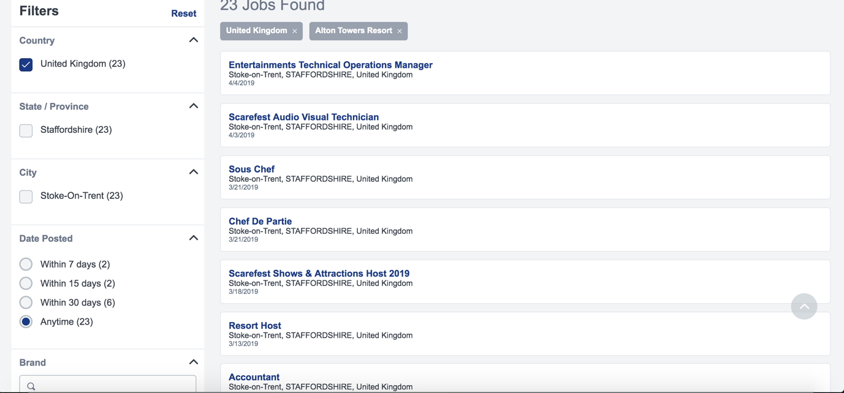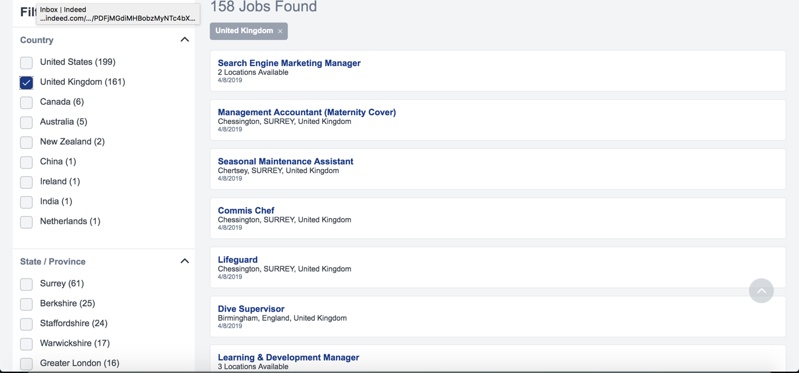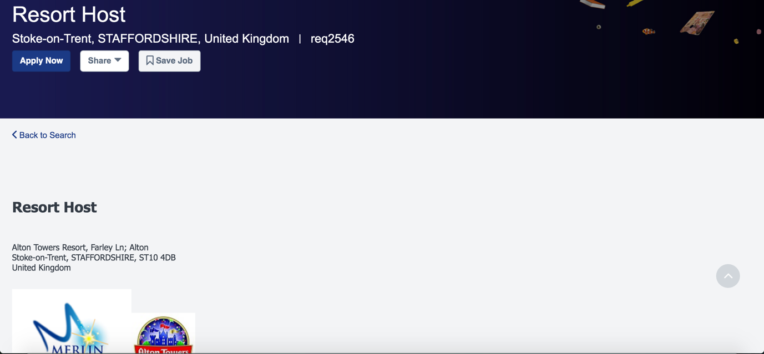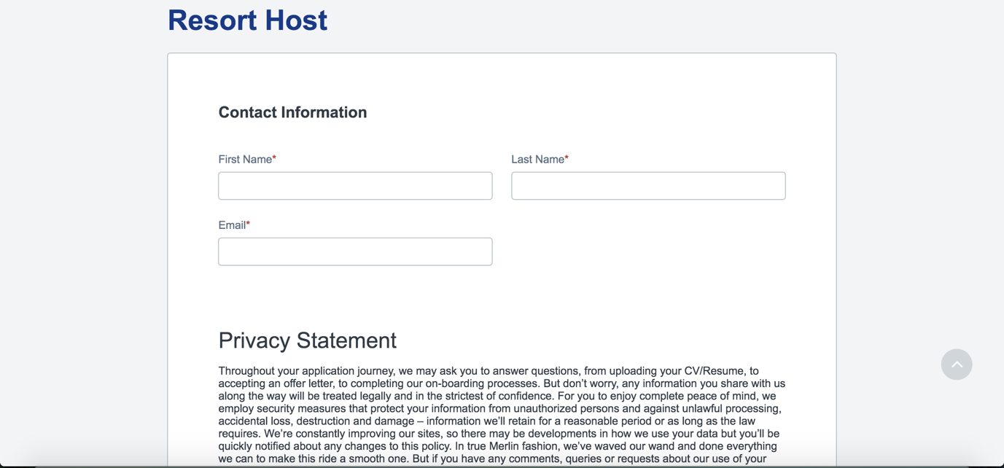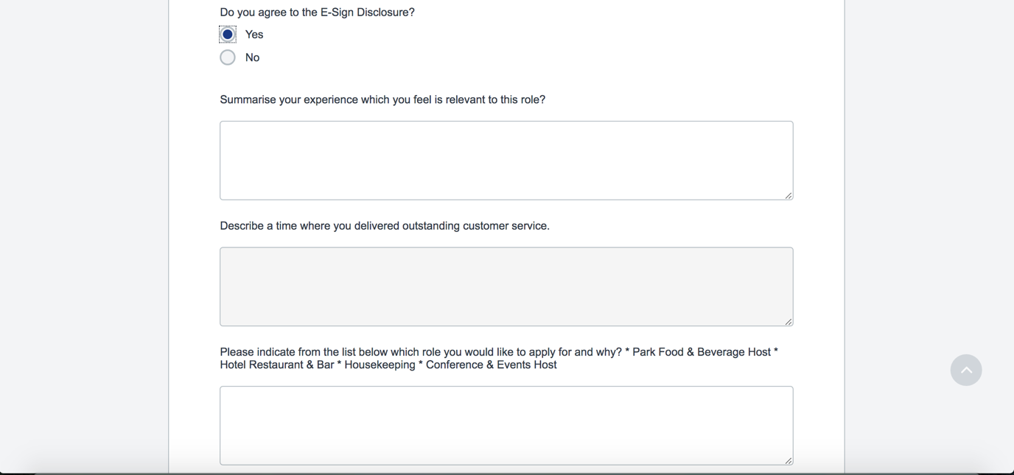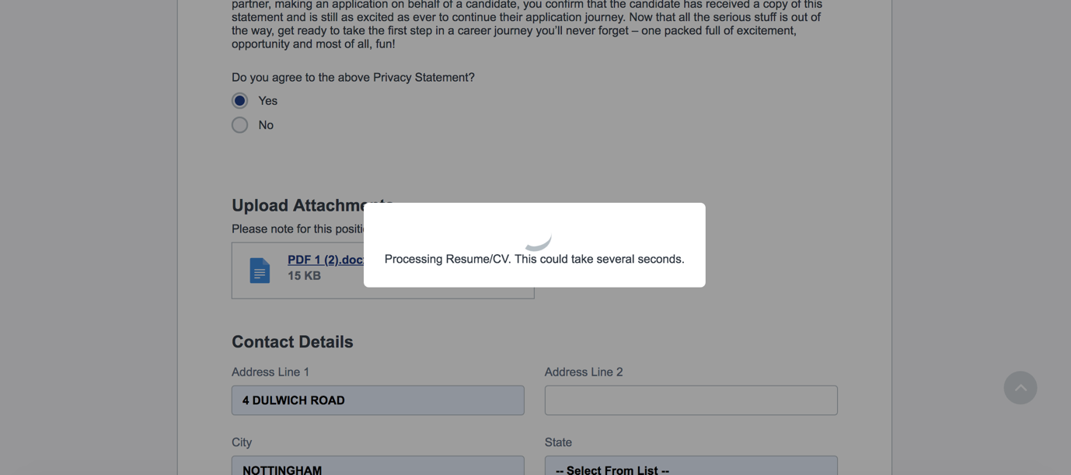
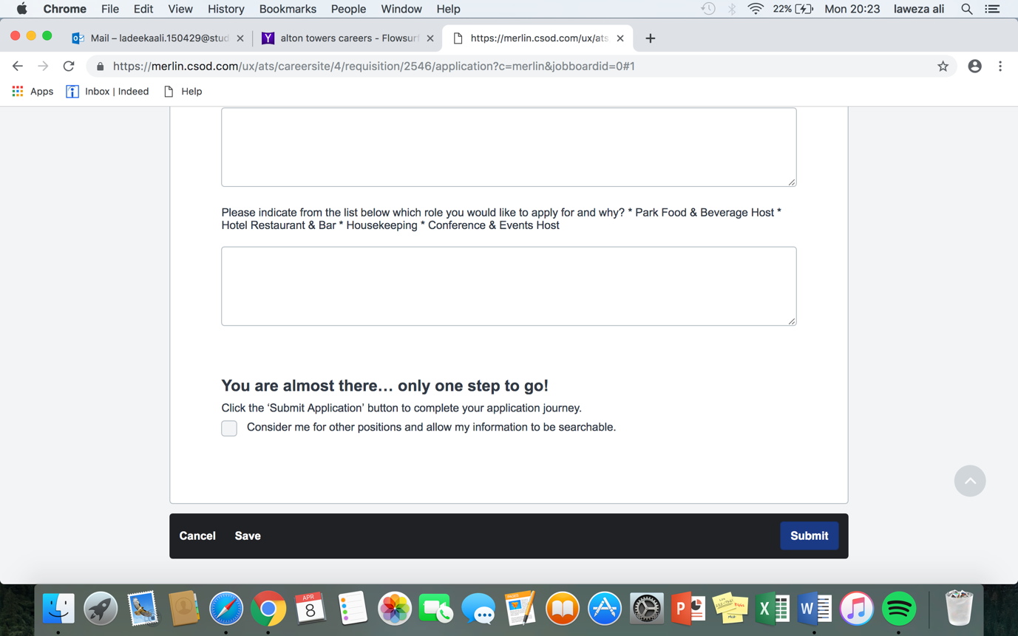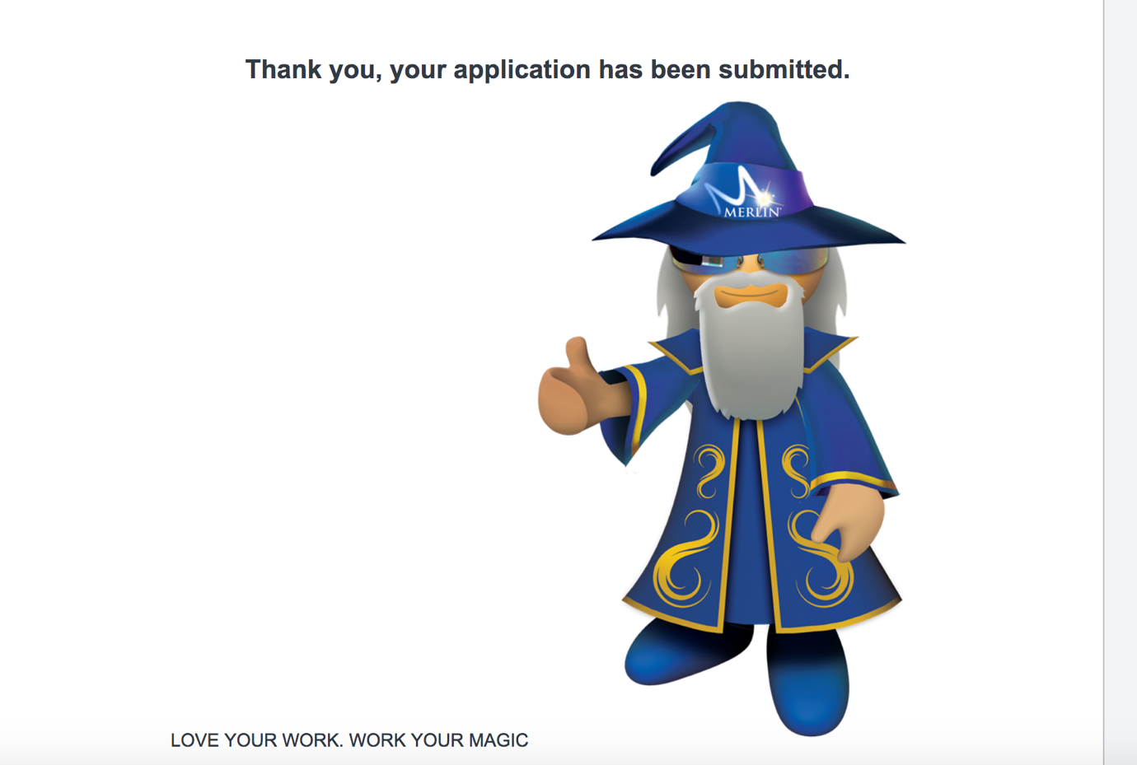Appendix 2
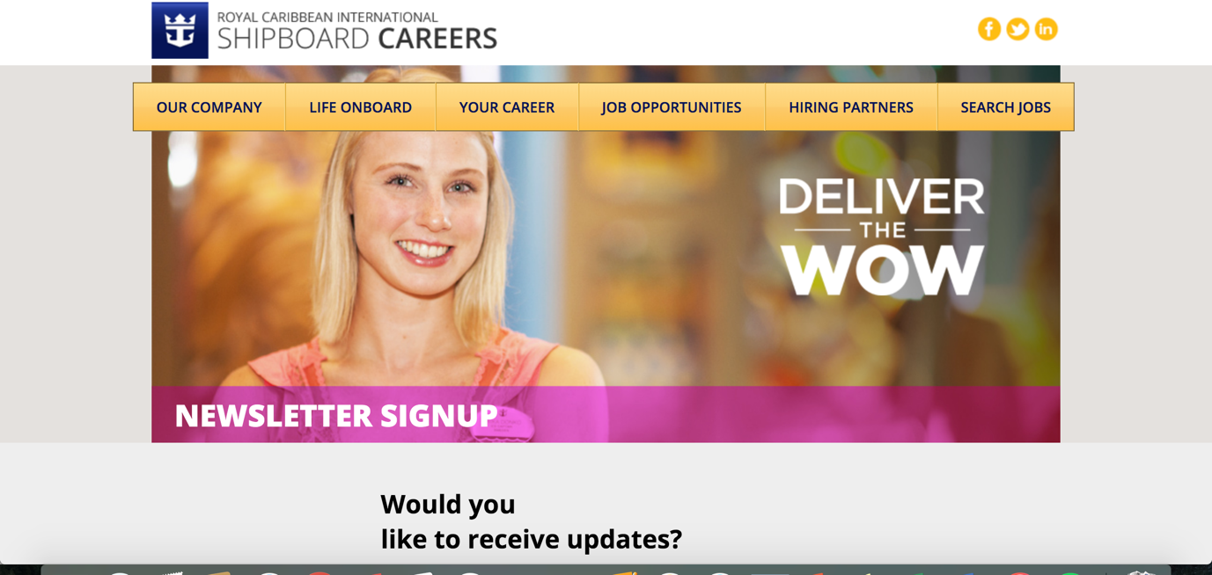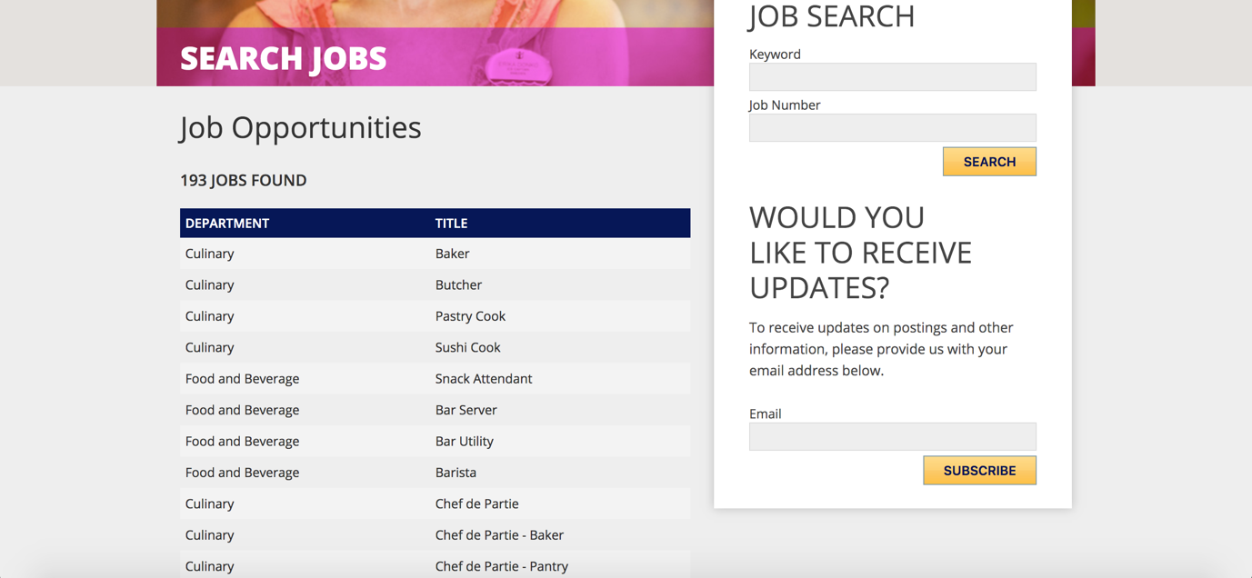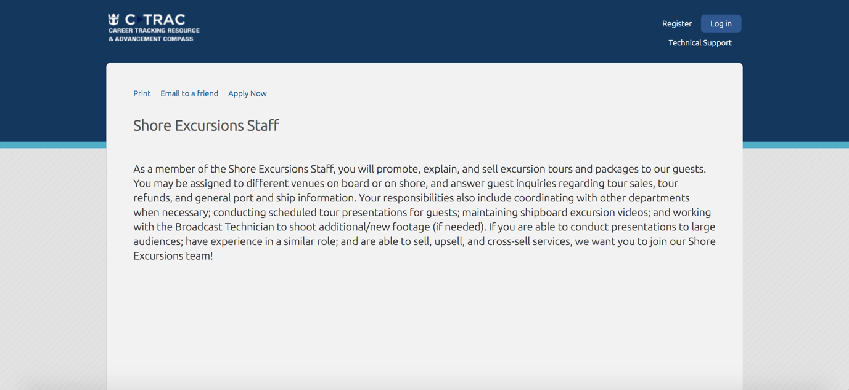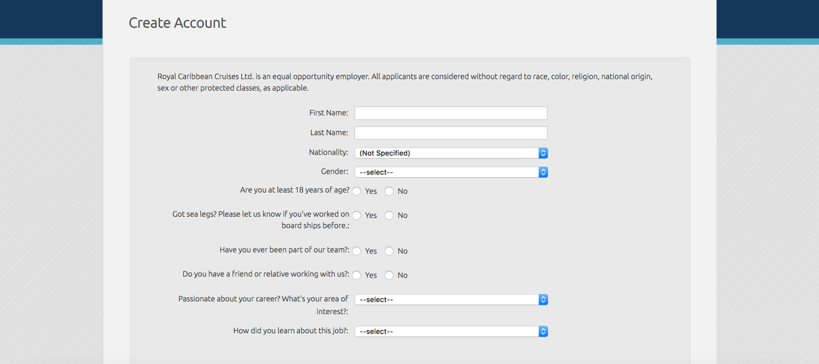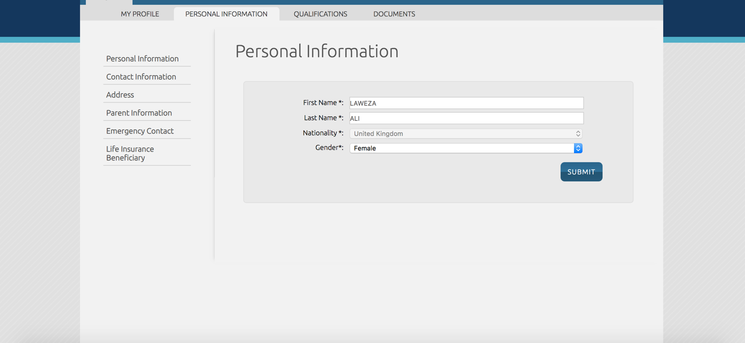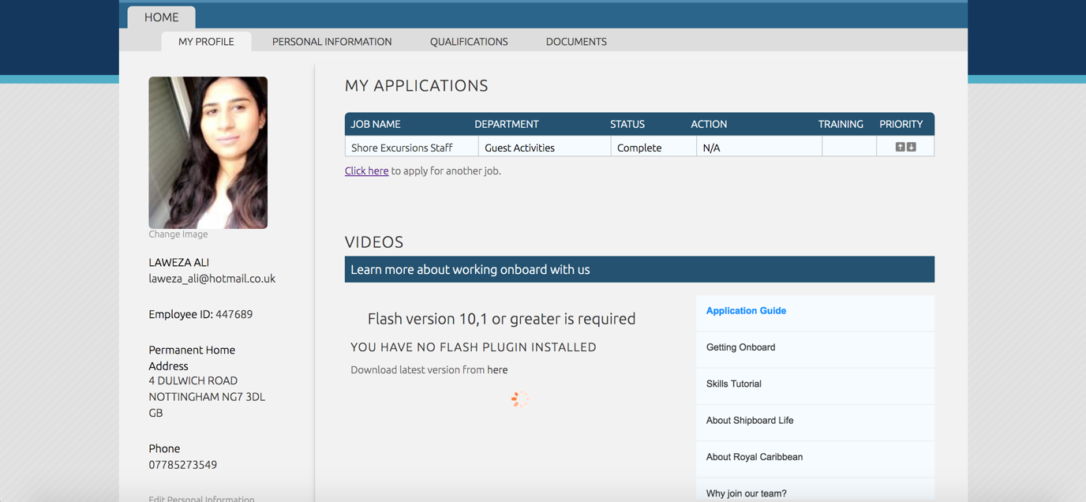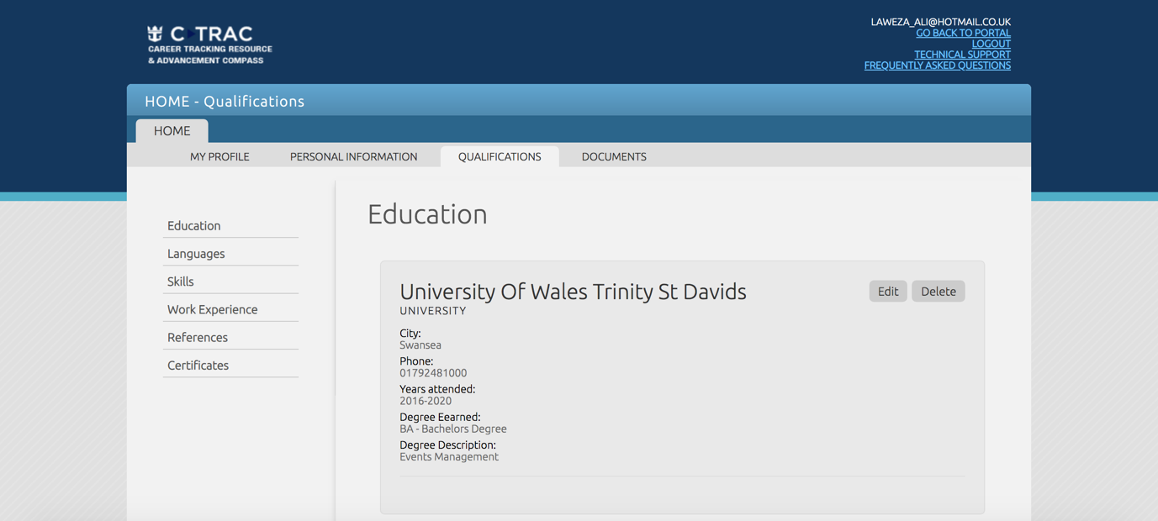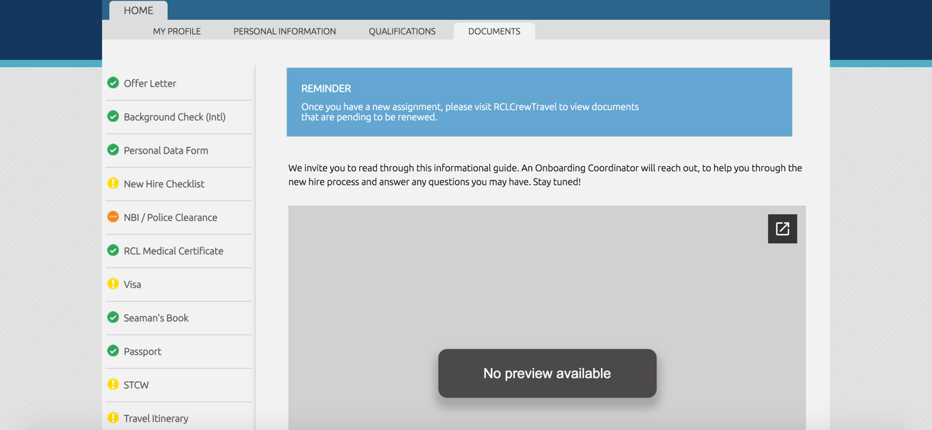Appendix 3
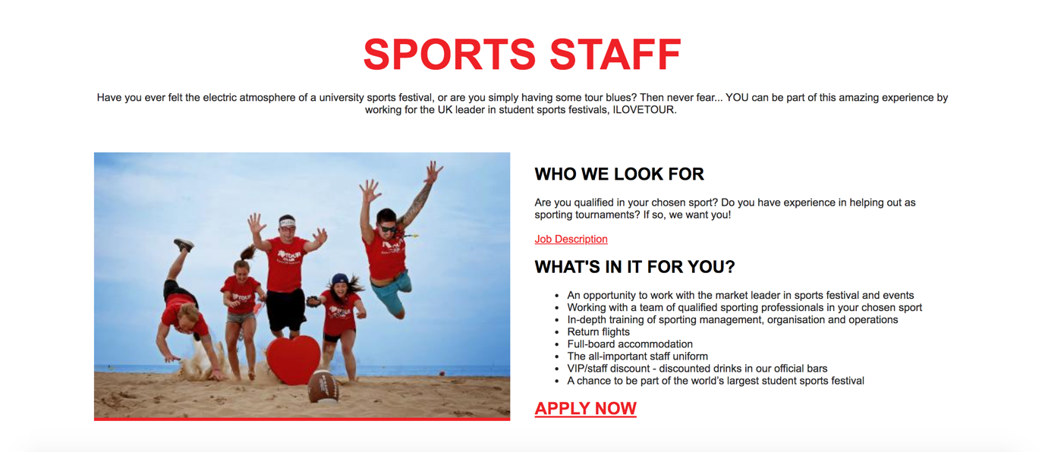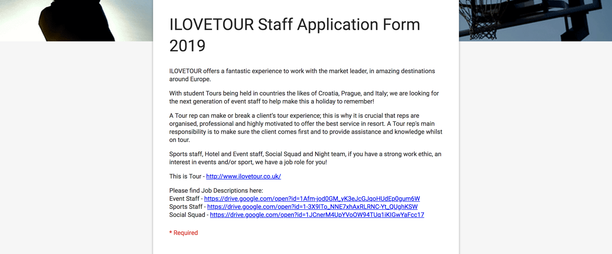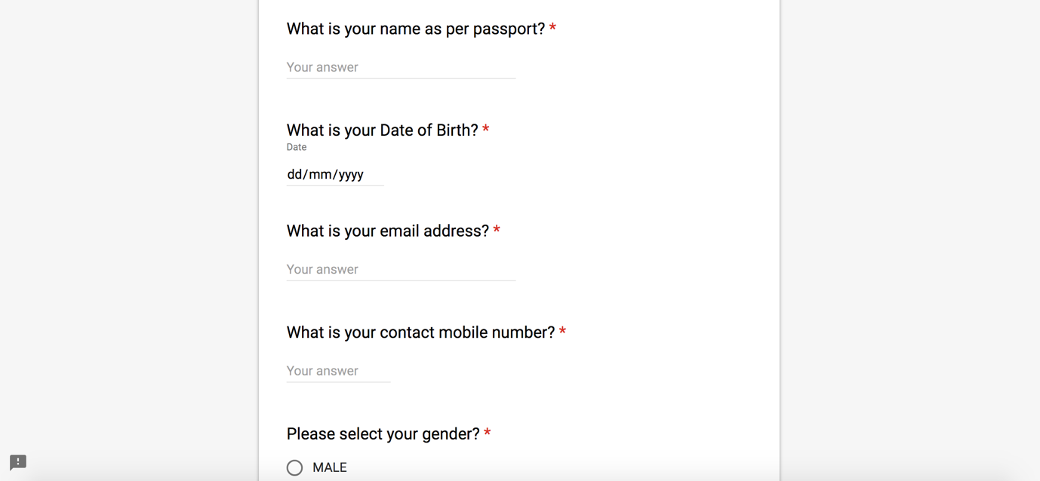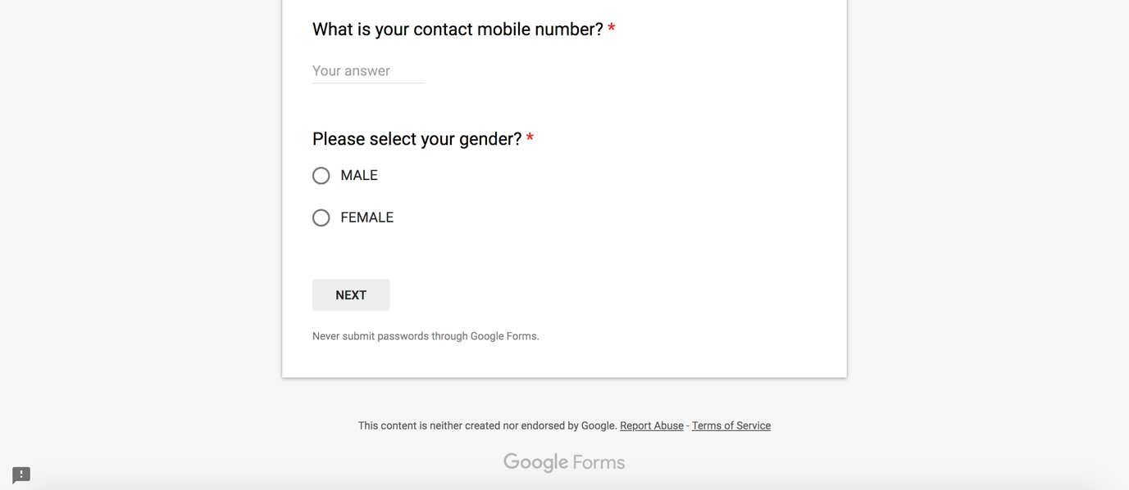
appendix 4

