Dr Md Nazmul Hasan
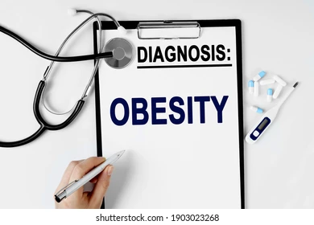
Nazreen Akhtar
(2128933)
Introduction to Public Health
(LCHS4004)
Written Report: Obesity
Introduction
In this report obesity will be discussed as well as statistics regarding the population of overweight and obese people in the UK and around the world. Risk factors, measures and the consequences will also be talked about. Overweight and obesity are defined as abnormal or excessive fat accumulation that presents a risk to health (Obesity 2022 World Health Organisation). Body mass index (BMI) is a method used to check If you’re a healthy weight, BMI can also determine whether a person is overweight.
According to the 2019 Health Survey for England, 36.2 percent of adults in England are overweight but not obese, and 28.0% of adults in England are obese. Typically, having a BMI of 30 or higher is obese. A BMI of 25 to 30 is considered "overweight”. Men are more likely than women to be overweight or obese, according to the survey (68.2% of men vs. 60.4% of women). Overweight and obese people tend to be between the ages of 45 and 74.
It is estimated that one billion people globally will be living with obesity by 2030, According to the World Obesity Federation's World Obesity Atlas 2022, one in five women and one in seven men worldwide will be affected by obesity by 2030. Not only will countries fail to meet the WHO's goal of halting the rise in obesity to 2010 levels by 2025, but the number of obese people is also expected to double worldwide, according to the findings.

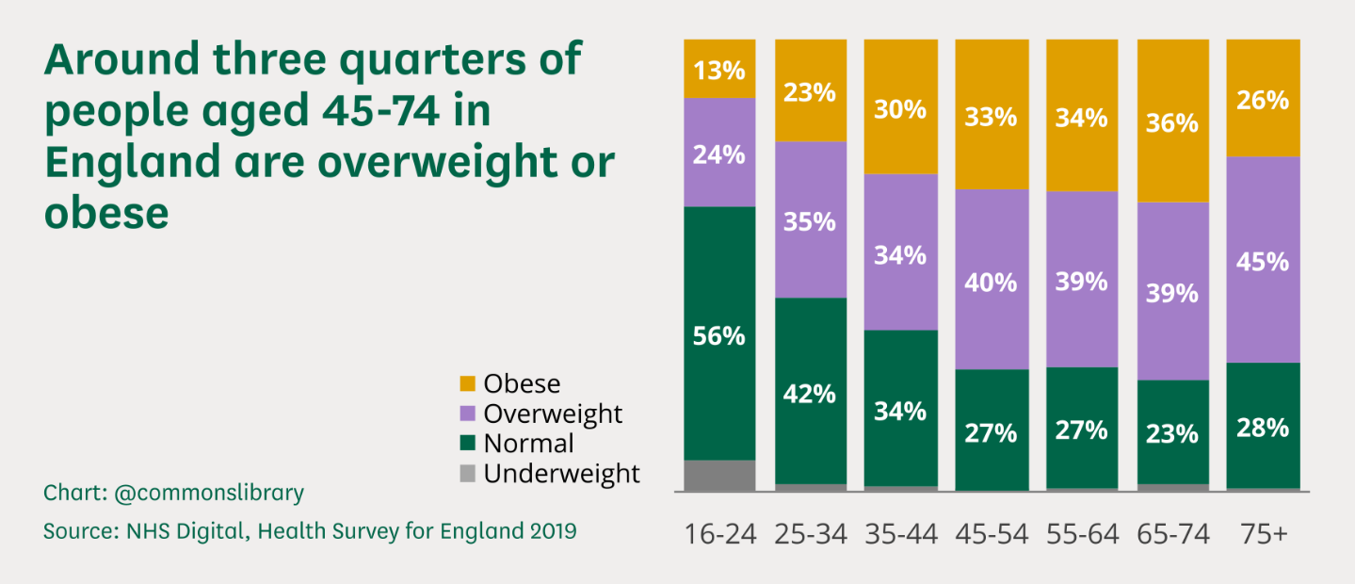
This graph shows the people that are obese in the UK

Public Health Measures
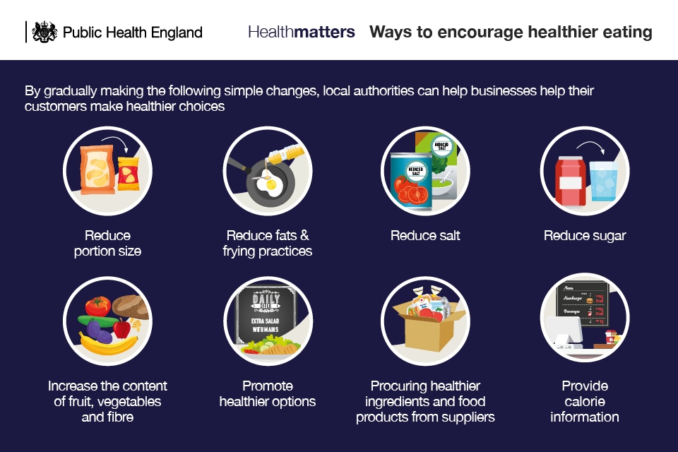
The government has raised the issue of obesity by enforcing new policies and legislation that will help people make healthier choices and live a healthier lifestyle. One thing the government has introduced is the Better Health Campaign, the campaign helps people make changes to their diet and allows them to eat better preventing them of this disease obesity. The government has also developed a healthy eating app; the 12-week weight loss plan app helped people make healthier eating habits enabling them to maintain a healthier weight by eating better and exercising regularly.
The 2020 Obesity management strategy: enabling children and adults to lead healthier lives (Department of Health and Social Care 2020): This includes a call to action to get people to lose weight, plans to improve the quality of food labelling by requiring restaurants to list calorie counts on their menus, and plans to control how food is sold, like not showing junk food ads on television before 9 p.m. The implementation of the Obesity Strategy will receive £100 million in funding from the Department for Health and Social Care in March 2021 (Department for Health and Social Care 2021b).
The Innovation and integration plan in 2021: cooperating to improve social and health care for all: outlines legislative proposals to enact the calorie labelling and advertising restrictions outlined in the Obesity Strategy. In addition, it explains how, in the coming years (Department for Health and Social Care 2021a), the NHS will place a greater emphasis on health and obesity prevention.
The 2021 a public food system policy: This independent review, which was ordered by the Department for Environment, Food, and Rural Affairs, will produce a comprehensive strategy for the UK's food system (Department for Environment, Food, and Rural Affairs 2020).In its interim report, which was released in July 2020, the National Food Strategy 2020 emphasized that children from poor families are more likely to experience both hunger and obesity and that trade deals should be used to protect food standards.
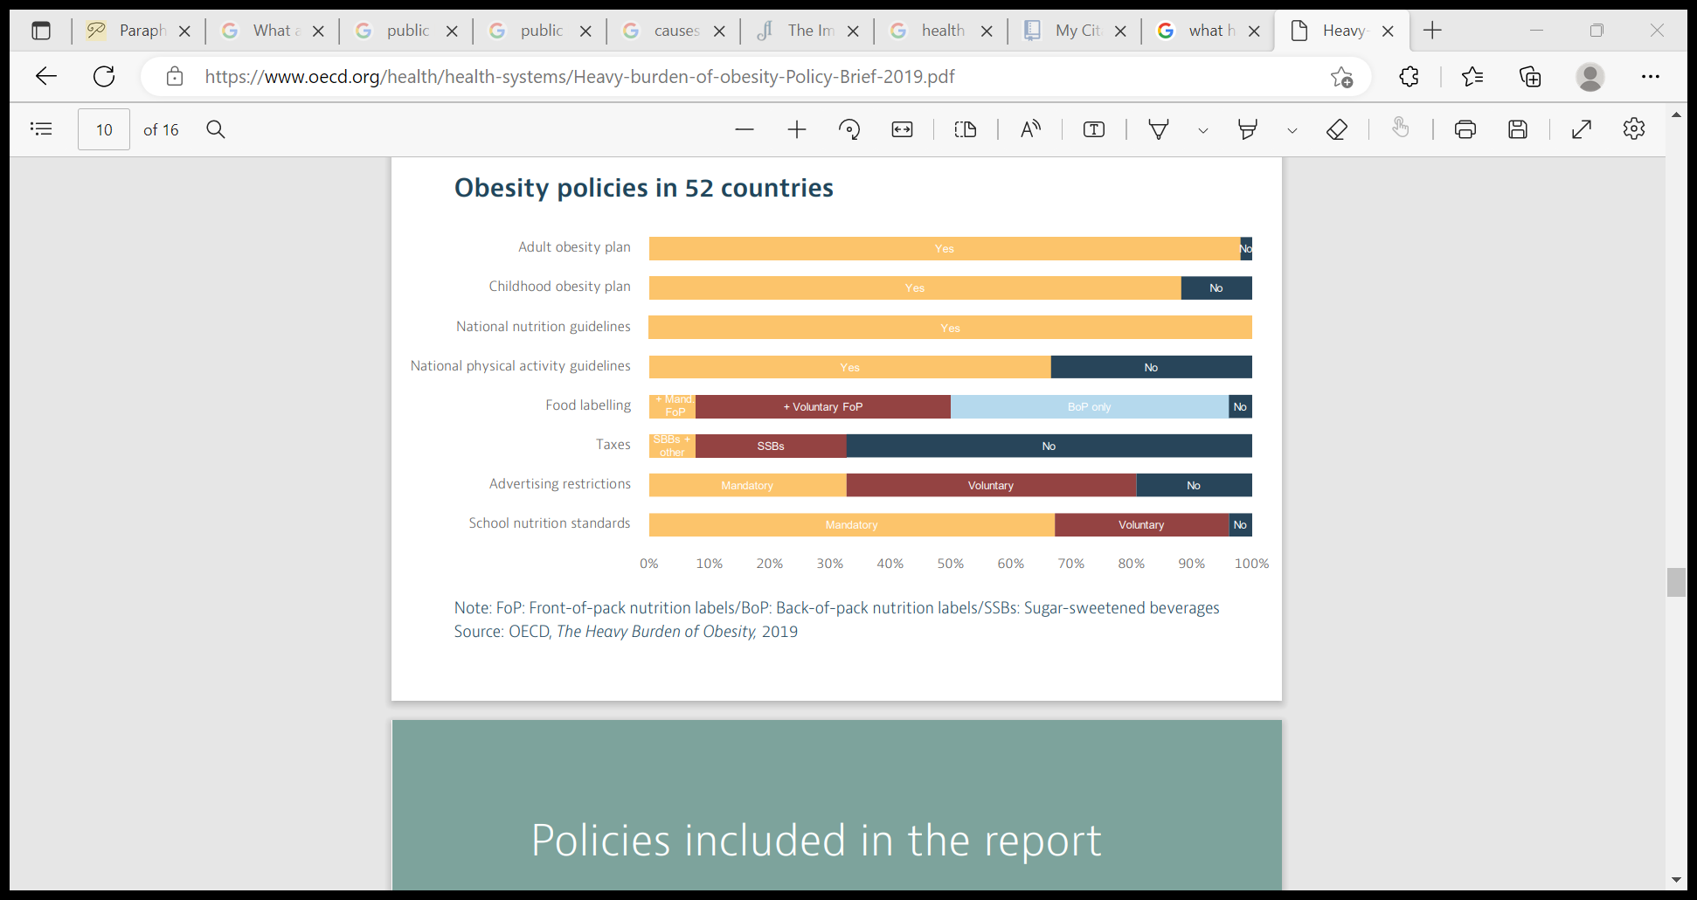
In the past ten years, countries have made significant progress in implementing policies to combat unhealthy eating and inactivity. A national obesity action plan is in place in almost all 52 countries examined. Most nations have both national guidelines for promoting healthy diets and active lifestyles and a specific action plan to combat childhood obesity. In general, countries have been particularly active in enacting policies to increase the number of healthy options and provide people with more information. There is less widespread implementation of policies to regulate unhealthy choices and to lower the cost of health-related choices, such as advertising restrictions or taxes on energy-dense foods and drinks. Despite this, the rising rates of overweight individuals demonstrate that the response has not yet fully met the challenge. Policies are sometimes put into action in ways that aren't the most effective, or actions aren't done the same way all over the country. Other times, the number of people who could benefit from the interventions is limited by practical issues or insufficient resources. The OECD examined a variety of policy options and packages to comprehend how various policies affect population health and the economy.
The key Determinants/Risk Factors for Obesity
When you consume more calories than you burn over time, you may become overweight or obese. When your energy in (calories) does not equal your energy out, this is often referred to as an energy imbalance (calories your body uses for things such as breathing, digesting food, and being physically active). Your body creates and stores energy using certain nutrients from the meals you eat, such as proteins, lipids, and carbs or sugars. Food is immediately converted to energy to power regular bodily processes and physical exercise. Your body stores food as energy for later use. Sugars are kept in the muscles and liver as glycogen. In fatty tissue, fats are mostly retained as triglycerides. The key determinants or risk factors are things considered to increase the chance of developing a disease, in this case obesity. Many factors can cause weight gain such as physical activity levels such as exercise, sleep routines, eating patterns, social determinants of health, genetics and taking certain medications. All these factors play a significant role in increasing a person’s weight.
Social determinants of health (SDOH) are the conditions in which we live, work, play, and learn. If these conditions don't help your health, it can be hard to choose healthy foods and exercise enough. Contrasts in SDOH influence persistent sickness results and dangers, including heftiness, among racial, ethnic, and financial gatherings as well as in various geologies and among individuals with various actual capacities. Through the foods and beverages, they offer and the opportunities they provide for physical activity, places like childcare centres, schools, and communities influence eating patterns and activity.
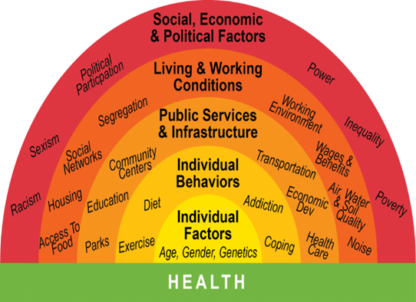
The affordability of healthy food options, social and peer support, marketing and promotion, and policies that determine community design are additional community factors that influence obesity. Human populations undergo genetic changes too slowly to be the cause of the obesity epidemic. However, by increasing hunger and food intake, variants in several genes may contribute to obesity. A clear pattern of inherited obesity in a family is rarely caused by a particular variant of a single gene (monogenic obesity). Obesity or weight gain may result from some diseases, like Cushing's disease. Steroids and some antidepressants can also make you gain weight. The role of other factors like chemical exposures and the microbiome is still under investigation.
Home. Available at: https://www.publichealthwm.org/ (Accessed: November 21, 2022)

Long before we go to the doctor or stop by the pharmacy, health starts where we live, work, learn, and play. The social, economic, cultural, and physical surroundings in which we live have a significant impact on our health. This includes everything from where we work and live to our level of education and our availability to nutritious food and water.
These circumstances are referred to as social determinants of health, which are the socioeconomic factors that influence life expectancy and quality of life and support health. Examples of these factors include housing, education, food access, and transportation. Too frequently, people lack control over their ability to access these resources that influence their health. Communities of colour, those with low incomes, and other vulnerable groups endure many health disparities that are caused by an inadequate distribution of resources. This links to our chosen disease which is obesity because there are certain risk factors such as excess consumption of high calorie foods, high intake of sugary drinks and lack of exercise. The factors discussed above also play a huge role in a person’s health as they determine whether a person is healthy or in this case obese.

Short-term and Long-term Public Health Consequences for Obesity
The body begins to convert the calories it consumes into fat when it consumes more calories than it can use. Each fat cell weighs very little - under 1 microgram. However, if a lot of them are combined, they can clog your limbs and surround your internal organs, making it more difficult to complete every action and process. In the short term, obesity frequently causes: Aches, headaches, vague pains, and physical discomfort Indigestion and digestive issues Infertility and complications during pregnancy like gestational diabetes and blood clots Restricted mobility Fatigue Psychological distress Physical incompatibility with surroundings Excess weight affects every aspect of life. High cholesterol, high blood pressure, and prediabetes are conditions in which blood glucose levels are elevated but not yet diabetic. Even as you try to keep up with your family, friends, and co-workers, your body is constantly struggling to function. Because your body's systems are being overworked, you end up feeling tired and achy.
Short-term effects eventually develop into long-term conditions and diseases. Problems like these only get worse when people are unable to move around: Stroke Osteoarthritis Pulmonary conditions such as chronic obstructive pulmonary disease (COPD) Sleep disorders such as sleep apnea Digestive disorders such as gastro-oesophageal reflux disease (GERD) Gall bladder disorders Non-alcoholic steatohepatitis, or non-alcoholic fatty liver disease Incontinence Cancer, particularly of the colon, kidneys, gall bladder, breast, and uterus Depression Social isolation and discrimination 10 to 15-year.
In England, almost two-thirds of adults are overweight or obese. 617,000 NHS hospital admissions in 2016–17 had obesity as a major or secondary diagnosis. Children who graduate from primary school make up one-third of the population and typically consume up to 500 additional calories per day. Children are exposed to a lot of television advertising for foods and beverages that are rich in salt, fat, or sugar; fast food restaurants are becoming more common on high streets and are concentrating near schools. By 2030, the government promises to have greatly reduced the obesity gap between children from the wealthiest and least affluent communities, as well as cut childhood obesity in half.
Not everyone in society bears the same burden of obesity . For those with a diagnosis of type 2 diabetes or hypertension and a BMI of 30 or higher (adjusted appropriately for ethnicity), the NHS will offer targeted support and access to weight management services in primary care, where we know we can have a significant impact on improving health, reducing health inequalities, and cutting costs. We also anticipate treating up to an additional 1,000 kids annually by 2022–2023 for severe obesity-related comorbidities such diabetes, heart disease, sleep apnea, and poor mental health. These programmes will spare kids from requiring more intensive care.
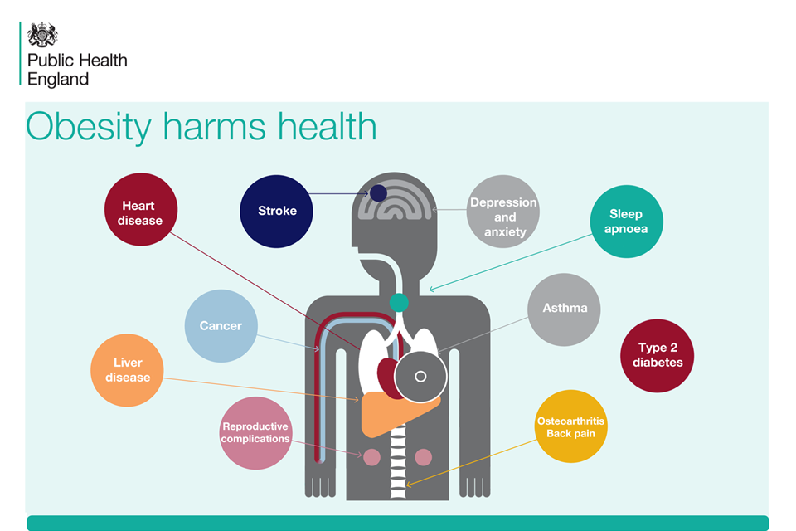

Conclusion
Following the discussion of obesity, it’s been concluded that this disease is significantly bad for a person’s health. Obesity is a very popular disease; the public health of England has released many policies and procedures such as the 2020 Obesity Management Strategy identified key plans and strategies to help adults and children make healthier choices and live a healthier lifestyle. Obesity is not only a problem in England but also around the world, it’s now been affecting younger age groups such as school children, this is because of the excess consumption of fast food and enriched sugary drinks along with a bad lifestyle. It’s important to recognise just how harmful these factors are to a person’s health, by exercising daily and eating balanced meals along with restricted sugary foods a better much healthier lifestyle can be lived. The social determinants of health in which the conditions we live, work, play and learn. The places we work, go to school and how we use transportation all play a significant part in our health; its good to be aware of the food choices we make whilst being at work or school settings. It can be very easy to give in to fast food along with a busy schedule but its good to eat better and exercise which can be in the form of walking or going to the gym regularly. Most people don’t recognise how harmful obesity is, to be in good shape it is recommended to exercise daily four times a week, this will ensure your bodyweight is maintained at a healthy weight.
Reference List
- Baker, C. (2022) Research Briefings Publications - House of Commons Library. Available at: https://commonslibrary.parliament.uk/research-briefings/ (Accessed: November 19, 2022)
- Obesity (2022) World Health Organization. World Health Organization. Available at: https://www.who.int/health-topics/obesity/#tab=tab_1 (Accessed: November 19, 2022).
- World Obesity Atlas 2022 World Obesity Federation. Available at: https://www.worldobesity.org/resources/resource-library/world-obesity-atlas-2022 (Accessed: November 19, 2022)
- Tackling obesity: Empowering adults and children to live healthier lives (2020) GOV.UK. Available at: https://www.gov.uk/government/publications/tackling-obesity-government-strategy/tackling-obesity-empowering-adults-and-children-to-live-healthier-lives#a-call-to-action (Accessed: November 20, 2022).
- Holmes, J. (2021) Ideas that change health and care | the king's fund. Available at: https://www.kingsfund.org.uk/sites/default/files/2021-07/Tackling%20obesity.pdf (Accessed: November 20, 2022).
- Causes of obesity (2022) Centers for Disease Control and Prevention. Centers for Disease Control and Prevention. Available at: https://www.cdc.gov/obesity/basics/causes.html (Accessed: November 20, 2022).
- Acweightloss (2016) The immediate and long-term effects of obesity, Acadiana Weight Loss Surgery. Available at: https://acadianaweightlosssurgery.com/blog/the-immediate-and-long-term-effects-of-obesity (Accessed: November 20, 2022).
- NHS choices. NHS. Available at: https://www.longtermplan.nhs.uk/online-version/chapter-2-more-nhs-action-on-prevention-and-health-inequalities/obesity/ (Accessed: November 20, 2022)
- Causes and risk factors (no date) National Heart Lung and Blood Institute. U.S. Department of Health and Human Services. Available at: https://www.nhlbi.nih.gov/health/overweight-and-obesity/causes (Accessed: November 20, 2022).
- What influences health? Public Health Institute of Western MA. Available at: https://www.publichealthwm.org/what-health-equity/what-influences-health#:~:text=Our%20health%20is%20largely%20determined,to%20healthy%20food%20and%20water. (Accessed: November 21, 2022).

