Student Name Simren Kaleem
Student ID 2464630
Lecture Name Samuel ofori

LCLM5003
Project Management

Table of Contents
Part A: Project proposal poster 3
Part B: Reflections 4
Introduction 4
What I Did Well 4
Areas for Improvement 4
Action Plan for Improvement 5
Part C: Project Management Plan 6
Introduction 6
Project Description 6
Project Scope 7
Work Breakdown Structure (WBS) 8
Quad Chart 9
Gantt Chart 9
Stakeholder Involvement 10
Resource Allocation 10
Risk Analysis 11
Conclusion 12

List of Figures
Figure 1: WBS 10
Figure 2: Quad Chart 12
Figure 3: Schedule Table 13
Figure 4: Gantt Chart 13
Figure 5: Network Diagram 13

List of Tables
Table 1: Risk Mitigation 15

Part A: Project proposal poster
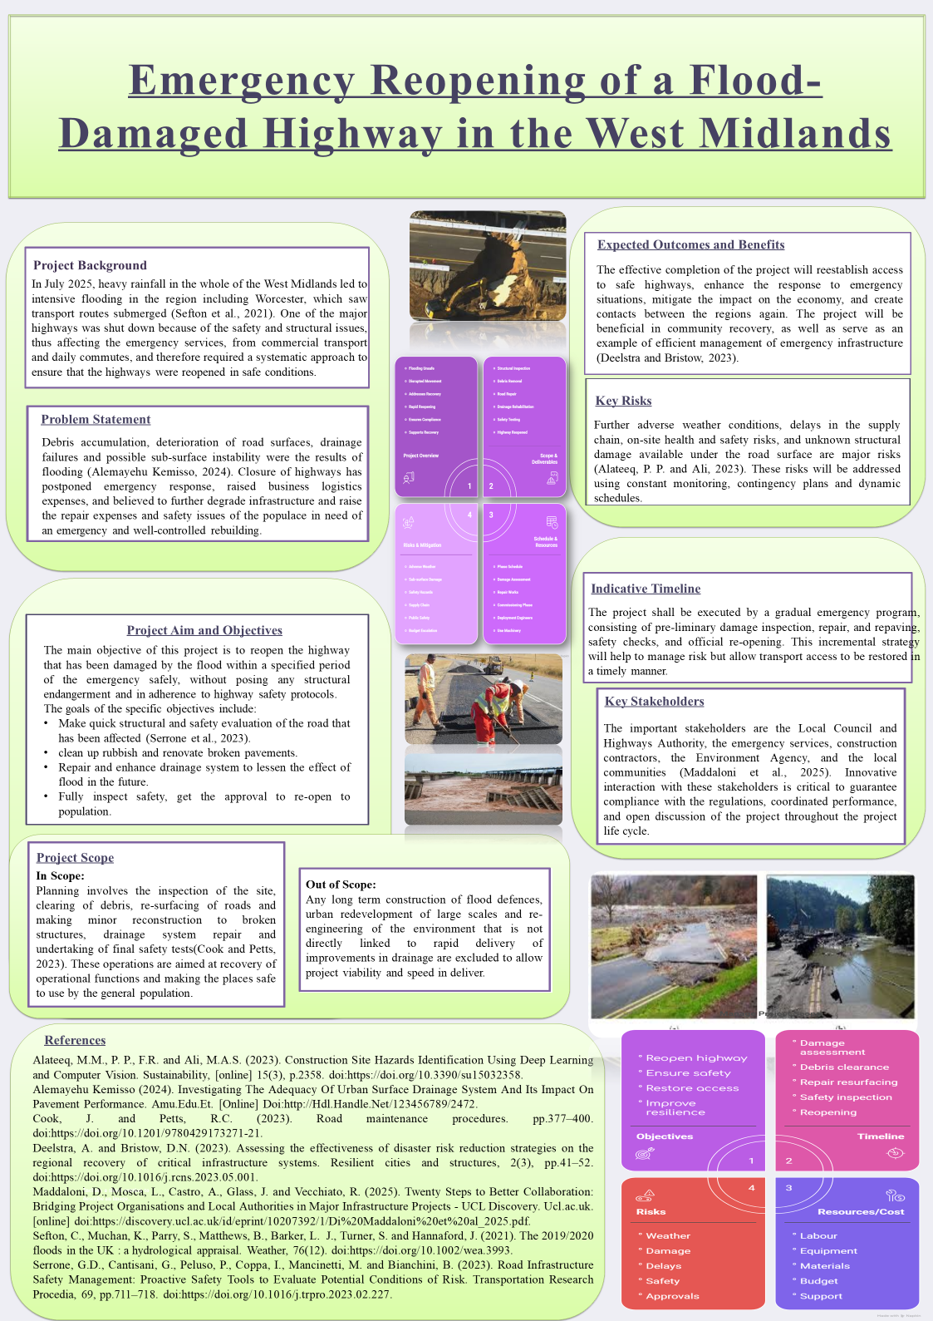

Part B: Reflections

Introduction
Feedback given to me by the tutor and other students proved to be priceless in making my project proposal to re-open a highway damaged by floods in the West Midlands emergency. Although my poster presentation was received well, the reviews showed me on areas that need to be improved on to make the performance more understandable, detailed and presented. This reflection shall be based on aspects that were done well, areas that must be improved on and actions that I intend taking in order to deal with the feedback in my final project management plan.

What I Did Well
The feedback was appreciative of the effective expression of the projects aim and mission. The major objective of the various bonds between the standbys of the flood-damaged highway within a definite span of emergency was easy to understand and the stakeholder participation when clearly defined featured the position of major players in the process; the local council, emergency service and construction contractors. The timeframes and risk-reduction measures too were taken well, as it easily communicated a feeling of urgency and necessity to address and handle unexpected risks like bad weather conditions, and inventory shortages. Also, it was noted that application of visual tools such as the indicative timeline, stakeholder mapping etc made the poster easier and interesting to use.

Areas for Improvement
Nevertheless, it is also evident in the feedback that there were some points where the company may seem to have served better. The Quad Chart section represented one of them. Although it was obvious, it was recommended that I have to balance it more graphically and make all the quadrants equally informative. To illustrate, the timeline and risks section should have been more precise, especially with regard to actionable milestones and profile of risk groups. It was also suggested to optimize the word count in certain areas of the poster specifically in the Project Scope and risks section, in order to make the Project Scope less wordy and make the poster more easily readable. Other feedbacks included simplifying the language to ensure that one did not overwhelm the audience with tools of project management since such tools might be alien to the audience who had no background details of the project management techniques being discussed.

Action Plan for Improvement
After taking into consideration the suggestions, my decision will be to implement some modifications prior to the eventual presentation of the project management plan. To begin with, I will update the Quad Chart so that the balance and clarity of the information in each quadrant is established in the most effective way namely the Quad Chart being fine tuned to have exact dates and more accurate milestones of the project. I will as well summarize the text presented in the scope and risk sections, making sure that every point is concise and is able to state its relevance. To manage the feedback regarding the language I will contribute toward a more approachable manner in which I will not employ too far-fetched technical terms and assure that the information will rather be digestible by a wider population. Lastly I will try to bring more balance in the poster, where every part catches the eye, so that the all-out poster will be more appealing in terms of balance and attractiveness.

Part C: Project Management Plan

Introduction
A heavy downpour in July 2025 led to disastrous flooding in the West Midlands causing severe destruction to key infrastructure, such as roads. The main project is an emergency reopening of a highway damaged by floods, but to be more exact, transport routes were in service of emergency services and the local communities (Alabbad et al., 2021). The objective will be to restore the highway safely, on time, and on budget and leave no structural hazards. The main goals in this regard will be the thorough safety assessment of the road in question, mending the infrastructures, like pavements and drain piping, and ensuring the highway is capable of supporting the flooding in the future. The drainage system will also be improved so that the consequences of possible floods in the future can be minimized and the resilience will be guaranteed in the long-term.

Project Description
Background
In July 2025, it was subject to a major weather event that resulted in unprecedented rainfall all over the West Midlands resulting in extensive flooding. The river Severn over-toppled its defences and flooded major roads including major highways commuted and emergency routes on a daily basis. This caused key routes to become impassable and disrupted logistical and public services as well as daily activity of the region. The impending concern of this project is to effectively open up a highly important highway, which will once again link access to emergency staff, businesses and citizens, as well as minimize the risk of future flooding.
Specific Project Tasks
The initial activities of relocating the highway include:
- Debris Removal: Clean the road from rubble that has collected, trees and debris as a result of the flooding (Franca et al., 2025).
- Drainage Repair: Discuss how to solve drainage system failures to reduce future flood effect by repairing and upgrading old systems (Oladunjoye et al., 2019).
- Road resurfacing: This involves repairing the damaged roads and foot paths to facilitate a safe passage by vehicles and human beings.
- Safety Tests: Before reopening ensure proper safety tests are done on the road structure and give a check on the road quality.
Scope of Work
The project scope is limited to the recovery of access along the highway, mitigation of damages caused by floods in immediate cases. The tasks will include:
- In-Scope: On-site inspection, cleanup of debris, resurfacing, small repairs to structures, upgrades of drainage system and safety testing (Townsend, 2023).
- Out of scope Long-term flood protection, large-scale redevelopment of city, or complete re-engineering of those areas. Such projects are not included in the direct scope since the priority is to ensure that operational access is regained as soon and safely as possible.
The project will re-establish critical infrastructure, minimize the long-term economic crisis, as well as assist society in overcoming the immediate effects of the flood.

Project Scope
This project study scope is on reopening an emergency highways damaged by floods in the West Midlands. There are some other major activities associated with the project like clearance of debris, repairing pavements where damaged, resurfacing pavements in the affected areas and improvement of the drainage system to lessen future flooding effect (New et al., 2020). Also, safety check-ups will be conducted to guarantee that the road is of the necessary standards that will be reopened to the people.
Long-term flood defense construction, urban redevelopment and extensive re-engineering of the environment are not part of this project (Dinić-Branković and Marković, 2021). Its main agenda is the immediate reparation of the highway and repair of damages caused by flood to allow safe transportation of emergency services, commuters and businesses.
Any infrastructure enhancements or large-scale alterations that are not directly related to the repairs in case of floods, e.g., large city renewals are not part of this project so that there is an opportunity to deliver the project on time and provide resources to it.

Work Breakdown Structure (WBS)
Work Breakdown Structure (WBS) is a hierarchical breakdown of the project, where it serves to breakdown the project into manageable tasks and sub-tasks to have clarity of responsibility and timelines on every aspect (Hartley, 2020). The project is broken down into core stages below:
Preliminary Inspection (Stage 1)
- Site Survey: Survey the site to determine the level of damage that was caused by the flood.
- Structural Assessment: Determine the integrity of the road, bridges and the infrastructure (Corredor, 2023).
- Drainage Check: Establish drainage blockages and damages in the drainage system.
Debris Removal (Stage 2)
- Rubble Clearance: Pick up debris (trees, rocks, and so on) on the road.
- Debris Disposal: The correct disposal of debris must be upheld as per the environmental requirements.
Road Repairs (Stage 3)
- Pavement Resurfacing: Reform damaged parts of the pavements and roads.
- Drainage System Repair: Repair damaged or blocked drainage systems so that flooding may be prevented in future (Kamenchukov et al., 2023).
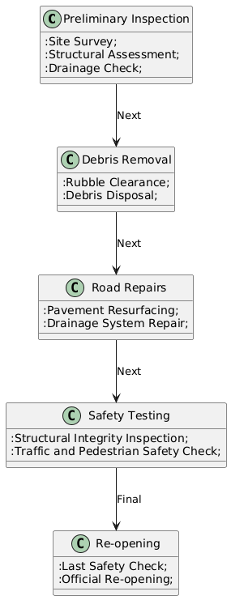
Figure 1: WBS
Safety Testing (Stage 4)
- Structural Integrity Inspection: Conduct detailed inspections to make sure that all the repairs are safe.
- Traffic and Pedestrian Safety Check: Be assured that the road can be safely used by the people, including signs and obstacles as well as pedestrian crossing.
Re-opening (Stage 5)
- Last Safety check: Unfortunately, just a last final check before the traffic is accredited.
- Official Re-opening: Have a road open to the public, by ensuring that it is as per the regulations on how to use it safely.
The present WBS sets out the different phases of the project clearly and thus delegation of tasks as well as monitoring of the progress can be done throughout the project.

Quad Chart
The Quad Chart links together in an easy to visualise form of presentation of the project with obvious factors illuminated.
Project Overview This quadrant is an overview of the project objective which was to reopen a highway damaged by floods and recover transportation channels (Lichty et al., 2025). It contains the major work of the project: drainage implementation, the work on the roadplugs, and controlling issues.
Stakeholder Involvement: This is where one is identifying the important stakeholders in the project, and that includes Local Council, Highways Authority and Emergency Services and Construction Contractors and Environment Agency. Their functions as well as their roles play essential consideration in the implementation of a successful project, compliance and coordination.
Key Risks: lists the significant risks which include adverse weather conditions, kink in supply chain and on-site health and safety. Dynamic scheduling, contingency planning and frequent monitoring are among some of the mitigation strategies.
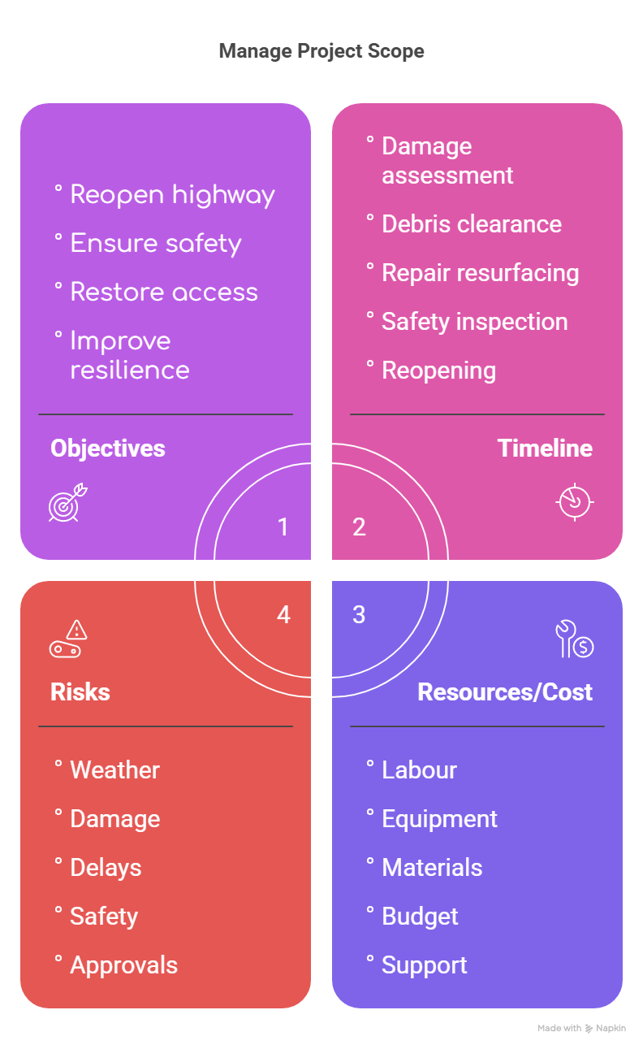
Figure 2: Quad Chart
Timeline & Milestones: Displays the schedule of the project, site inspection up to official reopening (Colonel, 2024). It must involve such milestones as the resurfacing of roads and final safety inspections so that each of the stages is delivered in time.

Gantt Chart
The time taken per phase has been considered according to the complexity of the phase and sufficient time has been given to every job in order to do it thoroughly. Site Inspection initiates the process, which is continued by Debris Removal and Road Resurfacing as far as the most important tasks in repairing the infrastructure. Drainage System Repair is followed by the Safety Testing phase which is done to ensure that the road meets the regulatory requirements. Lastly, the Re-opening of the highway will be finalized and the project will be finished.
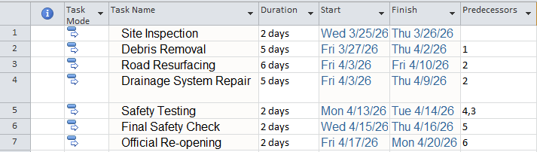
Figure 3: Schedule Table
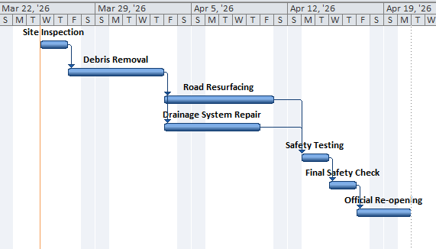
Figure 4: Gantt Chart
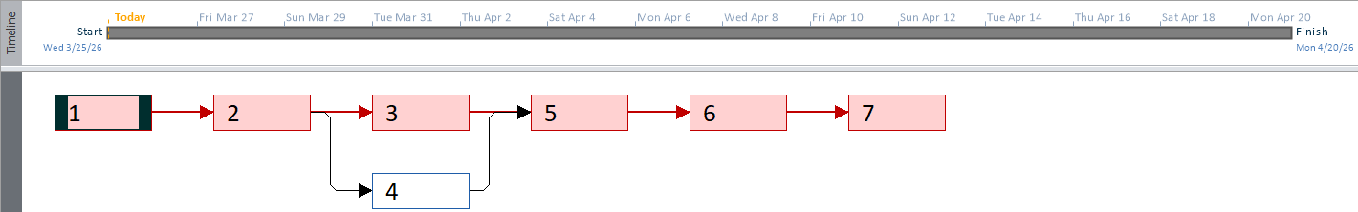
Figure 5: Network Diagram
This Gantt chart assists in visualization of the flow of the project, which needs to be completed in the schedule, and project milestones to be achieved within the set time.

Stakeholder Involvement
The highway reopening project will require the proactive participation of the key stakeholders, who are expected to make contribution towards various elements of the project.
- Local Council: Will be involved with the provision of the required permits, dealing with the local authorities and ensuring to correspond the project at the community needs. They will also help in evaluation of post project (Bourdin and Nadou, 2020).
- Emergency Services: Have a major role in the first evaluation, road safety priority and the accessibility of emergency services in time is taken care of by the project.
- Construction Contractors: They will be involved in carrying out the repairs, which involve removing of human debris, resurfacing of the road, and the upgrades of the drainage system. The On-site Safety and Good Workmanship responsibility lies on them.
- Environment Agency: This ensures that the project is environmentally compliant, especially on the drainages and the mitigation efforts on the floods.
- Local Communities: The Communities that are directly affected by the project they will be able to give a feedback, help in tracking the progress and that the highway re-opening satisfies their transportation requirements.
The role of each stakeholder is crucial to the successful and ideal project completion.

Resource Allocation
- Human Resources: The project will need the evaluation of a staff comprising engineers; to gauge and plan the works, safety inspectors, to see that all regulations were adhered to, constructions workers, to clear up both the rubbish and the road restorations, and formulate managers to manage the arrangements and welfare of time. Also, documentation and coordination should be supported through administration.
- Material Resources: The major materials that are needed will include construction materials like; asphalt to do the resurfacing, drainage piping, concrete to repair structures, and safety gears like signage and other barriers(Jasim, Ali and Al-Saadi, 2024). The removal of the debris and third-time resurfacing will require some specialized machines (excavators and road rollers).
- Financial Resources: The budget will be distributed by several phases, namely; initial assessments (10%), clearance of the debris (15%), road resurfacing and drainage repairs (40%), safety tests (15%) and final re-opening (20%). Nobody is prepared to face earning losses; therefore, a contingent budget of 10 percent will be allocated to unexpected expenses like postponements in supplies or the reason of more workforce.
Monitored material and human resources will be done regularly to avoid any delays and bottlenecks to achieve optimal resource management. The schedule of resource allocation will be following the project schedule closely which means that every phase will possess the sufficient work force, materials and equipment required(New et al., 2020). Furthermore, backup programs in the case of resource shortage will be established as countermeasures in case of any surprise at any time like supply chain delays or lack of labor. Presuming minimal disturbance, the project manager will be in charge of the efficient utilization of the resources so that all the stages will be executed within the budget and suitable timing.

Risk Analysis
Key Risks Identified
- Adversarial weather conditions: Unpredictable weather condition like additional heavy rainfall or storms may hamper construction and level of safety checking especially during the mining of debris and resurfacing.
- Supply Chain Breakages: The schedule might be impacted by the delays in the supply of materials like asphalt, drainage pipes, and other crucial supplies in construction projects like resurfacing and drainage repair works.
- Structural Damage: Unanticipated underlying sub-surface instability or undetected structural impairments under the road bed that might slow down the project or necessitate further repair (Franca et al., 2025).
- Health and Safety Risks: Accidents or health complications in the field because of the physical nature of the work might hold down progress particularly to the construction workers and the laborers.
Table 1: Risk Mitigation
Risk | Probability | Impact | Mitigation Strategy
Adverse Weather | High | High | Build buffer time in schedule, monitor weather forecasts.
Supply Chain Disruptions | Medium | High | Early procurement, alternative suppliers, close supplier liaison.
Structural Damage | Low | High | Pre-repair assessments, dynamic scheduling, real-time adjustments.
Health and Safety Risks | Medium | Medium | Strict safety procedures, regular training, health checks.

Risk Mitigation Strategies
- Contingency Planning: With regards to the worst weather, the project schedule will incorporate built-in buffer time. Tasks can be rescheduled in case of delays as the project will have a flexible schedule.
- Supply Chain Management: Early procurement of materials and sourcing of secondary suppliers of critical materials will help in curbing the risks related to supply chain. Close liaison with the suppliers will mean timely deliveries.
- Dynamic Scheduling: Project will also use real time adjustments in schedules and any unexpected structural problems can easily be adapted (Hartley, 2020). Pre-repair assessments will be done thoroughly to reduce unexpected occurrences by a dedicated team.
- Health and Safety Procedures: There will be stringent safety procedures in place, health and safety checks, employee trainings, and a set code of conduct to guarantee the occurrence of minimum accidents.
This mitigation analysis of risks is a detailed analysis of the risks and mitigation measures that can be used to ensure that the project is not derailed despite these difficulties.
To further facilitate the successful execution of the project, constant check-up and frequent reviews will be practiced in the life cycle of the project. This method will assist in monitoring the development of risk mitigation procedures, detect any arising risks and give actionable information to modify the plans accordingly. Moreover, risk management will be a joint venture where all stakeholders such as construction teams, suppliers, local authorities etc. will be engaged so that any problems which can emerge is addressed proactively. Frequent meetings dedicated to risk assessment will enable changing of the schedules and resources on the fly to effectively address any unexpected difficulties as it will be timely and efficient.
Besides that communication will also be a major aspect of the risk management process. Regular progress report and updates will keep the stakeholders posted and all the individuals involved in the project will be in sync with what is expected and know of the risk and delays that could come along (Corredor, 2023). This open attitude will allow the working team in the project to cooperate and make sure that the corrective measures can be implemented within a short period of time. With these holistic strategies and proactive risk management model established, this project will reduce such disruptions and in an effective manner when reopening the highway to traffic, it can be done in time, safely, and effectively.

Conclusion
The present Project Management Plan will indicate and detail the major activities that would be executed under the reopening of the highway damaged by the flood between the West Midlands with the removal of debris, the resurfacing of the road in good physical condition, the restoration of drains, and safety tests. The execution of the project will be divided into phases, and one of the primary points will be stakeholder engagement, resource distribution, and risk management. The timeframe of the project is to be timely, which will be guaranteed by addressing possible risks, including unfavorable weather and supply chain issues. The anticipated benefits are the secure reopening of the highway, reestablishment of vital transportation pathways, the availability of emergency services, and the ability of local infrastructure to withstand the occurrence of future floods.

References
Alabbad, Y., Mount, J., Campbell, A.M. and Demir, I. (2021). Assessment of transportation system disruption and accessibility to critical amenities during flooding: Iowa case study. Science of The Total Environment, 793, p.148476. doi:https://doi.org/10.1016/j.scitotenv.2021.148476.
Bourdin, S. and Nadou, F. (2020). The role of a local authority as a stakeholder encouraging the development of biogas: A study on territorial intermediation. Journal of Environmental Management, 258, p.110009. doi:https://doi.org/10.1016/j.jenvman.2019.110009.
Colonel, L. (2024). FUNDAMENTALS OF PROJECT SAFETY MANAGEMENT. Crown Publishing.
Corredor, E. (2023). Structural Damage Identification for Robustness Assessment of Railway Infrastructure Under Flood Effects - ProQuest. [online] Proquest.com. Available at: https://search.proquest.com/openview/84e78249459047fc215fcf7656213c7c/1?pq-origsite=gscholar&cbl=2026366&diss=y [Accessed 25 Mar. 2026].
Dinić-Branković, M. and Marković, M. (2021). Revitalizing small urban streams as an instrument of urban planning in creating resilient cities. Facta universitatis - series: Architecture and Civil Engineering, [online] 19(2), pp.193–205. Available at: https://doiserbia.nb.rs/Article.aspx?ID=0354-46052102193D.
Franca, M.J., Cook, R., Pourzangbar, A., Xia, X., Valero, D., Vanzo, D., Bayón, A. and Wright, N. (2025). Why Should Urban Debris Dynamics Be Considered in Urban Flood Management? Water Resources Research, 61(12). doi:https://doi.org/10.1029/2025wr041574.
Hartley, S. (2020). Project Management: A Practical Guide to Planning and Managing Projects. George Allen & Unwin.
Jasim, A.F., Ali, Z.K. and Al-Saadi, I.F. (2024). A Comprehensive Review of Life Cycle Cost Assessment of Recycled Materials in Asphalt Pavements Rehabilitation. Advances in Civil Engineering, 2024, pp.1–19. doi:https://doi.org/10.1155/2024/2004803.
Kamenchukov, A., Ishkov, A., Gajduk, A. and Voinash, S. (2023). Conceptual Approach to Performance Assessment Road Repair and Maintenance. Transportation Research Procedia, [online] 68, pp.670–679. doi:https://doi.org/10.1016/j.trpro.2023.02.093.
Lichty, B., Zhang, N., Nasrazadani, H., Adey, B.T. and Alipour, A. (2025). Project-Level Optimization of Repair Activities for the Recovery of Transportation Assets after Inland Flood Events. Journal of Infrastructure Systems, 31(2). doi:https://doi.org/10.1061/jitse4.iseng-2521.
New, K.E., New, K.E., Wright, J. and Smith, A.D. (2020). Modelling spatiotemporal dynamics of population, flooding and road travel for enhanced risk assessment: a case study of York, UK. [online] eprints.soton.ac.uk. Available at: https://eprints.soton.ac.uk/447823/.
Oladunjoye, O.A., Proverbs, D.G., Collins, B. and Xiao, H. (2019). A cost-benefit analysis model for the retrofit of sustainable urban drainage systems towards improved flood risk mitigation. International Journal of Building Pathology and Adaptation, ahead-of-print(ahead-of-print). doi:https://doi.org/10.1108/ijbpa-12-2018-0105.
Townsend, T. (2023). Construction and Demolition Debris. [online] Google Books. Available at: https://books.google.com/books?hl=en&lr=&id=_Y64EAAAQBAJ&oi=fnd&pg=PR5&dq=%E2%80%A2%09In-Scope:+On-site+inspection.

