

MODULE CODE: BMBS5000

ASSESSMENT COMPONENT: Academic Interview

STUDENT NAME: Stevie-Marie Surman

STUDENT NUMBER: 2508074

LECTURER: Chris Wilkin

DATE: 12th October 2026 at 23:59pm
AI Acknowledgement
I confirm that I have not presented any AI generated materials as my own work.
I confirm that I have copies of my drafts, notes, and other resources I used, which I may be asked to provide in evidence.

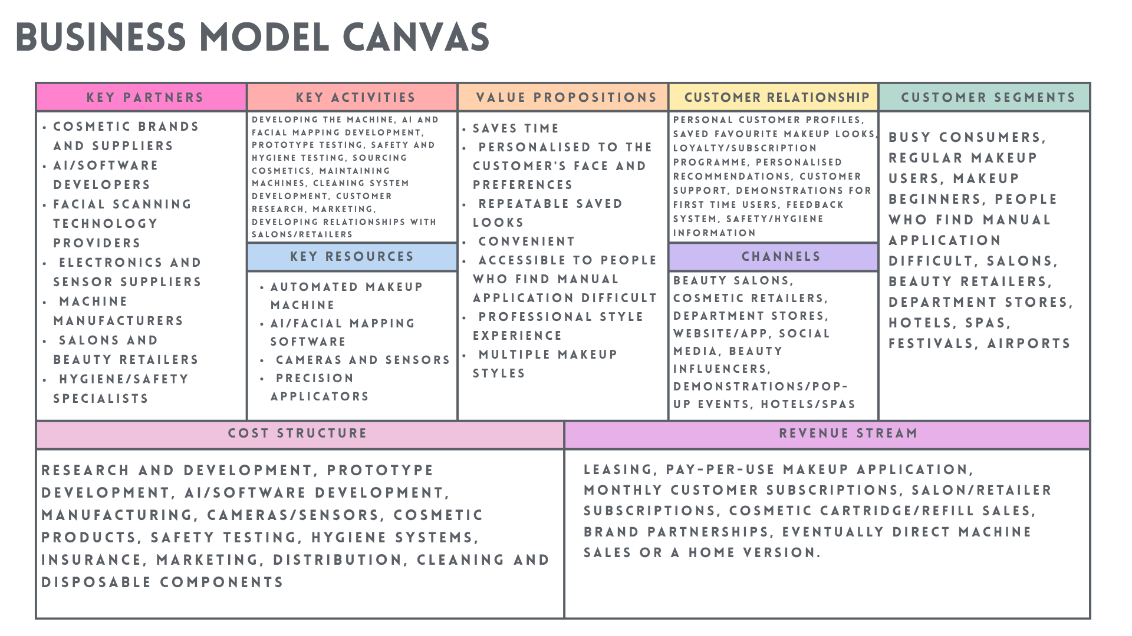
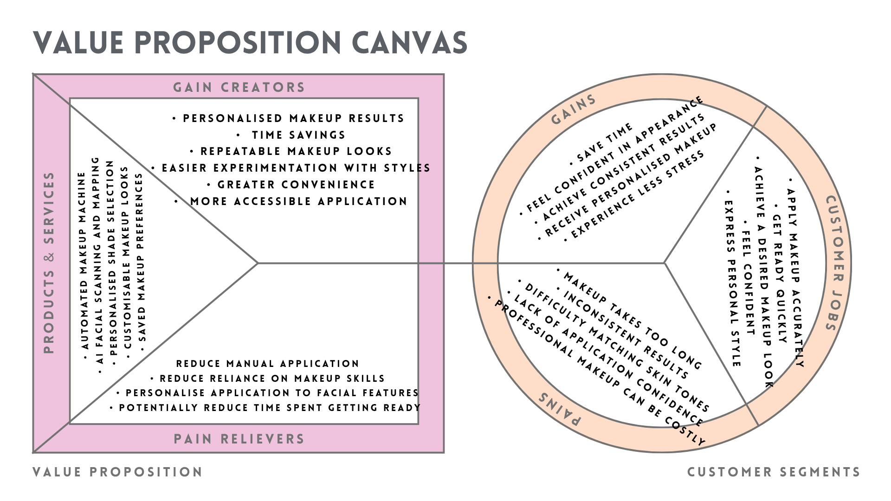
Make Up Application Machine - MindMeister Mind map
https://www.mindmeister.com/app/map/4099523255

Reference List
- Baek, K.J. (2022) ‘The effects of makeup barriers on the subsequent behavior of late middle-aged Korean women according to their makeup skills’, Journal of Investigative Cosmetology, 18(1), pp. 65–75. Available at: https://doi.org/10.15810/jic.2022.18.1.008 (Accessed: 4 October 2026).
- Barringer, B.R. and Ireland, R.D. (2021) Entrepreneurship: Successfully Launching New Ventures. 6th edn. New York, NY: Pearson.
- Bowman, C. and Faulkner, D. (1997) Competitive and Corporate Strategy. London: Irwin.
- Chekembayeva, G., Garaus, M. and Schmidt, O. (2023) ‘The role of time convenience and (anticipated) emotions in AR mobile retailing application adoption’, Journal of Retailing and Consumer Services. Available at: https://doi.org/10.1016/j.jretconser.2023.103260 (Accessed: 8 October 2026).
- Christensen, C.M., Hall, T., Dillon, K. and Duncan, D.S. (2016) ‘Know your customers’ “jobs to be done”’, Harvard Business Review, 94(9), pp. 54–62.
- DermNet (2023) Contact reactions to cosmetics. Available at: https://dermnetnz.org/topics/contact-reactions-to-cosmetics (Accessed: 4 October 2026).
- Food and Drug Administration (FDA) (n.d.) Eye cosmetic safety. Available at: https://www.fda.gov/cosmetics/cosmetic-products/eye-cosmetic-safety (Accessed: 8 October 2026).
- Fullmer, N., Cone, H., Gumarang, J., Kieffer, E., Bae, S.E. and Rosario, E.R. (2024) ‘Exploring beauty product accessibility for individuals with upper extremity disabilities’, medRxiv [Preprint]. Available at: https://doi.org/10.1101/2024.01.29.24301948 (Accessed: 9 October 2026).
- Health and Safety Executive (HSE) (n.d.) Introduction to machinery safety. Available at: https://www.hse.gov.uk/work-equipment-machinery/introduction.htm (Accessed: 8 October 2026).
- Henkel, A.P. et al. (2023) ‘Understanding and improving consumer reactions to service bots’, Journal of Consumer Research, 50(4), pp. 848–863. Available at: https://doi.org/10.1093/jcr/ucad023 (Accessed: 8 October 2026).
- Kanda, N., Martindale, S., Grant-Ross, P., Searing, C., Daniels, G. and Varcin, M. (n.d.) Color, corrected: Perfectly tuning to Black skin tones. Research associated with London College of Fashion. [Publication details to be confirmed].
- Kim, W.C. and Mauborgne, R. (2005) Blue Ocean Strategy: How to Create Uncontested Market Space and Make the Competition Irrelevant. Boston, MA: Harvard Business School Press.
- Kim, W.C. and Mauborgne, R. (2023) Beyond Disruption: Innovate and Achieve Growth Without Displacing Industries, Companies, or Jobs. Boston, MA: Harvard Business Review Press.
- Kumar, S.C.V. and Agrawal, R. (2024) ‘Developing customer convenience and experience through increased competency and efficiency: A strategic approach to retail operations mastery’, Heliyon, 10(16), e36395. Available at: https://doi.org/10.1016/j.heliyon.2024.e36395 (Accessed: 5 October 2026).
- L’Oréal Paris (2025) Beauty just got smarter – introducing our newest online tools. Available at: https://www.loreal-paris.co.uk/tools-and-services (Accessed: 4 October 2026).
- Mafra, A.L., Silva, C.S.A., Varella, M.A.C. and Valentova, J.V. (2022) ‘The contrasting effects of body image and self-esteem in the makeup usage’, PLOS ONE, 17(3), e0265197. Available at: https://doi.org/10.1371/journal.pone.0265197 (Accessed: 4 October 2026).
- Osterwalder, A. and Pigneur, Y. (2010) Business Model Generation: A Handbook for Visionaries, Game Changers, and Challengers. Hoboken, NJ: John Wiley & Sons.
- Osterwalder, A., Pigneur, Y., Bernarda, G. and Smith, A. (2014) Value Proposition Design: How to Create Products and Services Customers Want. Hoboken, NJ: Wiley.
- Perret, J.K. and Schwientek, J. (2025) ‘Beauty Tech—Customer Experience and Loyalty of Augmented Reality- and Artificial Intelligence-Driven Cosmetics’, Digital, 5(2), article 21. Available at: https://doi.org/10.3390/digital5020021 (Accessed: 8 October 2026).
- Serrat, O. (2017) ‘The five whys technique’, in Knowledge Solutions: Tools, Methods, and Approaches to Drive Organizational Performance. Singapore: Springer, pp. 307–310. Available at: https://doi.org/10.1007/978-981-10-0983-9_32 (Accessed: 12 October 2026).
- Tian, B., Janardhanan, M. and Marinelli, M. (2024) ‘A systematic investigation of the barriers to effective implementation of human-robot assembly line: an integrated multi-criteria decision-making approach’, International Journal of Computer Integrated Manufacturing, 37(1–2), pp. 198–223. Available at: https://doi.org/10.1080/0951192X.2023.2278114 (Accessed: 10 October 2026).
- Wei, L., Cheng, W., Yi, X., Cai, J., Zhou, K., Wang, F., Ma, Y. and Lin, Y. (2026) ‘Modeling the color preference of liquid foundation: The individual skin tone matters’, Color Research & Application, 51(2), e70054.

