PLANT AND ASSET ENGINEERING

Evaluating the Effectiveness of Chosen Maintenance Strategies for Dedicated Equipment
by Iwan Rees

Lecturer: Andrew Thorn

Word count 2210
Contents
Table of Figures 2
Table of Tables 2
Introduction 3
Critical review 3
The Cycle Sequence 4
Door locking 4
Air Removal 4
Air Detector Check 4
Heat 4
Sterilising 4
Drying 4
Current Maintenance Practice 5
Good 5
Planned 6
Corrective 6
Reliability 6
Bad 7
Software 7
Outsourcing Maintenance 7
Risk Based 7
Improvements 8
Integrated Thinking 8
Training 8
Stock Control 8
Supplier service contract 8
Procedures 9
Cost and Resource 10
Recommendations 15
Short 15
Medium 15
Long 15
Conclusion 15
Appendix 16
Bibliography 22

Table of Figures
Figure 1 Steam Sterilizer 3

Table of Tables
Table 1 Downtime vs Maximo/Training 10
Table 2 Proposed cost analysis #1 12
Table 3 Proposed cost analysis #2 14

Introduction
BTG (British Technology Group) is a pharmaceutical manufacturing organisation with the broadest antidote portfolio in the world making BTG a trusted partner and one-stop-shop for hospitals, emergency services, health departments, and government (Who we are, 2023).
This assignment seeks to evaluate a chosen equipment in operation at the BTG Wales site. A critical review of how the equipment is maintained and why BTG has chosen the method of maintenance. Furthermore, a full review of the current maintenance approach will be undertaken and where potential improvements can be made and how they will be implemented. The cost and resource implications will be considered following the improvement strategy. Finally, all the data will be collected, and any recommendations summarised.

Critical review
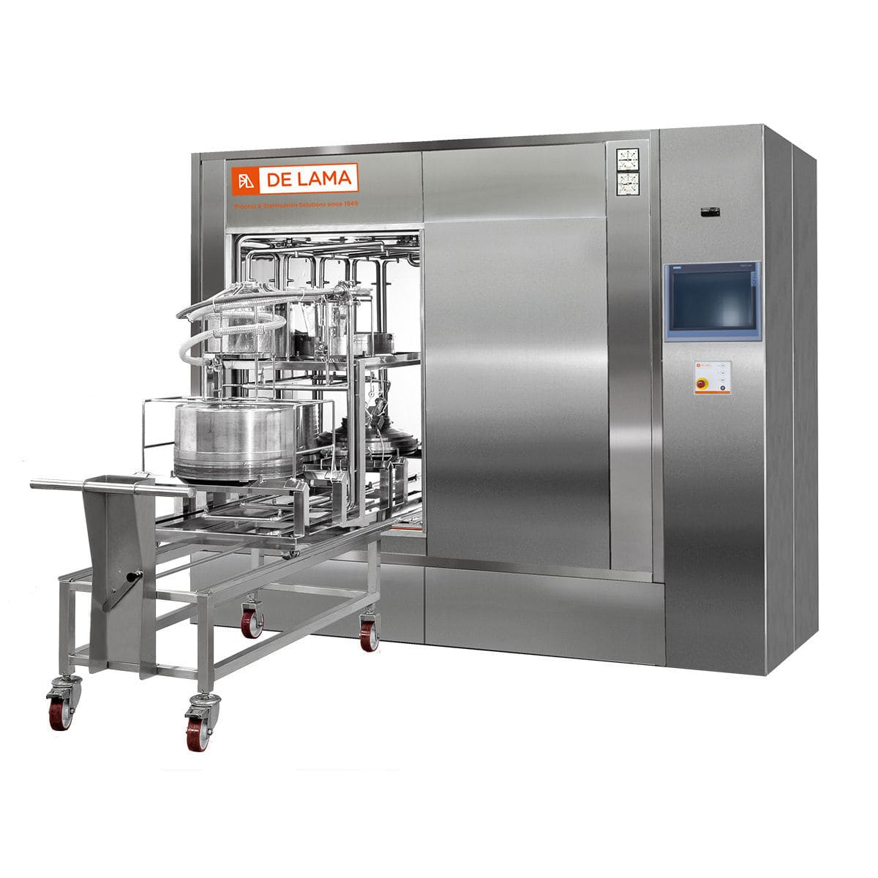
The chosen piece of equipment for this assignment is a Steam Steriliser (Autoclave) as seen in figure 1. Autoclaves are steam sterilisers which operate by injecting steam under pressure into sealed chamber where a load to be sterilised has been placed (Agency, 2004). Steam is generated by an offline pure steam generator (PSG). The temperature at which sterilisation takes place is pre-programmed between 121ºC or 134ºC, depending on the nature of load to be sterilised (Annex, 2006).
Figure 1 Steam Sterilizer

The Cycle Sequence

Door locking
When the load is placed inside the chamber of the autoclave, the door is closed and sealed preventing any air ingress or egress. (Advanced Autoclave Technology, 2019)

Air Removal
Steam is injected into the chamber through a steam control valve. The valve positively pulses several times which during this stage the pressure in the chamber increases to approximately 2000mBar (Advanced Autoclave Technology, 2019). Furthermore, with the aid of a vacuum pump negative pulsing is applied at which stage the steam no longer injects but a vacuum is drawn from the chamber to approximately 30mBar ensuring it is free of air.

Air Detector Check
The air detector probe monitors the high and low pressure points to ensure that no air is present in the chamber, making certain that the chamber is sealed.

Heat
The autoclave raises its pressure and temperature by injecting steam into the chamber to the set sterilising values.

Sterilising
During this stage, the sterilisation of the load takes place between 121ºC and 134ºC, depending on the nature of load to be sterilised; the length of time for sterilisation can take up to 30 minutes (Advanced Autoclave Technology, 2019).

Drying
The load is dried by relieving the pressure of the chamber and then relying both on the residual heat of the load as well as pulling a vacuum thoroughly drying any moisture that may be present. Additionally, a heated jacket around the chamber significantly reduces and assists the drying time by minimising any moisture that would gather during the steam injection phase (ISO, 2009).

Current Maintenance Practice
A thorough Planned Preventative Maintenance (PPM) program is an essential part of BTG’s Standard Operating Procedures (SOP) for safe and proper operation of the autoclave. It is designed to maximise the units operational time by minimising downtime as a direct result of poor maintenance (Thomas, 2018) .

Good
The maintenance activities for the autoclave are managed by Maximo, an Enterprise Asset Management (EAM) system (IBM Maximo Application Suite, 2023), and is used on site for the management of work including:
• Manage stock types.
• Manage people, teams, and groups.
• Manage plant equipment.
• Set up Planned Work (PPM)
• Manage Unplanned Work (UPM)

The maintenance activities for the autoclave are organised by frequency:
- Weekly
- 4 Weeks
- 3 Months
- 6 Months
- 12 Months
- 24 Months
- 36 Months

The benefit of Maximo to manage the PPM programme for the autoclave is (IBM Maximo Application Suite, 2023):
- Complete independency to human intervention
- Reliability to ensure work is organised and scheduled appropriately
- Store large amounts of historical data
- Standardisation and automation increase efficiency in workflows
- All in one place which is accessible from anywhere

Three types of maintenance practices are adopted on the autoclave:
- Planned Maintenance
- Corrective Maintenance
- Reliability / Condition Maintenance

Planned
Or preventative maintenance which is carried out at a predetermined time and a prescribed criterion (4 types of maintenance strategy, which one to chose?, 2023), which is documented within standard operating procedures on the Maximo system. The aim of planned maintenance is to reduce the performance degradation through regular routine maintenance and servicing. Planned maintenance on the autoclave include, filter changes, door seal replacements, steam trap overhauls, calibration and validation.

Corrective
Either a breakdown or detection of an anomaly highlighted during routine maintenance.
This methodology is built on the principle that the costs incurred for downtime because of a breakdown are lower than the investment required for a maintenance program (Joseph Dyro, 2004). This strategy may be cost-effective until catastrophic faults occur. Most recently, an air leak occurred through a tri-clover gasket resulting in 1 day downtime with a cost implication of £55,000, and as such an immediate corrective action was put in place to check and replace all gaskets annually.

Reliability
Condition monitoring measures the current performance over time of the equipment whilst in operation (Wireman, 2004). Equipment such as the vacuum pump, transmitters and temperature probes on the autoclave are assessed by on-line detection. Intervention is required when the monitoring devices detect degradation or a step change such that effects the performance of the autoclave and failure probability increases. Each item is calibrated twice a year by in house calibration engineers. A validation exercise concluded that the liquid ring vacuum pump required replacing every 3 years; since vibration monitors were secured to the vacuum pump to measure frequency which concluded a significant step change on year 3. Finally, each needle valve has a proximity counter whereby the valve open and close operations are tallied, and after exceeding the maximum amount are serviced.

The benefits of reliability maintenance are long term and allow for strategic financial planning and reinforce the need to carry out preventative maintenance (Wireman, 2004), which minimises the occurrence of serious faults and unnecessary downtime.

Bad

Software
The autoclave is run by Siemens S5 software which is no longer supported. In the event of a corruption to the software there is no back-up within BTG. The Vendor would need to re-install the software on site which could take a several days subject to availability. Currently the autoclave is not on the Company’s network and data is stored locally on an SD card which is compliant to CFR 21 but is not stored anywhere, therefore it would be advantageous to have the information backed up, duplicated, and archived, which would be retrievable, or synchronised to the Company’s cloud.

Outsourcing Maintenance
In the past the Vendor has been unavailable to attend breakdowns urgently due to the needs of other customers. This highlighted the necessity to train the engineers within the Company to become the subject matter expert in sterilisation, this was a significant investment of £15,000, however the downtime cost per day of not running the autoclave is £55,000, therefore it was to the Company’s advantage to make the investment. Often, when the Vendor attends site, a major overhaul is needed and requires the equipment to be sent off site, meaning a second visit is required. Neither can BTG properly control the time the overhaul may take, which can be very disruptive.

Risk Based

Business Risk
The autoclave is a critical piece of equipment and BTG only has one. This is a significant risk to the business since an unplanned deviation could cause significant downtime and quickly stop production. Not being able to sterilise the equipment for processing would result in not meeting manufacturing slots resulting in financial fines and loss to BTG.

Loss of Production
If the autoclave broke no onward processing could take place until the autoclave was back in service. AT BTG the primary form of manufacturing is done in batches and starts with a serum thaw. Once product has been committed to the process, there is no way of reverting or pausing the cycle and no processing can continue until each stage is complete consequently the autoclave is the first stage, therefore nothing downstream of the autoclave could continue resulting in losing manufacturing widows and discarding the product.

Improvements
Consideration for improvements of the current maintenance strategy include:
- Integrated thinking
- Training
- Stock control
- Supplier service contract
- Procedures

Integrated Thinking
To maximise the maintenance program on the autoclave, involvement from cross functional departments would be advantageous. For example, involving the production department in the upcoming maintenance activities would allow better planning and scheduling to take place to minimise disruption and downtime (Adams, 2017). Furthermore, the Validation and Quality department would ensure that compliance adherence to whenever planned or unplanned maintenance is being performed. If a significant change is required because of a breakdown, the validation and quality department can assist with documenting the changes whilst ensuring the validated status of the autoclave is not compromised.
Training
There is no training plan for the engineers for the service of the autoclave and as such there is no approved method of working apart from following standard operating procedures and subject matter experts. A significant improvement would be to arrange a training package from the vendor to train all the departments engineering team; this not only ensures compliance but complete standardisation of the working method, ensuring everyone is trained to the same standard. Further consideration of the cost will take place in section 7.

Stock Control
This is a capability on Maximo of inventory control but is yet to be utilised. Ensuring adequate stock of critical spares will significantly reduce downtime in the event of a breakdown. The autoclave is a specialist piece of equipment and as such lead times on spares can be considerable, therefore having correct inventory control is essential to the upkeep and continuation of the autoclave process. The improvement to the maintenance practice would be to adequately control the stock of items, including consumables and critical spares for supplying the autoclave.

Supplier service contract
Since the steriliser is a specialist piece of equipment it is essential to have a contract in place with the vendor ensuring regular maintenance is carried out to safeguard longevity and correct practices are adhered to. The benefits of a supplier service contract are many and include a comprehensive report complete with work carried out and recommendations, a quicker response and supply chain in the event of an emergency and ensures traceability back to correct standards. This is something the Company is looking into since the warranty has exceeded.

Procedures
Standard operating procedures are a fundamental part of compliance within the GMP industry and to deviate from them would result in disciplinary action and potential harm. Therefore, as part of improving the maintenance strategy on the steriliser, a periodic review is necessary on all operation and maintenance documents specific to the autoclave; this would capture any changes such as upgrades, or replacement parts, ensure training is aligned and up-to-date and the equipment is in a validated state such as calibration, PPMs and UPMs.

Cost and Resource
Manufacturing maintenance costs on the autoclave have been historically high pre implementation of Maximo and training:
PERIOD | 2018-2020  Pre Maximo and Training | 2020-2022  Post Maximo | 2022-Present  Post Maximo and Training
TOTAL DOWNTIME COST / £ | 1,100,000 | 440,000 | 55,000
NUMBER OF UPM RESULTING IN LOST DAYS | 50/20 | 28/8 | 12/1
Table 1 Downtime vs Maximo/Training
Additional cost considerations:
Prior to having no fixed maintenance on the autoclave, the number of days lost due to breakdowns was 20 resulting in a loss of £1.1million in production. However, since implementing a robust maintenance plan costing £125,000 the present-day results have lost days of production due to breakdowns by 95%, this is as a result of correct training and maintenance scheduling system.
Train all Engineering Team
Current Process
No Training Plan in Place for Engineers
£ per year:  0 | Operator hours per year:  0
Other useful information
By not implementing training, the Company saves ~£4,865.50 per year, however this is at the risk of a call out fee of ~£1,000 per visit per breakdown +consumables +downtime. Historically, pre-Maximo and training, out of the 20 lost days in table 1, 16 were call outs totalling £16,000 + spares.
Total cost savings: ~£-11,000

Proposed Change or New Process
Train all Engineering Staff in the Autoclave Operation and Maintenance Procedure
£ per year:  One off payment of £14,596.50 | Engineer hours per year:  24 hours per Engineer  5 Engineers = 120 hours
Other useful information
2 days training for all engineers over a course of 3 weeks will total £14,596.50 and has reduced the number of vendor call outs to 1 per year (not including routine service)

Resources Required to Make SOP Updates to Standardise Work
List the costs or operator hours required to implement the proposed change or process:
Capital Expenditure £:15,000.00 | Operator hours required: x2 engineers per week
Other useful information
Operators were required to update the necessary documentation following successful training and sign off.

Engineering
Update 2 document x 1 hr x 1 operator = 1 hr
Review 2 document x 0.5 hr x 2 operators = 1 hr
Training 2 document x 0.5 hr x 1 operators = 0.5 hr
Total = 2.5 hours

Quality
Update 5 document 2 hr x 1 operator = 2 hr
Review 5 document 1 hr x 2 operators = 2 hr
Training 5 document 1 hr x 1 operators = 1 hr
Issue 5 document 1 hr x 1 operators = 1 hr
Total = 6 hours

Validation
Update 5 document 2 hr x 1 operator = 2 hr
Training 5 document 1 hr x 1 operators = 1 hr
Issue 5 document 1 hr x 1 operators = 1 hr
Total = 4 hours

Grand Total = 12.5 hours

Additional Information
ENGINEERING 2 DAY – mixed theory and practical (50/50)
• Health & Safety – power and heat sources including emergency stop systems
• Operators – awareness of everyday requirements for the operators
• Process – guide to processes (autoclave)
• Process – guide to Washing processes
• P&ID – full breakdown of the unit
• Functionality – how the unit works
• Control – operation of the HMI/PLC systems
• Maintenance – entering service modes to test components
• Calibration – how to check/calibrate various sensors
• Alarms – how to deal with them and what they mean.
• Fault finding – diagnosis of various faults
• Manuals – use of manuals, part number identification & ordering
• Review – question & answer session

Payback
How long it will take for savings to re-coup any time or cost being spent:
Time to re-coup any costs:  N/A | Time to re-coup any operator time:  12.5 (£145.85) documentation changes and based on cost savings easily recouped.
Other useful information
Following vendor training in 2022-2023 the call outs for breakdown significantly reduced to 1 per year, making the Company a saving of 95 from 2018.
Table 2 Proposed cost analysis #1

Upgrade Autoclave Software
Current Process
Autoclave uses Siemens S5 Software
The current autoclave control system is approximately 10 years old and is no longer supported by manufacturer.
The Autoclave runs using obsolete Siemens S5 software which is no longer supported. Several breakdowns have occurred and have resulted in significant cost to the Company, the most recent being £21,000 for x2 Engineers from Finland for 5 days to diagnose and remediate a fault within the software.
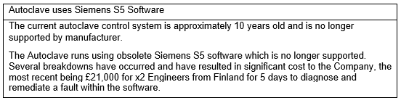
Proposed Change or New Process
Upgrade to latest Siemens S7 Software
£ per year:  One off payment of £75,000.00 | Personnel:  x3 Contractors for 2 weeks
Other useful information
A complete re-wire, hardware, and software upgrade to the current autoclave.

Resources Required to Upgrade Control System
List the costs or operator hours required to implement the proposed change or process:
Capital Expenditure £:74,278.13 | Operator hours required: 11 days
Other useful information
Control Conversion
Control Conversion
Control system upgrade S7-300 CPU315 2PN/DP,
Op panel Siemens IPC, Control system on a back plane
(Old cabinet used for the upgrade)
With option 10.3.20 Electronic Data Security
FDS, SDS, HDS FAT doc and SAT doc
Replacement Pneumatic Burkett Piston valves
New solenoid blocks
Installation to be quoted separately.
Estimated delivery time 12-16 weeks from the order.
Cost: £58,990.13

Installation
5 days 2 engineers at contract day rate
Sat and Sunday for 2 engineers at contract day rate
5 days for 1 engineer during IQ/OQ at contract day rate
Sat / Sun for 1 engineer during IQ/OQ at contract day rate
contract day rate £728 mon - fri
Sat - £1092
Sun - £1456
above days have been quoted including Sat / Sun working on normal
Mon - Fri day rates.
Cost: £15,228.00

Total: £74,278.13

Payback
How long it will take for savings to re-coup any time or cost being spent:
Time to re-coup any costs:  3 years | Each cycle on the autoclave costs the Company in consumables and consumption costs; £106.24 of which is deducted from the profit £172.80 = £66.56  The autoclave runs approximately 355 days a year and not all are manufacturing batches therefore approximately in 1 year a profit of £23,628.80 is made per year, to pay off the CAPEX investment of £74,278.13 will take 3.1 years which the Company has accepted.
Other useful information
It is a business-critical item and as such the investment is necessary to continue manufacturing sterile products to the global market
Table 3 Proposed cost analysis #2
To make the effective changes above a business case was put to management to justify the necessity to invest in the improvements. See Appendix 1 rationale and justification which was presented to management (Saleh, 2022).

Recommendations

Short
The so-called quick fixes for immediate improvement as discussed in sections 5 and 6 is to have a robust training plan for existing and joining engineers. This way the engineers are trained to the highest possible standard. Also, to update all necessary SOP to standardise the work as best as possible. Although there is a significant investment required to do this, there are immediate benefits that will eventually filter into the medium-long term strategy. Implementing a robust training plan will prevent the autoclave breaking down as frequently and will ensure it is well maintained throughout its lifetime regardless of its age.

Medium
To carry the appropriate stock and critical spares to prevent against long lead times and downtime. To better utilise the Maximo inventory to hold the appropriate stock to minimise business risk, ensuring appropriate stock levels are maintained and stored in appropriate conditions.

Long
Eventually, due to the criticality of the autoclave, it is to the Company’s advantage to add a second autoclave to the Wales site. This is a significant investment for approximately £210,000.00 that will enable more capacity and profitability to the site. It will also prevent downtime due to maintenance or unplanned deviations. The maintenance strategy would change allowing for a duty-standby situation to be implemented.

Conclusion
This assignment has highlighted the need for good maintenance practices and the implications to poor practices within BTG. Consideration was given to what BTG do well and what is done badly and how to improve and change poor practices. Fundamentally, change is required to improve and standardise working methods to ensure the longevity of the autoclave in a good working condition without the need for relying on external forces such as contractors and distributors. Finally, this assignment sought to highlight how lack of investment in maintenance can, in the short term be profitable but in the medium to long term is not sustainable, incurring significant cost. Financial planning is key to spread the cost evenly to ensure the autoclave service life is as long as possible.

Appendix

Site:  Wales (Protherics UK Ltd) | Capital Project No.
Capital Reference No. |  | …………………..
2a. Executive Summary
A capital investment of ninety seven thousand four hundred and eighty six pounds (£97,486) is required in order to complete a full control system upgrade to the current production autoclave X408.
The current autoclave control system is approximately 10 years old and is no longer supported by manufacturer so a new system is to be installed.
The user intention is that the control upgrade is completed with no change to the current operational description detailed in section 2b of this document.
In addition and computer system gap analysis has been completed and documented within WAL-CSV-VP0008-002 COMPUTER SYSTEM VALIDATION PLAN FOR AUTOCLAVE X408 and it has been concluded that the control system upgrade is necessary.
WAL-EPV-URS0027-001 has also been completed to support this project.

2b. Detailed Project Outline
The system is used within the B1 Manufacturing facility to support sterilisation and sanitisation of equipment in the manufacturing of CroFab and DigiFab at the Wales site. The preparation/loading of equipment is situated in Room 18 of the grade D area (ISO 8) and the receipt and unloading of equipment is routinely into Room 28 of the grade C area (ISO 7).
The current system operates as detailed below:
Control System - General Description
The control system consists of an Siemens S5 Programmable Logic Controller (PLC) and an Allen-Bradley PanelView Plus700 Operator Interface. The control system, printer, transformer(s), fuses, etc., are mounted within a separate control cabinet or other enclosure(s).
Figure 1 - Control System Block Diagram

Hardware General Description

All parts of the PLC control system (except the printer) are Siemens and Allen-Bradley products.

An SLC500 with the 5/05 CPU forms the basis of the control system. The 5/05 processor has 64K of flash memory, of which 60K is dedicated for application program and 4k is for data used by the application.

Panel View Plus 700 Operator Interface on the non-sterile side (located in Room 17) includes an active matrix colour touch screen (screen size 6.5 inches).

The logic module of Panelview Plus comes standard with Ethernet & RS232 Serial built-in communication ports, two USB ports for mouse and keyboard support, DC power input and Compact Flash slot for transferring files, logging data or system upgrades.

I/O modules are standard Simens modules. 24 V DC control voltage is used for discrete inputs and outputs. 4-20 mA signals are used for analog inputs and outputs.

A Basic Module is utilised for controlling the printouts and reports. This module is mounted to the same 10-slot rack together with the CPU and the I/O cards. However, it is a completely separate module with an independent processor.

Control Principles

Temperature Measurement

The measurement element used in temperature probe is a platinum Pt100 Ω resistance temperature detector (RTD) type to IEC 751 Class A standards. Uncalibrated probe accuracy at 121 °C is + 0.3 °C with a repeatability of better than 0.05 % of the measurement. Calibrated loop accuracy at 121 °C is + 0.15 °C. Probe size is 100 mm (4 in) long, 6 mm (1/4 in) diameter, wire length 5 m (16 ft.). The probe cable is manufactured from fine-textured tinned copper core with Teflon insulation and silicon exterior coating. One (1) flexible load temperature probe is provided as standard and may be freely positioned within the chamber.

Temperature transducers are provided that convert the RTD signal to 4-20 mA signal for each analog temperature measurement monitored by the PLC.

The analog current signal corresponding to the measured temperature is input to an analog input channel on the PLC.

Figure 1 - Typical Temperature Measurement Block Diagram

Pressure Measurement
The chamber pressure transmitter is tested at 121 °C under full vacuum. Functional pressure range is 0 - 400 kPa (0 – 4.0 barA) and temperature range is 20 150 °C.
A 4-20 mA output signal supplies pressure information to the control system.

Regulating Valve Control Principle
Pressure, Temperature, or Flow is controlled by PID (Proportional, Integral, Derivative) software controllers.

Figure 3 - Block Diagram of Proportional Control

Where:
w = Set value (controller setpoint)
e = Error value or difference between the set value and measured value (w-x)
yr = Analog control signal for regulating valve
y = Output of regulating valve
z = Process deviation (Disturbance)
x = Measured value (feedback information for PID controller)
xr = Analog signal to PLC
D/A = Digital/Analog converter

As stated in section 2a it is the intention following the upgrade that the system continues to operate as described but utilising a control system and associated hardware that ensures the system be supported for service by the manufacturers and that necessary spare parts are available.

A breakdown of the project costs is as follows :

Control system upgrade S7-300 CPU315 2PN/DP,
Op panel Siemens IPC, Control system on a back plane
(old cabinet used for the upgrade)
With option 10.3.20 Electronic Data Security
FDS, SDS, HDS FAT doc and SAT doc
Replacement Pneumatic Burkett Piston valves
New solenoid blocks

TOTAL = £58,990.13

Yokogawa DX1000-3-4-2/P1/R1/CC1/AS1 paperless recorder

TOTAL = £10,416.65

FAT / SAT

FAT (4 days) inclusive full supplier documentation and support
SAT ( on site) inclusive full supplier documentation and support
Travel and accommodation expenses for BTG personnel for FAT

TOTAL = £12,792.00

Installation
5 days 2 engineers at contract day rate
Sat and Sunday for 2 engineers at contract day rate
5 days for 1 engineer during IQ/OQ at contract day rate
Sat / Sun for 1 engineer during IQ/OQ at contract day rate
contract day rate £728 mon - fri
Sat - £1092
Sun - £1456

TOTAL = £15,288.00

2c. Benefits (incl financial / commercial factors)
The current autoclave control system is approximately 10 years old and is no longer supported by manufacturer so a new system is to be installed.
The user intention is that the control upgrade is completed with no change to the current operational description detailed in section 2b of this document.

This requirement was identified during the execution of the Wales Investment Strategy (WIS) equipment assessment as a result of the risk of obsolescence for the current control system.
Failure could potentially affect the manufacturing schedule as the production autoclave has no back up facility available.

2d. Financial Appraisal
2 quotations were received and a 6K reduction in cost negotiated.

2e. Project Timelines
It will be necessary to implement the project during the shutdown 2016

2f. Key project measurement points
Completion of full validation requirements

2g. Quotations/estimates obtained
Quote 1: £103,323.76 Supplier
Quote 2: £97,486.00 Supplier
Quote 3: Supplier
(Tier 1 only)
Rationale for preferred supplier
This project is an upgrade to existing STERIS equipment.
Consideration has been given to a complete new autoclave however, this is not considered the best business approach due to the additional cost ( approx. 100K additional) and the condition of the mechanical equipment is sound.

2h. Project Manager Sign off Finance Sign off
……………………………………………….. ……………………………………….

2h. Project Sponsor Sign off
…………………………………………….. ………………
Project sponsor Date

Post Investment Appraisal Required: Yes/no
(mandatory if Tier 1 or 2 Project)

Follow on Assessments Required: Yes/no
(mandatory of Tier 1 project)

Bibliography
4 types of maintenance strategy, which one to chose? (2023, 03 27). Retrieved from ABB: https://new.abb.com/medium-voltage/service/maintenance/feature-articles/4-types-of-maintenance-strategy-which-one-to-choose
Adams, C. (2017). Understanding Integrated Reporting. Chicago: Taylor & Francis.
(2019). Advanced Autoclave Technology. Manchester: LTE Scientific .
Agency, E. M. (2004). Sterilization . EMEA, 3.
Annex, I. (2006). Composition and preparation of media. Sydney: Australia Government.
Anonymous. (1994). Accuracy, Stability and Convergence . Retrieved from people.maths: https://people.maths.ox.ac.uk/trefethen/4all.pdf
IBM Maximo Application Suite. (2023, 04 01). Retrieved from IBM: https://www.ibm.com/products/maximo
ISO. (2009). Sterilization of health care products — Mosit Heat. Switzerland: ISO.
Joseph Dyro, J. F. (2004). Clinical Engineering Handbook. Elsevier Science.
Saleh, J. (2022, 03 31). Change Management: The Impact on Organizations. Retrieved from Monitask: https://www.monitask.com/en/blog/change-management-the-impact-on-organizations#:~:text=for%20the%20organization.-,Change%20management%20helps%20to%20ensure%20that%20changes%20are%20made%20in,help%20to%20improve%20decision%2Dmaking.
Thomas, D. S. (2018). Advanced Maintenance in Manufacturing: Costs . Gaithersburg: NIST.
Who we are. (2023, 03 31). Retrieved from Serb Pharmaceuticals : https://serb.com/about-us/who-we-are/
Wireman, T. (2004). Benchmarking Best Practices in Maintenance Management. Industrial Press.

