

Human Resource Management in Context

Module Code BMHR7004

The Major Environmental Factors Affecting Organisations

Re-Submission date: 1st May 2020

Student ID: 1904665

Glossary of Terms

- AI - Artificial Intelligence
- COGS - Consumption, Orders, Goods and Services
- CSR – Corporate Social Responsibility
- ERP – Enterprise Resource Planning
- Grp – Glass Resin Polymers
- LPCB – Loss Prevention Certification Board, Security rating
- MML – Morgan Marine Ltd
- PESTLE – Political, Economic, Sociological, Technological, Legal, Environmental
- VUCA – Volatile, Uncertain, complex and ambiguous

Contents

Glossary of Terms 2
Executive Summary 4
Introduction 5
Literature review 7
PESTLE 7
SWOT 9
Political 11
Sociological factors - Mental Health. 12
Technological 14
Conclusion 16
Recommendations 17
Action Plan 17
References 18

Executive Summary

The following report examines the use of three elements of the PESTLE tool to analyse the managerial and business environment of Morgan Marine Ltd (MML). MML is a profitable SME, privately owned limited company and a market leader in the manufacturing of security rated kiosks for the utilities industries

There are rapid changes in the world of work and business, the report will review current trends and how the organisation can strategically plan to prepare for the future.

In the current VUCA climate the business needs to develop a strategy to proactively plan and avoid a reactive approach. This will ensure the business remains profitable, retains competitive advantage within the customer and labour market, while continuing to provide Quality Standards to customer specifications.

Three elements of the PESTLE analysis will be referred to. The report will consider whether this is an effective tool to develop a strategic plan for the management of the business and its external environment.

Introduction

Morgan grp encompasses MML and two acquisitions, Envico Engineering and PSF Wales.
The organisation is a family owned manufacturing business based in South Wales, established in 1965 and provides secure buildings for access to Utilities, water, gas, electricity and telecoms. The organisation is concerned with the immediate microenvironment as there is direct competition from four similar enterprises which were set up by ex-Directors and staff. MML remain the market leaders due to their LPCB fire safety accreditation.
The company currently patents two of its current designs which will prevent the competition from manufacturing a similar design. Patents reduce the tax rates and allow R & D expenses to be deductible.
All the labour force is directly employed and range from Engineers, Finance and manual workers, a majority live locally in a rural location. The variation of the roles and skill sets means recruitment can be problematic.
The organisation had a traditional personnel HRM approach for over 20 years, the organisation had strong union representation this has started to decline in the last 2 years.
The company is constantly evolving and developing a formal approach to management with the development of products, the introduction of technology and Quality driven systems and processes.
With a new Board of Directors driving the change for a shared purpose. “Creating roles, opportunities, organisations and working environments that help bring out the best in people, delivering great outcomes, in turn driving our economies, and making good fair and inclusive work societal outcomes”. (CIPD 2019) the HR strategy will develop in line with the CIPD principles of the professional map.
It is the company aim to develop the organisation strategy to better prepare for the VUCA environment and the mega trends that currently affecting the global economy.
The basic principles of Best practice strategies should consider the following according to Youndt et al (Farnham, 2015)
“…..enhancing the skill base of employees through HR activities such as selective staffing, comprehensive training, and broad development efforts like job rotation and cross-utilisation. Promotion of empowerment, participant problem-solving and team work with job re-design, group-based incentives and a transition from hourly to salaried compensation for production workers.”
Best fit practice is applied within the organisation ensuring rewards, appraisal, development and staff selection. This approach is adapted across the organisation to ensure the culture fit varying sectors. This can lead to a failure in providing a consistent approach and varying degrees of employee motivation and employee relations.

Literature review

PESTLE

PESTLE analysis comprises of six external contexts, these are key drivers in which organisations are operating.
Figure 1. CIPD PESTLE Framework
Political | Tax policy, environmental regulations; trade restriction and reform; tariffs; political stability
Economic | Economic growth/decline; interest, exchange, inflation and wage rates; minimum wage; working hours; unemployment (local and national); credit availability cost of living
Sociological | Cultural norms and expectations; health consciousness; populations growth rates; age distribution; career attitudes; health and safety
Technological | New technologies are continually emerging (for example, in the fields of robotics and artificial intelligence), and the rate of change itself is increasing how will this affect the organisations products or services?
Legal | Changes to legislation impacting employment, access to materials, quotas, resources, imports/exports and taxations
Environmental | Global warming and the increased need to switch to sustainable resources; ethical sourcing (both locally, nationally, including supply chain intelligence).

According to the CIPD, PESTLE is the most effective tool to understand the external environment which allows business leaders and HR to develop business strategies for a sustainable business.
The PESTLE tool was developed in the late 1990’s and formulated from the PEST tool, political and legal were separated, environmental was incorporated as environment and global warming became an issue which required action across the world. The descriptions in figure 1 highlights the changing world we work in.
The business world is rapidly changing including uncertain political times, changing ethical views, legislation and regulation changes, environmental impact of global warming and the gig economy, for these reasons it has become volatile, uncertain, complex and ambiguous. (Havard Business Review, 2014)
The environment is specific to each organisation and could be anything external to the business. Analysing and gathering information assists with planning a business and HR strategy however, according to (Kew & Stredwick, 2016) organisations can be too overwhelmed with information which can lead to “paralysis by analysis”.
In the 1970’s Shell developed contingency strategies, scenario planning and correctly predicted the oil crisis. While many scenario’s may be incorrectly anticipated the theory suggests that Managers are better able to cope and overcome a crisis.

SWOT
Figure 2. SWOT Analysis
Strengths | Weaknesses
Opportunities | Threats
SWOT analysis was predominantly used since the 1960 by Harvard business school academics.
The analytical table usually consists of bullet points which is not definitive regarding the information contained to develop a strategic plan. The world has changed rapidly since the development of this tool over fifty years ago. Very often there is duplication where an opportunity is also considered a threat. A simple tool which allows a business to identify what it does well.
(Hill & Westbrook , 1997) suggest that the tool is outdated and not used effectively. Their research shows that the tool, used by consultants was not used in the final stages of strategy planning and habitually consisted of long lists of factors which were too generalised.
Whilst the PESTLE might be more suited to incorporate all the changing forces the SWOT or Porters Five Forces is useful underpin the environmental factors. 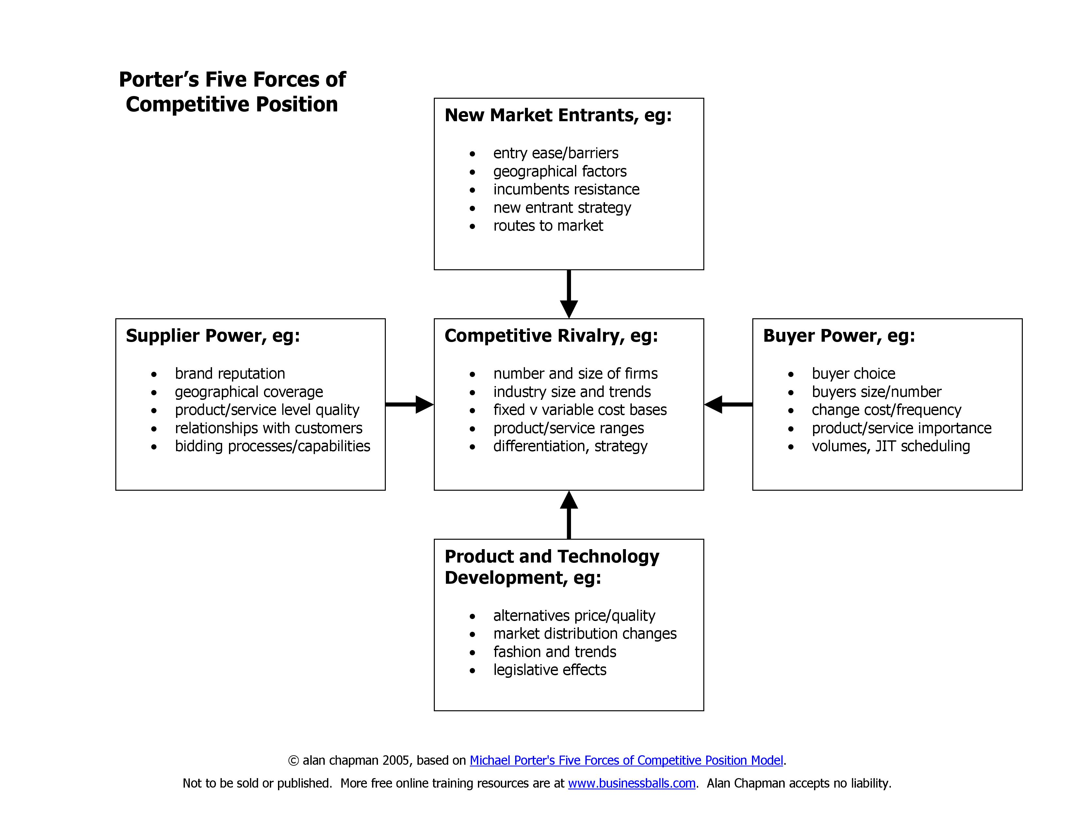

Political

The development of the internet has led to globalisation, Europe is no longer the centre of the world map (Wood 2008). The four largest economies are the United States, India, China and Japan.
In 2016 Britain voted to leave the European Union. The UK is in a climate of political turmoil which will lead to significant changes for the future of businesses and potential changes in HR Law. Gerwyn Davies advisor to the CIPD states that with the Brexit uncertainty “hardly any” employers are preparing for post Brexit. The Office for National Statistics (ONS 2019) reported that the rate of growth had slowed to 59,000 in the 12 months ending March 2019, compared to 75,000 in the 12 months ending December 2018. (People Management 2019).
MML have begun preparing to leave the EU, stock piling overseas goods to ensure no delays in manufacturing. For HR, the concern will be the recruitment of labour. The current labour market is tighter than spring 2019 according to the CIPD’s labour market outlook, fewer applicants for low skilled roles. There are potential restrictions to end free movement for European citizens on October 31st. Employment of EU Nationals had increased, as the UK has an attractive employment growth of 42%. According to the CIPD 2017, Facing the Future, it is stated that EU employed workers have a “willingness to do unattractive unskilled work.”
The staff turnover for the lesser skilled roles has increased over the last 3 years. While manufacturing is in decline, a high percentage of the customers are Utilities which is a growing market.
The low skilled jobs are labour intensive with unfavourable working conditions. As suggested by Ulrich the solution may be to buy in talent via a recruitment agency for the EU workers. However, workers will be below the suggested £30,000 salary threshold for workers to be sponsored by an employer to work in the UK. The CIPD suggest that there should be trusted sponsors in the UK which could be facilitated by law firms or trade employer bodies rather than small firms having to take on sponsor role themselves.

Sociological factors - Mental Health.

The coalition government pledged to improve mental health by 2020. According to MIND, mental health-related absences are estimated at £26bn annually in the UK.
Statistics published by the HSE proves that mental ill health is affecting over half of the UK attendance issues in the last year.
Health and wellbeing are high on the government agenda with 44% of work absence attributed to mental ill health in 18/19 (HSE). According to a recent report in the People Management Magazine 31% of employers are taking a proactive approach to wellbeing, prioritising stress and resilience.
Providing an empathetic and inclusive work culture will help reduce turnover. There is a moral and legal obligation to ensure the health safety and welfare of all staff, in line with the Health and Safety at Work Act 1974. Long term mental ill health will be considered a protected characteristic, all businesses must ensure that employees are supported with reasonable adjustments if required. Doing nothing may result in prolonged periods of mental ill health, employment tribunals and associated costs, damage to reputation, lost time due to sickness, higher recruitment costs, the organisation is not likely to be perceived as an employer of choice.
The manufacturing workforce predominantly men, often feel there is a stigma disclosing mental ill health. 67% of the affected workforce did not admit to having mental health issues because of embarrassment or felt it would affect their employment.
ACAS and the CIPD recommend developing strategies to educate the workforce to change attitudes, implement a mental health policy and address work related causes of mental ill health.
Line managers play an essential role in identifying mental health concerns early, during wellbeing or return to work meetings. They will require training such as Mental Health First Aid and Stress Management. Senior Management and HR must support to help facilitate the change and promotion of a positive mental health at work culture. Empowering employees and allowing them to have more control over their workload and decision making will help reduce the “organisational anxiety”.
According to the CIPD wellbeing report 49% of employees who have suffered with mental health issues have not had attendance issues. Therefore, one could argue that it is not necessary to implement a strategy, however, just 4% of these employees claim that their work performance is not affected. Out of those that do not take time off there are concerns regarding ability to concentrate and make decisions. It is inevitable then that production, outputs and customer service will be affected if we choose to ignore the issue. Deloitte’s believe investment in Mental Health Strategies will result in ROI for all concerned, employer, employee and the economy by 2025.

Technological

The CIPD Executive Summary (2017) suggested technology will cause job losses on a large scale, but also contradicts this theory as it is debated that a low percentage of jobs are likely to become automated. The Deloitte’s review of 2017 suggests that AI will impact the workplace, not solely replacing humans and tasks but work collaboratively with automation for creative solutions.

There is a pessimistic view of economists and consultants, talk of job losses and automation, McInsey Report (Maryika, 2017) While some of the manufacturing functions are repetitive it is unlikely that the human workforce in MML will be replaced by robotics due to investment and space required for machines and advancement in the manufacturing technology.

MML invested £1,000000 in Enterprise Resource Planning Software, this is used to provide real time information regarding the status of production. Until 2016 the business relied on applications in Microsoft excel to provide information which required extensive manipulation and human intervention to report on COGS.

The ERP system was implemented via project working of key individuals within various departments. The organisation identified and developed the talent in house rather than engage external consultants ’for implementation, this ensured the employees had a voice and with their working knowledge helped to tailor the technology introduced.

The system has improved communication across departments including the 3 organisations which run across the whole group. Part of the business case for the system was the reduction in jobs and wage costs. The reality is people have become more knowledgeable and skilled and have been retained to develop and maintain the data system. While some roles will disappear, some will develop opportunities and creative ways of working.

ERP technology has enabled the company to be agile in its approach to how people work. Remote access to the ERP data system means the company has the infrastructure to support flexible working, homeworking and remote working, which was implemented fully in 2018.

Technology and social media play a key role in resourcing and talent planning for, the organisation relies on websites such as LinkedIn, Monster, Indeed Facebook, Twitter.
The feedback from applicants is that apps are easily accessible and user friendly on phones and iPads

(Deloitte, 2018) give an example of how social media has supported Starbucks. “Just a few months after adopting Workplace by Facebook, 80 percent of Starbucks’ store managers were actively using the tool to share knowledge, best practices, and support one another. Likewise, Walmart claims that an offering like Workplace is helping the company break down language barriers, increase knowledge-sharing, and even manage emergencies like Hurricane Harvey.”

Conclusion

To enable the organisation to develop, there needs to a culture change and introduce mental health training for managers. Morgan Marine Ltd must evolve the HR Strategy with a proactive approach rather than reactively dealing with staff absence and poor performance.

To retain the shop floor staff there needs to be more temporal flexibility. The company needs to focus retention of current staff with job share, job rotation, and part time working, overtime and a review of shift patterns. Recruiting the ageing workforce to support these roles.
A report by the CIPD and PA consulting suggest that HR are the least likely to be consulted when implementing AI but suggest HR lead the way, lack of involvement could lead to less productivity.

Develop ERP data systems within HR Department for training there are plans to develop the system for use in HR as a database and to standardise documentation ensuring HR are involved in the future of the infrastructure and reporting of the business.

Analysis will inform the Senior team for people planning, identify skills gaps and allow for Scenario planning for the future.

Recommendations

The business must continue to explore opportunities for flexible working which will support the recruitment and retention of employees and encourage diversity in the workplace.

Upskill managers to be confident to hold open conversations with their staff to include wellbeing and mental health.

Implementation of HR software systems which will provide an infrastructure for mobile and remote working. In addition, new data systems will capture information to spot trends and influence future HRM decisions.

Action Plan
Action Plan
Action | Direct Costs | Indirect Costs
Training Managers in Mental Health x 20 | Training Course  £2000 | Average salary  X 20 persons training at 8 hours  £2000
Development of HR Data systems | 3-month project with IT & HR | 6,923.07

References
.Gov, 2010. Equality Act. [Online]
Available at: https://www.legislation.gov.uk/ukpga/2010/15/notes/division
[Accessed 18 November 2019].

.Gov, 2016. The Fourth Industrial Revolution. [Online]
Available at: https://www.gov.uk/government/speeches/the-4th-industrial-revolution
[Accessed 18 November 2019].

Anon., n.d. Work-related stress, anxiety or depression statistics in Great Britain, 2019. [Online]
Available at: https://www.hse.gov.uk/statistics/causdis/stress.pdf
[Accessed 19 November 2019].

CIPD, 2017. FactSheet Gig-Economy report. [Online]
Available at: https://www.cipd.co.uk/knowledge/work/trends/gig-economy-report
[Accessed 10 November 2019].

CIPD, 2017. Podcast Gender Pay Gap Reporting. [Online]
Available at: https://www.cipd.co.uk
[Accessed 17 November 2019].

CIPD, 2019. Factsheet Workforce Planning. [Online]
Available at: : https://www.cipd.co.uk/knowledge/strategy/organisational-development/workforce-planning-factsheet
[Accessed 2019 November 2019].

CIPD, n.d. News article Automation AI and technology [. [Online]
Available at: https://www.cipd.co.uk/news-views/viewpoint/automation-ai-technology
[Accessed 10 November 2019].

CIPD, n.d. SWOT Analysis Factsheet. [Online]
Available at: https://www.cipd.co.uk/knowledge/strategy/organisational-development/swot-analysis-factsheet
[Accessed 17 Novembe 2019].

Deloitte, 2018. Global Human Capital Trends. [Online]
Available at: https://www2.deloitte.com/content/dam/insights/us/articles/HCTrends2018/2018-HCtrends_Rise-of-the-social-enterprise.pdf
[Accessed 28 April 2020].

Farnham, D., 2015. Human Resource Managment in Context. 4 ed. London: Chartered Insitute of Personnel and Development.

Greeves , J., 2010. Power Control and organisational Change . In: O. university, ed. organisational Change, Themes and Issues. Oxford : Oxford University Press , pp. 213-216.
Havard Business Review, 2014. What VUCA Means to you. [Online]
Available at: https://hbr.org/2014/01/what-vuca-really-means-for-you
[Accessed 18 November 2019 2019].
Havard Business Review, 2014. What VUCA really means for you. [Online]
Available at: https://hbr.org/2014/01/what-vuca-really-means-for-you
[Accessed 30 April 2020].

Hill , T. & Westbrook , R., 1997. SWOT analysis: It's time for a product recall. Science Direct, 30(1), pp. 46-62.

Insights, Deloitte, 2018. The Rise of the Social Enterprise. [Online]
Available at: https://www2.deloitte.com/content/dam/insights/us/articles/HCTrends2018/2018-HCtrends_Rise-of-the-social-enterprise.pdf
[Accessed 30 April 2020].

Jeffrey, R., 2018. People Management. [Online]
Available at: https://www.peoplemanagement.co.uk/news/articles/hr-must-more-outward-looking-dave-ulrich-love-hr-conference
[Accessed 30 April 2020].

Kew, J. & Stredwick, J., 2016. Human Resource Management in a Business Context. 3rd ed. London: Chartered Institute of Personnell and Development.

Maryika, J., 2017. Technology Jobs and the Future of Work. [Online]
Available at: https://www.mckinsey.com/featured-insights/employment-and-growth/technology-jobs-and-the-future-of-work
[Accessed 10 November 2019].

Mind Tools , n.d. Mind Tools PESTLE Analysis Factsheet. [Online]
Available at: https://www.mindtools.com/pages/article/newTMC_09.htm
[Accessed 28 April 2020].

Statistics, O. f. N., 2019. Labour Market Overview. [Online]
Available at: https://www.ons.gov.uk/employmentandlabourmarket/peopleinwork/employmentandemployeetypes/bulletins/uklabourmarket/november2019
[Accessed 20 November 2019].

