Comparative quantitative studies of academic procrastination

Content page

Abstract

Academic procrastination has long been a hot area of educational and psychological research. The COVID-19 pandemic has made online education a major part of school education. Academic procrastination mainly manifests itself in academic tasks such as preparing homework, writing papers, and studying for tests. Academic procrastination is associated with negative emotions such as anxiety, insomnia and depression. Prior to this, studies on academic procrastination were mainly focused on classroom teaching. Since 2020, a large number of studies on academic procrastination in online education have appeared. Academic procrastination in face-to-face courses focuses on different directions such as teaching system and teachers, students' self-control, teaching environment and group effect. In the case of online education, there is a new situation of academic procrastination. The author chooses two articles on quantitative research of academic procrastination published after 2020. The author analyzes the theories and research methods of the two articles respectively, and puts forward some suggestions for revision. The author suggests choosing a mixed approach and adding qualitative research as the research method of academic procrastination. In fact, the author hopes to build a theoretical model based on the original research, adding some factors such as family influence, cultural differences, professional and educational level. The author suggests choosing a mixed approach and adding qualitative research as the research method of academic procrastination.

Introduction

Procrastination is a common phenomenon that has been extensively studied among college students（Ferrari,2010 and Steel,2007）. The theories of different schools of psychology also have different influences on the authors. Procrastination is often thought of as a problem of phenomenon, cause difficulty with time management and organization, their studies into a low grade, distracted, the apparent gap between intention and action(Akhtar and Faisal Malik, 2016).It might also with those related to research areas which aren't directly related, such as dissatisfaction with social relationships, sleep problems, irritability and anger, guilt, anxiety and stress, Negatively correlated with students' mental health (Duru & Balkis, 2017 Sirois,2014). Humanistic psychology pays more attention to the elite class and regards the research objects as ordinary people or elite class (DeRobertis, 2020). In contrast to other psychological theories, psychoanalysis and experimental psychology focus on brain imaging and patients(Hook, 2017). Therefore, it is important to consider different psychological theories about the orientation and focus of procrastination. There are different interpretations of how these theories constitute procrastination. (Al-Imarah, Shields and Goroshit and Hen, 2019 and Zhou, 2018)These different theories and terminology explain some of the obstacles to research in the field of academic procrastination. For example, scholars in the past believed that procrastination was a psychological problem, unrelated to individual impulsivity and motivation. (Grund and Fries, 2018 and Steel and Weinhardt, 2018) Other studies have shown that individuals' short-term emotions and impulses influence decision-making(Krause,& Freund, 2014)..
Academic procrastination
Academic procrastination is often considered a type of state-related procrastination, defined as "voluntary delay of an expected course of learning-related action despite the expectation that procrastination will make the situation worse" (Steel,2007 and Agustin and Winarso,2021). Research in this area has found many inconsistencies in its causes and consequences. Surveys show that more than 70 percent of college students are reportedly associated with poor academic performance, low happiness, stress and anxiety((Tavakoli,2013). Studies have found that academic procrastination is closely related to task aversion, task delay, self-efficacy, impulsivity, conscientiousness and its self-control, distraction, organization and achievement motivation (Steel 2007 and Ferrari,2001).

Self-efficacy
Academic self-efficacy is a person's belief that he or she can successfully complete academic tasks and achieve desired results. According to the cognitive social theory of Steel (2007). Self-efficacy runs through a person's life and is influenced by four main sources: successful experience, social persuasion, observation of social patterns, and a reduction in the sense of stress. Lin-siegler et al. (2016) argue that when students perceive their abilities as being developed, they are more likely to accept challenges, work persistently, and learn from mistakes and obstacles, thereby reducing any tendency to procrastinate and evade learning. Thus, students who encounter learning difficulties and lack confidence in their abilities may simply give up and conclude that they lack the abilities or talents they need to succeed (Lin-Siegler et al).

Rationale for choice of articles

My research focuses on the impact of online education on academic procrastination during the lockdown. The subjects were Chinese international students in the UK. While this issue has received widespread attention, more research has focused on self-efficacy and outside interventions in universities, and the results have not been encouraging. (Michałowski, Wiwatowska and Weymar, 2020 and Dias, et al. ,2020 ) Due to the rapid development of Internet technology and mobile phone services, online education is becoming more and more common, and online procrastination has become a new hot spot. ((Zheng et al., 2016; Şahin, 2014 and (Beech and Anseel, 2020), 2019) although many students reported low participation in online courses. In many cases, the teacher did not know about the students because the students did not turn on the camera (Walker, et al., 2020). I first chose two 1-star Psychology journals on ABS that I am familiar with, namely, Psychological Reports and Current Psychology. After extensive reading and comparison, I chose Online and Academic Procrastination in Students With Learning Disabilities: The Impact of Academic Stress and self-efficacy (Article 1) and The effects of decisional and Academic procrastination on The two article will serve as research papers for quantitative analysis.

Discussion of methodology and research design

Both articles begin with a very detailed theoretical review of procrastination and academic procrastination. For example, Klingsieck (2013) identified four main theoretical perspectives to understand the causes of this behavior. All studies will mention academic procrastination as a typical self-regulatory failure (Steel, & Ferrari, 2013 and Ferrari,2001). Interestingly, although a self-correcting failure, earlier studies have shown that, in some cases, upset mood and negative academic outcomes are only weakly associated with academic procrastination (Naaman, 1996). In some cases, academic procrastination is not necessarily dysfunctional, and the result may motivate students to deal more effectively with boring and everyday tasks.
In the theoretical part, the two articles respectively introduce the key words of their concerns, such as the Decisional Procrastination of article 1; Article 2 learning disabilities （LD）and online procrastination. Next, I will introduce the data collection and analysis process of the two quantitative analysis articles respectively.

Article 1
The effects of decisional and academic procrastination on students’ feelings toward academic procrastination

Decisional Procrastination
Decision-making procrastination is considered to be a chronic cognitive procrastination, which represents a stable variable of individual differences and is characterized by the delay of decision-making, especially under stressful circumstances (Ferrari 1994). One possible explanation for this behavior is the protection of self-esteem and social self-esteem. Procrastinators are afraid to expose possible incompetence to themselves and others, so they make endless excuses (Ferrari et al. 2007).
Decision delay has also been found to be strongly associated with decision anxiety and regret, discomfort, and high anxiety ( Steel,2010;; Tibbett and Ferrari 2015). In addition, decision supports have reported more difficulty making important life choices, and they show negative health outcomes and lower life satisfaction (Patalano and LeClair, 2011).
Participants
Data Collection Instruments
The study participants were 373 undergraduates (85 per cent female) in professional social sciences at a university in northern Israel. Their ages ranged from 19 to 58 years (m = 25.44, SD = 4.19). 37% According to the general principle of random sampling, 1 the proportion of women is too high, although there is a gender imbalance in many majors and many studies show that men and women show the same performance in academic procrastination (Dami, Tameon and Saudale, 2020). The sampling needs to be broadly representative, for example: the distribution of majors is only social humanities, not engineering and basic subjects, and the arts.
There is no incentive for participation throughout the data collection phase. This part is encouraged and welcomed by academics. Scholars do not expect interviewees to complete the questionnaire due to reward or temptation. We received online questionnaires from 373 students (83% participation rate) out of 450 students. This truly reflects that students' participation in the project is normal, and there is no subjective enthusiasm to complete the questionnaire due to the hope of winning rewards.
Statistical Analysis
Hayes (2013) analyzed the PROCESS macro developed in SPSS21.0. In our study, there were two predictors discomfort associated with academic procrastination and the desire to change the procrastination habit. To test our hypothetical mediation model, where these two variables are predicted by decision delay caused by academic procrastination, the importance of the connection effect is the only requirement for mediation . When the confidence interval of the deviation correction does not include zero, we can account for significant indirect effects. To assess the vulnerability of regression coefficients to the possibility of spurious associations, we input some control variables. Consistent with previous studies on learning behaviour, these included gender and year of learning. The data were normally distributed and were parameterized.
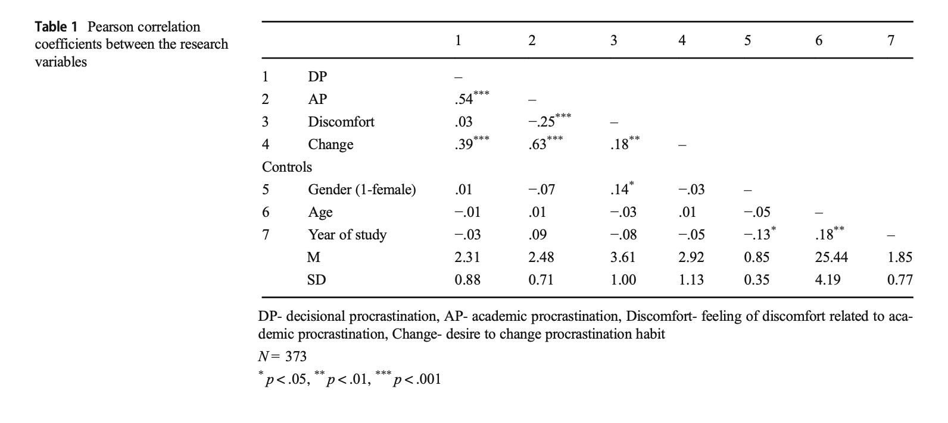
When we looked at the relationship between academic procrastination in decision making, discomfort associated with academic procrastination, and the desire to change this habit, we noticed a pattern change. Decisive procrastination had a negative indirect effect on academic procrastination related discomfort and a positive indirect effect on the desire to change this habit. This pattern change may indicate that there are immediate effects when the decision-making process is mediated by an actual technical procrastination, such as mitigation, tactical emotional changes (Sirois and Pychyl, 2013) or protection of the vulnerable self by avoiding tasks (Ferrari, 2010). And these tasks can only be shielded from the negative emotions associated with decision delay. Furthermore, it can be argued that the existence of academic procrastination has also raised awareness of this dysfunctional behaviour and its consequences far beyond the despair raised in the decision-making process (Fernie et al. 2015).
This is a pilot study examining the relationship between decision-making tendency procrastination and academic procrastination and discomfort and desire to change procrastination behavior. Limitations of this study are self-reported measurements, cross-sectional study design, and specific samples, mostly women studying the social sciences. The sample needs to consider major, age, school, gender ratio, cultural conflicts and other factors. In addition, future research should explore more specifically the root causes of students' academic procrastination, how the tendency to procrastinate on decisions affects the tendency to procrastinate on behaviors, and how to address this problem. The impact of other types of behavioral procrastination (i.e., workplace procrastination) on procrastination and contributes to a comprehensive understanding and unique intervention in other situations and areas of life.
P < 0.001 in the data analysis of the article is a valid statistical analysis. The level of R value shows the correlation degree and positive and negative correlation among different factors. For example, (1) there is a weak positive correlation between the discomfort related to academic procrastination and the desire to change the procrastination habit (R = 0.18; P < 0.01), indicating that these are two different concepts; (2) There was a moderate positive correlation between decision making and academic procrastination (R = 0.54; P < 0.001); (3) There was a moderately positive correlation between decisive procrastination and the desire to change the procrastination habit (R = 0.39; P < 0.001) and was not associated with discomfort of academic procrastination (r = 0.03; P = 0.56); (4) There was a weak negative correlation between academic procrastination and academic procrastination related discomfort (R =-0.25; P < 0.001), was positively correlated with the desire to change the procrastination habit (r = 0.63; P < 0.001). In addition, there is a decisional reduction (r = −.09; P =.07). Negative and weak correlations between years of study and decisive procrastination (r =-0.09; P = 0.07).

Article 2
The introduction and theory section of article 2 provides additional definitions and research on learning disabilities and online procrastination。

Learning Disabilities
Learning disability (LD) is defined in the Diagnostic and Statistical Manual of Mental Disorders, Edition 5 (DSM-5) as a neurodevelopmental disorder that includes specific difficulties with reading, writing, and arithmetic, which are sig- significantly lower than expected for the same age group, and can affect daily functioning or academic performance. One way students cope with emotional, social and learning overload is by avoiding academic tasks. They put it off until the last minute, even though they know it will negatively impact their academic performance (Hen, 2018). Although there are a large number of studies on students' procrastination behavior, only a few studies on students with learning difficulties (Goroshit & Hen, 2019) show that students with learning difficulties have higher degree of academic procrastination than other students (Hen & Goroshit, 2014).
Online procrastination is defined as the tendency to use the Internet to avoid performing other tasks that are considered boring, challenging or boring (Thatcher et al., 2008). It is also Internet leisure disorder (Yilmaz & Yurdugul, 2018), which is mainly studied in organizations and companies. In this sample from different regions of North America, 50.7% of people spend 47% of their online time indulging in Internet surfing as a way to relieve stress and amuse themselves, as well as on social media. Online procrastination is also becoming common among students in higher education (Lee et al., 2017; Ragan et al., 2014) Rakes and Dunn (2010) found that the reduction of intrinsic motivation and effort management in online learning negatively predicted online procrastination among graduate students. However, Metin-Orta and Demirutku (2020) reported that college students' online loitering behavior was influenced by their values and attitudes. In a study on the causes of online loafing from the perspective of college students, four categories were proposed: characteristics of teachers, emotional characteristics of students, complexity of course content and accessibility of learning environment (Varol & Y LD R M, 2019).
Methods
Participants
The study included 173 university undergraduates from Israel (74% female, 26% male: Magicians 1 -- 424). Students are freshmen or sophomores (78.7%). About 45.7% of the students are from the psychology department and 54.3% from the humanities and Social sciences department. A total of 77 participants (56 women, 21 men) were clinically diagnosed with LD through the formal examination (MATAL) developed in Israel to assess LD in higher education (Hen and Goroshit, 2018), while 96 participants (72 women, 24 men). Students with learning disabilities were recruited through the School's Learning Support Center and non-learning disabilities through the computer experiment system of the School's Department of Psychological Education. Existing problems: 1. Is there a major distribution problem for students without the introduction of majors? 2. LD is mainly about whether reading and writing disorders are affected by language or cultural differences among international students. 3. A formal LD examination (MATAL) is performed to determine whether there is an error in the diagnosis of learning disability.

The self-reporting Academic Procrastination Scale (Milgram et al., 1998

Students without learning disabilities took an online questionnaire using Qualtrics (www.Qualtrics. Com) through the College's experimental system. They received a link to the questionnaire through the university support Centre. The center is available only to students who have updated their LD diagnosis within the last three years. The questionnaire includes an explanation of the study and a consensually signed form to ensure the anonymity of the participants and the confidentiality of the data, which will be used only for the data collection reliability and validity of this online database
The purpose of the study. Participants were asked to leave an email address at the end of the questionnaire that would allow them to enter a raffle, which would entitle them to a voucher for breakfast for two. The reward is small but not encouraging. They told the students that email addresses would not be associated with the questionnaire, so the information would remain anonymous. The study was authorized by the college's ethics Committee.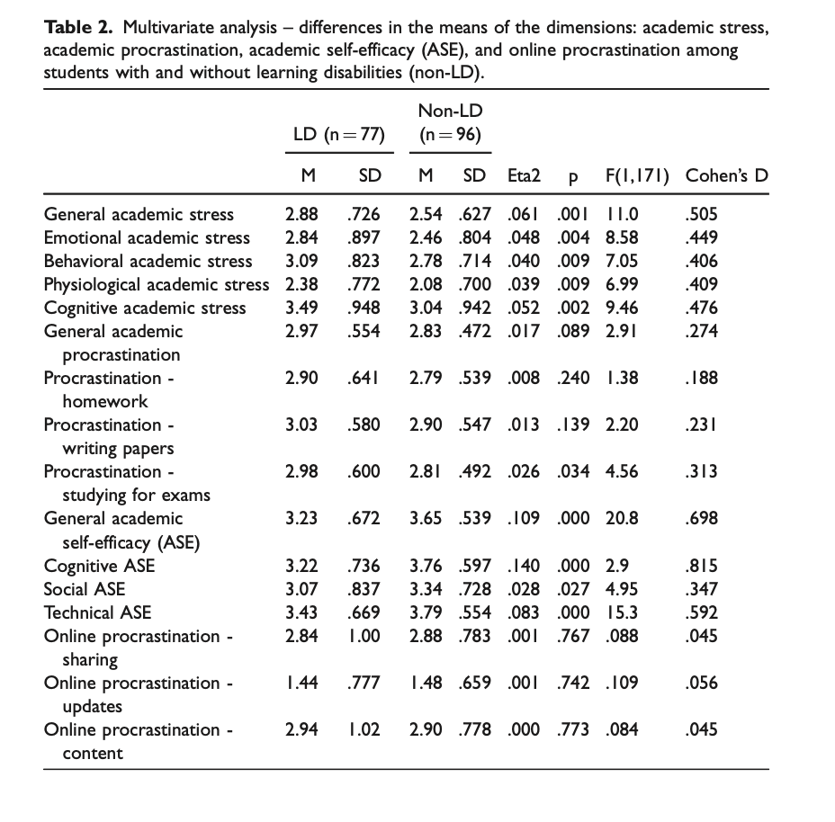
As shown in Table 2, students with learning difficulties had significantly higher levels of general academic stress as well as stress levels in each content area compared to students without learning difficulties. Similarly, compared with students without learning difficulties, students with learning difficulties have significantly lower academic self-efficacy and self-evaluation in all aspects. In addition, the study found that multivariate analysis of variance (MANOVA) is a procedure for comparing multivariate sample means with students without learning disabilities in statistics . As a multivariable procedure, it is used when there are two or more dependent variables and is usually followed by a saliency test involving each dependent variable separately. It helped answer that students with learning disabilities had significantly higher levels of learning procrastination in "studying for tests.
The amount varies from moderate to very large. Thus, the first hypothesis is only partially confirmed.
LD was positively, weakly and significantly correlated with academic stress, and negatively, weakly and significantly correlated with ASE. Academic stress is positively, moderately and significantly correlated with academic procrastination, and negatively, moderately and significantly correlated with academic procrastination. In addition, there are positive, weak and significant correlations between academic burnout and emotional academic stress, while there are positive, weak and significant correlations between emotional academic stress and online procrastination sharing. A positive, weak, and significant relationship was found between ASE and online delayed sharing. Table 3 shows that there are significant statistical relationships between variables, so there are conditions to check the mediation model.
The article 2 lies in the investigation of online procrastination behavior of college students with learning difficulties. Although our results did not show that these students' online procrastination was higher, we did find that the emotional academic pressure of students with learning difficulties had a positive effect on the tendency of online procrastination, while the emotional academic pressure of students with low academic self-efficacy had a positive effect on the tendency of online procrastination.
The results of this study should be interpreted taking into account several limitations. One aspect comes from data collection. First, this is a cross-sectional and correlated design study, utilizing self-reported measures that tend to be biased towards various research biases, such as social expectations, as well as the effect of time when conducting intermediary design. Second, most subjects reported that they had received help from the college support center, which could be interpreted as an intervention from the outside that may have affected LD. In addition, almost half of the subjects were from the university's psychology department, and whether there were other confusions to self-reporting. Finally, the entire sample was drawn from a large school in northern Israel, which may also affect the ability to generalize the findings to other populations.

Another limitation is related to the research tool. In measuring the ‘online procrastination’ variable, we included three out of five content areas from the questionnaire of Akbulut et al. (2016), assuming that these are the most relevant content areas for our research, and to avoid burdening the subjects as they complete the questionnaire. As a result, we might have received an incomplete picture concerning the ‘online procrastination’ variable, which in turn could have led to not finding differences between the research groups and inversing the findings in the relationship between academic self-efficacy and online procrastination.
Another limitation has to do with research tools. We may have got an incomplete picture of the online procrastination variable when measuring it, which in turn may have led to not finding differences between study groups and reversing the results of the study on the relationship between academic self-efficacy and online procrastination. In addition, we used the "sharing" aspect of the "online procrastination" variable and the "emotional" aspect of the "academic stress" variable, because Pearson's analysis found no significant association between the total scores of these variables. In addition to statistical considerations, there is a theoretical basis for this decision, as emotional academic stress represents the strongest variable of stress compared to other content areas (Lakaev, 2009). In online procrastination, sharing is the most common behavior of students on the Internet (Akbulut et al., 2017).

Conclusion and recommendations
The qualitative analysis process of article 1 and Article 2 has basically achieved the author's initial goal. There are some problems in the process of data collection, such as uneven distribution of majors from the same university. Article 2 Breakfast vouchers in the process of data collection do not encourage the voluntary data collection will bring some interference. SPSS and other qualitative analysis tools were selected in the two articles, and P < 0.01 was controlled to ensure the statistical validity. Data normal distribution is parameterized design. Assumptions are set up in accordance with norms, without advance judgment. Based on the current academic level of the author, the analysis of the two articles proves that the understanding degree is limited, which is considered to be a very high level of quantitative analysis of the articles.

Recommendations

1 Mixed research design
It is suggested to adopt a mixed research design, that is, a combination of quantitative and qualitative research methods, and draw conclusions on this basis. The quantitative phase is helpful to understand the relationship between academic expectation and academic delay and decision delay. The qualitative stage is used to analyze why students have academic procrastination. Quantitative data was collected using two self-report instruments (closed question- naire) and one self-report instrument (open questionnaire). The interviews took place in the coaching and consulting room. When students come in for an interview, a questionnaire is collected and the format of the interview is briefly explained to students. Students were told they were free to discontinue participation and to refuse to answer questions without penalty. All interviews were recorded on smartphones. In fact, qualitative methods are more helpful to collect information and judge whether students are decision-making procrastinators. In article 2, since many participants had received LD intervention from schools, qualitative research could more effectively distinguish LD students.
2 A theoretical study of the psychology of procrastination
The two articles are deficient in theory. For example, the author previously focused on TMT theory as a theoretical model for effective research on procrastination.
Expectancy × Value 1
Motivation = __________________
+ Impulsiveness × Delay
(Steel et al.， 2019; Akbay and Delibalta, 2020) This theory has been used by many researchers to study academic procrastination and other types of procrastination . This can better explain the influence of time control, motivation, temptation and other related factors mentioned in the last two articles.

3. Data collection
As mentioned above, there are some problems in the data collection process of the two articles. We can expand the data collection scope of the survey and increase data sources from different levels, majors and countries. Avoid the influence of the latter major of a single school on the reliability and validity of the sample. Another problem with data collection is the influence of religion in Israel. Previous studies have shown a highly positive correlation between religious factors and motivation to learn. The influence of middle and culture on academic procrastination and students' self-control is not mentioned in the two articles.

Bibliography

Reference
Akbulut, Y., Dursun, O€. O€., Do€nmez, O., & S ̧ ahin, Y. L. (2016). In search of a measure to investigate cyberloafing in educational settings. Computers in Human Behavior, 55, 616–625.

Hayes, A. (2013). Introduction to mediation, moderation, and conditional process analysis: A regression-based approach. New York: Guilford Press.
Ferrari, J. R., 2010. Still procrastinating? The no regrets guide to getting it done. Hoboken: Wiley.

Steel, P., 2007. The nature of procrastination: A meta-analytic and the- oretical review of quintessential self-regulatory failure. Psychological Bulletin, 133(1), 65–94.

DeRobertis, E., 2020. The Humanistic Revolution in Psychology: Its Inaugural Vision. Journal of Humanistic Psychology, 61(1), pp.8-32.

Al-Imarah, A., Shields, R. and Kamm, R., 2020. Is quality assurance compatible with technological innovation? Case studies of massive open online courses (MOOCs) in United Kingdom higher education. Quality in Higher Education, 27(1), pp.4-19.

Goroshit, M. and Hen, M., 2019. Academic procrastination and academic performance: Do learning disabilities matter?. Current Psychology, 40(5), pp.2490-2498.

Zhou, M., 2018. Gender differences in procrastination: The role of personality traits. Current Psychology, 39(4), pp.1445-1453.

Krause, K., & Freund, A. M.,2014. How to beat procrastination. European Psychologist, 19(2), 132–144. https://doi.org/10.1027/ 1016-9040/a000153.

TAVAKOLI, M.A., 2013. A study of the prevalence of academic procrastination among students and its relationship with demographic characteristics, preferences of study time, and purpose of entering university.
Lin-Siegler, X., Dweck, C. S., & Cohen, G. L. (2016). Instructional interventions that
motivate classroom learning. Journal of Educational Psychology, 108(3), 295–299.
Klingsieck, K. B. (2013). Procrastination. When good things don’t come to those who wait. European Psychologist, 18(1), 24–34.
Ferrari, J. R.,2001. Procrastination as self-regulation failure of perfor- mance: Effects of cognitive load, self-awareness, and time limits on Bworking best under pressure^. European Journal of Personality, 15(5), 391–406.

Steel, P., & Ferrari, J. R.,2013. Sex, education and procrastination: An epidemiological study of procrastinators’ characteristics from a global sample. European Journal of Personality, 27(1), 51–58.

Kandemir, M., İlhan, T., Özpolat, A. R., & Palanci, M.,2014. Analysis of academic self-efficacy, self-esteem and coping with stress skills predictive power on academic procrastination. Educational Research and Reviews, 9(5), 146–152. https://doi.org/10.5897/ err2014.1763.

Hen, M. and Goroshit, M., 2018. The effects of decisional and academic procrastination on students’ feelings toward academic procrastination. Current Psychology, 39(2), pp.556-563.

Niazov, Z., Hen, M. and Ferrari, J., 2021. Online and Academic Procrastination in Students With Learning Disabilities: The Impact of Academic Stress and Self-Efficacy. Psychological Reports, p.003329412098811.

Saudale, J., 2020. The Predictive Role of Academic Hope in Academic Procrastination Among Students: a Mixed Methods Study. Pedagogika, 137(1), pp.208-229.

Li, L., Gao, H. and Xu, Y., 2020. The mediating and buffering effect of academic self-efficacy on the relationship between smartphone addiction and academic procrastination. Computers & Education, 159, p.104001.

Moller, N., Clarke, V., Braun, V., Tischner, I. and Vossler, A., 2021. Qualitative story completion for counseling psychology research: A creative method to interrogate dominant discourses. Journal of Counseling Psychology, 68(3), pp.286-298.

Govender, P., 2019. Use of Mixed Methods and Reflection: A Novice Researcher’s Perspective. Global Journal of Health Science, 11(13), p.8.

Tandon, A., Dhir, A., Islam, N., Talwar, S. and Mäntymäki, M., 2021. Psychological and behavioral outcomes of social media-induced fear of missing out at the workplace. Journal of Business Research, 136, pp.186-197.

Collings, D. G. et al. (2021) Leading through paradox in a COVID‐19 world: Human resources comes of age. Human resource management journal. [Online]

Clark-Gordon, C., Workman, K. and Linvill, D., 2017. College Students and Yik Yak: An Exploratory Mixed-Methods Study. Social Media + Society, 3(2), p.205630511771569.

Nie, D., Panfilova, E., Samusenkov, V. and Mikhaylov, A., 2020. E-Learning Financing Models in Russia for Sustainable Development. Sustainability, 12(11), p.4412.

Uher, J., 2021. Quantitative psychology under scrutiny: Measurement requires not result-dependent but traceable data generation. Personality and Individual Differences, 170, p.110205.

