Science Coursework
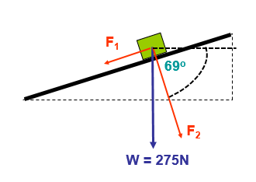
Q1) a. i)
The given angle of 69° means that the angle between F₂ and the weight must be 21°. Given that W is perpendicular to the 69° angle and the total angle must be 90° therefore $90-69=21°$. The angle of the plane is equal to this component therefore the angle of the plane = 21°.

$F_{1}=W×\sin{(Θ)}$
$F_{1}=275×\sin{(21)}$
$F_{1}=98.55N$
F₁ is equal to the force of friction acting up the slope due to the block being at rest on the slope so these forces must be equal. Therefore:
Friction = 98.55N
Q1) a. ii)

Q1) a. iii)
$F_{2}=W×\cos{(Θ)}$
$F_{2}=275×\cos{(Θ)}$
$$F_{2}=256.7N$$
$F_{2}=F_{N}$ due to the block being at rest on the slope therefore:

$$F_{N}=256.7N$$

Q1) b. i)
$Momentum=Mass ×Velocity$ mathematically:

$$p=mv$$

Q1) b. ii)
The units of momentum(p) are:
$$kg·m/s$$

Q1) c. i)
Firstly, to calculate the resultant force we must calculate the mass of the block.
Where: $W=m×g$. Rearranged to: $m= \frac{W}{g}$.
Therefore: $m=\frac{275}{9.81}$
$$m=28kg$$
Now we must use $F=ma$ where: $F=28 ×2.5$
Therefore: $F=70N$

Although there is force F₁ acting down the slope at 98.55N. Therefore, 70N is only the difference between the downwards force (F₁) and the upwards force parallel to the slope. So:
$$F=98.55+70$$

$$F=168.6N$$

Q1) c. ii)

Firstly, we must work out the momentum(p) at the moment before the block starts moving up the slope:
$$p=mv$$
$p=28×0$ as the block is at rest.
$$p=0kg·m/s$$

Secondly, we must work out the momentum(p) when the block is moving at 7.5m/s:
$$p=mv$$
$p=28×7.5$ as the block is moving at a velocity of 7.5m/s
$$p=210kg·m/s$$

Now the difference:
$$∆p=210-0$$
$$∆p=210kg·m/s$$

Q1) c. iii)

To find the resultant force we must first find the acceleration of the block:
$$a=\frac{∆v}{t}$$
$$a=\frac{12.5-0}{3.2}$$
$$a=3.91{m/s}^{2}$$
Now all required values are present to calculate the resultant force:
$$F=ma$$
$$F=5×3.91$$
$F=19.55N$

Q2) a. i)
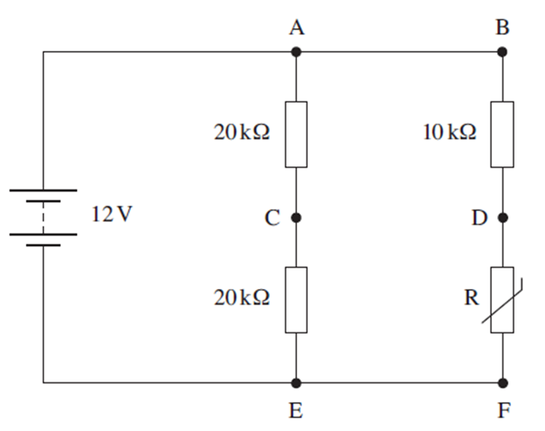
To calculate the total resistance of the circuit we must first find the sum of the resistors in series:

$R_{T1}=R_{AC}+R_{CE}$ $R_{T2}=R_{BD}+R_{DF}$
$R_{T1}=20+20$ $R_{T2}=10+5$
$R_{T1}=40kΩ$ $R_{T2}=15kΩ$
Now in parallel:
$${\frac{1}{R}}_{T}=\frac{1}{R_{T1}}+\frac{1}{R_{T2}}$$
$$\frac{1}{R_{T}}=\frac{1}{40}+\frac{1}{15}$$
$${\frac{1}{R}}_{T}=\frac{3}{120}+\frac{8}{120}$$
$$\frac{1}{R_{T}}=\frac{11}{120} \frac{R_{T}}{1}=\frac{120}{11}$$
$$R_{T}=10.91kΩ$$

Q2) a. ii)

For the current leaving the battery:

Use $V=IR$
Rearranged to $I=\frac{V}{R}$ as we are trying to find current.
$$I=\frac{12V}{10,909Ω}$$

$I=1.1mA$

Q2) a. iii)

Use $P=IV$
Power for resistors BD and DF:

Current Between points B and F:
$$I_{BF}=\frac{I}{R}×R_{AE}$$
$$I_{BF}=\frac{0.0011}{55}×40$$
$$I_{BF}=8×{10}^{-4}A$$
$$I_{BF}=0.0008A$$

Now use $V=IR$ to find the voltage drop over the resistor BD and then the power:
$R_{BD}=0.0008×10,000$ $R_{BD}=0.0008×8R_{BD}=8V$ $R_{BD}=0.0064W$
Now to find Resistor DF:
$R_{DF}=0.0008×5,000$ $R_{DF}=0.0008×4$
$R_{DF}=4V$ (Q2 b.ii) $R_{DF}=0.0032W$
Power for resistors AC and CE:
Current between points A and E:
$$I_{AE}=\frac{I}{R}×R_{DF}$$
$$I_{AE}=\frac{0.0011}{55}×15$$
$$I_{AE}=3×{10}^{-4}A$$
$$I_{AE}=0.0003A$$

Now use $V=IR$ to find the voltage drop over resistor AC and then the power:
$R_{AC}=0.0003×20,000$ $R_{AC}=0.0003×6$
$R_{AC}=6V$ (Q2 b.i) $R_{AC}=0.0018W$

$R_{AC}=R_{CE}$ Therefore:

$$R_{CE}=0.0018W$$

Q2) b. iii)

Potential difference across points C and D:
Use $V=IR$ Where:
$$I=0.0011A$$
$$R=10.91V$$

$V=12V$ as it is essentially the voltage difference between the only two parts of the circuit and covers all components.

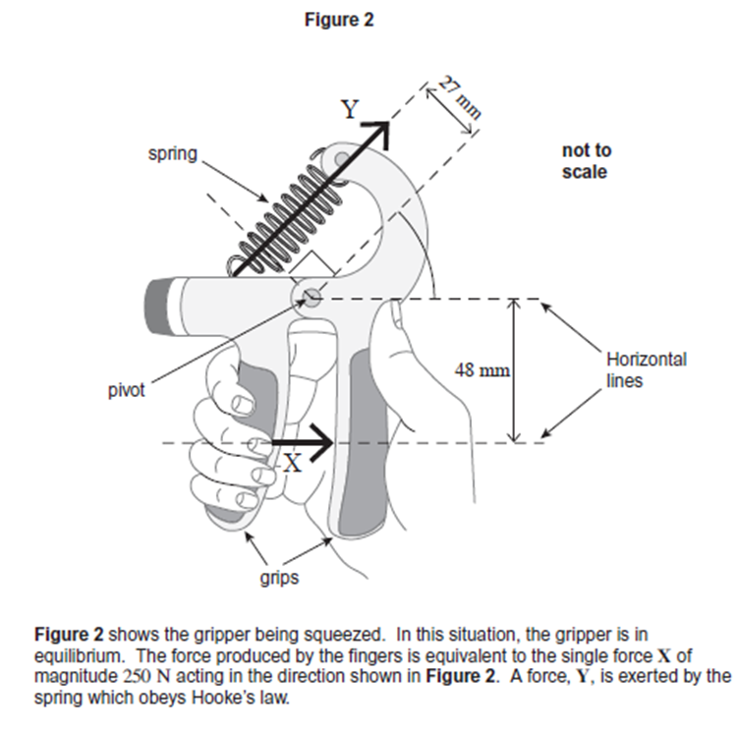
Q3 a. i)

$$Moment=Force \left(N\right)×Distance \left(m\right)$$

Q3) b. i)

Use $Moment=Force×Distance$:
48mm in meters is 0.048m
$$250×0.048=12Nm$$

Q3) b. ii)

Use $Moment=Force ×Distance:$
27mm in meters is 0.027m
$$250×0.027=6.75Nm$$

Q3) b. iii)

Use Hooke’s law $F=kx$ although we do not know k. Therefore:

$$k=\frac{F}{x}$$
$$k=\frac{6.75}{0.015}$$
$$k=450Nm$$

Q3) C. i)

An equation for Power:

$$Power (W)=\frac{Energy (j)}{∆ Time (s)}$$

Q3) C. ii)

$$Power=\frac{12}{2.2}$$
$$Power=5.45W$$

Q3) d. i)

$$3.2kJ=3,200j$$

$$\frac{3200}{12}=266 times$$

