Contextual practices: ways of thinking.

Eight statements regarding my practice in Design Crafts;
- Designers, including myself, put a lot of time and effort into all of their pieces of artwork and designs.
- Handmaid art pieces are more precious than factory made art pieces.
- Every art piece/object has its own conversation/story to tell.
- Newer designed buildings have lost their historical values and aspects, alongside their historical architecture.
- Art should always be viewed slowly to allow the artists work to be broken down and really understood.
- Artists/designers never see things as they are, there is always more to an art piece or design than can’t be seen by the naked eye.
- Inspiration should always be taken from things that you find intriguing, beautiful or creative.
- Design crafts is a subject which allows you to express yourself using a variety of different materials and processes.

Task 1 Manifesto –

Statement 3:

This statement refers to how an object, or an art piece, came together. What went into the different stages of it being manufactured?
“Paintings are more than just pictures in a frame—they are unfolding stories that contain multiple perspectives” (Every Picture Tells a Story, 2021).
Every piece of artwork is made using different processes, techniques and equipment. Looking at select processes and different materials allows us to see the different conversations and stories that the object/artwork contains within. Not only this, during the design process an artist will set their selves different tasks in which they look at different artists pieces of artwork and then compare and connect them into your own piece of work.

Statement 5:

This statement has a lot of meaning to me because it is something I try and allow myself to do when I’m viewing an artist’s work, whether that be online or at a gallery. I always try and slowly break down the piece by inspecting certain aspects of it delicately and seeing how each piece relates to the next. Doing this it allows me to see the different objects and material which have gone into making the piece. This allows me to appreciate an art piece and the time and effort that has gone into making the finished piece.
Over the years there has been questions such as “Is ‘slow art’ the next big movement?” (Davies, 2017). Personally, I would say that Slow Art has always been a movement because an Art Movement is defined as a “collective title that is given to artworks which share the same artistic ideals, style, technical approach or timeframe” (Art Movements - Artists, Styles, Techniques, Ideas, 2021). The technical approach with Slow Art is to look at the art piece slowly, but in great depth, which most audiences attending an art viewing will adhere to, if they are applying the ‘slow art’ approach.

Statement 6:

This statement is the one I most strongly consider honest. I believe that a designer can see fellow artists or designers work with a distinct eye. In expansion, a designer can always see deeper meanings to an object or sculpture. My favourite example of this is the “LOVE IS THE ONLY THING THAT CAN OVERCOME HATE (ROERMOND, NETHERLANDS)” (Nascimento, 2021), referring to figure 1.
To the naked eye the figure illustrates a sculpture of two graves connecting, via a bridge, for a husband and wife to be buried together. However, there is a much deeper significance here. These are the graves of a husband and wife who were not allowed to be buried together due to one being Catholic and the other being Protestant. There religious backgrounds stopped them from being together even after death, the wall in between the two graves represents this and symbolises the separation they faced. The two hands connecting shows they are still together despite the problems they faced which “As you can see, true love conquers all barriers” (Nascimento, 2021)

Bibliography

References

Nga.gov. 2021. Every Picture Tells a Story. [online] Available at: <https://www.nga.gov/learn/teachers/school-tours/every-picture-tells-a-story.html> [Accessed 21 October 2021].

Davies, B., 2017. Is 'Slow Art' the Next Big Art Movement? | Artnet News. [online] Artnet News. Available at: <https://news.artnet.com/art-world/is-slow-art-the-next-big-art-movement-1061195> [Accessed 21 October 2021].

Eden Gallery. 2021. Art Movement Definition: What is an Art Movement? - Eden Gallery. [online] Available at: <https://www.eden-gallery.com/news/art-movement-definition> [Accessed 23 September 2021].

Artyfactory.com. 2021. Art Movements - Artists, Styles, Techniques, Ideas. [online] Available at: <https://artyfactory.com/art_appreciation/art_movements/art_movements.htm> [Accessed 21 October 2021].

Nascimento, G., 2021. 10 Brilliant Sculptures From Around The World With Deeper Meaning. [online] Anewkindofhuman.com. Available at: <https://anewkindofhuman.com/10-brilliant-sculptures-with-deeper-meaning-from-around-the-world/> [Accessed 21 October 2021].

Figures

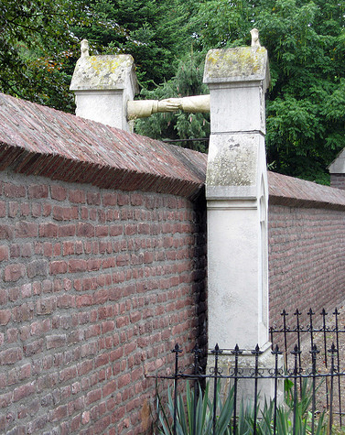
Figure 1

