
International Business Report: Competitiveness of the UK Online Grocery and E-commerce Retail Industry and a Critical Evaluation of Amazon UK
Programme | Master of Business Administration
Module | International Business Concepts
Module code | LCMB7034
Lecturer | Ejike Udeogu
Student name | Himadhri Bardhan Dhrubo
Student ID | 2505915
Word count | 7135
Submission date | 20 March 2026

Table of Contents
1. Introduction 1
2. Industry and country overview 1
3. Porter’s Diamond Model and the global competitiveness of the UK industry 7
3.1 Factor conditions 7
3.2 Demand conditions 8
3.3 Related and supporting industries 8
3.4 Firm strategy, structure and rivalry 9
3.5 Government and chance 10
4. Critical evaluation of Amazon UK 11
4.1 Political and policy factors 11
4.2 Economic factors 12
4.3 Legal and regulatory factors 13
4.4 Cultural factors 14
4.5 Strategic fit and competitive position 15
4.6 Critical judgement 16
5. Conclusion 18
Section 2. Reflective account using Gibbs’ Reflective Cycle 19
Description 19
Feelings 19
Evaluation 19
Analysis 20
Conclusion 21
Action plan 22
References 23

1. Introduction
This report is aimed at analysing the competitiveness of the online grocery and e-commerce retail sector in the United Kingdom as well as critically assessing the opportunities of one of the largest foreign multinational corporations, Amazon UK, in that environment. The UK is a good fit since it has a digitally sophisticated consumer base, developed logistics, stiff supermarket competition and a regulatory framework that is increasingly questioning formidable networks. According to the recent data presented by the Office for National Statistics, online retail sales contributed 28.3 per cent to the total retail sales in December 2025, with online sales values being 11.1 per cent higher than the values of December 2024 (ONS, 2026a). This shows that digital retail is still strategically relevant despite the outstanding pandemic years. The report claims that the UK has good demand-side and ecosystem benefits, yet these same benefits increase service expectations, regulatory pressure and margin intensity. Amazon UK enjoys economies of scale, logistics, Prime membership and brand awareness, but its long-term success will be reliant on legitimacy, relations with suppliers and fit to the particular economics and practises of UK grocery retailing.

2. Industry and country overview
The chosen industry is the UK online retail, e-commerce grocery industry. To this report, we are not interested in all the possible types of digital commerce that can be applied but the point of convergence between online retailing, grocery fulfilment and platform-based retail competition. This limit is suitable since the brief involves research of both local and international companies and since presence of Amazon in the UK borders on general merchandise, market places retail, subscription services and grocery related activities.
UK is among the highly digitalised consumer markets in Europe. Evidence of ONS indicates that online expenditure constituted 50.5 per cent of total card expenditure in September 2025, as opposed to 43.7 per cent in September 2019, whereas the domestic online expenditure ratio also rose over the same time (ONS, 2026b). This is important on a strategic level since it implies that online retail in UK ceases to be a niche channel. It is incorporated in the daily consumption. Meanwhile, official retail sales statistics indicate that online sales continued to constitute more than a quarter of retail sales in total in December 2025 (ONS, 2026a). These are signs that digital channels are economically significant to retailers, payment systems, warehousing, last-mile logistics and data-driven marketing.
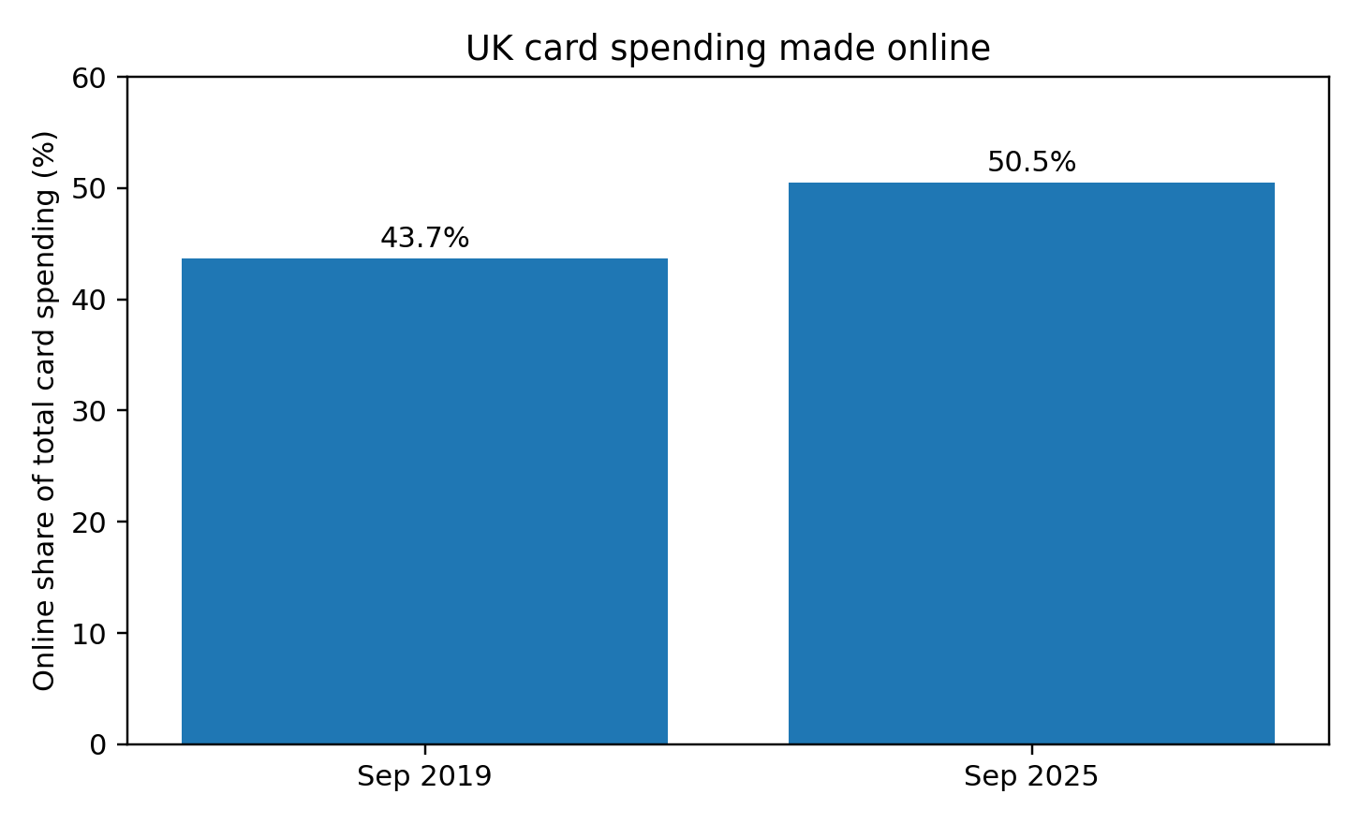
Figure 1. UK card spending made online, September 2019 versus September 2025
Source: ONS (2026b).
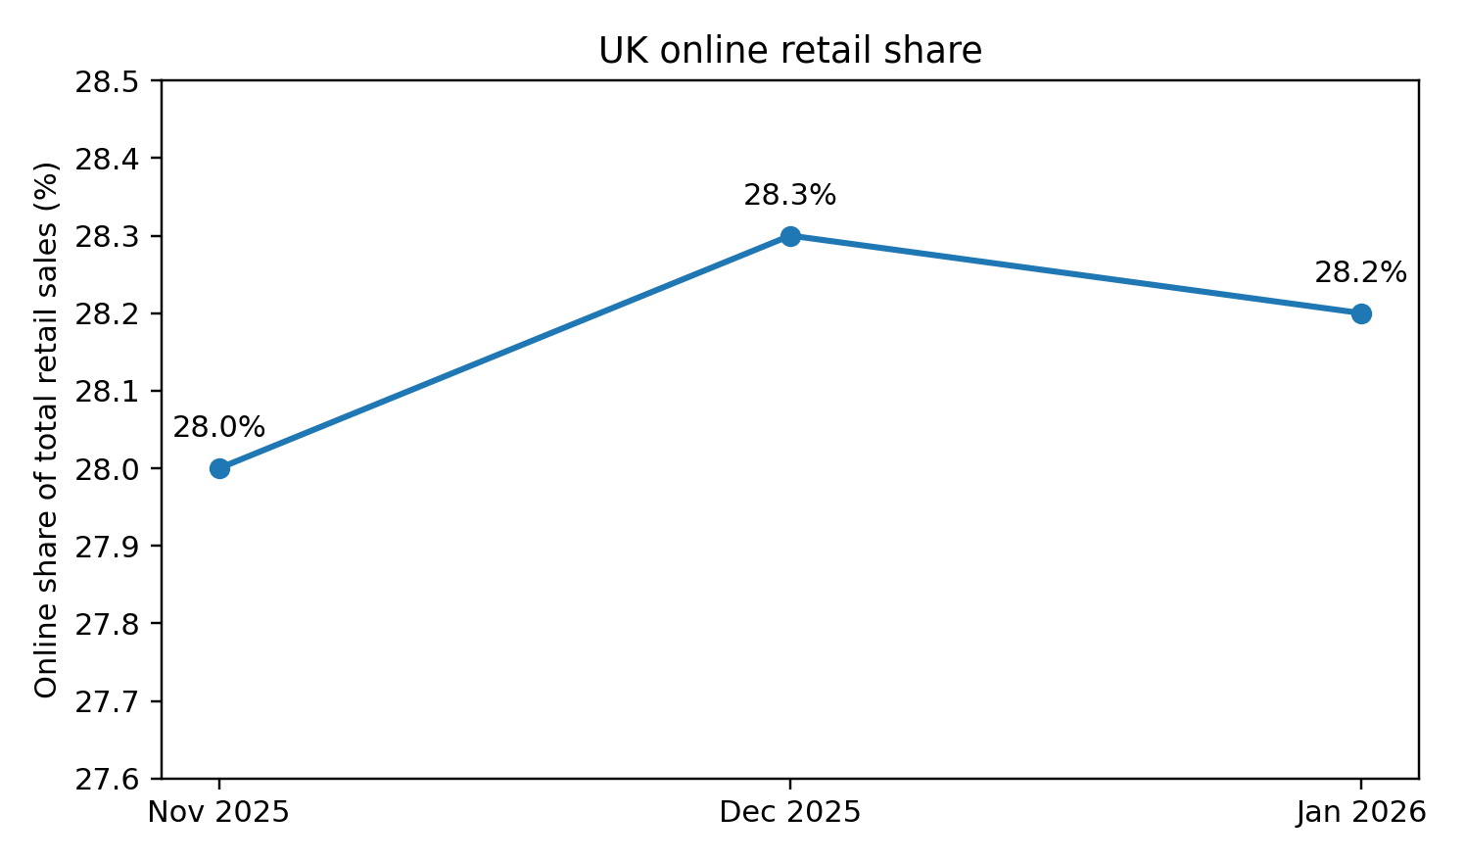
Figure 2. UK online retail share of total retail sales, November 2025 to January 2026
Source: ONS (2026a). January 2026 figure based on ONS January 2026 retail release.
Grocery plays a specific strategic role in this larger market. Groceries shopping is operating intensive and low-margin. When it comes to success, proper demand forecasting, speedy picking and packing, reliability in delivery windows, cold-chain and consumer confidence is needed. This renders online grocery a much-better exam of execution competency than numerous non-food segments. It also gives the reason that online grocery competition in the UK has proved to be an effective tool through which to evaluate national competitiveness and firm-specific capability.
Tesco, Sainsbury and Ocado are the essential local or UK-based participants in the selected market. Tesco is still the leader in the British grocery market, as well as having established a significant online presence. According to the 2025 annual report, the UK online sales are growing by 10.2 per cent and online market share grows by 173 basis points to 35 per cent, with the support of the rise in orders per week and capacity growth (Tesco, 2025). Sainsbury is a large full-range supermarket competitor that has a robust multichannel offer. According to its 2025 annual report, online grocery sales have grown by 7 per cent annually as the company has continued to invest in value, availability and convenience (J Sainsbury plc, 2025). Ocado is an organisation that is not structurally similar to the traditional supermarket groups as its model is more digitally specialised. Ocado Retail annual report 2025 records revenue growth of 15.5 per cent to PS2.83 billion, indicating that even in a market with high levels of maturity, a highly digital grocery proposition can still grow (Ocado Retail, 2025).
The most significant foreign multinational in this competition is Amazon. It is not an ordinary supermarket incumbent, but it is highly pertinent to the industry since it integrates marketplace scale, fulfilment support, Prime loyalty, speed of delivery services and grocery-related supplier relations. The UK presence of Amazon is large. The UK contribution to tax and economy According to the Amazon contribution to tax and economy report (UK), in 2024, the UK revenues were PS29 billion, the amount of taxes paid and collected was over PS5.8 billion, and the amount of direct tax payment was PS932 million (Amazon, 2025a). Planned PS40 billion UK investment programme over 2025 to 2027, including fulfilment centres, delivery infrastructure, offices and digital capacity, with Amazon already employing more than 75,000 people across over 100 sites in the UK (Amazon, 2025b; UK Government, 2025) were also announced by Amazon and the UK government. These numbers are important since they indicate that Amazon is not a fringe player. It is a big player whose competition decisions influence the labour markets, suppliers, infrastructure and retail competition.
The comparative analysis of the leading companies shows that the UK market does not have a single basis of competition. Tesco has advantages that are linked to scale, extensive customer coverage, integration of physical stores, Clubcard data, and its capacity to combine value positioning and omnichannel convenience. Competitive advantages of Sainsbury are brand trust, middle-market quality, solid food heritage and inbuilt digital convenience. The competitive advantage of Ocado is based on a highly digital offer, a better user experience and advanced fulfilment, however, it does not have the physical breadth and mass-market coverage, that Tesco or Sainsbury has. The situation of Amazon is different once again. It boasts of remarkable breadth of assortment, developed fulfilment, prime ecosystem lock-in and data, although not as ingrained into mainstream British grocery behaviour as Tesco or Sainsbury.
The differentiated picture is backed by current market evidence. According to Reuters, based on Worldpanel by Numerator statistics, Tesco had a 28.7 per cent grocery market share, Sainsbury had 16.1 per cent and Asda had 11.5 per cent, and Ocado was the retailer with the most rapid growth in sales, which was 15.1 per cent in the four weeks to 22 February 2026 (Reuters, 2026a). The strategic implication is that the digital growth is disputed, and the structural position of the incumbents is solid. This market thus punishes companies that are able to blend low-friction shopping, reliable service, value discipline and responsiveness of the supply-chain.
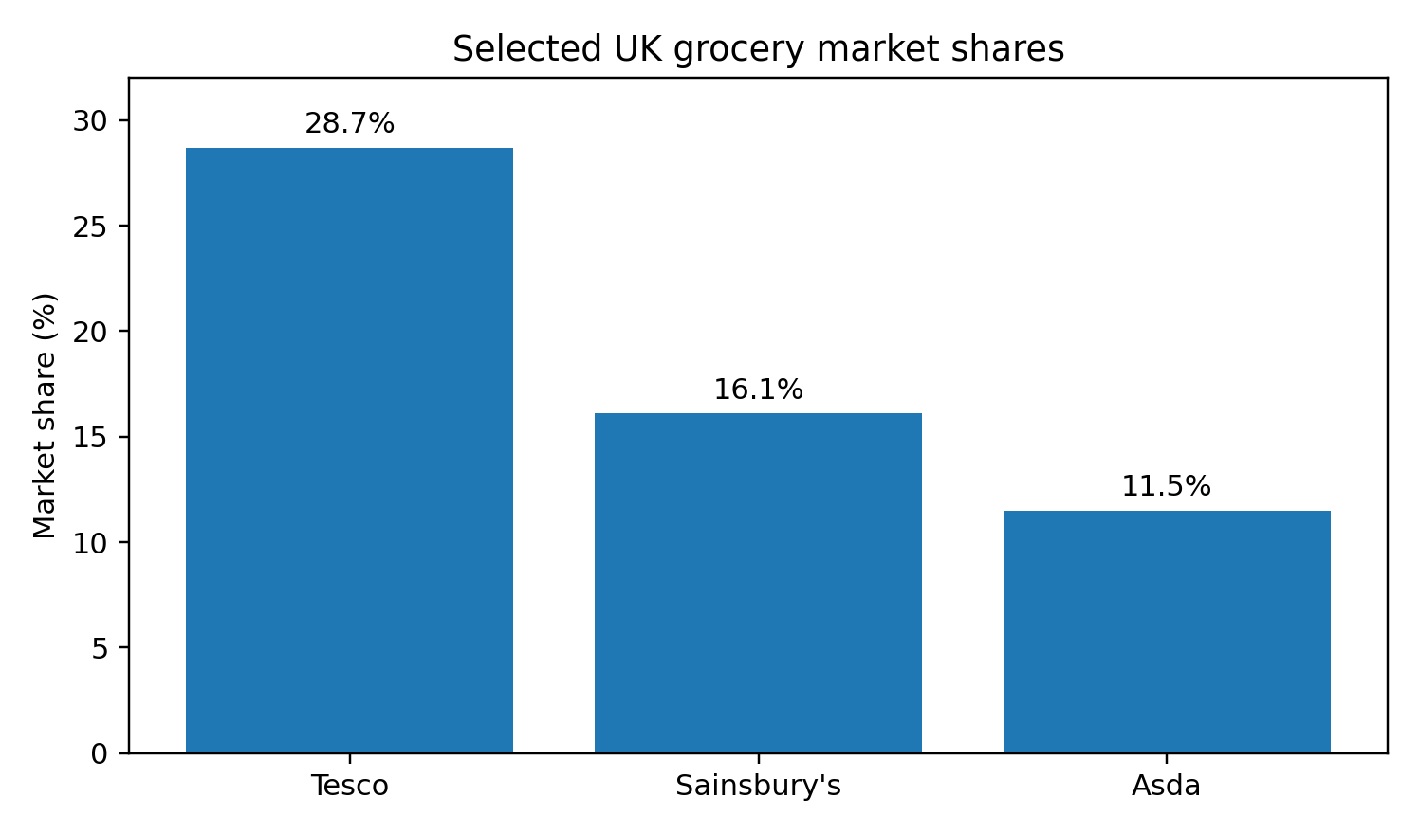
Figure 3. Selected UK grocery market shares, four weeks to 22 February 2026
Source: Reuters (2026a), reporting Worldpanel by Numerator.
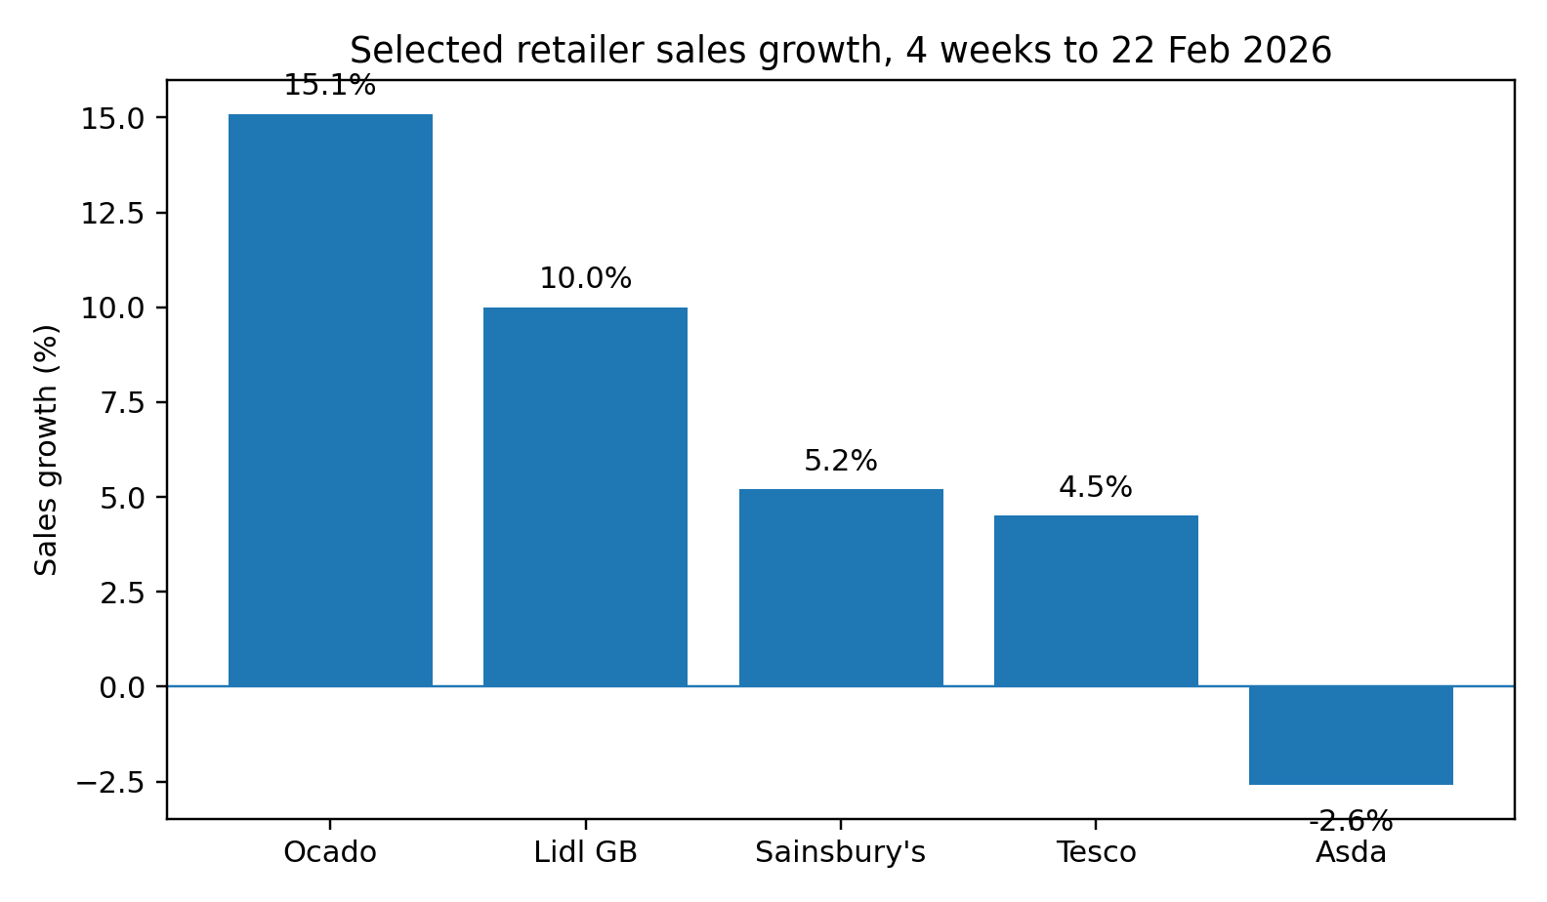
Figure 4. Selected retailer sales growth, four weeks to 22 February 2026
Source: Reuters (2026a), reporting Worldpanel by Numerator.
Three preliminary conclusions can be made about the industry. First, the UK market itself is a large and digital-sophisticated market to lure and maintain strong domestic players as well as international platforms. Second, the success of online retail in the UK is based on operations capabilities and not on the presence of the site. Third, Amazon has a strong ecosystem and weak grocery-specific embeddedness competitive position compared to supermarket incumbents. The following analysis is based on the Porters Diamond analysis.
Table 1. Relative positioning of key firms in the UK online grocery and e-commerce retail industry
Firm | Ownership / origin | Core strategic position | Recent indicator | Key vulnerability
Tesco | UK-rooted incumbent | Scale leader combining store network, loyalty data and omnichannel convenience | UK online sales up 10.2%; online market share up 173 bps to 35% (Tesco, 2025) | Margin pressure from discounters and service-cost intensity
Sainsbury’s | UK-rooted incumbent | Mid-market quality and value proposition with integrated online grocery offer | Online grocery sales up 7% year on year (J Sainsbury plc, 2025) | Need to balance premium cues with affordability
Ocado | UK-rooted digital specialist | Digitally specialised grocery model with strong fulfilment and user experience | Ocado Retail revenue up 15.5% to £2.83bn (Ocado Retail, 2025) | Narrower physical reach and dependence on digital economics
Amazon UK | US multinational | Platform ecosystem built on Prime, fulfilment scale, broad assortment and data capability | UK revenue £29bn in 2024; over 75,000 UK employees (Amazon, 2025a; Amazon, 2025b) | Supplier-regulation scrutiny and weaker grocery embeddedness than incumbents
Source: Author’s synthesis based on Tesco (2025), J Sainsbury plc (2025), Ocado Retail (2025), Amazon (2025a) and Amazon (2025b).

3. Porter’s Diamond Model and the global competitiveness of the UK industry
The Diamond Model by Porter states that competitive advantage at national level is generated by interaction of factor conditions, demand conditions, related and supporting industries and firm strategy, structure and rivalry (Porter, 1990). The model is also applicable since it can be used to explain why certain national environments continually result in firms that are globally competitive. It must, however, not be used in a mechanical way. Subsequent literature has demonstrated that the original framework may understate the importance of multinational networks and external connections, in particular, in open economies (Rugman and Verbeke, 1993; Brouthers, Brouthers and Ensign, 1997). That is why this section takes a critical approach to the framework formulated by Porter instead of a checklist.

3.1 Factor conditions
The UK has high advanced factor conditions of online retail. It possesses a huge consumer base, well developed digital payment systems, well developed transport systems, high internet penetration and advanced professional labour force in the fields of technology, marketing, finance and logistics. They are not inherent natural gifts. They are developed conditions that are created through investment, concentration of the cities, innovative service and retail sector and depth. In the case of online grocery, in England and Wales the population density and metropolitan concentration of the population make the commercial feasibility of home delivery and fast fulfilment models viable. The capability to run fulfilment centres near large population hubs reduces delivery periods and contributes to increased frequency of orders.
Simultaneously, the factor conditions in the UK are not favourable everywhere. The cost of labour, warehousing, property and energy is very high compared to the global standards and recruitment in the field of logistics and fulfilment is subject to inflation of wages and labour supply. These costs are more in grocery than most other categories since basket values may be low and fulfilment complexity may be high. Therefore, the UK is a technologically and logistically favourable environment, yet not the low-cost one. Productivity, density and operational excellence are the key to competitiveness not the low inputs.

3.2 Demand conditions
The UK diamond has a significant strength in the demand conditions. British consumers are digitally savvy, time conscious and used to price and delivery option and service quality comparisons across platforms. The statistics published by ONS that online spending is now 50.5 per cent of all card spending in September 2025 is a powerful indication that online buying behaviour is not marginal (ONS, 2026b). Loyalty systems, subscription offers, click-and-collect, and next-day delivery, and app-based shopping are also highly familiar with the consumers in the UK. These features drive companies to be more innovative with convenience, user experience and fulfilment precision.
But, sophisticated demand does not necessarily imply benign demand. The consumers that appreciate convenience are also highly price-conscious particularly in times of inflation. According to a report published by Reuters, the UK grocery price inflation increased to a new 4.3 per cent in the four weeks up to 22 February 2026, highlighting the current pressure on the cost-of-living, and the value-at-the-point of-sale strategic value (Reuters, 2026a). That is, the UK demand conditions incite innovation yet exert greater pressure on price, service reliability and product availability. It is a tough market that favours good performance and penalises inconsistency.

3.3 Related and supporting industries
UK has a good number of related and supporting industries. These are advanced parcel and courier systems, fintech and card payment systems, cloud and data services, digital ad systems, packaging, and warehousing services, and a profound food supply system. The online retail is dependent not only on a single capability but rather a network of interoperable industries. This system is relatively developed in the UK. Increased digital payments, data analytics, route optimisation and customer relationship technologies enhance the responsiveness of retailers and render omnichannel retailing more feasible.
Firm-level strategy also displays the supporting system. Store networks and supply relationships to Tesco and Sainsbury support their digital offers, whereas the performance of Ocado is based on automated fulfilment and quality of its digital interface. Another indicator that the UK ecosystem is capable of absorbing and making use of large-scale platform investment is the investment programme by Amazon in the UK, such as fulfilment centres, transportation connexions, and wider infrastructure (Amazon, 2025b; UK Government, 2025).
Yet this strength has limits. The support system is so complicated that it is more susceptible to interference. All this can transmit to groceries and pressure on service prices to climate shocks, imported food prices, transport bottlenecks and geopolitical energy risks. The GCA supplier research of 2025 also identified supplier issues of volatility, inflation, climate change and short-termism in the retailer supplier environment (Groceries Code Adjudicator, 2025a). Hence, the associated industries in the UK are robust; however, they are also highly dependent and vulnerable to external instability.

3.4 Firm strategy, structure and rivalry
This is arguably the best aspect in the UK diamond. The competition in the UK grocery and online retail is active, evident and strategically varied. The market is influenced by Tesco, Sainsbury, Asda, discounters, specialists online players and Amazon. The competition in the UK is not based on a single generic formula. Aggression between firms occurs in terms of scale, value, data, assortment, loyalty, speed, convenience and customer experience. This healthy competition will foster national competitiveness as the firms will be compelled to keep on enhancing their operations.
Evidence points to the stiffness of competition in the recent past. Both Tesco and Sainsbury were gaining market share in early 2026, and Ocado was the fastest-growing retailer in the mentioned time period (Reuters, 2026a). Practically, it implies that no company can afford to use either heritage or technology only. Tesco needs to protect value and enhance digital service. Sainsbury has to strike a balance between quality and prices. Ocado needs to transform digital superiority into economies of scale. Amazon needs to demonstrate that the ecosystem scale can also triumph in a grocery context that is defined by trust, habitual and local shopping practises.
This competition is a strength in terms of international business. The reasoning behind this is that high levels of domestic rivalry can increase international competitiveness since the firms are disciplined at an early stage (Porter, 1990). The UK market seems to be appropriate to that proposal. Nevertheless, it requires a critical reading. Competition also squeezes profits, and may disrupt long-term relationships with suppliers or labour unrest. Thus, competition increases the UK competitiveness, yet the competition increases the sustainable profitability threshold.

3.5 Government and chance
Government and chance are the primary keys to the UK case despite being considered secondary factors. Regulation influences the behaviour of big retailers and platforms towards consumers and suppliers. The Groceries Code Adjudicator has taken on a central institutional role particularly with the growth of the Amazon role in the grocery sphere. The government also has a role to play under the labour market policy, data protection, planning rules, business rates, and industrial strategy. Other fortunate accidents like the pandemic, inflation shocks, Brexit friction and geopolitical energy volatility have also impacted on labour, supply chains and consumer demand.
All in all, the Diamond analysis demonstrates that the UK online grocery and e-commerce retail sector is globally competitive since it is characterised by digitally advanced demand, sophisticated support systems, favourable conditions of operation factors and atypically high competition. But the competitiveness does not go smoothly. It is costly, regulatory and operationally intolerant. This implies that the UK is appealing to competent companies, although, they must be large, robust, locally adapted, and institutionally disciplined.

4. Critical evaluation of Amazon UK
Amazon UK is a suitable focal company since it is a large foreign MNE that is large, and has operations in the country-industry combination of choice, but does not fit well into the conventional supermarket paradigm. This brings about analytical value. The strengths of Amazon such as platform breadth, the lock-in of Prime, fulfilment scale, and data capability are evidently relevant in the UK e-commerce. The more difficult question is whether those strengths can be easily transferred into the long-term success in the UK grocery-related retail setting. In order to provide the answer to that question, in this section, the attractiveness of UK market to Amazon is assessed based on political, economic, legal and cultural factors, and the strategic fit is also evaluated.
It is a good place to begin by the fact that market attractiveness is not synonymous with market ease. The CAGE logic by Ghemawat is a reminder to managers that despite the fact that a foreign company might have entered a seemingly familiar market, significant differences between cultures, administration and economy continue to influence the competitive results (Ghemawat, 2001). The home country of Amazon is the United States, which has a language similarity with the UK, a lot of legal customs, and widespread consumer knowledge. At a glance, therefore, distance appears constrained. However, there are unique institutions, anticipations and control systems within the UK grocery environment that make entry seem less straightforward than it may appear.

4.1 Political and policy factors
Politically, the UK is appealing to Amazon due to the fact that it is a fairly consistent, and rule-based market with robust property rights, predictable institutions and a government that still welcomes large-scale investment. The fact that the UK government publicly supported the PS40 billion investment plan of Amazon in 2025 can be considered an indicator that the company is still considered as an important factor in the economic landscape of the country in terms of job creation, infrastructure and regional growth (UK Government, 2025). In the case of Amazon, this is important since long term investment in fulfilment centres, transport and digital infrastructure needs policy stability.
The UK, however, is a country with a wider interest in the strength of large digital companies and in equity within the retail economy, which qualifies political attractiveness. Huge platforms have now become political participants, and Amazon is frequently drawn into the discussion of taxation, labour conditions, business rates, treatment of suppliers and the health of high-street retail. This does not turn the UK into a politically unfriendly place, but it does imply that Amazon is placed under more extensive public and institutionalised scrutiny compared to a traditional retailer with a simpler business framework. Political legitimacy is thus a strategic concern in itself.

4.2 Economic factors
The UK is still one of the most significant foreign markets of Amazon in economic terms. The size of the opportunity is confirmed by the self-disclosures of Amazon which state that the UK revenues amounted to PS29 billion in 2024 (Amazon, 2025a). The online channels are also still supported by the wider UK retail market with ONS data indicating robust online penetration (ONS, 2026a; ONS, 2026b). These are good pointers of market appeal. Amazon has the advantage of having a population that has already been initiated into digital purchasing, subscription and expedited delivery. This saves customer education expenses and enables the company to concentrate on share capture and ecosystem deepening as opposed to fundamental market creation.
Maturity is however a limitation to economic attractiveness. The UK is not a market in the first stages where a first mover can expand without significant opposition. It is a developed market where all incumbents, discounters and digital experts compete fiercely. The inflation of 4.3 per cent of the grocery in early 2026 is also the reflection of the household budget strain and the further relevance of value competition (Reuters, 2026a). In the case of Amazon, it implies that scale will have to be transformed into perceived customer value. Unless the company is able to demonstrate how its offer would enhance the convenience and affordability, particularly in relation to their frequent purchases of groceries, customers still have an option of using Tesco, Sainsbury or discounters.
Another constraint of the economy is the cost structure. Quick fulfilment and grocery are costly to operate. The cost of labour and property in the UK is high and profitability is difficult to achieve, and the demands in terms of services are high. These pressures can be absorbed more efficiently by Amazon than most of their competitors due to the fact that fixed investments are distributed through a wider ecosystem of marketplace retail, advertising, subscriptions and cloud-related capabilities. However, grocery economics is not very lenient as compared to third-party marketplace sales economics. This undermines the naive belief that the overall scale of Amazon is automatically a guarantee of excellent grocery performance.

4.3 Legal and regulatory factors
One of the most significant variables that can influence the success of Amazon UK in the future is the legal aspect. The legal environment in the UK safeguards the consumers and market players, yet it also subjects other strong retailers and platforms with responsibilities. The present state of affairs with the Groceries Code Adjudicator is of particular importance to Amazon as it directly addresses the question of whether Amazon is capable of acting as a legitimate participant in the grocery-sector or it can be seen as a disruptive outsider.
The GCA initiated an inquiry against Amazon in June 2025 on suspicion of delays in paying its suppliers under paragraph 5 of Groceries Supply Code of Practise (Reuters, 2025a). The regulator said that the investigation would look at the time before Amazon was called by its current name in March 2022 to June 2025 and determine whether the payment practises, dispute handling and deductions process employed by Amazon were in compliance. This is a strategic issue since slow payment systems may hurt supplier cash flow, dishearten innovation and foster lack of trust in the operating model of the retailer.
The importance was increased after the GCA 2025 supplier survey reported that Amazon was once again last in the 14 selected grocery stores on net consistently or mostly adhering to the Code. Amazon scored 66.42 per cent on that metric, which is significantly lower than all the other assigned retailers, despite the fact that this was an increase relative to the previous year (Groceries Code Adjudicator, 2025a). Legal exposure is not the only problem in this case. It is institutional legitimacy. Suppliers in grocery are not inactive inputs. Operation capability in itself includes strong relationships with suppliers that are trusted. In case Amazon is regarded as administratively challenging, transactional or slow in resolving conflicts, its scale advantage may be compensated by lower relation quality.
The broader legal questions are also broader. The environment that Amazon is working in is a data-intensive one, and consumer trust is attributed to privacy, security and transparency. Singh et al. (2024) demonstrate that the trusting beliefs about e-commerce platforms are closely linked to the information integrity, confidentiality and consumer awareness of privacy protection. In the case of Amazon UK, this implies that compliance is not just a formal legal need. It belongs to customer retention and recurrent buying. Law and perceived credibility in a digitally mature market like the UK are business-level constructs.

4.4 Cultural factors
Amazon has a high level of compatibility with the UK market culturally. The cultural distance is decreased by the common language, years of exposure to the Anglo-American consumer culture, and the high level of digital penetration in the UK. According to the framework offered by Hofstede, the UK is characterised by a high individualism and comparatively low power distance, which also corresponds to the consumer environment where autonomy, convenience, self-service and efficiency in transactions are valued (Hofstede and Hofstede, no date). The model of Amazon would suit these preferences. A low-friction, choice rich shopping experience is facilitated by prime, personalised recommendations, simple search, wide assortment and fast delivery.
However culture fit online grocery cannot be overrated. The UK shopping is rather routine, trust-based and combined with weekly buying habits, familiarity with local stores and brand demands. This is more beneficial to the incumbents like Tesco and Sainsbury whose brands are inseparable in the day to day food shopping. The convenience strength of Amazon does not necessarily mean the same level of emotional or habitual embeddedness in grocery. In addition, even national-culture models are limited. McSweeney (2002) also decries the propensity to consider national culture scores as deterministic, and the criticism is pertinent here. The consumers in the United Kingdom are not uniform culturally. Shopping behaviour is determined by age, class, region, urban density and household structure. Thus, culture must be viewed as a situational force and not an explanation.
A more down-to-earth explanation is that the UK culture facilitates Amazon in terms of the overall e-commerce since people appreciate convenience, speed and self-directed digital choice. In grocery, there is a philtre of cultural acceptance through trust, value perception and routine. It implies that Amazon will be able to fit the British convenience culture, and yet stay less central than the established grocers in the daily food purchase.

4.5 Strategic fit and competitive position
Amazon has a good strategic fit in the UK market in a number of aspects. To begin with, UK is already broad enough and digitally developed enough to warrant ecosystem-based competition. Prime is also especially significant as it reduces the marginal cost of repeat activity in several categories. Second, the investments in fulfilment and delivery at Amazon support the service proposal and increase the entry barriers. Third, the intense and crowded market in the UK is rewarding when it comes to data-driven optimisation, which is an appropriate fit to the operating model of Amazon.
Strategic fit is however not similar to strategic completeness. Amazon performs best where diversity, search, subscriptions and delivery speed are considered. It is less obviously dominant in the areas where fresh food, regular replenishment, collaboration with suppliers, and grocery trust are the key aspects. The areas are structural strengths of Tesco and Sainsbury, and the digital expertise of Ocado in the field of grocery is also a significant force. This implies that the strength of Amazon in the UK can be characterised as a powerful but asymmetric one. It does not have the natural ownership of all the value chain.
Another significant conflict between the logic of scale in Amazon and the UK grocery ecosystem norms also exists. Standardisation of processes is an activity that the company commonly engages in to compete, utilising data and increasing the intensity of operation control. However, the GCA evidence suggests that the supplier-facing systems and dispute mechanisms may cause tension when applied to grocery relationships (Groceries Code Adjudicator, 2025a; Reuters, 2025a). That is, the efficiency of the operation may conflict with the relational demands of a highly controlled grocery industry. To have long-term resilience in the UK grocery-proximate market, Amazon must not only possess a better infrastructure but also more robust institutional accommodation.

4.6 Critical judgement
Cumulated, the evidence indicates that the UK is still a good market to Amazon UK, although this attractiveness is relative and not absolute. The UK is a scale, infrastructure, investment support and digitally advanced demand, both politically and economically. It has significant legal and institutional burdens that can limit offensive platform-style operating patterns. It encourages convenience-based digital shopping, culturally, yet grocery behaviour remains biassed toward familiar existing and established players and familiar value.
The most significant conclusion is thus not that Amazon will probably not succeed in the UK. That would not be realistic considering its size, resources and ecosystem richness. The more robust finding is that success in the future will be determined more by the concept of legitimacy, supplier control and strategic responsiveness in a highly scrutinised market that has already been penetrated and made known to the target audience. Amazon UK is in a good place to be one of the top digital retailers, but its comparative advantage in the UK online grocery and e-commerce sector will be maximised where it integrates platform efficiency with institutionally plausible market behaviour. Unless it considers grocery as another transactional category, its growth ceiling will not be as high as its broad e-commerce capabilities would imply.
Table 2. Summary PESTLE view of Amazon UK in the chosen market
Factor | Evidence | Implication for Amazon UK
Political | Stable investment environment, but strong public scrutiny of large digital firms; UK government publicly backed Amazon’s £40bn investment plan (UK Government, 2025). | Supports long-term infrastructure investment, but legitimacy must be actively managed.
Economic | Large digital market, with online retail still 28.3% of total retail sales in December 2025 (ONS, 2026a). | Sustains demand for Prime, fulfilment and marketplace retail, but growth comes with mature-market competition.
Legal | GCA investigation into alleged delayed supplier payments; Amazon ranked lowest designated retailer on supplier Code compliance in 2025 (Groceries Code Adjudicator, 2025a; Reuters, 2025a). | Supplier governance and compliance are strategic, not peripheral, issues.
Cultural | High digital familiarity and convenience orientation support Amazon’s model, but grocery shopping remains habitual and trust-based (Hofstede and Hofstede, no date; McSweeney, 2002). | Amazon fits UK convenience culture, but must adapt to grocery-specific trust expectations.
Technological / ecosystem | Strong UK logistics, payments and data ecosystem, plus Amazon’s own fulfilment and investment programme (Amazon, 2025b). | Reinforces service speed and scale advantages.
Source: Author’s synthesis based on cited sources.

5. Conclusion
This report has assessed the competitiveness of the online grocery and e-commerce retail segment in the UK and opportunities of Amazon UK in that environment. The facts indicate that UK is a very lucrative yet challenging market. Its advantages are digitally mature individuals, large expenditure on the internet, well-developed support sectors and stiff domestic competition. The diamond by Porter thus describes much of the competitiveness of the industry particularly due to the advanced level of demand, robust ecosystems and sustained competition. Meanwhile, it also requires a critical reading since it is not in terms of low inputs and lax regulation that the UK is competitive. It is grounded on the productivity, density, innovation and constant adaptation.
The analysis of the major companies reveals that Tesco, Sainsbury, Ocado and Amazon are strategically placed differently but similar. Tesco and Sainsbury still have a strong sense of grocer legitimacy and physical integration; Ocado demonstrates the enduring value of a digitally specialised grocery model; Amazon delivers platform breadth, scale of fulfilment and ecosystem lock-in. Amazon UK thus has strong advantages to play in the market, which are not guaranteed by inherent dominance in all subsegments.
The company analysis indicates that the UK is still appealing to Amazon due to political, economic and demand-side factors, but its long-term success is predetermined by legal and institutional ones, in particular, supplier relations and compliance specific to the industry. Amazon has a cultural alignment that will support the convenience proposal, but still, the routine grocery shopping will prefer established players. The conclusion is that Amazon UK will probably continue to be a significant player in the British online shopping sector, however, the long-term viability of success in the online grocer and online commerce retail sector comes with the capacity to integrate scale and technology with regulatory plausibility, relationship ability and local strategic responsiveness.

Section 2. Reflective account using Gibbs’ Reflective Cycle

Description
Section 1 preparation is a process that started with a strategic topic-selection decision as opposed to writing. The short needed a combined country-industry report, a Porters Diamond analysis, a specialised assessment of a foreign multinational and a methodical reflection. My initial assignment was hence to find a topic that was based in the UK and would substantiate all these needs with solid evidence by the people. There were other options, such as UK automotive manufacturing, UK fashion retail, but I had chosen the online grocery and e-commerce retail industry due to the possibility of rich current data, clear comparison of domestic and foreign firms, and the presence of the foreign multinational, Amazon UK, whose position could be studied in terms of political, economic, legal and cultural factors. The research procedure subsequently proceeded in four phases which include, scoping the industry frontier; assembling existing market, company and regulatory information; synthesising scholarly frameworks; and writing a consistent argument instead of a narrative account.

Feelings
When I began the process, I was sure that an issue in the UK could be globalised, but I knew about two threats as well. The first danger was that the report would become too descriptive since retail generates too much news and company commentary. The second was that, in the case of Amazon and UK grocery, the company may be overemphasised in the role it plays unless I assumed all of the aspects of UK online retail were directly comparable to grocery competition. I thus had a desire to be conceptually disciplined. I also realised that UK retail is a known ground and this could be of assistance and peril. Familiarity may be helpful in interpretation, but also it may stimulate unjustified assumptions. This consciousness influenced my choice of sources and the analysis.

Evaluation
Some of the aspects of the research process were successful. The former was starting with the assessment framework and marking standards instead of the separate sources. This facilitated the consideration of whether every evidence was useful in the assignment. The use of the ONS retail and card-spending data, as an example, was valuable since they were not only up to date and official, but also they provided direct support to the industry overview and Porters demand-side analysis. On the same note, annual reports of Tesco, Sainsbury and Ocado were more insightful in a strategic manner compared to the generic media commentary since they indicated how the companies reflected their own online development, capabilities and priorities.
The choice to deploy the regulatory relationship between Amazon and the Groceries Code Adjudicator as a key element of the company analysis was also a positive factor. This shifted the report off the generic discussion of market size and innovation and to a more critical discussion of legitimacy, supplier governance and legal exposure. It also assisted me in meeting the brief requirement to address the political, economic, legal and cultural factors through proper frameworks.
What was not as effective was the issue of delimiting industry boundaries. Amazon is engaged in the UK e-commerce in numerous categories, and the grocery aspect is significant and institutionally unique. I was forced not to generalise marketplace success with grocery success. This demanded constant paring down of the wording and argument to ensure that the report was logical.

Analysis
The model developed by Gibbs promotes the deeper explanation of the reasons why things happened the way they did instead of merely writing them down (Gibbs, 1988). The greatest lesson learned during the research process was the value of triangulation. There was no one source type which was adequate. Strategic positioning was informed by the official statistics that set scale and trend; information in company reports were used to cast light on it; institutional constraints were known through regulatory material and conceptual discipline was created through academic literature. The report would have been less strong without triangulation. As an example, had I primarily used corporate statements, the position of Amazon in the UK would have been virtually all good. Had I used solely news regarding regulators, the analysis could have been too compliance-oriented. The mixture of the two permitted a more delicate judgement.
It was also demonstrated in the process that the theoretical frameworks are most effective when they are treated as a lens, but not as templates. The Diamond of Porter was used to organise the industry analysis, but scholarly criticisms of the model made me remember that multinational networks and cross-border linkages are not insignificant, particularly in an open economy. This promoted a critical application. Similarly, Hofstede gave me a point of departure in my thinking about the UK consumer culture but the critique of national culture models given by McSweeney did not allow me to apply those dimensions as explanatory determinants. I came to know that postgraduate level entails the use of frameworks that are not only disciplined but also self-critical.
The other valuable lesson is the connexion between the existing evidence and the long-term theory. The international business assignments may in some cases alienate theory and reality with classical models in one part and present events in the other. In this assignment, I discovered that the most convincing analysis was achieved when theory and evidence were combined paragraph by paragraph. As an example, the demand conditions were discussed more intensively when the ONS data on online spending were directly related to the concept proposed by Porter that advanced home demand encourages companies to innovate. On the same note, the legal analysis gained greater strength as the regulatory evidence of Amazon supplier practises was linked to the broader IB query of whether the capabilities of a foreign multinational can be institutionally transportable across settings.
The reflective phase also helped me to get more conscious of the gap between market desirability and operating success. Initially, I was tempted to look at a huge digital market as something naturally appealing to Amazon. The study altered the perception. UK is appealing, albeit conditionally. It is also established, expensive and closely inspected. This solidified a larger point of international business analysis that companies do not enter into abstract markets, but into institutional and competitive systems.

Conclusion
On the whole, the research and report writing experience helped me to enhance my knowledge of how to construct a postgraduate business argument based on several kinds of evidence. I also learned that the final analysis is largely dependent on the choices made before one starts writing the draught, in particular, choice of topic, scoping and source hierarchy in the industry. I also got to know that critical writing is not realised by merely adding negative points. It involves balancing the opportunities and limitations and identifying the places where seemingly good benefits may be having some hidden flaws.
To make the process even better I would start earlier with a formal source matrix that would have classified every source according to purpose, reliability and relevance according to section. This would facilitate the process of establishing evidence gaps prior to writing. I would also develop a more elaborated note system on separating between company claims, regulator findings and independent media interpretation. That would enhance transparency in work in the future.

Action plan
There are three practises that I will embrace in future business assignments in the international field. To begin with, I will draught a source map prior to writing so as to differentiate between official information, company disclosures, independent reporting and scholarly literature. Second, I will ensure that every framework is subjected to at least one critique to make the analysis not formulaic. Third, I will write tentative statements of argument in each section, and then start gathering too much detail which should help avoid overflowing in description. Using these steps is likely to enhance the coherence, depth and critical confidence of future reports. The usefulness of Gibbs cycle here is that reflection can be used as a retrospective summary instead of a plan to improve their scholarly practise (Gibbs, 1988).

References
Amazon (2025a) 2024 economic and tax contributions in the UK. Available at: https://assets.aboutamazon.com/4b/e4/d4bf87a447beaa13b108eb82cfcd/uk-tax-report-2025.pdf (Accessed: 8 March 2026).
Amazon (2025b) Amazon announces plans to invest £40 billion in the UK. Available at: https://www.aboutamazon.co.uk/news/job-creation-and-investment/amazon-40-billion-uk-investment (Accessed: 8 March 2026).
Amazon.com, Inc. (2025) Annual report 2024. Available at: https://s2.q4cdn.com/299287126/files/doc_financials/2025/ar/Amazon-2024-Annual-Report.pdf (Accessed: 8 March 2026).
Brouthers, K.D., Brouthers, L.E. and Ensign, P.C. (1997) ‘Explaining national competitive advantage for a small European country: a test of three versions of Porter’s diamond’, International Business Review, 6(1), pp. 53-67.
Ghemawat, P. (2001) ‘Distance still matters: the hard reality of global expansion’, Harvard Business Review, 79(8), pp. 137-147.
Gibbs, G. (1988) Learning by doing: a guide to teaching and learning methods. Oxford: Further Education Unit, Oxford Polytechnic.
Groceries Code Adjudicator (2025a) The Code and supplier experiences 2025. Available at: https://assets.publishing.service.gov.uk/media/68dd577ec487360cc70ca001/YouGov_slides_-_GCA_Annual_conference_2025.pdf (Accessed: 8 March 2026).
Hofstede, G. and Hofstede, G.J. (no date) 6D model of national culture. Available at: https://geerthofstede.com/culture-geert-hofstede-gert-jan-hofstede/6d-model-of-national-culture/ (Accessed: 8 March 2026).
J Sainsbury plc (2025) Annual report and financial statements 2025. Available at: https://corporate.sainsburys.co.uk/media/e1lfnybd/sainsbury-annual-report-and-financial-statements-2025.pdf (Accessed: 8 March 2026).
McSweeney, B. (2002) ‘Hofstede’s model of national cultural differences and their consequences: a triumph of faith, a failure of analysis’, Human Relations, 55(1), pp. 89-118.
Ocado Retail (2025) Annual report and financial statements for the 70 weeks ended 1 December 2024 and the 52 weeks ended 30 November 2025. Available at: https://ocadoretail.com/wp-content/uploads/2025/09/OCADO-ANNUAL-REPORT_2025.pdf (Accessed: 8 March 2026).
ONS (2026a) Retail sales, Great Britain: December 2025. Available at: https://www.ons.gov.uk/businessindustryandtrade/retailindustry/bulletins/retailsales/december2025 (Accessed: 8 March 2026).
ONS (2026b) Consumer card spending, e-commerce and digital trade insights in the UK: 2019 to 2025. Available at: https://www.ons.gov.uk/economy/nationalaccounts/balanceofpayments/articles/consumercardspendingecommerceanddigitaltradeinsightsintheuk/2019to2025 (Accessed: 8 March 2026).
ONS (2026c) Retail sales, Great Britain: January 2026. Available at: https://www.ons.gov.uk/businessindustryandtrade/retailindustry/bulletins/retailsales/january2026 (Accessed: 8 March 2026).
Porter, M.E. (1990) The competitive advantage of nations. New York: Free Press.
Reuters (2025a) ‘UK grocery watchdog probes Amazon over alleged supplier payment delays’, 20 June. Available at: https://www.reuters.com/sustainability/boards-policy-regulation/uk-grocery-watchdog-probes-amazon-over-alleged-supplier-payment-delays-2025-06-20/ (Accessed: 8 March 2026).
Reuters (2026a) ‘UK grocery inflation edges higher to 4.3%, says Worldpanel’, 3 March. Available at: https://www.reuters.com/business/retail-consumer/uk-grocery-inflation-edges-higher-43-says-worldpanel-2026-03-03/ (Accessed: 8 March 2026).
Rugman, A.M. and Verbeke, A. (1993) ‘Foreign subsidiaries and multinational strategic management: an extension and correction of Porter’s single diamond framework’, Management International Review, 33(2), pp. 71-84.
Singh, N., Misra, R., Quan, W., Radic, A., Lee, S.-M. and Han, H. (2024) ‘An analysis of consumer’s trusting beliefs towards the use of e-commerce platforms’, Humanities and Social Sciences Communications, 11, 899. Available at: https://doi.org/10.1057/s41599-024-03395-6.
Tesco plc (2025) Annual report and financial statements 2025. Available at: https://www.tescoplc.com/media/ky0bfwpo/tesco_ar25_interactive.pdf (Accessed: 8 March 2026).
UK Government (2025) (Accessed: 8 March 2026).

