Keyworkers Handbook to Support Children Through Transitions

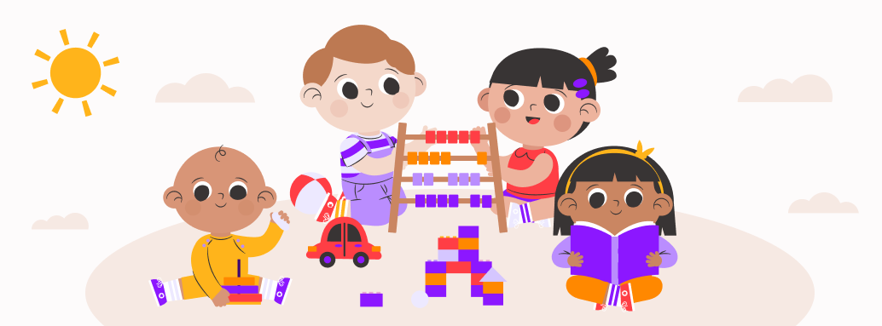
(Source: Parent 2023)

Contents

Induction

This guide is intended to aid childhood professionals in assisting children as they move from one stage to another. The guide explores the meaning of 'transition', the role of adults, the needs of children, the learning environment, the value of partnerships, and practical methods for professionals to aid in these transitions and desired outcomes for children. Practitioners will find important information about child development and the underlying theories behind modern practice in this guide

What is a transition?
A transition is a change from one thing to another. In early years this could involve changes in keyworkers, environments, routines and much more. ​‘’Transitions are the moves children and young people make from home to an early learning and childcare (ELC) setting, from there to primary, from stage to stage, from primary to secondary, between schools and from secondary to further education and beyond.’’ Education Scotland (2023). From a contemporary standpoint, transition is viewed as a slow and steady process, much like a journey, rather than a one-time event centred around a child's first day at nursery. The transition process goes beyond the first day and continues until the child has completely adjusted. Twinkl (2023)states A transition is a period of change, from one significant stage or experience, to another.
During the formative early years of childhood, children undergo significant developmental transitions, and it is important that everyone involved with the child works together to provide support. According to PACEY (2016) should be seen as a journey or process that together children, parents/carers and practitioners can be involved in.

The Needs of the Child
To meet a child's needs, you must first understand what they are. Every child is individual; therefore, their needs are also individual. However, each child have similar basic needs, according to Maslow.

Establishing and maintaining successful relationships with individuals, especially when working with children, requires effective communication. The process of effective communication can be hindered by a multitude of factors. Certain children may be non-verbal and have unclear body language when they are feeling discomfort. Children encounter difficulties in communicating their emotions when they are feeling anxious, fearful, or overwhelmed. Some children may not speak and show unclear body language when they are uncomfortable. Spotting the symptoms of anxiety or distress in a child is a talent that is often gained through professional education and practical experience among experts. They have a wide range of methods and actions to successfully manage and reduce the child's worries.

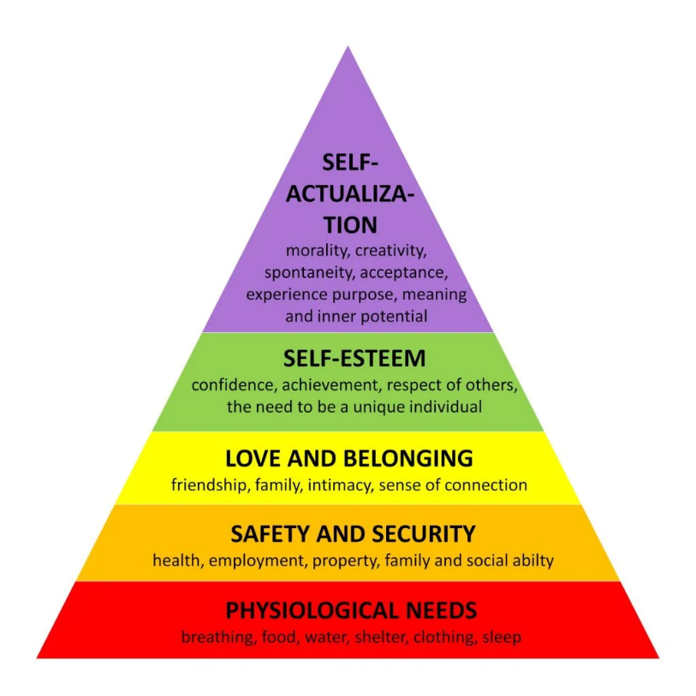
(Simple Psychology 2023)

Role of the Adult

Environment

Partnerships

Interventions

Proposed Outcomes

Reference List
Education Scotland (2023) What are Transitions? Available at: https://education.gov.scot/parentzone/my-child/transitions/what-are-transitions (Accessed: 27th November 2023)

PACEY (2016) Transitions and Settling in. Available at: https://www.pacey.org.uk/Pacey/media/Website-files/PACEY%20member%20practice%20guides%20(PDFs)/PG10-transitions-and-settling-in.pdf (Accessed: 18th November 2023).

Parent (2023) Smooth Transitions: Effective Strategies for Helping Children Adapt to a New Daycare. Available at: https://www.parent.app/blog/effective-strategies-for-easing-your-childs-transition-to-new-daycare (Accessed: 18th November 2023)

Simple Psychology (2023) Maslow’s Hierarchy Of Needs. Available at: https://www.simplypsychology.org/maslow.html (Accessed 21st November 2023)

Twinkl (2023) Different Types of Transitions in Child Development. Available at: https://www.twinkl.co.uk/blog/different-types-of-transitions-in-child-development(Accessed 18th November 2023)

