Did the Dambuster Raid “chastise” the Germans: Evaluating the success of Operation Chastise.

Rachel Marsh
Dissertation submitted in partial fulfilment
of a B.A. (Hons.) in History and Archaeology
University of Wales Trinity St David
May 2019

Abstract
In the 76 years since Operation Chastise took place, on the night of the 16/17th May 1943, there has been continued debate on every part of the mission; which has long since become a part of British culture. Famous in books, screen and even music, everybody has heard of the ‘Dambuster raid’ as it has become immortalised. The inspiration for this essay stemmed from the commemorations surrounding the 75th anniversary in May 2018, with the publication of a slew of new articles, books and documents to satisfy public interest in the mission. Despite all this interest, controversy still remains, and historians are unable to reach consensus on many of the simplest issues. The largest of all these is whether Chastise can be considered a successful mission at all, with many arguing that the loss was not worth the cost, and others arguing the exact opposite.
This dissertation aims to examine this issue in detail, and to attempt to come to a decision as to the success of the operation. This has been done by analysing the mission’s effects and how it was perceived at the time. The controversy is nothing new, from the moment the first Upkeep bomb was dropped, the authorities of both Britain and Germany were evaluating its worth, and this debate has only grown as new information becomes available.
Analysis will be divided into four chapters, each focusing on a different aspect of the raid. The first, a descriptive overview is important for gauging the context of the mission to provide a steady background for the evaluation of the raid. Chapters two and three will discuss the short- and long- term impacts of the operation, comparing different known effects with the historical debate and published report data from both countries. The final chapter concerns the way Germany perceives Chastise, both contemporary to the raid itself and with the modern German populous, shaped by decades of peace and commercial interest. Through this analysis, it is hoped to provide insight as to whether Operation Chastise was a success or not, and to evaluate to what degree this success is in evidence.
Historical documents, both British and German have been compared to show the differences in official estimates for each nation, though due to the very nature of the attack it is impossible for any report issued to be completely accurate. Some documents have not survived to the present day, and some aspects never documented; whilst some of this missing information can be surmised from other documents or from survivors, other information is lost. This missing or occasionally contradictory information perhaps goes some way to explaining why there are so many differing views on the outcome.
This dissertation will show that whilst Operation Chastise cannot be considered an unqualified success, meeting all the optimistic hopes of the British planners, it was also by no means a failure. Two primary targets were destroyed having a significant effect on the German ability to wage war, the infrastructure of the Ruhr region and on German morale.

Acknowledgements
Enormous thanks go to my family, for bribing me with ice cream and chocolate to make me work, for listening as I tried to work out my arguments and for valuable proof-reading of this dissertation, especially since you must all have got bored by November. Proof reading credit is also due to Neil McDonald. For my goldfish, for listening to me vent about difficulties.
Thank you to my friends for their moral support, and for allowing me to bore them to tears when trying to work with them. My dissertation owes a lot to the ideas discussed between us when we were discussing our projects.
Special thanks are owed to Dr. Alexander Scott, for his patience and help in supervising this dissertation. The feedback given has been invaluable. Also a debt of gratitude for the support and advice given over these three years at Lampeter.
To my friends at Brooklands Museum, Weybridge who kickstarted an interest in the Dambusters at age 14, this dissertation serves as an indicator that I do indeed listen when people tell me things, and that university is not a waste of time.
To the fine people at r/AskAcadamia (reddit) for advice on minor points of phrasing.

List of Figures

Figure 1: A reproduction Upkeep on Display at the RAF Museum………………………………………11
Figure 2: Damage to the town of Affoldern, below the Eder………………………………………………15
Figure 3: The Mohne before the attack………………………………………………………………………………17
Figure 4: The Mohne the morning after Operation Chastise……………………………………………….18
Figure 5: The 617 Squadron Crest……………………………………………………………………………………….40

Table of Contents

- Title Page …………………………………………………………………………………………………………………1
- Abstract…………………………………………………………………………………………………………………….2
- Acknowledgements…………………………………………………………………………………………………..3
- List of Figures……………………………………………………………………………………………………………4
- Introduction: An Overview of Operation Chastis……………………………………………………….6
- Chapter 2: The Immediate Aftermath of the Mission………………………………………………12
- Chapter 3: The Long-Term Effects of Operation Chastise…………………………………..……25
- Chapter 4: The German Perspective of the Mission……………………………………………….31
- Conclusion………………………………………………………………………………………………………………39
- Bibliography……………………………………………………………………………………………………………42

Introduction: An Overview of Operation Chastise
Operation Chastise, more commonly known as the “Dambusters mission” was one of the smallest airborne missions of the Second World War, but undoubtedly it is also one of the most famous. As will be argued in this essay, it was also one of the conflict’s most significant airborne operations. On the night of 16-17th May 1943, nineteen Lancaster bombers of the newly-formed formed 617 Squadron, each carrying a specially developed “Upkeep” mine, took off with a monumentally important task to complete. If achieved, the planners – senior officials in the War Cabinet, and military, Sir Arthur ‘Bomber’ Harris among them; were sure the war would be shortened drastically. Primarily the force were to destroy the Mohne, Eder and Sorpe dams of the Ruhr in order to cause flooding and deny valuable water and electricity to the enemy to curb production of war materiel and raw resources. If, as planners hoped, spare bombs were still available after these attacks, three secondary targets, the Ennepe, Lister and Diemel would also be struck.
Eliminating these targets would cripple the war production of the Ruhr, Germany’s Industrial heartland beyond repair. The Mohne and Sorpe in particular were highly valued targets – a Ministry of Economic Warfare study independently recommended destroying both, writing that this was ‘worth much more than twice the destruction of one.’ The Ruhr produced 80% of Germany’s coal and 75% of its steel among other resources, and produced much of the war materiel as well, though it also boasted much of Germany’s infamous flak. A chance to wreak widespread devastation rather than ineffective costly repeated missions, was a brilliant opportunity for Bomber Command. It was also intended to have an impact on morale; both British and German. The former would receive a much needed boost, and regain trust in a Command that needed to make a visible difference; whilst the latter would suffer from lack of water, and widespread flooding. Harris also expected that there would be a crisis of confidence as he surmised Germany’s leadership would be blamed along with the physical perpetrators.
On the morning of the 17th May just eleven of the Lancasters would return to Scampton, having successfully destroyed the Mohne and Eder dams, and having damaged the Sorpe. It was initially hoped that cracks had been caused in the Sorpe’s concrete core that would develop into a breach; but this was not to be. Two of the secondary objectives had also been targeted by the mobile reserve of 5 Lancasters, but neither was hit – and controversy remains over whether an attack was made against the Diemel or had been mistakenly made against the Bever. Three aircraft, of which two were bound for the Sorpe were forced to return to base over the course of the mission, meaning that actual force was 16 aircraft, of which half were downed in the raid - a 50% casualty rate. The official 42% casualty rate, including the other three aircraft is little better, still indicating a mission gone wrong: a failure in terms of losses.
None of the original operation orders still survive for Chastise, also known as Operation Downwood. However there are a number of sources that can be used to piece together what happened on the mission. Post mission documents, especially detailed analysis have survived and provide insight as to how the operation was seen to occur. Survivors among the Dambusters and interviews with the planners can attest both to how the mission was supposed to occur, and to how this differed from what actually did happen. There were, as in any mission, things that did not go to plan in Operation Chastise; some the fault of the planners, others the squadron and some to which no fault can to be attributed. German reports and post-war analyses have also been used to piece together a detailed timeline of Operation Chastise. However there remains controversy on a number of issues; for instance, whether Young caused a small breach at the Mohne; and whether it was the Diemel or the Bever attacked by a reserve force crew. Other less vital questions, such as what colour the weapon was painted also remain points of contention among historians.
Chastise had been planned in just eleven weeks, from the greenlighting of the Upkeep weapon, before even finalised drawings had been made, due to the incredibly small window of opportunity – a short period of full moon and maximum water level occurring at the beginning/mid May. Any delay beyond this would make the mission pointless as the weapon would be ineffective. Even as 617 were undergoing training for given parameters of 150ft altitude and 300mph Wallis was redesigning the weapon and changing the drop parameters to stop Upkeep from disintegrating on impact. The final requirements would be 60ft and 232mph, helped by special modifications including a pair of Aldis lights mounted to converge in a figure of eight at exactly 60ft. The weapon, modified Lancaster and operations plan were all designed in these eleven weeks – an incredible undertaking. 617 trained at ultra-low altitude for formation flying; absolutely unheard of; and crews were held to the highest standards of secrecy, navigation and bombing accuracy, all absolutely vital skills for such a mission. Crews varied from the experienced, medalled crews famed in the film and indeed originally sought by the planners; to crews who had completed just a few combat missions. Standards were still incredibly high, even though a few members did not reach the squadron until April, crews who didn’t make the grade were replaced; contrary to the film’s conviction of expert personnel who fell into place immediately.
Operation Chastise was a mission fought up to the last minute in many ways. With the weapon, planes and squadron ready, final authorisation had still not been given even as the opening for a successful attack narrowed in early May. In order to succeed scientists calculated that the water level in the dams must be no more than 5% off maximum capacity for full effectiveness. However on the 14th May, well into the possible attacking period, the Vice-Chiefs of Staff still disagreed on whether to use the weapon at all. The Upkeep weapon had been developed in tandem with Highball, a similar weapon intended for Naval use, and the stalemate came from the need for secrecy for both weapons – the Navy were keen that Upkeep should wait for their weapon to be ready, yet the RAF had only a small window. With no consensus reached the matter was urgently referred to the Chiefs of Staff – then meeting with their American counterparts in Washington – to make the decision. The Chiefs of Staff authorised Chastise late on 14th May; to make place on the next suitable night. Even as this was approved the priority of the targets was still being argued – one last-resort target; the Henne was scrapped due to proximity with flak protected towns. The Sorpe despite being considered one of the two most valuable German dams was relegated to a ‘diversionary target’ for five of the lesser crews so that the Mohne and Eder could be attacked by the ‘main force’ of nine Lancasters. The next morning 617 were given their “warning order” that the mission was imminent, and briefings began, though the vast majority of the squadron still did not know what the targets would be, with most believing it would be the Tirpitz. On the 16th May the final version of the Operation Order was issued and the crews were finally briefed. It was because of this updated order not surviving, Dildy claims, that confusion stems among many historians about what happened; though since every other historian consulted for this essay comes to more or less the same timetable, it is more likely that Dildy is the confused party.
On the afternoon of 16th May crews attended what many termed the ‘longest briefing of their lives’. Nothing was recorded of this briefing, everything known comes from the recollections of those present. George ‘Johnny’ Johnson remembered finding out the target on the day, being tasked with pinpoint accuracy, and swore Wallis said it would take ‘six bombs to crack the Sorpe’ but that a crack could develop into a breach. The requirements were covered in exhaustive detail and crews shown models of the Mohne and Sorpe to aid the bombing run, though no model of the Eder was available as its classification as a main target came too late to have one ready. Other details such as ingress/exit routes and radio protocol, were finalised; and interestingly the meteorological briefing mentioned no wind over the North Sea. Later on winds over the sea would lead most of the Lancasters to cross the Dutch coast slightly south of their intended routes. For several, who found themselves crossing over heavily-defended Texel, this would prove disastrous. The second wave, bound for the Sorpe was all but wiped out by this mistake – one shot down, two forced to turn back, one more damaged and downed later. Only one Lancaster of this wave would survive to attack the Sorpe, McCarthy, who had been late, reaching the dam at 0046 on the 17 May and damaging the dam with a drop on the 10th attempt. One more run would be made by a reserve Lancaster, again damaging the dam’s crown but failing to create a breach. Two other mobile reserve Lancasters were dispatched to the Sorpe, with one redirected to the Ennepe and the other turning back before reaching the dam.
The other two mobile reserve Lancasters were dispatched to the last resort target, somewhat inexplicably; since the third primary target had not been destroyed. One reached the Ennepe, making an unsuccessful bombing run. The other crew, the last Dambusters to land having attacked, aimed for the Diemel, though they may have in fact reached the Bever; a short distance away. Regardless of which dam was attacked, these unsuccessful runs against the last resort targets did not make overmuch influence on the raid as a whole, and therefore will not be a focus of this essay.
Meanwhile Gibson’s wave of nine Lancasters made their way towards the Mohne; their first target. They had managed to correct their position onto the track but came across more flak than expected; Gibson breaking radio silence to pass on a warning. Surprisingly absent, at least at this stage, were German night fighters – though Lancasters had passed close to enemy airfields, they had avoided stirring them into action, almost certainly due to low altitude. However one of Gibson’s wave would pay the ultimate price on the outward journey, Astell flew into a pylon; a stark demonstration of the unique risks of the ultra-low level flying. By 0028 all surviving main force Lancasters met over the Mohne and Gibson led the attack but his bomb exploded too far from the dam to cause any damage. Four more attacks would follow, with Hopgood lost, before Maltby breached the Mohne with the fifth Upkeep. Some controversy exists over whether Young had damaged the wall beforehand but little evidence exists to prove the issue one way or another. Six light guns at the dam damaged all the aircraft on their runs at least minorly, but only destroyed Hopgood’s.
There are many factors that need to be considered in order to evaluate the raid. The success against two of the 6 dams listed or 4/5 dams attacked, the high casualty rate, the lesser than hoped results, and that the destruction had taken far more of the resources than anticipated, raises many questions about the success of the mission. On first glance the mission does appear rather successful, with two main targets destroyed and the third damaged, though some historians, such as Dildy argue this is overstating the issue. It is however very wrong to downplay Chastise, as the evidence presented will show, though it is true there can be a tendency to simplify the influence the mission had on the German war machine. The short term and long term effects are complex, and will be discussed in the following chapters.
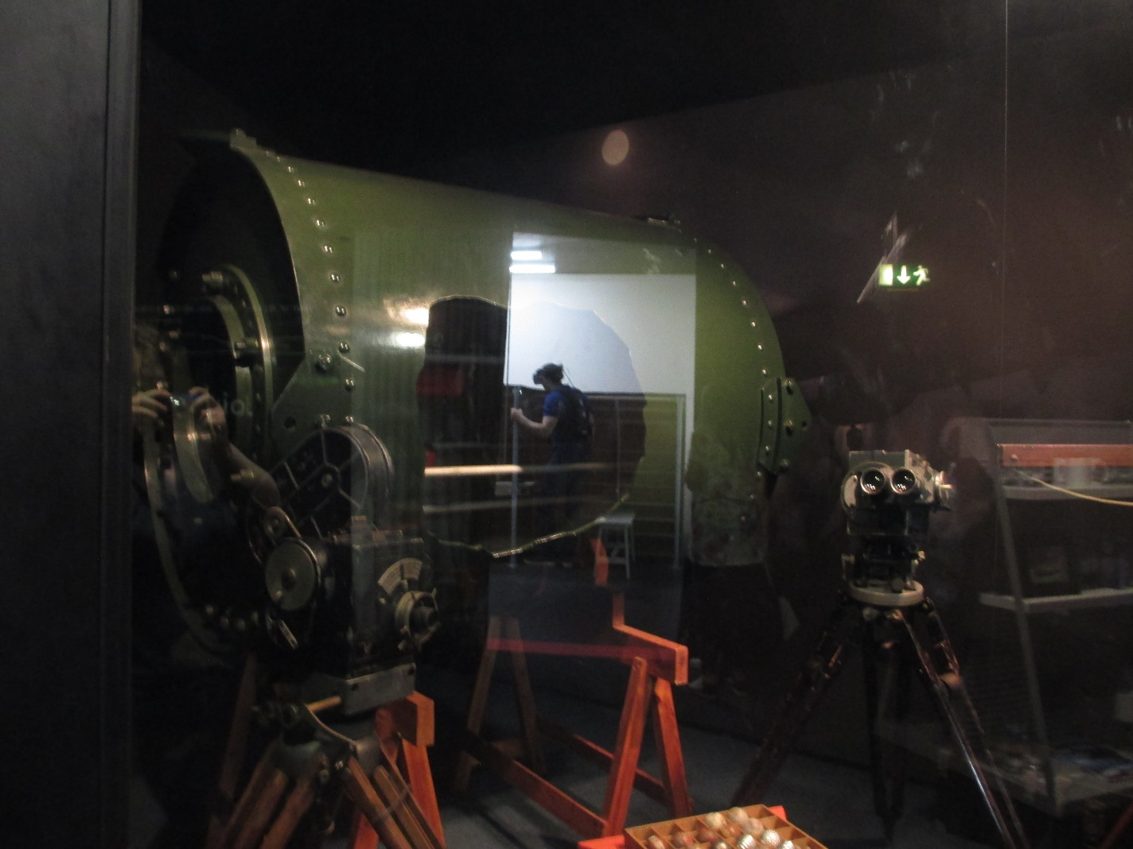
(Figure 1: a reproduction Upkeep at the RAF museum, Hendon. Author’s photograph)

The Immediate Aftermath of the Mission
Since the very moment Operation Chastise began, with pilot Norm Barlow’s take-off shortly after 2100, to the instant the last Lancaster landed at 0615 the following morning, every movement of 617’s aircraft were followed keenly by a team at Grantham. This team included Harris; the quick-to-find-fault overseer; and Wallis, the (possibly overly-) optimistic designer of the Upkeep weapon. The analysis did not end there; every facet of the operation has been pored over by press, public and historians ever since, to fuel an endless interest in such a dramatic display of military might. The largest question, asked in 1943 as now was whether the mission was in fact a success. Did the ends justify the means? Were the losses worth the effect? Had the German war effort been damaged enough to have a lasting impact? These and other questions have been debated from the moment the mission ended and still there is no agreement. There likely never will be.
In this chapter the short term implications of Operation Chastise will be taken into account. Here short term should be taken to mean those results obvious in the immediate aftermath - the first month or so – before organised efforts to repair the damage were completely underway. Effects that lasted, or became known after this point are discussed later, where long term effects are addressed. However fast they were repaired, the short term results were just about as chronic as Germany was able to bear, and further damage would have crippled the Ruhr.
Some historians like Rowley vehemently believe that the mission was a success, that to call it otherwise is an insult to the memory of all those who died; that to minimise what happened shows lack of understanding towards the time and the people involved. Others believe that the mission was not worth the cost, that only civilians suffered greatly and it should never have been authorised in the first place. ‘Bomber’ Harris himself was in two minds about the mission. Just after the signal announcing the destruction of the Mohne arrived at Grantham, Harris seemed proud. He told Wallis, ‘I didn’t believe a word you said when you came to see me. But now you could sell me a pink elephant’. Harris had been loathe to approve the mission, one of the most outspoken critics during the developmental stages, and had tried to cancel the mission in his role as Commander-in-Chief of Bomber Command. Portal, Chief of the RAF had authorised it over his head. Shortly after the war Harris wrote that since his driver had driven over rough roads and he had not complained, that he must have considered the attack a success at the time. This, in his brief mention of the attack in his Bomber Offensive, is the closest he comes to giving an opinion in his public writings. But his pride and excitement would not last; he would never authorise Upkeep’s use again, and was scathing in his personal opinion. In December 1943 he wrote that the effort was not worthwhile and in January 1945, in more detail:
‘The destruction of the Mohne and Eder Dams was to achieve wonders. It achieved nothing compared with the effort and the loss. The material damage was negligible compared with one small area attack.’
Harris; a proponent of area bombing, and of the Battle of the Ruhr, preferred this method. Despite publicly supporting the work the squadron did on this raid, his personal opinions would remain critical of the missions planning and organisation except where he himself had been the driving force. His ire especially lay with Wallis, the weapon’s designer, whom Harris disliked as a ‘panacea monger scientist’.
Newspapers of the time were jubilant. The Daily Mail wrote ‘The Air Ministry was aware soon after the attack that it had apparently been a sensational success’. Gibson went on record as saying; ‘we had high hopes but the immediate results of breaching the dam were far beyond our expectations’ in The Times, whose headline proclaimed ‘Ruhr Dams Breached: Daring Low Level Attack By Lancasters’. Similar headlines appeared in many national and local newspapers and magazines in the following days. Many included; just as intended, details from the Air Ministry cover story, created to hide details of the weapon so it could be reused. Specially released aerial reconnaissance photographs also proved popular.
Regardless of any arguments about the overall success of Operation Chastise, few deny that it did not at least have dramatic and devastating short term effects on the Ruhr area. The breaching of the Mohne and Eder dams sent a shockwave through the upper echelons of the Nazi regime, in addition to the literal waves that obliterated everything along their paths, causing huge amounts of damage for many kilometres. The devastation even reached the River Ruhr, with the Mohne river spanning 400m across at the confluence with the Rhine, with other stretches over 1km across. The flooded portion of the Mohne and Ruhr valleys from that breach totalled 83km^{2.}The Eder valley suffered similarly, though reconnaissance photographs here were not widespread, focusing on the town of Affoldern, a short distance downstream, and with others photographing Kassel even further downstream.
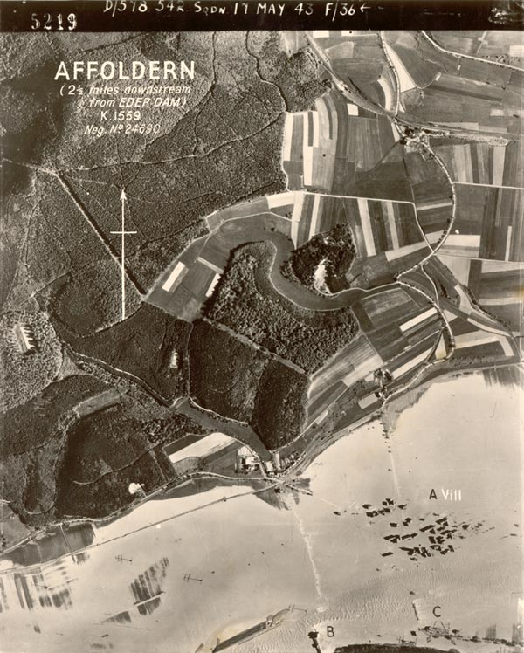
(Figure 2: Reconnaissance photograph 17th May 1943, showing Affoldern, downstream of the Eder, and the annihilation of a town. Credit Royal Air Force Museum)
When considering these short term effects it is prudent to confine the discussion to those dams in which the attack was successful; so that the effect on each can be discussed in greater detail. Therefore whilst the other targets, particularly the Sorpe will be mentioned, the bulk of the analysis will be focused on the Mohne and Eder attacks, since these successful breaches caused the most visible effects, at least immediately afterwards.
The most obvious and immediate result of Operation Chastise were the immense waves that crashed down the valleys, travelling many kilometres and precipitating flooding that would destroy everything in its path, including towns and vital infrastructure. This is easiest seen in comparing the aerial photographs taken of the area before and after the raid. Walls of water travelled down the valleys and then settled, becoming a burst river up to a kilometre wide in places which had the further effect of spoiling agricultural land and making the waterways unnavigable to traffic for several days, though this was not so long as was hoped. Below the Eder, even the large town of Kassel suffered considerable levels of flooding, stopping much war industry as factories were damaged or otherwise inaccessible, and below the Mohne a similar tale was told at Dortmund and other towns. A truly accurate report of the damage caused is unavailable, partly because of the chaos caused by the raid, which naturally complicated communications in the area; and other complications prompted by a face-saving exercise of propaganda designed to hide the truth from the German public. As with any wartime record there is also not guarantee that what survives is all that was written; perhaps others were destroyed.
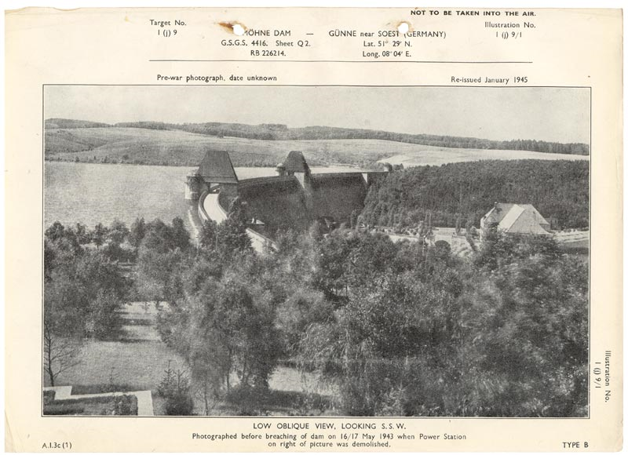
(Figure 3: The Mohne dam before the attack. Credit: Royal Air Force Museum)
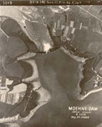
(Figure 4: The Mohne Dam after attack. Credit: Royal Air Force Museum.)
The first estimates of damage, the morning after the raid painted a picture of cataclysmic proportions. The earliest reports suggested upwards of 10,000 deaths in the Mohne valley, no power, no water for such essentials as industry, domestic use and for firefighting in some of Germany’s major manufacturing centres – which were already being razed night after night in the greater Battle of the Ruhr. Albert Speer, Minister of Armaments and War Production, had flown over the Mohne and Eder reservoirs shortly after dawn, and was horrified by what he saw, with towns and villages missing in swathes of mud and water that lingered in the valleys. The Mohne was empty and the Eder was still gushing water, due to its greater volume. He immediately sent a report to Hitler, who was greatly disturbed by its contents. Another report forwarded to Hitler’s desk, this by civic authorities in the Ruhr, only compounded this disturbance, though Goebbels was quick to denounce this, claiming the figures had been gathered from the BBC. Whilst it quickly became clear that these initial figures were an exaggeration, the raid should not be thought anything less than devastating. The official figure given by German authorities of the dead was 1300 at the Mohne, with about another 300 killed beneath the Eder, but thousands more were injured or rendered homeless. Thousands of homes and farms were destroyed, or damaged so severely that they were abandoned; putting stress on the already overworked authorities as residents had to be rehomed in different districts; also stymying efforts to smother news spreading across Germany. Over 100 factories, some engaged in war production, were put out of action in the immediate aftermath, and over 5000ha of agricultural land was ruined, creating even greater demand on Germany’s food supplies. Rations were reduced and there was less to send to troops. Finally, 47 bridges, including the famous Herdecke viaduct were damaged severely or destroyed, in some cases carried away whole, meaning few resources could initially come in or out of the valleys and rescue and recovery efforts were hampered by this. Euler concedes that these figures are ‘largely incomplete’, though there are few other documents to suggest more accurate numbers.
Some consequences of the operation were well anticipated, and came to pass to some extent, even if to a lesser degree than hoped, such as the disruption to the industrial workings in factories. Other results were less anticipated; for instance, the extended influence the attack had on power levels in the Ruhr, most notable in the first week. The anticipated aims of the mission were to deny Germany water for their war industries and for personal use, to drain morale and to, especially in the case of the Eder cause a flood through water courses and canals which would then render them unusable for the large boats which transported war materiel. Whilst all these goals were seen as at least somewhat successful, there were other consequences noticed in the fallout.
One such unseen consequence was the effect the raid had on the German power supply for the Ruhr. When the Western Air Plans, which first floated the ideas of attacking strategic dams in Germany, were formulated in 1937, British authorities did not believe that power resources could be much adversely affected by bombing. These plans may have listed the dams as targets but did not broach the idea of how; in fact their destruction was deemed unfeasible because no weapon then in development could damage them. It was known that much hydroelectric power was sourced from a number of power stations centred around the dams – the Eder alone had four. As Rumpf claims, Operation Chastise was not intended to have any direct effect on the power supply as a stated aim, because ‘Air Ministry experts wrongly assumed that the grid system was highly developed’ and any effect was to ‘be considered a bonus’. If this is indeed the case, it was well-deserved – at the Mohne, Hopgood’s bomb, dropped as the plane was shot down, punched through the power station below the wall. The bomb exploded and immediately wiped out the electricity supply for the vicinity, perhaps part of the reason flood warnings were not sent immediately. At the Eder, water rushed through the power stations, flooding them and silting the workings, as well as breaking much of the machinery, and killing some of the staff. Further down the valleys more power stations would be knocked out, including the massive works at Hemfurth which provided power for major towns- rendered useless for at least a fortniht. This is not long in theory but the repair was not complete, 390,000 kW in May and June were lost and only some of this could be made good by other resources.Only enough had been done for the stations to function once again, and parts for the repair were “liberated” from other vital places which had repercussions across Germany. In the meantime the German grid had not been sufficient for covering the loss and the shortages further affected industry. Whilst most of the repairs could be completed with the stations working at some level, even the short delays in repair caused frustration in the cities and made it harder for the workers dispatched to the Ruhr towns to do their jobs. Dildy writes that at best this was a temporary inconvenience not a major problem and therefore cannot be seen as designating the mission as successful. However this ‘temporary inconvenience’ is indeed a short term effect of Chastise, causing a noticeable effect on the electricity supply in the area and requiring a large amount of manpower and resources in order to make right. Whilst this did not extend into a long term issue this lack of power did have ramifications on production in May and June and therefore is an indicator for success.
However it cannot be argued that this consequence was completely unforeseen. One of Wallis’ original reasons for developing a weapon to target the dams was the hydroelectric power produced. This, with an engineer’s eye for selecting targets rather than a military strategist he deemed ‘white coal’ – water was the vital resource on which all Ruhr industry was based. Attacking where this resource was concentrated would make it far easier to strike a ‘knock-out blow’ than attacking the hundreds of factories all relying on it. Wallis had published this belief in two papers, ‘Surface Bomb: Spherical Torpedo’ and ‘A Note on a Method of Attacking the Dams’. It seems that to anyone who had read them, including the raid’s planners, the probable consequence to hydroelectric power must have been known.
The fine silt dislodged by the walls of water was highly successful at blocking machinery in factories, and further damaged the workings of each of the dams. At the Eder this included the closing mechanisms for the emergency spillways, which had opened when the dam was breached. This increased the rate of flow out of Germany’s largest dam slightly beyond that anticipated. What effect this increase in rate of flow had on the already deadly flow had is unclear but it cannot have helped the torrent. British newspapers proudly claimed ‘never before has such a blow been dealt from the air’
One aim of Chastise had been to disrupt travel along Germany’s navigable rivers and canals through changes in water levels. An especially sought after result would be to force the closure of the Mittelland and Dortmund-Ems Canals; the reason that the Eder dam had been added as a primary target. In the event whilst the water level in the canals did increase, and currents and silt affected the path of vessels bound for exchanging raw material for finished products, factories affected included those producing steel and U-boat components among other materiel. However this effect was easily fixed and highly temporary. On 30th May the Air Staff were already considering the use of Upkeep again – this time against targets including the Rothensee ship-lift, in order to stop ships easily travelling to Berlin, and two areas of the Dortmund-Ems canal, including where it merged with the Mittelland canal. This shows that at least as far as this aim went the mission was a failure as even the short term consequence was hardly an inconvenience, let alone devastation. In the event Upkeep would not be used again, and though 617 would be sent to attack the Dortmund-Ems canal later in 1943. This attack too would be a costly failure.
The extreme reallocation of manpower, both civilian and military, as well as resources, to the Ruhr area was a major problem for the German authorities. Whilst the majority of this manpower was transferred on a temporary basis, such as the workers of the Organisation Todt, who were responsible for the rebuilding efforts; the cost was immense. The areas first had to be secured at the orders of the highest authorities; who sought to hide any evidence for the damage from both possible spies and German civilians, except for the hastily organised work gangs formed of local residents, including many who had lost homes and family members. In other areas rescue crews from “pioneer” units, the National Labour Service, Hitler Youth, and work gangs formed of forced labourers, were set to work. This initial work would include rescuing survivors, burying the dead, clearing the silt from vital machinery and the canals, and the stabilisation of transport links – especially the heavily damaged railways. Before rebuilding the dam could take place in earnest, other construction was first carried out. At both the Mohne and Eder, barrack buildings and a small-gauge railway line, with stations for loading and unloading material were built using a mixture of foreign workers, Organisation Todt workers and local builders acting as overseers. Work continued 24 hours a day, using strong floodlights, so important was the repair considered. This determination was unprecedented, and extra resources were set aside for repairing damage which project leaders anticipated from disruptive bombing runs on the work.
Likely because of the costly nature of the original attack, and the lack of surprise, no such “nuisance raids” were carried out. The materials used were as close to the original as possible, with constant checks taking place to ensure that no sabotage occurred, however this does not mean that there were no shortcuts taken. The dams were not completely repaired at this time; to save money and resources and in order to allow the dams to be operational before the autumn rains. If the reservoirs could not be repaired within this deadline then water shortages the following year would enter critical levels and would then cripple industry with a lack of water and hydroelectric power from the dams. Fortunately for the Germans, and as a blow to the British authorities, though hidden from the contemporary British public, the dams were repaired before this deadline had elapsed.
The German dam repair would take five months, with the Mohne declared finished on 24 October and the Eder several days later. There had been concern that the flood had pushed the dams several centimetres further down the valley, the dams were repaired once it was decided this wasn’t critical, but both dams were monitored for the rest of the war in case complications developed. To save time, at the Eder several sluices were not replaced; hardly critical but an indicator of hurriedness when the rest of the project sought to repair the damage as close to the original specifications as possible. The Sorpe was damaged, would need to be drained for repair work to take place. This however was not critical, and could be completed at any time.
Overall the short term effects of the raid on the Ruhr are hard to quantify on their own; given it is hard to decide where short-term effects end and long-term begin. Undeniably the flooding was critical in the short-term, and stretched the capabilities of the German authorities. Though the canals were not as affected as hoped, delays were still caused temporarily at a critical juncture when Germany needed every piece of materiel. The greater than anticipated effect caused on a temporary basis to the power situation and water industry of the Ruhr which though quickly re-established would not reach full levels for some time goes some way to make up for this. The huge cost to manpower and resources required for the rescue and rebuilding caused a drain of the war effort both in the Ruhr and in greater Germany. Added to this the shock and awe effect it had on the population, and the morale influence this must have had, this caused a concerning loss to the war effort in the Ruhr. When these direct short-term and long-term effects are combined with the admittedly somewhat more ambiguous indirect consequences this shows that the operation was indeed successful overall.

The Long-Term Effects of Operation Chastise
Of course, the repercussions of Operation Chastise were not confined only to the first few weeks. In the Ruhr the carnage would take months, or even years to recover. This was time that Germany did not have, if they wished to continue with their total war. The recent defeat in North Africa and the continued commitment to the Eastern Front made Germany desperate for supplies, and any further drain could not easily be borne. Critics of the mission often point to the quick repair of the dams as evidence that the raid achieved nothing of tactical or strategic importance; only a waste of life. If this is indeed the case, why were so many men reassigned from the Atlantic Wall, working around the clock to get the dams operational so quickly. Why was the enormous project with the associated expense undertaken at all if, as some suggest, they were targets of limited value? As James Holland argues, surely the fact that Germany made repairs so quickly indicates that they were of some strategic importance.
Both direct and indirect consequences of Operation Chastise can be considered in the long-term. Although the original documents have of course not survived, it seems that the Operation Order did not much consider consequences beyond a hope that ‘it would shorten the war’. However discussions during the development of the weapon also wished that as an indirect effect the general public would resent the German authorities for their failure to protect them. In the event this resentment would not emerge as much as was hoped; but counter-propaganda issued by the Germans was clumsy and simply failed to control ill-feeing. A growth of negativity towards the Luftwaffe, who oversaw the flak and air defences went right to the top. Hitler lost a considerable amount of trust in his air force; and this would have knock-on repercussions concerning what they would be able to prioritise later, having fallen from grace. Whilst the raid didn’t, as was hoped, visibly shorten the war, it forced the German authorities into an unenviable position concerning manpower and resources that cannot have helped with their war effort. Chastise may not have lived up to Barnes Wallis’ somewhat optimistic claims, but it more than met Harris’ pessimistic assessment, and also much more effective than officials like Goebbels admitted or as critics like Dildy have since claimed. Some of what “Johnny” Johnson termed ‘revisionist historians’ have sought to downplay the raid, going as far as to make some Dambusters doubt the worth of the mission as the dams as a legitimate target. However it is easy to see that as well as a short-term inconvenience, Chastise had a lasting effect on the Ruhr and on Germany as a whole.
Repairing the dams was an incredible task, all the more so in that it was achieved in just five months. Both the Mohne and Eder were repaired and operational slightly ahead of the punishing schedule announced by Speer, and the chief of the project, imposed so that repairs would be complete before the autumn rains set in. If the rains could not be captured then the aquifers and rivers would not be sufficient to stave off drought in the long term, as had been temporarily possible. But all this came at a great price, both literally and more figuratively. Dam repairs cost an estimated 756 million Reichsmarks alone, and damage to the surrounding areas at millions more; with the Eder costing more than the Mohne. On 18th May 1943, in reporting on the dams raid, the Daily Mail wrote:
‘It is certain that the enemy will never be able to make good the greater part of the damage during the war. It would take years to restore the dams, let alone refill them. And it would be difficult to over-estimate what the long-term results will be when the winter rains descend unharnessed down the Ruhr’.
But the Germans were able to repair the dams before the rains came and were able to recover the dams remarkably quickly.
In addition to the money, many tons of resources and thousands of men were redirected from other projects, most notably the Atlantic Wall, then being constructed across Europe’s northern coasts. This allocation shows how critical the damage to the dams was, and how seriously it was taken by the German authorities. Thousands of Organisation Todt workers were redirected and led by expert German builders in a huge project that not only repaired the damaged more or less true to the original standards but also, with the help of youth organisations and bands of local forced workers, carried out recovery operations and replaced much of the local infrastructure. Bridges were replaced, and many miles of railway and roads were built, both replacing that destroyed and as a supply line for repairs. Workers were also tasked with repairing the factories and building barracks to help recover Ruhr to production levels. These barracks would later be used to help house the thousands of new gunners drafted to the dams.
The transfer of construction workers from the Atlantic Wall to the dams would greatly impede Hitler’s planned defences against the threat of Allied invasion. The Atlantic Wall itself was an Sisyphean project; spanning such a large distance and expected to perform such an important role that any delay could be intolerable, and indeed that caused by the dam repair had a great effect. In December 1943, Rommel inspected the construction and was horrified; the line was weaker than planned, or in places non-existent since during the months most conducive to work the force had been reassigned to the dams. The workers had also lacked material for the bunkers, resources used on the dams. Though efforts were made to rectify this lack, they came too late.If the resources and manpower spent on the dams had instead been focused on the Atlantic Wall, it is likely that the Allied invasions in June 1944 wouldn’t have proved so successful.
Militarily, Chastise also greatly changed the structure of the German air defence system and the Luftwaffe in general. In response to the raids, all major dams in Germany gained extensive defences. Thousands of flak guns were moved around all Ruhr dams, in addition to smoke generators, raised netting to stop both bomb and aircraft, and the distinctive towers atop the dams, which had greatly aided aiming, were either camouflaged or removed. The element of surprise had been lost and further use of Upkeep would have proved suicide and these defences also prevented nuisance raids against the repair work. But British authorities also had defend dams. One Upkeep was known to have been recovered and German scientists were soon able to reverse-engineer the weapon though in 1943 there was no aircraft capable of dropping it. Hitler called for weapons development and argued that all future aircraft should be capable of bombing, withholding funding for aircraft such as the Me262. Hitler would criticise the Luftwaffe heavily for their failures in defending the Reich and would resent this greater defensive role, seeking revenge even as he knew the commitment was necessary. His prejudice against air defence intensified, with Goering supporting his decisions to prioritise aerial aggression and at the same time push efficiency in the German air defences. As a result the increase would have to come from the existing resources, pulling these from towns and therefore having a continued effect on German safety against bombing, though Germany remained a formidable target for the RAF. Troops were drafted in to prevent any sabotage efforts and in an effort to prevent locals from viewing the damage. The new defences were incredibly costly but were necessary both for morale and to prevent exploitation of these targets.
As a passive air defence water levels in the dams were capped to peacetime levels to prevent a repeat attack. This meant a loss of millions of litres of water, much resented by the industrial authorities though necessary to stabilise the repairs. Whilst hardly causing any critical loss of water, levels in the dams were not quite sufficient to allow for all purposes needed. This left an uncomfortably small surplus for emergencies such as drought or fire extinguishing which could cause further problems. Luckily this was not tested.
Morale remained changed by Chastise for the rest of the war. In Germany the effect on civilians is somewhat ambiguous, coming so soon after the loss of North Africa. With the war turning on Germany it is impossible to say how much Chastise is responsible for. Propaganda about the raid was dropped by British bombers over Germany but it is also impossible to say whether this had real notable effect, since other bombing raids also had a sapping affect, and counter-propaganda sought to control opinion. There is no such difficulty in evaluating the influence it had on Allied morale, both commonwealth and American. Press quickly struck upon the raid as an example of commonwealth cooperation with aircrew from around the empire. Americans made a hero of Joe McCarthy, the sole American Dambuster; and Churchill, then in America for a meeting of Allied leaders, gave a rousing speech to congress to promote further cooperation. Some Americans had lost faith in the British effort, and wanted to withdraw their forces from Europe, but Chastise forced them to acknowledge Britain’s abilities and considered it a ‘milestone of standards’. Gibson was to be sent on a publicity tour of North America to promote war bonds, which proved highly successful. Hollywood also were enthused by Chastise; King Pictures wrote to the Air Ministry seeking information and aid in making a film, as early as a few weeks later. They cooperated to a degree, though the film was never made, due to disagreements regarding the proposed script and the need for secrecy. The full details of the mission would not be released until September 1963, by which time a film had already been produced, which included carefully altered original test footage.
Whilst not critical, supplies of food and war materiel were affected by Chastise in the long term. Immediate shortages had been prevented by using the extant stockpiles; but these could not last forever. The Mohne and Eder valleys were valuable agricultural land, with thousands of animals and much of the Ruhr’s crops. When the dams flooded, topsoil was washed away, fields were covered in gravel and contaminants, and many animals killed. Many farms were destroyed. The farmland wouldn’t be workable until the 1950s in many places, the land barren. Food supplies across Germany dropped even as the military need for food increased. The meat ration fell by 50% a few days after the raid, made worse by the bad potato harvest of that winter. Taken altogether, the drop in food rations had a great morale effect and also impeded productivity. In factories and mines production dropped for several months, though this wasn’t immediately noticeable due to stockpiling, and new German production techniques. But maintaining usual output wiped out such stockpiles, and this prevented availability as the German army withdrew leaving equipment behind them.
Dingle Foot, of the Ministry of Economic Warfare, noted: ‘the results… have to be measured not only in the actual stoppage of production in certain factories but also in the vast amount of additional work which it makes necessary’. This is certainly fair, and Operation Chastise resulted in a great diversion of effort from the front, both to repair the damage done and to prevent any further attacks. Though it is true that production in war factories was only stopped for a couple of weeks until machinery dried out and was repaired, this stoppage took place at a critical moment, and production remained lower than usual for months. The extra effort continued for many months, and new air defences created a drain on military resources already affected by production losses and retreats.

The German Perspective of the Mission
One of the lesser covered aspects of Operation Chastise is the damage caused by the raid from the German perspective, or at least the perspective of those on the ground. Whilst every historiographical analysis of the mission will include the extensive damage and whether this was worth the losses sustained to the British, fewer accounts give any real details of the German experience, or the aftermath beyond a few short selected quotes from eyewitnesses. These are usually only used to support contentions about the validity of the official reports of both sides, or often the historian’s own arguments about the success or otherwise of the mission and its long-term effects, both of these are large elements in the continued debates on Chastise. In addition much of what is written details the Mohne attack only, though this limitation is arguably more valid – this attack had more witnesses than that of the other dams, and a death toll far larger than the Eder, and so may be regarded as the greater tragedy.
Naturally Germans are not inclined to promote the raid as an example of triumphant engineering or allied pluck, as many Commonwealth historians are wont to do. Nor do they, for equally obvious reasons regard 617, Harris, Gibson and Wallis as heroes. German historiography, at least that which is published in English, regard the raid as a minor success, with only two of the six targets destroyed, others join the critics who call Chastise an unmitigated failure. Likewise modern opinion is different in the Ruhr even compared to other parts of Germany; with the attacks memorialised rather than commemorated; a subtle difference perhaps, but an important one to make; with ceremonies dedicated to the losses of all sides rather than the celebrational tone of the 75th anniversary events in Britain.
Through examination of many eyewitness accounts, especially those published in Euler’s collection of statements, it is possible to compare these accounts with official reports; to evaluate the truth through witnesses without agendas to either glorify the act, or to reduce its effects in order to save face. Whilst these statements cannot each provide the full story of Chastise, only the experiences of their author, they can at least provide a different viewpoint for analysis and humanisation. In this way the effects of the raid can be justified or otherwise; in a fairer way than whether Operation Chastise went as planned. It is easy to forget the human involvement, the loss of life, the misery and displacement caused to the many civilians, the long struggles of conscience for surviving Dambusters in favour of focusing on the clearer cut reports covering the technical attributes. Partly this is because the loss was on such a scale that it is hard to comprehend. Estimates vary but the official number of casualties is around 1600, spread across the Ruhr; and partly because there is always a tendency in evaluating success to forget the human impact in favour of the glory or vilification of the mission.
Of course to say that the German perspective is confined to these limited eyewitness statements would be an overgeneralisation. Other accounts are more official, Speer wrote briefly in his memoirs about the Mohne-Katastrophe, as the attack is known in Germany; stating:
‘A torrent had flooded the Ruhr valley. That had the seemingly insignificant but grave consequence that the electric installations were soaked and muddied so that industry was brought to a standstill and the water supply of the populous imperilled. My report of the situation which I soon after delivered at the Fuhrer’s hut made a “Deep impression on the Fuhrer”. He kept the documents with him.’
Later on in this brief description Speer would go on to say that this was overstating the issue; that since the damage had been repaired so quickly, within five months, the situation had not been so bad as he had initially feared. But he did concede that this damage had taken vast numbers of men and resources to be redirected from the Atlantic Wall, and could also not understand why the RAF had not pressed home the attacks whilst the dams were at their most vulnerable – whilst they were being repaired including when night work was carried out under floodlights and easily visible. Especially in the time before the new fuller defences could be established closing the window. Similarly, Joseph Goebbels originally recorded the operation in his diary on May 18th ; ‘air raids during the night inflicted heavy damage on us. The attacks of British bombers on the dams in our valleys were very successful. The Fuhrer is exceedingly impatient and angry about the lack of preparedness… Damage to production was more than usual…’
Whilst the initial reaction was one of surprised honesty from German officials; this was soon covered up once more by responses covering up the extent of the damage; a tactic in which they excelled. Speer concluded his statement:
‘… the British came close to a success which has been greater than anything they had achieved hitherto with a commitment of thousands of bombers. But they made a single mistake which puzzles me to this day: they divided their forces and that same night destroyed the Eder valley dam, although it had nothing whatsoever to do with the supply of water to the Ruhr.’
Goebbels too changed the tone of his diary entries to nullify the raid. By the 20th May he reported:
‘The damage to the dams has not been quite so serious as first feared. The reports by Berndt which caused me such a headache the first day are now proved to have been tremendously exaggerated. It is quite obvious that Berndt got his information from the BBC, This fact illustrates once more how impractical and irrational it is to forward alarmist reports of this kind to the higher leadership’.
The German reports in the fallout of the raid would understate the damage caused by the bomb especially in regards to the indirect losses of production which resulted from the limitations of water, manpower and redirection of resources. The number of attacking aircraft involved would be stretched, sometimes comically so, and even with the impressive number of British casualties proved, some would claim larger losses. Despite later reports emphasising the inaccuracy of the initial assessments, Hitler never seemed to quite believe in the lower figures given in later accounts and lost trust in the Luftwaffe. Production in the Ruhr was a vital issue, and in addition to returning to full productivity Hitler strived to lay blame somewhere. The Luftwaffe was held liable; since limitations in airborne radar had allowed the bombers to enter the German heartland. At the Mohne (the only defended dam attacked) both active defences in the form of AA guns, and torpedo nets fitted in front of the dam had failed to prevent its destruction. This had all been within the Luftwaffe’s purview. Immediately the commands were forced to reorganise defences to satisfy these criticisms but this would have a lasting influence on Luftwaffe operations.
It is important to note that not all the ground eyewitness statements were made by Germans themselves. Many come from the forced labourers in the area, those from occupied countries and therefore perhaps more inclined to support the British viewpoint. But these follow the same patterns of discussing the sense of loss they felt. The tragedy transcended the nationality of individuals; Germans and foreigners were all swept away in the flood; death was indiscriminate. Put simply an eyewitness on the ground will discuss things very differently to a Dambuster, and again very differently to a report from either government. Therefore this chapter, discussing the German point of view, also has to concern itself with the accounts of individuals of other nations affected. Especially among them were the Eastern European women labourers based underneath the Mohne at Neheim-Husten with around 500 of the 1200 workers killed in the floods – making up many of the Mohne casualties. Other came from French prisoners of war based further along the Mohne flood-path, here the guards had opened the barrack doors and most survived.
Nevertheless the vast majority of evidence of the opinions of those affected on the ground comes from Germans. Reporting on the destruction of the dams was forbidden in Germany itself, even after news of the raid became widespread, and so newspaper reports, usually a valuable source of information, are largely unavailable. Many of the witness statements available have been recorded years later; like any other event looked at in hindsight details have been confused, stories embellished. When Euler started research in 1990 he lamented that many important characters had died, and that details had been confused with later operations, especially in the case of the Sorpe, which was unsuccessfully attacked again in September 1943.
However what is there among the eyewitness accounts, the modern attitudes in the Ruhr, official reports and summaries and even the propaganda produced by Goebbels’ department are valuable indicators as to the German view. Some local newspapers provide clues in obituaries and articles on livestock damage.
Operation Chastise remains an important part of the mindset of Germans, particularly those living close to the Ruhr. Karl-Heinz Wilmes, Mayor of Gunne in 2013, and survivor of the raid said:
‘No one harbours any bad feelings about the British here. It was a long time ago and it was war. Before the Dambusters came, the Germans had laid waste to British cities. Many British people come here each year and we welcome them.’
Wilmes’ comments are typical of many Germans in that he stresses his lack of ill will against the British. There seems a general acceptance among many witnesses, passed on to their communities that the dams were almost revenge for German raids in Britain, more acceptance than is the case for other raids such as Dresden. Gunne is the town closest to the Mohne dam, and a large part of their economy comes from tourism brought by it – Germans admiring its construction, and Brits remembering its destruction. Wilmes seemed most aggrieved by the selling of copies of The Dambusters film on stalls at the dam, telling a newspaper reporter, ‘It glorified a mission that did not succeed, and killed thousands of civilians and lost the RAF valuable crew. It was, perhaps, technologically impressive, but a failure by any other measure’. This too, seems to be a popular opinion among Germans, at least in branding the mission a failure by most standards.
The success or failure of the mission is questionable, based on various factors and made more difficult in that no two analyses can agree on what these factors are. Most agree that the main aims were to destroy infrastructure, to damage war materiel production and to do so dramatically so that distress was spread among the populous. It was hoped this would have a notable effect on civilian morale which would then continue to have an influence on production rates and cause resistance and animosity towards the leadership despite Harris’ conviction that German attacks on British cities had not caused this. The dams raid does seem to have had an effect on the morale of the people living under dams, most particularly the Mohne and Eder, but also beneath other reservoirs; where civilians soon realised a new level of danger beyond normal bombing raids. However the morale significance of the raid pales under the shock and awe of the attack itself, and must be inferred from the accounts, since they rarely detail the rebuilding efforts or what happened beyond the immediate aftermath.
Corporal Karl Schutte, a flak gunner on the Mohne dam was probably the closest witness to the events. At the time of the attack the dam battery was considered a restful posting. British aircraft were seldom seen and usually used the dam as a navigational waypoint, rather than as the target. People along the Mohne valley were used to air raids as a precaution, complacent in their shelters but did not fear a breach. Schutte adds that their being the target was a surprise though they had been warned that attackers were close. He describes in detail the firefight between air and flak gunners, and the frustration of later flypasts by 617 Lancasters bound for other targets; which he believed to be scout planes. He noted that the morning after the attack senior officials visited the ruined dam; expecting punishment he was amazed to be awarded the Iron Cross. ‘[we] were very astonished and asked ourselves for which deed we received them. The object to be defended had actually been destroyed.’ He also notes that air defence was, naturally taken more seriously as a result, though his immediate superior had always recognised ‘all that depends on the Mohne reservoir, all the works in the Ruhr area are fed by it’. In the 1970s and 1990s he would be among those who welcomed representatives of the Dambusters when they visited the Mohne for the anniversary of the attack and met survivors.
Below the Eder; towns such as Wickede were inundated by the flood. The then-16 Hanna-Maria Kampschulte’s family had climbed up to the attic, seeing water flow towards them. She became convinced her family was to die in the floods, as their neighbour’s house was picked up by the torrent and crushed in the waves, then their own followed. She and a brother tried to save themselves, escaping from the house and grabbing floating wreckage. She floated all night, cold and exhausted. ‘Gradually it began to dawn. The water started to fall… I heard voices from afar…’ She was rescued by villagers as soon as the flood fell enough, and returned to Wickede to find it flattened. She was the only survivor of her immediate family, her brother’s body was never found. Her anguish seems mainly in that the dead were interred largely anonymously and does not lay blame with any one party.
Another German method of damage mitigation was to create their own propaganda campaign; though this largely failed. Propagandists based their efforts on the cover stories issued by the Air Ministry after the raid, and to a certain extent manipulating the gossip that could not be stopped; the British cover story especially being used to cause furore in the Ruhr where information could not be hidden. British newspapers attributed the idea of a dam attack to a ‘German – Jewish refugee’ scientist who had emphasised the importance of the dams to a journalist who’d then passed information to the Air Ministry. Whilst protecting the identity of those actually involved, it created some problems. A German witch-hunt blamed Lindemann, Churchill’s scientific advisor; because of his Jewish surname, though ironically he’d been among the mission’s greatest critics. Goebbels used this news to justify the Reich’s treatment of Jewish people, with his department reporting ‘the German people need no further evidence of Jewish unholy guilt…’ stirring up even more anti-Semitic feeling. At first Goebbels had attempted to block news from reaching the press. Only in the local press of the affected towns where the truth could not be denied was any initial report made. When the news continued to spread regardless a report was made in the Volkischer Beobachter which spoke of the “terror attack” and treason involved. However the Germans found that this had been largely unconvincing to the populous and efforts to direct intense anger against the British and demand more from the war moved towards other raids and perceived injustices.
Overall, the German perspective on Operation Chastise seems to be one of memorialisation. Survivors hold no great spite towards the British in general, preferring to remember the victims in their communities at events and memorials, with many towns holding services on the anniversary. Communities have moved past resentment and ill-feeling towards the British, and hold much respect for the Dam Busters themselves; in many ways different to the way popular culture in Britain remembers the mission. The effects of the raid have been long-lasting, many in the Ruhr villages lost family and friends, towns were flattened in the torrents, but these have become just another part of the history of the Ruhr. In greater Germany where initial news came from rumour and propaganda the dams are known as a symbol of the Germanic conquering of the natural world celebrated for sheer size and technical ability; the Mohnekatastrophe and Ederkatastrophe are part of their history, but not overwhelmingly.

Conclusion
Overall, the conclusion of this dissertation is that Operation Chastise was a success, but one that must be qualified. Chastise may not, as the British planners and weapon’s designer hoped, have ended the war, but it certainly did make it harder for Germany to continue waging it. How it did this, and therefore how to qualify this success is covered in this conclusion.
Careful analysis of the existing historiography and the reports of the British and German authorities has allowed this essay to evaluate the long-standing argument on the success of Operation Chastise. This analysis has first been used to understand what specific evidence is cause for controversy and disagreement and whether these are the same in different interpretations of the raid, or whether historians oppose differing pieces of evidence. Disputed aspects seemed especially to stem from several key points, whether industry was affected given overall production growth in the war, whether the raid actually achieved its aims, and since they were repaired so fast, whether the dams were actually significantly affected. There was even some dispute as to the actual strategic importance of the dams. Other more minor issues were also debated but these were not vital to the question asked in this essay and were not discussed further.
Some confusion in the historiography is to be expected; with the missing documents and the deliberate deception of British cover stories to maintain security. The earliest analysis of the raid, Brickhill’s The Dam Busters, was first published nine years before British documents were declassified. Other inaccuracies stem from a desire to “revise” history, to make criticisms using modern bias. The conclusion reached aims to avoid these pitfalls while also not becoming a slave to patriotism and the famous film’s simplified portrayals.
It is true that the Air Ministry listed six targets to be attacked during Chastise, but even then this was recognised as extremely optimistic. Of the three primary targets, two were destroyed and the third damaged, though not enough to put it out of action. In addition power stations and factories were knocked out for some time, many of these recognised as being viable targets, in a strategic campaign, in their own right, the floods also caused a noticeable effect on the morale of the populous which cannot be ignored. In the long term resources were expended don repairing the damage and preventing further attacks that Germany desperately needed elsewhere. One major disruption was to the building of the Atlantic Wall, intended to defend Germany’s hold on mainland Europe. The redirection of men and material to the dams meant that when the landing was made, Allied armies could gain a hold and push the Germans into retreat. More immediately infrastructure and authorities in the Ruhr were left in chaos. Chastise took place at a point when the war had already turned on Germany. North Africa had just been lost; with much equipment left behind, and the Russian Front was claiming much more resources than anticipated. The German war machine could not afford any further loss. British morale was also bolstered by the raid, and the RAF gained a specialist squadron, with much positive press, at a time when Bomber command needed visible results.
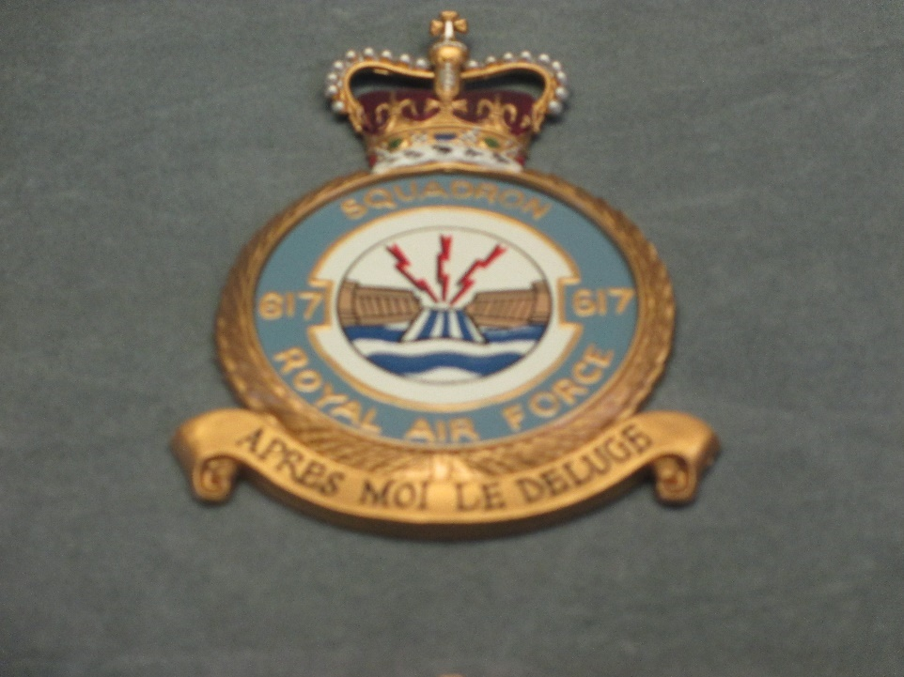
(Figure 5: The crest of 617 squadron shows the legacy of Chastise. Author’s photograph)
Critics’ claims that the raid was not a success do hold some merit. Many are based in that losses of aircraft and men were not worth the cost, a valid point, though it paints the loss of those who died as a waste. Others claim that the dams had no strategic value, that the only outcome was a huge loss of civilian life. This is not so. Whilst over 1000 civilians were killed, factories, power stations and farms were severely damaged, having great effect on the Ruhr’s output. Further, if the dams lacked any strategic value, even without the damage done by the flooding, why were the German authorities compelled to repair the dams at such expense and so quickly; even risking further bombing through the use of spotlights to work through the night. Furthermore huge quantities of anti-aircraft defences, including skilled gunnery teams were then deployed to every major dam in Germany though these defences could be valuable elsewhere. If the dams were not significant, why would such effort be used to defend them against further attack when Germany needed all the resources they could get to maintain their fronts.
Both the direct and indirect effects of the operation have been considered in coming to the conclusion reached in this dissertation. The damage caused by the raid has been given credence, as has the extra demand to men and resources required in response to the damage. Conversely, what impacts it had been hoped would occur and yet did not come to pass has also been examined. Whilst missing documents, for example the original operations order, and the first German reports of damage, as well as the somewhat chaotic other records held by the German authorities has complicated matters, where possible existing material has been used instead of making overly broad statements. Every effort has been made to remain empirical in any inferences made.

Bibliography
Primary sources
Books
Gibson, G., Enemy Coast Ahead, Bomber Crews Collection, (St Peters Ports: Goodall, 2001)
Goebbels, J., The Goebbels Diaries, trans. by Lochner, L.P., (London: Hamish Hamilton, 1948)
Harris, ACM Sir A.T., Bomber Offensive, 1st edn (London: Collins, 1947)
Johnson, “Johnny” G,. The Last British Dambuster (Ebury Digital, 2014)
Speer, A., Inside the Third Reich, trans. by Winston, R., (New York: Avon, 1971)
Newspapers
Bednall, C., "Dambusters!", Daily Mail, 18th May 1943
The Times, "Ruhr Dams Breached", 18th May 1943 , The Times Digital Archive, http://tinyurl.galegroup.com/tinyurl/9ntwE7 (Accessed 28 April 2019)
Reports
Foot, D., and Ministry of Economic Warfare, Ministry Of Economic Report 10 July 1943, (Not Published)
Civil Defence Department Intelligence Branch, I.O No.493, Air Attack On Mohne And Eder Dams, 1943 (Cited in Morpurgo, J.E)
Wallis, B.N., Surface Bomb: Spherical Torpedo (Weybridge: Vickers Armstrong Ltd, 1942)
Wallis, B.N., A Note On A Method Of Attacking The Dams (Weybridge: Vickers Armstrong, 1943)
Secondary sources
Books
Brickhill, P., The Dam Busters, Pan Grand Strategy Series, (London: Pan Publishing, 1983)
Dildy, D.C., Dambusters: Operation Chastise 1943, (Botley: Osprey, 2010)
Euler, H., The Dambuster Raid: A German View, (Barnsley: Pen and Sword Aviation, 2015)
Foster, C., The Complete Dambusters: the 133 Men Who Flew on the Dams Raid, (Stroud: The History Press, 2010)
Holland, J., Dambusters: The Race to Smash the Dams, (London, Corgi, 2003)
Morpurgo, J.E., Barnes Wallis: a Biography, (Harmondsworth: Penguin, 1972)
Rowley, C., Dambusters: The Most Daring Raid in the RAF’s History, (Horncastle: Morton’s Magazine, 2018)
Rumpf, H., The Bombing of Germany, trans. by Fitzgerald, E., (London, White Lion Publishing, 1975)
Sweetman, J., The Dambuster Raid: The Most Audacious Bombing Raid Of The Second World War (London: Weidenfeld and Nicholson, 2002)
Newspapers
Ediss, T., "Bouncing Bomb That Flew In The Face Of Reason", The Independent, 12th May 2003 https://www.independent.co.uk/travel/uk/bouncing-bomb-that-flew-in-the-face-of-reason-590434.html [Accessed 10 April 2019].
Martinscroft, T., “German Survivors of the Dambusters Raid remember the Human Cost 75 years on” https://www.abroadintheyard.com/german-survivors-of-dambusters-raid-remember-human-cost/ [Accessed 4 April 2019]
McKinstry, L., Bomber Harris Thought The Dambuster's Attacks On Germany Achieved Nothing", The Telegraph, 2009 https://www.telegraph.co.uk/news/uknews/6033603/Bomber-Harris-thought-the-Dambusters-attacks-on-Germany-achieved-nothing.html [Accessed 12 April 2019].

Broadcasts and films
Anderson, M., The Dam Busters, Shepperton Studios: Associated British Picture Corporation, 1955).
Holland, J. The Race to Smash the Dams, (Channel 4, 2011)
Rodger, S., The Lancaster of War, (PBS, 2010)
Images
Figure 1: Author’s Photograph
Figure 2: Royal Air Force Museum, Damage To Affoldern, Downstream Of The Eder Dam, 2018 https://www.rafmuseum.org.uk/research/online-exhibitions/617-squadron-and-the-dams-raid/reconnaissance-photos-of-the-damaged-dams.aspx [Accessed 14 April 2019].
Figure 3: Royal Air Force Museum, Target Photo Of The Mohne, Reissued January 1945 https://www.rafmuseum.org.uk/images/online_exhibitions/target_photo_mohne.jpg [Accessed 29 April 2019].
Figure 4: Royal Air Force Museum, Damage To The Mohne Dam, 1945 https://www.rafmuseum.org.uk/research/online-exhibitions/617-squadron-and-the-dams-raid/reconnaissance-photos-of-the-damaged-dams.aspx [Accessed 29 April 2019].
Figure 5: Author’s Photograph

Michael Anderson, The Dam Busters (Shepperton Studios: Associated British Picture Corporation, 1955).
John Sweetman, The Dambuster Raid: The Most Audacious Bombing Raid of the Second World War, (London: 2002, Weidenfeld & Nicholson) p.104
Struan Rodger, The Lancaster At War (PBS, 2010).
Tina Ediss, "Bouncing Bomb That Flew In The Face Of Reason", The Independent, 12th May 2003 https://www.independent.co.uk/travel/uk/bouncing-bomb-that-flew-in-the-face-of-reason-590434.html [Accessed 10 April 2019].
Clive Rowley, Dambusters: The Most Daring Raid in the RAF’s History, (Horncastle: Morton's Magazines, 2018) p.7
Guy Gibson, Enemy Coast Ahead, Bomber Command Crew Series, (St Peter Port: Goodall, 2001)
Paul Brickhill, The Dambusters, Pan Grand Strategy Series, (London: Pan Publishing 1983)
J.E Morpurgo, Barnes Wallis: a Biography (Harmondsworth: Penguin, 1972) p.316
James Holland, Dam Busters: the Race to Smash the Dams 1943, (London: Corgi, 2013) p.360
Clive Rowley, Dambusters: The Most Daring Raid p.59
James Holland, Dambusters p.327-328
During the weapons development stage the originally very similar Highball and Upkeep weapons had diverged massively. Upkeep’s final form was a cylindrical weapon measuring 60in long and 50in diameter whilst Highball was a smaller sphere. Highball testing was not going well but the Navy argued using Upkeep would compromise secrecy. The RAF believed that a cylindrical dams weapon would no longer be a danger for a spherical shipping weapon.
John Sweetman, The Dambuster Raid, p105
Paul Brickhill, The Dam Busters, p.87
Douglas C. Dildy, Dambusters: Operation Chastise 1943, (Bottely: Osprey, 2010)
George “Johnny” Johnson, The Last British Dambuster (Ebury Digital, 2014). p.195
James Holland, Dambusters pp. 390-391
Ibid
Douglas C. Dildy, Operation Chastise, pp.78-79
James Holland, Dam Busters, p. 460
Charles Foster, The Complete Dambusters: the 133 Men Who Flew on the Dams Raid, (Stroud: The History Press, 2018) p.94
Douglas C. Dildy, Operation Chastise, p.70
John Sweetman, The Dambusters Raid, p.135
Clive Rowley, The Most Daring Raid
James Holland, Dambusters p438
ACM Sir Arthur Harris, Bomber Offensive, (London: Collins, 1947) pp.157-158
Leo McKinstry, "Bomber Harris Thought The Dambuster's Attacks On Germany Achieved Nothing", The Telegraph, 2009 https://www.telegraph.co.uk/news/uknews/6033603/Bomber-Harris-thought-the-Dambusters-attacks-on-Germany-achieved-nothing.html [Accessed 12 April 2019].
John Sweetman, The Dambusters Raid, p.55
Colin Bednall, "Dambusters!", Daily Mail, 1943, p. 2.
“Ruhr Dams Breached." The Times, 18 May 1943, p. 4. The Times Digital Archive, http://tinyurl.galegroup.com/tinyurl/9ntwE7 [accessed 14 April 2019]
Helmuth Euler, The Dambusters Raid p.123
Ibid p.124
Royal Air Force Museum, Damage To Affoldern, Downstream Of The Eder Dam, 2018 https://www.rafmuseum.org.uk/research/online-exhibitions/617-squadron-and-the-dams-raid/reconnaissance-photos-of-the-damaged-dams.aspx [Accessed 14 April 2019].
Helmuth Euler, The Dambusters Raid, p.209
Ibid, p.210
John Sweetman, The Dambuster Raid, pp.233-234
Royal Air Force Museum, Target Photo Of The Mohne, Reissued January 1945 https://www.rafmuseum.org.uk/images/online_exhibitions/target_photo_mohne.jpg [Accessed 29 April 2019].
Royal Air Force Museum, Damage To The Mohne Dam, 1945 https://www.rafmuseum.org.uk/research/online-exhibitions/617-squadron-and-the-dams-raid/reconnaissance-photos-of-the-damaged-dams.aspx [Accessed 29 April 2019].
ACM Arthur Harris, Bomber Offensive, p.122
Joseph Goebbels, The Goebbels Diaries, trans. by Louis P. Lochner (London: Hamish Hamilton, 1948) p.305
Helmuth Euler, The Dambusters Raid p.210-211
Ibid p.213
Hans Rumpf, The Bombing of Germany, trans. by Edward Fitzgerald (London: White Lion Publishing, 1975) p.74
Helmuth Euler, The Dambuster Raid, p.211
Douglas Dildy, Operation Chastise p.68
Hans Rumpf, The Bombing of Germany, p.67
Helmuth Euler, The Dambusters Raid, p.138
James Holland, Dambusters, p.448
John Sweetman, The Dambusters Raid, p.231
Helmuth Euler, The Dambusters Raid pp.189-190
ibid
Douglas Dildy, Operation Chastise, p.71
Barnes Wallis, Surface Bomb: Spherical Torpedo, (Weybridge: Vickers Armstrong, 2 April 1942)
Barnes Wallis, A Note on a Method of Attacking the Dams, (Weybridge: Vickers Armstrong 5 April 1943)
Helmuth Euler, The Dambusters Raid, p.215
Colin Bednall, “Dambusters!” p.1
John Sweetman, The Dambuster Raid p.240
Paul Brickhill, The Dambusters pp.123-124
Helmuth Euler, The Dambusters Raid, p.211
Albert Speer, Inside the Third Reich, Trans. By Richard Winston (New York: Avon, 1971) p.368
Helmuth Euler, The Dambusters Raid, p.217
John Sweetman, The Dambusters Raid, p.236
Helmuth Euler, The Dambuster Raid, p.219
James Holland, Dambusters: The Race To Smash the Dams(Channel 4, 2014).
Helmuth Euler, The Dambusters Raid p .66
John Sweetman, The Dambusters Raid p. 236
Douglas C. Dildy, Operation Chastise
George “Johnny” Johnson, The Last British Dambuster p.136
Helmuth Euler, The Dambuster Raid, p.227
James Holland, Dambusters, p.495
Colin Bednall, "Dambusters!", p. 3.
Helmuth Euler, The Dambusters Raid, p.207
Ibid pp.220-221
James Holland, Dambusters p.508
Ibid, p.509
John Sweetman, The Dambuster Raid, p.275
Helmuth Euler, The Dambusters Raid, p. 240
John Sweetman, The Dambuster Raid, p. 237
Ibid , p.237
James Holland, Dambusters p.506
John Sweetman, The Dambuster Raid p.234
Ibid p.231
Charles Foster, The Complete Dambusters p.291
John Sweetman, The Dambuster Raid p.238-239
Helmuth Euler, The Dambusters Raid pp.227-229
Ibid
Ibid, p.210
John Sweetman, The Dambusters Raid p.233
Ibid, p.234
James Holland, Dambusters, p.492
Dingle Foot, Ministry of Economic Warfare Report, 10 July 1943, cited in John Sweetman, The Dambusters Raid, p.234
Helmuth Euler, The Dambusters Raid
Clive Rowley, The Most Daring Raid, p. 31.
Albert Speer, Inside the Third Reich, pp. 366-367
Ibid
Joseph Goebbels, The Goebbels Diaries, p. 301.
Albert Speer, Inside the Third Reich, p.366
Joseph Goebbels, The Goebbels Diaries, pp. 302-303
J.E Morpurgo, Barnes Wallis: a Biography (Harmondsworth: Penguin, 1973), p. 329
John Sweetman, The Dambusters Raid pp.209-210
"Air Attack On Mohne And Sorpe Dam", 1943, [German] Civil Defence Department. Intelligence Branch I.O.No.493 cited in Barnes Wallis: A Biography
Helmuth Euler, The Dambusters Raid p.156.
Ibid p. 148
Ibid. p.94
Tom Martinscroft, “German Survivors of the Dambusters Raid remember the Human Cost 75 years on” https://www.abroadintheyard.com/german-survivors-of-dambusters-raid-remember-human-cost/ [accessed 4 April 2019]
Ibid
John Sweetman, The Dambusters Raid, p.104
Helmuth Euler, The Dambuster Raid, pp.82-83
James Holland, Dambusters: The Race To Smash The German Dams (Channel 4, 2011).
Helmuth Euler, The Dambuster Raid pp.169-171
Colin Bednall, "Dambusters!", pp. 1-3
J.E Morpurgo, Barnes Wallis pp.331-332
Helmuth Euler, The Dambuster Raid pp. 162
Paul Brickhill, The Dam Busters, (London, Pan Publishing, 1983)

