Name – Ema Roxana Matei
Student number – 1816275
Module title –Marketing Essentials
Assignment title – Marketing Information System
Module lecturer name – Olu Adegbite

Introduction
A advertising information system is a gadget that analyses and assesses advertising and marketing data, which gathers constantly from suppliers inside and outside a company.
This includes:
• Pricing
• Packaging
• Distribution
• Media choice
• Advertising
Benefits | Drawbacks
Consists of prepared facts series - A wide range of data can be composed from the market. However, the chief word is “Organized”. Organising data is extremely significant or else the data is worthless. Therefore, MIS gives you the ability to organise your database which also enables improving productivity. | Maintenance, complexity and putting in place a MIS are one of the major interferences to Marketing records structures. Additionally, incorrect information being fed in MIS can come to be unwieldy and suitable filters want to be established.
Storage of significant data- MIS offers the security to every business owner; it protects the data of any company and avoids any risk of hacking.
Avoidance of crisis- MIS aids you to keep tracks of margins and profits.
Control- Just like MIS can useful resource you in a emergency, in regular times it offers manipulate as you've got records of the numerous approaches taking place and what's taking place across the employer. Thus it presents you with a experience of manage.

Main body:
A Marketing Information System includes 3 additives:
- The laptop hardware and software wanted to examine information and generate reviews
- An output system for marketing and promoting decision executors for Hilton.
- 4 kinds of records that can be observed by way of the MIS Hilton Hotel

What Types of Data Can a Marketing Information System use for Hilton?
Since an MIS is created to be a multifunctional system, it may take care of several styles of information. A few assets offer the MIS with facts, and these may be categorized:
1. Aquired databases: A clearly sizeable amount of records is to be had within the shape of databases, and a stunning body of information can be seen without fee to organizations. Information systems , for example include financial and demographic statistics on people, businesses, and groups.
2. Internal Company Data: Information from income & advertising sports are despatched to the MIS, and the management throughout the information bases permits the making of stories. In adition, introduction of the MIS with the organisation intranet platform can permit to get entry to specific company devices, departmental databases, or personnel. An intranet is an internal corporate communications network
3 .Marketing intelligence: All of the applicable statistics approximately the target marketplace surroundings can be entered via smart intelligence sports that reveal rivals' websites, enterprise alternate guides & market observations with the aid of human beings in the trenches. Several other avenues for market intelligence include alternate indicates, speakme with clients and potential clients, speaking with shareholders as they pass approximately their company, and tasty in sports along with hiring thriller shoppers and buying and trying out competition goods.
4. Marketing Resarch: The advertising studies and statistics incorporated into the MIS consists of statistics from syndicated studies reviews and custom studies reports, which may be derived from secondary studies or new primary studies. The greater specific and unique the marketplace studies facts is set the commercial enterprise surroundings, competition, and clients, typically the extra price it has to the organization.
The MIS may be set to generate a record series for extraordinary categories of selection makers for Hilton Hotel.
Solomon, M.R., Marshall, G. W., Stuart, E. W., Smith, J. B. Charlebois, S., & Shah, B. (2013). Marketing: Real people, real choices (4th Canadian ed.). Pearson Canada Inc.
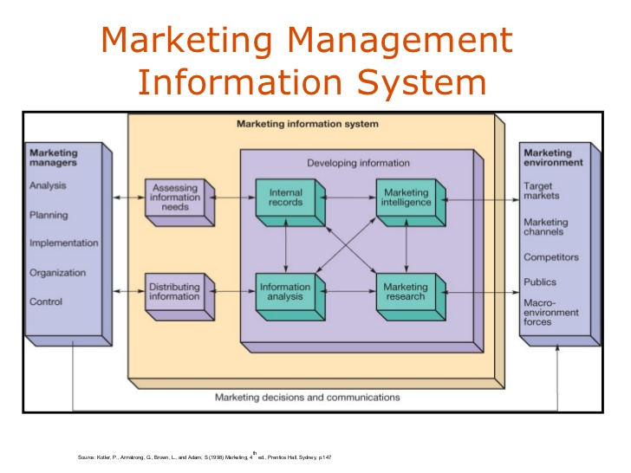

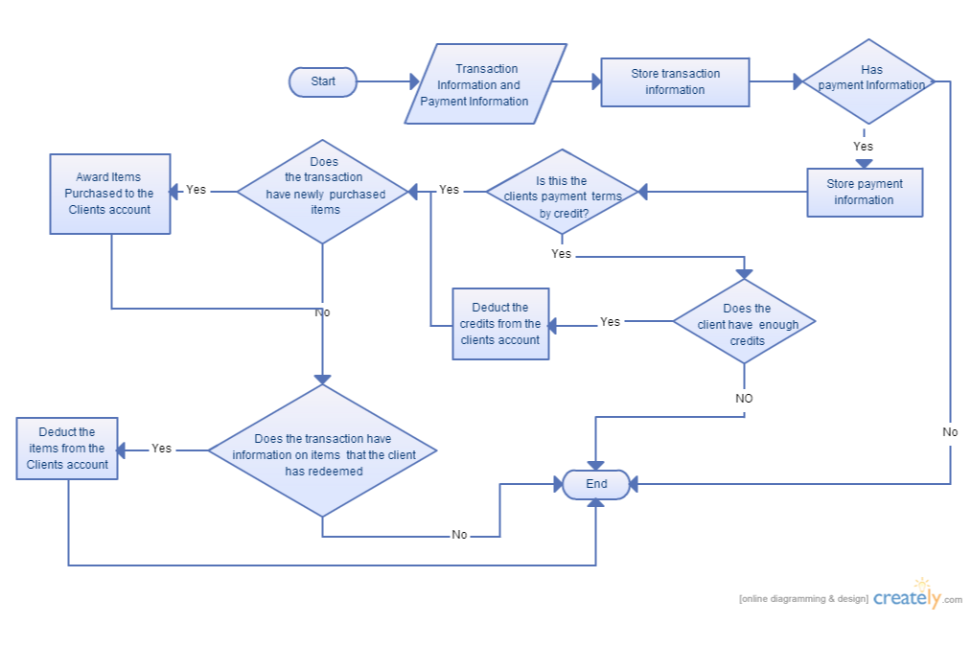
Google Books. (2019). Marketing. [online] Available at: https://books.google.com/books/about/Marketing.html?id=XPoJAQAAMAAJ [Accessed 24 May 2019].

Advantage and Disadvantages of Marketing Information System of Hilton Hotel:
Bhasin stated that,"With an increasingly more competitive and increasing market, the amount of statistics wished every day by means of manner of an company is profound. So they must establish a Marketing Information tool. There are numerous benefits of Marketing facts systems
Organized Data series – MkIS can assist the managers to prepare masses of information gathered from the marketplace, therefore consequences in an increment within the productiveness.
Storage of important data:
The agency can be tracked which can be used to research independent strategies. This lets in in setting up a broader perspective which helps us recognize which steps may be taken to facilitate development.
Analysis of Planning: The making plans process, thinking about the planning device requires information. For making plans, the primary aspect which is wanted is the groups skills, then the organization environment and in the end competitor assessment. In a right MIS, those types of are present via approach of default and are continuously up to date. Therefore, MIS could be very essential for making plans and evaluation .
Control: Just like Marketing Information System can help in a crisis, in normal times it provides control as you have information of the various processes going on and what is happening across the company."

Possible Risks or Disadvantages for Hilton Hotel: The gathering of advertising facts ought to obey a excessive-common way because of the speedy alternate inside the outside marketplace." The possible risks the commercial enterprise can also face in the event that they disobey the manner in line with Bhasin are:
Opportunities:Data series may be hard to analyze over numerous time periods. may be ignored. There may be a lack of know-how of environmental adjustments and competition' moves.
Marketing plans and choices may not be properly reviewed
Actions : may be reactionary rather than anticipatory.
Maintenance: Complexity and putting in area a MIS are one of the critical obstacles to Marketing statistics systems. Furthermore, wrong records being fed in Marketing Information System can become bulky and appropriate filters want to be installation.
Conclusion: The importance of Marketing Information System is extremely essential because the electricity of economies rely on services and to better recognize the precise wishes of customers.
Kotler, et al. (2006) -defined it greater broadly as "human beings, equipment, and processes to collect, type, analyze, evaluate, and distribute wanted, timely, and correct information to advertising and marketing selection makers." Based at the findings it became obvious that there may be a superb impact .ranging from susceptible to sturdy between advertising information system and the proportion of the served. Few service companies will follow a natural transaction marketing approach. Even fairly standardized service operations encompass direct contacts with clients, and the clients do apprehend the manufacturing and delivery technique. Hence there are detail-time marketers and functional brilliant results, so we cannot speak about a natural transaction advertising and marketing and advertising and marketing state of affairs. However, the more standardized the method is, the extra dominating is the middle carrier and the technical quality of the final consequences of the manufacturing and shipping machine and the plenty less difficult it's far to govern the personnel from a advertising and marketing point of view. Firms can role their strategic approach along the strategy continuum, and the more a relationship method is referred to as for, the more wishes to be invested in interactive marketing and marketing, the practical best impact, and internal marketing. In this sort of scenario, it's miles on the same time greater crucial to create facts systems in which the company is dealing with its customer base immediately and not counting on marketplace proportion records and ad hoc client surveys.
Further references:
- Hilton.com available@: http://(www.hilton.com), (accessed on 20/05/2019)
- Gronroos, C, (1991). “The Marketing Strategy Continuum: Toward a Marketing Concept for the 1990s.”Management Decision 29 (1): 7–13.
- Rathmell, J., M. 1974.Marketing in the Service Sector. Cambridge, MA: Winthrop.

BusinessDictionary.com. (2019). What is marketing information system? definition and meaning. [online] Available at: http://www.businessdictionary.com/definition/marketing-information-system.html [Accessed 18 May 2019].
Kotler, P., Bowen, J. T., Makens, J., and Baloglu, S. (2017). Marketing for Hospitality and Tourism. Boston, MA: Pearson Education.
Lee, K and Carter ,S.,(2012).Global Marketing Management,3rd Edition,Oxford University Press.
(1983). “Relationship Marketing.” In Emerging Perspectives on Services Marketing. Eds. Leonard L. Berry, G. Lynn Shostack, and Gregory Upah. Chicago, IL: American Marketing Association, 25–8
(1983).Strategic Management and Marketing in the Service Sector. Cambridge, MA: Marketing Science Institute. (Original work published 1982, Swedish School of Economics and Business Administration, Helsingfors, Finland)
Hilton, (2019). Hilton Performance Advantage, available @: http://www.hiltonworldwide.com/development/performance-advantage/information-technology/http://research-methodology.net/hilton-hotels-pestel-analysis/ , (accessed on 20/05/19)

