Management & Organisational Behaviour

2214591
Catalin Alexandru Cocos

Executive Summary
The task is going to discuss the management and organisational behaviour of a renowned UK-based hotel InterContinental Hotels Group (IHG). This hotel group has followed a tall organisational structure which enables them to promote a culture of diversity and inclusion. The main goal of the company is to maintain true hospitality for goods. The company has followed many change initiatives such as conducting the IHG One Rewards loyalty programme, opening a new brand, using IHG studio, eliminating plastic use and many more. In this way, the company is capable of ensuring change and attracting more customers. Moreover, the strategic direction of the Company towards growth has also been covered here.

Table of Contents
Introduction 4
Main Body 4
Organisation Structure, Culture and Goals 4
Recent Change Initiatives, Their Impact and How Well These Were Managed 9
The Organisation’s Strategic Direction 11
Conclusion 12
References 13

Introduction
Understanding individual behaviour enables organisations to improve their recruitment process, foster an organisational talent pipeline and ultimately ensure organisational growth (Mullins, 2020). This report here chose InterContinental Hotels Group (IHG) and critically analysed its management practices and organisational behaviour. It is one of the renowned hotel groups in the UK which is present in more than 100 countries (IHG, 2024). The organised leadership team helped this hotel group to improve its managerial and organisational behaviour. The organisation simultaneously deploys certain change initiatives to facilitate its growth and maintain a positive culture. Its impact and the ways of management have also been discovered here. Besides that, the company’s strategic direction has also been covered by the task which improves their market position.

Main Body

Organisation Structure, Culture and Goals
Organisational structure
An effective organisational structure ensures the allocation of work enables staff to achieve business goals and also supports professional learning (Bryant and Walker, 2024). There are two types of organisational culture which are hierarchical and flat organisational structure. InterContinental Hotels Group (IHG) has a hierarchical organisational structure which enables the organisation to maintain diversity and equality in its workplace. This type of organisational structure represents different levels of authority with a long command chain. Due to the inclusion of different members in the decision-making process, organisations with tall organisational structures are able to develop innovative and unique decisions. CEO, Non-Executive chair, Chief Financial officer, Independent Non-Executive Director and other non-executive directors are the board members of its organisational structure. Furthermore, they also have their own teams incorporated into this structure. They have a leadership team with six members and a director team with five members (THE ORG, 2024).
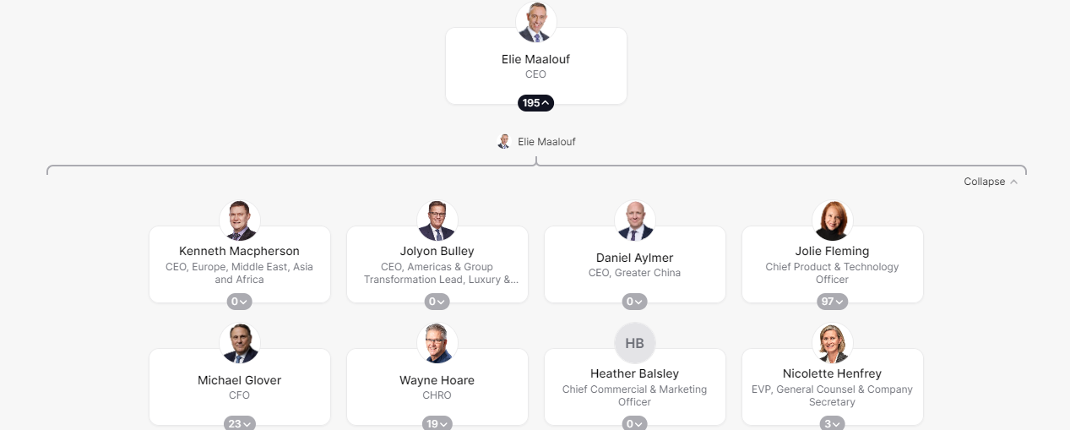
Figure 1: Organisational structure of IHG
(Source: THE ORG, 2024)
The discussion of Weber's Bureaucratic Theory at this point is adequate. This theory specifically focuses on hierarchical structure and well-defined roles and responsibilities of people which make the workplace productive. Organisational performance can also be improved by the effective management of people (Mullins, 2016). The perspectives of the theory also say that each and every element of an organisation guides its nature, structures and processes (Dash and Padhi, 2020). According to this theory, workers should be loyal to their team leader rather than the organisation. In this way, assigning special tasks to individual employees helps to maintain specialisation in the organisation. On the other hand, official in higher positions have maximum power which enables their job security. The benefit of this organisational culture is that it helps IHG to organise its operations on a regional basis such as Americas, Greater China and EMEAA. This structure also supported the global operations of IHG without any conflict. It enables the completion of reporting in every sector (marketing, finance, HR and many more) separately. Moreover, employees are aware of their roles and liabilities clearly which helps this hotel chain maintain its market position and generate more revenue. In the year 2023, they generated an amount of 2.16 billion U.S. dollars which was 1.84 billion U.S. dollars higher than the previous year (Statista, 2024).
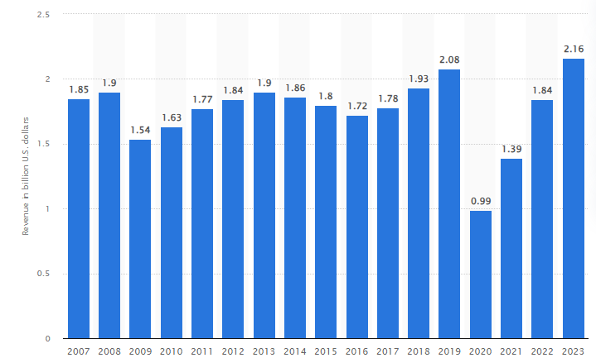
Figure 2: Revenue of IHG
(Source: Statista, 2024)
However, managing diversity and then its integration is quite difficult for companies like InterContinental Hotels Group (IHG). They always try to balance diversity and inclusion rather than embracing it in their work culture. Moreover, due to the long hierarchical structure, the decision-making process of the company is also slower than its other rivals. Quick responses and decision-making possess is important in this digitalised world to stay competitive.
Some of the major competitors of IHG are Haytt, Marriott, Premier Inn and many more. Premier Inn provided tough competition to IHG in its UK market. This is another UK-based hotel chain that has also followed a tall organisational structure. However, it has been noticed that a professional general manager primarily oversees all of the activities of this hotel organisation. From the overall evaluation, it has been stated that IHG focuses on following a management structure in its business model. On the other hand, Premier Inn follows an ownership model which ensures its growth in the competitive sector. One major difference between these two hotel chains is that IHG follows a decentralised decision-making process whereas Premier Inn follows a centralised decision-making process. A decentralised decision-making process means where authority is distributed among a large group (BBC, 2024). The power of making decisions in the case of IHG relies on different people as it has global business operations. Regional managers and managers of franchises make decisions as per the needs of the company and customers. On the other hand, the strategic decisions of Premier Inn should only be taken by its head office. Now, in the case of IHG, the reduction of hierarchical layers and following a decision-making framework may be effective in increasing the speed of its decision-making process.
Organisational culture
Organisational culture refers to the range of norms, values and conventions which stimulate the behaviour and act of a corporation (Tran, 2021). The global presence of IHG represents different cultures, regions, abilities and belief systems. In this way, by fostering a diverse culture, the company is able to increase its innovative sense. Executive Committee and the board members of InterContinental Hotels Group (IHG) have always maintained business ethics and true hospitable behaviour to foster goods. The company believe in solution-oriented activities and embraces different ethical codes of conduct to ensure growth. However, the impression of supply chain risk is a major issues that prevent the management agendas in the IHG (IHG, 2023). Schein's theory of organisational culture here helps to find out the areas of alignment and misalignment with organisational culture (Sridharan, 2022). Marriott International is a major rival of IHG that may compete with the organisational culture of the company. The organisational culture of IHG focused more on improving the work environment and its system. On the other hand, the organisational culture of Marriott International ensures the goodness of employees and people which makes the culture stronger and approachable.
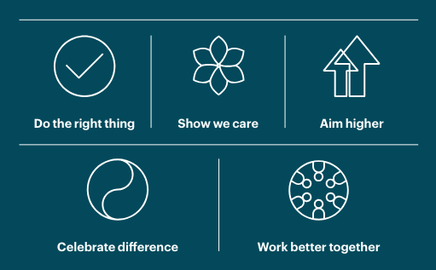
Figure 3: Organisational culture of IHG
(Source: IHG, 2023)
The main goals of InterContinental Hotels Group (IHG) are discussed below
- The main goal of IHG is to become the choice for their guests and owners. At this point, they only try to maintain true hospitable behaviour for goods.
- They also committed to shaping their culture by bringing their brand into the lifestyle of people which ensures different and innovative experiences for the people related to this hotel organisation.
- They launched Journey To Tomorrow in the year 2021 which is a ten-year plan (IHG, 2022). The main goal of this plan is to improve the travel in future and focus on strengthening their commitments. The hospitality for goods of IHG focuses on some major areas including people, communities, waste, carbon & energy and water. In this way, the company try to ensure a healthy lifestyle for all people from any age group.

Recent Change Initiatives, Their Impact and How Well These Were Managed
Recent change initiatives of IHG and its impacts are discussed below
- IHG transformed the “IHG One Rewards loyalty programme”, making improvements in the master brand, conducting more partnerships and establishing a web plan to bring positive change in communities and sustainable hotels. Sustainable business plans reflected the commitment of IHG towards the community which enabled them to target more customers. According to the data of 2022, the company booked 69,806 hotel rooms (Statista, 2019).
- Apart from this, Journey to Tomorrow 2030 is another strategic approach of IHG (IHG Development, 2024). In this approach, the company make certain changes in its business plan which ensures long-term positive change in operational areas. Supporting inclusive and diverse cultures, promoting human rights, supporting communities, and decreasing environmental emissions are the changes made by the company recently. All of these changes help them to improve their brand image and make their market position stronger in the cutthroat hotel market of the UK.
- Recently, the company also focused on building real momentum with transparent plans and priorities which help to ensure the operation and growth of the company. It guides the hotel company and is aware of every single market change which explores more growth opportunities.
- Moreover, at the end of the year 2019, IHG started using IHG Studio which is another change initiative. These change initiatives help the hotel group to offer a less maintenance operational framework which helps to save operational costs.
- In the same year, they made another change by ensuring the elimination of single-use plastics. In this way, they are able to eliminate almost 50 million straws from every hotel (New York to Tokyo) (Fcmtravel, 2024). It not only helps to decrease the carbon footprint of the company but also enlightens its brand image in the competitive market.
- IHG also launched a new brand named Garner in August 2023 (Hospitality, 2024). This change initiative enables the company to ensure its global expansion and generate more revenue.
All of these changes not only help IHG to increase its revenue generation but also enable it to reinforce its market position as well. In this way, the company can achieve an extraordinary position in the competitive market. Change is inevitable with time which not only explores growth opportunities but also ensures that a business can run smoothly. The discussion of the ADKAR Model has been effective at this point because this model initially tried to create awareness among people about the change. This model incorporates five stages that are awareness, desire, knowledge, ability, and reinforcement (Jaaron et al. 2022). From the above evaluation, it has been noticed that IHG also try to increase awareness about change among its employees and managers to execute change. After that, by acknowledging change, the company is capable of managing changes in its operational system. At this point, the company also provide necessary training to employees to increase their skills and competence in order to embrace change. In order to manage all the change initiatives, IHG has used a strong monitoring system which helps it to emphasise its diverse portfolio. The consistent monitoring process enables the company to maintain changes in their new brands as well which ensures their competitive growth.

The Organisation’s Strategic Direction
The strategic direction of IHG is to utilise its scale and expertise in order to improve its guest services and offer extraordinary guest experiences. Moreover, in their strategic direction, they also focus on using the returns of the owner in order to grow their brand in some of the most valuable markets in the industry. Holistically, the strategy of IHG focuses on the value creation by promoting brands in a superior position and also strengthening their loyalty programme. IHG use a lower-cost direct channel strategy to cut the cost involved for third parties. This kind of strategy enables companies to sell their manufactured products directly to customers. No intermediates such as wholesalers and retailers are involved in the strategic business practices of IHG. The company also have to make their packages available at a good and affordable cost which helps them to attract more people. In the year 2023, the company further modify and improve its ambition, strategic pillars and growth behaviours (InterContinental Hotels Group PLC, 2024). In this way, the company was capable of strengthen its brand portfolio from 11 to 19. They also received an award for being one of the world's largest hotel loyalty programmes with 130 million people (InterContinental Hotels Group PLC, 2024).

Conclusion
The overall evaluation concluded that understanding organisational behaviour is important to improve managerial activities, foster growth and also strengthen market position. InterContinental Hotels Group (IHG), the renowned hotel group in the UK has followed a hierarchical organisational structure. Here, the hotel group deploy an organisational culture of diversity, equality and inclusion. It not only helps the organisation to improve management and organisational behaviour but also fosters its growth in the competitive market. This task besides discussing organisational culture, people and structure of IHG, also deals with its change initiatives. The strategic directions of the company have also been covered in this report.

References
BBC., 2024. Where decisions are made - Decision making - Higher Business management Revision, Available at: https://www.bbc.co.uk/bitesize/guides/zkdc7nb/revision/2. [Accessed on 27/05/2024]
Bryant, D.A. and Walker, A., 2024. Principal-designed structures that enhance middle leaders’ professional learning. Educational Management Administration & Leadership, 52(2), pp.435-454.
Dash, S.S. and Padhi, M., 2020. Relevance of Max Weber’s rational bureaucratic organizations in modern society. Management Revue, 31(1), pp.81-91.
Fcmtravel., 2024. IHG is ditching mini toiletries in hotel rooms in favour of sustainable alternatives, Available at: https://www.fcmtravel.com/en-ie/resources/travel-news/ihg-removing-single-use-plastic-30072019#:~:text=Saying%20no%20to%20single%2Duse [Accessed on 27/05/2024]
Hospitality., 2024. IHG’s Garner brand expands with new openings and global reach, Available at: https://hospitality-on.com/en/opening/ihgs-garner-brand-expands-new-openings-and-global-reach#:~:text=Launched%20in%20August%202023%2C%20Garner [Accessed on 27/05/2024]
IHG Development., 2024, On a journey towards a better future, Available at: https://development.ihg.com/sites/ihgplc/files/IHG/A%20sustainable%20business/I-H-G-R-B-R-Interactive-280222.pdf. [Accessed on 27/05/2024]
IHG., 2022. Responsible business, Available at: https://www.ihgplc.com/en/responsible-business. [Accessed on 27/05/2024]
IHG., 2023. Strategic Report, Available at: https://www.ihgplc.com/~/media/Files/I/Ihg-Plc/investors/annual-report/our-culture-2022.pdf [Accessed on 27/05/2024]
IHG., 2024. About us, Available at: https://www.ihgplc.com/en/about-us#:~:text=IHG%C2%AE%20Hotels%20%26%20Resorts%20is. [Accessed on 27/05/2024]
InterContinental Hotels Group PLC., 2024. Our strategy, Available at: https://www.ihgplc.com/en/about-us/our-strategy#:~:text=Our%20strategy%20is%20to%20use. [Accessed on 27/05/2024]
Jaaron, A.A., Hijazi, I.H. and Musleh, K.I.Y., 2022. A conceptual model for adoption of BIM in construction projects: ADKAR as an integrative model of change management. Technology Analysis & Strategic Management, 34(6), pp.655-667.
Mullins, L., 2016. Management and Organisational Behaviour (11th edition) Harlow: Pearson
Mullins, L., 2020. Organisational Behaviour in the Workplace (12th edition) Harlow:Pearson
Sridharan, M.A., 2022. Schein’s Organizational Culture Model. Available at: https://thinkinsights.net/consulting/schein-organizational-culture/#:~:text=Schein. [Accessed on 27/05/2024]
Statista., 2019. Topic: InterContinental Hotels Group, Available at: https://www.statista.com/topics/1905/intercontinental-hotels-group/. [Accessed on 27/05/2024]
Statista., 2024. IHG revenue 2020, Available at: https://www.statista.com/statistics/273254/revenue-of-the-intercontinental-hotels-group/#:~:text=UK%2Dbased%20multinational%20hotel%20company. [Accessed on 27/05/2024]
THE ORG., 2024. IHG Org Chart, Available at: https://theorg.com/org/ihg. [Accessed on 27/05/2024]
Tran, Q.H., 2021. Organisational culture, leadership behaviour and job satisfaction in the Vietnam context. International Journal of Organizational Analysis, 29(1), pp.136-154.

