数字和年龄
rhifau ac oedran
numbers and age

Vocabulary

中文 | Pinyin | Welsh | English
一 | yī | un | one
二 | èr | dau | two
三 | sān | tri | three
四 | sì | pedwar | four
五 | wǔ | pump | five
六 | liù | chewch | six
七 | qī | saith | seven
八 | bā | wyth | eight
九 | jiǔ | naw | nine
十 | shí | deg | ten
十一 | shí yī | un deg un | eleven
二十 | èr shí | dauddeg | twenty
二十一 | èr shí yī | dauddeg un | twenty one
九十九 | jiǔ shí jiǔ | naw deg naw | ninety nine
一百 | yī bǎi | cant | a hundred
一千 | yī qiān | mil | a thousand
一万 | yī wàn | deg mil | ten thousand

* colour code for tones : first tone (blue), second tone (yellow), third tone (green), fourth tone (red)

sentence builder 1a

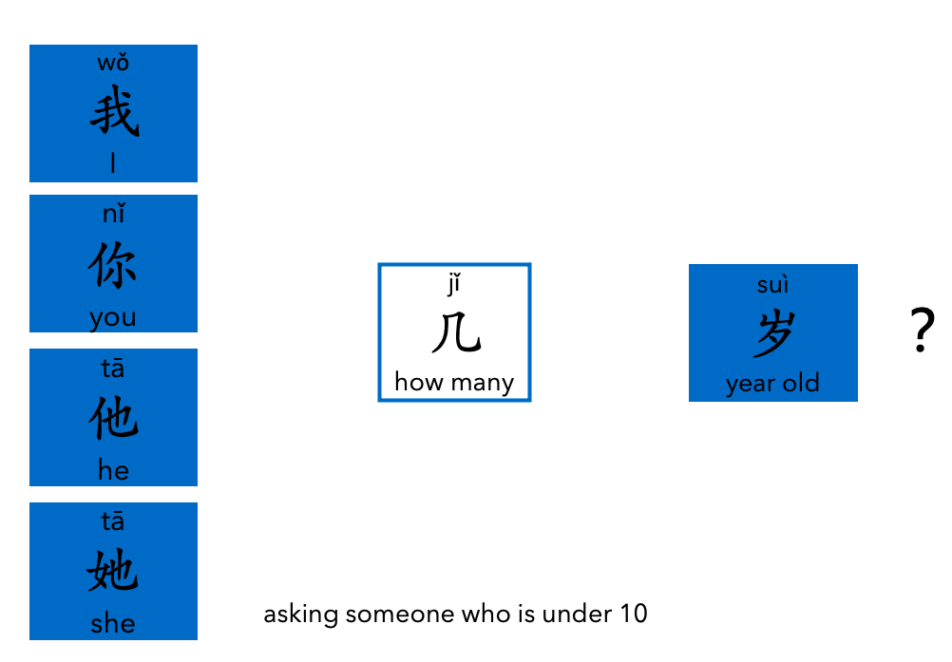

sentence builder 1b

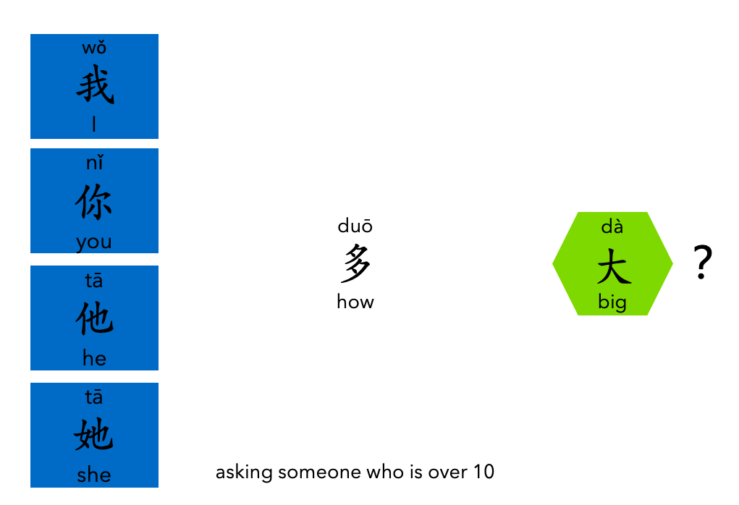

sentence builder 2



