Build, deploy, configure and manage a Type 2 Hypervisor platform based Virtualised network

Worksheet 4
ROUTING AND PACKET FILTERING WITHIN CORE
TCP/IP SERVICES AND CRITICAL
FAILOVER/REDUNDANCY PRACTICES

(ACCA5023)

University of Wales Trinity Saint David

27/04/2021

Jaromir Pauer (1801641)
Contents
Task 1 (Utilising ARP and Routing Tables): 2
Task 2, Deploy core services (FTP Server): 6
Task 3: Installing and configuring the Routing and Remote Access Service 14
Task 3: Observational Task: 21
Task 4: IP Packet Filtering 22
Task 5: Failover Clustering for high availability systems/services 33
Task 6: Observational Task 47
References 52

Task 1 (Utilising ARP and Routing Tables):
This task was initiated by launching cmd.exe and then issuing a command ‘arp -a’ to print out the routing table of Server 1, as shown in figure 1. The next step of this task was to attempt to ping the other hosts in the two networks. At this stage it was possible to see that the ping requests were in fact updating the routing table. In order to get a general view it was possible to print out a more detailed routing table by issuing the command ‘route print’ in the cmd.exe . The steps and a detailed routing table are set out in figures 2-5.

Figure 1 - issuing 'arp -a' command in cmd.exe
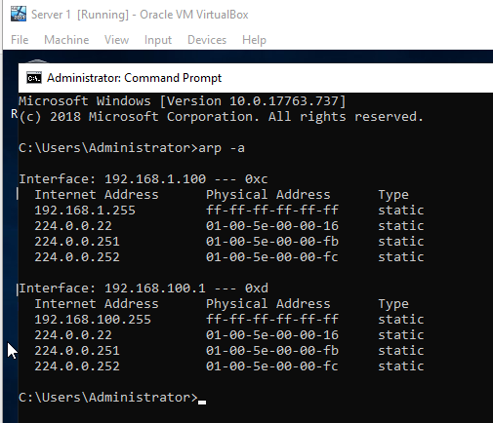

Figure 2 - Ping to Server 2 on Public Net – Success
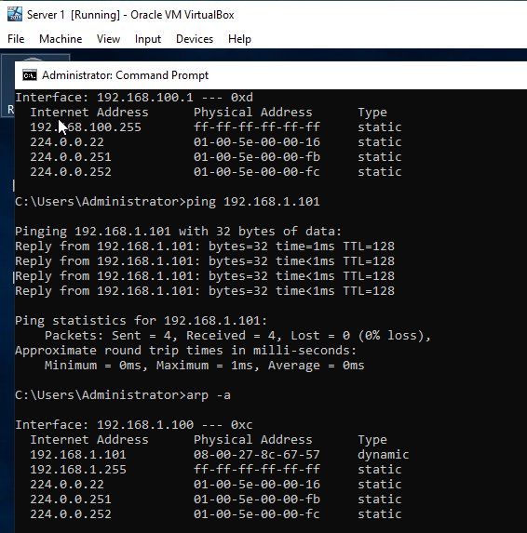

Figure 3 – Ping to Client 1 on Private Net – Success
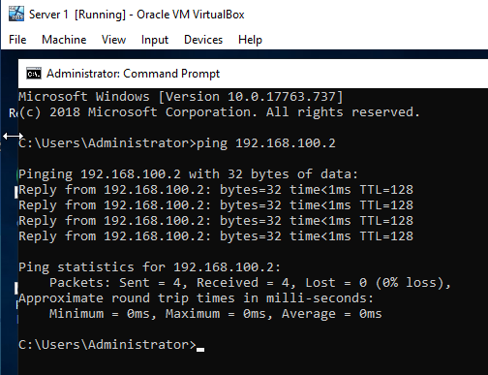
Figure 4 - Ping to Client 2 on Private Net 2 - Transmit failed. General failure.
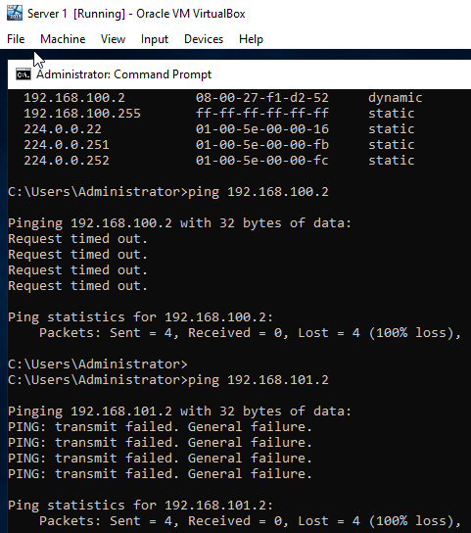

Figure 5 - Issuing 'route print' command in cmd.exe on Server 1.
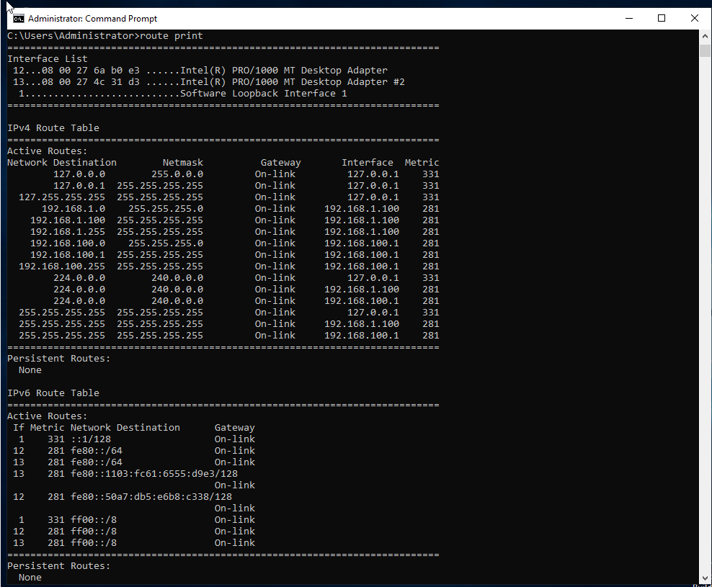

Task 2, Deploy core services (FTP Server):
The second task of this worksheet was to install the ‘Web Server Role (IIS)’. This was achieved by adding roles and features in the server manager app. Inside the ‘Web Server Role (IIS)’ feature there was an option to include the FTP server and FTP service. The steps taken to install the ‘Web Server Role (IIS)’ feature are set out in figures 6-9.
Figure 6 - Adding Roles and Features - Selecting Web Server (IIS).
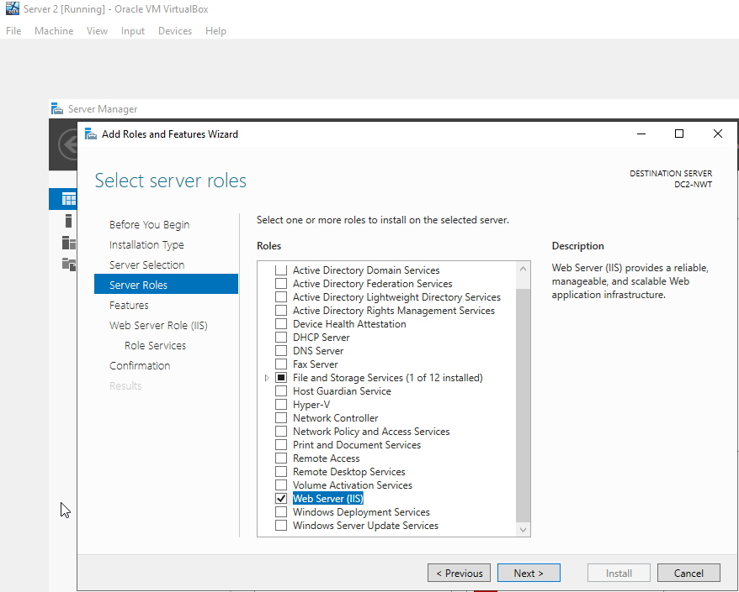
Figure 7 - Selecting FTP Server and FTP Service in Role Services.
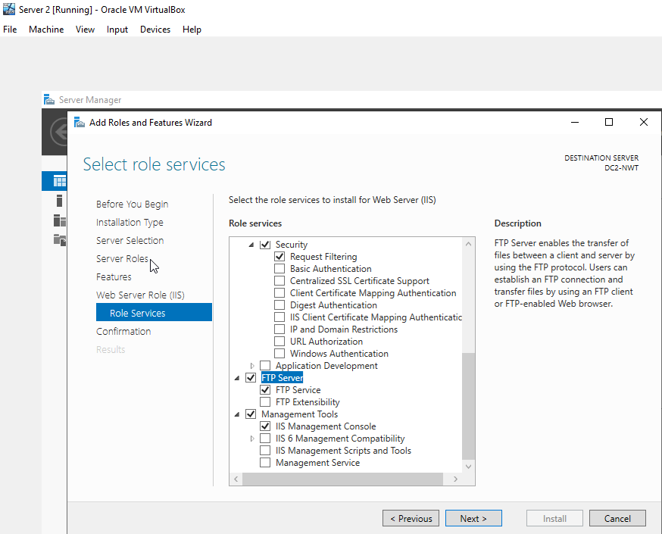

Figure 8 - Adding Roles and Features - Summary window
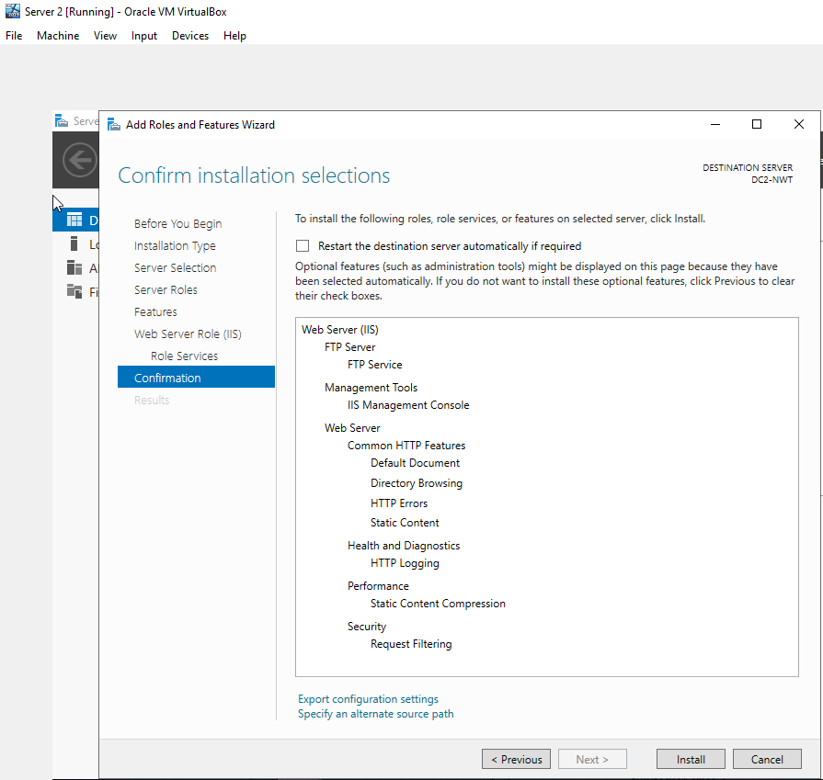

Figure 9 - Installation of the Feature Completed.
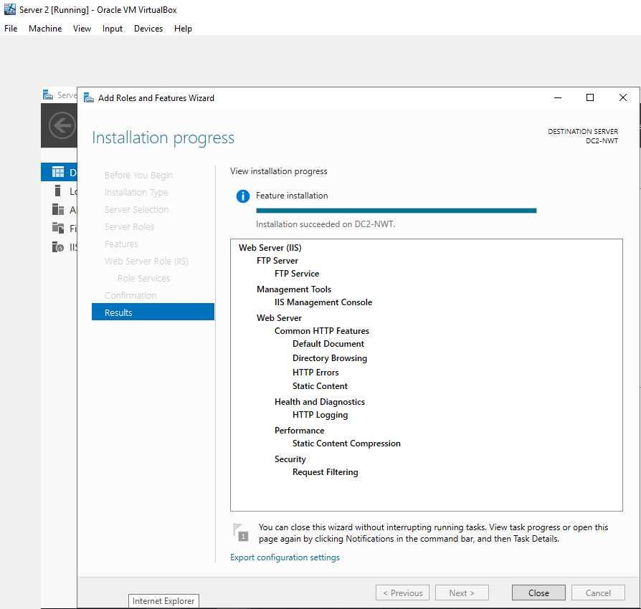
The next part of the task was to create a ftp user account by navigating to the Tools – Computer Management option in the Server Manager app. A new user was created by assigning to that person a username and a password, as shown in figure 10.

Figure 10 - Creating FTP user
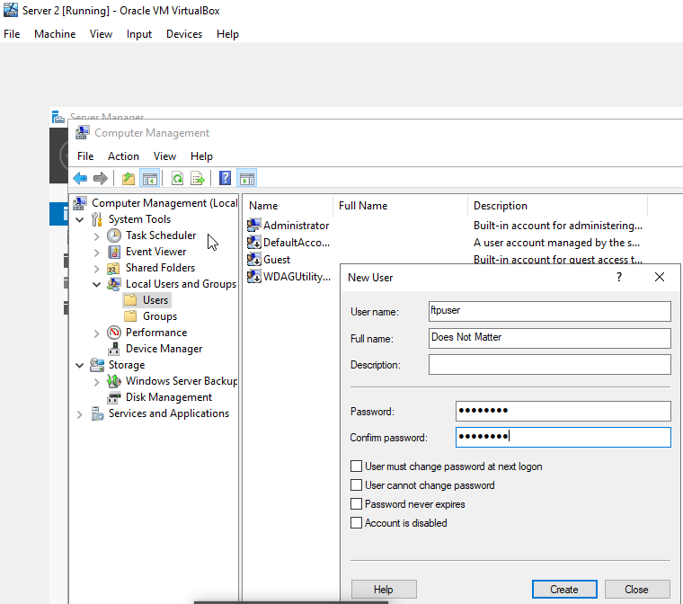

The task continued by adding a new FTP site. The name selected for this ftp site was ‘1STFTPSITE’. The physical path selected was C:\inetpub\ftproot. The decision was made not to select the SSL option. In the ‘Authentication and Authorization Window’ , the basic authentication option was selected. Access to the FTP site was allowed for specified users. In particular, the ftpuser was given permission to read and write, after which the initial setup of the FTP site was finalised. These steps are set out in figures 11-13.

Figure 11 - Adding FTP site.
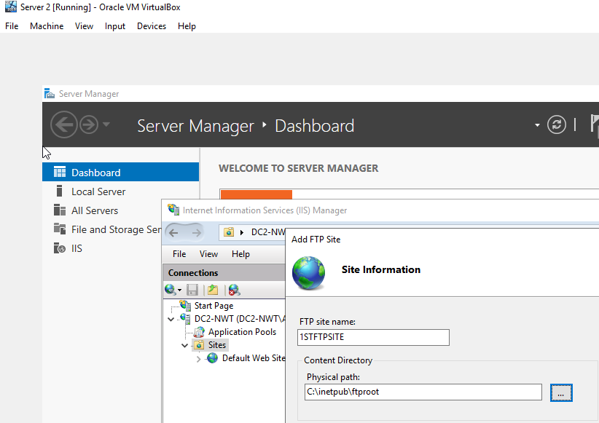

Figure 12 - Continuing the setup of adding FTP site - SSL - No SSL.
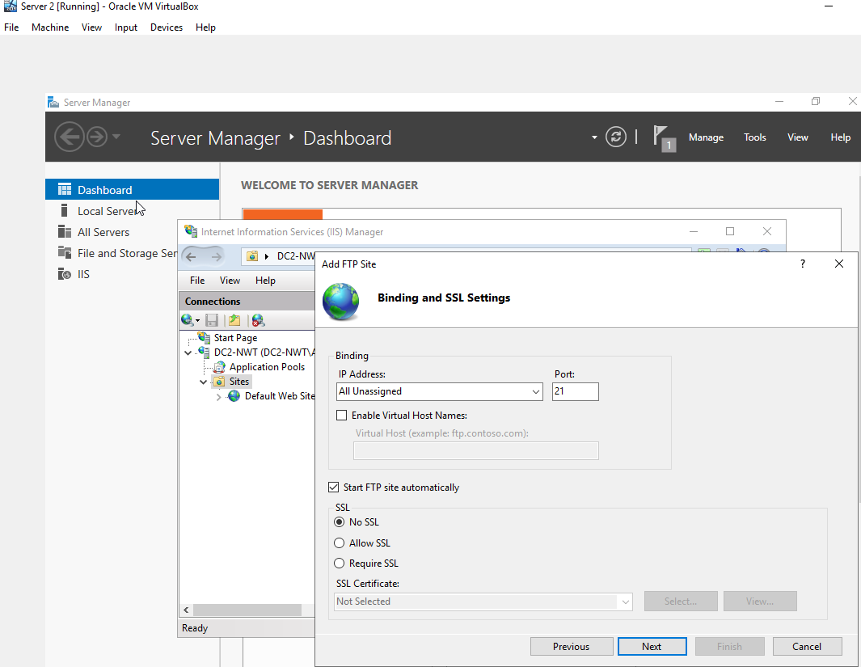

Figure 13 - Authorization - Allow access to Specified users and Finishing the configuration of the FTP site.
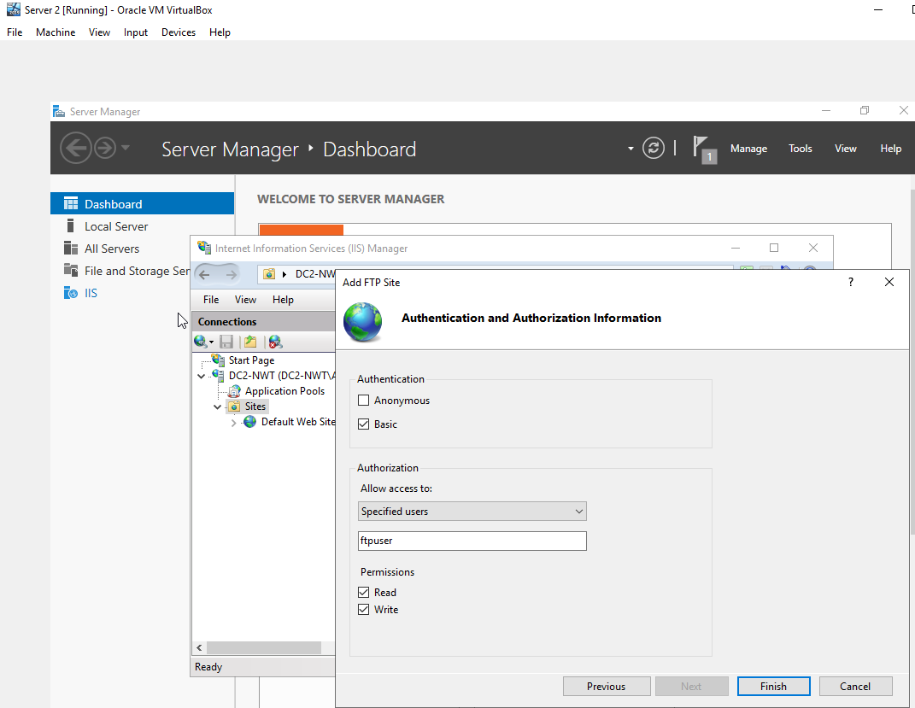

The next part of task 2 was to setup a banner message by ensuring that the ftp folder had the correct permissions and making sure that the firewall was turned off. Setting up a banner message was achieved by navigating to the Tools – Internet Information Services (IIS) feature in the Server Manager app. The left window in ‘Connections’ of DC2-NWT was expanded and then Sites - ‘1STFTPSITE’ was selected. In the right window ‘FTP Messages’ was opened. It was then possible to set up a banner message. The next step was to give permissions for the use of the ftp account which had been created earlier. This was achieved by navigating to the ‘C:\inetpub’, ftproot folder and then right-clicking and selecting properties. In the security tab, the Ftpuser was successfully added to the Groups of Users that were allowed to read/write on this folder. A precautionary step was taken to ensure that the firewall was turned off. The steps taken are set out in figures 14-16.
Figure 14 - Setting up a Banner Message.
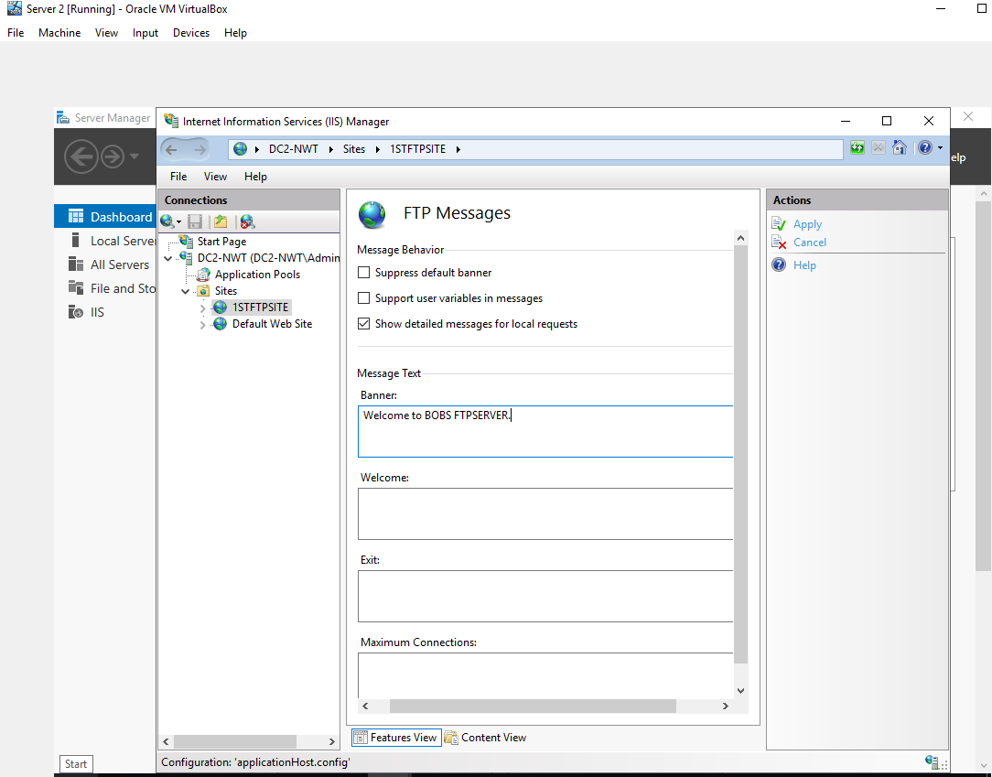

Figure 15 - Editing permissions for ftproot folder - Adding Ftpuser.
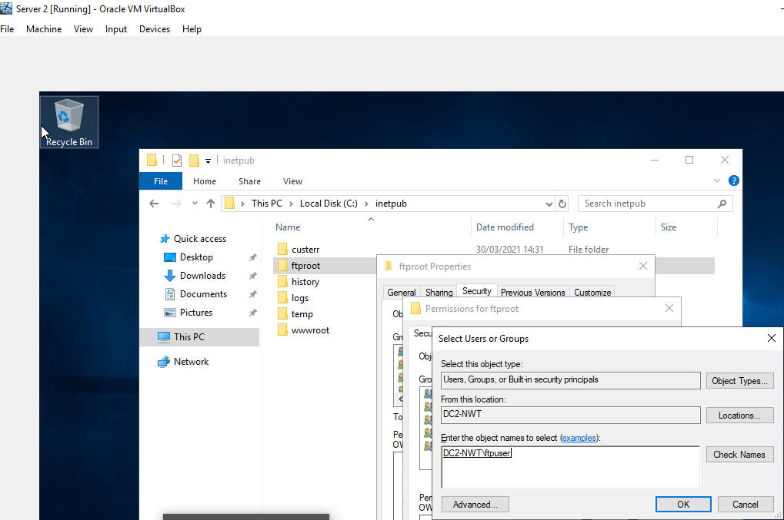

Figure 16 - Checking to see if Firewall is turned off.
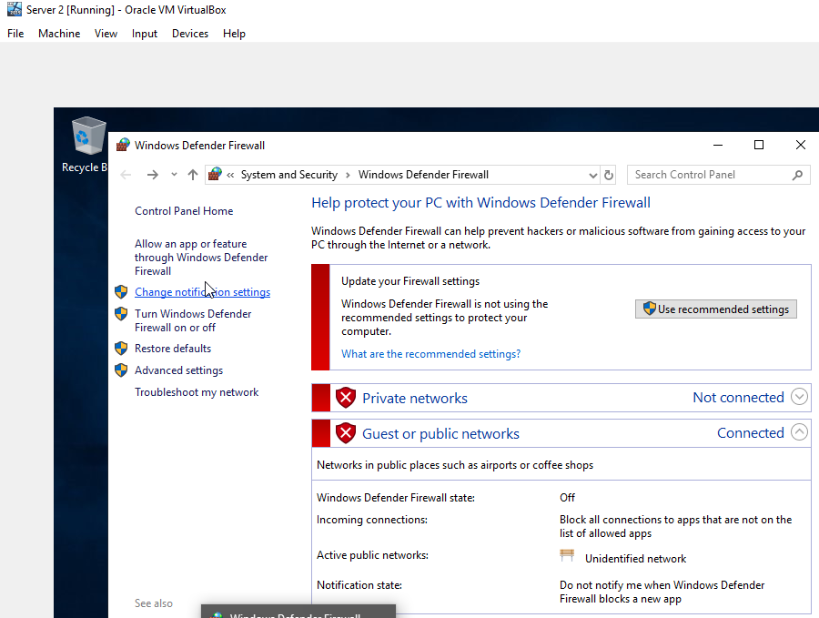

The final part of task 2 was to login to the Client 2 Virtual Machine using an administrator account. The administrator had created a folder called FTPFiles, in which a text file ftpfile2upload.txt was formulated. A connection was then made to the ftpservice by launching cmd.exe and typing ‘ftp 192.168.101.1’. At this point the administrator entered DC2-NWT\Ftpuser , where DC2-NWT was the name of the VM and Ftpuser was the name of the user. The password for ftpuser was then entered to confirm the authentication process. At this point the ftpuser was remotely connected to the ftp server. The ‘lcd C:\FTPFiles’ command was then issued so that it was possible to navigate to a local folder within the command prompt environment. The administrator then issued a command ‘put ftpfile2upload.txt’, which uploaded the text file to the FTP server. Where ‘put’ represented the action the administrator wanted to take and ‘ftpfile2upload.txt’ was the name and type of the file. By navigating to the C:\inetpub\ftproot folder on the Server 2 VM, it was possible to verify that the file had been successfully uploaded to the FTP server. These steps are set out in figures 17-19.

Figure 17 - Creating folder and a text file on Client 2 VM.
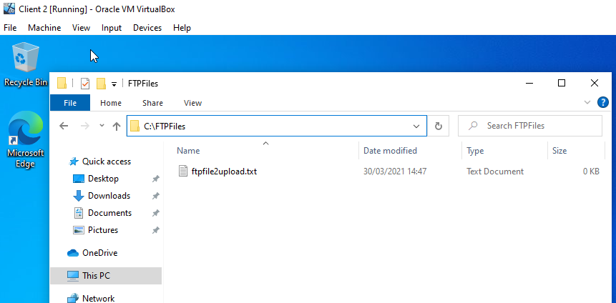

Figure 18 - Remotely connecting to the FTP server and uploading the file.
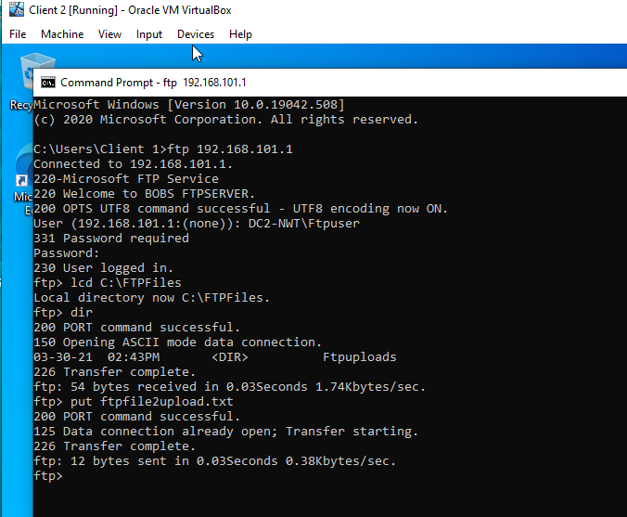
Figure 19 - Verifying that the file had been uploaded successfully.
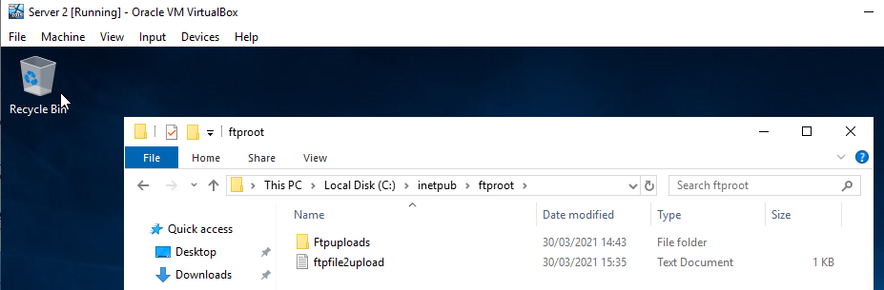

Task 3: Installing and configuring the Routing and Remote Access Service

Task 3 of Worksheet 4 was initiated by installing the ‘Remote Access’ feature on Server 1. This was achieved by using the ‘Add Roles and Features Wizard’ and selecting ‘Remote Access’. Using the summary window it was possible to double-check that the correct features had been selected. It was then possible to finish the installation. The steps taken are set out in figures 20-22.
Figure 20 - Selecting Remote Access in Add Roles and Features Wizard
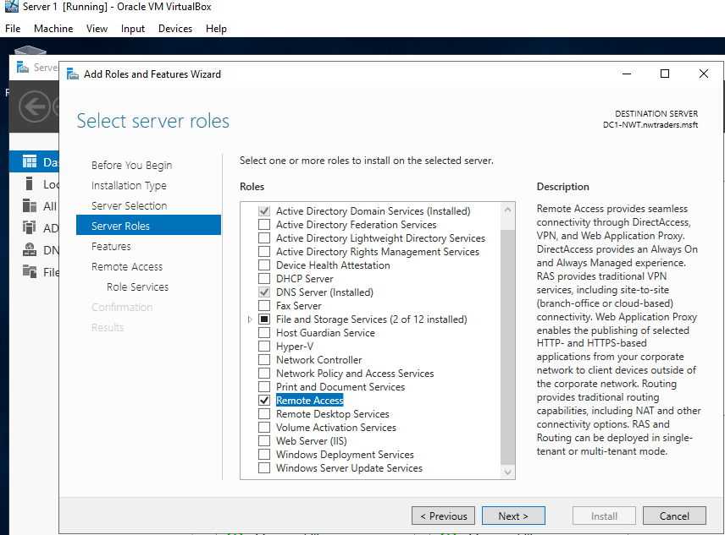
Figure 21 - Installing Remote Access Feature - Summary Window
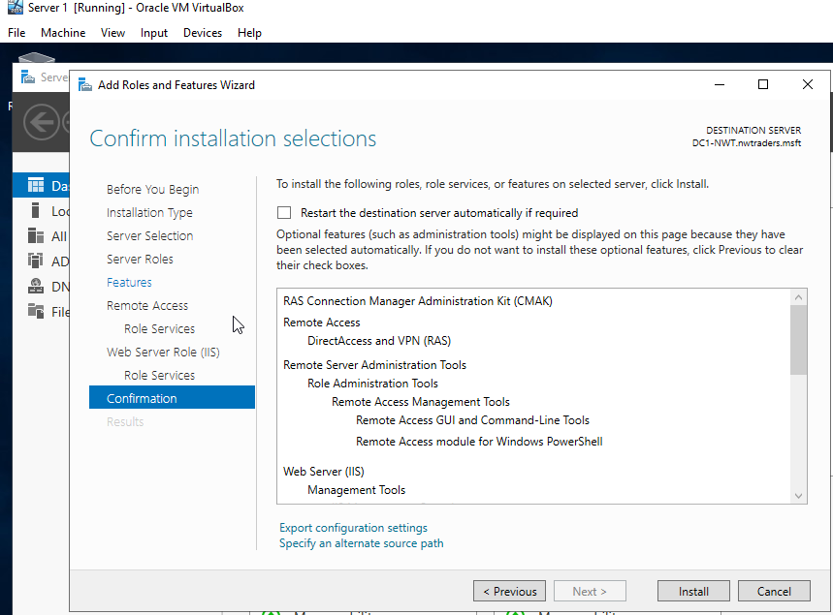
Figure 22 - Installation of the 'Remote Access' Feature Complete.
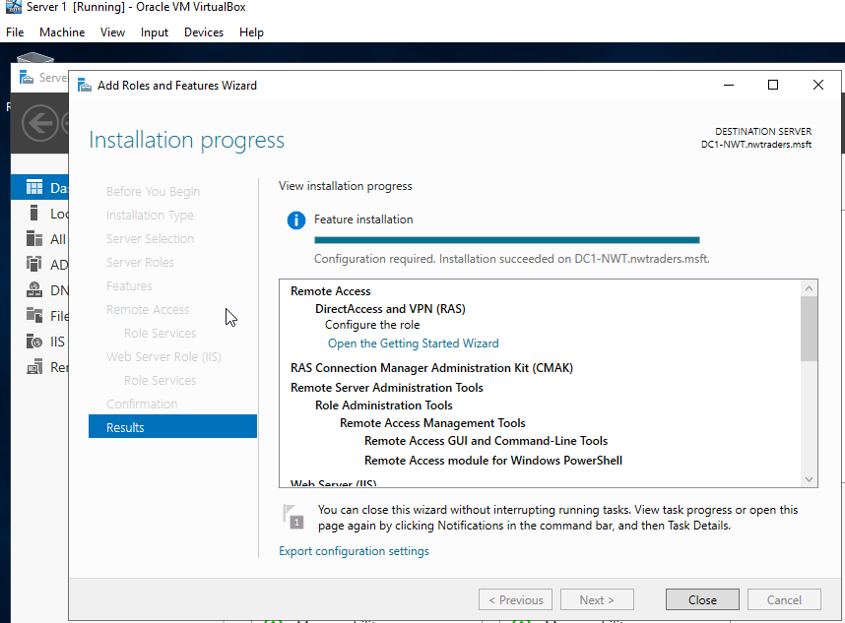

At this point it was possible to continue the task by configuring the remote access. Firstly, the administrator had to install an additional feature called ‘Routing’ since he had failed to install it in the previous setup wizard. The screenshot of this step is shown in figure 23.

Figure 23 - Selecting Routing in Server Role.
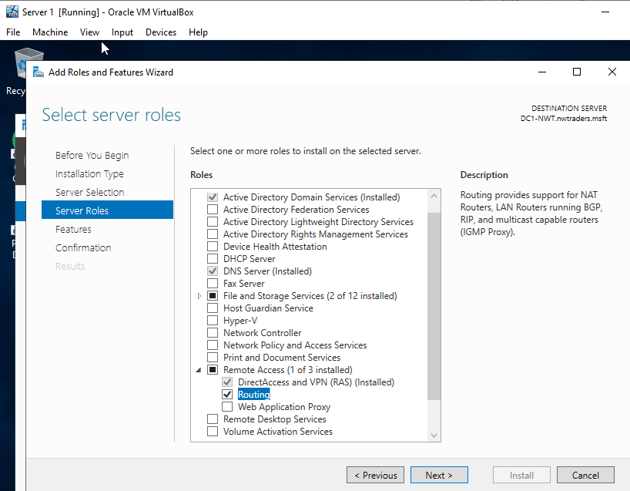

Now it was possible to configure the remote access on server 1, which was accomplished by completing the ‘Routing and Remote Access Server Setup Wizard’. Then the ‘Custom Configuration’ and ‘LAN routing’ options were selected before the ‘Routing and Remote Access Server Setup Wizard’ was completed. These steps are shown in figures 24 and 25.

Figure 24 - Selecting LAN routing in Routing and Remote Access Server Setup Wizard.
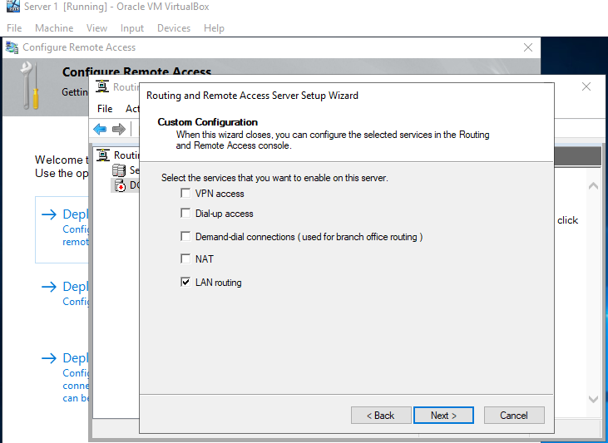

Figure 25 - Completing the 'Routing and Remote Access Server Setup Wizard'.
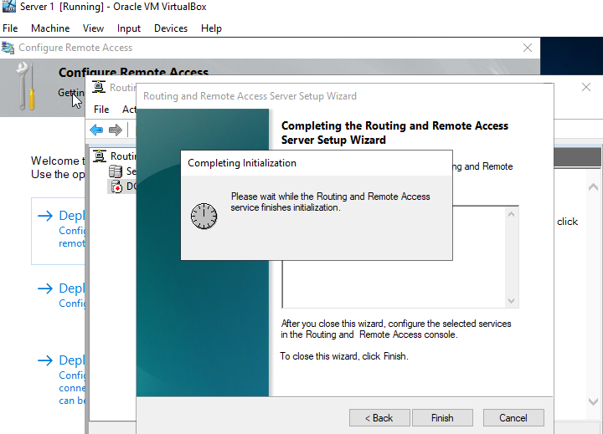

Upon completing the ‘Routing and Remote Access’ wizard it was possible to start the service. The next part was to enable the routing protocols on the network interfaces. This was achieved by navigating to IPv4 in the ‘Routing and Remote Access’ application and selecting a ‘New Routing Protocol’. All of the previous steps in Task 3 had to be completed for both Server 1 and Server 2 and the RIP configuration had to be completed on both networks (PublicNet and PrivateNet1 and PrivateNet2 [S1 & S2]). The completion of the steps are shown in figures 26-28.

Note: The screenshots below are taken from the Server 2 configuration ( this demonstrates that the Task 3 was completed for both Server 1 and Server2)

Figure 26 - Adding New Routing Protocol on Server 2.
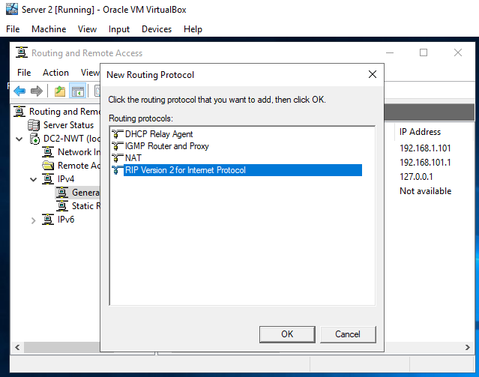

Figure 27 - Adding Routing Protocols for PublicNet and PrivateNet2.
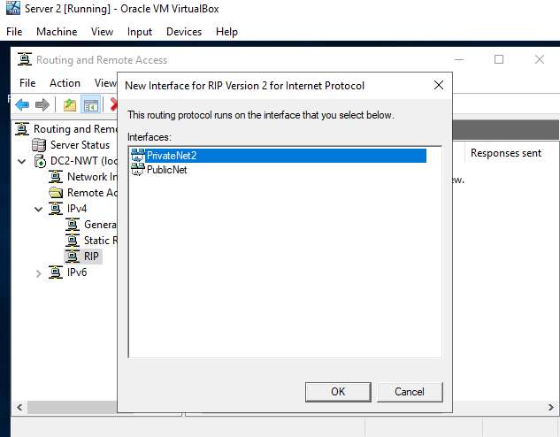

Figure 28 - Routing Protocols successfully added for Server 2.
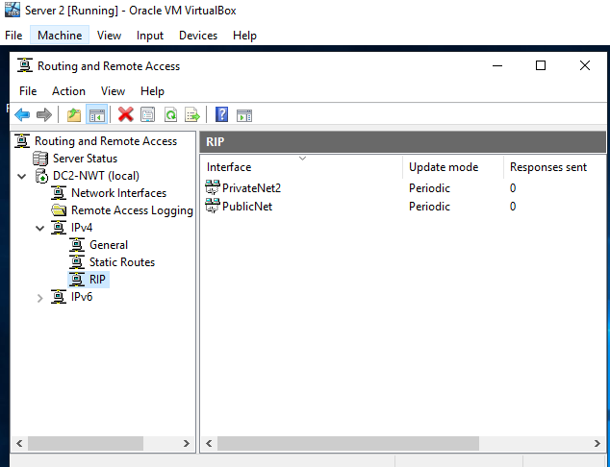

The final part of task 3 was to verify connectivity and the correctness of the previous steps. This was achieved by attempting to send an ICMP request from Server 1 to Server 2. Subsequently, another ICMP request was sent from the Client 1 to the Client 2 VM on its PrivateNet2 IP address. These steps are shown in figures 29 and 30.

Figure 29 - Attempting to send ICMP request from Server 1 to Server 2 – Success.
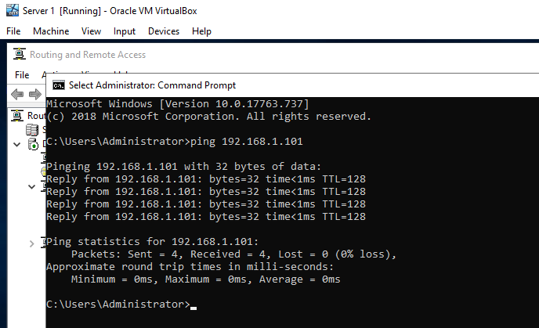

Figure 30 - Attempting to send ICMP request from Client 1 to Client 2's PrivateNet2 IP address - Success.
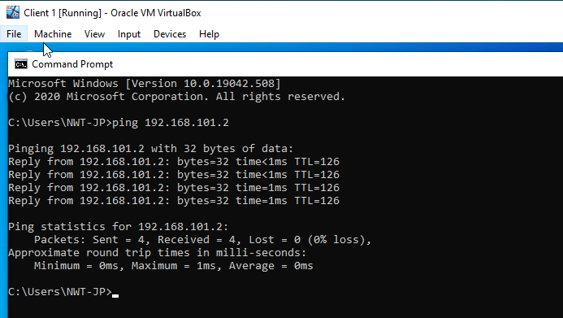

Task 3: Observational Task:

3 a) How do Routers reference which networks they are able to connect to?
Every end device has a unique IP address, which is a necessary component if it is to be connected to other devices on a local area network, or a wide area network, or the internet. The local router inspects the network address details in a data packet header to establish the ultimate destination. The router will then refer to its routing table consisting of directly connected routes and remote routes. The routing tables include details of network and next hop associations [1]. Essentially, each router will be familiar with the IP addresses of a local network and will dynamically determine the fastest and most efficient means of transmitting data packets between these local IP addresses. It should also be mentioned that an interior routing protocol is typically used in larger local networks, such as university campuses, to efficiently route packets across the network [2].

Routers connecting IP addresses over the internet rely on the Border Gateway Protocol (BGP). A router, via a modem, sends a data packet to the ISP provider who sends it onwards through a network of networks known as autonomous systems. Each autonomous system has its own routers which make use of the BGP to determine the next quickest and most efficient step of a packet’s journey [3] and [4]. Each autonomous system connects to each neighbouring autonomous system with a TCP/IP connection so that they can share routing information [3]. A packet is likely to pass through a number of autonomous systems until it reaches the router of the network that includes the destination address. The router of the destination network will forward the packet to the appropriate IP address [5]. A new packet confirming receipt of the original packet will sent to the IP address that sent the original packet.

Task 4: IP Packet Filtering

Filter 1: Stopping ‘anyone’ in PrivateNet 1 from Pinging the Router Firewall Service.

This task was completed by navigating to IP Routing – General and then right clicking the PrivateNet1 properties and adding a new inbound filter. After configuring the inbound filter it was possible to verify its correctness by attempting to send an ICMP request from the Client 1 to the Server 1 Router Firewall Service. Subsequently, a number of ICMP requests were sent to different devices on the network to check whether these were sent successfully. The steps taken are shown in figures 31-34.

Figure 31 - Routing and Remote Access PrivateNet1 Properties.
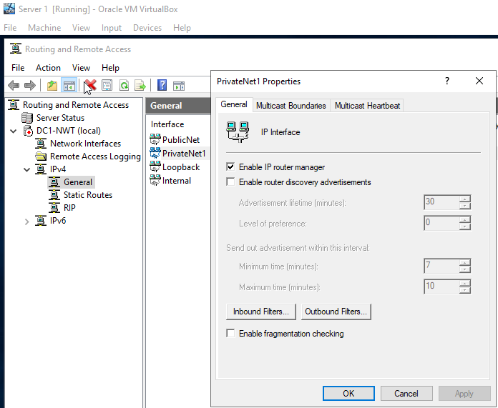

Figure 32 - Routing and Remote Access - Adding New Inbound Filter.
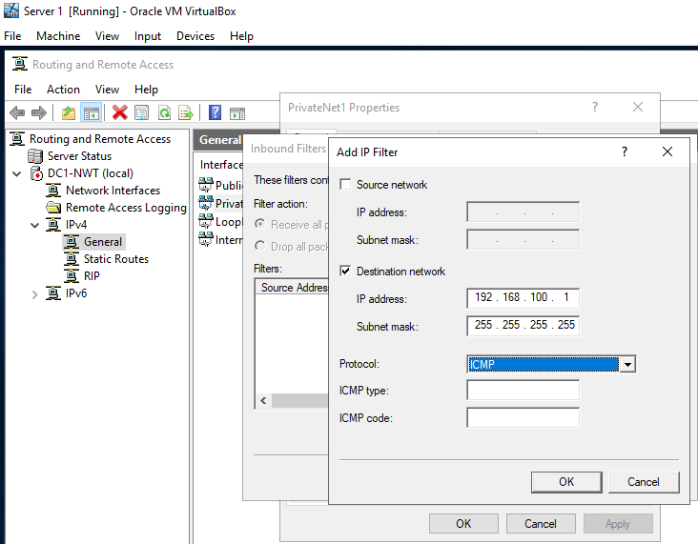

Figure 33 - Pinging Server 1 (Router Firewall Service) from Client 1 – Timed Out.
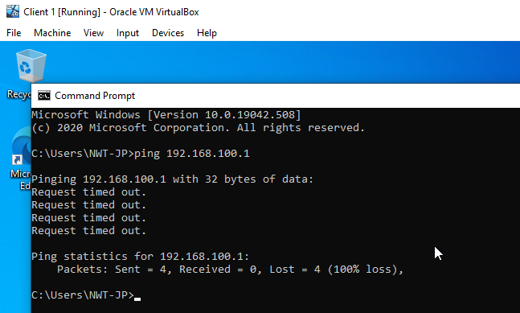

Figure 34 - Pinging Other Networks From Client 1 - Success.
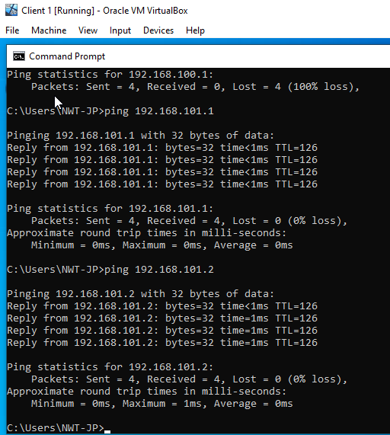

Filter 2: Restrict Access to FTP Service running on Server 2 to only hosts in PrivateNet2.

This task was completed by navigating to IP Routing – General and then right clicking the PublicNet properties and adding a couple of outbound filters. However, it was discovered at this stage that it remained possible to access the FTP service from other networks, such as PrivateNet1. The steps taken so far are in figures 35-39.

Figure 35 - Routing and Remote Access PublicNet Properties.
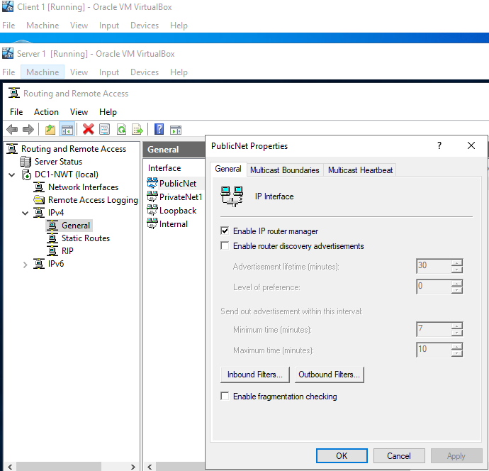

Figure 36 - Routing and Remote Access - Adding New Outbound Filter.
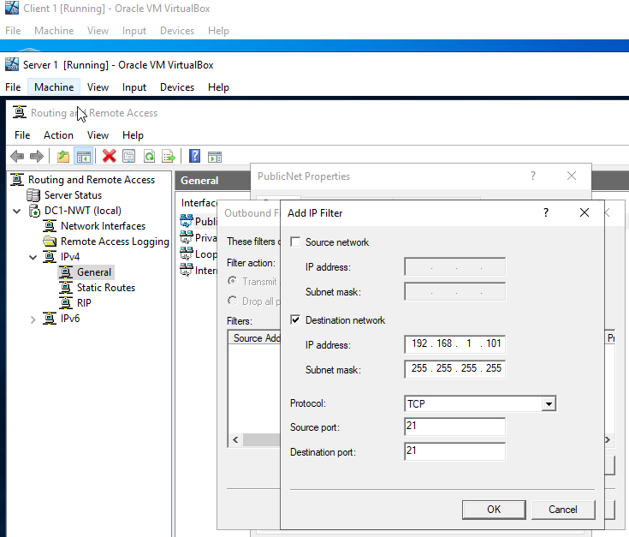

Figure 37 - Trying to Access the FTP service from Client 1 (PrivateNet1) - Success :(
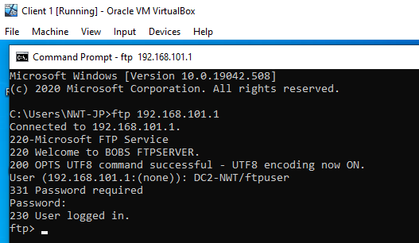

Figure 38 - Routing and Remote Access - Adding Another Outbound Filter On Server 1.
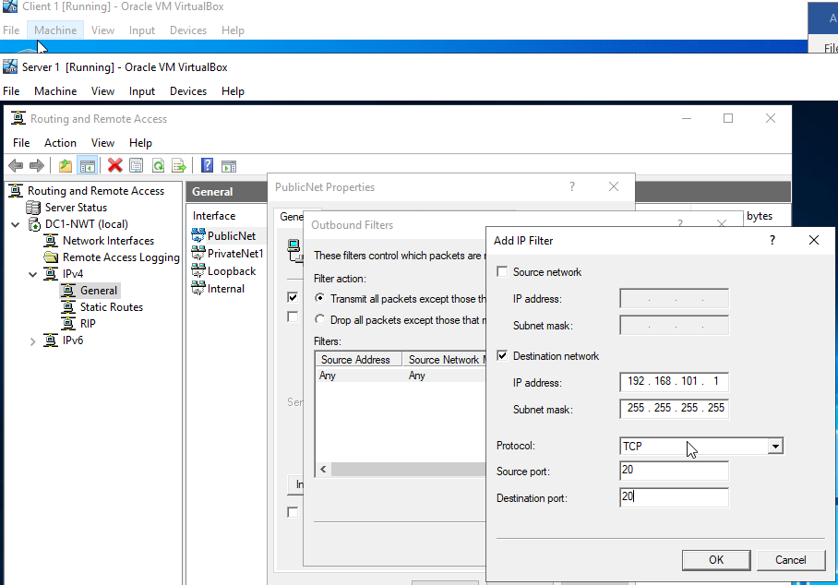

Figure 39 - Trying to Access the FTP service from Client 1 again (PrivateNet1) - Success :(
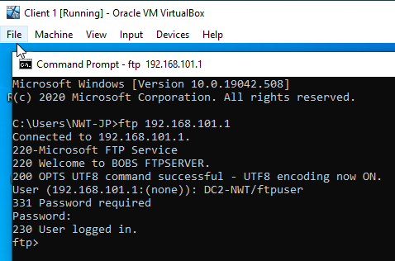

It was necessary to resolve the fact that devices from PrivateNet1 were still able to access the FTP service. In order to implement a desired working inbound/outbound filter, a specific inbound filter was added to PrivateNet2 properties within the ‘Routing and Remote Access’ app on Server 2. The purpose of this filter was to drop all packets except those from the Client 2. It was now impossible to access the FTP service from other networks.
It is worth mentioning that this inbound filter would not have been very effective on a large network as it would have blocked everyone except the specified IP address from accessing the FTP service. However, for the purpose of this assignment it works very well as it does exactly what was asked of it. The effectiveness of the inbound filter was checked by attempting to access the FTP service from the Client 1 and the Client 2 VMs. The results of these actions and the steps taken are set out in figures 40-42.

Figure 40 - Routing and Remote Access - Adding Inbound Filter on Server 2 VM.
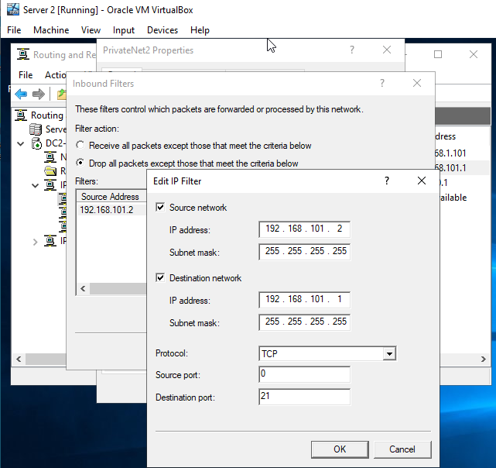

Figure 41 - Trying to Access the FTP service from Client 1 VM ( PrivateNet1) - Fail.
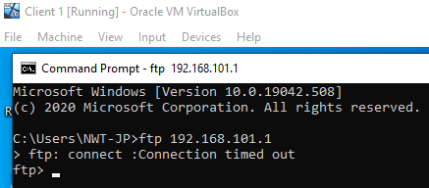
Figure 42 - Trying to Access the FTP service from Client 2 VM ( PrivateNet2) - Success.
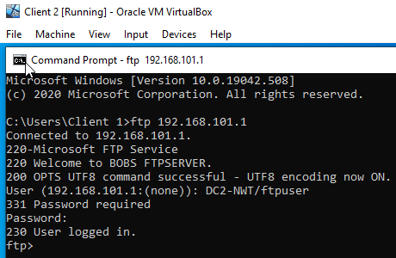

Filter 3: Only allow specific hosts in PrivateNet1 to access the FTP Service running on Server2

The purpose of the final filter was to restrict everyone except Client 1 from accessing the FTP service. As there were only 4 devices on the 3 networks, it was decided to apply an outbound filter on Server 1 that would specifically block its one device from reaching other networks. Subsequently, a specific inbound filter was added on Server 2 that blocked Client 2 from accessing the FTP service. Then another inbound filter was added on Server 2 that would specifically block it from accessing its own FTP service. At this point it was possible to test the effectiveness of these filters by trying to access the FTP service from each device on the networks. This resulted in Client 1 being the only device that was able to access the FTP service. The steps taken are set out in figures 43-49.

Figure 43 - RRAS - Server 1 PublicNet Properties - Adding New Outbound Filter.
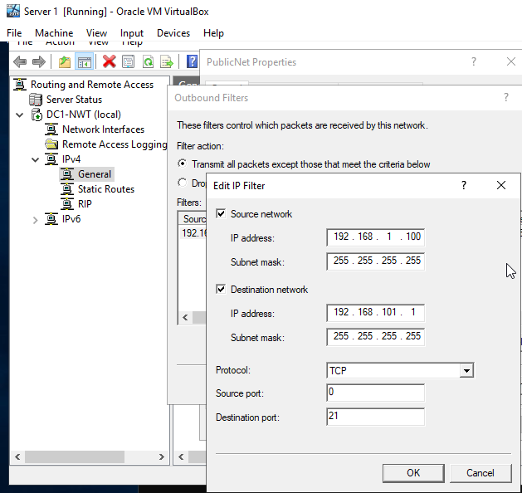

Figure 44 - RRAS - Server 2 PrivateNet2 Properties - Adding New Inbound Filter.
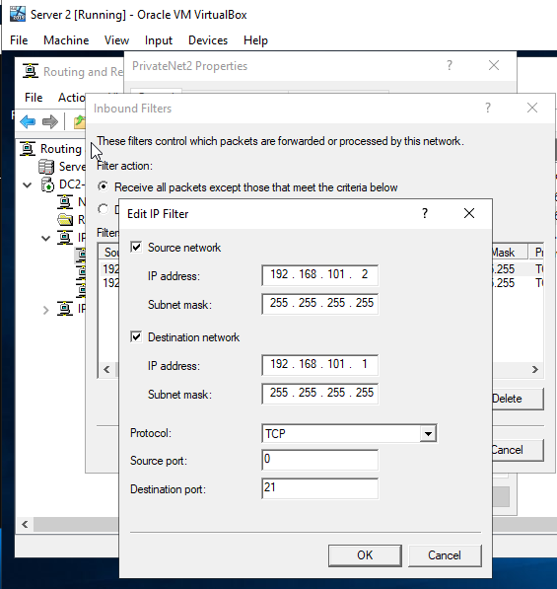

Figure 45 - RRAS - Server 2 PrivateNet2 Properties - Adding Another Inbound Filter.
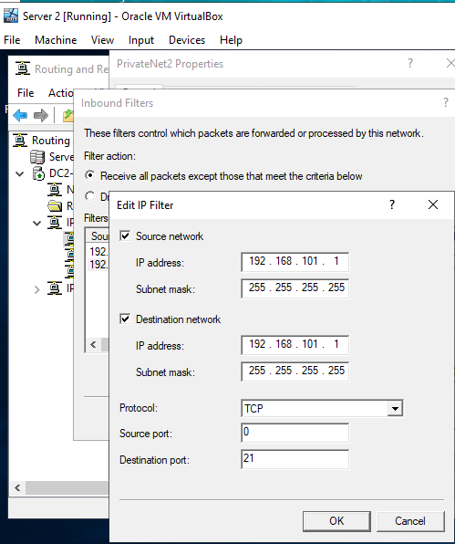

Figure 46 - Server 1 trying to access the FTP Service - Fail.
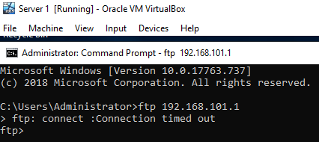

Figure 47 - Server 2 trying to access the FTP Service - Fail.
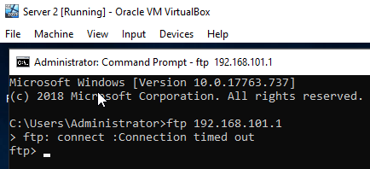

Figure 48 - Client 2 trying to access the FTP Service - Fail.
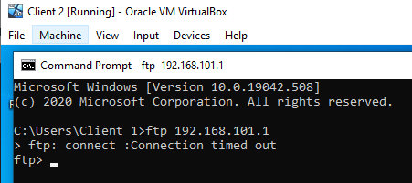

Figure 49 - Client 1 trying to access the FTP Service - Success.
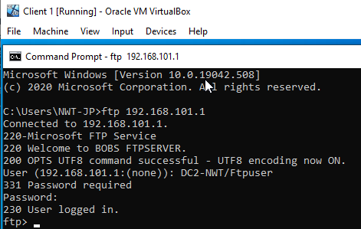

Task 5: Failover Clustering for high availability systems/services

A failover cluster is a set of physical or virtual computer systems that work together to facilitate a High Availability (HA) or Continuous Availability (CA) environment for the various applications and services that run within enterprise networks.
5 a) Give a detailed explanation of the concepts that need careful consideration when considering the usage of such a system. Also show one possible role within the Window Server OS environment that could provision these requirements. You should breakdown the aspects that need consideration when attempting to deploy this role/service. (Hint: Give screen shots of the role being configured and discuss these steps). YOU DO NOT HAVE TO BUILD, DEPLOY OR TEST A FAILOVER CLUSTER.

There are a number of factors that require careful consideration before deciding whether to deploy a failover cluster. Some cluster arrangements utilise physical servers only, whereas others involve VMs [6]. A good starting point is to ask whether the business can tolerate an interruption of its services ? A high availability (HA) failover clustering arrangement can experience minimal interruption of applications and data services per annum [6]. If for example, a Hyper-V host malfunctions in a HA model, the failover cluster system will automatically transfer the VMs to another host machine, although there may be a short interruption in services [7]. Whereas, a failover cluster arrangement with continuous availability (CA) will usually deliver uninterrupted access to applications and data [6]. The uninterrupted service is possible as the CA technology “consists of multiple systems that share a single copy of a computer’s OS [8] and [6]. It follows that “software commands issued by one system are also executed on the other systems” [6]. The CA model, sometimes referred to as 2N redundancy, delivers improved scalability, which may be an attractive consideration for large enterprises [9], [10] and [6]. The downside of the CA system is that it can be complex and costly to implement and maintain [9] and [10]. So, an organisation that can tolerate minimal interruptions to data and services my conclude that the lower investment and operational costs of the HA model are a decisive consideration in its favour. On the other hand, highly regulated organisations, such as financial institutions, are more likely to rely on the CA model.

However, clusters fail to work if the shared storage on which the VMs rely malfunctions [11]. So, an enterprise should consider the creation of a Disaster Recovery Strategy, of which failover clustering would form a component. One important consideration when planning a recovery strategy is the inclusion of a 3-2-1 backup arrangement, especially as a shared storage does constitute a single point of failure [6]. One option to consider is the deployment of a RAID 6 and RAID 10 arrangement, which will make another copy of the data available in an emergency [6]. In the worse scenario the IT infrastructure of a single data centre could be totally incapacitated by fire, flooding, or a power failure. Essentially, the enterprise will have to consider whether they also duplicate their clustering system and locate the secondary system at another location. Windows Server 2019 facilitates the replication of data with a “stretched failover feature of clusters spanning two geographical sites” [6]. As an alternative strategy, the enterprise should consider whether it would be more economical to outsource the replication to a cloud provider, such as AWS or IBM [12], [13] and [14]. In particular, consideration should be given to the optimal number of cluster nodes at each location [12], [13].

Servers based at a single location can be connected by cable, but access to them by means of the internet is likely to be necessary, particularly if the company’s failover clusters are geographically dispersed, or use is being made of servers provided by a cloud enterprise. So, inevitably the company will need to consider a holistic security strategy that will protect its hardware and software equipment and its data, whether stored or in transit. Part of the strategy may involve making use of Windows Server 2019, with its strengthened security specifications. These include the introduction of Advanced Threat Protection, which suppresses malicious files and shuts down malicious processes. The 2019 version also has increased encryption security delivered by means of the new Virtual Network Encryption, which protects data at rest and in transit [15] and [16].

Hardware and Software Specifications.

The selection of hardware and software specifications are of critical importance in any failover cluster system. Microsoft stress that it is imperative to consider a number of technical issues before installing a SQL server failover cluster. Microsoft recommends, for example, using a set of matching server nodes that include the same or similar components, and that these are running the same version of Windows Server. It is essential that all components of the storage stack share the same specifications if an organisation is using Serial Attached SCSI or Fibre Channel in all its clustered servers [17]. Careful consideration must be given to installing prerequisite software, such as Windows PowerShell; .NET Framework 3.5 SP1; a Microsoft update package; .NET Framework 4, and SQL Server Setup support files [18]. The above requirements are only examples of the care administrators must take to ensure that the mix of hardware and software are fit for purpose.

The Microsoft Failover Cluster Manager (MFCM) is one means of creating and managing failover clusters on a Windows server. Alternatively, it is possible to use the Windows PowerShell to establish and manage such clusters. MFCM is a snap-in located within the Microsoft Management Console (MMC). The Windows PowerShell is a command line shell, although it lacks any kind of Graphical User Interface (GUI).

In order to create a Failover Cluster, using Server Manager application, it was necessary to install some features, which was done by navigating the Server Manager section and selecting ‘Add Roles and Features’. Then the ‘Role-based or feature-based installation’ option was selected, as shown in figures 50 and 51.

Figure 50 - Add Roles and Features [19]
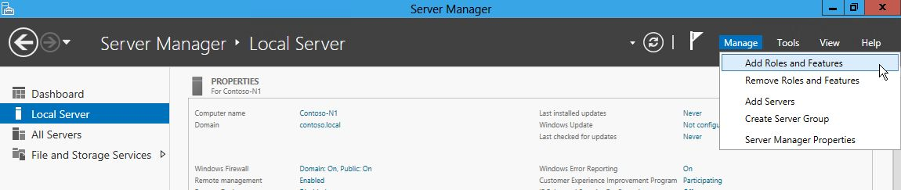

Figure 51 - Role-based or feature-based installation [19]
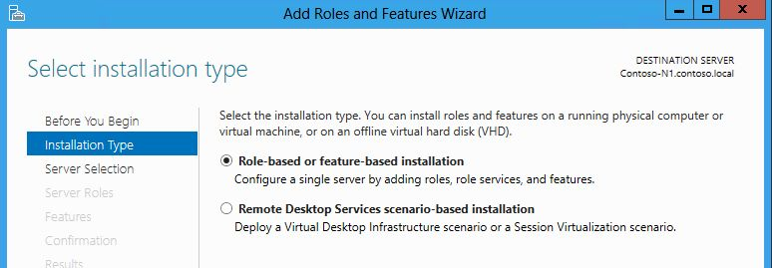

The next step was to select the correct server in the ‘Server Selection’ window of ‘Add Roles and Features wizard’. Subsequently, the words ‘Failover Clustering’ were selected and a pop-up window appeared listing a selection of additional features. At this stage it was possible to press ‘Add Role or Features’ if the user intended to install the ‘Failover Cluster Manager’ snap-in and the ‘Failover Cluster PowerShell’ cmdlets [19]. These steps are shown in figures 52 to 54.

Figure 52 - Selecting the Correct Server [19]
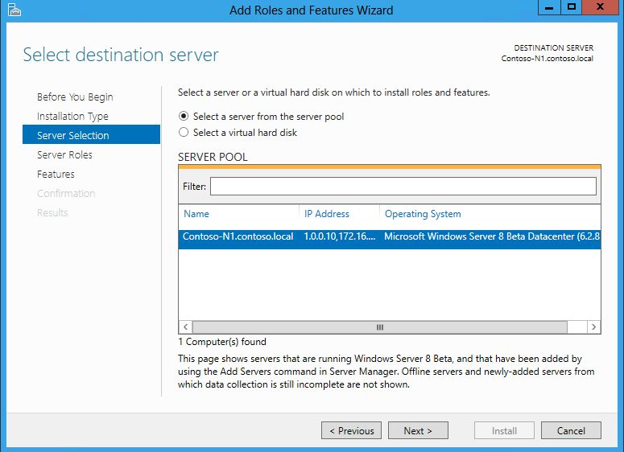
Figure 53 – Selecting Failover Clustering [19]
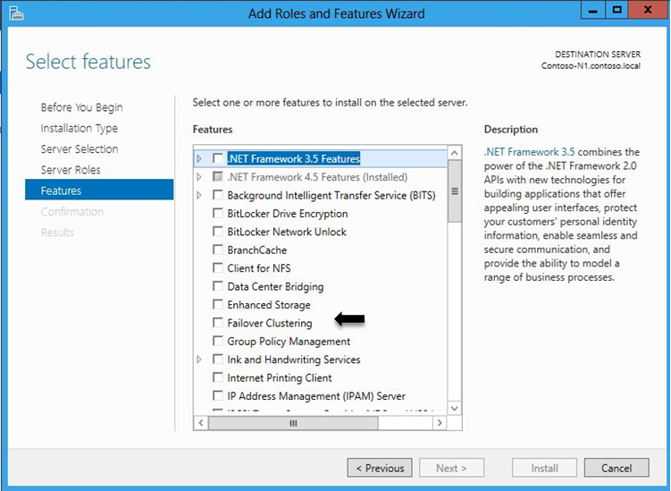

Figure 54 - Pop-up Screen to Add Features, for example, MFCM and PowerShell cmdlets [19]
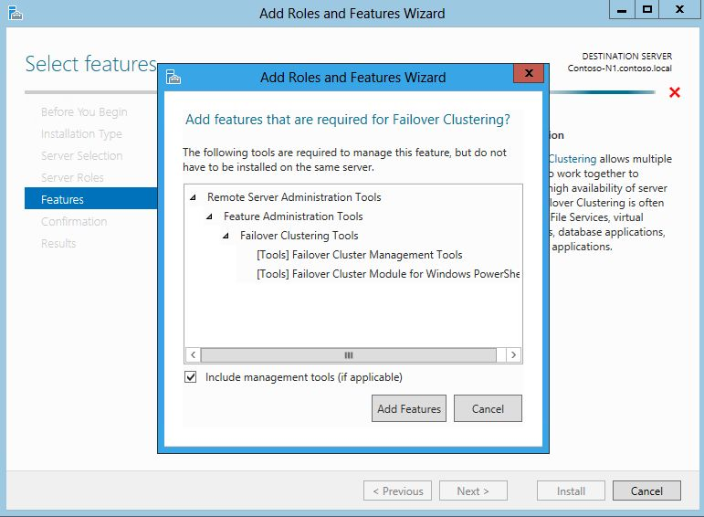

Next the administrator was presented with a summary window of the roles and features selected. A reboot of the system was not necessary as it was then possible to finalise the installation of the Failover Cluster by pressing the install button [19]. There were additional features that could have been installed regarding the Failover Cluster, such as ‘Failover Cluster Automation Server’ and ‘Failover Cluster Command Interface’. Examples of these steps are in figures 55 and 56.

Figure 55 - Summary Window of the Setup Wizard [19]
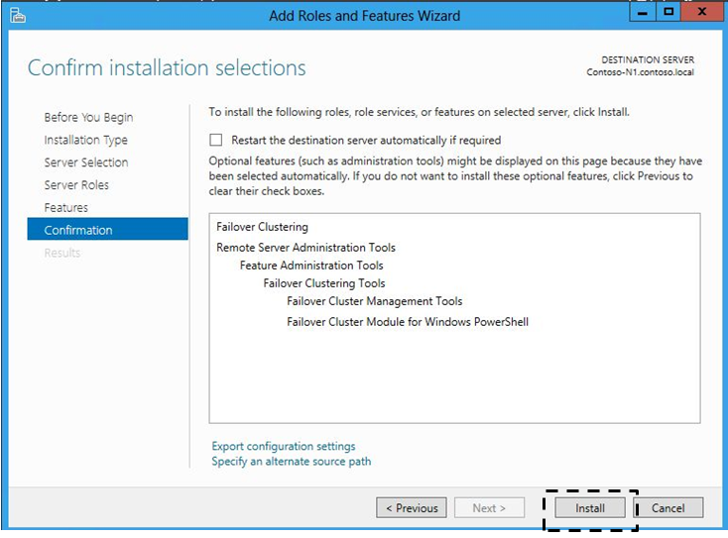

Figure 56 - Additional Features, such as Failover Cluster Automation Server. [19]
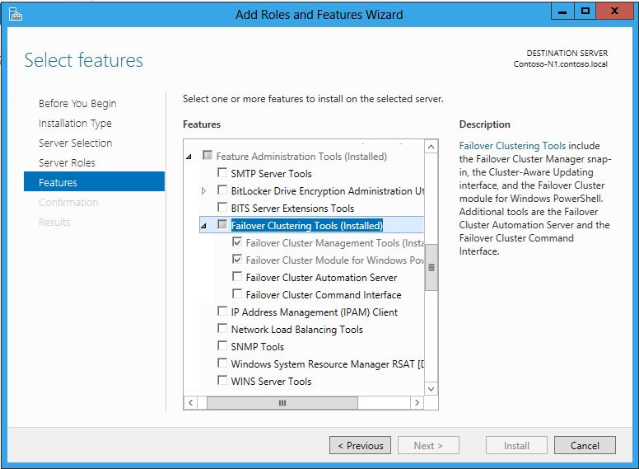

Now that the Failover Cluster Manager feature had been installed it was possible to navigate to the tools within the Server Manager app. Next the ‘Failover Cluster Manager’ was selected, which resulted in the opening of the Failover Cluster Manager snap-in. This procedure is shown in figures 57 and 58.

Figure 57 - Server Manager - Tools - Failover Cluster Manager. [19]
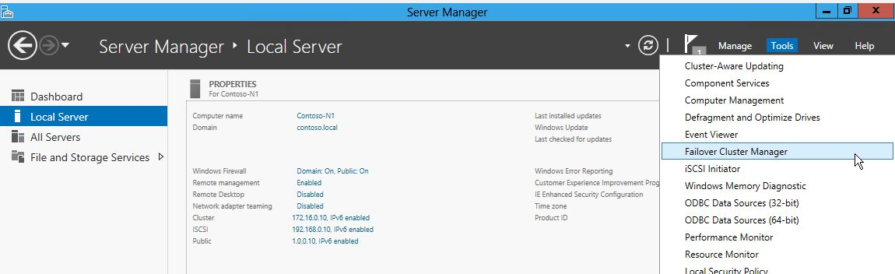

Figure 58 - Failover Cluster Manager snap-in. [19]
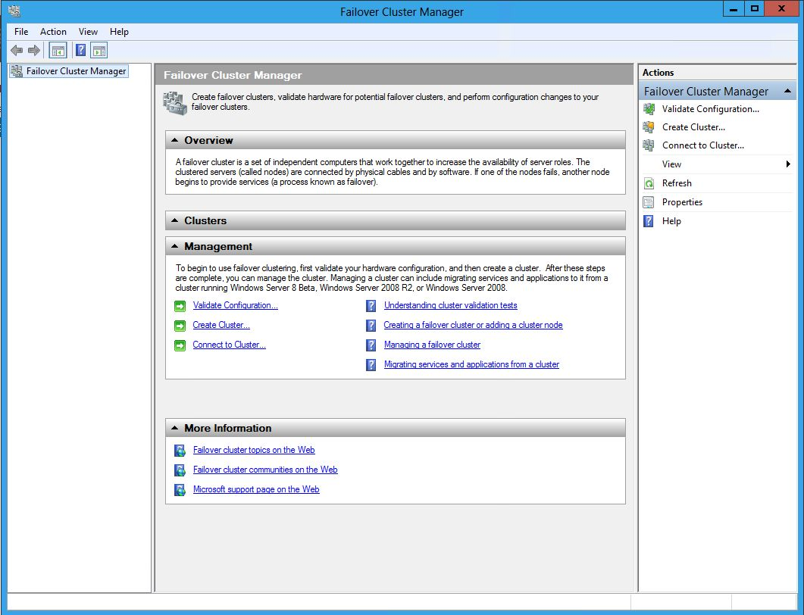

The features having been installed it was possible to create a cluster within the Failover Cluster Manager function. Microsoft strongly recommend administrators to use the ‘validate configuration’ option. Only if all the validation tests are successfully passed will it be possible to create a cluster [20]. The validations tests having been successfully completed, it was possible to finalise the ‘Validate the Configuration Wizard’ process. Examples of these steps are shown in figures 59-62.

Figure 59 - Validate a Configuration Wizard [21]
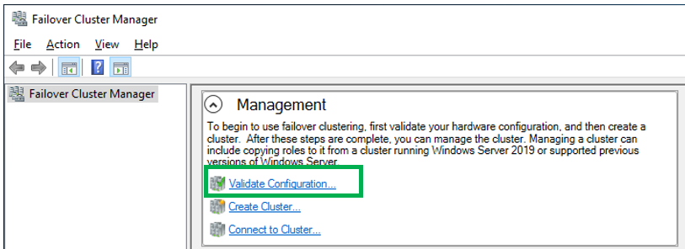

Figure 60 – Selecting Server(s) [21]
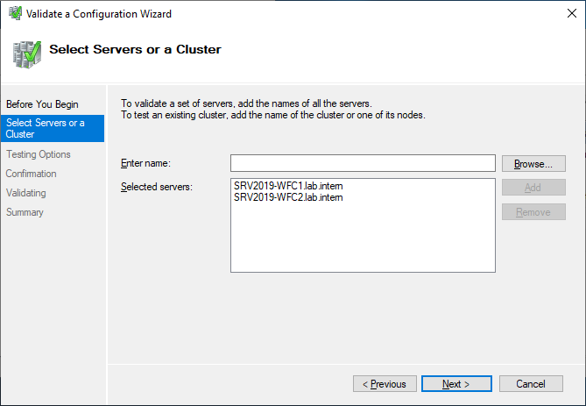

Figure 61 - Testing Options [21]
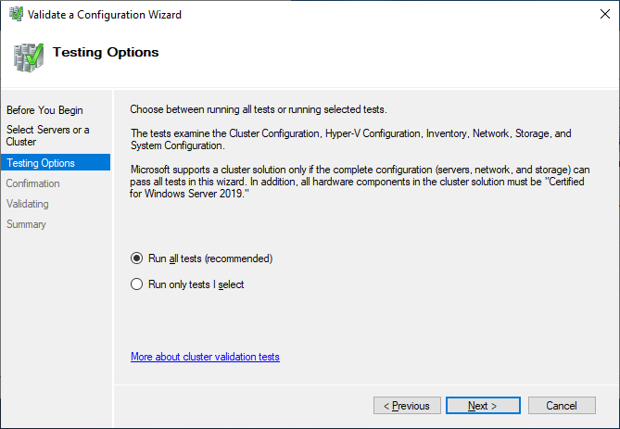

Figure 62 – Summary [21]
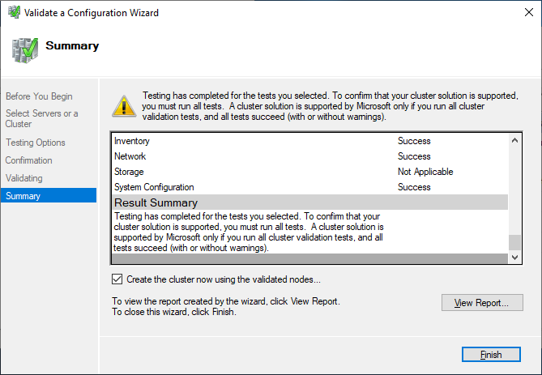

The creation of a cluster was achieved by navigating to the ‘Create a cluster wizard’ option within the Failover Cluster Manager app. These steps are summarised in figures 63-66. In narrative terms the steps were:

1. Select create a cluster option in the Failover Cluster Manager.
2. Type in a cluster name and IP address.
3. Confirm everything here to create the cluster and finish the setup wizard.

Figure 63 - Create a Cluster Wizard – Type in name and IP address. [21]
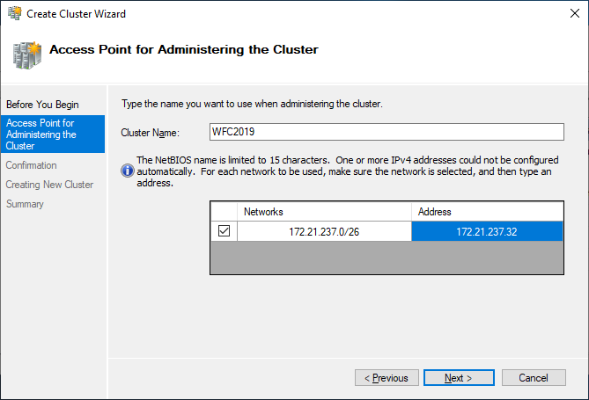

Figure 64 - Confirm Everything to proceed with installation. [21]
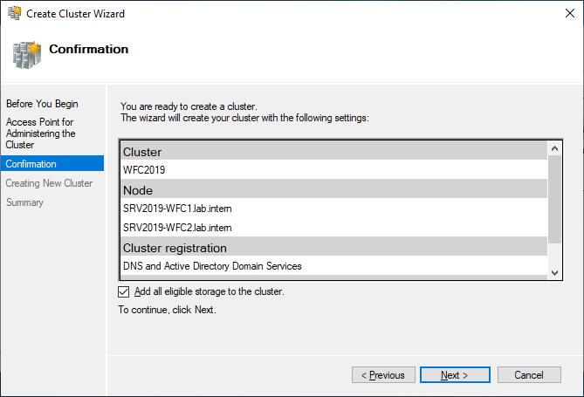

Figure 65 - Cluster created and new Computer Present [21]
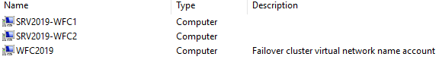

Figure 66 - Example of a ping command to verify that the cluster is online. [21]
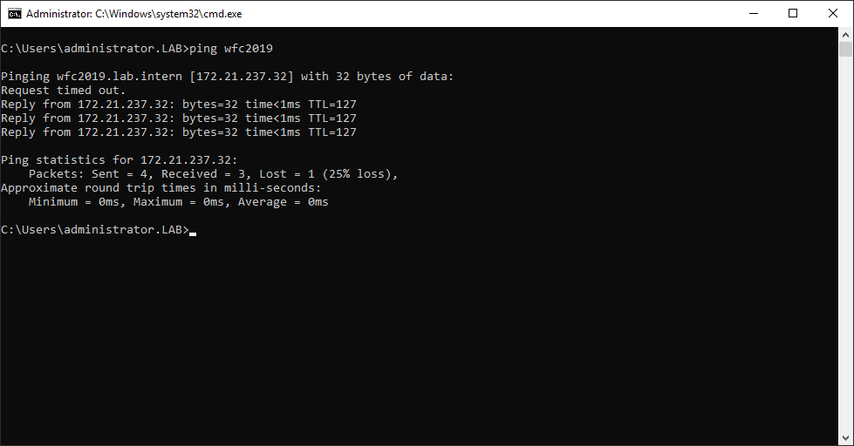

At this stage it was possible to create clustered roles. A clustered role was applied on each cluster node [20]. Below is a table that shows all the possible clustered roles that could be created:
Clustered Role | Role or Feature Prerequisite
Namespace Server | Namespaces (part of File Server Role)
DFS Namespace Server | DHCP Server role
Distributed Transaction Coordinator (DTC) | None
File Server | File Server Role
Generic Application | N/a
Generic Script | N/a
Hyper-V Replica Broker | Hyper-V role
iSCSI Target Server | iSCSI Target Server (part of File Server role)
iSNS Server | iSNS Server Service Feature
Message Queuing | Message Queuing Services feature
Other Server | None
Virtual Machine | Hyper-V Role
WINS Server | WINS Server feature
Figure 67 - Microsoft Table of Clustered Roles [20]

Task 6: Observational Task

6 a) Assume that you are the Head - Network Administrator of an Enterprise Network which operates in multiple locations nationwide. Draft a network policy, Critical business applications high availability practices and security practices for your network. State all assumptions made.

Architecture, topology and design.

The enterprise’s network consists of a number of physical nodes (hosts) that share a common physical storage [22]. To optimise performance and efficiency, the enterprise makes use of virtual machines on all these nodes. Use is made of Windows Server 2019 and the Hyper-V. Server, with N+1 technology [22]. Windows Server 2019 tools were used to create a virtual private network connecting computers at multiple enterprise locations [23] and [24]. The Hyper-V protection is provided at VM level. Should a clustered node fail, the VMs are restarted on a viable node or nodes in the network. There is enough capacity across the other nodes to ensure continuity of service, albeit with minimal operational interruption [11] and [25]. To cope with a possible failure of the single storage facility, a backup system is in operation consisting of a RAID 6 system, which is augmented by the use of RAID 10 [6]. The enterprise also makes use of AWS to backup its data.

Security risk assessment.

The hardware, software and data that comprise the network call for a holistic approach to security, for example an attack on its server could have a deleterious effect on virtual machines and the data stored. The IT team have performed a security risk assessment that has identified a number of critical points in the enterprise’s network that could make its hardware, software and data vulnerable to external or internal events. These include: malware attacks; unauthorised access to confidential data; infrastructure failure; employees using their own devices to access enterprise network resources; employees intentionally or accidentally compromising company data; and natural disasters, such as fire, or power cuts.

Scope for security innovations.

The enterprise has installed the latest version of Bitdefender Gravity Zone Business Security [26] to combat malware attacks and this protection is automatically updated. NIST argue that pass phrases are mathematically more secure than passwords [27]. The enterprise has therefore strengthened the authentication process required to access confidential data by replacing passwords with pass phrases. The phrases must consist of at least 3 uncommon words separated by spaces or special characters. The minimum length is 10 characters [28] and [29]. Memorisation of pass phrase words are easier for users as it is facilitated by word associations and images that are unique to them [27]. Also in line with NIST guidelines, the enterprise has introduced multi-factor authentication as part of the means of securing confidential online communications [27]. Lockout rules now apply after 8 incorrect logon attempts [28]. Also following NIST advice, pass phrases are salted with at least 32 bits of data and hashed with a one way derivation function [30].

Infrastructure Failure:
The network’s infrastructure is regularly maintained and, when appropriate, parts of it are updated or replaced. It is not possible, however, to eliminate the possibility of infrastructure failure, whether caused by equipment malfunction, human intervention or natural disaster. The enterprise has therefore engaged a cloud organisation to provide a backup service, which ensures that data at rest and in transit is protected by encryption and other security safeguards [31]. This decision is consistent with the enterprise’s 3-2–1 strategy, whereby data is safely stored at two separate locations. As part of the 3-2-1 strategy, the data stored on the enterprise’s in-house server is also kept on a NAS machine, incorporating RAID 6 and 10 technology [6].

Remote Working:

Some employees working outside the enterprise’s offices are permitted to use authorised private devices, including mobiles, to access personal data stored on the enterprise’s network. An Enterprise Mobility Management Scheme (EMM) has been introduced to remotely manage private devices and monitor compliance with the Bring Your Own Device (BYOD) policy [32]. The EMM scheme, incorporating VPN capabilities, encapsulation, encryption and authentication, means that personnel using private devices can connect securely to the enterprise’s database. Containers downloaded into these private devices separate the enterprise’s data from the private data owned by employees [33] and [34]. This scheme is also utilised to remotely update security provisions on all the authorised private devices, or to wipe corporate data from lost or stolen devices. Among other advantages, the scheme stops personnel transferring confidential data from authorised devices to unauthorised ones [33] and [34].

Unauthorised interference with company data.
In respect of data stored and processed on the company’s database, the ManageEngine ADAudit Plus system has been introduced to monitor and audit file activities. In particular, the system monitors unauthorised, whether intentional or accidental, modification or deletion of confidential data. This innovative file monitoring system provides enhanced security and its existence also acts as a deterrent to any member of staff who might be tempted to unlawfully interfere with confidential data [35]. ManageEngine ADAudit Plus augments the monitoring and audit tools in Windows Server 2019.

Security team.

The security team consists of a network engineer and four network administrators who are line managed by the engineer. The network engineer’s role includes the following: designing the company’s IT network; managing the implementation of the network and in particular the clustering and VM arrangements; defining, documenting and enforcing system standards; monitoring and maintaining the network; updating the systems and applications as required; undertaking risk assessments and implementing any measures required to keep the network secure; troubleshooting and resolving network problems; providing IT advice and support to staff operating IT equipment; liaising with the company’s cloud provider and monitoring their quality of service. The network administrators assist the engineer with many of his duties [36].

Monitoring Security.
The security team rely on the Windows System Center Operations Manager (WSCOM) to monitor and manage the health of company computers, whether virtual servers or otherwise, that have been placed in a clustered configuration [37]. The security team rely on the Windows System Center Operations Manager (WSCOM) to monitor and manage the health of company computers, whether virtual servers or otherwise, that have been placed in a clustered configuration [37].To undertake wider monitoring of network security, the company uses the IBM Security Information and Event Management system, known as IBM QRadar [38]. The IBM monitoring system can, among other features, detect advanced threats; uncover insider threats; protect data and address GDPR issues; address compliance, and organise incident responses [38].

Mitigating Violations of the Network.

A security strategy must include means of identifying, investigating and recovering from any violations to the network. To quickly detect any violations to the network the security team uses the Windows Active Directory and its many audit features, including Systems Events Audit (SEA). SEA records numerous events that can affect the system, such as security attacks; computer shutdowns and restarts; power failures; authentications; and impersonations [39]. Windows Advanced Audit (WAA) is used to create subcategories for each audit event, which allows the security team to fine tune what is and is not audited [39]. The Information provided by the audits enable the security team to initiate appropriate remedial action, including strengthening any security arrangement.

Enforcing Security Policies.

Personnel are required to attend training courses where issues regarding the operation of the network and security issues are discussed. In particular, the training courses draw attention to the company’s disciplinary procedures that may be initiated if staff members breach any security provision. All staff are aware that the UK General Data Protection Regulation (GDPR) specifically states that individuals can bring claims for compensation and damages against employees who are in breach of their responsibilities for safeguarding confidential data [40]. Staff are also aware that the enterprise, as a matter of policy, refers all unlawful conduct to the police.

References

[1] | Cisco, “Router Operations (1.3) > Routing Concepts,” Ciscopress.com, 1 1 2018. [Online]. Available: https://www.ciscopress.com/articles/article.asp?p=2756479&seqNum=6. [Accessed 16 4 2021].
[2] | Router-Switch, “Classification of Routing Protocols,” Blog.Router-Switch, 20 9 2011. [Online]. Available: https://blog.router-switch.com/2011/09/classification-of-routing-protocols/. [Accessed 16 4 2021].
[3] | Cloudflare.com, “What is BGP? | BGP Routing Explained,” Cloudflare.com, [Online]. Available: https://www.cloudflare.com/en-gb/learning/security/glossary/what-is-bgp/. [Accessed 18 4 2021].
[4] | L. Gamio, “How data travels across the Internet,” Washingtonpost.com, 31 5 2015. [Online]. Available: https://www.washingtonpost.com/graphics/national/security-of-the-internet/bgp/. [Accessed 18 4 2021].
[5] | Informit, “Routing and Forwarding Processes,” Informit, 11 1 2002. [Online]. Available: https://www.informit.com/articles/article.aspx?p=24922&seqNum=3. [Accessed 18 4 2021].
[6] | J. Emigh, “What is Failover Clustering?,” Serverwatch.com, 15 5 2019. [Online]. Available: https://www.serverwatch.com/server-news/failover-cluster/. [Accessed 19 4 2021].
[7] | E. Khnaser, “High availability guidelines and VMware HA best practices,” Techtarget.com, 2 5 2011. [Online]. Available: https://searchdisasterrecovery.techtarget.com/High-availability-guidelines-and-VMware-HA-best-practices. [Accessed 19 4 2021].
[8] | D. J. S. e. al., “The Design of a Practical System for Fault-Tolerant Virtual Machines,” Nil.csail.mit.edu, [Online]. Available: http://nil.csail.mit.edu/6.824/2020/papers/vm-ft.pdf. [Accessed 20 4 2021].
[9] | Github.com, “About clustering,” GitHub.com, [Online]. Available: https://docs.github.com/en/enterprise-server@2.20/admin/enterprise-management/about-clustering. [Accessed 20 4 2021].
[10] | Github.com, “Differences between clustering and high availability (HA),” GitHub.com, [Online]. Available: https://docs.github.com/en/enterprise-server@2.22/admin/enterprise-management/differences-between-clustering-and-high-availability-ha. [Accessed 20 4 2021].
[11] | M. Bose, “VM Failover Guide,” Nakivo.com, 23 7 2018. [Online]. Available: https://www.nakivo.com/blog/vm-failover-guide/. [Accessed 20 4 2021].
[12] | S. Perriman, “How to Configure Failover Clusters to Work with DR & Backup,” Altaro.com, [Online]. Available: https://www.altaro.com/hyper-v/failover-clusters-dr-backup/. [Accessed 20 4 2021].
[13] | Altaro.com, “How to set up and manage a Hyper-V Failover Cluster, Step by step,” Altaro.com, [Online]. Available: https://www.altaro.com/hyper-v/failover-cluster-manager/. [Accessed 20 4 2021].
[14] | J. Kozlowicz, “High Availability vs. Fault Tolerance vs. Disaster Recovery,” Blog.lunavi.com, 20 9 2018. [Online]. Available: https://www.lunavi.com/blog/high-availability-vs-fault-tolerance-vs-disaster-recovery. [Accessed 20 4 2021].
[15] | B. Lee, “Implementing Failover Cluster in Windows Server 2019,” Vembu.com, 29 6 2020. [Online]. Available: https://www.vembu.com/blog/implementing-failover-cluster-in-windows-server-2019/. [Accessed 21 4 2021].
[16] | Docs.microsoft.com, “What's new in Windows Server 2019,” Microsoft.com, 6 4 2019. [Online]. Available: https://docs.microsoft.com/en-us/windows-server/get-started-19/whats-new-19. [Accessed 21 4 2021].
[17] | Docs.microsoft.com, “Failover clustering hardware requirements and storage options,” Microsoft.com, 26 4 2018. [Online]. Available: https://docs.microsoft.com/en-us/windows-server/failover-clustering/clustering-requirements. [Accessed 23 4 2021].
[18] | Docs.microsoft.com, “Before Installing Failover Clustering,” Microsoft.com, 24 8 2016. [Online]. Available: https://docs.microsoft.com/en-us/sql/sql-server/failover-clusters/install/before-installing-failover-clustering?view=sql-server-ver15. [Accessed 23 4 2021].
[19] | R. Hindman, “Installing the Failover Cluster Feature and Tools in Windows Server 2012,” Microsoft.com, 15 3 2019. [Online]. Available: https://techcommunity.microsoft.com/t5/failover-clustering/installing-the-failover-cluster-feature-and-tools-in-windows/ba-p/371733. [Accessed 22 3 2021].
[20] | Microsoft.com, “Create a failover cluster,” Microsoft.com, 6 6 2019. [Online]. Available: https://docs.microsoft.com/en-us/windows-server/failover-clustering/create-failover-cluster. [Accessed 22 3 2021].
[21] | H. Kasparick, “How to create a Failover Cluster in Windows Server 2019,” Veeam.com, 27 6 2019. [Online]. Available: https://www.veeam.com/blog/windows-server-2019-failover-cluster.html. [Accessed 22 3 2021].
[22] | E. Siron, “High Availability: Shared Storage in Hyper-V,” Altaro.com, [Online]. Available: https://www.altaro.com/hyper-v/high-availability-shared-storage-in-hyper-v/. [Accessed 23 4 2021].
[23] | B. Posey, “CONFIGURE WINDOWS SERVER 2019 TO ACT AS A VPN: STEP-BY-STEP GUIDE,” 7 5 2020. [Online]. Available: https://techgenix.com/windows-server-2019-vpn/. [Accessed 23 4 2021].
[24] | BT.com, “Guide to Wide Area Network (WAN),” Business.bt.com, [Online]. Available: https://business.bt.com/help/guides/wide-area-network/. [Accessed 23 4 2021].
[25] | J. Reed, “Top 10 Features in Windows Server 2019 Failover Clustering: Full Overview,” Nakivo.com, 26 12 2019. [Online]. Available: https://www.nakivo.com/blog/windows-server-2019-failover-clustering-overview/. [Accessed 23 4 2021].
[26] | C. Jones, “The Top 10 Antivirus Software For Small Businesses,” Expertinsights.com, 1 1 2021. [Online]. Available: https://expertinsights.com/insights/top-10-antivirus-software-for-small-businesses/. [Accessed 24 4 2021].
[27] | M. Garcia, “Easy Ways to Build a Better P@$5w0rd,” NIST.gov, 4 10 2017. [Online]. Available: https://www.nist.gov/blogs/taking-measure/easy-ways-build-better-p5w0rd. [Accessed 24 4 2021].
[28] | NCSC.gov, “Password Policy: Updating your approach,” NCSC.gov, [Online]. Available: https://www.ncsc.gov.uk/collection/passwords/updating-your-approach. [Accessed 24 4 2021].
[29] | D. Stubley, “Passphrase Guidance,” 7elements.co.uk, 11 2 2015. [Online]. Available: https://www.7elements.co.uk/resources/guidance/passphrase-guidance/. [Accessed 24 4 2021].
[30] | D. Poza, “NIST Password Guidelines and Best Practices 2020,” auth0.com, 22 1 2021. [Online]. Available: https://auth0.com/blog/dont-pass-on-the-new-nist-password-guidelines/. [Accessed 24 4 2021].
[31] | Akita.com, “Playing it safe with cloud backup,” Akita.com, [Online]. Available: https://www.akita.co.uk/cloud-business-guides/cloud-backups-security/playing-safe-cloud-backup/. [Accessed 24 4 2021].
[32] | M. Kapko, “What is EMM? Enterprise Mobility Management explained,” Computerworld.com, 9 10 2017. [Online]. Available: https://www.computerworld.com/article/3230510/what-is-enterprise-mobility-management-emm.html. [Accessed 24 4 2021].
[33] | IBM.com, “Mobile security solutions,” IBM.com, [Online]. Available: https://www.ibm.com/uk-en/security/mobile. [Accessed 24 4 2021].
[34] | IBM.com, “Mobile device management (MDM) solutions,” IBM.com, [Online]. Available: https://www.ibm.com/security/mobile/mobile-device-management. [Accessed 24 4 2021].
[35] | ManageEngine, “ManageEngine ADAudit Plus,” ManageEngine.com, [Online]. Available: https://www.manageengine.com/products/active-directory-audit/. [Accessed 25 4 2021].
[36] | TargetJobs, “NETWORK ADMINISTRATOR: JOB DESCRIPTION,” TargetJobs.co.uk, [Online]. Available: https://targetjobs.co.uk/careers-advice/job-descriptions/276219-network-administrator-job-description. [Accessed 25 4 2021].
[37] | Microsoft.com, “Operations Manager key concepts,” Microsoft.com, 6 2 2019. [Online]. Available: https://docs.microsoft.com/en-us/system-center/scom/key-concepts?view=sc-om-2019. [Accessed 26 4 2021].
[38] | IBM.com, “IBM Security QRadar,” IBM.com, [Online]. Available: https://www.ibm.com/security/security-intelligence/qradar. [Accessed 26 4 2021].
[39] | Microsoft.com, “Monitoring Active Directory for Signs of Compromise,” Microsoft.com, 31 5 2017. [Online]. Available: https://docs.microsoft.com/en-us/windows-server/identity/ad-ds/plan/security-best-practices/monitoring-active-directory-for-signs-of-compromise. [Accessed 26 4 2021].
[40] | ICO.org.uk, “Controllers and processors | ICO,” ICO.org.uk, [Online]. Available: https://ico.org.uk/for-organisations/guide-to-data-protection/guide-to-the-general-data-protection-regulation-gdpr/key-definitions/controllers-and-processors/. [Accessed 26 4 2021].

