University of Wales Trinity Saint David
ACBA 4002
Digital Surveying Assignment 1
Mariah Edwards
12-1-2022

Contents
Introduction 2
Surveying 3
Classification based on Purpose: 5
Listed Buildings 6
Surveying Listed Buildings 6
Tools used to survey Listed Buildings 7
References 13

Introduction

This report consists of two parts, Part one discusses the definition of surveying, the process of surveying, highlighting the five main steps of a surveyor’s work, the two primary factors that surveying can be classified under which are Plane and Geodetic and other factors such as by equipment, method and purpose. The classification by purpose is discussed in further detail.
Part two Listed buildings and the application of digital technologies in carrying out the surveying process with special attention on appropriate tools to be used where access may be limited.

Surveying

Surveying is the practice or study of measuring altitude(height), angles and distances of natural and man-made features on or beneath the earths surface so that they can be accurately represented on plans and maps.
  - Reasons for surveying:
- To collect data
- To determine positions and boundaries of private and public lands
- To produce plans and maps
- To develop natural resources databases
- To analyze data for engineering operation
- To set field parameters for engineering works such as buildings, bridges, roads and land development

Five main steps of the Surveying process:
- Planning – this is also known as reconnaissance and it involves research and making field visits to determine or set up control points, decide on equipment and methods needed to conduct the job.
- Field Work – this is where the data collected by measurements and observations are recorded
- Data Processing and calculation – the data collected is processed and any further calculations that may be needed is done.
- Data Representation – information collected is then represented on plans and or maps.
- Setting out / Staking out – this is where parameters for engineering works are established.

There are two primary categories of surveying:
Plane surveying is more common and considers the survey area as flat while geodetic considers the curvature of the earths surface and is more accurate than Plane surveying.
The table below shows the differences in geodetic and plane surveying.
Plane | Geodetic
The earth surface is considered as a plane surface | The earth surface is considered as a curved surface
The line formed by any two points are considered as a straight line – as the same angles are plane angles | The line formed by joining any two points are considered as arch –as the same angles are spherical angles
Effect of the curvature of the earth’s surface is ignored. | Effect of the curvature of the earth’s surface is included.
Knowledge of plane trigonometry is required. | Knowledge of spherical trigonometry is required.
Used in general civil engineering survey project work | They are used for the precise location of a widely distant area
Involves smaller areas less than about 260 km². | Involves larger areas more than about 260 km².

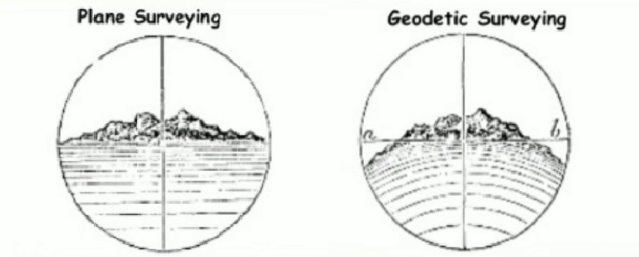
Photo showing difference between plane and geodetic surveying taken from Civil crews(n.d)
Surveying can be further classified by
- Method- Triangulation which is a method of surveying that involves control points of large areas being surveyed, being divided by a network of triangles to make the survey area more manageable. Trilateration is an alternative to triangulation but instead of measuring angles and distance, only distance is considered. Trans-versing, this is a circuit of lines joined at control points which can either be closed loop, close tied or open.

- Equipment Traditional which are plumb bob and line, compass, chain, pacing, etc. or Modern which includes Total Station, Global Positioning system, Electronic Distance Measurement.
- Purpose (reason for surveying)

(Dauda, 2021, p.8)

Classification based on Purpose:

Cadastral Surveying is also known as boundary surveying and is usually done in rural or urban areas. It is done for the purpose of determining boundary locations between public and private lands, determine the physical extent of land ownership rights, subdivide lands into two or more parcels, facilitate transfer of property deeds and reestablish boundaries of previously surveyed property. Data collected is used to create maps and plans to show these boundaries.
Hydrographic Surveying this is the measure and mapping the depth of bodies of water such as rivers, lakes, streams, etc.; to acquire data on the water levels, tides, currents, temperature and salinity to produce maps and nautical charts for safe marine navigation by identifying possible obstructions and the construction of sea defense works.
Route Surveying this is surveying done for the purpose of establishing a course for transport systems which includes but are not limited to, railways, roads or highways, transmission lines for water, sewage disposal and even communication systems.
Geographic Surveying this is done by remote sensing to identify physical features of the earth which are natural, or man made for the purpose of representing data collected on maps and plans.
Topographic surveying this type of surveying is done to identify the differences in height between mountains, valleys and the physical features of the earth which can be man-made or natural. It is very important to be able to identify the physical constraints of an area when doing surveying as it plays a factor in determining usability of the land for any construction works.
Construction surveying this is surveying done at a construction site for the purpose of accessing buildings, roads and provide data on dimensions, reference lines and establish markers for setting out. On completion of the project the survey data is used to access the final positions and verify that the construction was carried out as specified on plans and designs, within the control points set out.
City Surveying this is surveying carried out in or near a city with the purpose of identifying boundaries and setting out points for development.

(Dauda, 2021,p.13)

Listed Buildings

A listed building is a protected building or structure that is deemed to have special historical or architectural importance. The maturity and rarity of a building determines the likelihood of it to be listed to maintain a certain level of protection. In England and Wales, buildings are categorized into three groups.
Group 1 is the highest grade and is reserved for buildings of great interest and hence the reason they only account for 2.5% of the overall listed buildings. Grade 2 are the most common buildings. They are of special interest and account for 91.7% of listed buildings. Grade 2* buildings are buildings of more special interest and significance than a building that is simply Grade 2 buildings and they account for 5.3% of the listed buildings.

Historic England (2019)

Surveying Listed Buildings

Listed Building survey can be defined as the process of conducting a detailed inspection, taking measurements, recording and computing these measurements and then reporting on them.
Reasons for surveying listed buildings
Listed buildings are surveyed to assess the current condition of the building structure and its operating systems, to constructed detailed Plans and Elevations, to determine if any renovation or retrofitting is needed to be done and to fulfil building legislations.

The conditions of a listed structure or building can be categorized as:
CONDITIONS | DEFINITION
Good | Structurally sound (No significant repairs needed)
Fair | Structurally sound (showing signs of a lack of maintenance and in need of minor repairs)
Poor | Deteriorating masonry, leaky roof, general deteriorating of building elements or from any prior incidents or disasters where part of the building is affected.
Very Bad | Signs of structural instability, major deterioration on the interior or where most of the building was affected by a major fire or disaster.
Not Visible | Where building elements are not visible.

(English Heritage n.d)

Tools used to survey Listed Buildings
Because listed buildings are older buildings there is more likely that there would be some structural damage and surveyors are required to practice safety to protect themselves by using Personal Protective Equipment (PPE).
Some PPE tools used in listed building survey are:
- Eyes – safety spectacles and goggles to prevent chemicals, dust, projectiles, gas, vapour and radiation.
- Head- Helmets to protect from impact of falling or flying objects and risk of head bumping, etc.
- Hand and arms- Gloves and sleeving to protect against cuts and punctures/ abraisons, etc.
- Feet and Legs – Safety boots and shoes to protect against slipping, cuts, punctures and falling objects.
- Whole body- Reflective vests, gloves, etc to maximize the personel’s visibility.
Protection should also be extended to the data being collected by use of umbrellas, etc.
Health and Safety Executive (2020)

  - Odometer
An odometer consists of a wheel connected to a long handle, the distance is calculated by the number of turns or rotations the meter makes and then is displayed on a digital screen.
Odometers have limitations of not being able to measure elevations and where the surface is not smoothe the more likely there is to have inaccurate readings.
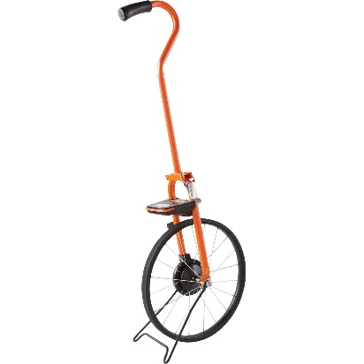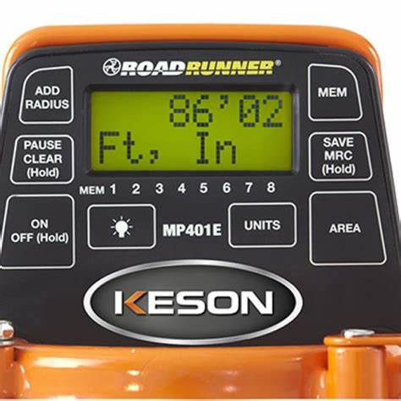

  - Optical Distance Measurement device
Is a lazer measuring device used to measure distances. A point to point system makes it faster, easier and safer to measure roof height, etc, it can be used especially where access is limted or there is no access.
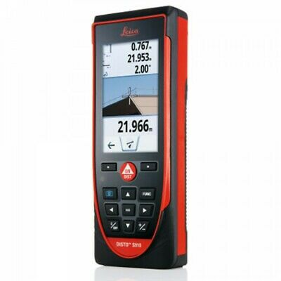
In the photo assuming that the other side of the room is inaccessibile and you would like to get the distance between point A and Point B. You can simply take those measurements at the safety of the ground by simply pointing the lazer at Point A and then Point B. The distance is then shown on the digital monitor of the device.
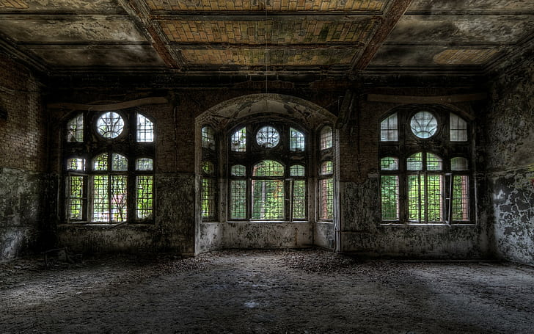

Detailed floor plans and elevations can be exported to CAD or Sketch apps or even to a laptop in real time. This saves time and ensures safe data transfer.
Telescopic Inspection Camera
A telescopic inspection camera is a quick safe detailed inspection to areas that have limited access with hard to reach places such as gutters and roofs.
A camera unit is mounted and extended on a self lockable pole and then relays that image or video to a monitor below for the surveyor to see.
Some telescopic camera units can connect wirelessly through wifi to the monitor which can display and store videos or images on your smart device which is quite convenient.
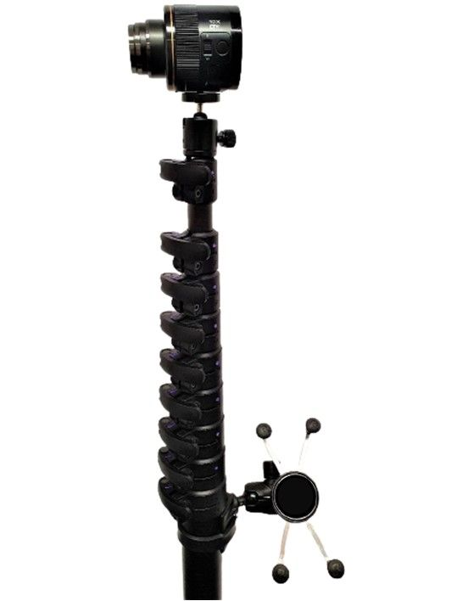

  - Thermal Camera
Thermal imaging cameras is a quick non-invasive way to access the condition and thermal efficiency of a building, it can show whether there is heat loss or heat gain in a building due to insulation problems, leaks in roofs or where there maybe a likelihood of mould.
When surveying older building there maybe leaky roofs, cracks in the structure, poorly insulated walls, etc. To determine the heat loss, you simply point the thermal imaging camera towards the inspection area which shows thermal conditions by using infrared. The camera pics up the intensity of the infrared radiation (IR) and shows the differences in colour on the image. The user can then tell if an area has heat gain or loss (if the area is hot or cold).
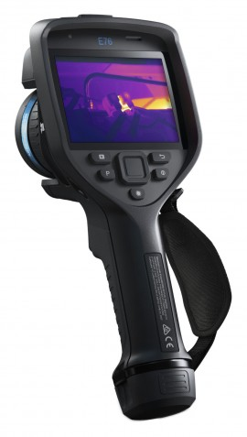

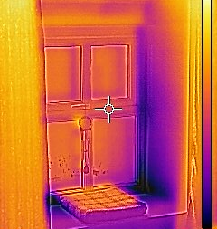
Darker areas indicate moisture

  - Moisture Meter
Moisture meters can be invasive, non-invasive or both (Dual Function). Moisture meters measure the dampness of an area. To get surface readings you hold the instrument’s pin to the surface of the material being careful not to push in too far to damage the material. In search mode or to get sub surface readings the meter can scan for moisture in walls and floors without damaging the surface by simply holding it against a surface, it transmits a signal into the material and then the meter shows the readings through the return signals indicating relative moisture level and the intensity by the LED colour arcs.
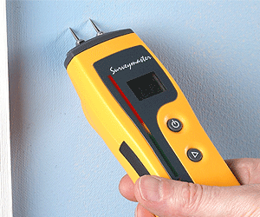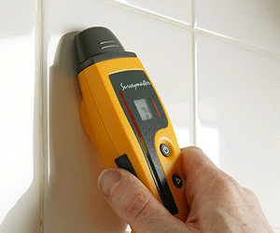

It is important to note that improper usage of these tools can result in inaccurate data or damage to tools.

References

Historic England (2019) Listed Buildings. Available at: https://historicengland.org.uk/listing/what-is-designation/listed-buildings/ (Accessed: 10 January 2022)
English Heritage Methodology and Guidance for Surveying Listed Buildings Available at: https://www.york.ac.uk/media/archaeology/documents/researchpages/English Heritage Methodology and Guidance for Surveying Listed Buildings.pdf
(Accessed: 10 January 2022)
VIP Structures (2020) The Importance of Building Condition Surveys Available at: https://www.vipstructures.com/importance-building-condition-surveys/ (Accessed: 10 January 2022)
Pass (N.D) Building Thermal Camera Applications
Available at: https://www.pass-thermal.co.uk/thermal-camera-applications-building (Accessed: 10 January 2022)
Health and Safety Executive (2020) Risk at Work - Personal protective equipment (PPE)
Available at: https://www.hse.gov.uk/toolbox/ppe.htm (Accessed: 10 January 2022)
Red Current Limited (2012) Thermographic Surveys of Buildings using Flir Thermal Imaging camera[video] Available at: https://www.youtube.com/watch?v=ntuTsB7tuJs (Accessed: 10 January 2022)
Protimeter Moisture Meter (2020) Introduction to Protimeter Surveymaster | Our best-selling dual-function moisture meter! [video] Available at: https://www.youtube.com/watch?v=qdvIXWJEGj0
(Accessed: 10 January 2022)
Emagine Create (2015) Ballcam Telescopic Pole Camera
Available at: https://www.youtube.com/watch?v=VFbQz5dy4Is
(Accessed: 10 January 2022)
Leica Geosystems US & Canada (2017) Leica DISTO S910: How to do a P2P Application
Available at: https://www.youtube.com/channel/UCIZ03tYu5Ddz3T1S0U_lWFg
(Accessed: 10 January 2022)
South Survey (N.D) Telescopic Inspection Camera
Available at: https://www.surveyorsequipment.co.uk/telescopic-pole-camera.htm
(Accessed: 10 January 2022)
Keson (2019) “MEASURING WHEELS: WHAT ARE THEY AND HOW ARE THEY USED” [blog] 25 April.
Available at: https://www.keson.com/measuring-wheels-what-are-they-and-how-are-they-used/
(Accessed: 10 January 2022)
Ward, P. (N.D) Heritage House, Building Condition Survey.
Available at: https://www.heritage-house.org/building-surveys/thermal-imaging-surveys/heat-loss-around-windows.html
(Accessed: 10 January 2022)
Dauda,J 2021, Lecture Week 3, lecture notes, Digital Surveying ACBA 4002, UWTSD (delivered, 11 October, 2021)

