

MODULE CODE: LCBB5003
PROJECT MANAGEMENT
ASSESSMENT TYPE: ASSIGNMENT

Assessment: 1
Name: Daniela Elena Petrescu
ID: 1814733

TABLE OF CONTENTS
1 Introduction 1
2 Objectives 1
3 Project Scope 2
4 Project Scheduling 2
4.1 Method 2
5 Schedule Representation 4
5.1 Gantt Chart 4
6 Work Breakdown Structure 5
7 Milestone and Deliverables 6
8 Stakeholder Concerns 7
9 Risk Analysis 7
9.1 Business Risks 8
9.2 Direct Risks 8
9.3 External Risks 8
9.4 People Risks 8
10 Cost-Benefit Analysis 8
10.1 Plus-minus-implication Model 10
11 Project Execution Challenges 10
11.1 Low Engagement Level of Stakeholders 10
11.2 Lack of Communication 11
11.3 Insufficient Skills of Team 11
12 References 12

Introduction
As healthcare services are related to people's lives and their daily routines, this project deals with the healthcare service-related issue (Steenkamp et al., 2019). The medical records in NHH were handled manually which is highly open to human errors and also time-consuming (Aspevig and Singletary, 2020). The aim of this project plan is to make the routine activities of the health center automated such as new patient admission, discharge records, room service activities, assigning of medical doctors, and lastly, billing records and so on (McGivern et al., 2018). As a healthcare assistant, I aimed to change the complex manual process of healthcare management as a simple process by implementing a modular and structured technique with a menu-driven interface (Ralph et al., 2016). Software is designed through which the user might not face any difficulty in applying this software package. The primary goal of this project is to perform every activity in the healthcare center in an automated way instead of performing manually in order to save time (Strode et al., 2012). It also ensures that the software can be easily used and help in preventing human-handled probabilities of error (Steenkamp et al., 2019).

Objectives
Healthcare centers are the significant part within a community, offering medical facilities to those individuals who need medical care. It is important for any healthcare centers to keep the record of its everyday operations and patients' records, even the records of doctors, staff, nurses, and other related persons which make the overall operations of the healthcare center effectively and smoothly (Aspevig and Singletary, 2020). Yet keeping all these records on a paper is outdated, prone to human error, and even exhausting (McGivern et al., 2018).
This is also found as a time-consuming and inefficient process. By noting the greatly increased population and the high number of patients visiting the healthcare centers. Record maintenance is very error-prone, inefficient, and unreliable if done manually. This is also not technically and economically feasible to maintain hospital records on a paper. Therefore, in this project, the manual record system in NHH was taken as the base for working on this project. We have created an automated manual system version which we named as the administration support software. The primary purpose of this project is to introduce a paperless setup. Another goal of this project is to give reliable and low-cost automation of the current systems. Moreover, this system gives effective data security at each user-system level interaction. In addition to it, it offers a reliable and strong backup and storage facilities (Aspevig and Singletary, 2020).

Project Scope
This proposed software, Hospital Management Support System (HMSS). This software can be used in different pathological labs, dispensaries, clinics and hospitals. This helps these healthcare centers to gain the patient information and then storing the patient data for further use (McGivern et al., 2018). The existing system is the paper system which is outdated. These systems are not efficient in providing an upgraded patient list in real-time. This software is designed to minimize overtime pay and maintain the number of patients given the care. The requirement documents in these statements are functional as well as non-functional (Steenkamp et al., 2019).

Project Scheduling
Project scheduling is an important aspect of project management that links to the use of project schedules, for example, the Gantt chart for project planning and consequently report development in the project setting (Aspevig and Singletary, 2020). Primarily, the scope of the project is described and the relevant methods and techniques to finish the project are decided (Ralph et al., 2016). By following the steps, the time duration for different tasks involved in completing the project are grouped and listed in the project work breakdown structure (WBS) proposed below. The logical project dependencies among different tasks are described in the WBS which helps in identifying the project critical path (Ralph et al., 2016).

Method
In this project, the PRINCE2 project management approach is used for project development. The PRINCE2 project management approach gives a background of when and how the project objectives are to be accomplished within a specified time-period (Schwaber and Beedle, 2002).
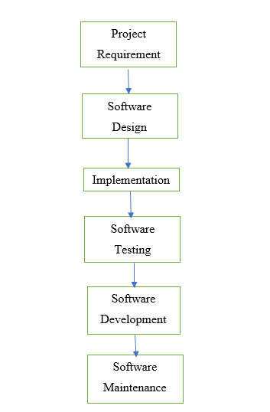
The plan will indicate that the project deliverables which will be delivered for that resource and activities are needed. In this project, PRINCE2 help in the software development process within the time frame of 6 months. The PRINCE2 approach is structured to manage this kind of software development project plan (McGivern et al., 2018). Software projects mainly demand effective testing methods and complex departmental processes (Aspevig and Singletary, 2020). Therefore, the PRINCE2 approach is used for this project.
There are some benefits that the PRINCE2 model gives to this project:
- This is a product-oriented approach and classifies projects into various steps making it easier to manage as a whole.
- It promotes communication among all the stakeholders and project team members.
- It provides the project stakeholders a better insight into the project activities during the decision-making process (Strode et al., 2012).

Schedule Representation
After project scheduling, the representation of that scheduling is also an important activity in a project plan (McGivern et al., 2018). As highlighted by Butler et al. (2020), “it involves deciding which tasks would be taken up when. In order to schedule the project activities”. In this software project, the project manager is required to consider the steps involved in developing the software so that a Gantt chart can be prepared.

Gantt Chart
Gantt chart is generally the graphical representation of the scheduling in the project activities. The information which is present in the Gantt Chart includes sequence, task dependencies, and the time duration of each task (Shirley, 2020). Aspevig and Singletary (2020) explained that "because of the way the information is displayed, it is easier to interpret project data, especially when there are many hundreds of tasks”. The below figure demonstrates the Gantt Chart for the activities of this HMSS project.

TASKS | 2020
TASKS | Months
TASKS | 1 | 2 | 3 | 3 | 4 | 4 | 5 | 6
Analyze the present situation
Project planning
Software designing
Coding
Testing software
Delivery

Work Breakdown Structure
Steenkamp et al. (2019) defined work breakdown structure as a project deliverable-driven sequential composition of project tasks that are to be implemented by the team members to attain the objectives. Moreover, to develop the needed project deliverables. This explains and organizes the complete project scope (Moro et al., 2019). The work breakdown structure will be arranged in a top to down way with a greater-level classification for every major project deliverable. All of such deliverables will be further breakdown into more details (Butler et al., 2020). The work breakdown structure of this project contained every project activity needed to be delivered in this project.
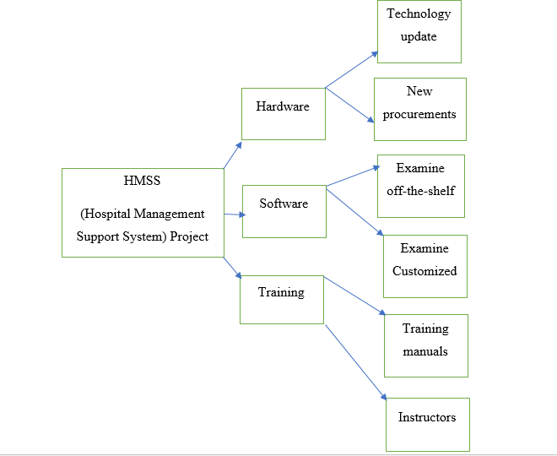

Milestone and Deliverables
In this step, some particular milestones and project deliverables will be defined. Steenkamp et al. (2019) explained milestone as “a point in time that requires no resources and has a duration of zero, there is no time associated with it". A project milestone for this HMSS project is the point within a specific time just when every hardware is applied to the project. Moreover, the project deliverable in this project is the hardware to be used (Moro et al., 2019). This is the tangible project part that is needed (Strode et al., 2012). In most of the case, a project deliverable has a specific time limit linked to the initiating date and completion date (Butler et al., 2020). The project deliverable in this case is significant as it has a project milestone attached. This deliverable is a substantial concept in project planning as it talked about the final concept throughout the plan (Strode et al., 2012).

Stakeholder Concerns
For the HMSS project, one of the most important concerns of the facilities management was very particular to achieve project success (Strode et al., 2012). Standards, procedures, and policies showed a current demand by the final users to have an automated solution for the daily operations of the healthcare center (Moro et al., 2019). Another important concern of the Healthcare management was the problem of staff performance that is usually a challenge in the healthcare sector because of a high risk of information handling of the patients (Strode et al., 2012). This risk related to the performance is commonly known within the sector, well-discussed, and recorded in practice as well as in the research.
Concerns | Facilities Management | Owner Administration | Healthcare Management | Project Management
1 | Staffing (at financial level) | Communication | Communication | Teamwork among stakeholders, communication.
2 | Standards, procedures and policies | Dealing with expectations, staffing  (financial), teamwork among stakeholders | Dealing with expectations, developer issues, staffing (rate of turnover) | Project cost and expenses
3 | Communication | Project cost | Standards, procedures and policies | Staffing turnover

For the owner administration, staffing (financial) and facilities management concern was crucial. As public funding was given to design and development of the new software development, yet no extra funding was given to hire more staff in order to maintain the new software.

Risk Analysis
Risk identification in software development is an active technique to reduce the potential loss and uncertainty within the context of this project (Steenkamp et al., 2019). Some classifications of risk involve cost, product size, schedule, business impact, staffing (experience and size), customer-related, development environment, technology, and process (Butler et al., 2020). Risk identification is an exercise with tools, methods, and processes to manage the project risks. This is considered as a systematic technique to find the threats that can be posed to project planning (Strode et al., 2012). Through the identification of predictable and known risks, a first step can be taken toward preventing them whenever it is possible and create a risk control when it is required (Moro et al., 2019).
In order to conduct a risk identification process, this project plan has classified the risks into the following categories:

Business Risks
The business risks include liability issues, high competition, sales potential is not identified. The risks related to the business case is the cost changes, the rate of interest gets increased on the borrowed loan. Thus, making the project costly in relation to its revenue potential. Moreover, changes within the financial status that do not allow project execution (Steenkamp et al., 2019).

Direct Risks
Direct risks involve changes in the requirement, ineffective estimates of the resources (project schedule, people, cost), software design errors, no clarity in the goals among all the team members, leading-edge (bringing the automated system for the first time is a riskiest practice). In addition to them, direct risks also include poor skills set for individuals on the project.

External Risks
It includes regulatory risks, particularly with the medical information and patient records. Moreover, acts of nature are also included in the external risks (Ralph et al., 2016).

People Risks
The risks related to people involve ineffective conflict management skills among the project team, ineffective communication skills, poor leadership, insufficient quality control, ineffective organizational; structure, and adversarial relationships.

Cost-Benefit Analysis
In order to conduct a cost-benefit analysis, initially, a force-field analysis is used. The foundation of force-field analysis is establishing a determination for a single choice on another option by analyzing the forces which are favorable to the decision as well as checking the forces that are going against the final decision (Butler et al., 2020).
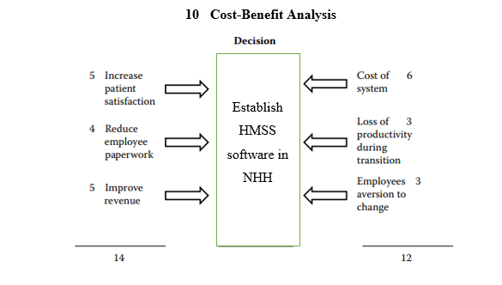
Figure 1: Cost-benefit analysis
One of the benefits of force-field analysis is highlighted by Ralph et al. (2016) that these forces are to be weighted depending on the significance of some of the particular forces (Steenkamp et al., 2019). It can be seen in the below figure that applying the factors of weighting analyzed by HMSS project, the decision is taken on 14-points while 12-points are against of the decision.

Plus-minus-implication Model

Plus | Minus | Implication
Quality of record improved (3) | Fewer errors (-3) | Information retrieval in real-time (2)
The organization will incur relocation pay (4) | Get rid of old records once entered into the system (-3) | Less paperwork (-2)
Improved data storage and security (4) | Less paperwork (-2) | High integration (2)
11 |  | 2

Since the cost-benefit analysis of HMSS project for NHH indicated, on the basis of historical benefit data and current cost data, the project may influence the efficiency of NHH positively along with substantially enhancing patient and staff satisfaction as well. A plus-minus-implication tool is used in this section for the decision-making process in this project (Butler et al., 2020). The implication section of this method also applies the weighting to support in the process of decision making.

Project Execution Challenges

Low Engagement Level of Stakeholders
This was necessary for the project leaders to assure that every project stakeholder is on a same ground and must have a clear project vision in their mind (Carroll, 2016). But during this project, there was a low level of stakeholder engagement (lack of communication among management and the staff) that created issues in the final project stages such as lack of integration (Choudhury and Sabherwal, 2003). Therefore, to overcome this problem, the project managers invite every stakeholder in the project meetings to share the project status and other related information in a way that this proactive participation improved the stakeholder engagement (Ralph et al., 2016).

Lack of Communication
As mentioned above, it was noted that there was a lack of communication and sometimes miscommunications among the management and the staff level related to the patient information which was a major problem in the healthcare setting (Lee at al., 2006). As the accurate information provided by the staff to the senior healthcare practitioner ensures the proper treatment of the patients and any miscommunication could lead to serious outcomes (Steenkamp et al., 2019). To overcome this, project managers used transparent communication methods and regular meetings to resolve this issue (McGivern et al., 2018).

Insufficient Skills of Team
The performance of the project and the whole team is highly based on the individual skills and competencies of all the members involved in the project team (Ralph et al., 2016). In this project, some of the team members are not trained previously for the current project that creates a performance gap which can be seen in the overall performance of the project such as delays in the project tasks (Steenkamp et al., 2019). The project manager handled this issue by including more skilled-employees in team and provide ongoing training to the unskilled ones.

References
Aspevig, J. and Singletary, V., 2020. Project Management and Public Health Informatics. In Public Health Informatics and Information Systems (pp. 221-236). Springer, Cham.
Butler, C.W., Vijayasarathy, L.R., and Roberts, N., 2020. Managing software development projects for success: Aligning plan-and agility-based approaches to project complexity and project dynamism. Project Management Journal, 51(3), pp.262-277.
Carroll, N., 2016. Key success factors for smart and connected health software solutions. Computer, 49(11), pp.22-28.
Choudhury, V., and Sabherwal, R., 2003. Portfolios of control in outsourced software development projects. Information systems research, 14(3), pp.291-314.
Lee, G., DeLone, W. and Espinosa, J.A., 2006. Ambidextrous coping strategies in globally distributed software development projects. Communications of the ACM, 49(10), pp.35-40.
McGivern, G., Dopson, S., Ferlie, E., Fischer, M., Fitzgerald, L., Ledger, J. and Bennett, C., 2018. The silent politics of temporal work: A case study of a management consultancy project to redesign public health care. Organization Studies, 39(8), pp.1007-1030.
Moro Visconti, R. and Morea, D., 2019. Big data for the sustainability of healthcare project financing. Sustainability, 11(13), p.3748.
Ralph, P., Chiasson, M. and Kelley, H., 2016, June. Social theory for software engineering research. In Proceedings of the 20th International Conference on Evaluation and Assessment in Software Engineering (pp. 1-11).
Schwaber, K. and Beedle, M., 2002. Agile software development with Scrum (Vol. 1). Upper Saddle River: Prentice Hall.
Shirley, D., 2020. Project management for healthcare. CRC Press.
Steenkamp, A.L., Alawdah, A., Almasri, O., Gai, K., Khattab, N., Swaby, C. and Abaas, R., 2019. Enterprise architecture specification case study. Journal of Information Systems Education, 24(2), p.3.
Strode, D.E., Huff, S.L., Hope, B. and Link, S., 2012. Coordination in co-located agile software development projects. Journal of Systems and Software, 85(6), pp.1222-1238.

