

Daniel Stone
ID- 1803523
Module code – ABCA5009
Reflective journal part 4 – 500 words
Lecture – Lara Hopkins

During my time at the work-based project placement I have moved on to a different project with Heyworkers construction. This project has given me different experiences in different topics within the roles of a construction manager. I have learnt a lot more different roles in this project as there many more different things to account as well as the general health and safety.
I have gathered a lot of positive knowledge and skills from the previous project that was carried out by Heyworkers Construction which has stayed with me to carry on the roles of this recent project, but in this project, I have taken on new roles. This has given me giving me a deeper understanding and knowledge.
The most interesting things about this job is looking at different ways of waste disposal and pricing up the wastes of the materials coming from the refurbishment window fit job. This is different to what I had been doing recently. In this task I was looking into the legislations on waste and the types of licences to apply and look for within the UK regulations of waste management.
The most challenging parts of the job roles that were given to me during the project was to look at the different types of waste restrictions and licences that companies have to carry in order for the specific type of work can be carry out. For me this took some time to get used to as I had to look at what was needed for the job, make sure that the regulations were still up based and look for local waste distributes near the location of the job. I also had to weigh up the options of where the waste was going to go regards to the cost.
By doing this I felt that my learning was progressing a lot more than previous times in the office with regards to the previous jobs, such as the method statements and legislations. By moving on from the project to this particular job it makes it challenging using my skills to the full potential that I have gathered from being in the work base placement.
While being at placement I helped others by giving the correct advice after finding out the correct options on the waste cost and availability around the area and then advising what option to take on what benefits they will gather form the specific option.
The way I could do this differently would be to ask what the upcoming projects are involving so I would be able to prepare for the next project and do the research in to the waste legislations so that it doesn’t take long to process it though the work systems and already have the opportunity to give the advice before the job begins with the management team and the clients of the project.
What I have learnt so far with the new project I will use in the upcoming projects within the work placement and in the further education I will use the skills within the industry with the assignments that are due as some of the knowledge gained can link to them, overall the experience gained in this time of the placement has been a massive impact on my learning skills.

References
Where I got my information about licences and applications and work material.
Environmental licences 2019 – protecting our environment- viewed February 4th available from : https://www.environmental-licences.co.uk/?www.environmental-licences.co.uk&gclid=CjwKCAjwmKLzBRBeEiwACCVihhhpu4QRRz3H_vijcFfqh-jdlDnRr0mFOYer6gh0d8FHy0euCE7BsBoCsEsQAvD_BwE
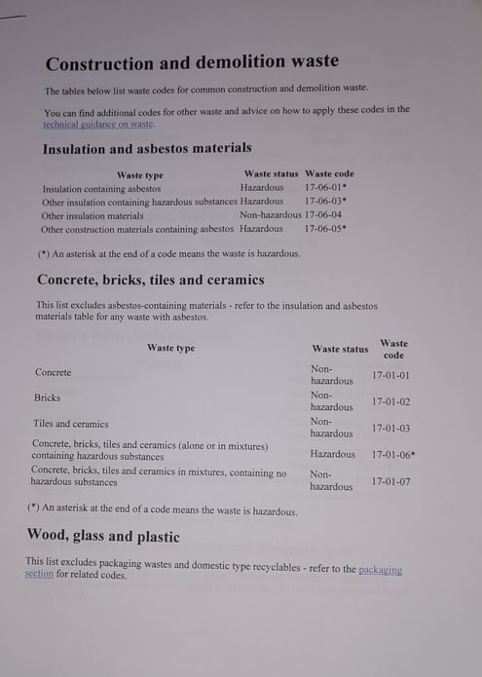
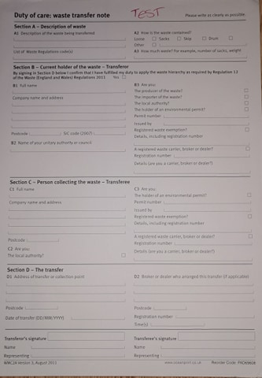
Natural resources wales – 2019- permit and permissions – viewed 4^{th February} available from : https://naturalresources.wales/permits-and-permissions/check-for-a-permit-licence-or-exemption/?lang=en

