Ace Practical Portofolio Task 1

Acedemic and Employability Skills
Student Name:Roxana Cochilet
Student Number:2019600
Module and title and code: Academic and Employability Skills BMSW4001
Lecturer name :Joanna Walsh
Assigment title:ACE Practical Portofolio

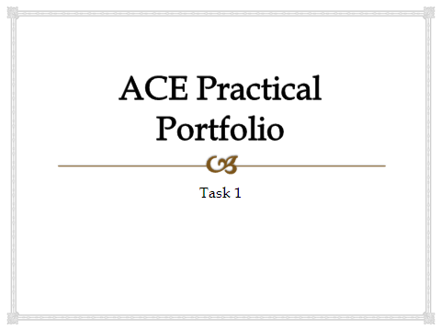

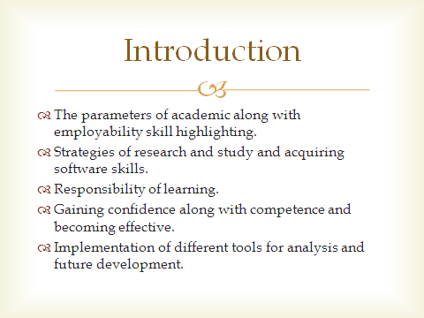
The presentation will cover the parameters associated with academic together with the aspects of employability in highlighting the skills among the employees. Several strategies associated with study and research is essential for acquiring the software skills. The responsibilities linked to learning will be highlighted for gaining confidence together with developing competencies and staying effective. Furthermore, implementation of different kinds of tools for generating analysis for future development is essential and will be covered adequately.
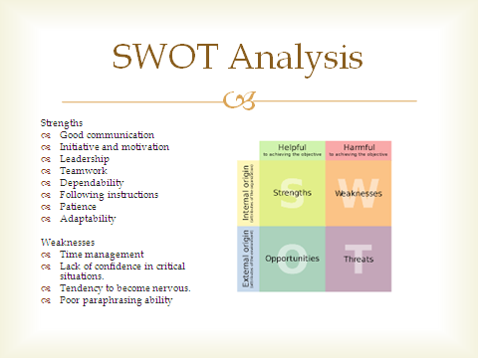
In this aspect, the application of the SWOT model is done for analysing my strengths, weaknesses, opportunities, and the threats (Gürel, and Tat, 2017). Different strengths have been figured out along with the weaknesses identified.
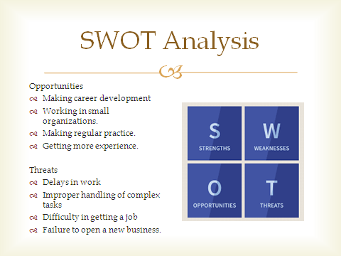
Further application of the SWOT analysis is done for figuring out the opportunities together with threats regarding me and the ones to be considered for making betterment in the future (Sarsby, 2016).
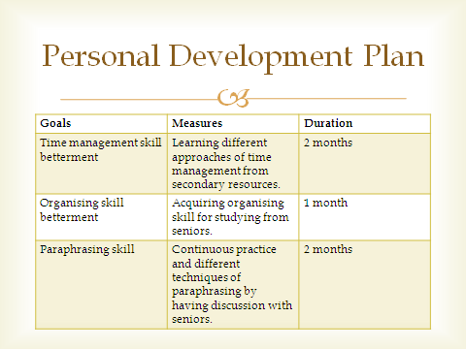
The personal development plan linked to my developmental plan based on the identified weaknesses has been presented in a tabular planned format.
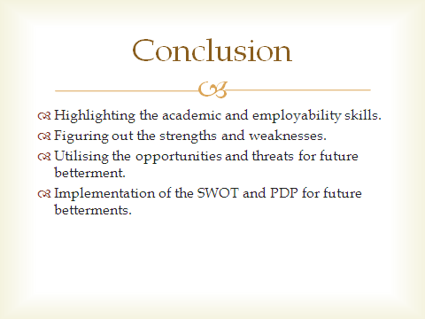
It can be concluded that highlighting the academic and employability skills has been done, followed by figuring out the strengths and weaknesses. Moreover, proper utilisation of the opportunities and threats for future betterment together with the implementation of the SWOT and PDP for future betterments is done.


