“The Merchant’s Prologue and Tale”
from The Ellesmere Manuscript

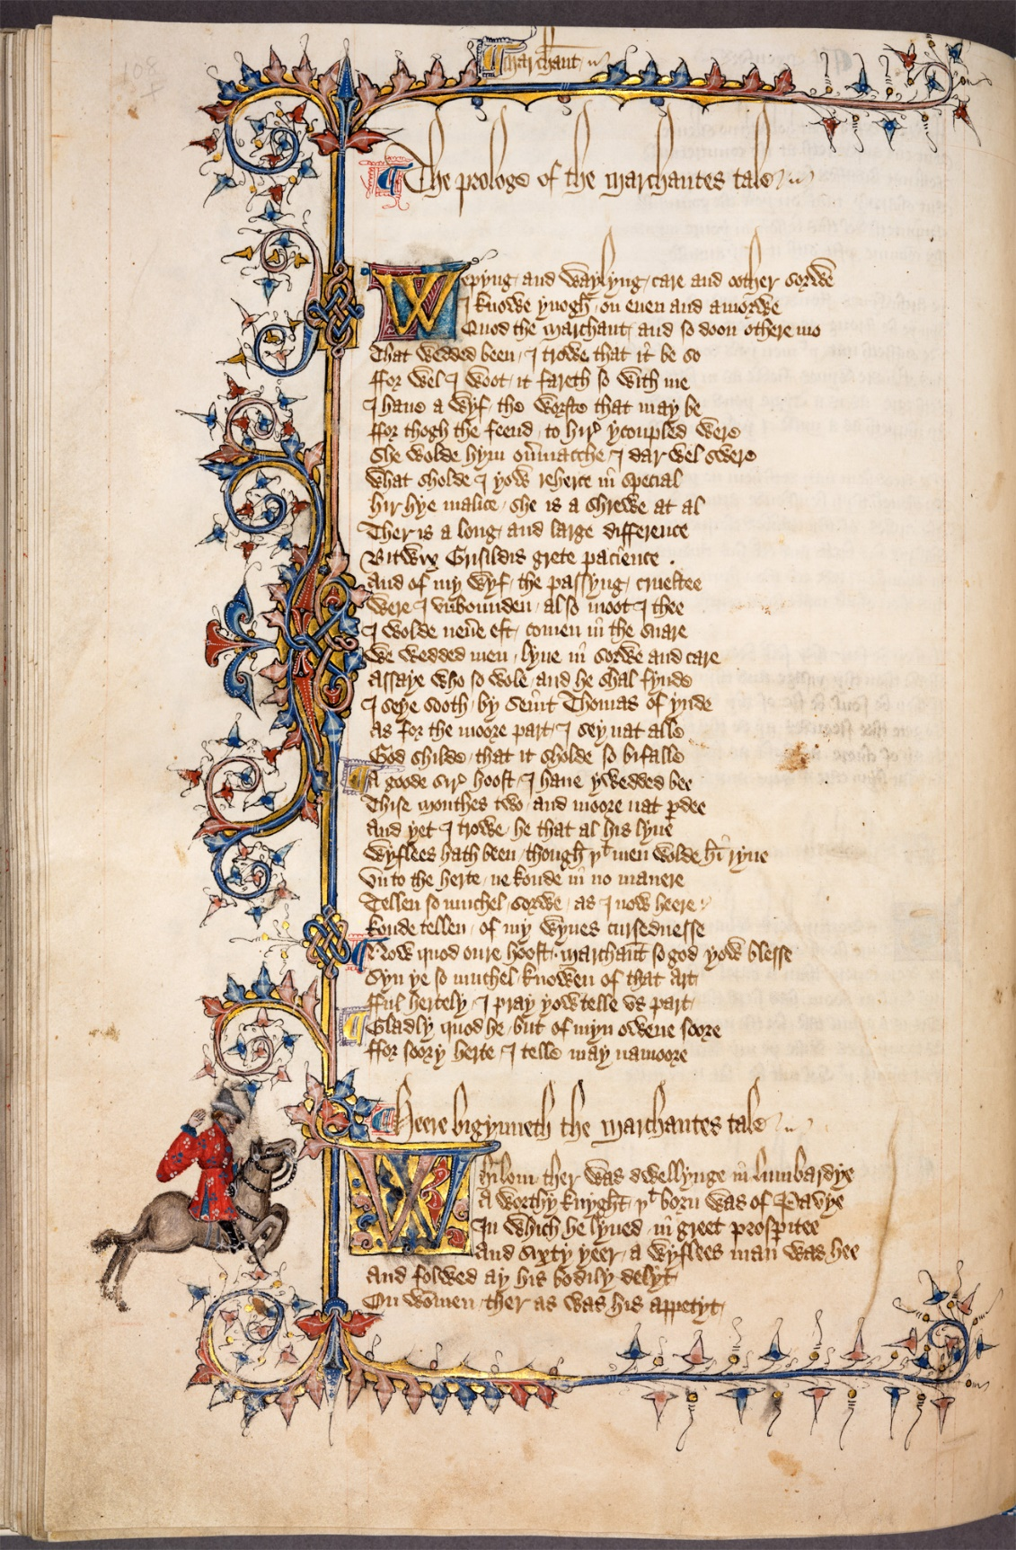
California, The Huntington Library, MS EL 26 C 9, f. 102v. (The Ellesmere Manuscript).

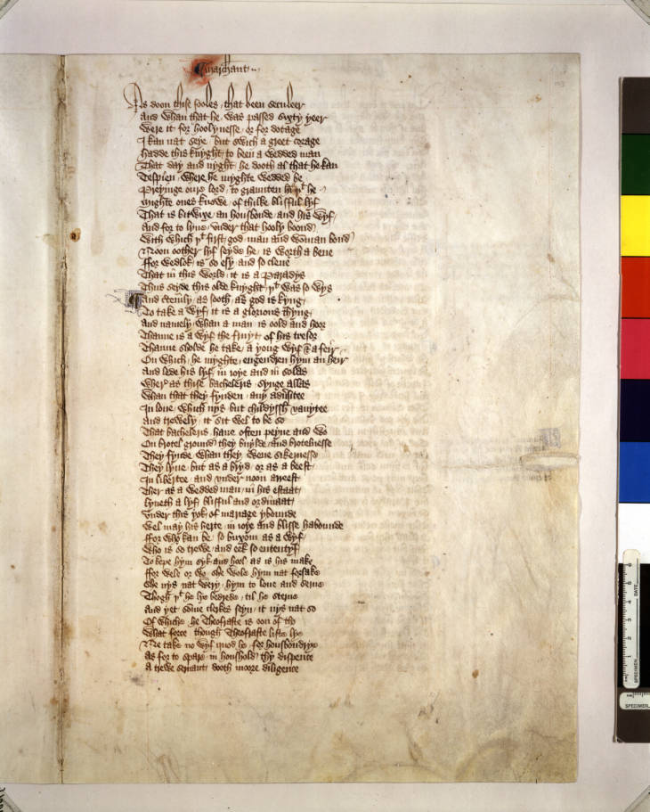
California, The Huntington Library, MS EL 26 C 9, f. 103v. (The Ellesmere Manuscript).

Produced between 1400 and 1410, the Ellesmere Manuscript is often cited as one of the earliest and most authoritative editions of Geoffrey Chaucer’s The Canterbury Tales. It is believed to have been compiled either shortly before Chaucer’s death, or just after, and could possibly be traced “to a scribe directly employed or supervised by him”. It is significant because it was the first known edition of The Canterbury Tales to list Chaucer’s pilgrims, their Prologues and their Tales in order, and was the example that subsequent editions were based upon (which may explain why it has survived in such good condition). The manuscript is complete, and for the most part is in perfect condition, save for a handful of instances of natural breakdowns and minor repairs. The Ellesmere Manuscript can be accessed online on the Huntington Library’s website, which shows the manuscript in its entirety.
The text is handwritten in ink on parchment and resembles either the fraktur or gothic calligraphic script. It is written in Old English, the original language of The Canterbury Tales. Historian Margaret Rickert argues that four laymen (rather than monks) worked upon the illuminations, borders and initials in the manuscript, but only one scribe had worked upon the text itself. This may be possible, however when transcribing the text I noticed that the word ‘merchant’ had been spelled differently on three different occasions, with spellings varying from ‘marchant’, ‘marchante’ and ‘marchaunt’, perhaps indicating that more than one scribe had worked upon this manuscript. Or, this may have simply been a spelling error.
In the process of this transcription exercise, I compared the Ellesmere Manuscript to other early editions of The Canterbury Tales. One of these editions was the Hengwrt Chaucer, currently held at the National Library of Wales. When comparing the manuscripts, I noticed the close similarities between the penmanship of the two, most notably the shared stylistic features of the ‘h’s and the ‘w’s. This led to me to believe that the scribe working on the Hengwrt Chaucer may have possibly been the same one that worked upon the Ellesmere Manuscript.
The text is highly decorated in vivid pigment colours, including crimson, blue and gold leaf. The text is within a decorated foliate border and is accompanied in the margin by the relevant pilgrim, “reproduced [in] the styles of dress of the 1380s”, that signifies the beginning of their Tale (in this case it is the Merchant on horseback). As well as this, the text includes decorated initials that represent the displaced authorial voice between the Host and the Merchant, as well as the break in conversation between the pilgrims. In this case, the first initial signifies the Host (who is telling the Prologue of the Merchant’s Tale), and the second signifies the Merchant. This specific leaf (f. 102v) has two initials. Both are decorated, but one is of more foliate a design than the other. The second leaf (f. 103v) does not feature any prominent illuminated initial.
As for the conventions of the text, there are no apparent contractions, nor any examples of suspensions. There are also no visible signs of erasure, nor damage to the page. There are no examples of rubrication in the text, however there are on occasion, small decorated initials that indicate breaks in conversation between the characters of the Merchant’s Prologue and Tale. There are also no noticeable corrections, and the language and spelling remain consistent and legible throughout the text. The script is consistent throughout the entirety of the Ellesmere Manuscript, supporting the idea that only one scribe had worked upon the text. However, it may be worth noting that around halfway down the page on f. 103v, the script gets slightly smaller, and then larger again, perhaps indicating where the scribe took a break from writing.
There are no examples of interlineation, and the text has clearly been written upon pre-drawn lines (this is easiest to make out in f. 102v.) There are a handful of abbreviations throughout the text, namely, ‘yt’ (meaning ‘that’), ‘pdee’ (meaning ‘pardee’) and a symbol on f. 103v that has been used in place of the word ‘and’. The text follows most medieval stylistic conventions, such as representing double ‘s’ as ‘ʃʃ’. Most, if not all of the sentences begin with a capital letter, however this was not always clearly discernible. As a final note, the ‘y’s in the text are unique because they are marked with a small accent-like signifier.

The Transcription (f.102v):

marchant | [within a decorative border] The prologue of the marchantes tale | [decorated initial] Wepyng and waylyng care and oother sorwe | I knowe ynough on even and amorwe | Quod the marchant and so doon othere mo | That wedded been I trowe that it be so | ffor well I woot it fareth so with me | I have a wyf the woorste that may be | ffor thogh the feend to hire ycoupled were | She wolde hym overmacche I dar wel swere | what sholde I yow rehere in special | hir hye malice she is a shrewe at al | Ther is a long and large difference | Bitwix Grisildis grete pacience | And of my wyf the passing crueltee | were I unbounden also moot I thee | I wolde nevere eft comen in the snare | we wedded men lyven in sorwe and care | Assaye who so wole and he shal fynde | I seye sooth by Seint Thomas of ynde | as for the moore part I sey nat alle | God shilde that it sholde so bifalle | A good sire hoost I have ywedded bee | Thise monthes two and moore nat pdee | And yet I trow he that at his lyve | wyflees hath been though yt men wolde himryve | Un to the herte ne koude in no manere | Tellen so muchel sorwe as I now heere | koude tellen of my wyves cursednesse | Now quod oure hoost marchaunt so God yow blesse | Syn ye so muchel knowen of that art | fful hertely I pray yow telle us part | Gladly quod he but of myn owene sooze | ffor sorry herte I telle may namooze | Heere bigynneth the marchantes tale | [decorated initial] Whilom ther was dwellynge in Lumbardye | A worthy knight yt born was of Pavye | Yn which he lyved in greet prosperitee | And sixty yeer a wyflees man was hee | And folwed ay his bodily delyt | On women ther as was his appetyt | [end of page].

The Transcription (f.103v):

marchant | as doon thise fooles that been seculeer | and whan that he passed sxyty yeer | were it for holynesse or for dotage | I kan nat seye but which a greet corage | hadde this knyght to been a wedded man | that day and night he dooth al that he kan | tespien where he myghte wedded be | preyinge our lord to graunten him yet he | might ones knowe of thisse blissful lyf | That is bitwixe an housbonde and his wyf | and for to lyve under that hooly boond | with which yt first god man and woman bond | noon oother lyf seyde he is worth a bene | ffor wedlock is so esy and so clene | That in this world it is a Paradys | thus seyde this olde knyght yt was so wys | and cetenily as sooth god is kyng | to take a wyf is it a glorious thyng | and namely when a man is oold and hoor | thane is a wyf the fruyt of his tresor | thanne sholde he take a yong wyf [symbol] a feir | on which he myghte engendren hym an heir | and lede his lyf in joye and in solas | where as thise bachelers synge allas | whan that they fynden any advsitee | In love which nys but childyssh vanytee | and trewely it sit wel to be so | That bachelers have often peyne and wo | on brotel ground they buylde and brotelnesse | They fynde whan they wene sikenesse | They lyne but as a bryd or as a beest | in libertee and under noon arreest | Ther as a wedded man in his estaat | lyveth a lyf blissful and ordinaat | under this yok of marage ybounde | wel may his herte in joye and bliss habounde | ffor who kan be so buxom as a wyf | who is so trewe and eek so ententys | to kepe hym syk and hool as is his make | ffor wele or wo she wold hym not forsake | she nys nat wery hym to love and serve | thogh yt he lye bedrede til he sterve | and yet some clerkes seyn it nys nat so | of which he Theofraste Is oon of tho | what focce though Theofraste liste lye | Ne take no wyf quod he for husbandrye | as for to spare in household thy dispence | a trewe servant dooth moore diligence | [end of page].

To conclude this transcription exercise, I wanted to comment upon the issues that I had encountered whilst transcribing the text. Although the handwriting was legible enough to read, certain letters were particularly difficult to make out. For example, the ‘x’ in ‘bitwix’ resembled an ‘ng’, and I often found myself mistaking ‘t’ for ‘s’, ‘h’ for ‘b’ and ‘v’ for ‘n’. However, certain letters, particularly the vowels and ‘w’ were easy to distinguish, making the manuscript easier to transcribe.
As well as this, the punctuation in the original codex was difficult to discern, making it difficult to distinguish when the line breaks, and making it seem as though the text was just one continuous sentence, hence any lack of punctuation in the transcription. Certain words were also difficult to make out, such as “tespien” and “engendren” in f. 103v, possibly because they are unfamiliar in modern English. However, on the whole, the Ellesmere Manuscript was easily accessible and relatively simple to transcribe.

Wordcount: 1905

Bibliography

Archival Sources
California, The Huntington Library, MS EL 26 C 9, f. 102v. (The Ellesmere Manuscript). Available online at: https://www.bl.uk/collection-items/ellesmere-manuscript [first accessed 8 November 2020].
California, The Huntington Library, MS EL 26 C 9, f. 103v. (The Ellesmere Manuscript). Available online at: https://hdl.huntington.org/digital/collection/p15150coll7/id/2570 [first accessed 2 December 2020].
London, The British Library, GRC 167.c.26. (Caxton’s Editio Princeps). Available online at: https://www.bl.uk/collection-items/first-printed-edition-of-the-canterbury-tales [accessed 8 December 2020].
Aberystwyth, The National Library of Wales, Peniarth MS 392D. (The Hengwrt Chaucer). Available online at: https://www.library.wales/discover/digital-gallery/manuscripts/the-middle-ages/the-hengwrt-chaucer/#?c=&m=&s=&cv=&xywh=-1323%2C0%2C6272%2C5333 [accessed 8 December 2020].

Secondary Sources
The British Library (2020) First printed edition of The Canterbury Tales by Geoffrey Chaucer. Available online at: https://www.bl.uk/collection-items/first-printed-edition-of-the-canterbury-tales [accessed 8 December 2020].
Burgess, A., The Riverside Chaucer: New Edition, 3rd edn. (Oxford: Oxford University Press, 1987), pp. 153 - 178.
Cambridge School of Chaucer, The Merchant’s Prologue and Tale. (Oxford: Oxford University Press, 2016), pp. 9-11.
Goepp, P. H. ‘The Ellesmere Chaucer’, University of Rochester Library Bulletin, Vol. 2 (1952).
The Huntington (2011) Canterbury Tales. Available online at: https://hdl.huntington.org/digital/collection/p15150coll7/id/2569 [accessed 5 December 2020].

P. H. Goepp, ‘The Ellesmere Chaucer’, University of Rochester Library Bulletin, Vol. 2 (1952).
The Huntington, Canterbury Tales, 2011, https://hdl.huntington.org/digital/collection/p15150coll7/id/2569 [accessed 5 December 2020].
P. H. Goepp, ‘The Ellesmere Chaucer’, University of Rochester Library Bulletin, Vol. 2 (1952).
Aberystwyth, The National Library of Wales, Peniarth MS 392D. (The Hengwrt Chaucer).
Cambridge School of Chaucer, The Merchant’s Prologue and Tale. (Oxford: Oxford University Press, 2016), p. 11.
For the purpose of this exercise, I have written “ʃʃ” as “ss”.

