A Report into The Effectiveness of the Current Structure of NHS Wales
Managing Organisations.

Name: Eva Williams
ID Number: 1805556

Abstract

This report analyses and evaluates the effectiveness of the current structure of NHS Wales. As a nation we are living longer. In 2008, 18 per cent of the population was over 65, by 2033 this is projected to increase to 26 per cent. There is also an increase in the amount of obesity. Taken together these will place more demands on a health service already under pressure.
This report gives an overview of NHS Wales and how it’s constituent seven health boards and three trusts work. It examines their management structure, highlighting the advantages and disadvantages, and if they are best suited to meet the future requirements of the Welsh people. The report investigates how NHS Wales is funded by the Welsh Government and what influences how the money is allocated. The emphasis in Wales is to target preventative measures as the most efficient way to provide long-term cost effect healthcare; supporting people to take more responsibility for their health and wellbeing by choosing healthier lifestyles. Also explored is how Brexit may affect health of individuals across wales. In the final analysis putting the citizen first is not the same as giving citizens everything they want, it’s about a shared attitude of mind which puts the interests of the citizen first, before the interests of the organisation.

Table of contents

- Tittle.............................................................................................................. 1
- Abstract.......................................................................................................... 2
3. Table of contents........................................................................................... 3 4. Introduction to the Report............................................................................. 4
- Overview of NHS in Wales.........................................................................4
- The seven health boards...........................................................................4
- How NHS Trust Work in Wales. ............................................................... 4
4.-Information / Statistics / Guides .................................................................... 5
- How management structures generally work within each Health board......................................................................................................5-6
- Diagram of Old structure of The Health Board in Wales..........................7
- Diagram of New Structure of The Health Board in Wales.........................8
- Where funding comes from and what influences it................................ 8
- Diagram of Draft Welsh Budget 2018/2019..............................................9
5.- Evaluation of Current Structure ...................................................................10
- Advantage of the structure......................................................................10
- Disadvantage of the structure ...........................................................10-11
- Other Issues or concerns relevant to the report ....................................11
- Conclusion...................................................................................................12
- Recommendations.......................................................................................13
- Reference List ...............................................................................13-14-15-16
4
3.- Introduction to the Report
There are many demands being made on health services provision in Wales. It is only to be expected that this will increase due to the ageing demographic. This report will examine the effectiveness of the National Health Service in Wales as it is currently organised. It will outline the existing structure, evaluate performance, conclusion, and make recommendations as to how improvements can be made.

- Overview of NHS Wales
NHS Wales, (2010a) informs that the Welsh Government is responsible for health policy in Wales and the funding of The National Health Service of Wales which delivers healthcare to around three million Welsh citizens covering everything from treatment for coughs and colds to end-of-life support. A core value of NHS Wales is that high-quality care should not depend on the ability to pay but must be accessible to all. Each year the NHS in Wales carries out more than 700,000 first out-patient consultations and treats an additional 600,000 inpatients.

The seven health boards
On 1st October 2009, NHS Wales reorganisation established seven new local health boards (LHBs) responsible for development and providing healthcare in their geographical regions. Those seven health boards at that time were:
- Aneurin Bevan University Health Board (ABUHB)
- Abertawe Bro Morgannwg University Health Board (ABMUHB)
- Cardiff and Vale University Health Board (CVUHB)
- Hywel Dda University Health Board (HDUHB)
- Cwm Taf University Health Board (CWMTAF)
- The Betsi Cadwaladr University Health Board
- Powys Teaching Health Board (PTHB)

5
On April 1st, 2019 there was a boundary change reorganisation and the eastern end of the ABMUHB Health Board, centred on Bridgend, merged with CVUHB to form Cwm Taf Bro Morgannwg University Health Board (CTBMUHB). The remaining western end, based on Swansea, became Swansea Bay University Health Board (SBUHB).

- NHS Trusts in Wales
There are currently 3 NHS Trusts in Wales with an all - Wales focus. These are the Welsh Ambulance Services Trust for emergency services, Velindre NHS Trust offering specialist services in cancer care and a range of national support services and the new Public Health Wales.

4.- Information / Statistics / Guides
- How management structures generally work within each Health board
ABUHB, (2016) advises that it covers the areas of Torfaen, Caerphilly, Blaenau Gwent, Newport, South Powys and Monmouthshire. It employs more than 13,000 staff including 250 consultants, 750 other hospital and general practice doctors and 6,000 nurses, midwives and community workers.

SBUHB, (2019) describe that Swansea Bay University Health Board (formerly ABMU) was created on April 1, 2019 when healthcare in the Bridgend County Borough Council area passed to the new Cwm Taf Morgannwg University Health Board. Swansea Bay UHB serves around 390,000 people in the Neath Port Talbot and Swansea areas and has a budget of around £1bn and employs roughly 12,500 staff. Morriston and Singleton in Swansea, and Neath Port Talbot Hospital in Baglan.

CVUHB, (2015) advises that Cardiff and Vale University Health Board is one of the biggest NHS bodies. The Health Board spends approximately £1.4 billion each year on delivering health services to around 472,400 individuals residing in Cardiff and The Vale of Glamorgan.

6

HDUHB, (2017) advises that Hywel Dda University Health Board, 2017 provides healthcare to a population of approximately 384,000. Carmarthenshire accounts for 183,936 of these, Ceredigion with 79,488 and Pembrokeshire 120,576. It delivers mental health and learning disabilities services via community hospitals, as well as GP surgeries, and dentist, pharmacist and optometrist services.
CTMUHB, 2019) From (April 1st) Cwm Taf University Health Board changes its name to Cwm Taf Morgannwg UHB as it takes responsibility for providing healthcare services for the people in the Bridgend County Borough Rhondda Cynon Taf and Merthyr Tydfil area. The boundary change means the health board will now serve a population of 450,000 and employ 13,500 staff.

The Betsi Cadwaladr University Health Board is the largest health organisation in Wales with an annual budget of £1.3 billion and a workforce of approximately 16,500. It combines the North Wales NHS Trust (previously North East Wales NHS Trust and Conwy & Denbighshire NHS Trust), the North West Wales NHS Trust, and the six Local Health Boards of Anglesey, Conwy, Denbighshire, Flintshire, Gwynedd and Wrexham. It, and provides a full range of primary, community, mental health and acute hospital services for a population of around 678,000 people in the six counties of North Wales.

PTHB, (2019) Powys Teaching Health Board is responsible for providing healthcare to the people of Powys in mid Wales. As an essentially rural area, the health board has the 133,000
people for whom it cares scattered across a geographic area that is a quarter of Wales and aims to provide as many services as possible locally through GPs and other primary care services, community hospitals and community services.

7
- How NHS Trust works in Wales
Welsh Ambulances Service NHS Trust, (2019) advises that it covers an area of 20,640 kilometres and serves a population of 2.9 million. Operating from three regional offices, three control centres and ninety ambulance stations, the service employs 2,576 people and responds to 250,000 emergency and 50,000 urgent calls a year.
Velindre University Trust, (2016) provides specialist cancer and blood services to 1.5 million people across South and Mid Wales through the Velindre Cancer Centre and the Welsh Blood Service. Each year the trust’s workforce of 670 deals with over 5,000 new referrals and around 50,000 outpatients.

NHS Wales, (2010b) Public Health Wales became fully operational on 1 October 2009 and is the unified Public Health organisation in Wales. The organisation exercises the functions of the National Public Health Service, Wales Centre for Health, Welsh Cancer Intelligence & Surveillance Unit, Congenital Anomaly Register & Information Service for Wales, and Screening Services Wales all with a nationwide remit.
OLD STRUCTURE OF THE HEALTH BOARD IN WALES
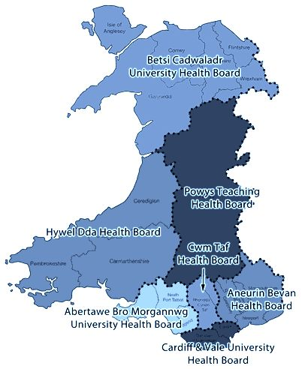

8

NEW STRUCTURE OF THE HEALTH BOARDS IN WALES

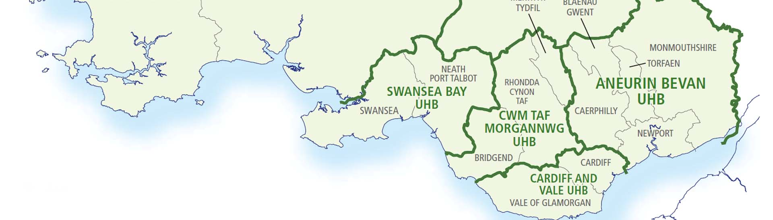

- Where funding comes from and what influences it

The NHS Confederation, (2019a) informs that most of NHS Wales funding comes from the Welsh Government. Local health boards receive two kinds of funding: revenue allocations which are used to finance primary and community care services as well as hospitals; and capital allocations used for both strategic capital developments and operational costs. Capital allocation is also granted to NHS Trusts. There is also targeted funding for health improvement and other Welsh Government initiatives. BBC News, (2019) and The NHS Confederation, (2019b) report the Draft Budget for the next two years proposes an extra £450 million in revenue funding; £230 million in 2018–19, and £220 million 2019–20, as well as an additional £90 million for the NHS Wales’ capital programme. National Assembly of Wales (2018c) Report that Health remains the largest area of spending for the Welsh Government, with 90.4%, or approximately £6.78 billion, of the health and social care budget paid directly into NHS services. Annual increased NHS investment is needed to properly meet local population needs. Even with additional resources, NHS organisations are still required to make significant savings, and some may still run a planned deficit.

9
BMA Cymru Wales, (2014) suggests that leadership in NHS organisations needs to have skilled clinical leaders working alongside experienced managers. The complex nature of funding in the Welsh healthcare system, together with various external pressures, suggests that growth in funding and the more careful use of existing resources is needed. However, this will be hard to find and require difficult choices regarding public services in Wales.

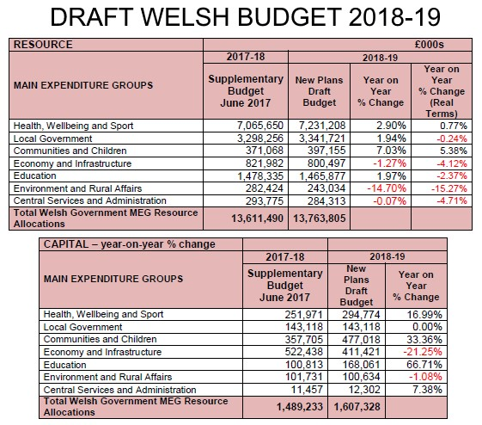

10
5. Evaluation of current structure
A traditional bureaucratic organisation like the NHS has a hierarchical structure which can have positive and negative effects.

- Advantages of Hierarchical Structure

National Assembly for Wales, (2014a) describes hierarchical authority as designed to benefit both the organisation and the employees. A competent management provides clear leadership and the organisation improves. Hierarchy also maintains managerial integrity. A manager must prove to be competent, or else they will lose employee confidence. An organisation’s hierarchy of authority is crucial to its sustained success. Hierarchical structure establishes clear authority. Managers have authority according to their seniority and can direct their subordinates and allocate resources. Everyone understands the chain of command. There is clarity in the demarcation between departments so there is no confusion over responsibilities. A hierarchical structure has the advantage of allowing employees to recognise clearly defined levels of management making the levels of authority and responsibility obvious. Employees are motivated to perform well because of the opportunity for advancement. Hierarchical structures promote developing employees as specialists.

Disadvantage of Hierarchical Structure

National Assembly for Wales, (2014b) describes how hierarchical structures centralise control and authority at the highest levels possible. This can be problematic. Managers may be caught up in mundane tactical operations, making decisions about things best left to those closer to the situation, instead of providing leadership with strategic thinking and planning. Another negative aspect is that the same organisational configuration that allows departments to work together may also isolate them from each other. Interdepartmental cooperation and communication may be reduced as a consequence. Departments can develop a narrow-minded outlook becoming less aware of the problems and requirements of other groups. This tunnel vision may lead departments to put their own goals ahead of organisational needs. As
11
a hierarchical structure expands, its hierarchy also grows. This slows things down – decision-making, communication, action – and even the most energetic organisation becomes bogged down with bureaucracy. This slowdown in activity is because communication must travel up and then back down a chain of command. Bureaucracy causes most negative consequences in dynamic situations that require quick action.
Issue of concern relevant to the report

NHS Wales, (2010c) and Lloyd-Jones, (2018) agree that Brexit may impact health. Law Wales (2016) identify other broader health considerations such as:
- Delayed or even lessened access to new medicines and clinical trial results due to the UK leaving key regulatory and coordinating bodies.
- Reduced health protection due to the UK no longer participating in key public health coordinating systems and evidence sharing mechanisms.
- Effects on the recruitment and retention of healthcare workers.
- Loss or reduced access to future EU funding for research and development, infrastructure, tackling inequalities and poverty and economic development.

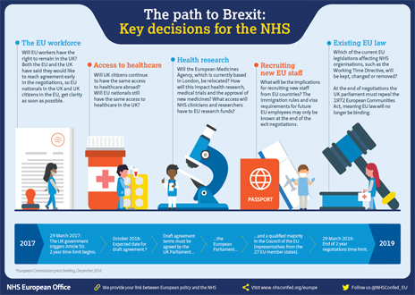

12
6.- Conclusion
As demands made on the National Health Service increase and people’s needs become more complex, the delivery of health and care services has to change in order to remain effective. Although Health Boards and Trusts continuously try to stay engaged with the public, it has to be recognised that it needs a significant change in ethos and approach to get the public to accept the different practices that the NHS of the future requires. To manage demand and implement new models of service, change will be needed. The public will have to be shown that delivering care in different ways and within different settings has many advantages. The service area and objectives will dictate the method of public engagement. To gather information about a specific service. A Local Health Board could invite members of the target population to a local forum meeting; whilst for broader issues, where a multi-disciplinary approach to the planning, design and delivery of services is required then a stakeholder reference group is likely to be a more effective. The public should be encouraged to monitor their Health Board’s website for information about the provision of services in their localities and also to attend and participate in regular board meetings.
Patients and staff should be encouraged to ask questions when they feel concerned. It is wrong for NHS organisations to react defensively and require formal complaints via a procedure that is cumbersome and unresponsive. A more positive approach will nurture a culture of openness where patients will feel free to ask questions and receive a sensitive response. Both patients and professionals should have better accessibility to accurate and relevant information on the performance of local health services. Performance, both good and bad, should be shared, and lessons learned. For this reason, both local and national data collection systems that record comments made about services need to be improved. The public should also have a greater role in informing management at the highest levels – for instance by playing a part in hospital inspections.

13
6.- Recommendations
The Welsh Assembly Government, (2009) informs that unhealthy lifestyles have both health and economic consequences, causing around 30% of premature deaths and a substantial drain on resources. Cancer, cardiovascular diseases, chronic obstructive pulmonary disease and diabetes are the cause of most premature deaths. All of these are closely linked to unhealthy diets and obesity, physical inactivity and the use of alcohol and tobacco. Consequently, we need to decrease the amount of obesity, cut smoking, alcohol and drug misuse. It will be essential to support people to take more responsibility for their health and wellbeing by choosing healthier lifestyles. This can be achieved through education as well as improving access to services and by creating healthier environments.

Reference List

Aneurin Bevan University Health Board (ABUHB) (2016) Aneurin Bevan University Health Board's Committee Structure. Available at:
http://www.wales.nhs.uk/sitesplus/866/page/52736 (Accessed 18 February 2019).

BBC News (2019) Sparring on spending: The latest round in the NHS funding row. Available at: https://www.bbc.co.uk/news/uk-wales-politics-44615723 (Accessed 15th April 2019).

Cardiff and Vale University Health Board (CVUHB) (2015) Our health Board Structure. Available:
http://www.cardiffandvaleuhb.wales.nhs.uk/our-health-board-structure (Accessed 18 February 2019).

14

Cwm Taf University Health Board (CWMTAF) (2019) We are Cwm Taf. Available at:
http: http://www.wales.nhs.uk/sitesplus/863/page/41169//cwmtaf.wales/we-are-cwm-taf/ (Accessed 10th April 2019).

Hywel Dda University Health Board (HDUHB) (2017) Overview of Hywel Dda University Health Board. Available at: http://www.hywelddalhb.wales.nhs.uk/ (Accessed 18 February 2019).

Law Wales (2016) Public Services. Available at:
https://law.gov.wales/publicservices/?lang=en (Accessed 5 March 2019).

Lloyd-Jones, N. (2018) Public engagement and NHS Wales. Available at:
https://www.nhsconfed.org/-/media/Confederation/Files/Wales-Confed/Public-Engagement.pdf (Accessed 5 March 2019).

National Assembly for Wales (2014a) The organisation in NHS in Wales. Available at: http://www.assembly.wales/research%20documents/15-020%20-%20the%20organisation%20of%20the%20nhs%20in%20the%20uk%20comparing%20structures%20in%20the%20four%20countries/15-020.pdf (Accessed 15th April 2019).

National Assembly for Wales (2014b) Deciding on the shape of the NHS. Available at: http://www.assembly.wales/laid%20documents/cr-ld11904/cr-ld11904-e.pdf (Accessed 15th April 2019).

National Assembly of Wales (2018c) The Welsh Government’s Draft Budget 2019-20. Available at:
http://www.assembly.wales/laid%20documents/cr-ld11904/cr-ld11904-e.pdf (Accessed 15th April 2019).

15
National Health Service of Wales (NHS Wales) (2010a) NHS Wales Funding. Available at:
http://www.wales.nhs.uk/governance-emanual/individual-patient-funding-requests (Accessed 3 March 2019).

National Health Service of Wales (NHS Wales) (2010b) Public Health Outcomes Framework.
Available at: http://www.wales.nhs.uk/nhswalesaboutus (Accessed 18 February 2019).

National Health Service of Wales (NHS Wales) (2010c) New National Report examines how Brexit may affect health and well-being of people across Wales. Available at: http://www.wales.nhs.uk/sitesplus/888/news/50275 (Accessed 15th April 2019)
NHS Confederation (2019a) Securing a settlement for health and social care. Available at:
https://www.nhsconfed.org/supporting-members/finance-funding-value/a-settlement-for-health-and-social-care (Accessed 6th April 2019).

NHS confederation (2019b) Funding health and social care. Available at:
https://www.nhsconfed.org/supporting-members/finance-funding-value/a-settlement-for-health-and-social-care (Accessed 6th April 2019).

Powys Teaching Health Board (2019) About us. Available at:
http://www.powysthb.wales.nhs.uk/home (Accessed 10th April 2019).

Swansea Bay University Health Board (SBUHB) (2019) About us. Available at:
https://sbuhb.nhs.wales/ (Accessed 10th April 2019).

The British Medical Association (BMA Cymru Wales) (2014) Raising Concerns about NHS Services in Wales. Available at:
file:///C:/Users/admin/Downloads/welshcouncil_making_nhs_wales_better_sep2014%20
(1).pdf (Accessed 3 March 2019).

16
The King’s Fund (2019) The NHS 10 years plan: How should extra funding be spent? Available at:
https://www.kingsfund.org.uk/publications/nhs-10-year-plan (Accessed 6th April 2109).

The Welsh Assembly Government (2009) Health Education and improvement in Wales. Available:
https://gov.wales/about/?skip=1&lang=en (Accessed 10th April 2019).

Velindre University Trust (2016) Welcome to Our Trust. Available at:
http://www.velindre-tr.wales.nhs.uk/about-us (Accessed 3 March 2019).

Welsh Ambulances Service NHS Trust (2019) About us. Available at:
http://www.was-tr.wales.nhs.uk/Default.aspx?pageId=8&lan=en (Accessed 3rd March 2019).

