8/17/2026
University of Wales Trinity Saint David
London campus
Code Link: https://github.com/AzizUWTSD/SmartHomeDeviceManager
SPC Assignment on
Smart Home Device Manager System for Bright Minds Academy
Module Name: Scripting and Programming Concepts
Module Code: ACCA5036

Student Name: Aziz Ahmad Tahir Bhatti
Student ID: 2424161

Lecturer’s Name: Koushik Modak

Contents
Introduction 2
Main Body 3
1.1 Requirements Analysis 3
1.2 Functional Requirements 3
1.3 Non-Functional Requirements 4
1.4 Justification 4
2. Software Design and Development 4
2.1 System Design 4
2.2 System Flowchart 6
2.3 Pseudocode 8
2.4 Data Structure Design 9
2.5 Programming Constructs 10
2.6 Python Libraries 13
2.7 Implementation Decisions 14
3. Testing and Debugging Report 15
3.1 Test Cases 16
3.2 Debugging Report 22
3.3 Debugging Summary 23
4. Evaluation 24
5. Conclusion 26
References 28
Appendices 29
Appendix A – Python Source Code 29
Appendix B – Test Evidence (Program Screenshots) 32

Introduction
Technology plays an important role in modern educational institutions by supporting teaching, learning and administrative activities. Bright Minds Academy uses various smart classroom devices, including smart lights, projectors and digital equipment, to improve the learning environment. Managing these devices manually using paper records or spreadsheets can be inefficient, leading to inaccurate information, duplicate records and difficulties in tracking device status. To address these challenges, a simple software solution was developed to organise and manage smart devices more effectively.
The Smart Home Device Manager System is a menu-driven Python application designed to help academy staff register new devices, update device status, search for devices and display all stored records. The system stores information using a nested dictionary, providing efficient data storage and retrieval while demonstrating the practical application of fundamental programming concepts such as functions, loops, conditional statements and input validation. These concepts contribute to a structured, reliable and maintainable software solution.
This report presents the complete software development process used to create the application. It begins with the analysis of user requirements, followed by software design and implementation decisions. The report then discusses the testing and debugging activities carried out to verify that the program performs correctly under different conditions before evaluating the completed system and identifying possible future improvements. Overall, the project demonstrates the application of scripting and programming principles to develop a practical solution that improves the management of smart classroom devices at Bright Minds Academy while providing a strong foundation for future enhancements.

Main Body

1.1 Requirements Analysis
The Smart Home Device Manager System was developed to help Bright Minds Academy manage classroom smart devices more efficiently. The academy uses devices such as smart lights, projectors and other digital equipment to support teaching and learning activities. Managing these devices manually using paper records or spreadsheets can result in inaccurate information, duplicate entries and delays when updating device status. These issues reduce administrative efficiency and make it difficult to monitor the availability and condition of classroom equipment.
The primary users of the system are administrative staff and classroom support personnel responsible for managing smart devices throughout the academy. These users require a simple and reliable application that allows them to record, update and retrieve device information quickly. The proposed system provides a centralised method of storing device records, enabling staff to register new devices, update operational status and search for specific equipment whenever required. This reduces the risk of human error while improving the accuracy and accessibility of device information.
The application has been developed as a menu-driven Python program that stores data using a nested dictionary. Each device name acts as a unique key, while the associated values store the room location and current operational status. This data structure enables efficient searching, updating and retrieval of records while maintaining a simple program design suitable for the project requirements [3]. The software also adopts a modular programming approach by dividing the application into separate functions, making the source code easier to understand and maintain [1]. Overall, the Smart Home Device Manager System provides a practical solution that replaces inefficient manual processes with an organised software application. It improves administrative efficiency, supports accurate device management and provides a foundation for future enhancements such as database integration and graphical user interfaces.

1.2 Functional Requirements
The software satisfies the following functional requirements:
- Add a new smart device by entering the device name, room location and operational status.
- Update the status of an existing device.
- Display a list of all registered devices.
- Search for a device using its full name or part of its name.
- Exit the application safely.
The program also validates user input by preventing blank entries, duplicate device names and invalid status selections. This improves data accuracy and reduces user errors.

1.3 Non-Functional Requirements
The application was designed to meet several non-functional requirements. Usability is achieved through a simple menu-driven interface with clear prompts and error messages that enable users with limited technical knowledge to operate the system effectively. Reliability is improved through input validation and controlled status options, ensuring that only valid information is stored. Performance is satisfactory because Python dictionaries allow fast searching and updating of records. The modular structure also improves maintainability, allowing future enhancements without major changes to the existing program [2].

1.4 Justification
Python was selected because it is an easy-to-learn programming language that supports structured and modular programming. Features such as dictionaries, loops, functions and conditional statements allow developers to create reliable applications with relatively little code [1]. The use of separate functions for adding, updating, searching and displaying devices reduces code duplication and improves readability.
Overall, the Smart Home Device Manager System provides Bright Minds Academy with a practical solution for organising smart classroom devices. It replaces inefficient manual processes with a structured software application that improves accuracy, efficiency and ease of use. The modular design also provides a strong foundation for future developments, such as database integration, graphical user interfaces and user authentication, making the application scalable and easier to maintain.

2. Software Design and Development

2.1 System Design
The Smart Home Device Manager System was designed using a modular programming approach to improve code readability, maintainability and reusability. Rather than writing the entire application inside one large program block, the solution separates individual tasks into dedicated functions. Each function performs one specific operation, making the software easier to understand, test and modify. This design also follows the principle of separation of responsibilities because every function has a clearly defined purpose.
The application uses a menu-driven interface that repeatedly displays five options until the user selects the Exit option. When a menu option is selected, the program calls the corresponding function to perform the required task before returning to the main menu. This design creates a simple workflow that is suitable for users with limited technical experience.
The overall system design follows a top-down development approach, where the application is divided into smaller and more manageable components before implementation. This approach enables each function to be designed, tested and refined independently, reducing software complexity and making the program easier to maintain. By separating the application into individual modules, changes made to one function have minimal impact on the rest of the program, improving both reliability and scalability.
Another important design principle applied during development is modular programming. Each module has a single responsibility, such as validating user input, searching for devices or displaying stored records. This improves code readability because each function performs one clearly defined task rather than combining multiple operations into a single block of code. The modular structure also simplifies debugging, as errors can be isolated within individual functions and corrected without affecting unrelated parts of the application. Furthermore, this design provides flexibility for future enhancements, such as integrating a graphical user interface or replacing the in-memory dictionary with a database, while requiring only limited changes to the existing program structure [5].

The system consists of the following main functions:
- show_menu()
- get_non_empty_input()
- find_device()
- get_valid_status()
- add_device()
- update_device_status()
- view_devices()
- search_device()
- main()
Each function contributes to one specific part of the application's functionality, reducing duplicated code and improving software quality.

2.2 System Flowchart
The system flowchart shown in Figure 2 illustrates the overall workflow of the Smart Home Device Manager System.
The flowchart illustrates how the application displays the main menu, validates the user's input, executes the selected operation, displays the corresponding result or error message, and repeatedly returns to the main menu until the user selects the Exit option, at which point the program terminates.

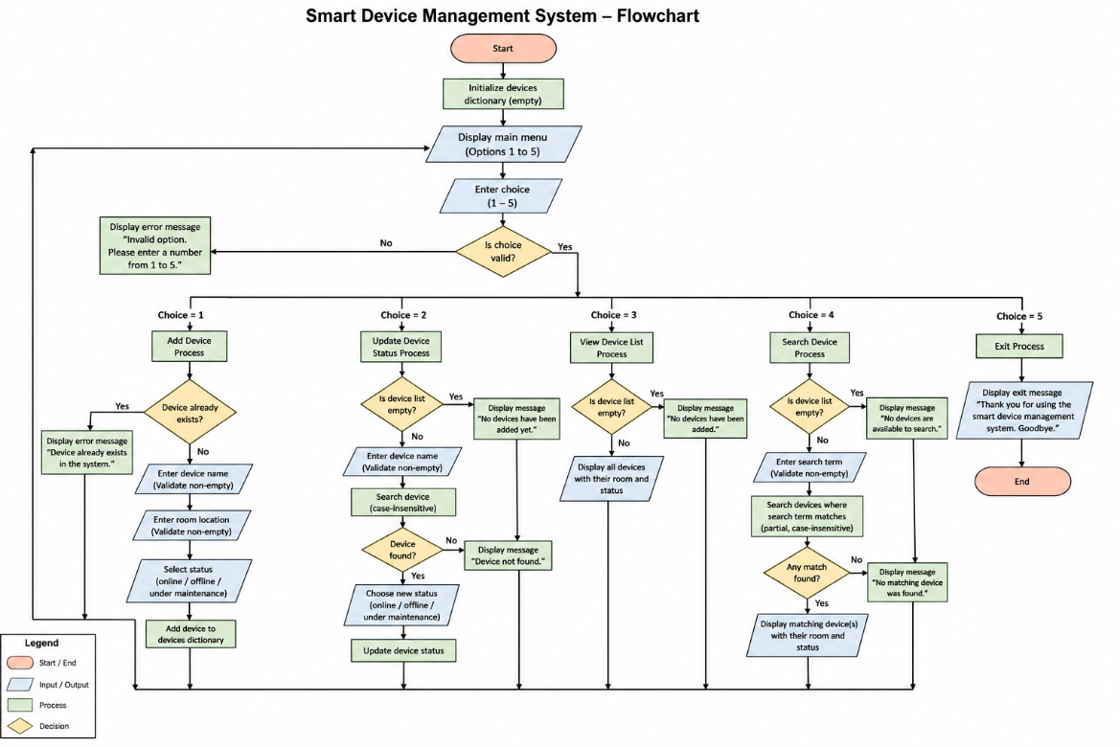
Figure 2. Flowchart of the Smart Home Device Manager System.

2.3 Pseudocode
The pseudocode below describes the overall operation of the application before implementation.
BEGIN
Create empty dictionary called Devices
REPEAT
Display Main Menu
Read User Choice
IF Choice = 1 THEN
Add New Device
ELSE IF Choice = 2 THEN
Update Device Status
ELSE IF Choice = 3 THEN
Display All Devices
ELSE IF Choice = 4 THEN
Search Device
ELSE IF Choice = 5 THEN
Exit Program
ELSE
Display Invalid Option
END IF
UNTIL User Chooses Exit
END
The pseudocode demonstrates the logical sequence of operations and reflects the final implementation of the Python program.
Developing the pseudocode before writing the Python program provided a structured plan for implementing the application's functionality. It allowed the overall logic of the system to be organised into a sequence of clearly defined steps without focusing on Python syntax. This approach made it easier to identify the required decisions, loops and processing stages before the coding process began. During implementation, the pseudocode acted as a reference that guided the development of each function and ensured that all functional requirements were addressed systematically. It also reduced the likelihood of logical errors because the program flow had already been planned and reviewed. Furthermore, the pseudocode improved communication by presenting the algorithm in a format that could be understood by both technical and non-technical readers. As a result, the transition from design to implementation was more efficient, contributing to a well-structured and maintainable software solution [5].

2.4 Data Structure Design
The application stores information using a nested Python dictionary.
A dictionary was selected because every smart device has a unique device name that can be used as the dictionary key. Each key stores another dictionary containing the room location and operational status.
Example:
devices = {
"Smart Light A1": {
"room": "Room 101",
"status": "online"
}
}
This structure provides several advantages:
- Fast searching using keys.
- Easy updating of individual records.
- Simple storage of related information.
- Reduced program complexity.
Unlike lists, dictionaries allow direct access to records without searching every element sequentially, making them an appropriate choice for this application [1].

2.5 Programming Constructs
The software demonstrates several fundamental programming constructs.
Variables
Variables store user input and device information.
Examples include:
- name
- room
- status
- choice
- devices
Variables make the program dynamic because values change according to user input.
These variables play an important role in controlling the execution of the application and ensuring that user information is processed correctly. The name variable stores the unique identifier for each smart device and is used as the key within the nested dictionary. The room variable records the physical location of the device, allowing users to identify where each item is installed. The status variable stores the current operational condition of the device, such as Online, Offline or Under Maintenance, enabling staff to monitor equipment availability efficiently. The choice variable records the user's menu selection and controls the program flow by determining which function is executed. Finally, the devices dictionary acts as the primary data structure, storing all registered device records throughout the execution of the program. Using meaningful variable names improves code readability, making the source code easier to understand, maintain and debug. It also follows good programming practice by ensuring that each variable has a clear purpose within the application.

Selection
This modular approach follows recognised software engineering principles by separating the program into individual functions, each responsible for a specific task [2]. The application makes extensive use of input validation to improve software reliability and ensure that only valid data is processed. Appropriate validation also enhances the user experience by providing clear error messages whenever invalid input is detected [2].
Selection statements allow the program to make decisions based on user input and system conditions. The Smart Home Device Manager System uses if, elif, and else statements to control the program flow and validate user actions.
Examples of selection include:
- Checking whether a device already exists before adding it.
- Validating the user's menu option.
- Validating the selected device status.
- Checking whether the device exists before updating its status.
- Determining whether a search query matches an existing device.
These decision-making statements ensure that only valid operations are performed and appropriate error messages are displayed when invalid input is entered, improving both the reliability and usability of the application [2]
Iteration
Iteration enables the repeated execution of program instructions until a specified condition is met.
The application uses:
- while loops
- for loops
The while loop repeatedly displays the main menu until the user selects the Exit option, allowing the application to continue running until the user chooses to terminate the program.
The for loop is used to:
- Display all registered devices.
- Search for a device by comparing device names.
- Locate an existing device when updating its status.
Using loops reduces code duplication, improves efficiency, and allows the application to process multiple devices effectively.
Functions
Functions divide the application into smaller, reusable modules, making the program easier to understand, maintain, and extend. Each function performs a single, well-defined task.
The Smart Home Device Manager System contains the following user-defined functions:
Function | Purpose
show_menu() | Displays the main menu options.
add_device() | Adds a new smart device after validating the input.
update_device_status() | Updates the operational status of an existing device.
view_devices() | Displays all registered smart devices.
search_device() | Searches for a device using its full or partial name.
main() | Controls the overall execution of the application and repeatedly displays the menu until the user exits.

2.6 Python Libraries
The Smart Home Device Manager System does not require external Python libraries because it uses only Python's built-in functionality.
The application relies on:
- Dictionary
- Lists
- Loops
- Functions
- Input and Output
- String methods
Examples include:
.lower()
used for case-insensitive searching.
.strip()
enumerate()
In addition to these methods, the application relies on several other built-in Python functions to improve its overall functionality and usability. The input() function is used throughout the program to collect information entered by the user, while the print() function displays menus, prompts, confirmation messages and error notifications in a clear and user-friendly format. String methods such as strip() remove unnecessary leading and trailing spaces from user input, helping to prevent accidental blank entries or inconsistent data. The lower() method converts text to lowercase before comparisons are made, allowing device searches to be performed without requiring users to enter the exact capitalisation of stored device names. Furthermore, the enumerate() function is used when displaying lists of registered devices, automatically generating numbered output that improves readability and makes the information easier to follow. By relying exclusively on Python's built-in functionality, the application remains lightweight, portable and compatible with any standard Python installation, eliminating the need for additional third-party packages while maintaining efficient performance and ease of maintenance [1].

Using built-in functions reduces software complexity and improves compatibility because the program can run without installing additional packages.

2.7 Implementation Decisions
Several important design decisions were made during development.
Dictionary Storage
Instead of using lists, a nested dictionary was selected because every device has a unique name. This allows fast searching and updating while keeping related information grouped together.
Modular Programming
The software was divided into functions rather than writing all logic inside the main program. This improves readability, debugging and future maintenance.
Input Validation
User input is validated before being stored. Blank entries are rejected, duplicate device names are prevented and device status can only be selected from predefined options. This helps maintain data accuracy and improves reliability.
Case-Insensitive Search
The application converts user input and stored device names to lowercase before comparison. This improves usability because users do not need to match the exact capitalisation of device names.

Menu-Driven Design
A simple text-based menu was chosen because it is easy to understand and suitable for demonstrating scripting and programming concepts. The menu repeatedly prompts the user until the Exit option is selected, ensuring smooth navigation throughout the application.
The implementation decisions made during the development of the Smart Home Device Manager System were guided by the objectives of simplicity, reliability and maintainability. A console-based application was selected because it provides an effective way to demonstrate fundamental programming concepts without the additional complexity of designing a graphical user interface. This allowed greater attention to be given to the application's logic, data management and input validation while ensuring that the software remained easy to develop and test.
The use of modular programming was another important implementation decision. By dividing the application into separate functions, each component could be developed, tested and debugged independently. This reduced code duplication and improved readability, making the program easier to maintain and extend. The implementation of input validation further strengthened the application by ensuring that only valid and complete information could be stored. This reduced the likelihood of user errors and maintained the consistency of the stored data.
Finally, the decision to use a nested dictionary together with case-insensitive searching improved both performance and usability. Device records can be retrieved and updated efficiently using unique keys, while users are able to search for devices without needing to enter the exact capitalisation of the device name. These implementation decisions collectively contribute to a reliable, user-friendly and scalable software solution that satisfies the functional requirements identified during the analysis stage [5].

3. Testing and Debugging Report
Testing is an essential stage of the software development life cycle because it verifies that the system performs according to the specified requirements. The Smart Home Device Manager System was tested after implementation to ensure that each function operated correctly under different conditions.
Software testing is an essential activity because it confirms that an application satisfies its functional requirements and performs reliably in different situations. Testing enables developers to identify defects before the software is released, reducing the possibility of system failures and improving the overall quality of the final product. A structured testing process also verifies that user input is handled correctly, calculations are accurate and program logic produces the expected results. In this project, testing was carried out throughout the development process rather than only after the program had been completed. Each function was tested individually before being integrated into the complete application. This incremental approach made it easier to identify errors, verify corrections and ensure that new changes did not introduce additional problems. Consequently, software testing contributed significantly to the reliability, stability and usability of the Smart Home Device Manager System [5].
Functional testing was carried out on all major features, including adding devices, updating device status, viewing stored devices and searching for existing records. The objective of testing was to identify errors, validate user input and confirm that the system produced the expected output consistently.
The testing process demonstrated that the application successfully met all functional requirements. Both valid and invalid inputs were tested to ensure that appropriate validation messages were displayed and that incorrect information was not stored. Testing also confirmed that the menu system continued operating until the user selected the Exit option, preventing unexpected program termination.

3.1 Test Cases
The following table summarises the functional testing performed on the application.
During software development, different types of programming errors may occur and must be identified through testing and debugging. One common type is a syntax error, which occurs when the program does not follow the rules of the Python language. Examples include missing brackets, incorrect indentation or typing errors in keywords. These errors are usually detected immediately by the Python interpreter and were corrected by reviewing the affected lines of code before the program was executed.
A second type is a runtime error, which occurs while the program is running. Runtime errors may result from invalid user input or attempts to perform operations that cannot be completed successfully. To reduce the likelihood of runtime errors, input validation was implemented throughout the application to ensure that users entered appropriate values before processing continued.
The third type is a logical error, where the program executes without producing an error message but generates incorrect results because the implemented logic is flawed. During this project, logical errors were identified by comparing the actual output with the expected behaviour during functional testing. Once identified, the program logic was modified and tested again until the correct results were consistently produced. Understanding these different error types helped improve the quality and reliability of the completed application.
The test results demonstrate that all p rimary functions operate correctly and satisfy the system requirements. Input validation successfully prevented invalid entries, duplicate device names and unsupported menu options, improving the overall reliability of the application.

Test ID
Test ID |  | Test Description |  | Test Data | Expected Result | Actual Result | Status
 | TC01 | Add a new smart device |  | Smart Light A1, Room 101, Online | Device added successfully | Device added successfully | Pass
TC02 |  | Add duplicate device |  | Smart Light A1 | Duplicate device message displayed | Duplicate device prevented | Pass
TC03 |  | Update device status |  | Smart Light A1 → Offline | Device status updated successfully | Device status updated successfully | Pass
TC04 |  | Search existing device |  | Smart Light A1 | Matching device displayed | Device found successfully | Pass
TC05 |  | Search non-existing device |  | Camera X | Device not found message displayed | Correct message displayed | Pass
TC06 |  | View all devices |  | Multiple stored devices | All registered devices displayed | Device list displayed | Pass
TC07 |  | Invalid menu option |  | 9 | Invalid option message displayed | Error handled correctly | Pass

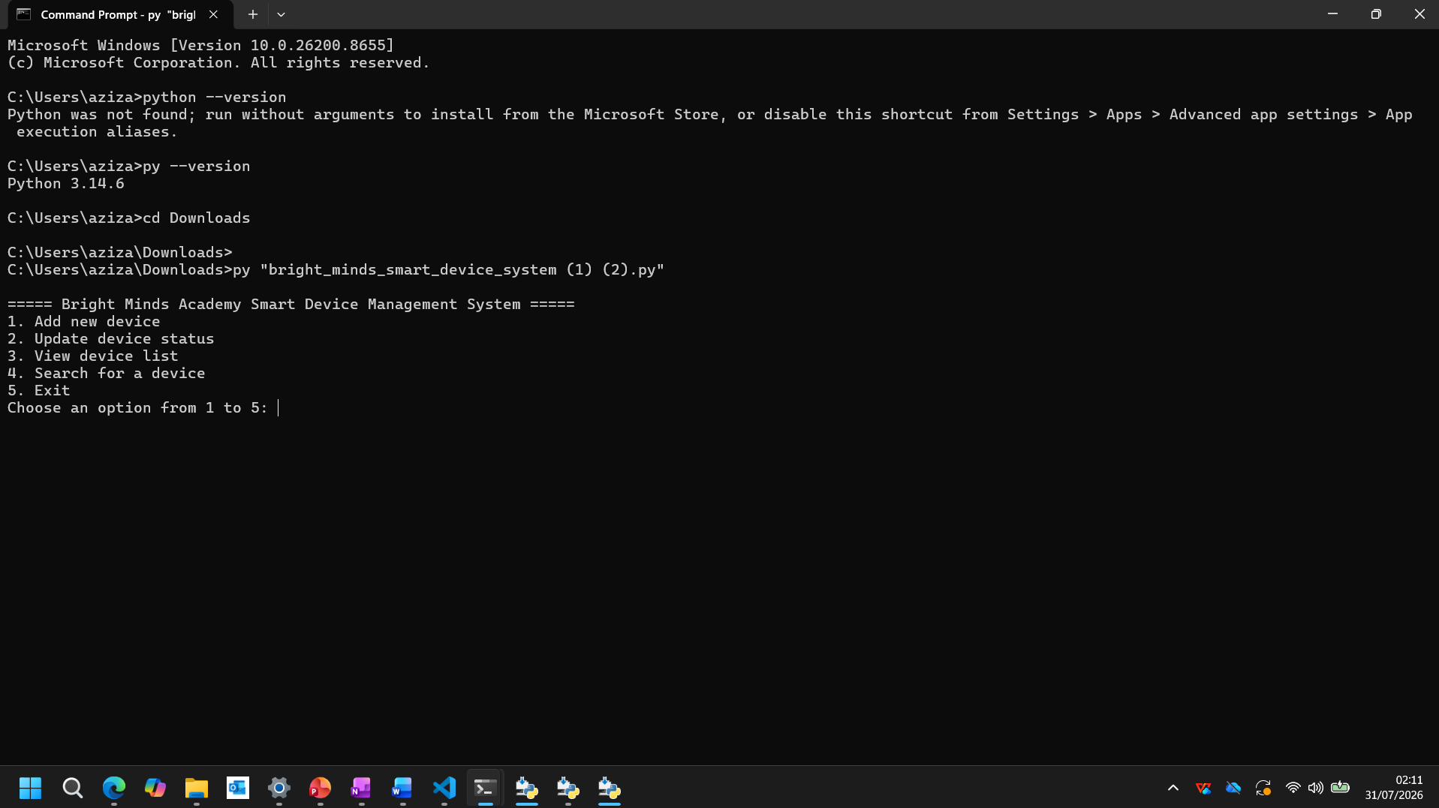
Figure B.1: Main menu displayed when the Smart Home Device Manager System is launched
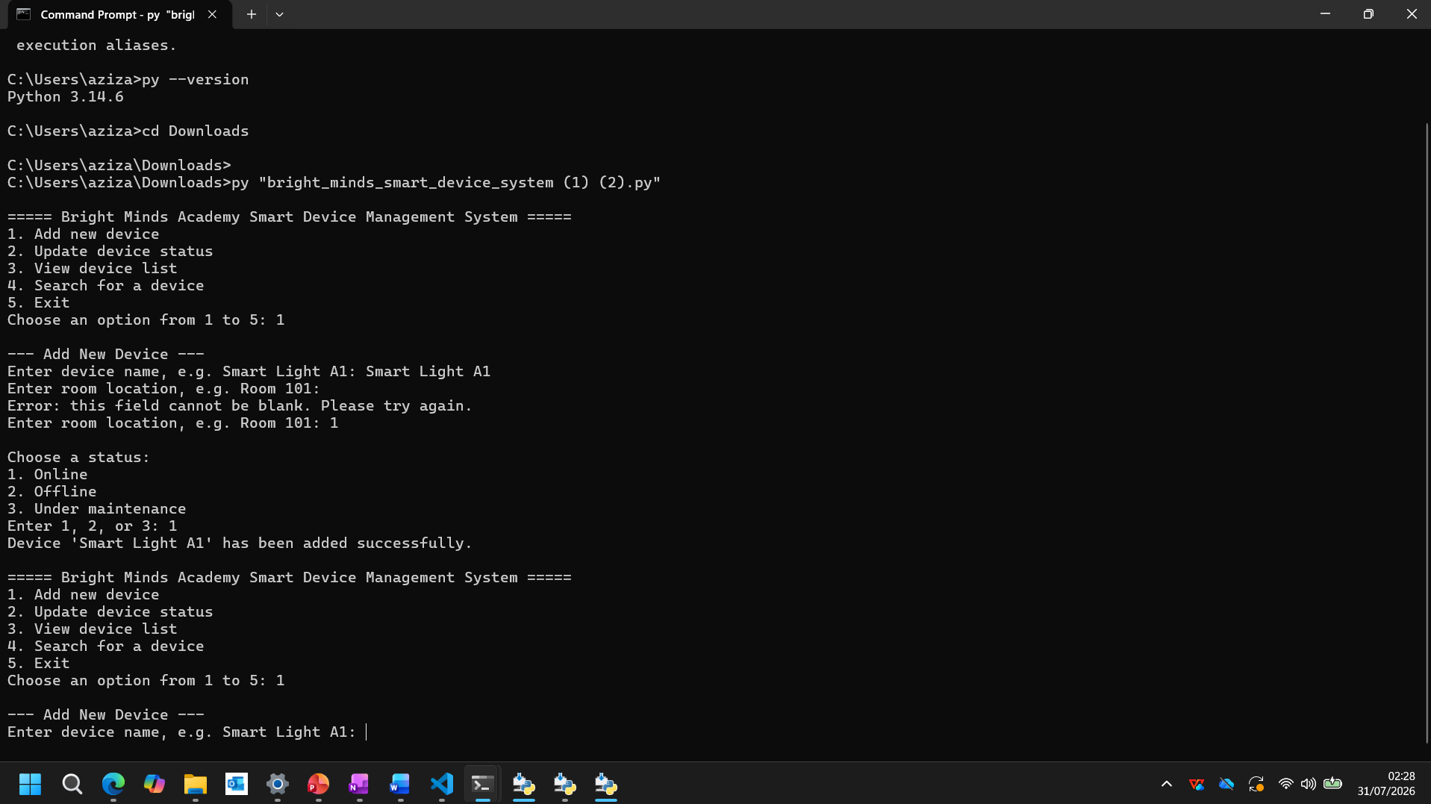
Figure B.2: Successful addition of a new smart device with input validation and status selection.
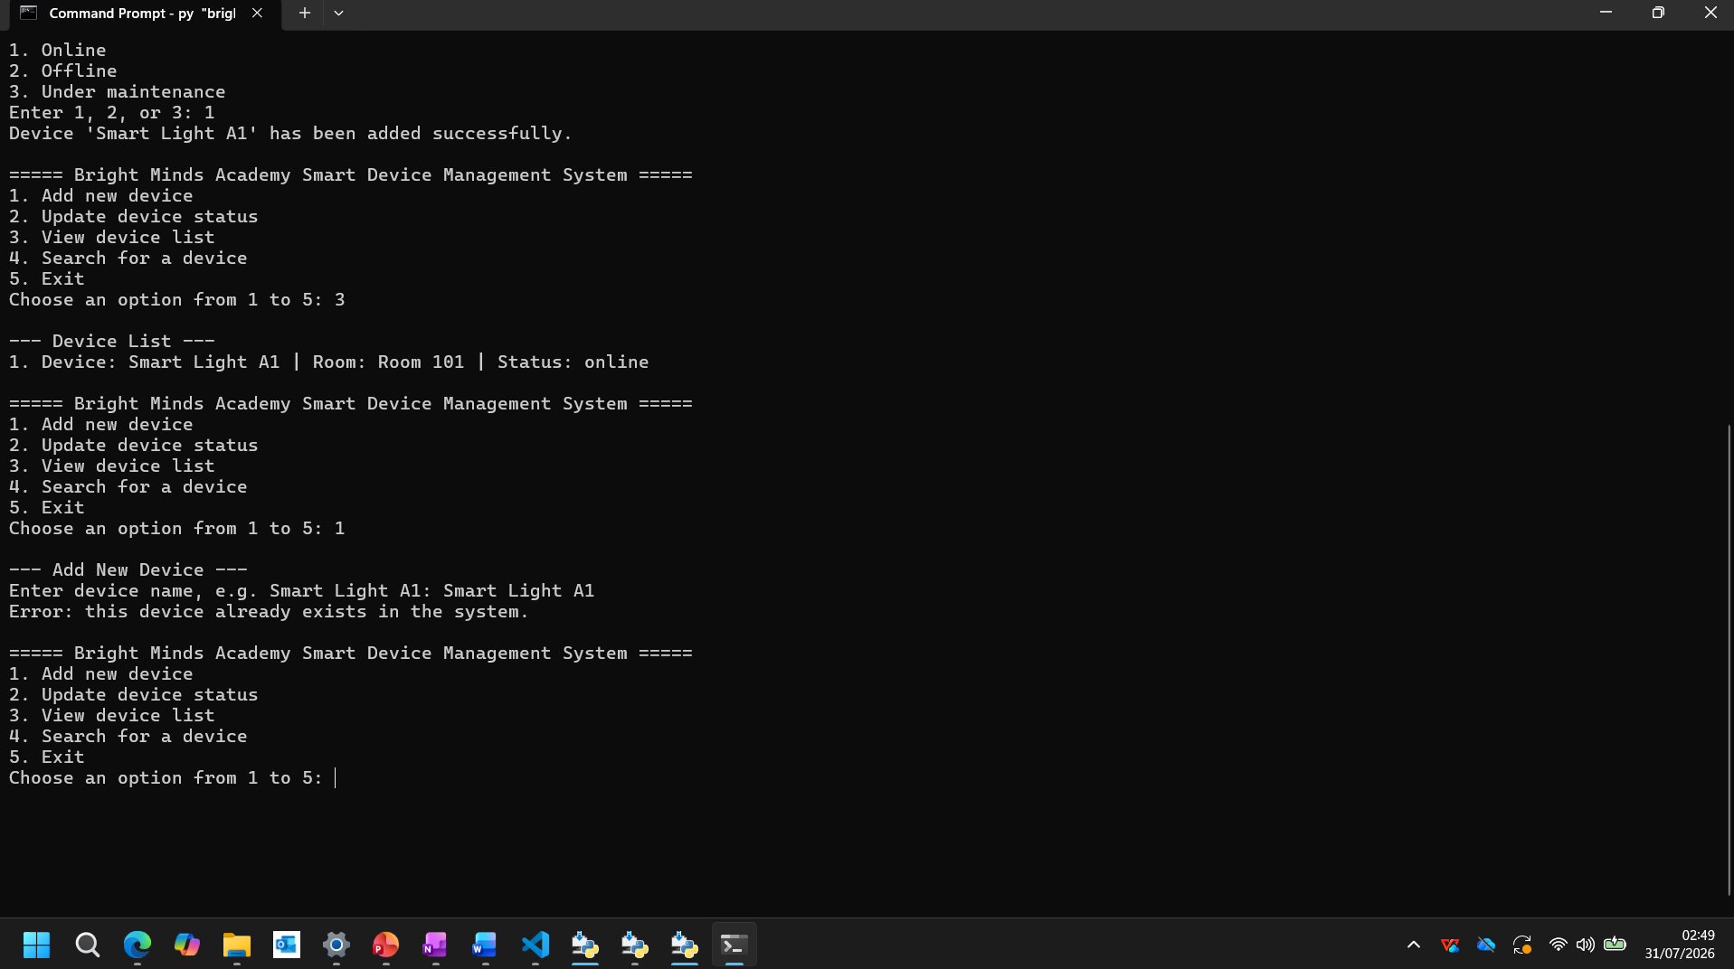
Figure B.3: Display of the Registered Smart Device in the Device List

Figure B.4: Validation Preventing the Addition of a Duplicate Smart Device

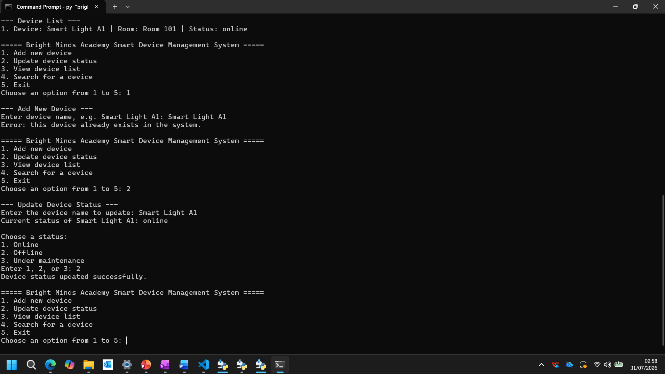
Figure B.5: Successful Update of the Smart Device Status.
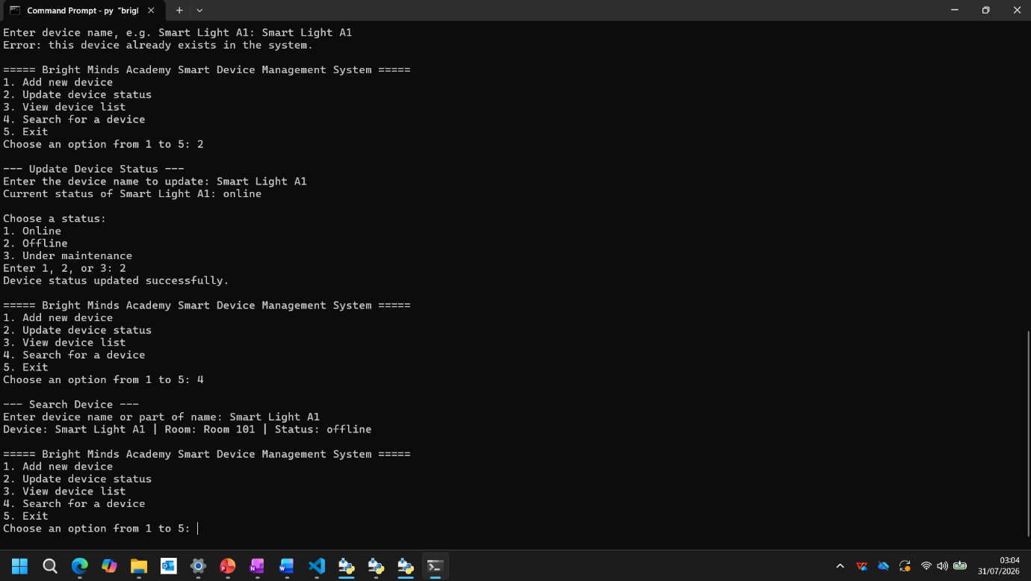
Figure B.6: Successful Search for an Existing Smart Device.
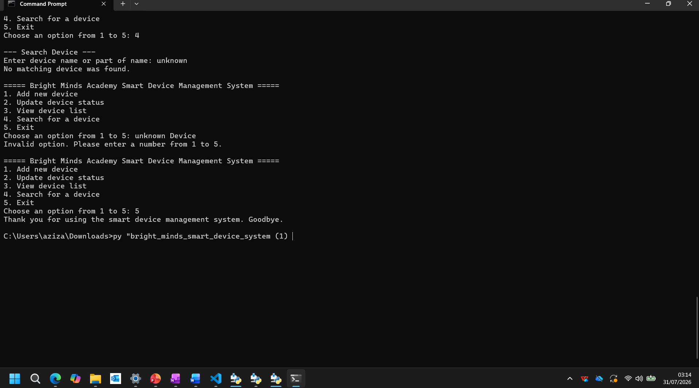
Figure B.7: Search for a Non-Existent Smart Device.

Figure B.8: Validation of an Invalid Menu Option.

3.2 Debugging Report
During software development, several issues were identified and resolved through debugging. Debugging involved analysing program behaviour, locating the cause of errors and modifying the source code to achieve the expected results. This process improved both the reliability and usability of the application.
One of the initial issues occurred when users attempted to add a device with a name that already existed. Without validation, duplicate entries could overwrite existing information or create inconsistent records. This problem was resolved by checking whether the device name already existed in the dictionary before storing new data.
Another issue involved blank user input. Initially, users could press Enter without entering a value, resulting in incomplete records. A validation function was introduced to repeatedly request input until a valid value was provided. This ensured that all mandatory fields contained meaningful information before processing continued.
The search function was also improved during debugging. Early testing showed that searches were case-sensitive, requiring users to type the exact capitalisation of the stored device name. The solution was to convert both the stored device names and user input to lowercase before comparison, allowing flexible and user-friendly searching regardless of letter case.
Menu validation represented another important improvement. Invalid menu selections originally produced unexpected behaviour. Additional validation was implemented using conditional statements so that invalid choices display an informative error message while returning users safely to the main menu.
The debugging process was carried out continuously throughout the implementation stage rather than being treated as a separate activity after development. After each function was completed, it was tested using both valid and invalid input values to verify that it behaved as expected. When unexpected behaviour occurred, the source code was reviewed systematically to identify the underlying cause before modifications were made. Following each correction, the affected function was tested again to confirm that the issue had been resolved and that no additional problems had been introduced into other parts of the application.
This iterative approach to debugging improved both the quality and reliability of the software. Repeated testing also increased confidence that each feature operated correctly under different conditions, including incorrect menu selections, duplicate device names and incomplete user input. As a result, the final version of the Smart Home Device Manager System demonstrated consistent behaviour, provided informative feedback to users and satisfied the functional requirements established during the analysis stage.

3.3 Debugging Summary
Issue Identified | Cause | Solution Implemented | Result
Duplicate devices | No uniqueness check | Check dictionary before adding | Resolved
Blank input | Missing validation | Added input validation function | Resolved
Case-sensitive search | Direct string comparison | Convert strings to lowercase | Resolved
Invalid menu selection | No validation | Added menu validation | Resolved
Invalid status entry | Incorrect user input | Restricted status options | Resolved
The debugging process significantly improved software quality by reducing input errors and ensuring that the application behaved consistently under different testing scenarios. The final version of the software performed reliably throughout all functional tests.

4. Evaluation
The Smart Home Device Manager System successfully achieved the objectives established during the analysis stage. The application enables users to add devices, update operational status, display all stored devices and search for specific equipment using a simple menu-driven interface. Each function was tested successfully, demonstrating that the software performs its intended tasks accurately and efficiently.
One of the application's main strengths is its modular design. Individual functions perform specific tasks, making the source code easier to understand, maintain and extend. The use of dictionaries provides efficient storage and retrieval of device information, while input validation improves data accuracy by preventing invalid or duplicate entries. These features contribute to a reliable and user-friendly application suitable for the needs of Bright Minds Academy.
During the development of the Smart Home Device Manager System, several challenges were encountered that required careful problem-solving. One of the main challenges was designing an appropriate data structure to store device information efficiently while keeping the program simple and easy to understand. After evaluating different options, a nested dictionary was selected because it allowed related information to be grouped together while providing fast access to individual records. Another challenge involved implementing effective input validation to prevent blank entries, duplicate device names and invalid status values. Developing these validation routines required repeated testing to ensure that the program responded correctly to both valid and invalid user input. Implementing the search functionality also presented challenges because users could enter device names using different letter cases. This issue was successfully resolved by converting both stored data and user input to lowercase before comparison, improving the usability and accuracy of the search feature.
Despite its success, the current version has some limitations. Device information is stored only in memory, meaning all data is lost when the program closes. The system also operates through a command-line interface, which may be less intuitive than a graphical interface for some users. Additionally, the application does not include user authentication or reporting functionality.
Future enhancements could include integrating a database to provide permanent storage, developing a graphical user interface using Tkinter, implementing secure user login and password protection, generating printable reports and expanding the application to support maintenance scheduling and device history. These improvements would increase the practicality of the system and make it suitable for larger educational organisations.
Completing this project provided valuable practical experience in applying programming concepts to solve a real-world problem. Throughout the development process, I gained a deeper understanding of Python programming, particularly the use of functions, nested dictionaries, loops and conditional statements to develop a structured and maintainable application. I also improved my ability to analyse software requirements, design algorithms using flowcharts and pseudocode, and implement effective input validation to improve system reliability. In addition, testing and debugging the application strengthened my problem-solving skills by encouraging a systematic approach to identifying, analysing and resolving programming errors. This project also highlighted the importance of planning before implementation, as careful design made the coding process more efficient and reduced the number of logical errors encountered during development. Overall, the experience increased my confidence in developing software solutions and reinforced the value of following recognised software engineering practices throughout the software development life cycle.
Additional enhancements could further improve the usefulness of the Smart Home Device Manager System. For example, barcode or QR code support could be introduced to allow staff to identify devices quickly using mobile devices. An automated maintenance reminder feature could notify users when equipment requires inspection or servicing, helping to reduce unexpected failures. Cloud-based storage could also be implemented to enable authorised staff to access device information from different locations while ensuring that records remain available even if a local computer fails. Furthermore, generating reports on device usage, maintenance history and operational status would provide management with valuable information for planning equipment replacement and budgeting. These improvements would transform the current prototype into a more comprehensive asset management solution suitable for larger educational institutions with a greater number of smart devices.
Overall, the Smart Home Device Manager System provides an effective demonstration of scripting and programming concepts while offering a practical solution for managing smart classroom devices. It satisfies the project requirements and establishes a strong foundation for future software development.

5. Conclusion
The Smart Home Device Manager System was successfully developed to provide Bright Minds Academy with a simple and effective solution for managing smart classroom devices. The application demonstrates the practical application of scripting and programming concepts by allowing users to add new devices, update device status, search for devices and display all stored records through a menu-driven interface. The use of modular programming techniques improved the organisation of the source code by dividing the program into reusable functions, making the software easier to understand, maintain and extend.
The project also demonstrates the effective use of Python data structures, particularly nested dictionaries, to organise device information efficiently. Input validation and error handling ensure that invalid or duplicate data cannot be entered, increasing the reliability and accuracy of the application. Testing confirmed that all functional requirements were achieved successfully and that the program produced the expected results under both normal and invalid input conditions.
Although the current application stores data only during program execution, it provides a solid foundation for future enhancements. Features such as database integration, graphical user interfaces, user authentication and maintenance scheduling could significantly improve the system's functionality and usability. Overall, the project has successfully met its objectives while demonstrating the knowledge and practical programming skills gained throughout the module.
The project also demonstrated the importance of following a structured software development process, beginning with requirements analysis and continuing through design, implementation, testing and evaluation. Each stage contributed to the successful development of a reliable and maintainable application that satisfies the identified user requirements. By applying fundamental programming concepts alongside software engineering principles, the project has provided a strong foundation for developing more advanced applications in the future. Overall, this experience has strengthened both technical knowledge and problem-solving skills, while demonstrating how carefully planned software solutions can improve efficiency and support the effective management of technological resources within an educational environment.

References
Note: Ensure that the in-text citation numbers in your report match the numbering below.
[1] Python Software Foundation, The Python Tutorial. [Online]. Available: https://docs.python.org/3/tutorial/. [Accessed: 18 July 2025].
[2] Python Software Foundation, Built-in Data Types. [Online]. Available: https://docs.python.org/3/library/stdtypes.html. [Accessed: 18 July 2025].
[3] Python Software Foundation, Data Structures. [Online]. Available: https://docs.python.org/3/tutorial/datastructures.html. [Accessed: 18 July 2025].
[4] G. van Rossum and F. L. Drake Jr., Python Reference Manual. PythonLabs, Virginia, USA, 2001.
[5] I. Sommerville, Software Engineering, 10th ed. Harlow, UK: Pearson Education, 2016.
[6] K. A. Lambert, Fundamentals of Python: First Programs, 3rd ed. Boston, MA: Cengage Learning, 2019.
[7] T. Budd, Exploring Python, New York, NY: McGraw-Hill Education, 2015.

Appendices

Appendix A – Python Source Code
This appendix contains the complete Python source code developed for the Smart Home Device Manager System. The program demonstrates the implementation of the system described in this report, including device registration, status updates, device searching, device listing and input validation.
"""
Bright Minds Academy - Smart Device Management System
This program helps staff manage smart home-style classroom devices.
It uses a dictionary to store device information and does not use a database.

Staff can:
1. Add a new smart device and room location.
2. Update the status of a device.
3. View all devices.
4. Search for a device by name.
"""
# Dictionary used to store smart devices.
# Key = device name
# Value = another dictionary containing the room and status
# Example:
# devices = {
# "Smart Light A1": {"room": "Room 101", "status": "online"}
# }
devices = {}

# List of valid status values. This prevents unsuitable status entries.
VALID_STATUSES = ["online", "offline", "under maintenance"]

def show_menu():
"""Display the menu options for staff."""
print("\n===== Bright Minds Academy Smart Device Management System =====")
print("1. Add new device")
print("2. Update device status")
print("3. View device list")
print("4. Search for a device")
print("5. Exit")

def get_non_empty_input(prompt):
"""
Ask the user for input and reject blank values.
This avoids saving empty device names or room names.
"""
while True:
value = input(prompt). strip ()
if value == "":
print ("Error: this field cannot be blank. Please try again.")
else:
return value

def find_device(device_name):
"""
Search for a device name in a case-insensitive way.
It returns the stored device name if found, otherwise returns None.
"""
for existing_name in devices:
if existing_name.lower() == device_name.lower():
return existing_name
return None

def get_valid_status():
"""
Ask the user to select one of the allowed device statuses.
Numbered input is used to reduce typing mistakes.
"""
while True:
print("\nChoose a status:")
print("1. Online")
print("2. Offline")
print("3. Under maintenance")
choice = input("Enter 1, 2, or 3: ").strip()

if choice == "1":
return "online"
elif choice == "2":
return "offline"
elif choice == "3":
return "under maintenance"
else:
print("Error: please enter 1, 2, or 3 only.")

def add_device():
"""Add a new smart device to the devices dictionary."""
print("\n--- Add New Device ---")
name = get_non_empty_input("Enter device name, e.g. Smart Light A1: ")

if find_device(name) is not None:
print("Error: this device already exists in the system.")
return

room = get_non_empty_input("Enter room location, e.g. Room 101: ")
status = get_valid_status()

devices[name] = {
"room": room,
"status": status
}

print(f"Device '{name}' has been added successfully.")

def update_device_status():
"""Update the status of an existing device."""
print("\n--- Update Device Status ---")

if len(devices) == 0:
print("No devices have been added yet.")
return

name = get_non_empty_input("Enter the device name to update: ")
matched_name = find_device(name)

if matched_name is None:
print("Error: device not found.")
return

print(f"Current status of {matched_name}: {devices[matched_name]['status']}")
new_status = get_valid_status()
devices[matched_name]["status"] = new_status
print("Device status updated successfully.")

def view_devices():
"""Display all devices, their rooms and their current statuses."""
print("\n--- Device List ---")

if len(devices) == 0:
print("No devices have been added.")
return

for number, (name, details) in enumerate(devices.items(), start=1):
print(f"{number}. Device: {name} | Room: {details['room']} | "
f"Status: {details['status']}")

def search_device():
"""
Search for a device by name.
The user may type the full device name or part of the name.
"""
print("\n--- Search Device ---")

if len(devices) == 0:
print("No devices are available to search.")
return

search_term = get_non_empty_input("Enter device name or part of name: ").lower()
found = False

for name, details in devices.items():
if search_term in name.lower():
print(f"Device: {name} | Room: {details['room']} | "
f"Status: {details['status']}")
found = True

if not found:
print("No matching device was found.")

def main():
"""Main program loop. The menu repeats until the user chooses to exit."""
while True:
show_menu()
choice = input("Choose an option from 1 to 5: ").strip()

if choice == "1":
add_device()
elif choice == "2":
update_device_status()
elif choice == "3":
view_devices()
elif choice == "4":
search_device()
elif choice == "5":
print("Thank you for using the smart device management system. Goodbye.")
break
else:
print("Invalid option. Please enter a number from 1 to 5.")

if __name__ == "__main__":
main()

Appendix B – Test Evidence (Program Screenshots)
This appendix provides screenshot evidence demonstrating the execution and testing of the Smart Home Device Manager System. The screenshots show that the main program functions operate correctly, including adding, viewing, updating and searching for devices, as well as validating incorrect user input.
Figure B.1: Main menu displayed when the Smart Home Device Manager System is launched
Figure B.2: Successful addition of a new smart device with input validation and status selection.
Figure B.3: Display of the Registered Smart Device in the Device List

Figure B.4: Validation Preventing the Addition of a Duplicate Smart Device

Figure B.5: Successful Update of the Smart Device Status.
Figure B.6: Successful Search for an Existing Smart Device.
Figure B.7: Search for a Non-Existent Smart Device.

Figure B.8: Program Exit Confirmation.

