Qualification: CIPD Diploma in Applied Human Resources

Module Name:

Developing Professional Practice in Human Resources

Word Count: 4708

Student Name: Chloe Phillips
Student Number: 1919555
CIPD Membership Number: 56803356

By signing below, I confirm that the work/evidence presented is my own, unaided work. I understand the regulations pertaining to candidate malpractice and the action that may be taken as a result.

Signed: 

Date: 09.12.20
Contents

Page 1 Title Page

Page 02 Contents Page

Page 04-05 Evidence Matrix

Page 06-08 Activity 1 – Understand the Components of a specific HR career development programme

Page 09-17 Activity 1 – Evidence - Understand the Components of a specific HR career development programme

Page 18 Activity 1 – References - Understand the Components of a specific HR career development programme

Page 19-22 Activity 2 – Understand the range of HR Roles and behavioral requirements of the HR Professional

Page 23 Activity 2 - Understand the range of HR Roles and behavioral requirements of the HR Professional

Page 24-26 Activity 3 – Be able to manage self and workload to meet performance requirements

Page 27-32 Activity 3 – Evidence - – Understand the range of HR Roles and behavioral requirements of the HR Professional

Page 33 Activity 3 – References - Understand the range of HR Roles and behavioral requirements of the HR Professional

Page 34-37 Activity 4 – Be able to work collaboratively with others, as a member of a team or working group

Page 38 Activity 4 – References - Be able to work collaboratively with others, as a member of a team or working group

Page 39-42 Activity 5 – Be able to apply CPD techniques to devise, implement and review a personal development Plan

Page 43-44 Activity 5 – Evidence - Be able to apply CPD techniques to devise, implement and review a personal development Plan

Page 45 Activity 5 – References - Be able to apply CPD techniques to devise, implement and review a personal development

Candidate name: Chloe Phillips |  |  |  | CIPD Membership/registration No.: 56803356
Qualification title: CIPD L5 Diploma in Applied Human Resources |  |  |  | Unique Learner No. (ULN): 1919555
Unit code | Unit title | Assessment criteria no. | Evidence description | Evidence reference number | Assessor  initials | I/V initials if sampled
5CDPP | Developing Professional Practice in Human Resources | 1.1, 1.2, 1.3 | CIPD Fulfilling your full potential screenshot | EV1
5CDPP | Developing Professional Practice in Human Resources | 1.1, 1.2, 1.3 | UWTSD Learning Library screenshot | EV2
5CDPP | Developing Professional Practice in Human Resources | 1.1, 1.2, 1.3 | UWTSD Quicklinks screenshot | EV3
5CDPP | Developing Professional Practice in Human Resources | 1.1, 1.2, 1.3 | UWTSD Student support services screenshot | EV4
5CDPP | Developing Professional Practice in Human Resources | 1.1, 1.2, 1.3 | UWTSD Student Timetable screenshot | EV5
5CDPP | Developing Professional Practice in Human Resources | 1.1, 1.2, 1.3 | CIPD Knowledge hub screenshot | EV6
5CDPP | Developing Professional Practice in Human Resources | 1.1, 1.2, 1.3 | UWTSD HWB screenshot | EV7
5CDPP | Developing Professional Practice in Human Resources | 1.1, 1.2, 1.3 | UWTSD Moodle tiles screenshot | EV8
5CDPP | Developing Professional Practice in Human Resources | 1.1, 1.2, 1.3 | UWTSD Privacy policy screenshot | EV9
5CDPP | Developing Professional Practice in Human Resources | 1.1, 1.2, 1.3 | UWTSD Handbook screenshot | EV10
5CDPP | Developing Professional Practice in Human Resources | 1.1, 1.2, 1.3 | UWTSD Induction questionnaire screenshot | EV11
5CDPP | Developing Professional Practice in Human Resources | 3.1, 3.2, 3.3 | Morrisons RHRP screenshot | EV12
5CDPP | Developing Professional Practice in Human Resources | 3.1, 3.2, 3.3 | Morrisons proposed Management New Structure screenshot | EV13
5CDPP | Developing Professional Practice in Human Resources | 3.1, 3.2, 3.3 | Morrisons confidential Toolkit for Management New structure screenshot | EV14
5CDPP | Developing Professional Practice in Human Resources | 4.1, 4.2 | Morrisons email Request of Meeting screenshot | EV15
5CDPP | Developing Professional Practice in Human Resources | 4.1, 4.2 | Morrisons Service presentation screenshot | EV16
5CDPP | Developing Professional Practice in Human Resources | 4.1, 4.2 | Morrisons Service Presentation email of Final draft screenshot | EV17
5CDPP | Developing Professional Practice in Human Resources | 4.1, 4.2 | Morrisons Service Presentation email Thank you confirmation | EV18
5CDPP | Developing Professional Practice in Human Resources | 4.1, 4.2 | Communications Style Questionnaire | EV19
5CDPP | Developing Professional Practice in Human Resources | 5.1, 5.2 | CIPD CPD Profession Map Screenshot | EV20
5CDPP | Developing Professional Practice in Human Resources | 5.1,5.2 | Communications Style Questionnaire | EV21
Candidate declaration:
- I confirm that the work/evidence presented for assessment is my own unaided work.
- I have read the assessment regulations and understand that if I am found to have ‘copied’ from published work without acknowledgement, or from other candidate’s work, this may be regarded as plagiarism which is an offence against the assessment regulations and leads to failure in the relevant unit and formal disciplinary action.
- I agree to this work being subjected to scrutiny by textual analysis software if required.
- I understand that my work may be used for future academic/quality assurance purposes in accordance with the provisions of the Data Protection Act 1998.
- I understand that the work/evidence submitted for assessment may not be returned to me and that I have retained a copy for my records.
- I understand that until such time as the assessment grade has been ratified through internal and external quality assurance processes it is not final.

Activity 1

The key components of the HR programme is CIPD level 5 Diploma in Applied HR, Higher Apprenticeship qualification with Coleg Sir Gar and delivered by UWTSD. It consists of 16 modules (5 core, 6 knowledge based, 5 competence). EV1

Key sources for the program available are found on various platforms such as Formal study and informal study. Formal study consists of Training (classroom face to face instruction held by the course tutor), seminars, web-based training (CIPD website, University website). Informal Study comes in many forms including attending conference/events (Eventbrite/CIPD website), viewing videos, reading literature (academic/professional journals), Chat rooms, networking events, work shadowing like performance mentor/coach at work.

All information to enable completion of the course was supplied at induction with detailed slides showing how to access all the resources available. The University of Wales Trinity St Davids registration allows you to access all materials and is easy to navigate. The platform incudes links to all listed below. Each module has specific contents to guide each candidate. Key resource materials are: - EV2,3,4,5,7,8,10

- Programme Handbook
- The learning Plan for each module
- Timetable
- Induction Questionnaire
- Reading lists
- Moodle
- Student email
- Library
- Quick links
- CIPD guide – How to write an academic essay
- Level 5 Diploma Specification (CIPD document)
- Module Handbook
- University Regulations
- Turnitin Guidance
- Managing Your Learning Guidance
- CIPD – Privacy Policy
- CIPD – Membership Page
- University Student Code of Conduct
- Guide to good Academic Writing and Referencing
- Social media – Linked In, Facebook

Codes of Practice must be professional and be reflective of the professional body for HR. EV9 Members of the CIPD must be committed to championing better work and working lives. Alleged breaches are taken very seriously (CIPD, 2020). Obligations are grouped into headings of: -

- Professional Competence and Behavior
- Ethical Standards and Integrity
- Representative of the Profession
- Stewardship

The Student Code of Practice for the University of Trinity St. Davids states that all students must adhere. There is a non-exhaustive list of unacceptable behavior. The general principles outline the breach of discipline. EV9

The University is keen to foster a culture where all are expected to behave appropriately and to provide an inclusive, supportive, and safe learning environment in which all students and staff can flourish and are able to fulfil their personal potential. The Code of Conduct complements the Student Charter which states that students are expected to:

• Recognise the important of equality and diversity in the University by treating all members of the university community with respect both in person and on other channels such as social media.
• Act as a responsible ambassador for the University through good conduct and engagement with the local community and environment.
• Use the facilities and resources of the University with respect and consideration

Coleg Sir Gar have program to support students with apprenticeship training. After a successful application I can utilise this service. This provides me with a training coach to facilitate my development. An agreement has been made between my employer and the governing body to provide me the time and tools to complete, such as study time at home or in work. My employer has committed to allowing me to plan and organise my own training along side my work, which includes attending workshops and assessments whether it be in the workplace or in the student campus. Coleg Sir Gar apprenticeship requires work-based evidence to be produced throughout the course. All evidence will be provided to comply by submitting with all assignments.

Planning and organising plays an integral part of a learning journey to achieve the end goal. Planning tools can be utilised to keep you on track along with self-discipline. Managing your time is key. A ‘learning log’ is designed to aid having a more structured approach in recording and analysing events, learning experiences and can also be a tool to write conclusions, actions and deadlines as well as giving you a clear vision.

Interpreting the key components of the HR adviser is different for each individual but there is evidence to suggest that there are main categories that fall under this umbrella. (ExploreHR.org) suggest that it is split in to three categories: -

- Individual Development (Personal)
- Career Development (Professional)
- Organisational Development

Individual Development is mainly new knowledge or skills and/or improve behaviours that enhance your own knowledge. It is achieved in the workplace via informal on-the-job training.

Career Development This mainly consist of individual ad organisational activities. Identify the necessary skill gap for a particular role. Activities could include values, competencies, and assignments. Resources utilised could be mentoring systems, career center and Managers mentoring.

Organisatonal Development An organisation should be able to introspectively discover weaknesses and problems that could direct the resources necessary for improvement. Several factors will enable this process. Teamwork with collaboration, research, and technology. This will aid a solution in culture, process, and strategies.

To aid individuals with development a Personal Development Plan should be devised tailored to them. The CIPD profession map consist of Core Knowledge, Core behaviors and Specialist knowledge. It has been designed as a working tool as development is continuous, this can be updated on a regular basis as your development needs change.

Reflective practice on learning enables you to link development activity with practical outcomes. Gain knowledge on how you learn best whether it be through networking, formal courses, mentoring or private study.

EV1

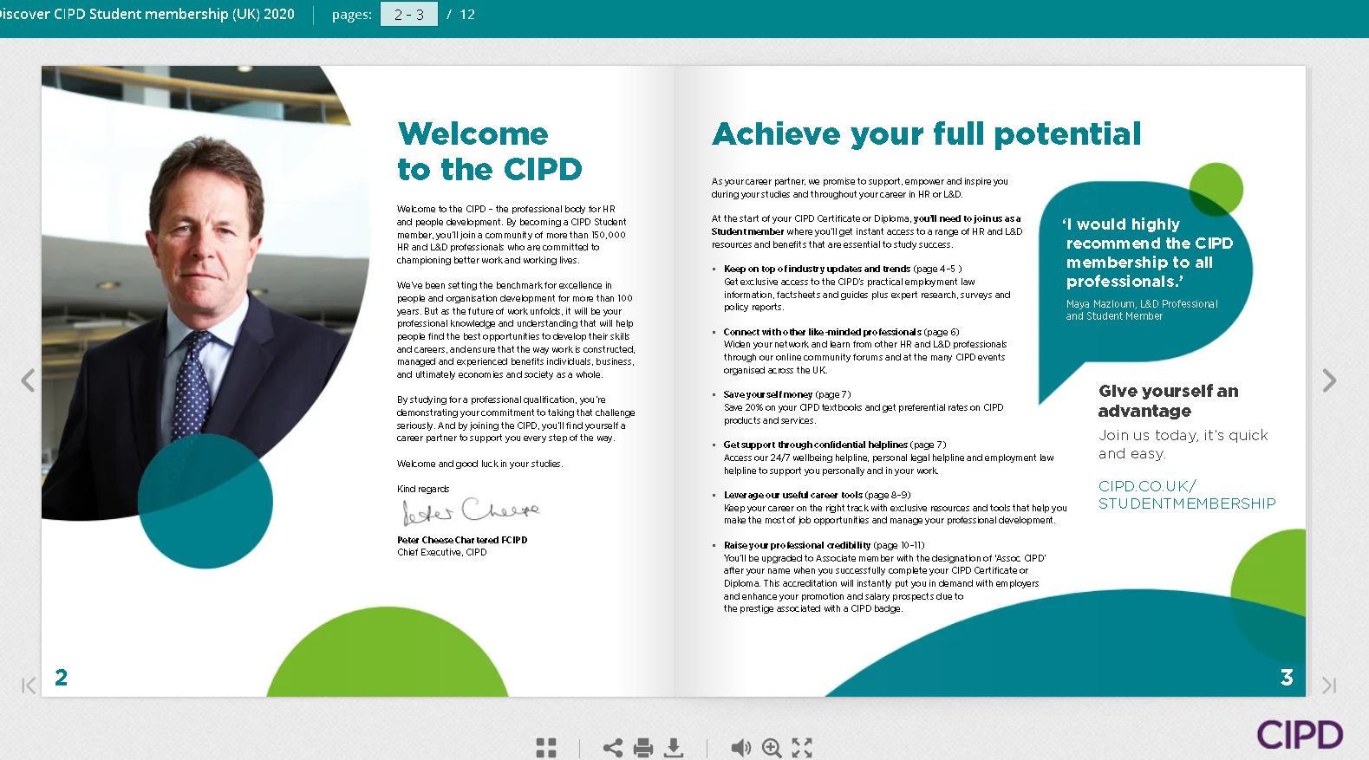

EV2

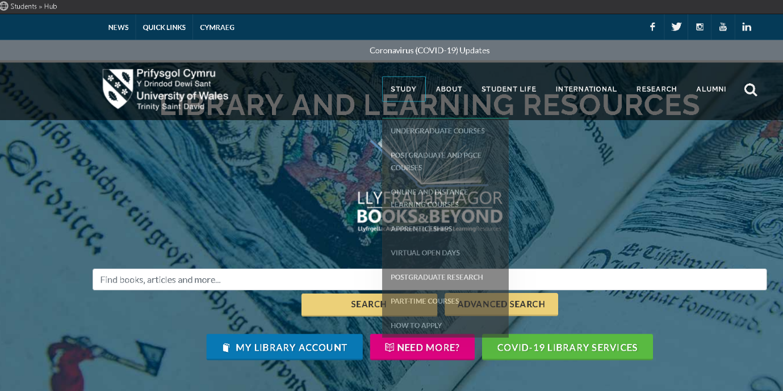

EV3
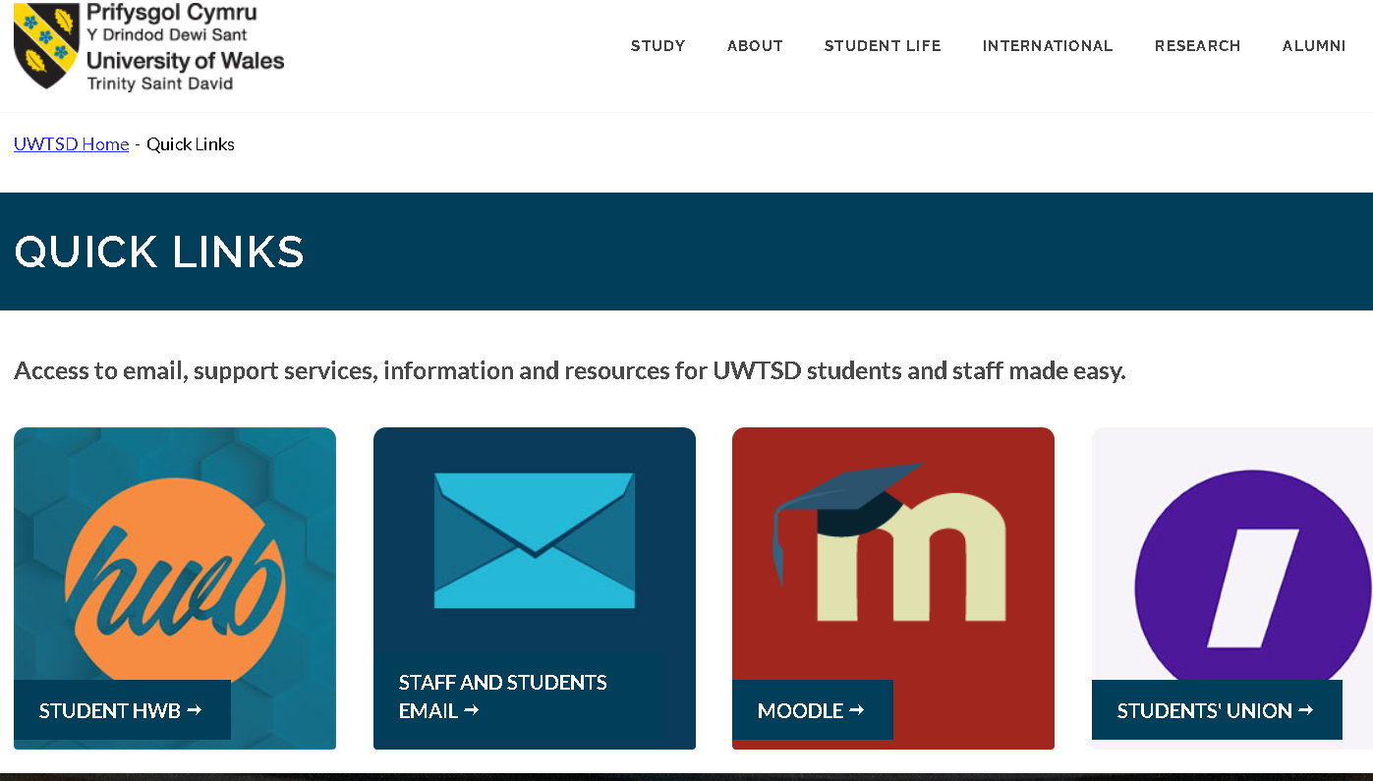

EV4

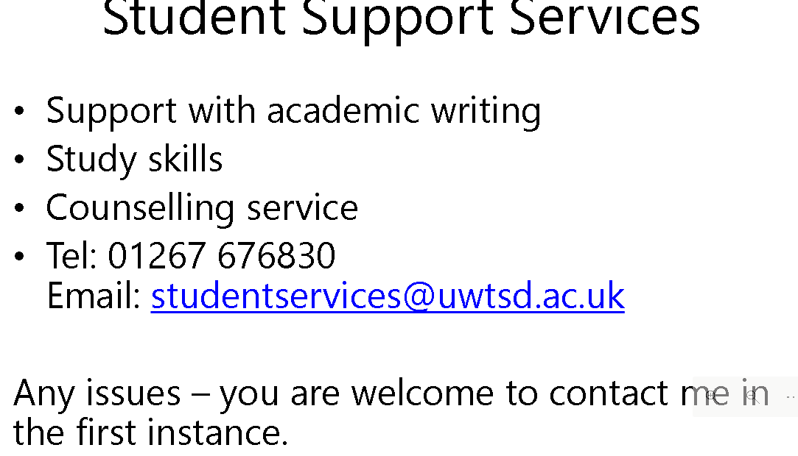

EV5
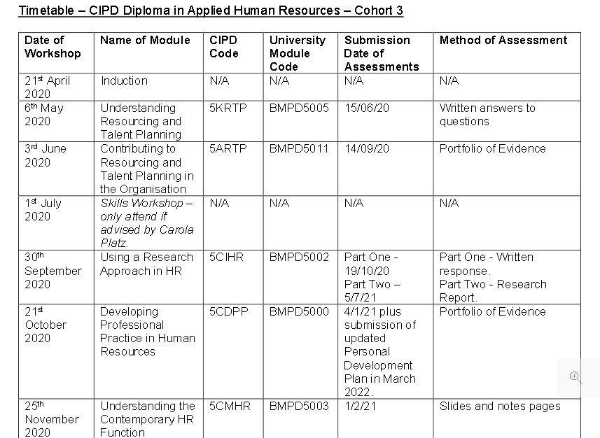

EV6

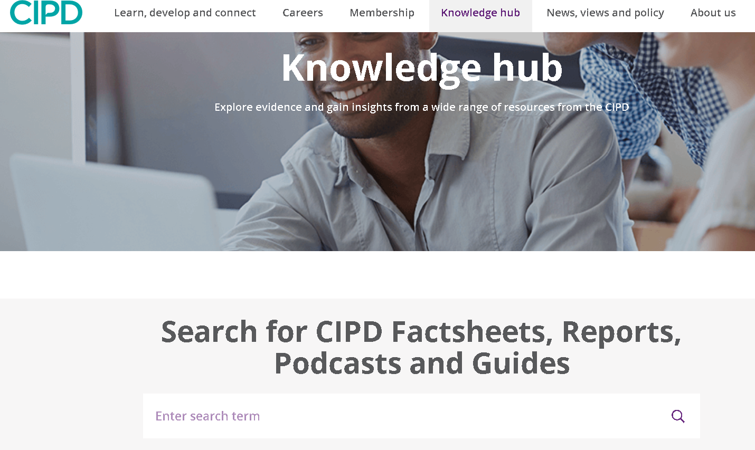

EV7

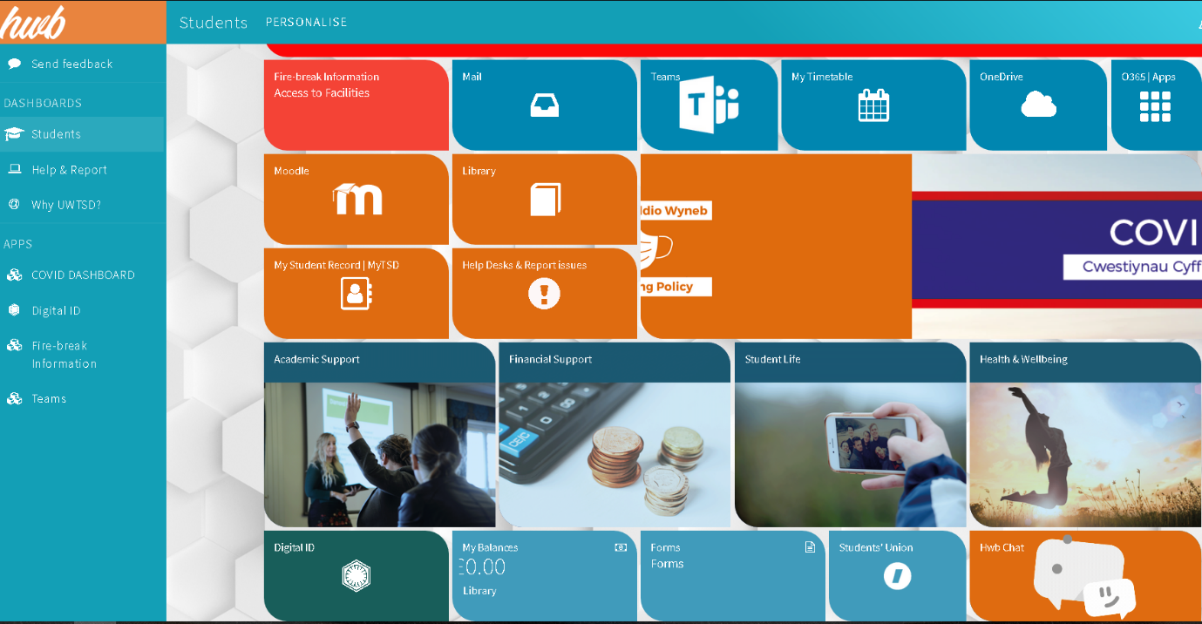

EV8

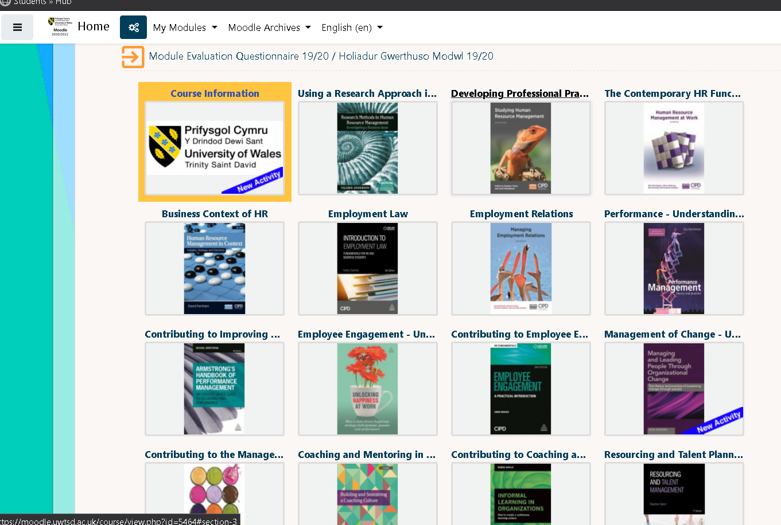

EV9

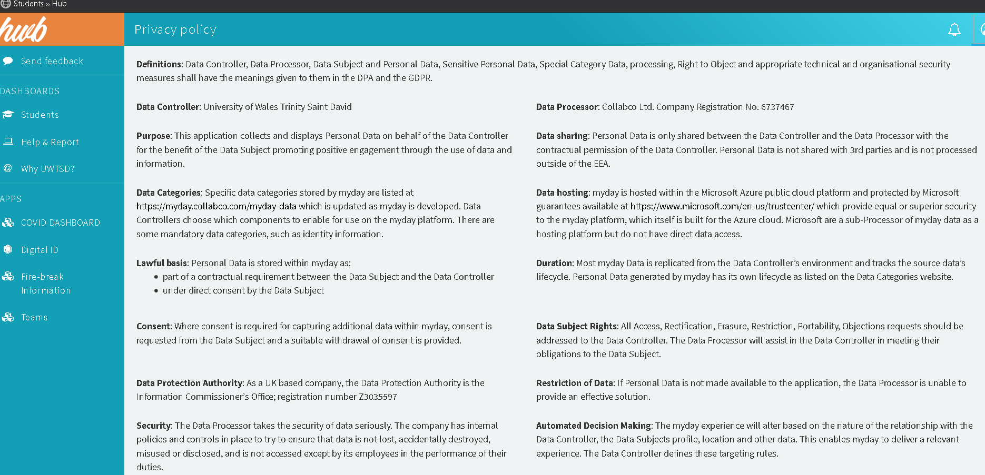

EV10

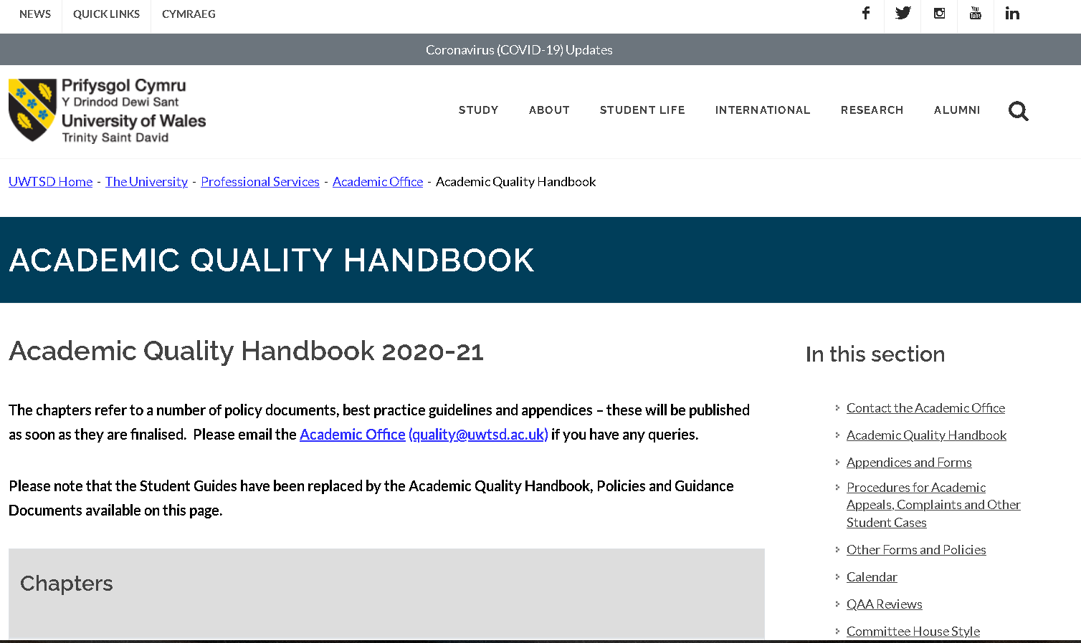

EV11
Induction Questionnaire
Diploma in Applied Human Resources
April 2020

 | Question | Answer
1. | When, where and at what time will the course be delivered? | Coleg Sir Gar, Pibwrlwyd campus. 9.30am on the specified dates
2. | How many modules form part of the programme? | 16
3. | What are the term dates for this year? | 20/4/2020-10/7/2020.
4. | What is Moodle? | The learning platform
5. | What is Eduroam? | Free on-site WIFI.
6. | What is Turnitin? | Upload the documents when completed for tutors to mark.
7. | Do you know when you are required to hand in work? | Yes, on the timetable clearly stated
8. | What are the core texts for this programme? | Human Resource Management: People and organisations  Studying Human Resource Management.
9. | Do you know how to access the library catalogue? | Quick links
10. | Do you know who to go to if you have a question/concern about the course? | Julie Thomas
11. | What is the name of the Training Adviser? | Carola Platz
12. | What is the name of the course lecturer? | Julie Thomas
13. | Will you be expected to complete work outside lessons? | Yes
14. | Do you need to be a member of the CIPD? | Yes
15. | What support is available for study skills? | Learning library and Student Services
16. | Do you know where the fire-exits and first aid points are for the building? | N/A until September 2020.
17. | How many credits is the programme? | 90 credits
18. | What is the length of the programme? | 2 years March 22 end
19. | Do you know where to find the student handbook and timetable? Where? | Yes hwb – Moodle
20. | What academic level is this qualification? | Level 5 diploma

References

http://www.explorehr.org/articles/HR_Planning/Key_Components_of_Human_Resource_Development.html

Code of professional practice, available at; -
https://www.cipd.co.uk/Images/code-of-professional-conduct-april-2020_tcm18-14510.pdf

CIPD membership guide
https://www.cipd.co.uk/membership/grades/student

Student code of conduct available at: -
file:///D:/Chloe%20Work/Course%20Info%20+%20induction/Student%20Code%20of%20Conduct.pdf

Turn it in guidance available at; -
file:///D:/Chloe%20Work/Course%20Info%20+%20induction/Student%20Turnitin_201415_Moodle.pdf

Term timetable available at; -
file:///D:/Chloe%20Work/Course%20Info%20+%20induction/Timetable%202020%20Cohort%203%20and%204.pdf

Activity 2

The HR Role is built around integrity, transparency, and trust. People professionals need to be seen to champion ethical practices and work with the wider business to ensure the best possible outcomes for people throughout. HR professionals should role model ethical practice.

Making difficult decisions quickly and under pressure is a risk factor for unethical behavior. Individuals must take an ethical approach for the best possible outcome. Business are under pressure and will be likely to be publicly scrutinised and called out when they behave unethically. Social wellbeing is a focus. HR professionals need support from leaders to create practices that support their workforces especially in unprecedented times (CIPD, 2020)

Companies strive to have a culture, which in turn, improves morale. Good relationships with customers lead to an ethical reputation. This will enable companies outperform their piers financially in the long term (CIPD, 2020). The success of organisations relies on trustful relationships with employees, suppliers, customers, and community.

The ‘say/do gap’ can cause serious risk when leaders say one thing but do another. This is detrimental and can cause employees to be disengaged. HR professionals play a part in ensuring an organization’s ethical values and expectations are set out to enable employees to reflect this in their behaviors.

The CIPD Profession Map has been designed to guide the HR professional in relation to activities, knowledge and behaviors needed for success. The map has four bands. These bands define the contribution that professionals make at every stage of their HR career.; -

- The Client relationship that the HR professional have
- The activities that need to be performed by the Professional
- Where the time is spent
- Client services
- How to measure success

Band One – This band is a support mechanism for processes of administration, the individual would customer orientated data and information.

Band Two – Would give advice on HR related issues in the HR function and would have some knowledge/understanding of solutions available.

Band Three – Consultant or Partner in this field and would address HR challenges in the long-term

Band Four – Would be a leader in a specific professional area(s) and would take responsibility for all HR strategies development and delivering.

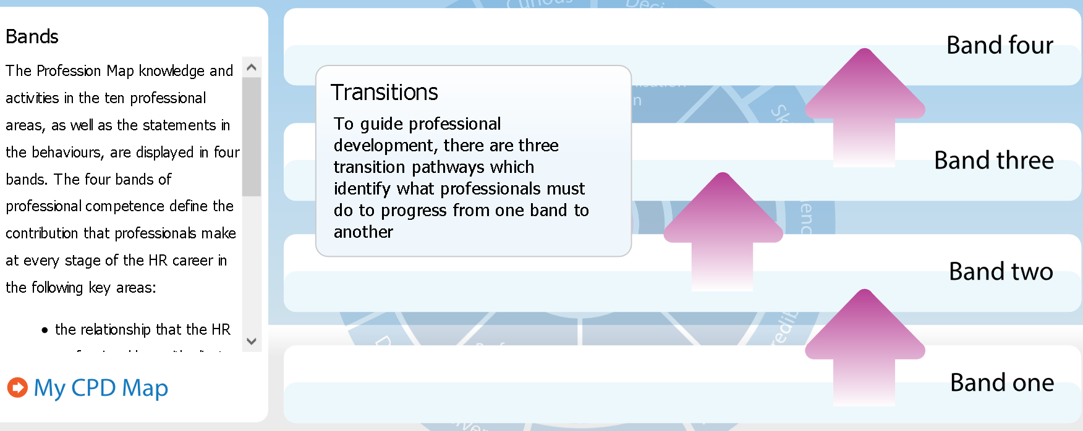

A ‘professional’ is someone that completes their job role to a high standard. HR has many dimensions. There are many elements that can be summerised to concentrate on as the ‘four concentric circles of HR professionalism’: - (Taylor and Woodhams, 2017).

- Managing Self – Managing your own skills, knowledge, and behaviors.
- Managing in Groups/Teams – To be able to network in tams or groups, working with other HR professionals to brainstorm solutions.
- Managing Upwards – To be able to work with senior professionals within organisations. To be able to implement specific strategies and plans with the wider organisational strategies.
- Managing across the organisation – To be able to set plans in motion across the organisation. Influence and communicate to Line Managers. Promote the benefits that can arise from successful cooperative HR activity.

The CIPD Profession Map states that there are ten professional areas set out in four bands of competence. These set out activities and knowledge for each area. Insights, strategy, and solution sit at the heart of the Map. There are Eight areas that identify what activities and knowledge needed to provide specialists HR support (CIPD, 2020)

The Eight behaviors within the CIPD Profession Map detail how to carry out activities and/or make contributions for success. Each behavior has been described within the four bands of competence. Within each behavior there is a contra-indicator illustration of negative manifestations. This will enable everyone to identify what good looks like and recognise the behaviors that are hindering development. The eight behaviors are – (CIPD, 2020)

- Driven to Deliver - Demonstrates determination, resourcefulness, and purpose.
- Courage to Challenge - Shows courage and confidence to speak up skillfully, challenging others even when confronted with resistance or unfamiliar circumstances
- Role Model - Consistently leads by example. Acts with integrity, impartiality, and independence, balancing personal, organisation and legal parameters.
- Curious - Is future-focused, inquisitive, and open-minded; seeks out evolving and innovative ways to add value to the organisation.
- Decisive thinker - Demonstrates the ability to analyse and understand data and information quickly. Uses information, insights, and knowledge in a structured way to identify options, make recommendations and make robust, defendable decisions.
- Skilled influencer - Demonstrates the ability to influence to gain the necessary commitment and support from diverse stakeholders in pursuit of organisation value.
- Personally credible - Builds and delivers professionalism through combining commercial and HR expertise to bring value to the organisation, stakeholders and peers.
- Collaborative - Works effectively and inclusively with a range of people, both within and outside of the organisation.

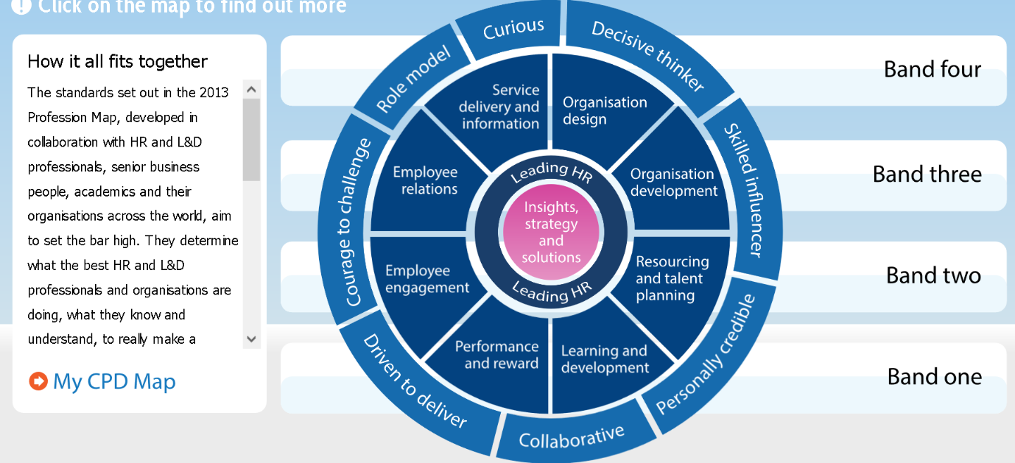

The behaviors set out from the Profession Map are essential to a HR Professional as it provides the individual ‘with the strongest foundation yet for effective decision making’. The behaviors outline ‘what it takes to be an effective People Professional in an uncertain world of work’ (salestrainingint.com, 2020). I believe the CIPD Profession Map is a continuous ongoing development tool which can be used in all stages of professionalism during a career. It provides the tools to improve personal challenges and/or provide you with knowledge and strategies to influence constructively and confidently. In an ever-changing high-pressured environment, the behaviors set out in the CIPD Profession Map, including the self-reflection tool keep values at the heart of any decision making and strive to encourage the practice of ethical principles. This will encourage the Professional to behave, act and champion better working environments.
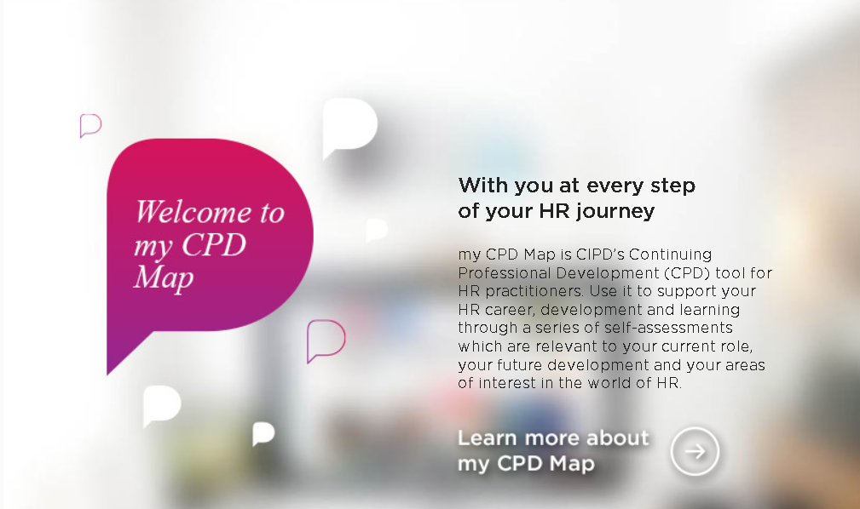
(Screenshot of PDP tool, 2020)

References

CIPD Profession Map available at; -
https://www.cipd.co.uk/learn/career/profession-map

Corona virus and the workforce – doing the right thing, available at: -
https://www.cipd.co.uk/news-views/changing-work-views/future-work/thought-pieces/coronavirus-workforce-crisis

CIPD 8 behaviors of the successful HR professional available at; -
https://www.salestrainingint.com/wp-content/uploads/2019/02/CIPD-8-behaviours-of-the-successful-HR-professional1.pdf

Taylor, s. (2017) 'chapter 4', in Perkins, G. (ed.) Studying Human Resource Management. Great Briton: CIPD, Pg. 75-78.

Activity 3
To be able to manage self and workload to meet performance requirements there is a non-exhaustive list of when and what needs to be Project Managed. Project Management can be used in everyday life but is more commonly used in the world of work. (Horn, 2009) considers using a Work Breakdown Structure (WBS).
- How long will something take?
- How much time will it take in hours to complete the work?
- Who is doing each task?
- What resources are needed?

Project Managing can seem overwhelming for an individual but should be broken down into a manageable structure. An example of this could be -
- Task Description
- Research
- Brainstorming
- Structure
- Using time effectively is key. There are 168 hours in one week. Time planning plays an integral part of achieving. The common goals of High achievers are -
- Set one Goal, achieve then move to the next goal
- Start with small steps
- Avoid negativity, e.g., not enough time.
- Dream about the benefits, visualise your goal.
- Be enthusiastic when talking to others
- Find inspiration – Talk to others that have been successful (success breeds inspiration)
- Think about your main goals daily – (what can I do to achieve that goal today)
- Create support networks
- Understand your own ebb and flow – find the best time for you to work and plan most of your workload/tasks to coincide with your most effective periods of time
“To be successful you need to develop effective habits early in your studies and career. Poor organisation will interfere with the quality of degree you achieve and slow your promotion at work.” (Horn, 2006)

There are four basic steps in solving a Problem: -
- Defining the problem
- Generating alternatives
- Evaluating and selecting alternatives
- Implementing solutions
“Problems are opportunities in work clothes” (Henry Kaiser, American industries)
Assertiveness is integral to Problem Solving which involves; - (Chris Rogers, 2020)
- Using opinions in an appropriate manner
- Being comfortable to ask for help
- Can say “no” to others but come to a compromise
- Make eye contact
- Be a good listener and equally other people listen to what you have to say
Morrisons were due to announce a managerial restructure on 23rd January 2020 to all Managers in the business to streamline managerial posts throughout the company with a potential loss of 3000 jobs. The business called all Store Managers and People Managers (stakeholders) to Head office in Bradford at the beginning of January 2020 to inform, plan and implement the stages to enable correct process and project management of the task. (Setting and prioritizing goals) The details were embargoed to enable all relevant materials and time planning to be put in place. The company stated what day the announcement was to be made and all the Management team needed to attend so a consistent message was relayed (Define Deliverables). Each manager affected needed an individual consultation meeting following the announcement to be informed of how the changes would affect their roles. The restructure was proposed with a 45-day consultation to all Team and Senior Managers in which period several follow on meetings commenced with the managers. The new management roles were due to commence on the 30th March 2020, (EV8) and all managers affected needed to have a clear understanding every step of the way. Time planning was essential to this major activity with very strict timescales. Brainstorming with the Store Manger on an hourly/daily basis continued throughout the whole process (creating the project schedule). Remaining positive through the process, continuing to be professional while implementing the change I focused on the goal that needed to be achieved.

The restructure was implemented successfully. Listening and responding was integral during the restructure and planning time around the needs of the business and adapting to adhoc meetings requested meant reorganising the daily diary to coincide with the Store Manager frequently.

During the managerial restructure, the Covid-19 pandemic arose having a dramatic impact on the business. The company took the decision to postpone the restructure until the 1st June 2020 delaying the effective date of the new structure by 8 weeks (EV8) this in turn added more consultation meetings for all effected managers (EV8). The ‘lockdown’ announced on the 23rd March 2020 by the government enforced the ceasing trade of all fresh food departments, Bakery, Deli, Oven fresh, Fish Counter, Butchery Counter and Customer Café. The enforcement of department closures required an immediate action plan to plan where the workforce from those departments were required most. Internal planning meetings were held daily within the management population with colleagues being deployed to work in other areas of the store on a temporary measure.
Defining the problem - this was to establish how to communicate with all affected colleagues and to inform of what department the business required resource.
Generating alternatives, Evaluating, and selecting alternatives and Implementing solutions – All affected colleagues were given the opportunity to change their working pattern to suit the needs of the business. This consisted of a reduction of days/hours that would suit both the individual and the business and understanding what the colleague’s abilities were to ensure that they were selected for a department best suited to their strengths. The main goal for the business was to continue to trade through troubling times. The change for the business was actioned within a matter of days through shoulder-to-shoulder shop floor communication. Many brainstorming meetings with the Store Management team were held and networking with other branches across the company via video messaging took place.

When reviewing the RHRP (ev) tool for planning and resourcing I discovered that the Fresh Food Department had too much resource. To meet the business needs a colleague was required to move to a different department within the business. I had identified a colleague on a full-time contact for the possible move required. A meeting was organised with the Line Manager for the Department. At the meeting I explained the desired outcome to meet the business need and why the colleague was selected for the move. A further meeting was arranged with me, the Line Manager, and the colleague. I applied a ‘Win Win’ technique (mindtools, 2020). My aim was to find a compromise with the colleague that suited their individual needs within the business model. I fully explained the rationale to the colleague and gave them an opportunity to ask questions. I listened and responded with empathy while outlining the reasoning. The colleague was given a timescale to respond to the request where another meeting was scheduled. At the meeting, the colleague agreed to the department move. The negotiation was successful for both the colleague and the company.
“The gap between desired change and achieved change can be down to a failure to recognise the hidden, messy, and informal dynamics of complex organisational life. Deliberate, informed engagement with these inevitable, informal coalitions is a leader's only meaningful choice” (Chris Rogers,2006)

EV12
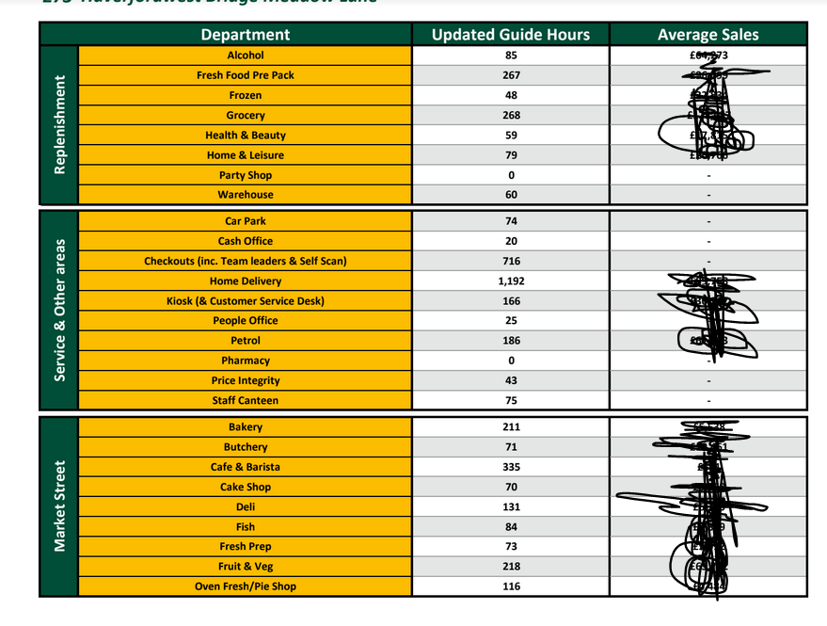

EV13
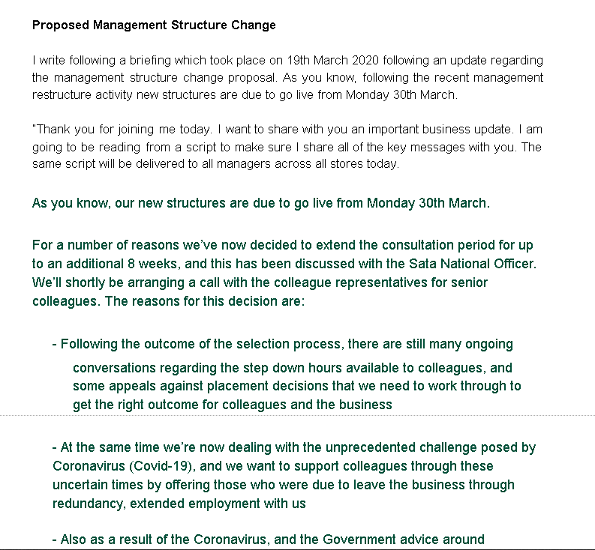

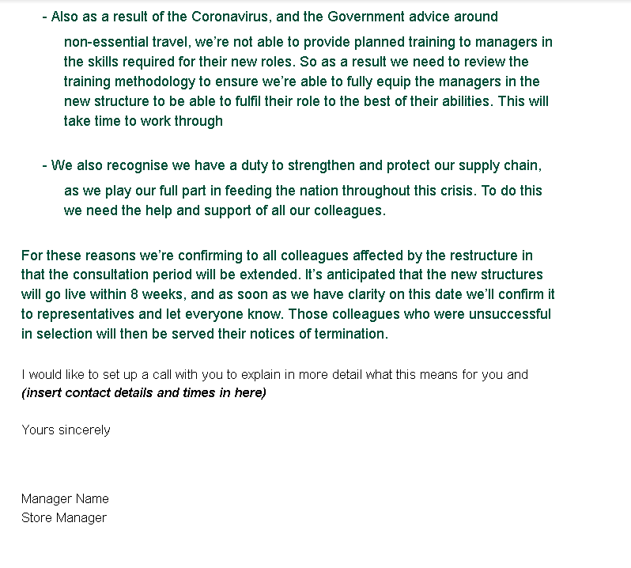

EV14
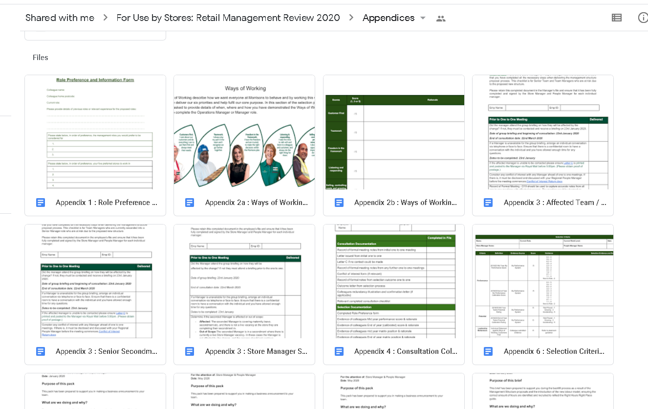

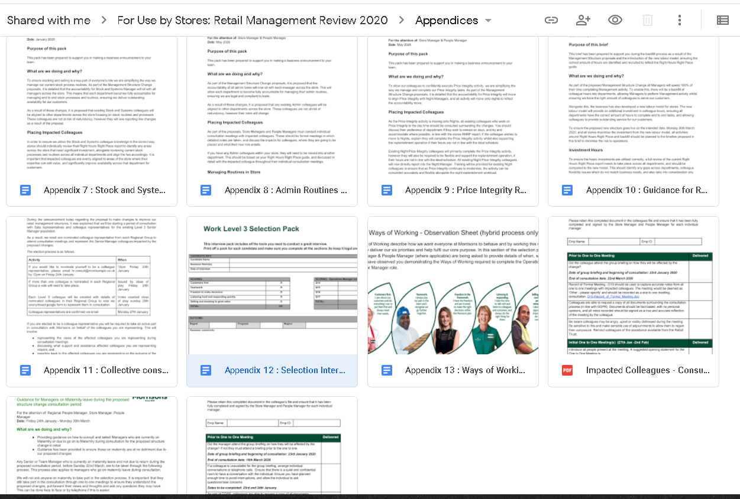

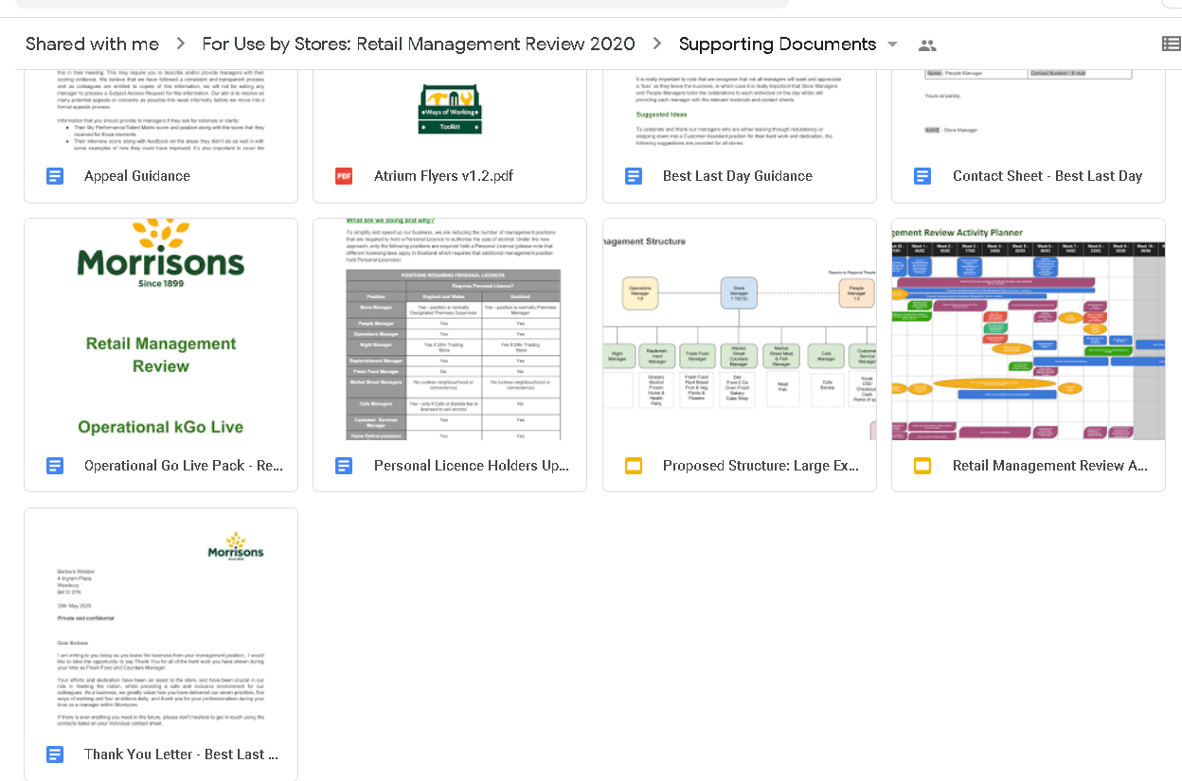

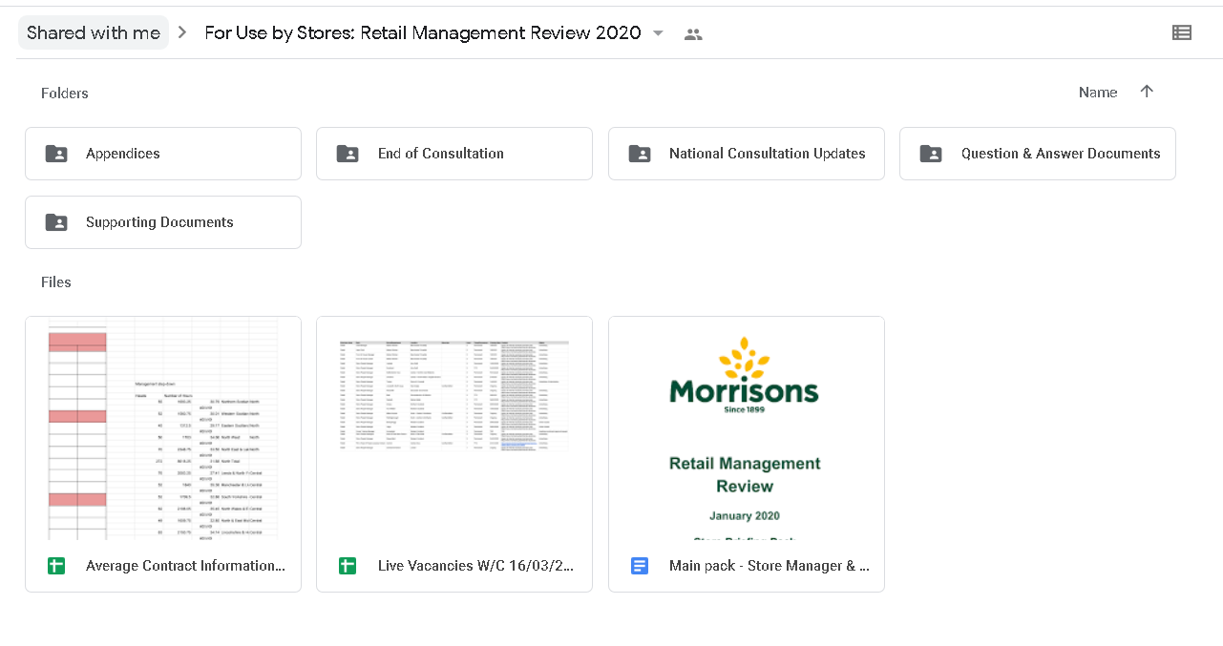

References

Roy horn sample available at; -
file:///D:/Downloads/business-skills-handbook_horn_9781843982180_c01.pdf

What is problem solving? Available at; -
https://www.mindtools.com/pages/article/newTMC_00.htm

Informal Coalitions article available at; -
https://moodle.uwtsd.ac.uk/pluginfile.php/204899/mod_resource/content/1/INFORMAL_COALITIONS_-_RE-ISSUE.pdf

Activity 4
Group dynamics is a set of behavioural and psychological processes that occur within a social group or between groups. It refers to the "nature of groups, the laws of their development, and their interrelations with individuals, other groups, and larger institutions" (Cartwright and Zander, 1968).
Group leaders and team members can contribute to a negative group dynamic (Mindtools, 2020)
- Weak leadership: This team man does not have a clear leader and often a strong member of the team will naturally take the lead. It may cause lack of focus and direction or to focus on the wrong points
- Excessive deference to authority: Colleagues may want to ‘People Please’ the leader and agree with every suggestion, therefore not having their own opinion.
- Blocking: Team members can be disruptive. Such as:
  - The aggressor: this person often disagrees with others or is inappropriately outspoken.
  - The negator: this group member is often critical of others' ideas.
  - The withdrawer: this person does not participate in the discussion.
  - The recognition seeker: this group member is boastful or dominates the session.
  - The joker: this person introduces humour at inappropriate times.
Free riding: some group members may make no contribution and have a lack of or no input. Free riders tend to work hard on their own but limit their contributions in group situations; this is known as "social loafing."
Evaluation apprehension: Perceptions can also create a negative group dynamic. Members can feel self-conscious, therefore not contributing from embarrassment.
To strengthen your team's dynamics, these strategies may be useful.
- Know your team.
- Tackle problems quickly with good feedback.
- Define roles and responsibilities.
- Break down barriers.
- Focus on communication.
- Pay attention.
Observing how your group interacts is an important part of your role as a leader. Many of the behaviours that lead to poor dynamics can be overcome and resolved at the earlier stages (mindtools, 2020).
Psychologist Bruce Tuckman developed a model that is widely used. It describes elements of group dynamics. There are five stages in the model. The first four were written and developed in 1965 with the fifth being added in 1977 (toggl.com, 2020). The example of the stages is described below; -
Forming Stage
A newly introduced team, all are pleasant and well mannered. It can be very exciting to start a new project. The first meeting format could be.
- Member’s skills, background, and interests
- Project goals
- Timeline
- Ground rules
- Individual roles
When the group familiarise themselves, roles and responsibilities will begin to form. It is crucial for team members to develop relationships and understand what part each person plays for clear understanding going forward.
At this stage, the team is more likely to get to know each other and productivity would be low.
Storming Stage
The storming stage can be a daunting as the size/need of the project/task this can be clearer. Self-doubt can creep in which can snuff out the excitement and politeness. This can also be interpreted as the Danger Zone” (Tesco, 2013)
Many personalities my not see eye-to-eye and there could be disagreement on how to complete tasks. Will call out team members if they think they are not contributing enough. Sometimes, the Group Leader is questioned over their leadership style.
It is important to remember that this is normal and most groups experience conflict. Members of the team/group need to understand that this behaviour/feeling is normal.
Conflict is a natural occurrence; however, some teams try not to acknowledge this stage. This avoidance usually makes the problem escalate until it is unmanageable later. Best practice is to recognise conflicts and resolve them as soon as they arise.
Norming Stage
Strengths of team members become recognised and appreciated. The team starts to settle. All members are contributing and working unitedly.
Storming has been known to be part of the norming stage. When a new task arises, it can unbalance the team and provoke a little conflict. It can be easier to address this if you have dealt with minor conflicts at the previous stage.
Performing Stage
The team is motivated which brings confidence and familiarity. The team will most likely have very little guidance/supervision. Everyone is like minded and driving towards the goal set at the beginning.
The performing stage is what all groups strive to reach. Conflict can make teams fail if it is not overcome and therefore do not make it to this stage.
Adjourning Stage/Mourning
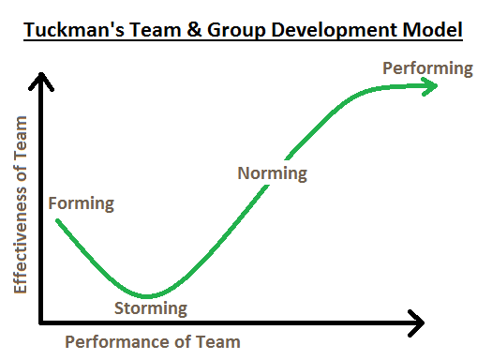
Tuckman added a fifth stage called adjourning in 1977. When a project comes to close, the team disbands. It can also be known as mourning. Teams grow close and can feel a loss when the experience has been completed to the full.

I have worked with a successful team within Morrison’s delivering a ‘Service Success’ presentation aimed at Customer Service Managers from 24 Stores. I quickly realised when preparing for the presentation that leading a group of professionals to the same goal was going to have characteristics of the Bruce Tuckman model.
Forming - I led a team of 4 People Managers. We met to discuss the aim and to delegate roles and responsibilities that the individuals were to have. Each Manager contributed and delivered a different part during the presentation.
Storming – One People Manager was not happy with their role, we discussed what the reasons for this were. We came to a compromise within the group and negotiated a different role. The pressures of the time constraint contributed to the storming stage. This was resolved with a clear time scale for each module.
Norming – We met to confirm the content of the presentation and were happy with the content that each member had contributed.
Performing – A video link meeting was held to share content for the final draft of presentation. The presentation was successfully delivered on time.
Adjourning – The presentation was a success; the team were happy with the result. There was sadness that the project had ended when the team disbanded to enable them to focus on other projects within the business.
Recognising Group Dynamics and Group Behaviours will strengthen and benefit any organisation. Organisational politics are a natural result of the fact that people think differently and want to act differently (Hrmars, 2020). It is important to point out at every stage that this process is ‘normal’. The HR professional is integral to this. Coaching /guiding and formal training is an imperative role within the business and will contribute to drive success throughout.

References

Effect of Organizational Politics on Organizational Goals and Objectives, Available at; -
https://hrmars.com/papers_submitted/1877/Effect_of_Organizational_Politics_on_Organizational_Goals_and_Objectives.pdf

Improving Group Dynamics available at; -
https://www.mindtools.com/pages/article/improving-group-dynamics.htm

Five Stages of Team Development -Understanding team development process Available at;-https://toggl.com/track/stages-of-team-development/

Group Dynamics: it’s characteristics, stages, types, and other Details | Management available at; -
https://www.yourarticlelibrary.com/management/group-dynamics-its-characteristics-stages-types-and-other-details-management/5363

Activity 5
Band two
The CIPD profession state that; -

Advises on and/or manages HR related issues relating to an individual or a team. Has a clear understanding of the evaluation process and the solutions available.

The standards set out in the 2013 Profession Map, developed in collaboration with HR and L&D professionals, senior businesspeople, academics, and their organisations across the world, aim to set the bar high. They determine what the best HR and L&D professionals and organisations are doing, what they know and understand, to really make a difference and drive the performance of the organisation.
Covering 10 professional areas and 8 behaviours, set out in 4 bands of competence, the Map covers every level of the HR profession, from Band 1 at the start of an HR career through to Band 4 for the most senior leaders.
It has been designed to be relevant and applicable to HR professionals operating anywhere in the world, in all sectors and in organisations of all shapes and size
Insights and Strategy - Develop understanding of the organisation and its context and use these insights to tailor strategy and solutions to meet organisational needs now and in the future.

Leading HR - Act as a role model leader, maximising the contribution that HR, or your specialist function, makes throughout the organisation both through your own efforts and through supporting, developing, and measuring others across the organisation (CIPD, 2020).

Personal Evaluation; -
As a People Partner to the Store Manager in retail, I have undertaken a self-assessment against the CIPD Profession Map 2013. I have set this against the benchmark to become a high performing HR Professional with personal integrity and professional knowledge. EV20
The two behaviours I have identified as my opportunity are: -
- Skilled Influencer - Demonstrates the ability to influence to gain the necessary commitment and support from diverse stakeholders in pursuit of organisation value.
- Courage to challenge - Shows courage and confidence to speak up skilfully, challenging others even when confronted with resistance or unfamiliar circumstances

The two core Professional areas identified as my opportunities are: -
- Performance and Reward -Help create and maintain a high-achieving organisation culture by delivering programmes that reward and recognise key employee capabilities, skills, behaviours, experience, and performance, and ensure that reward systems are market-relevant, fair and cost-effective
- Employee Relations - Ensure that the individual and collective relationship between the organisation and its employees are managed appropriately within a clear framework underpinned by organisation culture, practices, polices and, ultimately, by relevant law.

Select and justify different options for professional development.

I have chosen Performance and reward as my focus. It is an area of self-development that is currently necessary to develop the Management Team. It will benefit the organisation and improve the overall performance of the store. My aim is I can coach and guide the Management team to be more engaged and that they will see that there is a correlation between Performance Reward and culture. Coach mangers to sustain strategy and goals.

Employee relations is where my knowledge gap lies. Company policies are fully understood; however, legislation and law are minimal. To know and access relevant law in local and international jurisdictions and what the organisation needs to do. Understanding employment law will benefit the company and the employees to ensure the Management Team are coached in the correct manner. Tribunal claims would be prevented which could damage the company’s reputation and brand. It can also be very costly to the business. Consistency and fairness to employees is imperative.

Skilled Influencer My aim is to not overthink interactions and meetings and to prepare adequately. To understand different people and adjust my own behaviour to manage impact on others.

Courage to Challenge This development area shares areas of development with Skilled influencer. My aim is to have confidence in my own knowledge, abilities, and judgements especially when coming in to contact with peers.

EV20
Personal Development Plan (PDP)
Name | Chloe Phillips | Membership No. | 56803356
Covering Period From | December 2020 | Covering Period To | March 2022

What do I want/Need to Learn? | What will I do to achieve this? | What resources or support will I need? | What will my success criteria be? | Target dates for review and completion | Evidence of achievement and reflection.
Insights and Strategy. Expand knowledge on Employment Law | CIPD Level 5 Diploma.  Take active part in grievance and appeal hearings. Read ACAS Codes of Practice. Shadow/Note take for extensive knowledge in this field.  Use company training materials | Attend tribunals held in area. Establish Relationships with ER Head Office teams. Use of company training materials and toolkits. College lecturer. Online resources. | Qualification of CIPD level 5. Successful outcomes in Grievances and Appeals. Confident with Knowledge. Being able to Coach and guide others in this area. | March 2022
Insights and Strategy. Expand knowledge on Performance Management | CIPD Level 5 Diploma. Company training materials and toolkits. Take an active role in performance conversations with the Management team. | CIPD Level 5. Online resources. Networking with fellow PM. Company materials. Webinars, podcasts, and literature | Successful outcomes within performance Management within the Management Team. Confidence in my ability/knowledge | March 2022
Leading HR. Expand my knowledge on Influencing Skills. | CIPD Level 5. Take an active role in Regional Meetings and conference calls, force myself out of my comfort zone | Networking with Experienced PM/RM. Literature, podcasts. Company materials/toolkits | Full confidence and belief in my own knowledge to deliver to the wider team. Fully engaged Management team. | March 2022
Improve Coaching and Influencing skills | CIPD Level 5. Take an active role in Regional Meetings and conference calls, force myself out of my comfort zone | Networking with Experienced PM/RM. Literature, podcasts. Company materials/toolkits | Full confidence and belief in my own knowledge to deliver to the wider team. Fully engaged Management team | March 2022
Improve confidence. Have the confidence to challenge especially around peers. | CIPD Level 5. Read literature. Force myself to introduce self to industry leaders. Practice with Regional Manager asking for advice. | Networking with Experienced PM/RM. Literature, podcasts. Buddy up with experienced Store Manager arrange visits and, on the spot, questions coping techniques for nerves. | I will be seen to introduce myself with confidence to industry leaders and be confident in my ability. | March 2022
Improve Performance and Reward engagement within the Management Team | Create value added bitesize sessions around P&R, culture engagement. Monitor the Annual Review completion. | Company toolkit.  Store Manager Buy in – Booked in time slot in the weekly Managers Meeting – video clips – CIPD worksheet | Engaged colleague who feel valued and cared for. A two-way communication between colleague and Manager. Colleagues are heard. | March 2021

I have marked myself against h Honey & Mumford learning styles questionnaire (EV21) where I recognise that my style of learning is ‘reflector’. I am self-aware of my learning style, see below; -

My answers are highlighted in yellow.

EV20
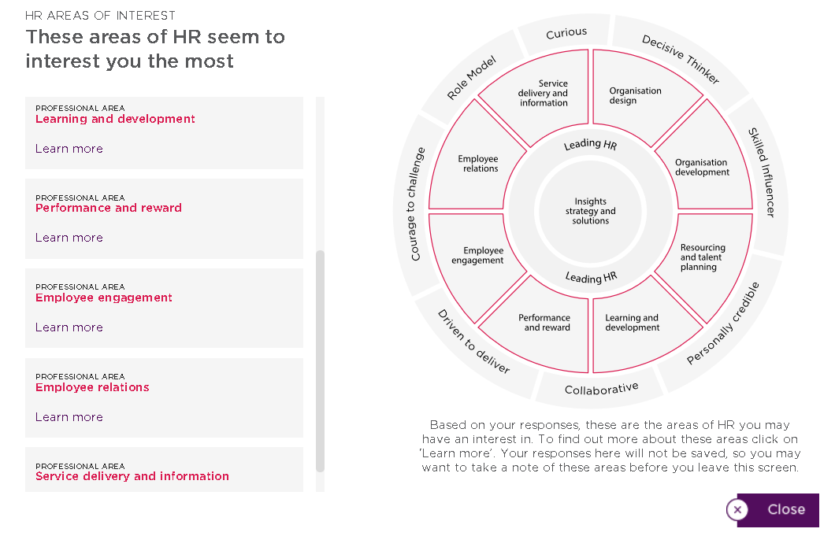

EV21

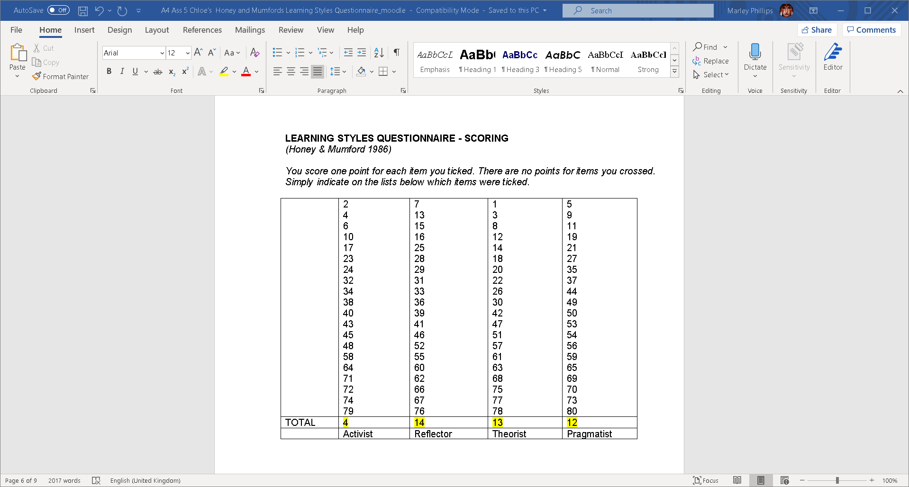

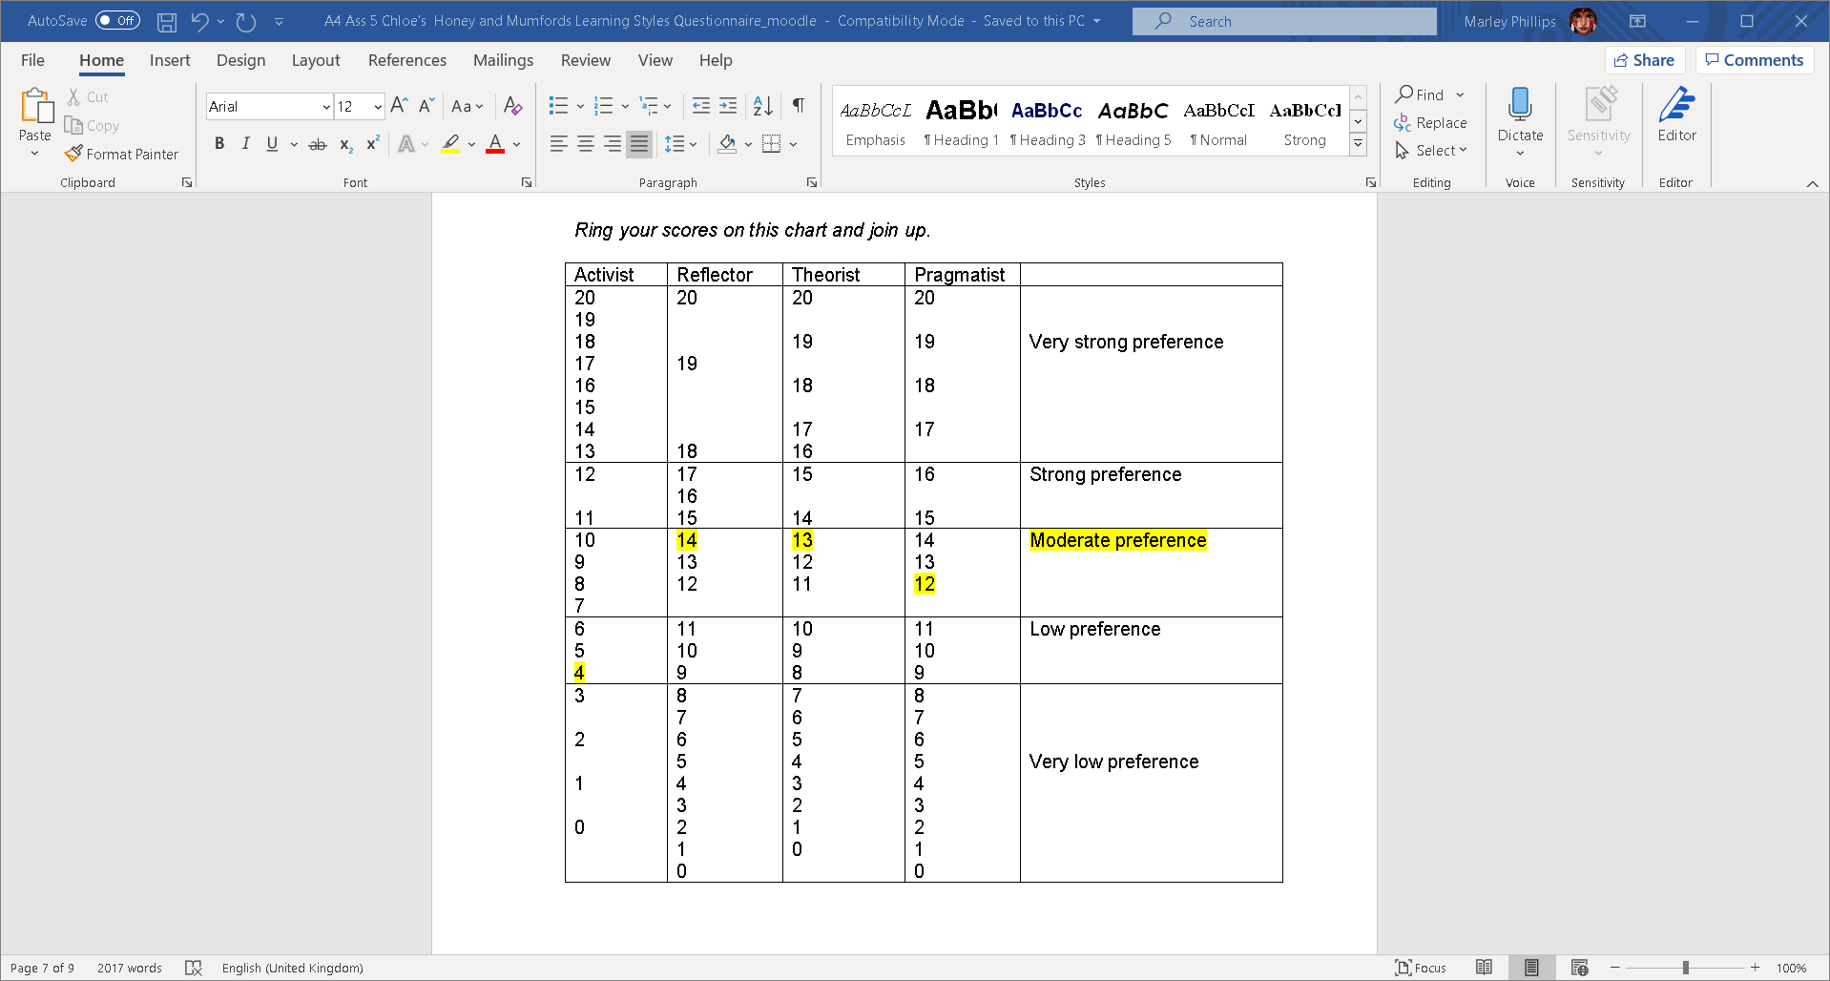

References

CIPD Profession map available at; -
https://www.cipd.co.uk/learn/profession-map

