

Applied Computing

Wales Institute of Science and Art (WISA)

Advanced Networking (ACCA5024)

Lab 8: Static Routing



n.kaliyamurthy@uwtsd.ac.uk 1

Design the topology and execute basic configuration as stated below
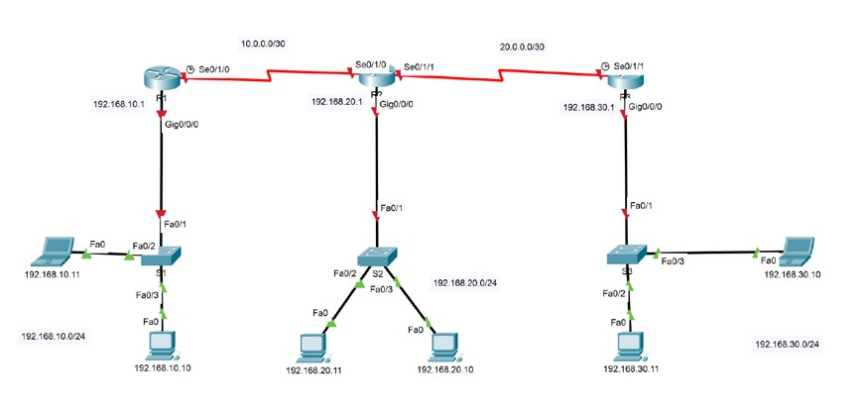
Refer to the above topology for addressing information.
Tasks:
- Set Up the Topology and Initialize Devices
- Configure Devices and Verify Connectivity
Assign static IPv4 information to the PC interfaces.

Configure basic router settings. (Refer to our previous labs. Basic Configurations includes hostname, passwords, line configurations, device security, domain lookups, banners)

Configuring your network with complete information is highly recommended.

Verify network connectivity.

- Configure IPv4 Address for all the router interfaces.
R1 = 192.168.10.1
Se 0/0/1 10.0.0.1
R2 = 192.168.20.1
Se 0/0/1 10.0.0.2
Se 0/0/0 20.0.0.1

R3 = 192.168.30.1
Se 0/0/0 20.0.0.2

Configure loopback address (Lo1) as 50.50.50.50/32 at Router R2.

On R1, R2 and R3 configure IPv4 static route to connect other networks. Do not include Lo1 network.
R1 –
20.0.0.0/8 [1/0] via 10.0.0.2
192.168.20.0/24 [1/0] via 10.0.0.2
192.168.30.0/24 [1/0] via 10.0.0.2
R2 –
192.168.10.0/24 [1/0] via 10.0.0.1
192.168.30.0/24 [1/0] via 20.0.0.2
R3 –
10.0.0.0/8 [1/0] via 20.0.0.1
192.168.10.0/24 [1/0] via 20.0.0.1
192.168.20.0/24 [1/0] via 20.0.0.

Configure default static route to reach Lo1 network using next-hop ip address at R1

Configure default static route to reach Lo1 network using exit interface at R3

Interpret the output from the routing table.

Verify the status of the interfaces.

Verify the status of the network connectivity.

Record your routers running configurations here!!! Do it separately for R1, R2 and R3

