University of Wales Trinity Saint David

School of Engineering

Turbo Charger Analysis

Matthew Perry

P147909

HND Motorsport Engineering

Powertrain Design and Efficiency

M5X02200

Abstract
This report will look at choosing the correct compressor for the v8 engine and working out the size of the intercooler needed to keep the turbo cool. The analysis is looking at converting a non-turbo engine to turbo charged engine. What would be needed to be changed and why? As part of the working out the correct compressor and the intercooler sizing will need to be done, to archive the calculations will be utilized from equations and formulas to produce the correct answers which correspond to choosing the most effective and efficient compressor and intercooler. There are diagrams in the report showing components and how they work.

Contents Page

Introduction Page 4

Literature Review Page 5-11

Methodology Page 12-16

Results Page 17-22

Analysis Page 23-25

Conclusions Page 26

References Page 27-30

1. Introduction
This report it will look at the turbo charging system, it will include a strip down guide of the turbo followed by pictures and steps to follow. It will then go to describe about how the air enters and leaves the turbo, from where the air gets sucked into the turbo to where it leaves the exhaust tail pipe. As part of the turbo there is a compressor and as part of this assignment choosing the correct compressor will be talked about and why it was chosen. It will then go on to discuss turbo charging a v8, this will be from the naturally aspirated v8 engine to start with. The components that need to be changed to be able to accept the turbo will be discussed compared to the non-turbo engine.

2. Literature Review
What is a turbo, a turbo acts like an air pump it draws air in from the atmosphere at ambient pressure. The ambient pressure is then compressed which then forces the compressed air into the engine through the inlet valves. By increasing either fuel or air this can create more power from the engine but if the fuel is increased it must be able to burn it off. To get more power out of the engine it will require more fuel and air getting more air in to cylinder can be more difficult than getting fuel in, to help with the air flow a turbo charger is fitted to force the air in. This air that is forced in will mix with the fuel and in return will get more power and efficiency. How does the turbo work, inside the turbo there is a turbine wheel that rotates this is done by kinetic energy that is converted from the turbine wheel, which is attached to the shaft and the compressor. The turbine wheel is rotated by using the exhaust gases. Choosing the correct turbine size is important as if it is to large there will be an increase in turbo lag, turbo lag is the time from pushing the pedal to where the exhaust pressure is building up to then spin the turbine wheel to achieve optimum power, if the turbine wheel is to small it can choke the engine due to backpressure. The air enters through the air filter and is sucked in by the compressor which is then directed into the throttle bodies, which is then forced into the cylinder. The compressor wheel is made of aluminium. The turbine housing helps direct the exhaust gases that are directed to the turbine of the turbo, and this then completes the cycle. When the turbo has done the cycle the exhaust gases which are used to turn the shaft then leave through the exhaust outlet area and then out the tail pipe.
Hot gases can be used by redirecting them to the turbocharger, after the combustion process, which flow to the turbo, rather than loose the gases through the exhaust and can be utilized by directing them to the turbo. Inside an internal engine the combustion cycle, means not all cylinder’s fire at same time. The gases leaving the cylinder chamber are irregular pulses. With the irregular pulse’s they can interfere with each other, if it has a single scroll turbo this can reduce the flow. To improve this there are twin scroll turbo’s which collect the gases from pairs of cylinder’s in a different sequence.
The turbine spins by having blades on it, this rotates by using the exhaust gases which can produce it to spin up to 150,000 rpm (revolution per minute). The turbo lag is reduced by the assist of the exhaust due to the alternating pulses. Once the exhaust gases have done their job, they will then flow through the outlet to the catalytic converter, once the converter has done its job of cleaning the exhaust gases of nitrous oxide, carbon monoxide and any other pollutants before leaving the tail pipe. The compressor is powered by the turbine, and the compressor compresses the good clean air to thirty percent higher than atmospheric pressure, and the air enters through a vent. The compressor wheel is connected to the turbine using a forged steel shaft. The compressor does an operation known as diffusion which is high pressure low velocity which is converted from low pressure to high velocity, this pushing more in to the chamber which in return creates more power by burning more fuel. There is an external part of the turbo which is called a blow of valve and this removes the unwanted boost via a vacuum operated spring and a diaphragm inside the valve and the spring moves which then releases the unwanted boost.

A radial bearing consists of a sleeve and a shaft, the shaft rotates in the sleeve on a film of oil. The bushing turns at half speed of the shaft, the bushings are brass floating bushes. Due to the design this prevents the shaft from directly being in contact with the bearings, which means high speed bearings can be used. The oil does more than just lubricate the clearances of the bearing and has a film of oil in-between which acts like a damping effect which helps with stability of the turbine wheel and shaft. An axial-thrust bearing helps with forces on an axial direction, the axial bearing absorbs the forces by having sliding surface with a bearing that has tapered lands.

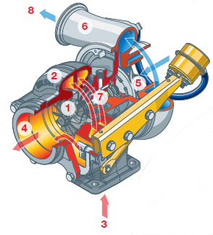
- 1.THE TURBINE WHEEL
- 2.THE TURBINE HOUSING
- 3.EXHAUST GAS
- 4.EXHAUST OUTLET AREA
- 5.THE COMPRESSOR WHEEL
- 6.THE COMPRESSOR HOUSING
- 7.FORGED STEEL SHAFT
- 8.COMPRESSED AIR

Fig.1 Turbo internal diagram

What is a waste gate, a waste gate controls the flow of the exhaust gases to the turbine, which is controlled by a valve. The valve prevents the turbine spinning to fast by letting unwanted pressure out, by controlling and limiting the speed of the turbine these insures a safety measure for the turbo and engine from damage due to regulating the boost pressure as a safety measure. The valve is controlled by pressure and boost pressure of the turbo these are connected via a link on the actuator. With waste gates, there are more than one option, there is an internal and external option. An internal option is that the turbo is fitted with a waste gate, that is inside the turbo which has a small chamber which consist of a spring. The spring open and closes the chamber letting the unwanted pressure out. The spring will be related to boost pressure. Option two is more for performance application such as race cars. This waste gate is usually fitted to the exhaust manifold the main difference is that the spring and components are upgraded and can be manually set to the required pressure needed.

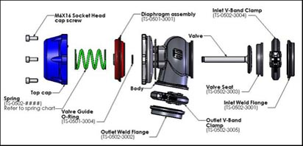
Fig.2 Waste gate exploded diagram

To help with turbos and performance, intercoolers are fitted. The Intercooler helps with reducing the temperatures of the compressed air after the turbo and before entering the intake and there by having dense air entering the engine. The intercooler works by cooling the compressed air, when the air is compressed by the turbo it gets hot. With the compressed air getting hot the density is reduced this is where the intercooler helps with the temperatures. By using the intercooler, the air has better density which allow a better mix due to rich air that allows more fuel to be burnt and resulting in more power and better efficiency. There are two different option of intercoolers air to air and air to water. The air to air intercool works by having fins and tubes which cool the air as it is passed through. With the air to water intercooler, the water is used to absorb the heat from the intercooler, when the water gets hot it then goes through another cooler to cool the water down to be reused again. This system is smaller due to water keeping it cool and less space is need, but it is more expensive and heavier than the air to air system. The air to water can handle more variable temperatures as well.
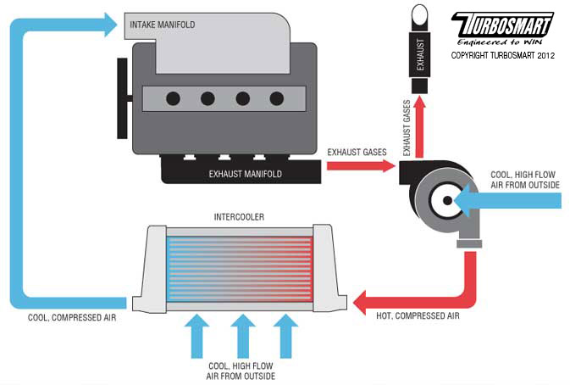
Fig.3 Air to air intercooler

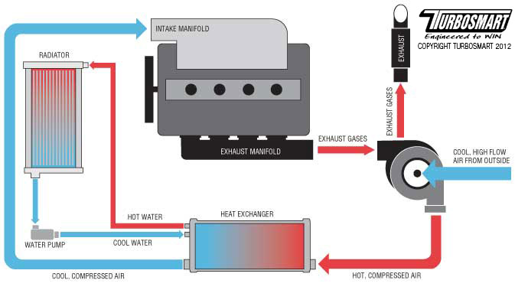
Fig.4 Air to water intercooler

3. Methodology
Turbo strip and rebuild
Step 1 | The red arrow on the left showing the nut that is attached to the actuator and waste gate, loosen this nut and remove rod. Arrow on the right pointing at a v band clamp undo this clamp and remove. This will separate the turbo from the manifold assembly. | 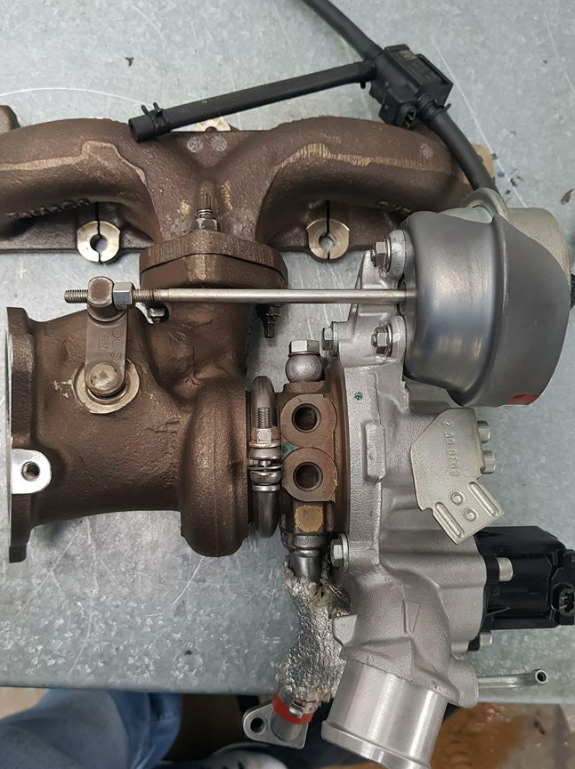
Step 2 | Both red arrows are pointing at oil feed and oil return pipes these need to be removed. Undo the bolt on the left and remove, undo the screw on the right and remove. | 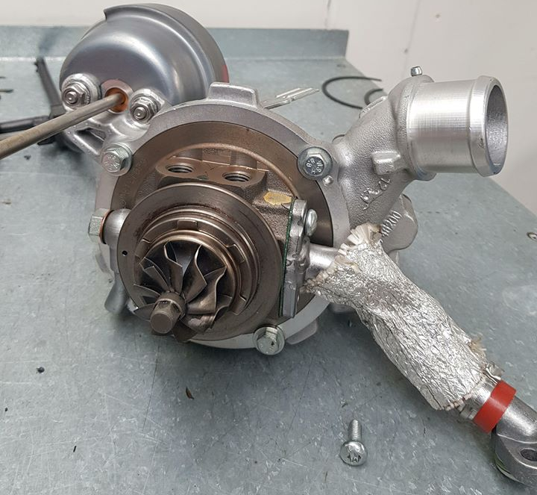
Step 3 | As you can see there are four arrows pointing at four bolts which are securing bolts. Remove the bolts and the whole assembly of compressor and turbine wheel can be removed. | 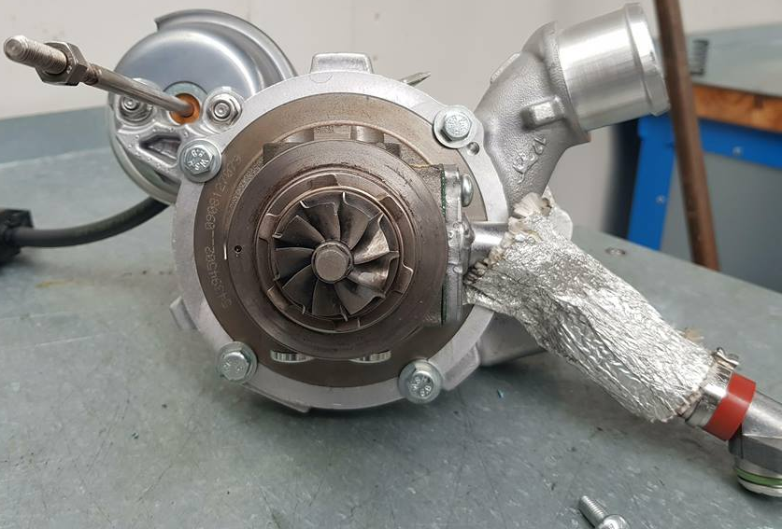
Step 4 | Once step 3 is completed the component should look like the picture, where the arrows are pointed you hold one side and turn the other being careful as it could be a left- hand thread. Once these are removed the shaft with the compressor/turbine should come lose. | 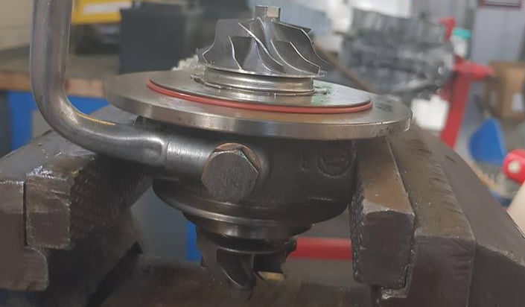
Step 5 | This shaft and turbine will slide out of the assembly. | 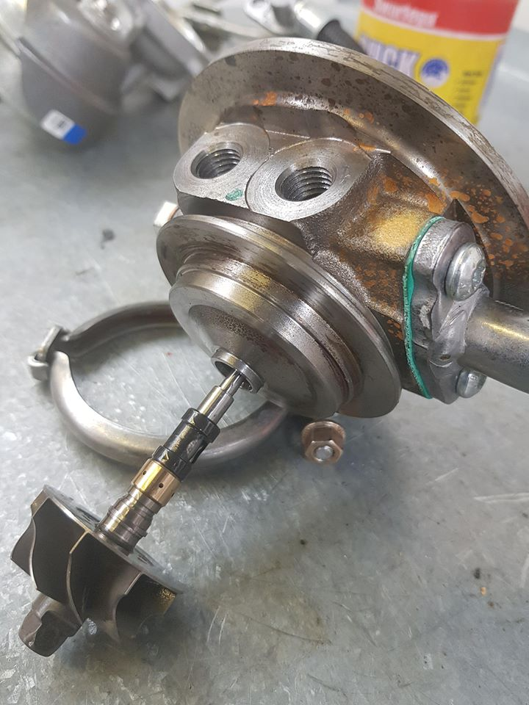
Step 6 | Undo the two torx screws (indicated by the arrows) to remove this centrepiece to check for damage and dirt inside and if any collects that aren’t worn. | 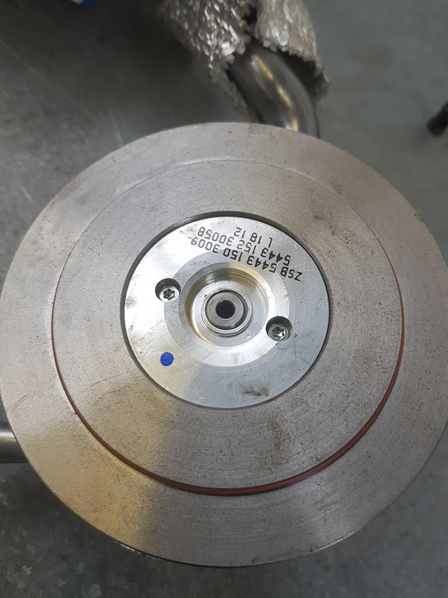
Step 7 | Check for damage and dirt. | 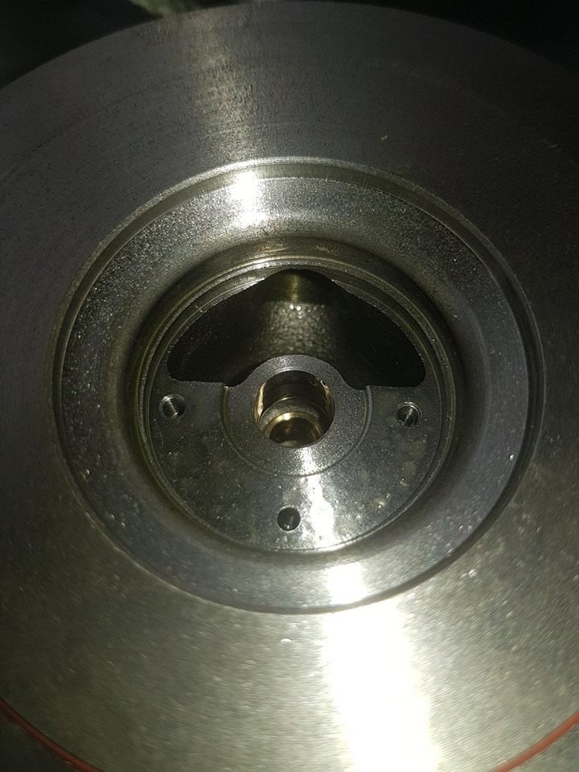

4. Results

From looking at the brief the information that is needed can be extracted from the brief.
Bore | 95mm
Stroke | 80mm
Engine speed | 9500RPM
Volumetric efficiency | 85%
Boost pressure | 12PSI

Using the information provided calculations can be made using the appropriate formulas to determine the correct compressor. The first equations used is:

$$V=\frac{vxn_{v}xN}{2x60}$$

V= Volumetric flow rate
v= Total engine displacement
N= Engine speed
n= Volumetric efficiency
For this equation above to work, the engine displacement needs to be calculated.
${πx\frac{b}{4}}^{2}x s x n.c$
b= bore
s= Stroke
n.c= Number of cylinders

Once the volumetric flow has been calculated for the naturally aspirated engine, this answer will then be used to multiply by the pressure ratio to work out volumetric flow rate for the turbo engine. The following equation is used to work out the pressure ratio.
$PR=\frac{14.7+Boost}{14.7}$
The answer from the first equation is V=656.89CFM
Pressure ratio = 1.82
To calculate the volumetric flow rate for the turbo engine, the equation needed is pressure ratio times V (volumetric flow rate) which is equals 1195.54CFM. To get this answer into pounds per minute times the CFM by 0.07 which equals 83.69lbs/min. Using these results the appropriate compressor can now be selected.
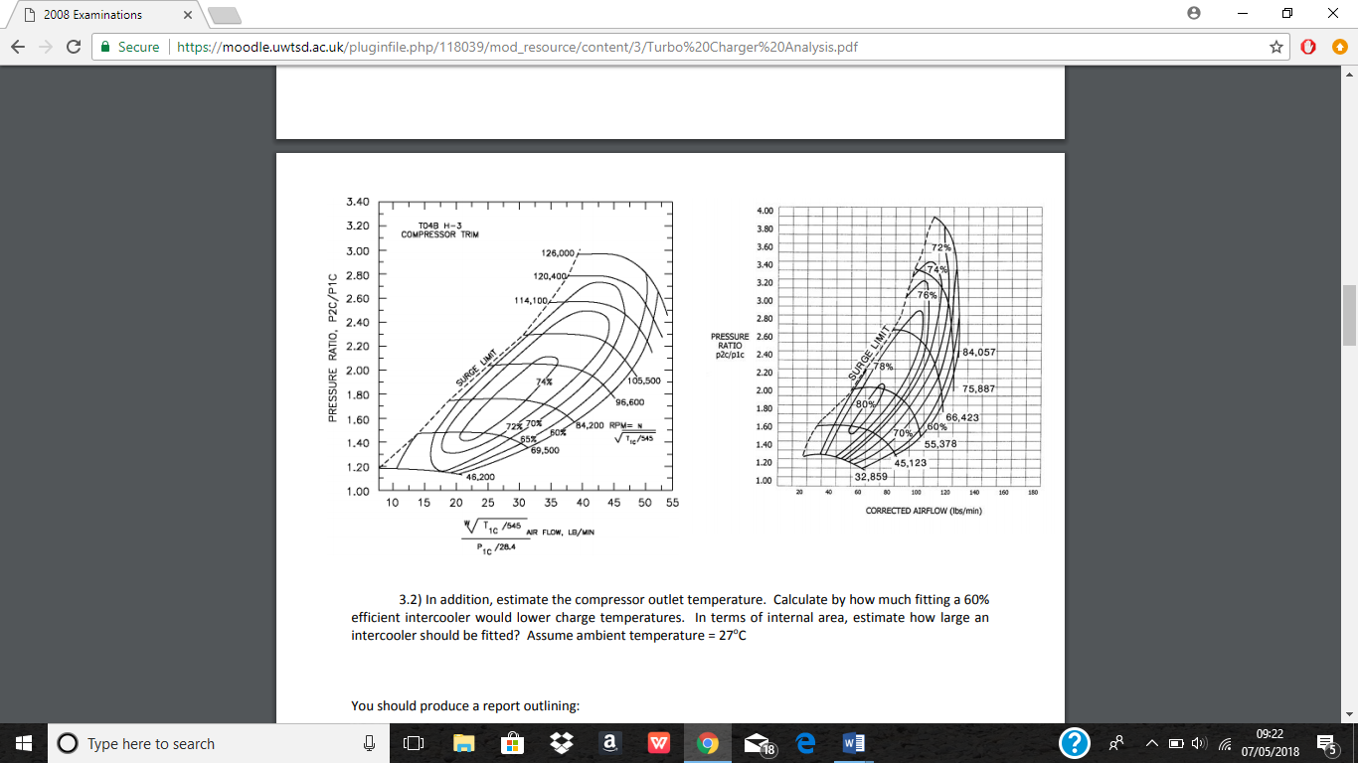
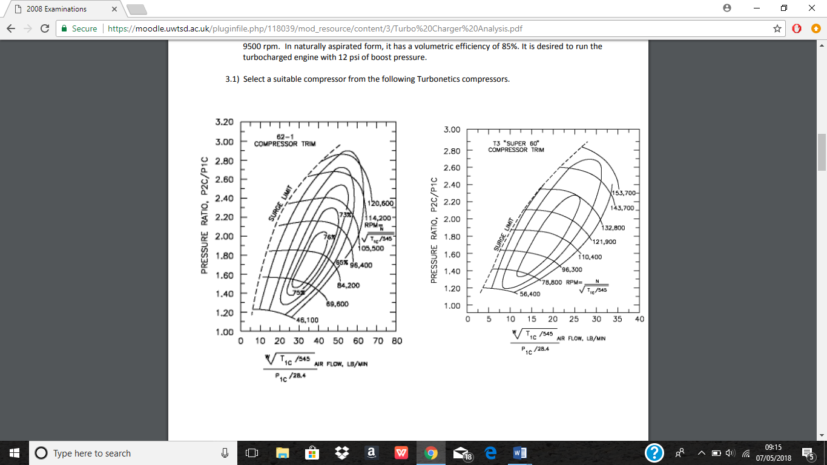
Fig.6 compressor 2
Fig.5 compressor trim

Comparing the both graphs, as you can see on the left graph it show good efficiency. The efficiency is only good at middle RPM, as the RPM is increased the efficiency decreases, this is due to the flow rate increasing which is related to engine speed, as the speed increased the compressor can’t handle the increase in flow rate. Looking at the graph you can see the efficiency is at a wider range of rpm which is starting low down to top end rpm.
Tio | Temperature intercooler outlet | ?
Tco | Temperature compressor outlet | ?
Pr | Pressure ratio | 1.82
Tin | Temperature inlet | 300 Kelvin
ηi | Intercooler efficiency | 60% (0.6)
Atr | Actual temperature rise | ?
ηc | Compressor efficiency | 78% (0.78)
Tout | Temperature outlet | ?
Ta | Ambient temperature | 300 kelvin

To work out the unknown values that have question marks above, these equation will be needed:
$Tout={PR}^{0.28}xTin$
$Tio=Tco-i(Tco-Ta)$
$Atr=\frac{\left({PR}^{0.28}xTin\right)-Tin}{c}$

Using these equations, get the following outcomes:
Tout=354.77kelvin
Tio=321.138 Kelvin
Atr=70.21
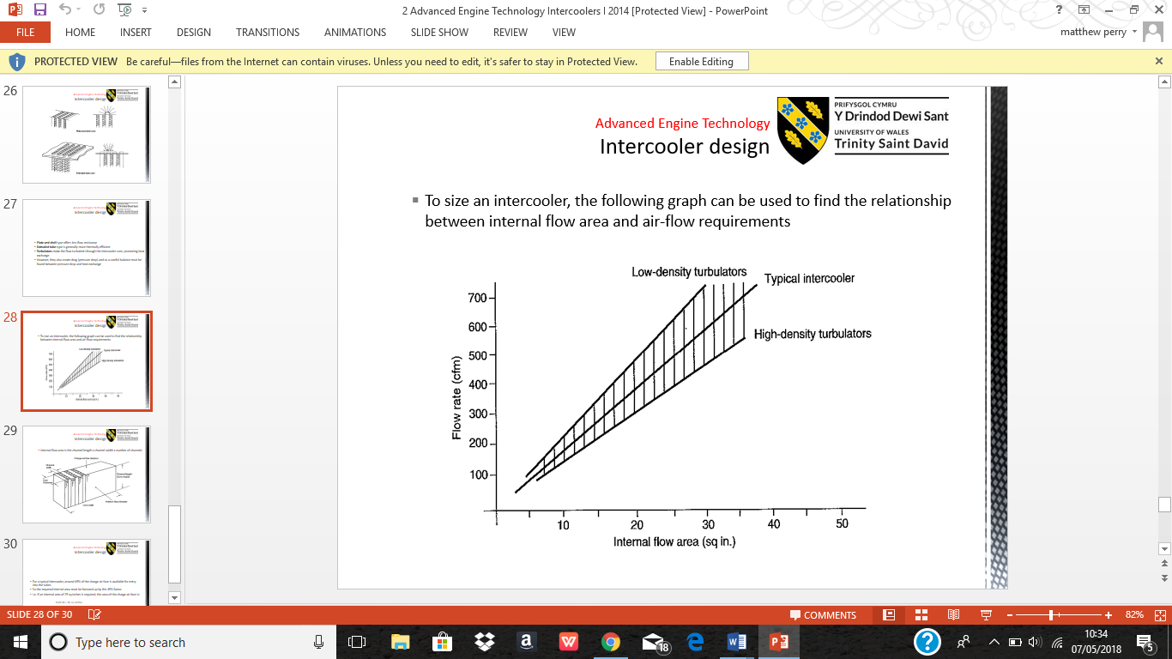
Fig.7 intercooler graph

The graph above shows the relation between flow rate and internal flow area. To provide the correct size intercooler for the best cooling, the appropriate size can be found by using the graph above. To work out the internal area of the intercooler, the gradient of the graph must be found. To achieve the gradient figure, take the maximum and minimum for y and x axis then get the differences from y maximum and minimum and same for x then divide them both together so y/x. To get the estimated internal area you take the volumetric flow rate of 1195.54CFM and divide by the gradient of 18.75 which equals 63.76 (SQ IN)

5. Analysis

When going from a naturally aspirated engine (non-Turbo) to a turbo charged engine a few alterations ae to be made due to the increase in power from the turbo. Depending on the power increase depends on what parts need to be changed but if it was a high-power turbo then looking at changing a lot. The crank and crank bearings would need to be changed due to the force acting on the crank. The con rods would need to be changed as these will try and bend again due to the force being pushed down. The piston would need upgrading as the force of the compressed air and fuel mix when ignited is going to try and pass the ring or damage the piston. The camshaft may need altering as the lift of valves open and close might change may need to stay open for longer or shorter due to the upgrade. The exhaust manifold will need to be altered to have the turbo mount to it or to have bigger exhaust to let the gasses out more efficiently. Inlet manifold need to be stronger as the compressed air is forced through it so may need to be stronger or the flow of the air may need to be altered. Intercool will need to be fitted to keep the temperatures cooler which is caused by the turbo compressing the air. The injectors may need upgraded due to the increase air which will mean possible increase in fuel or even for the injector to stay open for longer or shorter. The air fuel ratio will need to be altered as more will be more fuel to burn this can be controlled by an upgraded ECU (Electronic computer unit) which will manage the air fuel ratio. The timing may need to be altered as everything has changed the timing may need to be adjusted to manage with the cam and fuel air ratio change. Having a turbo fitted means there need to be a supply of oil or water or both to the turbo to keep lubricated and to help with heat.

6. Conclusions

From looking at the results you can clearly see that the better compressor would be Fig.6 due to the wider range of rpm and the efficiency. The reason for not choosing the other compressor which is fig.5 is because the lack of rpm range and the efficiency of that turbo. For the other compressors to be considered it would have to look at a twin turbo system for it to archive the optimum efficiency, a turbo would be fitted to both manifold to have the desired effect.

7. References

Turbodynamics.co.uk. (2018). Turbocharging A Naturally Aspirated Engine? | Turbo Dynamics. [online] Available at: https://www.turbodynamics.co.uk/technical/turbocharging-normally-aspirated-car/ [Accessed 6 May 2018].

TBrands, H., Cars, F., Reviews, N., Vehicles, P., Finds, B., To, H., Body, P., Suspension, C., Drivetrain, T., Electrical, I., Tires, W., To, A., Tour, H., Week, H., Nationals, C., Tour, S., Challenge, E., Show, T., Events, A., OnDemand, M., Videos, I., Garage, H., Videos, A., Top, B., Sands, J., Plus, G., Plus, G., Plus, G., Us, C., Use, T., Policy, P., Ads, A. and Trend, M. (2018). What Is Turbo Lag? And How Do You Get Rid Of It?. [online] Hot Rod Network. Available at: http://www.hotrod.com/articles/what-is-turbo-lag-how-do-you-get-rid-of-it/ [Accessed 6 May 2018].

Systems, B. (2018). Design and Function of a Turbocharger - Bearing system | BorgWarner Turbo Systems. [online] Turbos.bwauto.com. Available at: http://www.turbos.bwauto.com/products/turbochargerBearingSystem.aspx [Accessed 6 May 2018].

Tech, B. and Griffey, E. (2018). Blow-off Valves Explained - Super Street Magazine. [online] SuperStreetOnline. Available at: http://www.superstreetonline.com/how-to/engine/sstp-1211-blow-off-valves-explained/ [Accessed 6 May 2018].

Turbos, A. (2018). What is a Turbo Actuator? | AET Turbos. [online] Aet-turbos.co.uk. Available at: https://www.aet-turbos.co.uk/blog/story/what-is-a-turbo-actuator [Accessed 6 May 2018].

Turbos, A. (2018). Turbo technology – turbocharger parts and what they do | AET Turbos. [online] Aet-turbos.co.uk. Available at: https://www.aet-turbos.co.uk/blog/story/turbo-technology-turbocharger-parts-and-what-they-do [Accessed 6 May 2018].

101, B. (2018). Basic Turbocharging Components & Theory - GM High-Tech Performance Magazine. [online] Super Chevy. Available at: http://www.superchevy.com/how-to/engines-drivetrain/1105gmhtp-basic-turbocharging-components-and-theory/ [Accessed 6 May 2018].

Turbodynamics.co.uk. (2018). How Does A Turbocharger Work? | Turbo Dynamics. [online] Available at: https://www.turbodynamics.co.uk/technical/understanding-turbochargers/ [Accessed 6 May 2018].

Cummins Inc. (2018). How a Turbocharger Works | Cummins Inc.. [online] Available at: https://www.cummins.com/components/turbo-technologies/turbochargers/how-a-turbocharger-works [Accessed 6 May 2018].

Turbosmart. (2018). How does a Wastegate work? - Turbosmart. [online] Available at: http://www.turbosmart.com/news/how-does-a-wastegate-work [Accessed 6 May 2018].

Turbos, A. (2018). Turbo tech 101– what is a turbo wastegate and how does it work? | AET Turbos. [online] Aet-turbos.co.uk. Available at: http://www.aet-turbos.co.uk/blog/story/turbo-tech-101-what-is-a-turbo-wastegate-and-how-does-it-work [Accessed 6 May 2018].

Turbosmart.com. (2018). Technical Articles | How An Intercooler Works |Turbosmart. [online] Available at: http://www.turbosmart.com/technical-articles/how-an-intercooler-works/ [Accessed 6 May 2018].

