Write Up on Professional Issues
Communication is vital in healthcare and for healthcare professionals, and it allows healthcare professionals to provide high-quality, safe and effective care, evidence has shown that poor communication is behind a large vast of medication errors, unnecessary medical costs and insufficient patient care (Judd, 2013). Communication can be defined as verbal and non-verbal communication being sent and received between two or more individuals (Dougherty et al, 2015). Communication between healthcare professionals and patients allows healthcare professionals to gain and reveal information and gain the trust of the patient (Kozier et al, 2012). Effective communication needs the healthcare professional to understand the patient and what they are expressing when they are communicating, effective communication needs the healthcare professional to have a certain level of skill to understand what the concerns of the patient are and to relay the message to ensure they understand and accept what the patient is communicating (Kourkouta and Papathanassiou, 2014).

The three most valuable forms of communication in healthcare, amongst healthcare professionals, patients and their relatives include verbal communication, non-verbal communication and metacommunication (Kozier et al, 2012) which will be explored further throughout this piece of work. Verbal communication can be defined as the exchange of words which are spoken or written and is important when healthcare professionals and patients are expressing themselves and their feelings, verbal communication also involves the process of actively listening to the spoken or written words (Kozier et al, 2012). Active listening is the process of fully receiving and understanding what the patient is communicating and ensuring it is understood by the healthcare professional listening, it also includes trying to understand not only what the patient is communicating but also what the underlying feelings and thoughts are by assessing their non-verbal communication such as the patient’s body language, eye contact and gestures (Moss, 2020). It is also important that the healthcare professional is able to provide an appropriate amount of time to listen to the patient without any interruptions, to show interest in what the patient is conversing, use a certain amount of verbal encouragement such as ‘please continue’, being able to empathise with the patient and be able to summarise the words that the patient has spoken and define the purpose of those words (Jahroumi et al, 2016). Non-verbal communication can be defined as information which is conveyed without the use of spoken or written words and is argued to be more valuable than verbal information (Dougherty et al, 2015), the use of non-verbal communication is crucial as it can show how someone is truly feeling and what they are truly thinking as someone’s non-verbal communication may not always coincide with what someone is communicating verbally (Kozier et al, 2012). Non-verbal communication may include human behaviour factors such as the use of facial expressions, body movement or posture, eye contact the use of silence, touch, gestures and personal appearance (Kozier et al, 2012). Metacommunication refers to communication about communication, metacommunication can be both verbal and non-verbal and involves exceeding what is being verbally communicated (Kozier et al, 2012).

Effective communication is a crucial skill for healthcare professionals in order to have positive outcomes for everyone involved, it requires an understanding of oneself and others (O-Toole, 2016). Effective communication involves not only sending and receiving messages but also requires processing and understanding the messages in detail (O-Toole, 2016). Effective communication skills are key to ensuring the patient receives the highest quality of person-centred care, reducing errors and mistakes, promoting a positive working environment, working in a team effectively and communicating goals and expectations (Creative Health Care Management, 2023). Communication can come with some complexities, these can include gender as some individuals’ cultural beliefs are that women should be seen by a doctor who is the same sex, age can be another complexity, for example, some older individuals may not want to communicate about their health conditions with a younger worker, race as some individuals believe that they should be able to see a healthcare professional who is the same ethnicity as them, disability as everyone with a disability should have access to services meaning that every practice should be disability friendly and language as service users should be able to communicate in their preferred language (Moss, 2020). The code is a set of professional standards of practice and behaviours for nurses, midwives and nursing associates which was created by the Nursing and Midwifery Council (NMC) and exists to provide protection to the public (Nursing and Midwifery Council, 2015). One of the professional standards within the code states that nurses must practice effectively which includes communicating clearly, nurses are obliged to communicate using terms that the patients in their care, other healthcare professionals and the public understand, take logical steps to meet individual’s language and communication needs and providing assistance when they are able to, to the individuals who need assistance to communicate their own or other’s needs, use both verbal and non-verbal communication methods whilst considering other individuals cultural differences to understand and answer patient’s personal and health needs, they must check the other individual’s understanding to reduce misunderstanding and mistakes and they must be able to communicate effectively and clearly in the language of English (Nursing and Midwifery Council, 2015), this further highlights the importance of effective communication for healthcare professionals.

Barriers to effective communication can be defined as anything that will make the individual who is communicating feel uncomfortable, not accepted and not valued, which discourages the individual from communicating (Moss, 2020). Ineffective communication between healthcare professionals can have a negative impact on the safety of patients, the quality of care provided, patient outcomes and both patient and staff satisfaction this can occur both intentionally and unintentionally (Health Stream, 2021). The actions that can discourage communication can include, the professional's behaviour and attitude towards the individual, unsuitable surroundings such as a room layout with no privacy, the subject that is being communicated which can often in healthcare be a sensitive or uncomfortable subject, the use of language which the individual does not understand such as medical terms and fear which is a way in which the individual could be feeling which might have an effect on the individual communicating effectively (Kozier et al, 2012). Some of the barriers of the way to communication can be overcome by finding out whether or not it is a suitable time and place to communicate with the individual, using clear communication, using appropriate language that the individual can understand and if the individual is unable to understand using an interpreting service such as language line which is a reliable language service provider (Language Line Solutions, 2024), communicating one thing at a time, respecting another individual’s wish to not communicate, checking that the individual you are communicating with has understood what you have relayed to them, ensuring that you are communicating with the individual in a place which is free from any distractions and acknowledging the emotional responses the individual displayed in relation what you have communicated (NSW Government, 2024).

In conclusion, communication is vital in healthcare settings and allows healthcare professionals to provide high-quality, safe and effective person-centred care. Verbal communication, non-verbal communication and metacommunication are important forms of communication in healthcare to allow healthcare professionals to gain vital information and uncover vital information. Effective communication is important in healthcare and prevents the risk of medication errors, unnecessary medical costs and insufficient patient care. Healthcare professionals must communicate in a person-centred way and have the skills to effectively communicate both verbally and non-verbally. When healthcare professionals are faced with barriers to communicating effectively, they should attempt to overcome these barriers.

References
Creative Health Care Management (2023) Importances of Communication in the Healthcare Industry. Available at: https://chcm.com/importances-of-communication-in-the-healthcare-industry/ (Accessed on the 26th of February 2024).

Dogherty, L., Lister, S., and West-Oram, A. (2015) The Royal Marsden Manual of Nursing Clinical Nursing Procedures. 9th edn. West Sussex: The Royal Marsden NHS Foundation Trust.

HealthStream (2021) Effects of poor communication patterns between nurses & providers. Available at: https://www.healthstream.com/resource/blog/the-impact-of-poor-communication-patterns-between-nurses-and-providers (Accessed on the 26th of February).

Jahromi, V, K., Tabatabaee, S, S., Abdar, E, Z., and Rajabi, M. (2016) ‘Active listening: The key of successful communication in hospital managers’, Electronic Physician, 8(3), pp 2123-2128. Available at: https://www.ncbi.nlm.nih.gov/pmc/articles/PMC4844478/

Judd, M. (2013). ‘Patient Safety’, Broken Communication in Nursing Can Kill: Teaching communication is Vital, 19(2), pp. 101-104. Available at:
https://doi.org/10.1891/1078-4535.19.2.101

Kourkouta, L. and Papathanasiou, V, I. (2014) ‘Communicating in Nursing Practice’, Mater Sociomed, 26(1), pp. 65-67. Available at: https://doi.org/10.5455%2Fmsm.2014.26.65-67

Kozier, B., Erb, G., Berman, A., Snyder, S., Harvey, S., and Morgan-Samuel, H. (2012). Fundamentals of Nursing. 2nd edn. England: Pearson Education Limited.

LanguageLine Solutions (2024) Enabling Total Understanding One Encounter at a Time. Available at: https://www.languageline.com/en-gb/company (Accessed on the 26th of February 2024).

Moss, B. (2020) Communication Skills in Nursing, Health & Social care. 5th edn. London: SAGE Publications Ltd.

Nursing and Midwifery Council (2015) The Code: Professional standars of practice and behaviour for nurses, midwives and nursing associates. Available at: https://www.nmc.org.uk/standards/code/ (Accessed on the 25th of February 2024).

NSW Government (2024) How can I overcome communication barriers? Available at: https://www.health.nsw.gov.au/mentalhealth/psychosocial/strategies/Pages/communicating-barriers.aspx (Accessed on the 26th of February 2024).

O’Toole, G. (2016) Communication Core Interpersonal Skills for Healthcare Professionals. 4th edn. Australia: Elsevier.

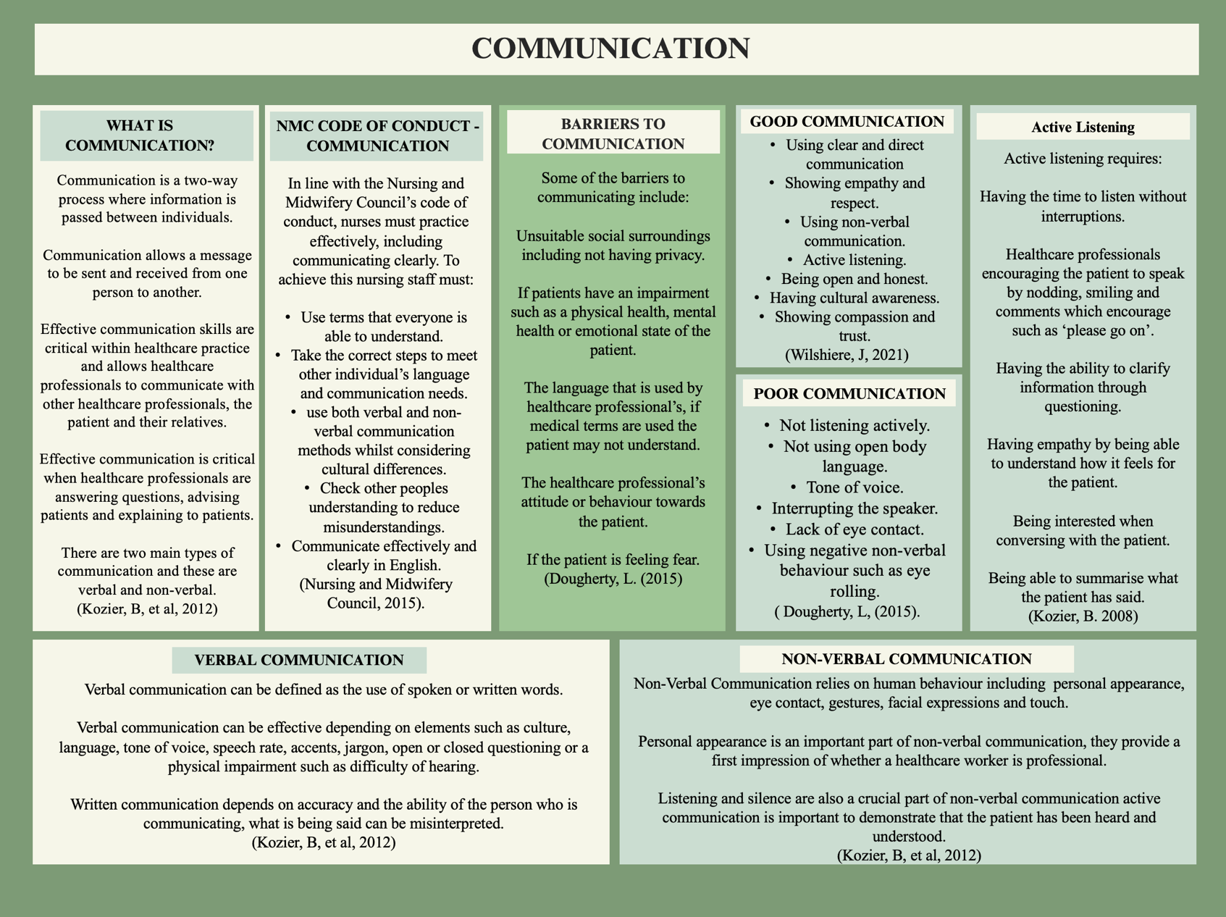
Poster Presentation



