

University of Wales Trinity Saint David

Computational Methods
Assignment 2

__________________
2D Diffusion Equation model using the Explicit Finite Difference Method
__________________________________________________

Author: Supervisor:

Morgan Wheeler

26th January 2024

Contents
1. Introduction: 3
2. The governing equation of the problem: 3
3. Full description of the numerical method chosen to discretise the governing equation: 4
4. The initial, boundary conditions and analytical solutions: 6
5. Codes details and explanations: 7
6. Validation of the code: 10
7. Sensitivity analysis of the code: 12
8. Main models limitations: 14
9. Suggested improvements and future developments: 15
10. Conclusion 15
11. Bibliography 17
12. Appendix: 19

Table of Figures

Figure 1 - Approximation Diagram (Archimedes's Approximation Of Pi - Amazing Discovery Of Mathematics- Archimedes (weebly.com)) 4
Figure 2 - Central Point With Four Neighbouring Points 5
Figure 3 - Representation of a grid mesh over an Aluminium plate 6
Figure 4 - Boundary Conditions(Marotin, 2023) 7
Figure 5 - Initial Domain Conditions (Marotin, 2023) 7
Figure 6 - Comparing Plate and Analytical Temperature Distribution 11
Figure 7 - Difference Between Matrix Tables 12
Figure 8 - Changing Tolerance Graph 13
Figure 9 - Changing Time Step Graph 13
Figure 10 - Changing Grid Spacing Graph 14
Figure 11 - Truncation Error of Taylor Series (What are Truncation Errors | Examples (byjus.com)) 15

Introduction:

This report is going to look at how the script, which was created on MATLAB for the first assignment was collated. The heat equation will be derived and explained, as it is the main equation that is used in the model. The script was created to calculate the temperature distribution within an aluminium plate over a period of time. The Taylor Series can be used to approximate a function with an infinite number of terms. This will be useful in this application as multiple singular points need to have a calculated value (Khan Academy, 2024). This equation could be calculated manually however, the script can perform the same calculation in a much quicker time, it also removes a lot of human error and is easily repeatable. The report will also entail details about the script and highlights how it can be validated. It’s important to have validation steps and boundaries within the script, because it will allow the user to enter values within a range of numbers, which will allow the equation to be in a stable state to work. It does this by distinguishing valid input data which will give realistic results compared to those unstable inputs, which could make the results worthless. The models limitations will also be identified, then improvements will be suggested on how future developments can help to make the model more efficient and user-friendly.
The aim is to superimpose a grid mesh on a six-meter by six-meter Aluminium plate, implement various boundaries and conditions, then ensure that the stability criterion can be fulfilled. This can then be displayed in graph form until thermal equilibrium is reached.

The governing equation of the problem:

The governing equation that is involved in this problem is the heat equation. The equation is:
$$\frac{∂^{2}T}{∂x^{2}}+\frac{∂^{2}T}{∂y^{2}}=\frac{1}{α}.\frac{∂T}{∂t}$$
$∂$ – This is the symbol for ‘partial’, it indicates that a derivative is being taken with respect to a variable while keeping some others constant.
T – Temperature.
$x$ and $y$ – Indicates unknown variables
$α$ – Indicates the thermal diffusivity (this can also be expressed as $\frac{k}{P × C}$)
$P$ – Density
$C$ – Specific heat
t – Time
The heat equation is used within this exercise as it allows the measurement of heat propagation within a solid. It also describes how heat energy will transfer from a warm object to a cooler object until thermal equilibrium occurs as described by Lavinia (2012). It was created by a French scientist called Jean Baptiste Joseph Fourier in 1822.
The heat equation is very important, as it is used in many different scientific and engineering disciplines. The heat equation can be used a lot within the design phases of engineering as it will be required to know the heat transfer of different materials, temperature distribution within buildings, thermal behaviour of electronic devices and hardware and many more examples (POPESCU, 2009).
It is also used in larger applications such as determining weather patterns and understanding the distribution of heat within the oceans, atmosphere and earth’s surface.

Full description of the numerical method chosen to discretise the governing equation:

This section will describe the procedure chosen to discretize the governing equation (heat equation). Firstly, the Taylor series was used, as using the Taylor series can assist numerical computations, when estimated values are required at different points of the solution (Saeed, 2022).
The Taylor series is a polynomial function which can be used for an infinite number of terms. It is useful in this application as a uniform grid was created with certain spacing to superimpose onto an aluminium plate, this meant that all the points of this grid could be given a value using this formula.
$$f\left(x\right)=f\left(x^{0}\right)+f^{\left(1\right)}\left(xo\right) \left(\frac{x-xo^{1}}{1!}\right)+ f^{\left(2\right)}\left(xo\right) \left(\frac{x-xo^{2}}{2!}\right)… f^{\left(n\right)}\left(xo\right) (\frac{x-xo^{n}}{n!})$$
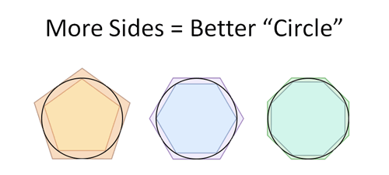
Figure 1 - Approximation Diagram (Archimedes's Approximation Of Pi - Amazing Discovery Of Mathematics- Archimedes (weebly.com))
From Figure 1, it is visible to see that sided shapes within a circle will never be able to fully fill the area of the circular shape however, the more sides added to the shape will increasingly look like more of a circle, but it will never completely fill the full area. At some stage, the approximation will become significant enough to be able to replace the full circle for the desired application (Verma, 2021).
Forward difference approximates the derivative from a point, also the point a small step ahead of it.
$$f^{\left(1\right)}\left(xo\right)= \frac{f\left(xo + h\right)-f (xo)}{h}$$

Backward difference approximates the derivative from a point, also the point a small step behind it.
$$f^{\left(1\right)}\left(xo\right)= \frac{f\left(xo + h\right)-f (xo-h)}{h}$$

Central difference approximates the derivative from two points either side of the interested point.
$$f^{\left(1\right)}\left(xo\right)= \frac{f\left(xo + h\right)-f (xo-h)}{2 h}$$

These three different derivatives can be used to calculate estimated values before, after and in the middle of certain points. This will help computations for the grid mesh which will be superimposed over the aluminium plate. Otherwise, there will be an infinite number of points and values which will not be useful.
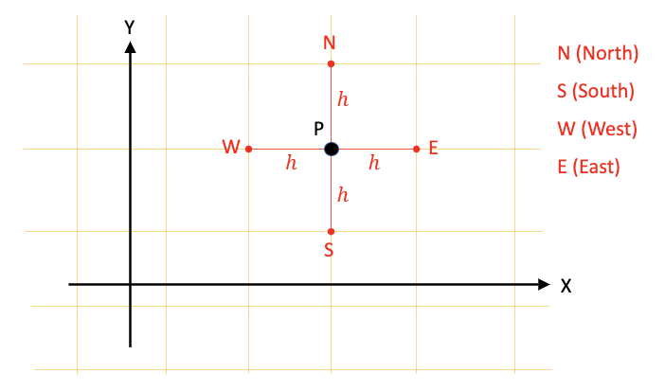
Figure 2 - Central Point With Four Neighbouring Points
For the differential thermal diffusion equation, the forward and central differences must be used to re-arrange the equation and get to the explicit finite difference equation.
0
0
0
0
0
0
0
0
0
0
0
0
0
0
0
0
0
0
0
0
0
0
0
0
0
0
0
0
0
0
0
0
0
0
0
0
0
0
0
0
0
0
0
0
0

Figure 3 - Representation of a grid mesh over an Aluminium plate
Above is a visual representation of how a mesh grid will look over the aluminium plate. The grid will be uniformly divided so that values in a uniform manner could be entered and provide a stable answer. The grid was small enough to be able to enter .5 of a full value. Kanchan M. Kelkar (2023) states that while the finer grid mesh will increase the accuracy of the calculations, the computational power will be much greater due to the amount of work which will be required. The stability conditions must also be met to ensure that there are not any errors which can grow exponentially and affect other neighbouring points – this would mean that it is ‘unstable’. To be stable in time-dependant situations, it will be classed as stable if any errors which are encountered in the solution, are not magnified and cause invalid / far-fetched values in correlation to the original situation (Manchestercfd, 2023).
The time-interval will then be divided into a sequence of time steps, which are usually small increments, to ensure that stability is achieved. Usually, a time-step which is proportional to the grid mesh spacing is applied.
Explicit finite difference is the technique which was carried out throughout the assignment. The different stages of the technique involve creating a grid of discrete points and dividing a time domain into time steps. The Partial Difference Equation (PDE) is then replaced with the finite difference approximations (Kong, 2020). The equation then updates relating the next time step, to the solution at the current time step and neighbouring points. This method must then pass the stability criterion by abiding to certain rules. The next step is for the computation to take place which will read through the method in a linear trail through until the final solution.
Below is the derivation of the explicit finite difference form of the heat equation, this is used as it allows the Fourier’s number to be introduced.

$$T_{P}^{t+∆t}=F_{0}\left(T_{E}^{t}+T_{W}^{t}+T_{N}^{t}+T_{S}^{t}-\left(4-\frac{1}{F_{0}}\right).T_{P}^{t}\right)$$
To find out the Fourier’s number, the equation F₀ $= \frac{a . ∆ t}{h^{2}}$ must be used. This will then provide a value which must be less than 1/4. This answer is important, as it provides a security barrier for the rest of the code to ensure that the stability criteria is met. The Fourier’s number also represents the balance between the heat conduction and storage of heat within a material body. The lower the Fourier number, the slower the rate of heat is transferred within the body (Testbook, 2023).
An example of NOT meeting the stability criterion with using relevant values is:
Conductivity: k = 143W/m.C
Density: $ρ$ = 2.8 x 10³ kg/m³
Specific Heat: c = 795 J/kg.C
Thermal Diffusivity: $a= \frac{k}{ρ . c}$
So; $\frac{143}{2.8 x {10}^{3}x 795}=6.424 x {10}^{-5} m^{2}/s$
Plate Dimensions: X = 6m, Y = 6m
Grid spacing (h) = 1m
Time Step $∆t=5 hours$
F₀ = $\frac{a . ∆t}{h^{2}}= \frac{6.424 x 3600 x 5}{1^{2}}=1.1563$ – as this number is over ¼, the equation is not stable and an error will occur.

The initial, boundary conditions and analytical solutions:

The initial and boundary conditions can be seen in Figure 5. This figure indicates that the bottom, left and right boundary temperatures and the initial domain temperatures are set at zero. The top boundary of the aluminium plate is set as shown in Figure 4, linearly increasing temperatures from 0°C to 50°C, up to 2/3 of the plate, linearly decreasing back to 0°C for the remaining part of the plate.
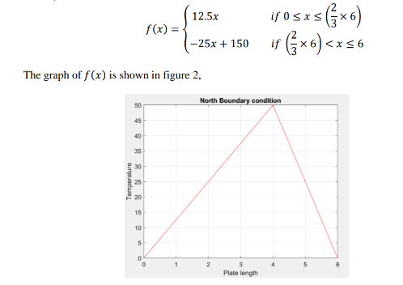
Figure 4 - Boundary Conditions(Marotin, 2023)
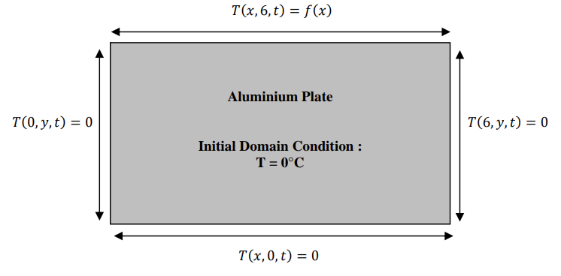
Figure 5 - Initial Domain Conditions (Marotin, 2023)

Codes details and explanations:
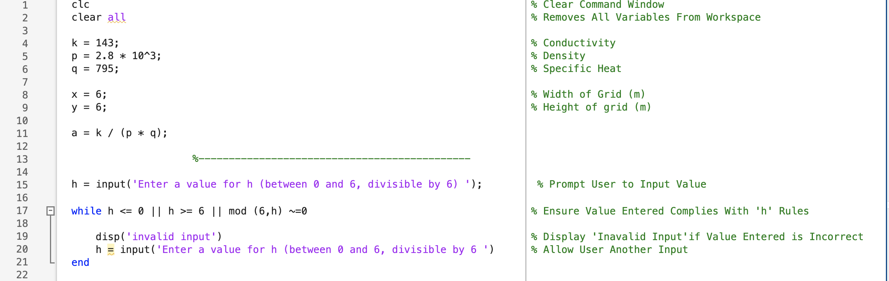
For lines 1 – 21 of the code, this section was the start where all the command window and workspace were cleared to avoid any mix-ups between different codes. The values for the plate properties and dimensions of the plates were all assigned to individual letters to make writing equations within the code much easier.
Between lines 15 - 21, this is where the rules for the grid spacing is defined. The code states that the value entered must be divisible by 6 and must be bigger than or equal to zero, and smaller than or equal to 6. If this rule isn’t followed, the user will be prompted to input a new value as the value entered was incorrect.
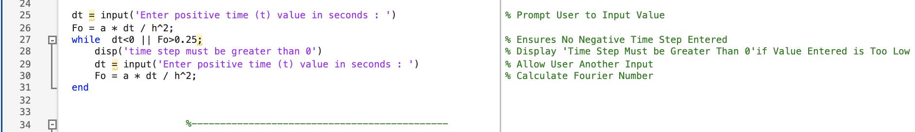
Lines 25 – 31 are where the user needs to input a time step value however, this value can only be a positive number. Fourier’s equation was also introduced, as if the time step value was too large, Fourier’s number would be larger than 1/4 and make the equation unstable. If this was the case, the user would have to enter a new time-step.
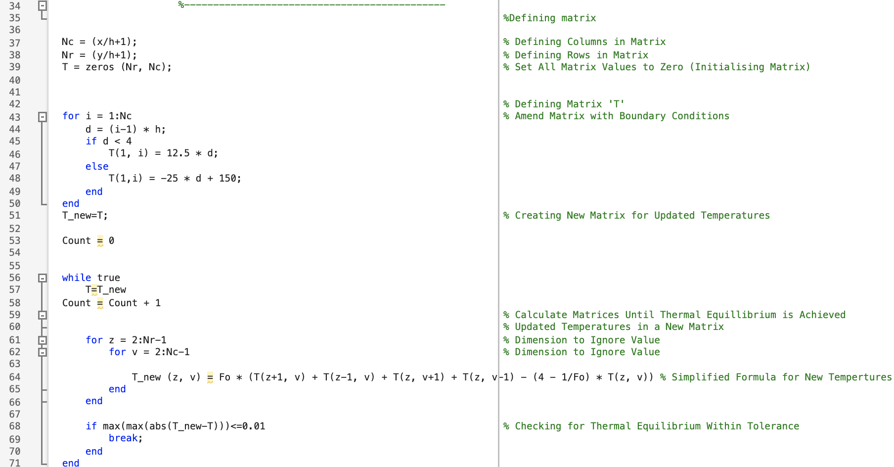

In lines 37 – 39, a simple matrix was created by defining the rows and columns, which were populated full of zeros for initializing the matrix.
In lines 43 – 50, the boundary conditions were introduced for the top boundary of the plate.
In lines 51 – 71, a new matrix was created to be able to display the updated temperatures so the two matrices would be subtracted from each other. This would be done until thermal equilibrium was achieved through the aluminium plate. A simplified equation was entered to be able to calculate the new temperatures, also ensuring that the thermal equilibrium was achieved within the stated tolerance input within the code, in this instance was 0.01.
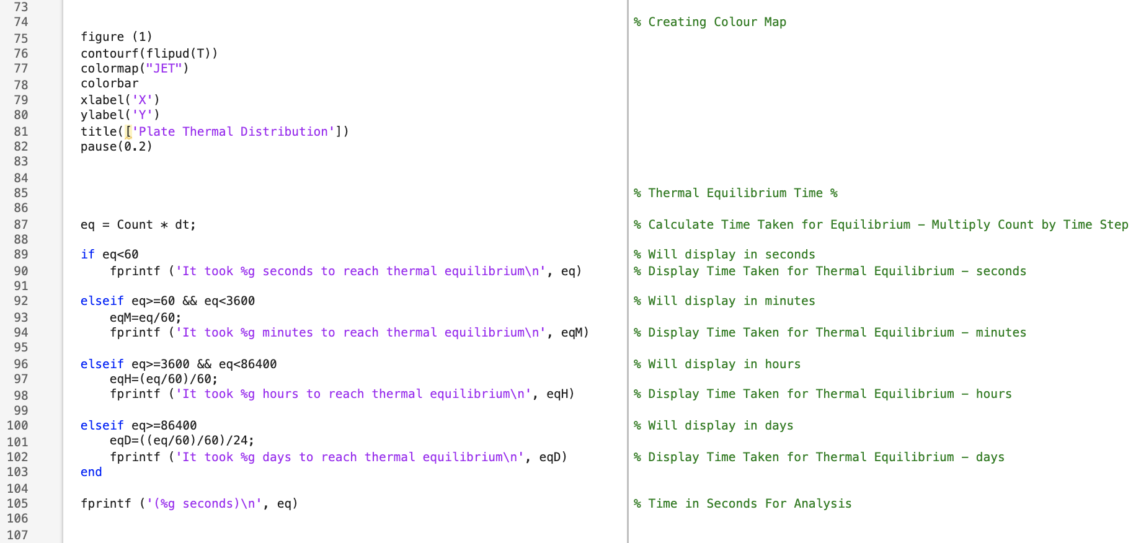
In lines 75 – 82, the colourmap was created to be able to have a visual representation of the heat transfer through the aluminium plate. The colourmap was displayed in ‘jet’ which made reading the map relatively easy.
In lines 87 – 105, once thermal equilibrium was reached, the time needed to be displayed correctly depending on the user’s inputs. If the time taken was achieved within certain time boundaries, the time would be displayed in either seconds, minutes, hours or days.
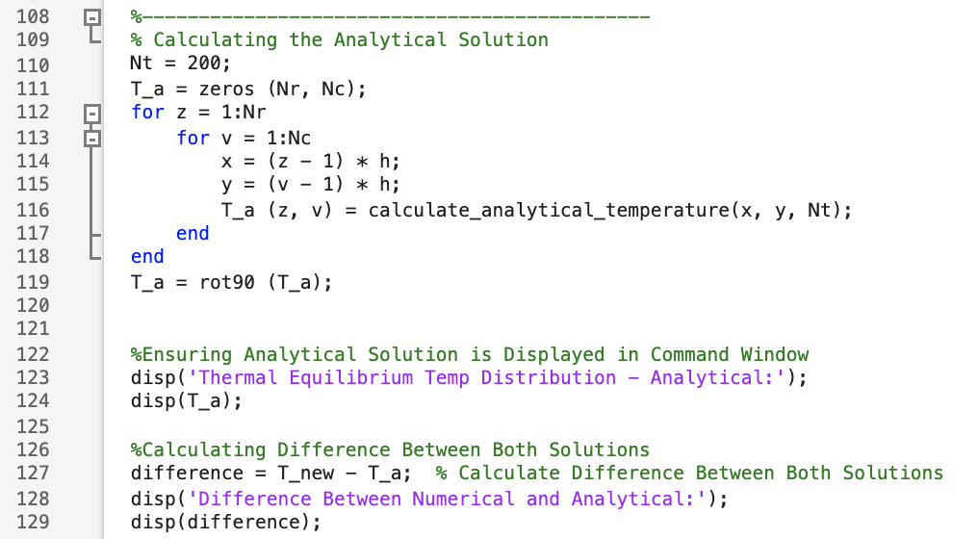
In this section, the analytical solution was introduced to be able to compare the analytical solution to the numerical solution. The values should only be small as they’re within the 0.01 tolerance, this also validates that both solutions are correct.
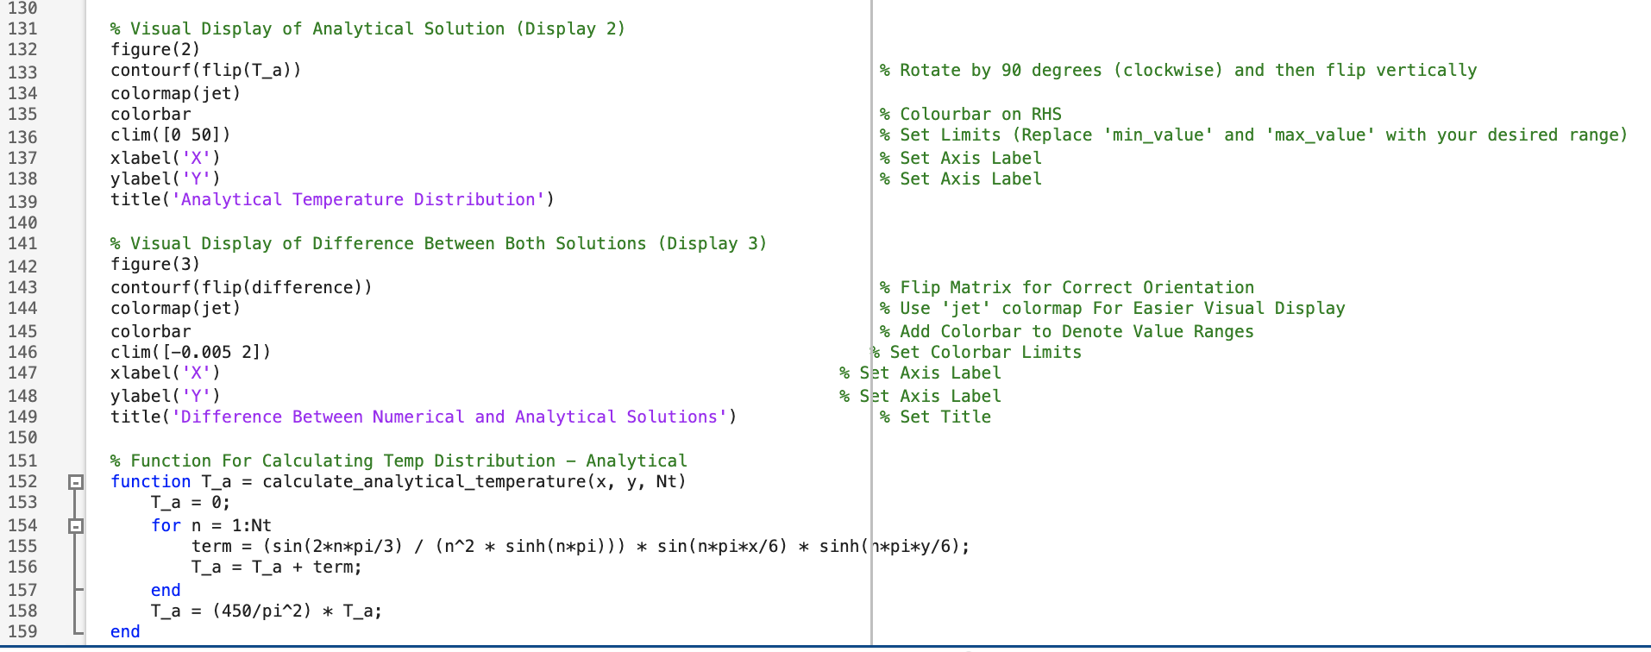
In lines 131 – 149, the second colourmap was created to show the analytical solution in a visual display, also the visual display of the difference between the two solutions was created. So once the code is run and completed, three colourmaps are generated for visual representation. These can be seen in Figure 6.
In line 151 – 159 (end of code), is where the analytical temperature distribution is calculated.

Validation of the code:

To validate that the code was giving correct resulting temperatures at thermal equilibrium, it was compared to the analytical solution to ensure that there were no anomalies. To achieve this, two matrices which were created in the code, had to be subtracted from each other to prove that the difference between the two are minimal.
In Figure 6, the thermal distribution of the plate and the analytical temperature distribution colourmap look identical, which validates that the thermal distribution of the plate is correct.
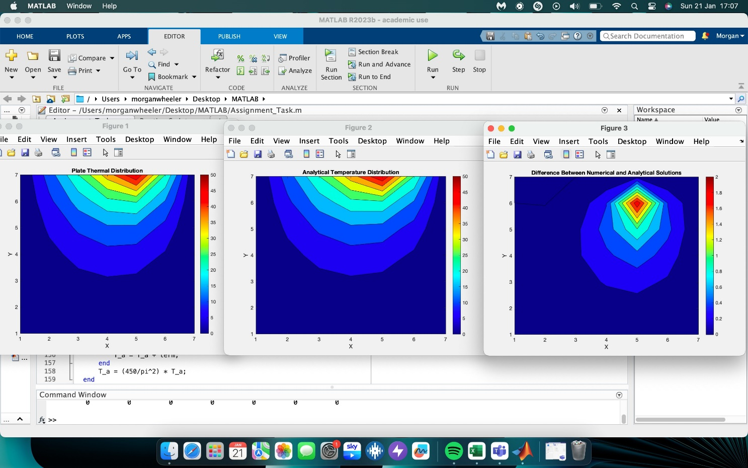
Figure 6 - Comparing Plate and Analytical Temperature Distribution
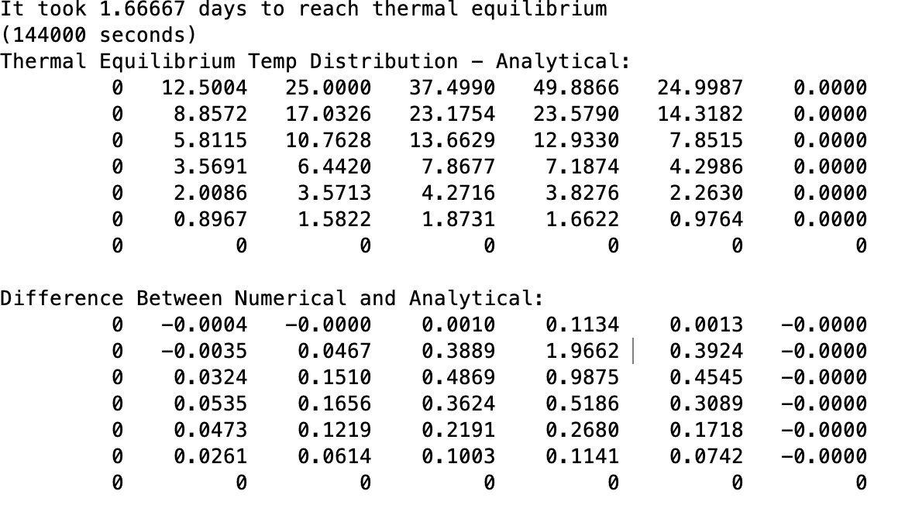
Figure 7 - Difference Between Matrix Tables
To implement more validation within the code, a rule was created which ensured that the Fourier number could not exceed 0.25 as this would ensure that the equation was kept in a stable condition.

Sensitivity analysis of the code:

To show the sensitivity of the code, some different value inputs were specified and entered to investigate how the scripts behavior then reacted to certain parameter changes, such as time steps, grid spacing and the tolerance which the code was set to use. In Appendix 2, is the table which was created when changing the tolerance within the script. This was so that the results were more accurate however, this can also lead to slower processing time and more iterations of calculations. This can be proved in Figure 8 as the tolerance got smaller, the longer it took to achieve thermal equilibrium.

Figure 8 - Changing Tolerance Graph
Another table was created to change the time step of the calculation. When the time step is larger, the simulation will advance quicker which can be more efficient however, it gives a less accurate representation of the behaviour of the plate.
The smaller time step will be slower but will allow for a more accurate representation of the plate over time. This can be taxing for a computer to deal with if the time step is very small.
The time step is an important parameter as it can determine how much detail is captured or not captured. It’s important to get a good trade-off between efficiency and accuracy.
In Figure 9. There’s a positive correlation between the increasing time step and time being taken to achieve thermal equilibrium. The variation table can be found in Appendix. 3

Figure 9 - Changing Time Step Graph
The last table created was for changing the grid spacing of the superimposed mesh.
The variation table for the grid spacing can be found in Appendix. 4
When looking at changing the grid spacing values, it is visible from the graph that the line starts to oscillate when the grid spacing increments become larger. Between the points 0.2 and 0.25 the line stays flat as there is very little difference within the results. Slater (2021) describes how the numerical error increases with larger grid spacings, which can be demonstrated between points two and three as that is the biggest step along the X-axis and has the largest line increase. The line oscillates as between 0.75 and 1 is 0.25 in difference, between 1 and 1.2 is only 0.2 difference so the line will decrease which is being displayed on the graph in Figure 10.

Figure 10 - Changing Grid Spacing Graph

Main models limitations:

Some of the limitations which occur due to the numerical method are round-off errors. This is when the computer is unable to accurately represent some numbers (Weisstein, 2024). The computer will usually change an answer to one with fewer decimals or an integer. This means that the computer will cause a small error as it will round-off the number. This is usually not noticeable however, in some circumstances, it can have a cumulative effect and potentially lead to larger errors being recorded (Kenton, 2021).
Another situation which could happen is truncation error. Truncation is the difference between the actual value and the truncated value. An example of this could be 1.23 x10⁶ compared to 1.234567 x 10⁶ (Byjus, 2023). This means that the truncation error is 0.004567 x 10⁶. This type of error usually appears when a series that can have an infinite number of terms is used. The Taylor Series is a good example of this, as if the Taylor Series is approximated to a term of plus one, the following terms are then truncated.
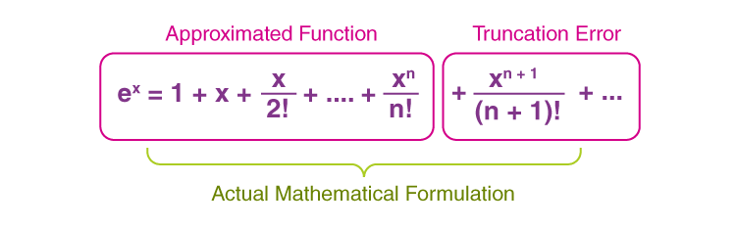
Figure 11 - Truncation Error of Taylor Series (What are Truncation Errors | Examples (byjus.com))

Complex geometry may also be a limitation as MATLAB has some built in functions for basic geometry however, for the more complex geometries, there might be a need to create some tools and algorithms for working with these sophisticated geometric structures. Dealing with such complex geometries can only be done if the memory and performance of the computer undertaking it is sufficient. As complex geometries can mean working with large data sheets, the performance of the software or computational resource can become a big limitation.
Numerical stability should always be achieved as unstable numerical equations can give large errors if not carefully monitored (Higham, 2020). Usually for a stable algorithm, the input values which are entered will have little to no effect on the final output. For an unstable algorithm, the input causes a more substantial error in the final output. To stop instability, there are boundaries set which will determine the stability of the algorithm.
Some limitations which are due to the coding is the way in which the thermal equilibrium is not modelled perfectly. This could be with regards to the time step which is used, it could lead to numerical instability and give an inaccurate representation of thermal equilibrium.
It could also be due to the grid mesh spacing not being small enough however, as mentioned previously, the grid spacing needs to give as accurate readings as necessary without taking too much computation power and time.
There could also be a better way of defining the thermal equilibrium, rather than interpreting two temperature maps and distinguishing the difference in value between the two.

Suggested improvements and future developments:

To improve on the code, some developments such as using the Alternating Direction Implicit (ADI) which is a finite difference method could be used. Al-taai (2020) describes how ADI was first used by Peaceman and Rachford in 1955. It was used as memory-efficient, fast methods were required to solve linear equations at every time-step. Later, when computers became more advanced and storage wasn’t as much of an issue, the ADI method became more developed to help calculate PDE in different dimensions.
Another method which could be implemented is implicit FDM, these types of methods are usually unconditionally stable and allows larger time-steps to be used while keeping computation costs down. Using these methods can help to increase the accuracy of the end results, also to help the stability issues.
Some alternatives to the Finite Difference Method (FDM) are Boundary Element Method (BEM), Finite Element Method (FEM) and Finite Volume Method (FVM).
BEM is a semi–analytical method meaning that a high accuracy can be achieved. It is suitable for solving boundary integral equations and is a very adaptable method which can easily produce surface meshes for complex geometry.
FEM has mostly been used in mechanical applications however, it has many other applications in thermomechanical and thermochemical applications to name a couple. It allows for unstructured meshes to be formed which can facilitate some intricate shapes. It can also handle different boundary types easily (Harish, 2023).
FVM is a popular method for fluid dynamics simulations, it can be useful for complex geometries by splitting the domain into control volumes and uses grids. This method can also use unstructured meshes to its advantage.
Alternative ways to model thermal equilibrium could be Computational Fluid Dynamics (CFD). The software can be very useful for simulating heat transfer especially when paired with a fluid flow however, it is not easy to learn and would require training for using these features.
Adaptive Mesh Refinement (AMR) could help to model thermal equilibrium more robustly as certain regions of interest can be focused on by superimposing a finer grid over the top of the original grid, improving the efficiency and accuracy of the model (Guarrasi, 2015).

Conclusion

To conclude, using the finite difference method was a useful tool for this application. The aluminium plate is a simple shape, so a square grid mesh could be created and superimposed over the aluminium plate. Taylors series was also used to ensure that every point of the grid was given a value. This allowed computational approximations to take place to calculate how long it would take to achieve thermal equilibrium throughout the aluminium plate. These approximations are much quicker than that which could be done manually. The importance of the time-step and grid spacing became apparent, as the accuracy depends on how fine the grid is. The time-step also has a big impact as the smaller the time-step, the more accurate results will be generated however, it will take more computational resource.
To be able to validate the code, the analytical method was also used so that the two solutions could be compared. As the results were very close to the analytical results, it gave confidence that the two solutions were correct. If there were large differences between the two, it would highlight errors which are causing the problem.
MATLAB was a difficult package to use, due to the nature of the software and using it for the first time however, it produced good, in-depth results once the script was run. It also produced good visual displays, which simulated the heat transfer through the aluminium plate. The results can be generated by just entering two inputs into the command window.
Some suggestions were mentioned within the report, that could be implemented into the script for different applications. Future developments that were mentioned could improve usability and ease of interpreting the results for future users.

Bibliography
Al-taai, E. A. (2020), Improved Alternating Direction Implicit Method. Journal of Physics: Confernce Series, Volume 1, pp. 2-3.
Byjus, (2023), Truncation Errors. [Online]
Available at: https://byjus.com/maths/truncation-errors/
[Accessed 22 January 2024].
Guarrasi, M., (2015), An introduction to Adaptive Mesh Refinement (AMR): Numerical Methods and Tools. [Online]
Available at: https://materials.prace-ri.eu/441/5/AMRIntroHNDSCi15.pdf
[Accessed 23 January 2024].
Harish, A. (2023), Finite Element Method – What Is It? FEM and FEA Explained. [Online]
Available at: https://www.simscale.com/blog/what-is-finite-element-method/
[Accessed 23 January 2024].
Higham, N. (2020), What is Numerical Stability?, Philadelphia: what-is.
Kanchan M. Kelkar, S. V. P. (2023), DEVELOPMENT OF GENERALIZED BLOCK CORRECTION PROCEDURES FOR, Minnesota: NASA.
Kenton, W. (2021), Rounding Error: What it is, How it Works, Examples. Investopedia, 26 June .
Khan Academy (2024), Maclaurin and Taylor Series intuition. [Online]
Available at: https://www.khanacademy.org/math/ap-calculus-bc/bc-series-new/bc-10-11/v/maclaurin-and-taylor-series-intuition#:~:text=A%20Taylor%20series%20is%20a,derivatives%20at%20a%20single%20point.
Kong, Q. (2020), Python Programming and Numerical Methods. 1 ed. London: Academic Press.
Lavinia (2012), Physics Forums. [Online]
Available at: https://www.physicsforums.com/threads/heat-equation-in-real-life.643597/
[Accessed 2 January 2024].
Manchestercfd (2023), Some very important terms any CFD user should know.. [Online]
Available at: https://www.manchestercfd.co.uk/post/some-very-important-terms-any-cfd-user-should-know#:~:text=Stability%20in%20this%20context%20refers,or%20otherwise)%20of%20this%20process.&text=In%20time%2Ddependent%20problems%20stability,exact%20solution%20should%20r
[Accessed 4 January 2024].
Marotin, A. (2023), 2D Diffusion Equation model using the finite difference method. Cardiff : UWTSD .
POPESCU, M.-C. (2009), Theoretical and Practical Aspects of Heating Equation. WSEAS TRANSACTIONS on SYSTEMS and CONTROL, 4(8), pp. 353-355.
Saeed, M. (2022), A Gentle Introduction to Taylor Series. [Online]
Available at: https://machinelearningmastery.com/a-gentle-introduction-to-taylor-series/
[Accessed 4 January 2023].
Slater, J. W. (2021), Examining Spatial (Grid) Convergence. [Online]
Available at: https://www.grc.nasa.gov/www/wind/valid/tutorial/spatconv.html
[Accessed 26 January 2024].
Testbook (2023), Fourier Number: Know Definition, Equation, Significance, and Applications. [Online]
Available at: https://testbook.com/mechanical-engineering/fourier-number#:~:text=It%20characterises%20the%20balance%20between,heat%20transfer%20within%20the%20body.
[Accessed 26 January 2024].
Verma, N. (2021), Taylor series- for dummies, by a dummy. [Online]
Available at: https://medium.com/@nisheetsun/taylor-series-for-dummies-by-a-dummy-6b3a703ae084
[Accessed 4 January 2021].
Weisstein, E. W. (2024), Roundoff Error. [Online]
Available at: https://mathworld.wolfram.com/RoundoffError.html#:~:text=Roundoff%20error%20is%20the%20difference,one%20or%20more%20intermediate%20steps.
[Accessed 22 January 2024].

Appendix:

Appendix 1. – MATLAB Code
clc % Clear Command Window
clear all % Removes All Variables From Workspace

k = 143; % Conductivity
p = 2.8 * 10^3; % Density
q = 795; % Specific Heat

x = 6; % Width of Grid (m)
y = 6; % Height of grid (m)

a = k / (p * q);

%---------------------------------------------

h = input('Enter a value for h (between 0 and 6, divisible by 6) '); % Prompt User to Input Value

while h <= 0 || h >= 6 || mod (6,h) ~=0 % Ensure Value Entered Complies With 'h' Rules

disp('invalid input') % Display 'Inavalid Input'if Value Entered is Incorrect
h = input('Enter a value for h (between 0 and 6, divisible by 6 ') % Allow User Another Input
end

%---------------------------------------------

dt = input('Enter positive time (t) value in seconds : ') % Prompt User to Input Value
Fo = a * dt / h^2;
while dt<0 || Fo>0.25; % Ensures No Negative Time Step Entered
disp('time step must be greater than 0') % Display 'Time Step Must be Greater Than 0'if Value Entered is Too Low
dt = input('Enter positive time (t) value in seconds : ') % Allow User Another Input
Fo = a * dt / h^2; % Calculate Fourier Number
end

%---------------------------------------------
%Defining matrix

Nc = (x/h+1); % Defining Columns in Matrix
Nr = (y/h+1); % Defining Rows in Matrix
T = zeros (Nr, Nc); % Set All Matrix Values to Zero (Initialising Matrix)
% Defining Matrix 'T'
for i = 1:Nc % Amend Matrix with Boundary Conditions
d = (i-1) * h;
if d < 4
T(1, i) = 12.5 * d;
else
T(1,i) = -25 * d + 150;
end
end
T_new=T; % Creating New Matrix for Updated Temperatures

Count = 0

while true
T=T_new
Count = Count + 1
% Calculate Matrices Until Thermal Equillibrium is Achieved
% Updated Temperatures in a New Matrix
for z = 2:Nr-1 % Dimension to Ignore Value
for v = 2:Nc-1 % Dimension to Ignore Value

T_new (z, v) = Fo * (T(z+1, v) + T(z-1, v) + T(z, v+1) + T(z, v-1) - (4 - 1/Fo) * T(z, v)) % Simplified Formula for New Tempertures
end
end

if max(max(abs(T_new-T)))<=0.01 % Checking for Thermal Equilibrium Within Tolerance
break;
end
end

% Creating Colour Map
figure (1)
contourf(flipud(T))
colormap("JET")
colorbar
xlabel('X')
ylabel('Y')
title(['Plate Thermal Distribution'])
pause(0.2)

% Thermal Equilibrium Time %

eq = Count * dt; % Calculate Time Taken for Equilibrium - Multiply Count by Time Step

if eq<60 % Will display in seconds
fprintf ('It took %g seconds to reach thermal equilibrium\n', eq) % Display Time Taken for Thermal Equilibrium - seconds

elseif eq>=60 && eq<3600 % Will display in minutes
eqM=eq/60;
fprintf ('It took %g minutes to reach thermal equilibrium\n', eqM) % Display Time Taken for Thermal Equilibrium - minutes

elseif eq>=3600 && eq<86400 % Will display in hours
eqH=(eq/60)/60;
fprintf ('It took %g hours to reach thermal equilibrium\n', eqH) % Display Time Taken for Thermal Equilibrium - hours

elseif eq>=86400 % Will display in days
eqD=((eq/60)/60)/24;
fprintf ('It took %g days to reach thermal equilibrium\n', eqD) % Display Time Taken for Thermal Equilibrium - days
end

fprintf ('(%g seconds)\n', eq) % Time in Seconds For Analysis

%---------------------------------------------
% Calculating the Analytical Solution
Nt = 200;
T_a = zeros (Nr, Nc);
for z = 1:Nr
for v = 1:Nc
x = (z - 1) * h;
y = (v - 1) * h;
T_a (z, v) = calculate_analytical_temperature(x, y, Nt);
end
end
T_a = rot90 (T_a);

%Ensuring Analytical Solution is Displayed in Command Window
disp('Thermal Equilibrium Temp Distribution - Analytical:');
disp(T_a);
%Calculating Difference Between Both Solutions
difference = T_new - T_a; % Calculate Difference Between Both Solutions
disp('Difference Between Numerical and Analytical:');
disp(difference);

% Visual Display of Analytical Solution (Display 2)
figure(2)
contourf(flip(T_a)) % Rotate by 90 degrees (clockwise) and then flip vertically
colormap(jet)
colorbar % Colourbar on RHS
clim([0 50]) % Set Limits (Replace 'min_value' and 'max_value' with your desired range)
xlabel('X') % Set Axis Label
ylabel('Y') % Set Axis Label
title('Analytical Temperature Distribution')

% Visual Display of Difference Between Both Solutions (Display 3)
figure(3)
contourf(flip(difference)) % Flip Matrix for Correct Orientation
colormap(jet) % Use 'jet' colormap For Easier Visual Display
colorbar % Add Colorbar to Denote Value Ranges
clim([-0.005 2]) % Set Colorbar Limits
xlabel('X') % Set Axis Label
ylabel('Y') % Set Axis Label
title('Difference Between Numerical and Analytical Solutions') % Set Title

% Function For Calculating Temp Distribution - Analytical
function T_a = calculate_analytical_temperature(x, y, Nt)
T_a = 0;
for n = 1:Nt
term = (sin(2*n*pi/3) / (n^2 * sinh(n*pi))) * sin(n*pi*x/6) * sinh(n*pi*y/6);
T_a = T_a + term;
end
T_a = (450/pi^2) * T_a;
end

Appendix 2. – Changing the Simulation Tolerance
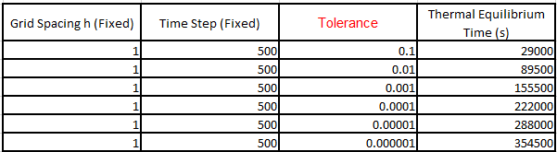

Appendix 3. – Changing the Simulation Time Step
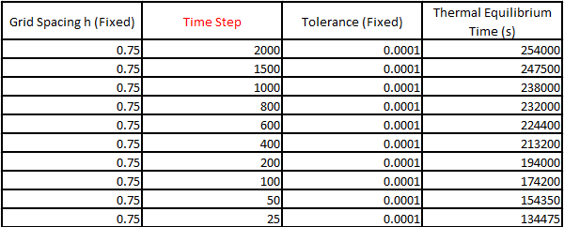

Appendix 4. – Changing the Simulation Grid Spacing


