Workshop Skills Logbook – Ruben Bhatia
Name: Ruben Bhatia
Student Number: 2104693
Course: Electrical & Electronic Engineering
Module Name: Workshop Skills/Learning In The Digital Era
Module Code: ACDA4004 – EEE Version
Lecturer: Gary Jones

I confirm all work done is my own unless stated otherwise – Ruben Bhatia

In the workshop, the task set was to see how frequency alters and affects an output voltage using set parameters such as input voltage, frequency increments and the circuit.

Three separate circuits were used during this experiment. The first was made using a program called ‘Proteus 8’, where a circuit was built and tested virtually using it. Here is an image of the circuit built virtually using proteus: 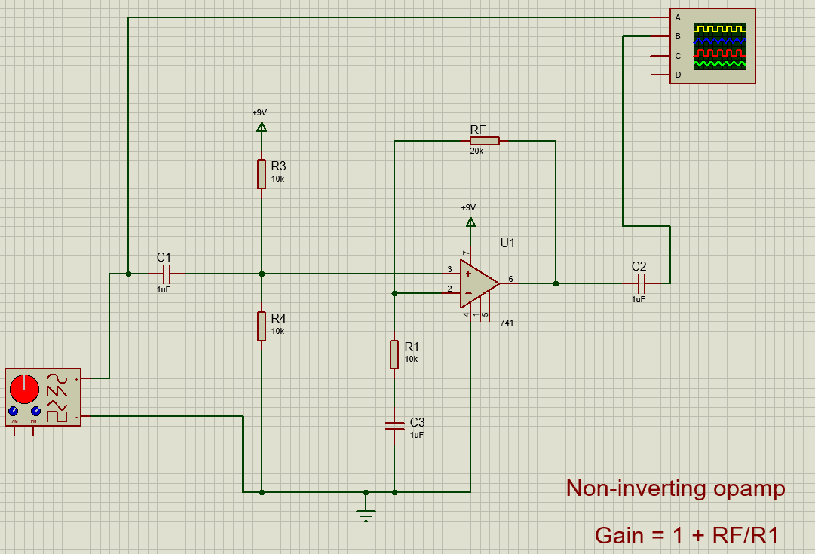
The second circuit used was made on a breadboard, where all wires and components are slotted in and tested using a real oscilloscope, signal generator and power supply. Here is an image of how the breadboard was set up:
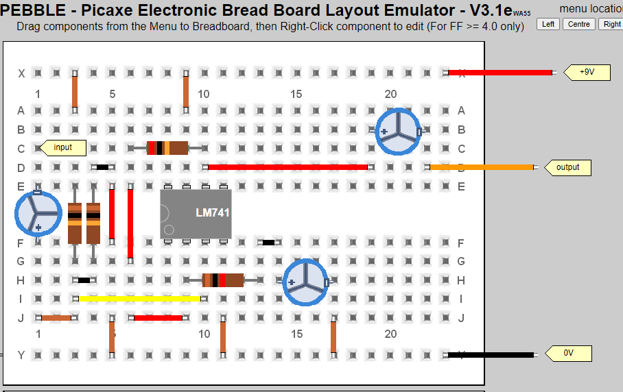
The final circuit used was a PCB, with all components soldered onto the board using a soldering iron. It was tested in a similar fashion to the breadboard, with an oscilloscope, signal generator and power supply.

Here are the results for the tests conducted in Proteus 8, on the virtual circuit:
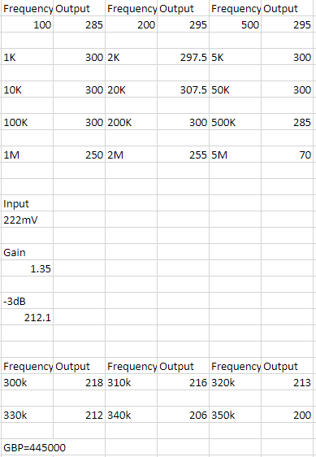

Here are the results for the tests conducted on the breadboard circuit, using an oscilloscope, signal generator and power supply:
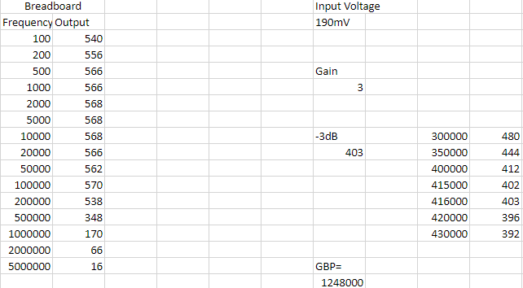

Here are the results for the tests conducted on the PCB circuit, using an oscilloscope, signal generator and power supply:
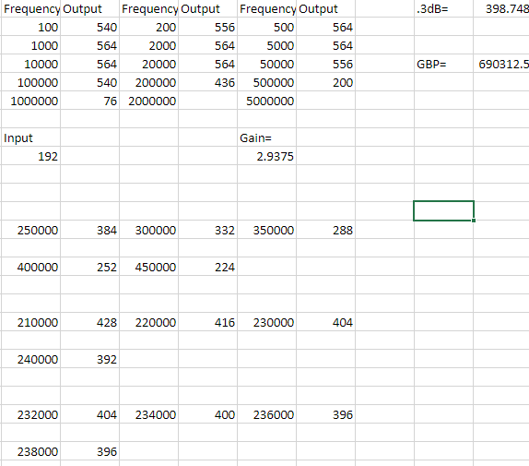

As shown above, the PCB circuit has a closer GBP to the simulated circuit’s GBP. The GBP for the breadboard circuit’s value is most likely inflated due to factors such as loose terminal connections and a poor integrity of the breadboard itself, as it was used multiple times before this test was conducted. Although not by much, the gain for the PCB circuit is closer to the simulated circuit’s gain than that of the breadboard circuit. The same can be said for the 3dB value.

